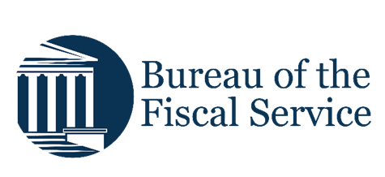

Chapter 4. Correcting Scanned Checks
OTCnet Participant User Guide

Table of Contents
Overview, Topics, and Audience 1
Overview 1
Topics 1
Audience 1
Topic 1 Purpose of Correcting Scanned Checks 2
Topic 2 Correct a Magnetic Ink Character Recognition (MICR) Code line 3
Correct a Magnetic Ink Character Recognition (MICR) Line 4
Topic 3 Edit a Check Item 5
Edit a Check Item 7
Summary 11

List of Figures
Figure 1. Code Line Correction Box 6
Figure 2: Search Batch 7
Figure 3. View Checks Page 9

List of Tables
Table 1. Code Symbol Descriptions 1 3
Table 2. Batch Status Types for OTCnet Online 5

Glossary
Select this link to access the full OTCnet Glossary.

Overview, Topics, and Audience

Overview
Welcome to Correcting Scanned Checks. In this chapter, you will learn:
- The purpose of correcting scanned checks
- How to edit a Magnetic Ink Character Recognition (MICR) code line
- How to edit a check item

Topics
The topics in this chapter include the following:
- Purpose of Correcting Scanned Checks
- Edit a Magnetic Ink Character Recognition (MICR) Code Line
- Edit a Check Item

Audience
The intended audience for the Correcting Scanned Checks Participant User Guide includes:
- Check Capture Supervisor (CCS)
- Check Capture Lead Operator (CCLO)

Topic 1 Purpose of Correcting Scanned Checks
As a Check Capture Supervisor (CCS) and Check Capture Lead Operator (CCLO) you are the only authorized users who can correct a scanned check in OTCnet. Correcting a check may involve one or more of the following resolutions:
- Adjusting the Magnetic Ink Character Recognition (MICR) code line
- Editing a check after it is entered and saved into OTCnet
Agency users who have permission to make corrections to checks must know the risks of submitting a check with incorrect information. They include debiting another individual’s/ company’s or Agency’s account and an increased likelihood of a returned check.
To avoid these risks, the CCS and CCLO can adjust a MICR line and edit a check after it’s scanned by either a CCLO or Check Capture Operator (CCO).

Topic 2 Correct a Magnetic Ink Character Recognition (MICR) Code line
As a CCS or CCLO, you are authorized to make MICR line corrections. You are prompted to key in your Login ID and Password before correcting the MICR line.
Keep the following items in mind when editing a MICR Code Line:
- If a CCO scans the check and the scanner detects an issue with the MICR code line data (certain characters or all characters could not be read by the scanner), the operator is prompted to correct the code line.
- If a CCLO scanned the check, additional authorization is not required. The Login ID and Password dialog box only appears if a CCS or CCLO is editing a MICR line for a CCO.
- When a Check Processing Error or Unsupported Bank Number message appears, the operator has the option to correct the code line, rescan the check, or cancel the scan. It is recommended that before attempting to correct the code line, the operator rescan the check. Rescanning the check usually corrects the error.
- If the error message continues to appear after the check is rescanned, contact your CCS to discuss options for capturing a check (e.g., rescanning the check again, correcting the MICR code line, or using the deposit processing functionality).
- If the issue persists, and the decision is made to correct the MICR code line, OTCnet provides the symbol replacement codes to make the necessary corrections. If the scanner continues to have difficulty reading the characters in the code line, create a deposit using the Deposit Processing tab within OTCnet. The Deposit Processing tab only appears if your Agency and appropriate users have permission to create deposits using this functionality.
- For detailed support, reach the OTCnet Customer Support Center at fiscalservice.otcchannel@citi.com or call toll free at 866-945-7920.
Table 1. Code Symbol Descriptions 1
Code | Symbol | Description
T |  | Beginning or ending of a transit number, also known as a Routing number or ABA number.
O |  | The On-Us field contains the account number and may also contain a serial number and transaction code.
A |  | Displays the amount of an amount-encoded check.
D |  | Dash separates the values of the other fields.

Correct a Magnetic Ink Character Recognition (MICR) Line
To correct a MICR line, complete the following steps:
- From the Check Scan – Perform Check Scan page, the Check Processing Error: Reject Characters Detected/Unsupported Bank Number message appears. Select Yes to correct the code line.
Or
Select Rescan to rescan the check (applies only to Reject Characters Detected message).
Application Tip

Select Rescan if the check image is skewed, illegible, or upside down.

Or
Select Cancel to cancel the transaction.
- The Login ID and Password dialog box appears. Enter the Login ID and Password and select Login.
Application Tips

- If a Check Capture Operator (CCO) scanned the check, OTCnet will prompt the operator for authorization.
- Only a Check Capture Supervisor (CCS) or Check Capture Lead Operator (CCLO) can perform MICR line corrections.
- The CCS or CCLO must key in his/her Login ID and Password before correcting the MICR line.
- If a CCLO scanned the check, additional authorization is not required.

- The Code Line Correction box appears. Enter the correct numbers and select OK.
- The Code Line Correction box closes, and the scanned check image appears.

Topic 3 Edit a Check Item
As a CCS or CCLO, you are the only authorized users who can edit a check within a batch. You can only edit checks in batches for OTC Endpoints that you have permission to access. You may choose to edit a check if the data entered in the amount or user defined fields were found to be incorrect.
Before editing a check, you must first search for the batch in which the check resides. You can search for batches by OTC Endpoint, Created On Date, Batch ID, Cashier ID, and/or Batch Status. You can only edit checks that carry an open or closed batch status.
Table 2. Batch Status Types for OTCnet Online
Open | Indicates the batch is open and accepting new checks
Closed | Indicated the batch is closed and no new checks are accepted
Approved | Indicates the batch is ready for settlement
Forwarded | Indicates the batch has been sent to debit Gateway to initiate the settlement process
For OTC Endpoints that are associated with an Agency Location Code (ALC) that is designated as a Government-Wide Accounting (GWA) Reporter, all check transactions must be classified with an accounting code. If an ALC is not a GWA Reporter, classifying it with an accounting code is optional.
The Agency Accounting Codes drop-down list displays the full Agency Accounting Code value (up to 50 alphanumeric characters) and some portion of the Description (up to 15 alphanumeric characters).
In the event an Agency becomes a GWA Reporter in between a captured check and an operator selecting to save updates, and if an accounting code is not specified and is available for selection, an overlay message appears asking, “Would you like to classify the check transaction with Accounting information?”
If Yes is selected, you are returned to the Show Item page and allowed to select an accounting code.
If No is selected, a Comment dialog box appears. Enter a reason why an accounting code is not classified for the transaction.
The single Agency Accounting Code and Multiple accounting codes option is available if checks are scanned against an OTC Endpoint designated for Item Level Classification. If an ALC is designated for Summary Level Classification the Agency Accounting Code and Multiple accounting codes options are disabled.
If multiple accounting codes are used, the combined accounting code subtotal must be equal to the deposit total before proceeding to the next step. If it does not, you must go back and re-validate your subtotal entries.

Application Tips

- As the CCS or CCLO, if you opt to make a MICR code line correction, you must look at the MICR line image closely to ensure all the characters are correctly entered in the Code Line Correction box as shown in Figure 1.
- OTCnet will indicate the character(s) that are illegible by replacing it with a question mark(s). Look at the MICR line image closely to ensure all the characters are correctly captured. If they are not captured or marked with a question mark, select Cancel and rescan the check.
- If the scanner continues to have difficulty reading the characters in the code line, the operator can create a deposit using the Deposit Processing tab within OTCnet. The Deposit Processing tab only appears if your agency and appropriate users have permission to create deposits for over-the-counter collections.

Figure 1. Code Line Correction Box
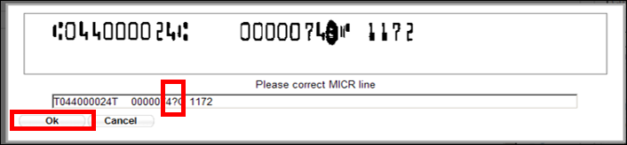

Edit a Check Item
To edit a check item, complete the following steps:
- Select the Check Processing tab and select Batch Management. The Search Batch page appears as shown in Figure 2.
Figure 2: Search Batch
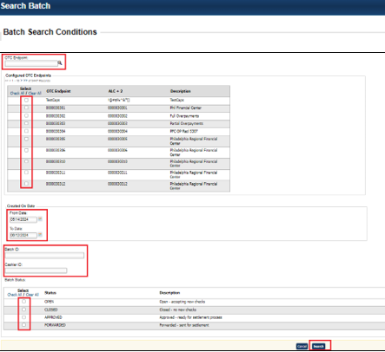
- In the search field, under Batch Search Conditions, enter an OTCnet Endpoint and select the magnifying glass icon (or the ENTER key) to retrieve a new set of results.
- Select the OTC Endpoint you want to Edit a batch for by checking the checkbox under the Select column.
- Under Created On Date, enter the From and To date range, as needed.

Application Tips

- There is an endpoint search restriction set based on user permissions (i.e., a CCLO, CCA user can only search for their Agency and any endpoints under their Agency.).
- The From and To Created On Date must be entered in MM/DD/YYYY format.
- The Created On Date range cannot exceed 30 days. Additionally, if more than 1,000 batches are created within 30 days then only the most recent 1,000 batches appear.
- If you run a search with the default From and To Created On Date range values, the search results include the most recent 30 days of batches that you have access to view. If more than 1,000 batches are created within the 30 days then only the most recent 1,000 batches appear.
- If you run a search without specifying any criteria (with the exception of the Batch ID field), the search results include the most recent 30 days of batches that you have access to view. If more than 1,000 batches are created within 30 days then only the most recent 1,000 batches appear.

  - Enter the Batch ID, optional.
  - Enter the Cashier ID, optional.
Application Tip

If the only search criteria entered is a valid Batch ID, only a single result appears, regardless of other search criteria specified.

Under Batch Status, optional
  - Select the Status you want to view by checking the Open or Closed box under the Select column.
Application Tip

Only batches in Open or Closed status can be edited.

- Select Search. The View Batches page appears.
- Select the Batch ID hyperlink. The View Checks page appears.
- Select the Item ID of the scanned check you would like to edit. An image and details of the check appear in a window below.
- Select Show Item to the right of the check image to edit as shown in Figure 3. The Show Item page appears.
Figure 3. View Checks Page
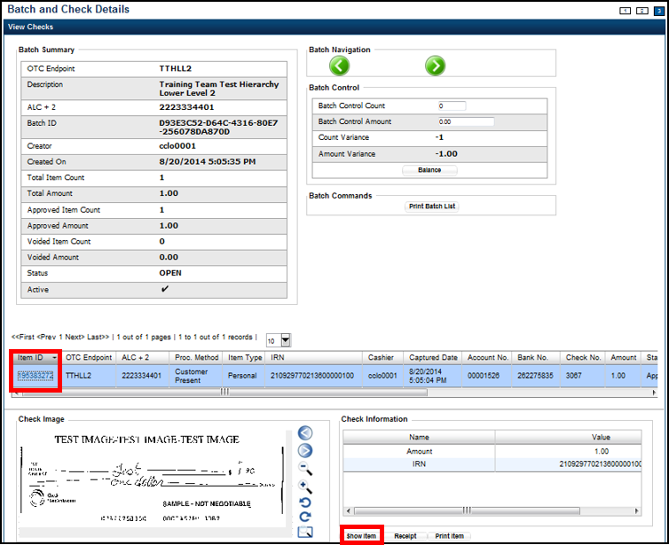
- Update the necessary form data.
To edit the form data, complete the following:
Under Agency Form Data, update the check data in the field(s) provided, if applicable
  - Enter the Amount.
  - Enter the User Defined Field (UDF) details.
Application Tips

- The Agency Form Data form is customizable and can include fields beyond the Amount field (e.g., Driver’s License Number). If your Agency has additional fields, they are displayed under the Amount field. Your Agency may deem the field(s) either mandatory or optional for you to complete an entry.
- Ensure that you type in the data rather than copying and pasting from another source. Data that has been copied and pasted may result in an error.

Under Agency Accounting Code, if applicable
  - Select the Agency Accounting Code radio button and select a single accounting code from the drop-down list.
Or
  - Select the Multiple radio button. The Account Classification dialog box appears.
    - Select an Accounting Code, enter the Amount, and select Add for each subtotal of the deposit.
    - Select Save.
Under Server Controls, required
  - Select Update.
- Select Confirm to confirm to update the check data.
- Enter comments concerning the updated request at the prompt and select OK.
- Select OK at the confirmation prompt stating that the check has been successfully updated.

Additional Buttons
Additional buttons on the pages that help you perform other tasks:
- Select Cancel to return to the OTCnet Home Page. No data is saved.
- Select Previous to return to the previous page.
- Select Void All to void all items in the batch.
- Select Print Batch List to print the batch list.
- Select < to go to the first batch.
- Select > to go to the next batch.
- Select <<Image to return to the previous check.
- Select >>Image to view the next check.
- Select Zoom- to reduce the image size.
- Select Zoom+ to enlarge the image size.
- Select Rotate Left to turn the image to the left.
- Select Rotate Right to turn the image to the right.
- Select Show Item to view the check item and perform update.
- Select Void to void a single check item.
- Select Receipt to print a receipt.
- Select Print Item to print an Item List report.
Additional buttons on the Show Item page that help you perform other tasks:
- Select -Front to return to the previous check.
- Select Back+ to view the next check.
- Select -Zoom to reduce the image size.
- Select Zoom+ to enlarge the image size.
- Select Rotate Left+ to turn the image to the left.
- Select Rotate Right+ to turn the image to the right.

Summary
In this chapter, you learned:
- The purpose of correcting scanned checks
- How to edit a Magnetic Ink Character Recognition (MICR) code line
- How to edit a check item

