

Chapter 6. Confirming, Rejecting and Adjusting Deposits
OTCnet Participant User Guide

Table of Contents
Overview, Topics, and Audience 1
Overview 1
Topics 1
Audience 1
Topic 1 Purpose of Confirming, Rejecting or Adjusting a Deposit 2
Confirm a Single Deposit or Multiple Deposits 2
Confirm a Single Deposit 3
Confirm Multiple Deposits 7
Topic 2 Rejecting Deposits 11
Reject a Deposit 12
Topic 3 Adjusting Deposits 15
Create a Credit/Debit Adjustment 15
Create a Credit/Debit Adjustment 16
Summary 20

List of Figures
Figure 1. Confirming, Rejecting or Adjusting Deposits Process Flow 2
Figure 2. View Deposits 3
Figure 3. Step 1 of 2: Define Information for Deposit Confirmation 4
Figure 4. View Deposits 7
Figure 5. Step 1 of 2: Confirm Deposits for Multiple Deposits 8
Figure 6. Reject Deposit 12
Figure 7. Enter Rejection Comments 13
Figure 8. Adjust Deposit 16
Figure 9: Adjusting a Deposit for U.S. Currency 17

Glossary
Select this link to access the full OTCnet Glossary.

Overview, Topics, and Audience

Overview
In this chapter, you will learn:
- The purpose of confirming or rejecting a deposit
- The criteria for confirming a deposit
- How to confirm a deposit
- How to reject a deposit
- How to create a credit/debit adjustment

Topics
- Purpose of Confirming, Rejecting or Adjusting a Deposit
- Rejecting Deposits
- Adjusting Deposits

Audience
The intended audience for the Confirming, Rejecting or Adjusting Deposits chapter is:
- Deposit Confirmer

Topic 1 Purpose of Confirming, Rejecting or Adjusting a Deposit
After a Deposit Approver submits a deposit for confirmation, the Deposit Confirmer at the Financial Institution confirms, adjusts or rejects the deposit. Only deposits that are saved with a Submitted status by the agency’s Deposit Approver can be confirmed, rejected or adjusted. Review the process flow for confirming, rejecting, or adjusting a deposit as shown in Figure 1.
When confirming a deposit as a Deposit Confirmer, the deposit status is Confirmed. When rejecting a deposit, the deposit status is Rejected.
A Deposit Confirmer at a Financial Institution may reject deposits if there are duplicate voucher submissions, items missing, funds not received, etc. After a deposit is adjusted, it is searchable using the Search Adjustments or Search Deposits function.
Figure 1. Confirming, Rejecting or Adjusting Deposits Process Flow
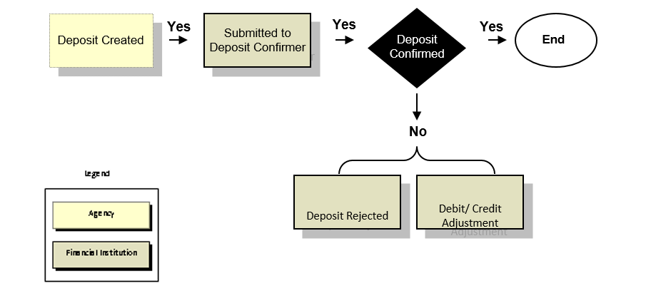

Confirm a Single Deposit or Multiple Deposits
To confirm a single deposit or multiple deposits simultaneously, the deposit must have a Submitted status. To locate deposits with a Submitted status, use the View Deposits or Search Deposits function. After locating the deposit, confirm the deposit preparation information. Once a deposit is confirmed, it is saved with a Confirmed status.

Confirm a Single Deposit
To confirm a single deposit, complete the following steps:
- From the Deposit Processing tab, select View Deposits. The View Deposits page displays.
Application Tip

To locate deposits, you can also select Search Deposits.

- From the Select Display drop-down menu, select My Deposits in Process.
- Select the Voucher Number for the deposit whose details you want to process, as shown in Figure 2. The View Submitted Deposit page displays.
Figure 2. View Deposits
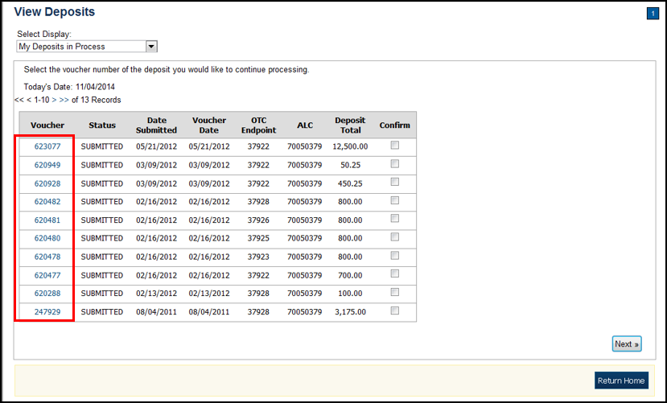
Application Tip

Depending on your user role, the My Deposits in Process page displays your current deposits. If you only have the Viewer role, the My Deposits in Process does not display any deposits.

- Select Confirm. The Step 1 of 2: Define Information for Deposit Confirmation page displays as shown in Figure 3.
Figure 3. Step 1 of 2: Define Information for Deposit Confirmation
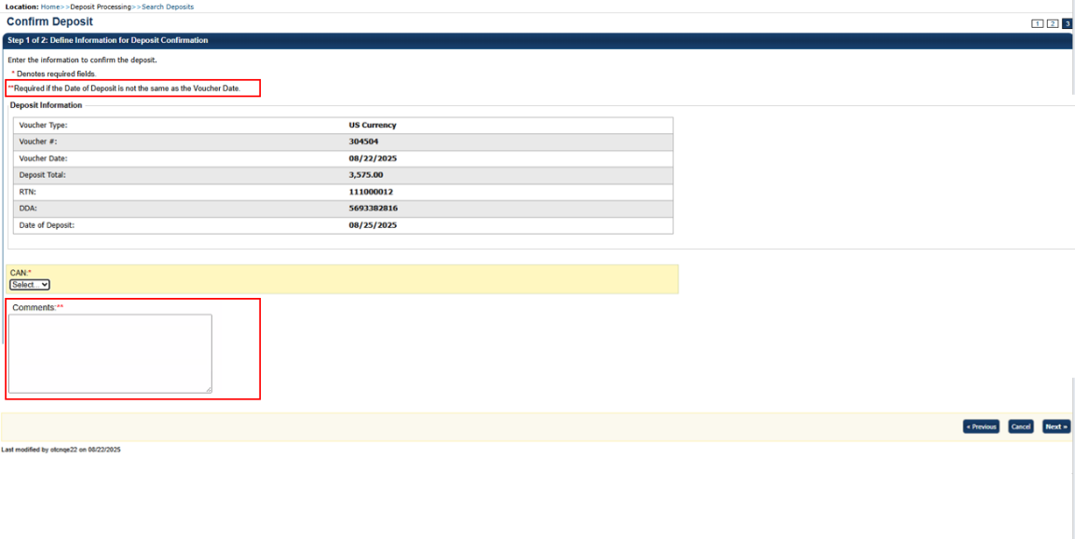
Application Tip

The system displays the static informational message reading: ** Required if the Date of Deposit is not the same as the Voucher Date, along with a corresponding Deposit Comment field marked with a double asterisk (**).

- Enter the deposit information and select Next. The Step 2 of 2: Review Information for Deposit Confirmation page displays.
US Currency Deposits (both cash and check)
  - Select the CAN/ACCT Key (CA$HLINK II Account Number/Account Key)
  - Enter the Date of Deposit
  - Enter Comments, if applicable and/or required (for example, explain why the date of the deposit is later than the voucher date to avoid a voucher delay fee.)
  - Enter the CCWU (Cost Center Work Unit Number)
  - Enter the 1 Day Deferred
  - Enter the 2 Day Deferred
Application Tips

- The system sets the date of deposit equal to the current system date in a read-only text for U.S. and foreign currency deposits.
- Users can adjust and confirm the deposit on weekends and holidays.
- The CCWU, 1 Day Deferred, and 2 Day Deferred are for FRB deposits only.

Foreign Currency Cash
  - Select the CAN/ACCT Key (CA$HLINK II Account Number/Account Key)
  - Enter the Date of Deposit
  - Enter Comments, if applicable and/or required (for example, explain why the date of the deposit is later than the voucher date to avoid a voucher delay fee.)
Foreign Check Items
  - Enter the Exchange Rate under Foreign Currency Information
  - Select the CAN/ACCT Key (CA$HLINK II Account Number/Account Key)
  - Select the Date of Deposit
  - Enter the Deposit Total (USE) (US Dollar Equivalent)
  - Enter Comments, if applicable and/or required (for example, explain why the date of the deposit is later than the voucher date to avoid a voucher delay fee).
Application Tips

- Financial Institutions will not be able to confirm deposits prior to the Voucher Date (chosen by the Deposit Preparer/Approver).
- If they attempt to confirm a deposit before the Voucher Date, they will receive the message stating that “the deposit date must be greater than or equal to the voucher date."
- CashLink account is required for commercial financial institution deposits.

- Verify the information is correct and select Submit. Select Edit to modify the data entered. A Confirmation page displays stating that the deposit has been confirmed.
Application Tip

When the Submit button is selected on the Confirm Deposit Step 2 of 2 page, an email notification will be sent to the deposit preparer, approver, and confirmer to alert them that the deposit has been confirmed by the financial institution.


Additional Buttons
- Select Adjust to adjust a deposit.
- Select Cancel to return to the OTCnet Home Page. No data is saved.
- Select Confirm to confirm a deposit.
- Select Edit to return to the previous page.
- Select View Voucher Event Log to view the history of the deposit voucher.
- Select Next to advance to the next page.
- Select Previous to return to the previous page.
- Select Return Home to return to the OTCnet Home Page.
- Select Reject to reject a deposit.

Confirm Multiple Deposits
To confirm multiple deposits simultaneously, complete the following steps:
- From the Deposit Processing tab, select View Deposits. The View Deposits page displays.
- From the Select Display drop-down menu, select My Deposits in Process.
- Select the Voucher Numbers you want to confirm by checking the boxes under the Confirm column, as shown in Figure 4.
Figure 4. View Deposits
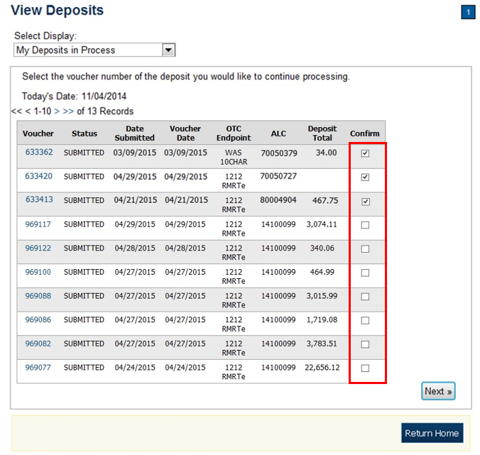
Application Tip

Depending on your user role, the My Deposits in Process page displays your current deposits. If you only have the Viewer role, the My Deposits in Process does not display any deposits.

- Select Next. The Step 1 of 2: Confirm Deposits page displays.
- Enter the deposit information. Select Next as shown in Figure 5.
Figure 5. Step 1 of 2: Confirm Deposits for Multiple Deposits
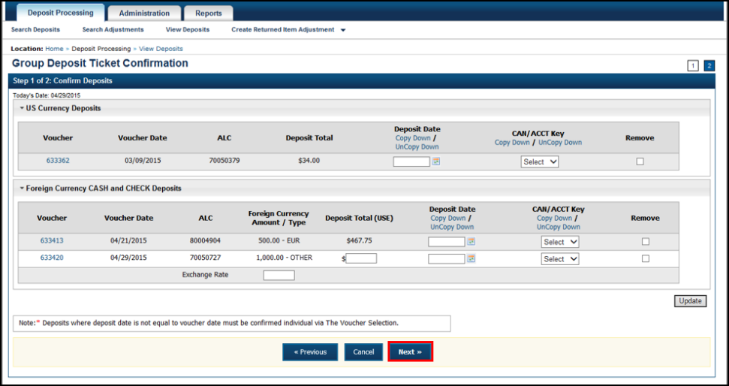
US Currency Deposits (checks and cash):
  - Select the Date of Deposit
  - Select the CAN/ACCT Key (CA$HLINK II Account Number/Account Key)
  - Enter the CCWU (Cost Center Work Unit Number)
  - Enter the 1 Day Deferred
  - Enter the 2 Day Deferred
Foreign Currency Cash and Check Deposits:
  - Select the Date of Deposit
  - Select the CAN/ACCT Key (CA$HLINK II Account Number/Account Key)
  - If Other was selected for Country of Deposit during deposit creation, enter Deposit Total (USE) and Exchange Rate.
Application Tip

If the deposit date is not the same as the voucher date, you will get a message on the screen that the deposit must be confirmed individually.

Application Tips

- When confirming a deposit ticket, ensure you confirm the deposit on the date received. Due to transit times, Fiscal Service is aware that deposits may not be confirmed on the Voucher Date entered by the Agency. Fiscal Service can adjust the value of funds, if needed, to account for these discrepancies.
- To use the same date for all deposits listed, select the Copy Down hyperlink in the Date of Deposit column.
- The system sets the date of deposit equal to the current system date in a read-only text for U.S. and foreign currency deposits.
- Users can adjust and confirm the deposit on weekends and holidays.
- CashLink account is required for commercial financial institution deposits.
- To use the same CAN or Account Key used for all deposits listed, select the Copy Down hyperlink in the CAN/ Acct Key column.
- To remove vouchers from the group being confirmed, select the Voucher Numbers you wish to remove by checking the boxes under the Remove column and select Update.

- Select Next. The Step 2 of 2: Review Information for Deposit Confirmation page displays.
- Verify the information is correct and select Submit.
- A Confirmation page displays stating that the deposits are confirmed.
Application Tip

When the Submit button is selected on the Confirm Deposit Step 2 of 2 page an email notification will be sent to the deposit preparer, approver, and confirmer to alert them that the deposit has been confirmed by the financial institution.

Additional Buttons
- Select Adjust to adjust a deposit.
- Select Cancel to return to the OTCnet Home Page. No data is saved.
- Select Confirm to confirm a deposit.
- Select Edit to return to the previous page.
- Select View Voucher Event Log to view the history of the deposit voucher.
- Select Next to advance to the next page.
- Select Previous to return to the previous page.
- Select Return Home to return to the OTCnet Home Page.
- Select Reject to reject a deposit.
- Select Update to remove the selected voucher(s) that are being confirmed.

Topic 2 Rejecting Deposits
To reject a deposit, it must have a Submitted status. To locate a deposit with a Submitted status, use the View Deposits or Search Deposits function. After locating the deposit, you can reject the deposit preparation information. Once a deposit is rejected, it is saved with a Rejected status.
Only deposits saved with a Submitted status by the agency’s Deposit Approver can be confirmed, rejected, or adjusted. As a best practice, Fiscal Service recommends that the Deposit Confirmer confirms, adjusts or rejects deposits as part of their daily activities. In addition, it is recommended that all deposits (except those issued from foreign checks) are confirmed no later than 30 days from the Voucher Date.

Reject a Deposit
To reject a deposit, complete the following steps:
- From the Deposit Processing tab, select View Deposits. The View Deposits page displays.
Application Tip

To locate deposits, you can also select Search Deposits and select the Voucher Number of the deposit you would like to continue processing.

- From the Select Display drop-down menu, select My Deposits in Process.
- Select the Voucher Number of the deposit you would like to continue processing.
The View Submitted Deposit page displays, as shown in Figure 6.
Figure 6. Reject Deposit
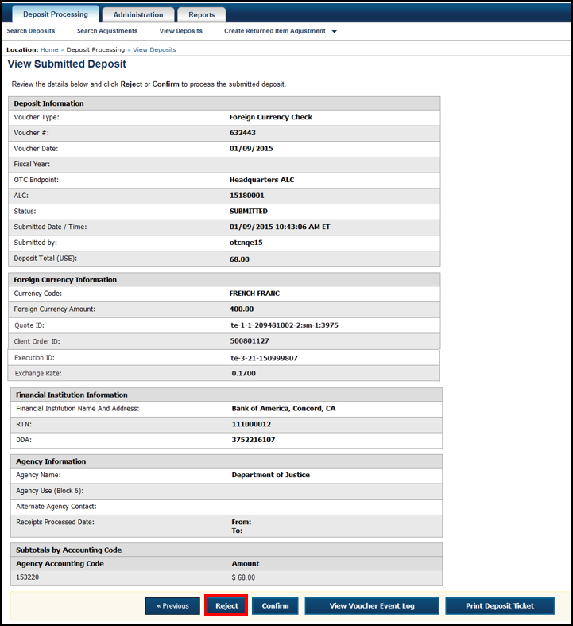
- Select Reject. The Step 1 of 2: Define Information for Deposit Rejection displays.
Application Tip

Deposit Total is not displayed on the Define Information for Deposit Rejection page for a foreign check deposit with Other selected for the country of deposit.

- Enter Comments describing the reason you are rejecting the deposit, as shown in Figure 7.
Figure 7. Enter Rejection Comments
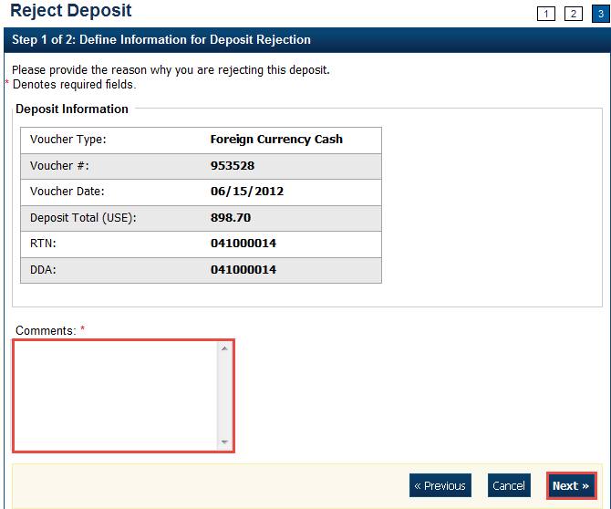
- Select Next. The Step 2 of 2: Review Information for Deposit Rejection page displays.
Application Tip

Deposit Total is not displayed on the Review Information for Deposit Rejection page for a foreign check deposit with Other selected for the country of deposit.

- If the information is correct, select Submit. Select Edit to modify the comment.
- A Confirmation page displays stating that the deposit is rejected.

Application Tip

When the Submit button is selected on Step 2 of 2: Review Information for Deposit Rejection page, an email notification will be sent to the deposit preparer, approver, and confirmer to alert them that the deposit has been rejected by the financial institution.

Additional Buttons
- Select Adjust to adjust a deposit.
- Select Cancel to return to the OTCnet Home Page. No data is saved.
- Select Confirm to confirm a deposit.
- Select View Voucher Event Log to view the history of the deposit voucher.
- Select Previous to return to the previous page.
- Select Return Home to return to the OTCnet Home Page.

Topic 3 Adjusting Deposits
As a Deposit Confirmer, you are authorized to create a credit or debit adjustment for a deposit. Only US Currency and Foreign Currency Cash deposits with Submitted or Confirmed status can be credited or debited.
To locate a deposit with a Submitted or Confirmed status, use the View Deposits or Search Deposits function. After the deposit is located, the deposit preparation information can be adjusted. Once the adjustment is applied, the deposit status is saved with a Confirmed status and an asterisk appears in the Adj. (Adjustment) column of the Deposit Transactions table. After a deposit is adjusted, search for adjustments using the Search Adjustments or Search Deposits function.
Your Financial Institution may have internal business processes related to creating an adjustment for a credit or debit. Part of those practices may include contacting the agency if there is a discrepancy, prior to performing the adjustment.
A credit adjustment is applied when the voucher deposit total indicated exceeds the actual deposit voucher amount. A debit adjustment is applied when the voucher deposit total indicated is less than the actual deposit voucher amount.
As a best practice, Fiscal Service recommends that the Deposit Confirmer confirms, adjusts or rejects deposits as part of their daily activities. In addition, it is recommended that all deposits (except those issued from foreign checks) are confirmed no later than 30 days from the Voucher Date.

Create a Credit/Debit Adjustment
To create a credit/debit adjustment, select a deposit in process and the corresponding voucher number and define the deposit adjustment information.

Create a Credit/Debit Adjustment
To create a credit/debit adjustment, complete the following steps:
- From the Deposit Processing tab, select View Deposits. The View Deposits page displays.
Application Tip

To locate deposits, you can also select Search Deposits.

- From the Select Display drop-down menu, select My Deposits in Process.
- Select the Voucher Number for the deposit whose details you want to process. The View Submitted Deposit page displays, as shown in Figure 8.
Figure 8. Adjust Deposit
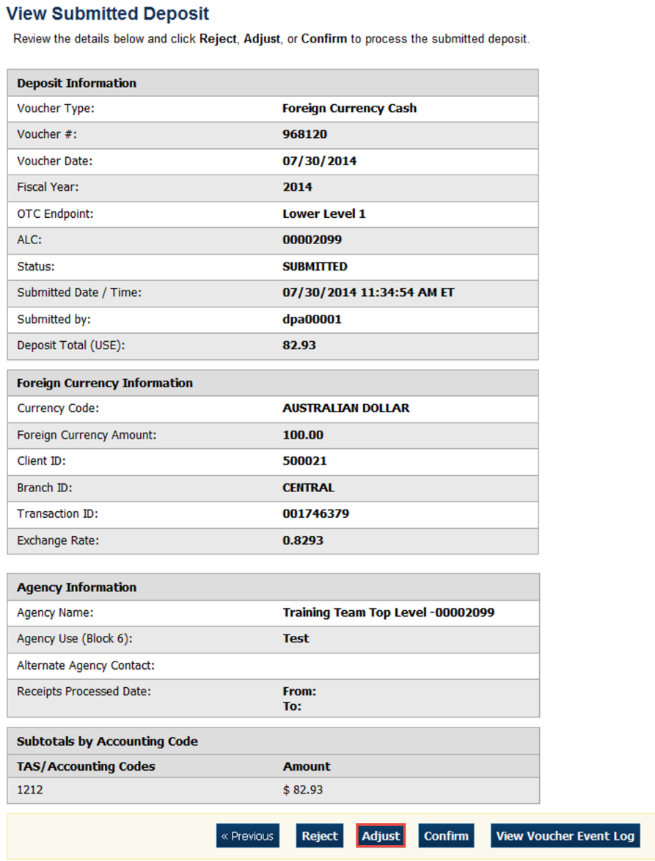
Application Tip

Depending on your user role, the My Deposits in Process page displays your current deposits. If you only have the Viewer role, the My Deposits in Process does not display any deposits.

- Select Adjust. The Step 1 of 2: Define Information for Deposit Adjustment page displays as shown in Figure 9.
Figure 9: Adjusting a Deposit for U.S. Currency
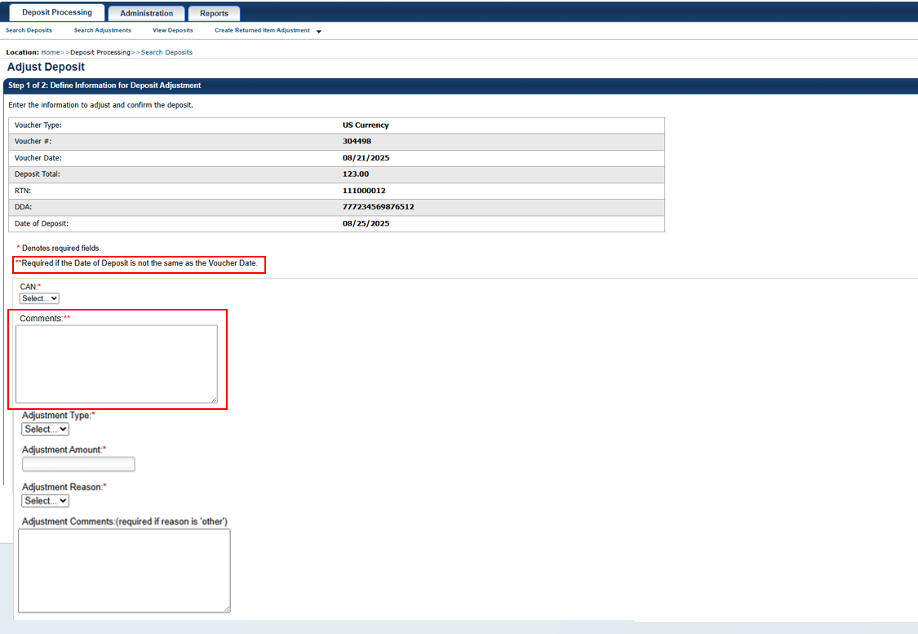
Application Tip

The system displays the static informational message reading: ** Required if the Date of Deposit is not the same as the Voucher Date, along with a corresponding Deposit Comment field marked with a double asterisk (**).

Application Tips

- You can only create adjustments for US Currency and Foreign Currency Cash deposits with Submitted or Confirmed status.
- The system sets the date of deposit equal to the current system date in a read-only text for U.S. and foreign currency deposits.
- Users can adjust and confirm the deposit on weekends and holidays.

- Enter the adjustment information and select Next.
  - Select the CAN/ACCT Key (CA$HLINK II Account Number/Account Key)
  - Enter the Date of Deposit
  - Enter Comments, if applicable and/or required (for example, explain why the date of the deposit is later than the voucher date to avoid a voucher delay fee.)
  - Enter the CCWU (Cost Center Work Unit Number)
  - Enter the 1 Day Deferred
  - Enter the 2 Day Deferred
  - Select Debit or Credit for Adjustment Type
  - Enter the Adjustment Amount
  - Select the Adjustment Reason
  - Enter Adjustment Comments
Application Tips

- The CCWU, 1 Day Deferred Amount, and 2 Day Deferred Amount are for FRB deposits only.
- Adjustment Comments are required if the reason is Other.

- The Step 2 of 2: Review Information for Deposit Adjustment page displays. Verify the information is correct and select Submit. Select Edit, to modify the adjustment information and review the information again.
- A Confirmation page displays stating the deposit was adjusted.
Application Tip

When the Submit button is selected on Step 2 of 2: Review Information for Deposit Adjustment page, an email notification will be sent to the deposit preparer, approver, and confirmer to alert them that a deposit adjustment has been created by the financial institution.

Additional Buttons
- Select Cancel to return to the OTCnet Home Page. No data is saved.
- Select Confirm to confirm a deposit.
- Select View Voucher Event Log to view the history of the deposit voucher
- Select Previous to return to the previous page.
- Select Return Home to return to the OTCnet Home Page.
- Select Reject to reject a deposit.

Summary
In this chapter, you learned:
- The purpose of confirming or rejecting a deposit
- The criteria for confirming a deposit
- How to confirm a deposit
- How to reject a deposit
- How to create a credit/ debit adjustment

