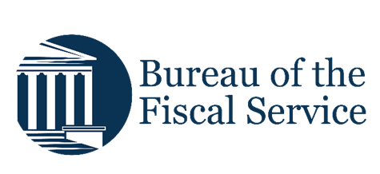

Chapter 3. Creating and Modifying Deposits
OTCnet Participant User Guide

Table of Contents
Overview, Topics, and Audience 1
Overview 1
Topics 1
Audience 1
Topic 1 Purpose of Creating and Modifying a Deposit 2
Topic 2 Creating a Deposit and Confirming or Submitting for Approval 4
Create a Deposit for US Currency 4
Create a Deposit for U.S. Currency 5
Create a Deposit for Foreign Currency Cash 9
Create a Deposit for Foreign Currency Cash 10
Create a Deposit for a Foreign Check Item 14
Create a Deposit for a Foreign Check Item 15
Topic 3 How to Modify a Deposit 20
Modify a Deposit 20
Modify a Deposit 21
Summary 26

List of Figures
Figure 1. Step 1 of 3: Define Deposit Preparation Information 5
Figure 2. Step 2 of 3: Define Subtotals by Accounting Code or TAS 11
Figure 3. Step 2 of 3: Define Subtotals by Accounting Code or TAS for Foreign Check Item in which Country of Deposit was Set to a Country Name 17
Figure 4. Edit Draft Deposit 22
Figure 5. Step 1 of 3: Update Deposit Preparation Information for U.S. Currency 23

List of Tables
Table 1. Deposit Processing Options Based on User Roles and Processing Option When Current Deposit Status is Draft 2
Table 2. Deposit Processing Options Based on User Roles and Processing Option When Current Deposit Status is AWAP 3

Glossary
Select this link to access the full OTCnet Glossary.

Overview, Topics, and Audience

Overview
Welcome to Creating and Modifying Deposits. In this chapter, you will learn:
- The purpose of creating and modifying a deposit
- How to create a deposit for US Currency
- How to create a deposit for Foreign Currency Cash
- How to create a deposit for Foreign Check Items
- How to save a deposit as a draft
- How to submit a deposit for approval
- How to submit a deposit for confirmation
- How to modify a deposit

Topics
This chapter is organized by the following topics:
- Purpose of Creating and Modifying a Deposit
- Creating a Deposit and Confirming or Submitting for Approval
- Modifying a Deposit

Audience
The intended audience for the Creating and Modifying Deposits Participant User Guide includes:
- Deposit Preparer
- Deposit Preparer and Deposit Approver

Topic 1 Purpose of Creating and Modifying a Deposit
The purpose of creating a deposit is to help you find the information needed quickly and easily to successfully complete deposits for your organization. The ability to modify those deposits ensures accurate deposits are made.
You may be assigned the Deposit Preparer role, the Deposit Approver role or both the Deposit Preparer and Deposit Approver roles.
As a Deposit Preparer, you can create deposits, save them as draft or save for approval, modify draft deposits and search for and view deposits.
As a Deposit Approver, you can submit (to your financial institution) or reject deposits saved for approval and to search for and view deposits.
As a Deposit Preparer and Deposit Approver, you have the ability to create deposits, submit deposits, modify draft deposits and search for and view deposits.
If your organization's Accounting Specialist has enforced separation of duties, you are not allowed to submit a deposit that you have created. A separation of duties means that a user does not have the ability to create and submit a deposit in OTCnet. This is enforced to ensure checks and balances.
Depending on your deposit status, role, and if there is an enforced separation of duties, you have certain deposit-processing options available to you (see Table 1).
Table 1. Deposit Processing Options Based on User Roles and Processing Option When Current Deposit Status is Draft
Option | Deposit Preparer  Without  Separation of Duties Enforced | Deposit Preparer/  Deposit Approver (user assigned both roles)  Without Separation of Duties Enforced | Deposit Preparer With Separation of Duties Enforced | Deposit Preparer/ Deposit Approver (user assigned both roles)  With Separation of Duties Enforced
Delete | Yes | Yes | Yes | Yes
Save As Draft | Yes | Yes | Yes | Yes
Save For Approval | Yes | Yes | Yes | Yes
Submit | No | Yes | No | No¹ / Yes²
Edit (Modify) | Yes | Yes | Yes | Yes
¹ assuming that this user created a deposit
² assuming that a deposit has been created by another user

Table 2. Deposit Processing Options Based on User Roles and Processing Option When Current Deposit Status is AWAP
Option | Deposit Preparer  Without  Separation of Duties Enforced | Deposit Approver  Without  Separation of Duties Enforced | Deposit Preparer/  Deposit Approver  (user assigned both roles)  Without  Separation of Duties Enforced | Deposit Preparer  With  Separation of Duties Enforced | Deposit  Approver  With  Separation of Duties Enforced | Deposit Preparer/  Deposit Approver  (user assigned both roles)  With  Separation of Duties Enforced
Submit | No | Yes | Yes | No | Yes | No¹ / Yes²
¹ assuming that this user created a deposit
² assuming that a deposit has been created by another user

Topic 2 Creating a Deposit and Confirming or Submitting for Approval
As a Deposit Preparer or Deposit Preparer and Approver you authorized to create deposits and modify deposits for:
- US Currency
- Foreign Currency Cash
- Foreign Check Item

Create a Deposit for US Currency
To create a deposit for U.S. currency, use the US Currency function to create a deposit for US cash, coins, checks, and money orders. Select your endpoint and your Deposit Information (deposit total and voucher date), Financial Institution Information, and Agency Information. Depending on your role, deposit status, and if there is an enforced separation of duties, you may have only certain processing options available to you.
Select an Accounting Code or Treasury Account Symbol (TAS) and enter the Amount. The combined accounting code subtotals must be equal to the deposit total before proceeding to the next step. Verify your deposit information and submit the deposit.

Create a Deposit for U.S. Currency
To create a deposit for US Currency, complete the following steps:
- From the Deposit Processing tab, select Create Deposit>US Currency. The Select OTC Endpoint page appears.
- Select an OTC Endpoint to create a deposit. The Step 1 of 3: Define Deposit Preparation Information page appears as shown in Figure 1.
Figure 1. Step 1 of 3: Define Deposit Preparation Information
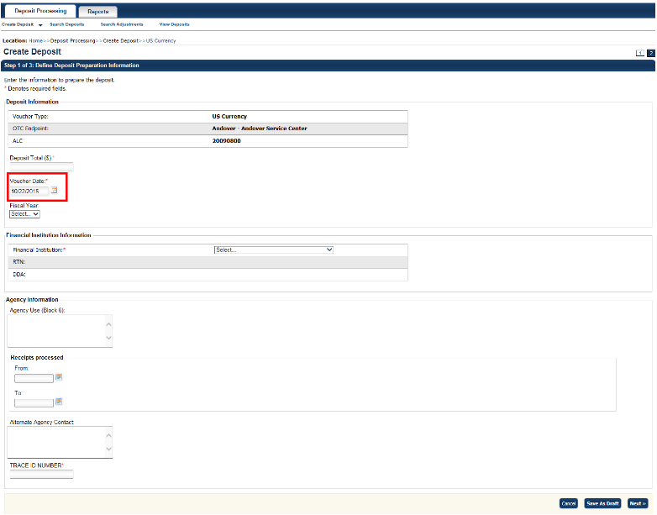
- Enter the information relevant to preparing the deposit.
Application Tips

- The deposit preparer/approver can submit a deposit with a voucher date of up to 5 days in advance including weekends and holidays.
- For data security a message displays discouraging users from entering Personally Identifiable Information (PII) in user Defined Fields (UDFs).

Under Deposit Information:
  - Enter the Deposit Total.
  - Select the Voucher Date.
- Select the Fiscal Year, optional.
Under Financial Institution Information:
- Select a Financial Institution.
Under Agency Information, optional:
  - Enter comments in Agency Use (Block 6).
  - Enter the dates the receipts are processed in From and To.
  - Enter the name of the Alternate Agency Contact.
  - Enter the User Defined Field (UDF) details.
Application Tip

When completing the Alternate Agency Contact field, include the following:
- Name
- Email Address
- Phone Number
The entry cannot exceed 400 characters.

Under Currency Denomination, if applicable:
- Enter the Paper Currency Count.
- Enter the Coin Currency Count.
Under Totals, if applicable:
- Enter the Checks and Money Orders Subtotal.
- Enter the Currency Subtotal.
- Enter the Coin Currency Subtotal.
- Select Calculate $ to determine the Deposit Variance.
Application Tip

The Deposit Variance must equal $0.00 before proceeding to the next step. If it does not, you must go back and re-validate your subtotal entries.

- Select Next. The Step 2 of 3: Define Subtotals by Accounting Code or TAS page appears.
- Select an Agency Accounting Code, enter the Amount, and select Add for each subtotal of the deposit.
Application Tips

- If the Agency Accounting Code label has been customized at the organization level, the custom label displays instead of the default label of Agency Accounting Code.
- At least one accounting code entry is required. Additional lines are optional.
- The combined accounting code subtotal must be equal to the deposit total before proceeding to the next step. If it does not, you must go back and re-validate your subtotal entries.

Application Tip

Accounting codes are listed in the drop-down menu:
- If they are not identified as TAS
or
- If they are identified as TAS and designated by SAM as “Valid”
Accounting codes are not listed in the drop-down menu if they are identified as TAS and are in the process of being validated by SAM.
If no accounting codes are listed, contact your Accounting Specialist or Local Accounting Specialist for assistance.

- Select Next. The Step 3 of 3: Review Deposit Preparation Information page appears.
- Verify the deposit information and select Save as Draft, Save for Approval, or Submit.

Application Tips

- Select Save as Draft an Acknowledgement page appears showing the Voucher Number of the deposit and a message confirming that the deposit information has been saved with Draft status.
- Select Save for Approval an Acknowledgement page appears showing the Voucher Number of the deposit and a message confirming that the deposit information has been saved with Awaiting Approval status.
- Select Submit a Confirmation page appears showing the deposit information detail. The OTCnet deposit ticket will also generate at that time.


Additional Buttons
- Select Cancel to return to the OTCnet Home Page. No data is saved.
- Select Edit to modify the deposit draft. (Visible if a user has Deposit
Preparer privileges.)
- Select Previous to return to the previous page.
- Select Return Home to return to the OTCnet Home Page.
- Select Update to remove any accounting code subtotal date from the accounting code subtotal summary table.

Create a Deposit for Foreign Currency Cash
To create a deposit for foreign currency cash, select the endpoint where you need to make a Foreign Currency Cash deposit and define the relevant deposit preparation information. You will receive the “Currency conversion service is not available” message if the conversion service is not available.
Define your subtotals by Accounting Code or Treasury Account Symbol (TAS), enter your Amount and Add the deposit. Verify your deposit information is correct and save or submit it.

Create a Deposit for Foreign Currency Cash
To create a deposit for Foreign Currency Cash, complete the following steps:
- From the Deposit Processing tab, select Create Deposit>Foreign Currency Cash.
- From the Select OTC Endpoint page, select an OTC Endpoint. The Step 1 of 3: Define Deposit Preparation Information page displays.
- Enter the deposit preparation information. The Step 2 of 3: Define Subtotals by Accounting Code or TAS page appears.
Application Tip

For data security, a message displays discouraging users from entering Personally Identifiable Information (PII) in User Defined Fields (UDFs).

If the currency conversion service is not available, “Currency conversion service is not available” is displayed on the page. If you receive this message, you may continue preparing your deposit by completing the steps in section A below and selecting Next. If you do not receive the message indicating the service is unavailable, follow the steps in section B.
A. Currency conversion service is not available:
  - Enter the Deposit Total (USE Dollars) in US Equivalent dollars, Currency Code, Foreign Currency Amount and Transaction ID.
  - (Optional) Under Agency Information: enter comments in Agency Use (Block 6), enter the From and To dates of the receipts processed, select the Fiscal Year, enter the Alternate Agency Contact, and, if applicable, enter the User Defined Field details.
  - Select Next.
B. Currency conversion service is available:
  - Select the Currency Code, enter the Foreign Currency Amount and select a Financial Institution.
  - (Optional) Under Agency Information: enter comments in Agency Use (Block 6), enter the From and To dates of the receipts processed, select the Fiscal Year, enter the Alternate Agency Contact, and, if applicable, enter the User Defined Field details.
  - Select Next.

Application Tip

When completing the Alternate Agency Contact field, include the following:
- Name
- Email address
- Phone Number
The entry cannot exceed 400 characters.

- Select an Accounting Code or Treasury Account Symbol (TAS), enter the Amount, and select Add for each subtotal of the deposit as shown in Figure 2.
Figure 2. Step 2 of 3: Define Subtotals by Accounting Code or TAS
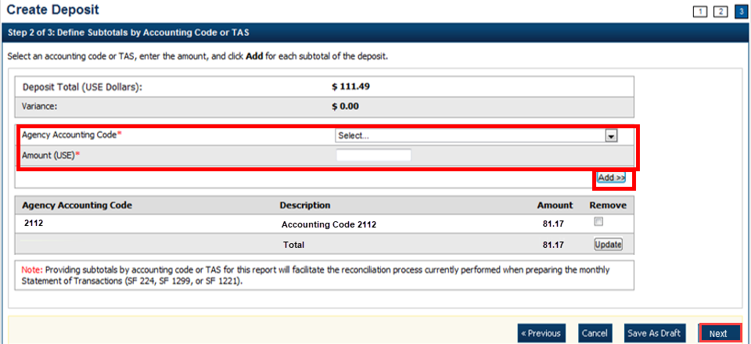
Application Tips

- If the Agency Accounting Code label is customized at the organization level, the custom label is displayed, instead of the default label of “Agency Accounting Code.”
- At least one accounting code entry is required. Additional entries are optional.
- The combined accounting code subtotal must be equal to the deposit total before proceeding to the next step. If it is not, re-validate your subtotal entries.

Application Tip

Accounting codes are listed in the drop-down menu:
- If they are not identified as TAS or
- If they are identified as TAS and designated by SAM as Valid
Accounting codes are not listed in the drop-down menu if they are identified as TAS and are in the process of being validated by SAM.
If no accounting codes are listed, contact your Accounting Specialist or Local Accounting Specialist for assistance.

- Select Next. The Step 3 of 3: Review Deposit Preparation Information page appears.
- Verify the deposit information is correct and select Save as Draft, Save for Approval, or Submit.
Application Tips

- Select Save as Draft an Acknowledgement page appears showing the Voucher Number of the deposit and a message confirming that the deposit information has been saved with Draft status.
- Select Save for Approval an Acknowledgement page appears showing the Voucher Number of the deposit and a message confirming that the deposit information has been saved with Awaiting Approval status.
- Select Submit a Confirmation page appears showing the deposit information detail. Your OTCnet deposit ticket generates at that time.

The Deposit Ticket and Foreign Currency Cash—send immediately to Bank of America:
- For foreign currency cash under $5,000 USD value mail to:
Bank of America GBN-LA
Mail Code: CA9-924-01-11
2706 Media Center Drive
Los Angeles, CA 90065-1733
- For foreign currency cash over $5,000 USD value:
Call Bank of America's banknote trading desk number (800-387-1012) for an armored courier pick up.
Additional Buttons
- Select Cancel to return to the OTCnet Home Page. No data is saved.
- Select Previous to return to the previous page.
- Select Return Home to return to the OTCnet Home Page.
- Select Update to remove any accounting code subtotal date from the accounting code subtotal summary table.

Create a Deposit for a Foreign Check Item
To create a deposit ticket for foreign checks only, use Foreign Check Item. You are asked to enter your deposit preparation information.

Select an Agency Accounting Code and enter the Amount.

Review your deposit information and save or submit it.

Create a Deposit for a Foreign Check Item
To create a deposit for a Foreign Check Item, complete the following steps:
- From the Deposit Processing tab, select Create Deposit>Foreign Check Item. The Select OTC Endpoint page appears.
- Select an OTC Endpoint to create a deposit. The Step 1 of 3: Define Deposit Preparation Information page appears.
- Enter the information to prepare the deposit and select Next. The Step 2 of 3: Define Subtotals by Accounting Code or TAS page appears.
Application Tip

For data security, a message displays discouraging users from entering Personally Identifiable Information (PII) in User Defined Fields (UDFs).

Canadian Foreign Checks:
Foreign checks drawn on Canadian banks, payable in foreign currency are treated as cash letter items that are immediately cleared and are granted provisional credit within two business days following the day the Financial Agent receives the foreign check.
Under Foreign Currency Information
- Select CANADA from the Country of Deposit drop-down menu.
NOTE: For All Other Foreign Checks (not Canadian), see the instructions on the following pages of this guide.
  - Enter the Foreign Currency Amount
Under Financial Institution Information:
  - Select a Financial Institution
(Optional) Under Agency Information:
  - Enter comments in Agency Use (Block 6)
  - Enter or select the From: and To: dates the receipts were processed
  - Select the Fiscal Year from the drop-down menu
  - Enter the name of the Alternate Agency Contact
Application Tip

When completing the Alternate Agency Contact field, including the following:
- Name
- Email Address
- Phone Number
The entry cannot exceed 400 characters.

- Select an Accounting Code or Treasury Account Symbol (TAS), enter the Amount, and select Add for each subtotal of the deposit (at least one accounting code entry is required).
Application Tips

- If the Agency Accounting Code label is customized at the organization level, the custom label is displayed instead of the default label of Agency Accounting Code.
- The combined accounting code subtotal must be equal to the deposit total before proceeding to the next step. If it does not, re-validate the subtotal entries.

Application Tip

Accounting codes are listed in the Agency Accounting Code drop-down menu:
- If they are not identified as TAS or
- If they are identified as TAS and designated by SAM as Valid
Accounting codes are not listed in the drop-down menu if they are identified as TAS and are in the process of being validated by SAM.
If no accounting codes are listed, contact your Accounting Specialist or Local Accounting Specialist for assistance.

- Select Next. The Step 3 of 3: Review Deposit Preparation Information page appears as shown in Figure 3.
Figure 3. Step 2 of 3: Define Subtotals by Accounting Code or TAS for Foreign Check Item in which Country of Deposit was Set to a Country Name
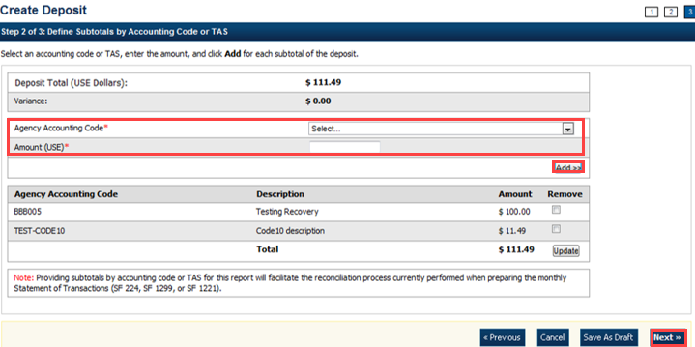
- Verify the deposit information is correct. Select Save as Draft, Save for Approval, or Submit.
- Mail the OTCnet deposit ticket and foreign check to:
Bank of America
Foreign Transit Items
GA 4-004-02-02
6000 Feldwood Road
College Park, GA 30349
Application Tips

- The processing options available to each user depends on your system role, the status of the deposit and the system settings that enforce the separation of duties.
- Select Save as Draft an Acknowledgement page appears showing the Voucher Number of the deposit and a message confirming that the deposit information has been saved with Draft status.
- Select Save for Approval an Acknowledgement page appears showing the Voucher Number of the deposit and a message confirming that the deposit information has been saved with Awaiting Approval status.
- Select Submit a Confirmation page appears showing the deposit information detail. Your OTCnet deposit ticket generates at that time.

All Other Foreign Checks:

Foreign checks (excluding Canadian foreign checks), payable in foreign currency, are treated as collection items. Foreign checks drawn on foreign banks outside of Canada, payable in U.S. dollars, are also processed as collection items.

Collection items are forwarded to the foreign banks that the checks are drawn on for clearance, prior to credit being granted.
- The collection process takes approximately six to eight weeks to clear the check.
- Collection items will not receive provisional credit during this process.

As an Agency Depositor you will:

- Create a deposit for a foreign check item.
- Select OTHER in the Country of Deposit drop-down menu (under Foreign Currency Information).
- Enter the foreign currency amount (under Foreign Currency Information).
- Select Financial Institution from drop-down menu.
- Select an Agency Accounting Code from the drop-down menu and add ‘enter foreign amount.’
- Save for Approval.
- Mail the OTCnet deposit ticket and foreign check to:

Bank of America
Foreign Clean Collections
TX 1-160-06-18
1950 N. Stemmons Fwy
Dallas, TX 75207

- Once the foreign check clears, the Financial Agent will notify the Agency and confirm the deposit in OTCnet.
Application Tips

- Cash letter items and collection items must have separately created OTCnet deposit tickets (i.e., vouchers).
- They cannot be listed on the same voucher.
- Cash Letter items should be mailed to the FTI (Foreign Transit Items) address and Collection items to the FCC (Foreign Clean Collections) address.
- Foreign checks drawn on Canadian banks, payable in U.S. dollars, will be processed as foreign check items (cash letter) in OTCnet.
- Foreign checks drawn on foreign banks outside of Canada, payable in U.S. dollars, will be processed as collection items in OTCnet.

Application Tip

The processing options available to each user depends on their system role, the status of the deposit and the system settings that enforce the separation of duties.

Additional Buttons
- Select Cancel to return to the OTCnet Home Page. No data is saved.
- Select Previous to return to the previous page.
- Select Return Home to return to the OTCnet Home Page.
- Select Update to remove any accounting code subtotal date from the accounting code subtotal summary table.

Topic 3 How to Modify a Deposit
A Deposit Preparer, or Deposit Preparer and Approver, is authorized to create deposits and modify deposits for:
- US Currency
- Foreign Currency Cash
- Foreign Check Item
The modify deposit’s function allows you to modify the deposit preparation information required to properly account for, track and direct the deposit transaction. Deposit preparation information can be modified if a deposit’s status is Save As Draft. Changing the endpoint of a deposit requires that the deposit be deleted, and a new one be created.

Modify a Deposit
To retrieve a deposit for modification, select your deposits in process and select the Voucher number of the deposit you would like to view. You can edit your deposit, update the deposit preparation information and update the subtotals by Accounting Code or Treasury Account Symbol (TAS). Verify your deposit information is correct and either save or submit the deposit.

Modify a Deposit
To modify a deposit, complete the following steps:
- From the Deposit Processing tab, select View Deposits. The View Deposits page appears.
Application Tip

You can also select Search Deposits to locate deposits.

- From the Select Display drop-down menu, select My Deposits in Process.
- Select the Voucher number of the deposit you would like to view from the list displayed.
Application Tip

To modify the number of records displayed per page, select from the drop-down menu options next to the record count.

- The View Draft Deposit page appears. Select Edit as shown in Figure 4.
Figure 4. Edit Draft Deposit
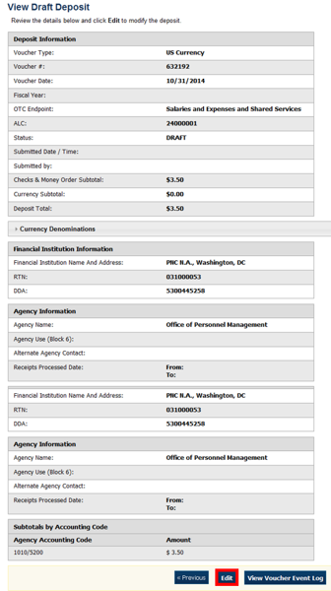

- The View Submitted Deposit page appears. Select Edit.
- The Step 1 of 3: The Update Deposit Preparation Information page appears as shown in Figure 5.
Figure 5. Step 1 of 3: Update Deposit Preparation Information for U.S. Currency
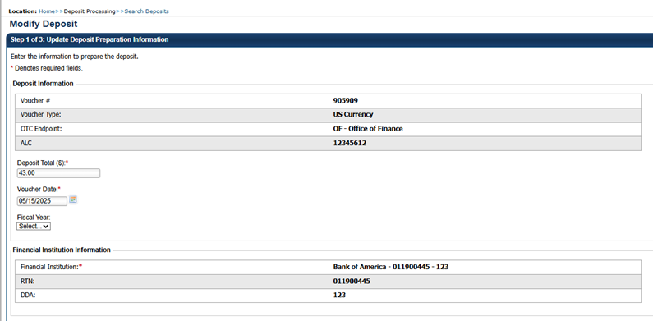
Application Tip

The voucher date can be updated. It can only be 5 days in advance including weekends and holidays.

- Update the deposit preparation information for the type of currency for the deposit, per the instructions provided below, and select Next.
- The Step 2 of 3: Update Subtotals by Accounting Code or TAS page appears.

For US Currency | For Foreign Currency Cash | For Foreign Check Items
Deposit Information:  - Enter the Deposit Total  - Select the Voucher Date  - Select the Fiscal Year, optional  Agency Information, (optional):  - Enter comments in Agency Use (Block 6)  - Enter the date the From: and To: dates the receipts were processed  - Enter the name, email address, and phone number of the Alternate Agency Contact  - Enter the User Defined Field details  Currency Denomination,  (if applicable):  - Enter the Paper Currency Count  - Enter the Coin Currency Count  Totals, (if applicable):  - Enter the Checks and Money Orders Subtotal  - Select Calculate $ to determine the Deposit Variance. The Deposit Variance must equal $0.00 before proceeding to the next step. If it does not, you must go back and re-check your subtotal entries. | Foreign Currency Information:  - Select the Currency Code  - Enter the Foreign Currency Amount  Agency Information, (optional):  - Enter comments in Agency Use (Block 6)  - Enter the date the From: and To: dates the receipts were processed  - Enter the name, email address, and phone number of the Alternate Agency Contact  - Enter the User Defined Field details | Foreign Currency Information:  - Select the Country of Deposit (CANADA or OTHER)  - Enter the Foreign Currency Amount  Agency Information, (optional):  - Enter comments in Agency Use (Block 6)  - Enter the date the From: and To: dates the receipts were processed  - Enter the name, email address, and phone number of the Alternate Agency Contact  - Enter the User Defined Field details

- Update the subtotals by Accounting Code or Treasury Account Symbol (TAS) and select Add. The combined accounting code subtotals must be equal to the deposit total before proceeding to the next step. If it does not, re-validate the subtotal entries.
- The Step 3 of 3: Review Deposit Preparation Information page appears.
Application Tip

If the Agency Accounting Code label is customized at the organization level, the custom label is displayed instead of the default label of Agency Accounting Code.

Application Tips

- Foreign checks drawn on Canadian banks, payable in foreign currency are treated as cash letter items that are immediately cleared and are granted provisional credit within two business days following the day the Financial Agent receives the foreign check.
- Foreign checks (excluding Canadian foreign checks) are treated as collection items.
  - Collection items are forwarded to the foreign banks that the checks are drawn on for clearance, prior to credit being granted.
  - The collection process takes approximately six to eight weeks to clear the check.
  - Collection items will not receive provisional credit during this process.

Application Tip

Accounting codes are listed in the Agency Accounting Code drop-down menu:
- If they are not identified as TAS or
- If they are identified as TAS and designated by SAM as “Valid”
Accounting codes are not listed in the drop-down menu if they are identified as TAS and are in the process of being validated by SAM.
If no accounting codes are listed, contact your Accounting Specialist or Local Accounting Specialist for assistance.

- Verify the deposit information and select Save as Draft, Save for Approval or Submit.
Application Tips

- Select Delete an Acknowledgment page appears stating the Voucher Number has been deleted.
- Select Save as Draft or Save for Approval an Acknowledgement page appears showing the Voucher Number.
- Select Submit a Confirmation page appears.

Additional Button
Select Return Home to return to the OTCnet Home Page.

Summary
In this chapter, you learned:
- The purpose of creating and modifying a deposit
- How to create a deposit for US Currency
- How to create a deposit for Foreign Currency Cash
- How to create a deposit for Foreign Check Item
- How to save a deposit as a draft
- How to submit a deposit for approval
- How to submit a deposit for confirmation
- How to modify a deposit

