

Chapter 3. Capturing and Managing Checks Online
OTCnet Participant User Guide

Table of Contents
Overview, Topics, and Audience 1
Overview 1
Topics 1
Audience 2
Topic 1 The Purpose of Capturing and Managing Checks Online 3
Topic 2 Capture a Check Online 5
Introduction to Capturing a Check 5
Types of Acceptable and Unacceptable Checks 7
Batch Processing Modes 8
Processing Methods 8
Item Types 9
Accounting Codes 9
Check Scanner Types and Check Placement 10
Check Capture Acceptance 13
Capture a Check Online 14
Capture a Check Online 16
Topic 3 Manage Poor Check Image Quality 20
Manage a Check with Poor Image Quality 21
Topic 4 Resolve a Duplicate Check 23
Resolve a Duplicate Check 24
Topic 5 Void a Check 26
Void a Check 27
Void All Checks in a Batch 31
Topic 6 Override a Master Verification Database (MVD) Record 34
Override a MVD Record 35
Topic 7 Perform Batch Control and Batch Balancing 37
Batch Control Options 38
On Batch Close (Optional/Mandatory) 39
Perform Batch Control on Batch Close 40
Perform Batch Control on Batch Create 42
Batch Balancing 44
Topic 8 View and Print a Batch List/Item Detail Report 46
View and Print a Batch List Report 47
View and Print an Item Detail Report 49
Topic 9 Activate/Deactivate a Batch 51
Activate/Deactivate a Batch 52
Topic 10 Classify a Batch 54
Summary Level Classification 54
Summary Level Classification 55
Edit a Batch 58
Edit a Batch 59
Topic 11 Close a Batch 62
Close Multiple Batches 62
Close a Single or Multiple Batch(es) 63
Topic 12 Approve a Batch 65
Approve a Single Batch 65
Approve a Single Batch 66
Approve Multiple Batches 69
Approve Multiple Batches 70
Topic 13 Print a Receipt 73
Receipt Printing from Check Scan (Single/Batch Mode) 73
Print a Receipt from Check Scan 74
Print a Receipt in Batch Management 75
Summary 77

List of Figures
Figure 1. RDM EC 7000i Scanner 10
Figure 2. RDM EC 9100i Scanner 11
Figure 3. RDM EC 9600i Scanner 11
Figure 4. RDM EC 9700i Scanner 12
Figure 5. Panini Scanner 12
Figure 6. Panini I: Deal Scanner 13
Figure 7. Agency Form Data Entry Fields 17
Figure 8. Poor Image Quality 20
Figure 9. Image Quality Failed Message 21
Figure 10. Duplicate Check Detected 24
Figure 11: Search Batch 27
Figure 12. Check Image Details 29
Figure 13. View Checks (Voiding) 32
Figure 14. Override Check Denial Box 35
Figure 15. Verification Report 36
Figure 16. Batch Control Page (Batch Create) 38
Figure 17. Print Batch List Report (Batch Close) 40
Figure 18. Batch Control (Failed to Balance) 44
Figure 19. Batch List Report 48
Figure 20. Item Detail Report 50
Figure 21. View Batches Page (Activate/Deactivate) 53
Figure 22. View Checks – View/Edit Classification 56
Figure 23. View Checks - View/Edit Classification 60
Figure 24. Confirm Batches to Approve (Approve Single) 67
Figure 25. View Batches Page (Approve Multiple Batches) 71
Figure 26. Receipt Print Image (Scan Check) 74
Figure 27. View Checks Page (Receipt) 76

List of Tables
Table 1. Check Capture/Processing and Batch Permission Matrix 4
Table 2. Scanner Types 10
Table 3. Batch Status Types 62

Glossary
Select this link to access the full OTCnet Glossary.

Overview, Topics, and Audience

Overview
Welcome to Capturing and Managing Checks Online. In this chapter, you will learn:
- The purpose of capturing and managing checks online
- How to capture a check online
- How to manage failed image quality
- How to resolve a duplicate check
- How to void a check
- How to override a Master Verification Record (MVD) Record
- How to perform batch control and batch balancing
- How to view and print a batch list/item detail item
- How to activate/deactivate a batch
- How to classify a batch
- How to close a batch
- How to approve a batch
- How to print a receipt

Topics
The topics in this chapter include the following:
- The Purpose of Capturing and Managing Checks Online
- Capture a Check Online
- Manage Poor Check Image Quality
- Resolve a Duplicate Check
- Void a Check
- Override a Master Verification Record (MVD) Record
- Perform Batch Control and Batch Balancing
- View and Print a Batch List/Item Detail Report
- Activate/ Deactivate a Batch
- Classify a Batch
- Close a Batch
- Approve a Batch
- Print a Receipt

Audience
The intended audience for the Capturing and Managing Checks Online Participant User Guide includes:
- Check Capture Operator (CCO)
- Check Capture Lead Operator (CCLO)
- Check Capture Supervisor (CCS)

Topic 1 The Purpose of Capturing and Managing Checks Online
The Check Processing functionality is primarily used to capture check images and transaction data. There are two components under this tab within OTCnet. They include the Scan Check and Batch Management functionality. Once the images and data are collected under Scan Check, a user may access Batch Management to perform certain tasks prior to forwarding the batch for settlement.
During check scanning, you may opt to use the Batch Control functionality, which allows you to balance your batch. If this option is configured to be optional or mandatory for your agency, the Batch Control page appears during the processing of the check.
Check Capture Operators (CCO) or Check Capture Lead Operators (CCLO), are the only authorized users who can capture a check.
As a CCO, you are authorized to scan checks into a Batch, change Processing Method (Customer Present / Customer Not Present), change an Accounting Code, change Item Type (Personal / Non-Personal checks), close a batch, and view a batch list.

As a CCLO, you are authorized to conduct the same actions as the CCO stated above, and you can balance batch and enter batch control values (total check count and total amount), accept duplicates, make magnetic ink character recognition (MICR) code line corrections, and accept checks with poor quality without approval (as shown in Table 1).
Table 1. Check Capture/Processing and Batch Permission Matrix
Task | Check Capture Operator  (CCO) | Check Capture Lead Operator (CCLO) | Check Capture Supervisor  (CCS)
Scan checks into a batch | ● | ● | blank
Change Processing Method (Customer Present / Customer Not Present / Back Office) | ● | ● | blank
Change Accounting Codes | ● | ● | ●
Change Item Type (Personal/Non-Personal checks) | ● | ● | blank
Make MICR code line corrections | blank | ● | ●
Resolve a duplicate check | blank | ● | ●
Accept checks with poor image quality |  | ● | ●
View a batch list | ● | ● | ●
Balance batch amount (total check count and total amount) | ● | ● | ●
Enter batch control during batch closing | ● | ● | ●
Classify a batch | ● | ● | ●
Close a batch | ● | ● | ●
Approve a batch | ●¹ | ●¹ | ●
Edit a batch | blank | ● | ●
Activate/Deactivate a batch | blank | black | ●
Void a check | blank | blank | ●
¹ = requires additional Batch Approver permission

Topic 2 Capture a Check Online

Introduction to Capturing a Check
As a CCO or CCLO, you are authorized to capture a check in two modes, single or batch. Once a Check Capture Administrator (CCA) sets up your Terminal Configuration settings, you can scan a check in Single or Batch check mode. There are other settings that your CCA may have also instituted for your location, many of which are visible as you begin the check scanning process.
Logical Processing Order for Scanning a Check
When creating a batch, it is important that the proper steps be taken to ensure that the batch reaches our system. Below is an outline of the logistics for creating a batch:
- Batch Control – This function may or may not appear, based on the computer’s configuration settings. If used, key in total dollar amount of checks and the total number of checks to be scanned. This function can be set up in the configuration as disabled, optional, or mandatory by the CCA. If this option is disabled, the Batch Control screen does not appear. If optional, the Batch Control screen can be skipped.
    - If mandatory, at Batch Create or Batch Close only, the user must enter the Batch Control values. However, if a user selects to set a Batch Control value at both Batch Create and Batch Close, then it can only be deferred at the beginning of the batch. Batch control is required prior to closing a batch in this case.
- Scan the check (or checks if processing in batch mode).
- Key in amount, configurable field data, and select accounting code information for each check, if accounting codes are set up.
- Cancel transactions while performing data entry, used only if necessary (i.e., image of the check is not legible).
- Print the receipt – Just after the item information is keyed into the data entry screen, press Enter, then select the Receipt button to print a receipt of the item or items.
- Void items – Used to delete invalid items only if necessary, prior to closing a batch if a CCA is available to authorize the void. Once data entry has been performed and the Enter key is pressed on a user’s keyboard, the item can no longer be cancelled and must be voided.
- Print the Batch list – A printout of the batch listing must be done prior to closing a batch.
- Pre-balance – Use the batch list that was just printed to reconcile all activity for this batch of work. If reconciling with cash drawers, count and reconcile to ensure activity is accurate.
- Batch Balancing – This screen only appears if the totals that are keyed into the Batch Control screen do not match with what was actually keyed into the data entry screen, or if the number of checks scanned does not match the number keyed into the Batch Control screen.
- Close – Closes the batch from further checks and prepared the batch for processing.
- Approve - Indicates that the batch is ready for the settlement process. Once the batch is approved, it is then sent to Debit Gateway to initiate the settlement process. The batch status then becomes Forwarded.
An Agency may have multiple OTC Endpoints to process checks. Each OTC Endpoint is unique, and batches can include items for multiple OTC Endpoints, however during the configuration setup, one OTC Endpoint is chosen to be the default. The default OTC Endpoint appears each time the CCO or CCLO begins the scanning process. However, they may select an alternate OTC Endpoint before scanning begins.

Types of Acceptable and Unacceptable Checks
Checks that CAN be processed through the OTCnet Check Processing Functionality
All of the items listed below can be processed through the OTCnet Check Processing Functionality.
The following check items must be processed as Non-personal:
- US Treasury Checks
- Traveler's Checks
- Money Orders (including Postal Money Orders)
- Third-party Checks (even if drawn on a personal account)
- State and Local Government Checks
- Credit card Checks
- Do not ACH Checks
- Official Checks
- Business Checks
- Cashier’s Checks
- Other US Government Checks
- Payroll Checks
If a customer chooses to opt out and does not want their checks processed via ACH, the customer’s personal check must be processed as a non-personal item. This allows the check to clear the financial institution as a Check 21 item.
The following item(s) must be processed as Personal check Items:
- Personal/Consumer Checks
The list of Items that CANNOT be processed through the OTCnet Check Processing Functionality include the following:
- Foreign items drawn on non-US Financial Institutions
- Check payable in non-US currency
These items may need to be processed through the Deposit Processing tab within OTCnet.
In regard to stamps, it is recommended that you apply any necessary stamps in a location that does not interfere with the dollar amount, financial institution information, or the signature. Since these items are not deposited at your bank, there is no need to stamp For Deposit Only on the back of the check. FRB-Cleveland becomes the bank of first deposit for all the OTCnet Check Processing items scanned and forwarded for settlement.

Batch Processing Modes
Keep the following in mind for Single vs. Batch Processing Mode:
- Agencies must choose to process checks in one of two processing modes. The Single check mode allows checks to be processed one at a time. Batch processing mode allows for check batches to be scanned prior to data entry. The Batch processing mode is available for RDM EC7000i, EC9100i, EC9600i, and EC9700i, and Panini VisionX.
- When scanning in Batch Processing Mode, ensure that the entire check image is visible on the screen and the dollar amount must be legible (a check may successfully scan even with the item folded going through the device). If the image is not legible, select Cancel under Scanner Controls and re-scan the check.
- It is recommended, while scanning in Batch mode, to scan a smaller quantity of items.
  - For example, instead of scanning 150 items, scan 75. Then, perform the data input.
  - Scan the second group of 75 and perform the data input. Using the keyboard after the 75 items are scanned may eliminate the system inactivity logout during batch processing.
  - Because the keyboard and mouse are typically not touched during the scanning process, the system interprets this as inactivity and an auto logout takes place. To avoid this situation, move the mouse every so often to simulate system activity during the scanning process.
  - The default setting is 15 minutes. Move the mouse every 10 minutes or so to keep the system active.
- The maximum number of items to include in one batch is 3,000 items. The maximum dollar amount per batch is $99,999,999.99. The max number of items is also limited by the tagged image file format (TIFF) file.
- All processing method types can exist within a batch, although typically Back Office processing types are processed independently of other types. Not all agencies utilize all modes. Furthermore, a site may choose not to use all modes every day, due to fluctuation in check volume.

Processing Methods
Operators choose the Processing Method where they would like to scan checks. This option indicates the mode of operation. They include Customer Present, Customer Not Present, or Back Office.
The Customer Present method is used when the person is present (i.e., standing in front the operator with a check). The Customer Not Present method is used when the check writer is not present (i.e., when checks are received through the mail or an unmanned drop box).
The Back Office processing method allows Agencies to convert received payments at the point-of-sale locations to ACH entries in a controlled, back-office environment.
The default is to allow all Processing Methods and Item Types, though restrictions can be set to allow only the Back Office processing method or Non-personal items. Operators must ensure they are selecting the proper choices for each item to avoid returned payments from the check writer’s financial institution.
Prior to scanning, checks must be pre-sorted by Customer present, Customer Not Present, and Back Office. All processing method types can exist within a batch, although typically back- office processing types are processed independently of other types. Not all agencies utilize all methods. Additionally, your site may choose not to use all methods daily, due to fluctuation in check volume scanning a check.

Item Types
Before or after the check is scanned in Single mode, the user must choose the Item Type. For Batch mode scanning, a user cannot manually select Personal or Non Personal, the system uses the default (previously established in the configurations). During the scanning process, if the system detects an Item Type other than the established default, it prompts the user for confirmation.
The choices are Personal or Non Personal. This indicates the type of item to be processed. When the operator selects Personal, the Agency Form data entry screen displays, Check: Personal.
If the operator selects Non Personal, the Agency Form data entry screen displays, Check: Non Personal. OTCnet can process both personal and non-personal checks within a batch. The operator must ensure they are selecting the proper choices for each item. Presort all items into two groups (Personal and Non Personal) prior to scanning to avoid the pop-up message indicating that it detected a different item type for the check. While most business checks are typically larger in size, business checks can look the same as personal checks.
Using the OTCnet Terminal Configuration functionality, authorized users can limit the Item Type to Non Personal only. When Non Personal Only is chosen under Terminal Configuration, the Item Type: Personal is no longer available for the operator to choose from the drop-down options. This can be set up for Agencies who never process personal checks.

Accounting Codes
By default, the Agency Accounting Code drop-down field displays a blank value. An accounting code is selected for a check transaction before or after scanning a check.
The Agency Accounting Codes drop-down list displays the full Agency Accounting Code value (up to 50 alphanumeric characters) and some portion of the Description (up to 15 alphanumeric characters).
Accounting Codes are displayed in the drop-down field if they are mapped or inherited from the higher-level OTC Endpoint. Additionally, accounting codes that are designated as Treasury Account Symbols (TASs) by the Agency are displayed if they are and have been validated by Shared Account Module (SAM).
If no accounting codes are available for selection and the Agency is a Central Accounting Reporting System (CARS)/Government Wide Accounting (GWA) Reporter, an operator cannot scan a check. If no accounting codes are available for selection, and the Agency is not a CARS/GWA Reporter, an operator can still scan a check.
If an OTC Endpoint is associated with an Agency Location Code (ALC) that is designated as a CARS/GWA Reporter, all check transactions must be classified with an accounting code. If an ALC is not a CARS/GWA Reporter, classifying it with an accounting code is optional.
The same accounting code is displayed after it is selected for the first time. The selected accounting code is “sticky” (remains the same) between transactions, batches within the same check scanning session, and prior to the next user login.

Check Scanner Types and Check Placement
Your Agency may scan checks using one of five scanner types (see Table 2). Some scanners are designed to scan only in Batch mode, whereas others may only scan in Single mode. The RDM EC7000i, EC9100i, EC9600i, and EC9700i, Panini MyVision X, Panini Vision X, and Panini I: Deal, however, can scan checks in both modes.
Table 2. Scanner Types
EC7000i | This scanner will automatically scan both sides of a check and can scan in single or batch mode (one or more checks in a batch)
EC9100i | This scanner will automatically scan both sides of a check and can scan in single or batch mode (one or more checks in a batch)
EC9600i | This scanner will automatically scan both sides of a check and can scan in single or batch mode (one or more checks in a batch)
EC9700i | This scanner will automatically scan both sides of a check and can scan in single or batch mode (one or more checks in a batch)
Panini MyVision X | This scanner will automatically scan both sides of a check and can scan in single or batch mode (one or more checks in a batch)
Panini Vision X | This scanner will automatically scan both sides of a check and can scan in single or batch mode (one or more checks in a batch)
Panini I: Deal | This scanner will automatically scan both sides of a check and can scan in single or batch mode (one or more checks in a batch)
RDM EC7000i Scanner
Place the check in the scanner with the MICR line of the check aligned with the right side of the scanner (shown in Figure 1). Gently push the check forward to allow the scanner to grasp the check. Guide the left side of the check with your finger to prevent the document from being skewed. The scanner automatically pulls the check through to begin the scan.
Figure 1. RDM EC 7000i Scanner
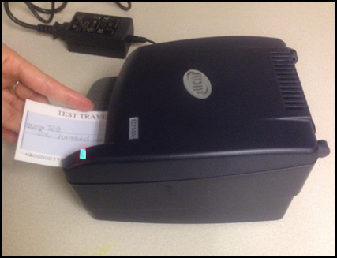
With the RDM EC7000i scanner, both the front and the back of the check are scanned automatically.
RDM EC9100i Scanner
Place the check in the scanner with the MICR line of the check at the bottom and facing towards the outside of the scanner (shown in Figure 2). Adjust the exit extension or the pocket stop to fit the check that you are scanning. The scanner automatically pulls the check through to begin the scan.
Figure 2. RDM EC 9100i Scanner
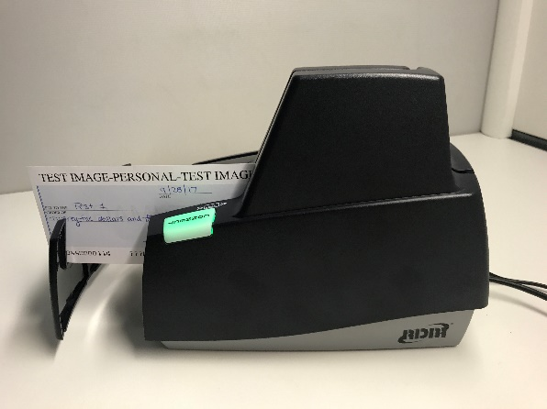
With the RDM EC9100i scanner, both the front and the back of the check are scanned automatically.
RDM EC9600i Series Scanner
Place the check in the scanner with the MICR line of the check at the bottom and facing towards the outside of the scanner (shown in Figure 2). Adjust the exit extension or the pocket stop to fit the check that you are scanning. The scanner automatically pulls the check through to begin
the scan.
Figure 3. RDM EC 9600i Scanner
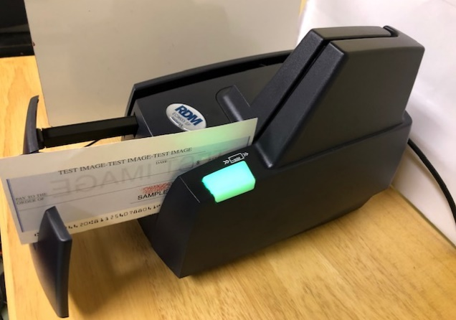
With the RDM EC9600i series scanner, both the front and the back of the check are scanned automatically.

RDM EC9700i Series Scanner
Place the check in the scanner with the MICR line of the check at the bottom and facing towards the outside of the scanner (shown in Figure 4). Adjust the exit extension or the pocket stop to fit the check that you are scanning. The scanner automatically pulls the check through to begin the scan.
Figure 4. RDM EC 9700i Scanner
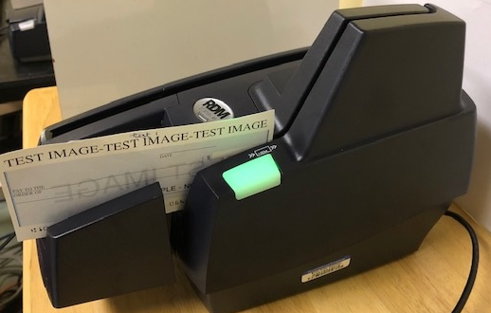
With the RDM EC9700i series scanner, both the front and the back of the check are scanned automatically.
Panini Vision X and MyVision X Scanners
Ensure that the check(s) is already in the hopper of the scanner, with the front of the check(s) facing (as shown in Figure 5) out. The first green light on the scanner begins to flash (if applicable).
Once the hopper is empty, the Hopper Empty message appears; the user can add more checks to the hopper. Select Yes to continue adding items to the batch. Select No if there are no more checks to scan. When No is selected, the system switches to the data entry phase and the first check that was scanned appears on the screen.
Figure 5. Panini Scanner
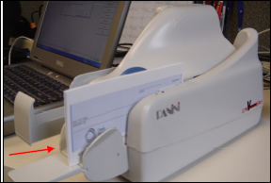
Use caution when selecting the Stop button during batch mode processing. Pressing too quickly (before the scanner has a chance to catch up to the system) may cause the last transaction to be lost.
Panini I: Deal Scanner
Place the check face up with the MICR line aligned to the right side of the scanner (as shown in in Figure 6). The scanner automatically detects the check and begins feeding. If the check is not aligned, the scanner automatically aligns the check to the proper position. When using the franking feature, the Panini I: Deal scanner franks the check as soon as it is scanned, rather than waiting until the operator has saved the transaction. This is a change in process from the EC7000i series scanner.
Figure 6. Panini I: Deal Scanner
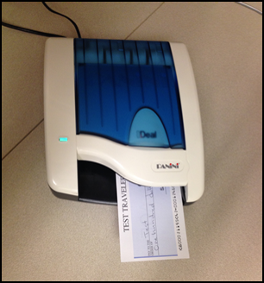
As the document is fed into the device, the scanner detects if the document was not automatically aligned correctly. If the document is skewed, the scanner prevents further processing, stops the document, and flashes a red light. The check can then be removed and reinserted.

Check Capture Acceptance
Once a user has successfully logged in to OTCnet, selected the appropriate OTC Endpoint to scan a batch to, chosen the correct processing method and Item Type, the next step is to scan the check.
Select Start Scan under Scan Controls options (scanner light may turn green depending on the type of scanner you have, indicating that the scanner is ready to accept a check). Scan the check and select Save under Scan Controls options. The bottom of the Agency Form entry screen displays Scan front of Check.
A Batch Control screen may appear, based on the Agency’s configuration settings.

Capture a Check Online
The Check Capture Operator and Check Capture Lead Operator are authorized to capture a check. In order to capture a check online, you must first start the OTCnet Local Bridge (OLB) application.
For the RDM EC7000i, EC9100i, EC9600i or EC9700i to scan checks in Batch mode, a READY FOR BATCH SCAN Waiting for check dialog box appears. Insert the checks one at a time. The dialog box presents the item count after each scan. When finished scanning, select Stop.
For the Panini I: Deal, Panini MyVision X, or Panini Vision X, to scan checks in Batch mode, a READY FOR BATCH SCAN Waiting for check dialog box appears. Insert the checks in the hopper. The dialog box shows the item count after each scan. When the hopper is empty or you finish scanning, select Stop.
Under Agency Form Data, complete the following:
- Enter the Amount, required
- Enter the check data in the field(s) provided, if applicable
Keep the following items in mind when capturing a check online:
- OTCnet accepts two different Amount entry formats. If the deposit amount is thirty-five dollars and fifteen cents, enter 35.15. If no decimal point is entered, OTCnet adds a decimal and two zeroes at the end and saves it as 3515.00 (three thousand five hundred and fifteen dollars).
- Ensure that you type in the data rather than copying and pasting from another source. Data that has been copied and pasted may result in an error. Use the Tab key on the keyboard to navigate to the next data field for entry.
- After saving the data, a message appears stating the transaction was successfully saved along with the Individual Reference Number (IRN) and check amount.
- Only numbers need input. For example, entering in 1290 would equal $12.90, and 56321 would be equal to $563.21. The maximum dollar amount that can be keyed into the data entry screen is 99,999,999.99. The minimum amount is .01.
- The Agency Form Data form is customizable and can include fields beyond the Amount field (e.g., Social Security Number). If your agency has additional fields, they display under the Amount field. Your Agency may deem the field(s) either mandatory or optional for you to complete an entry. If your Agency requires additional fields, contact your Deployment Specialist at 703-377-5586 or fiscalservice.otcdeployment@citi.com.
- Since the configuration field requirements are established by each Agency, minimum/maximum requirements may exist for certain fields. If the operator does not satisfy those minimum/maximum field requirements, an error message is displayed in the middle of the screen and corrections must be made to the field before the transaction is accepted.
- Recapture an image of a check if it is inserted upside down; appears skewed; or the image is illegible. Select Cancel and reinsert the check in the scanner. Then select Start Scan and re-enter the necessary data.
- Upon scanning the check and using enter on your keyboard to finalize, the IRN, Bank Number, Check Number, Account Number, Date & Time fields automatically populates located in the frame of the Agency Form Data). For details regarding your scanner configurations, select on Scanner Config, under Scan Controls.
- If there aren’t any accounting codes available for selection and the Agency is a CARS/GWA Reporter, an operator cannot scan a check. If there are not any accounting codes available for selection, and the Agency is not a CARS/GWA Reporter, an operator can still scan a check.
- If an OTC Endpoint is associated with an ALC that is designated as a CARS/GWA Reporter, all check transactions must be classified with an accounting code. If an ALC is not a CARS/GWA Reporter, classifying it with an accounting code is optional.
- The same accounting code is displayed after it is selected for the first time. The selected accounting code is “sticky” (remains the same) between transactions, between batches within the same check scanning session and prior to the next user login.
- The single Agency Accounting Code and Multiple accounting code options are available if checks are scanned against an OTC Endpoint designated for Item Level Classification. If an ALC is designated for Summary Level Classification, the Agency Accounting Code and Multiple accounting codes options are disabled.

Capture a Check Online
To capture a check in OTCnet Online, complete the following steps:
- From the Check Processing tab, Select Check Scan. The Check Scan-Select Batch page appears.
Under Select Open Batch, if applicable
- Select the OTC Endpoint for which you want to scan one or more checks
- Select Next
Application Tips

- If an operator has an OTC Endpoint with an Open batch, the batch details (Void Count, Approved Count, and Amount) are displayed.
- If a batch is in use and another user attempts to access the same batch, a Batch Lock message appears stating the batch is in use and he/she cannot access the batch.

- The Check Scan – Perform Check Scan page appears as shown in Figure 7.
Figure 7. Agency Form Data Entry Fields
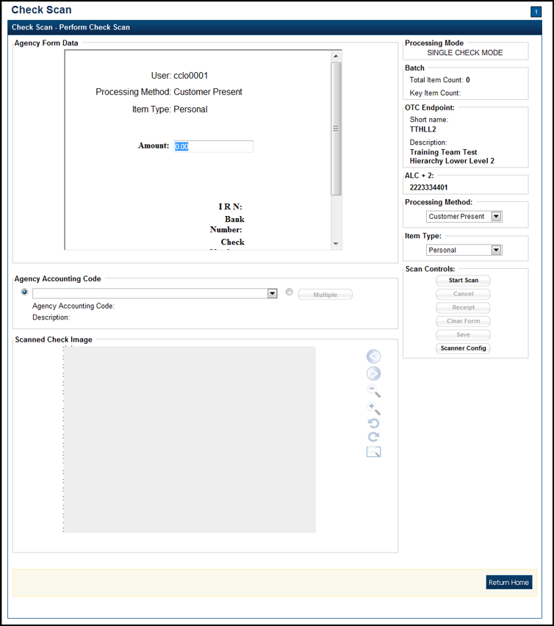
Under ALC+2 (Agency Location Code +2),
- Verify the OTC Endpoint. To change the OTC Endpoint, select Previous and return to Step 2
Under Processing Method,
- Select the Customer Present, Customer Not Present, or Back Office
Under Item Type,
- Select Personal or Non-personal
- Select Start Scan, under Scan Controls to scan a check.
Application Tip

If communication with the OLB application is not active, the Start Scan button is disabled. The OLB communication status must be active in order to scan a check. Determine if OLB communication is active by looking at the OLB Communication indicator, located in the upper right-hand corner of the screen, under the Connection Status indicator. The indicator is either green and shows Active, or red and shows Inactive.

- Insert the check into the scanner.
Application Tip

Recapture a check image if it is inserted upside down, appears skewed, or the image is illegible. Select Cancel and reinsert the check in the scanner. Select Start Scan and re-enter the necessary data.


Additional Buttons
Under Scanned Check Image, optional
- Select Cancel to cancel the transaction. No data is saved.
- Select Receipt to access a receipt for review or printing. This is only available once the initial check is scanned.
- Select Clear Form to clear the data entered.
- Select Save to save the transaction.
- Select < to view the front of the check
- Select > to view the back of the check
- Select - to reduce the image of the check
- Select + to increase the image of the check
- Select Left Rotate to turn the image to the left
- Select Right Rotate to turn the image to the right

- Enter the Amount under Agency Form Data and enter the check data in the field(s) provided.
Application Tips

- OTCnet accepts two different Amount entry formats. If the deposit amount is for thirty-five dollars and fifteen cents, enter 35.15. If no decimal point is entered, OTCnet adds a decimal and two zeroes at the end and save it as 3515.00 (three thousand five hundred and fifteen dollars).
- Use the Tab key on the keyboard to navigate to the next data field for entry.

Select the Agency Accounting Code, if applicable
- Select the Agency Accounting Code radio button, and select a single accounting code from the drop-down list
Or
- Select the Multiple radio button and from the Account Classification dialog box, select an Agency Accounting Code, enter the Amount, and select Add for each subtotal of the deposit. Then select Save.
- Select Save to save the check image and the data you entered. A message appears stating the transaction, Individual Reference Number (IRN) and check amount were successfully saved.
Application Tip

Upon scanning the check and selecting enter on your keyboard to finalize, the Individual Reference Number (IRN), Bank Number, Check Number, Account Number, and Date & Time fields automatically populate (located in the frame of the Agency Form Data).

Additional Button
Select Return Home to return to the OTCnet Home Page.

Topic 3 Manage Poor Check Image Quality
There are instances when the image of a scanned check is not captured successfully. OTCnet image quality tests are performed on each check, as soon as the check is captured, and the image is available. If a check passes the image quality tests, the item processing continues. If the check fails the image quality tests, an Image Quality Failed message is displayed.
It is vitally important that the check be fully visible and legible. The image that is on the screen is the image that is submitted to the payor bank for collection. It is also stored in the archives, for future retrieval purposes once the check is returned to the customer or destroyed. If collection is not possible on the Agency’s behalf with the image that has been submitted, the debit reverts back to the Agency and collection becomes the Agency’s responsibility.
If an Image Quality Failed message is displayed during the check scanning process and the check image is skewed, illegible, or upside down, an operator may consider the following options:
- Rescan the check (recommended to perform as many times as necessary)
- Cancel the check and opt to use the Deposit Processing functionality within OTCnet to deposit the check
- Accept the check (requires a CCS or CCLO to log in to OTCnet to authorize)
A CCS or CCLO can choose to override a poor image in hopes that it processes. The following example is of a poor image scan as shown in Figure 8. Agencies must be aware that overriding a poor image may result in a returned item, depending upon the paying financial institution.
Figure 8. Poor Image Quality
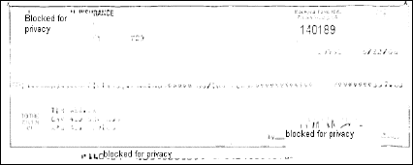

Manage a Check with Poor Image Quality
To manage a check with poor image quality, complete the following steps:
- From the Check Scan–Perform Check Scan page, the Image Quality Failed message appears, as shown in Figure 9. Select:
    - Rescan to rescan the check
Or
  - Cancel to completely cancel the transaction
Or
  - Accept to accept the image of the check (requires CCS to log in). The Email Address and Password dialog box appears. Enter the Email Address and Password and select Login.
Figure 9. Image Quality Failed Message
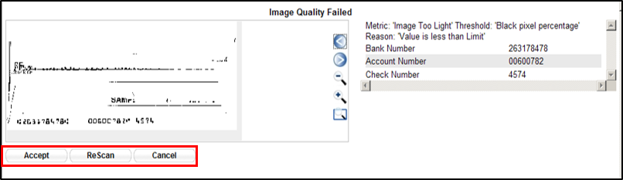
Application Tips

- Select Rescan if the check image is skewed, illegible, or upside down.
- If a Check Capture Lead Operator (CCLO) or Check Capture Operator (CCO) scanned the check, OTCnet prompts the operator for authorization.
- Only a Check Capture Supervisor (CCS) can approve a check with poor image quality. The CCS must key in his/her Email Address and Password before approving the check.

- Resume check scanning tasks and enter the check item details into the form fields.
- Select Save to save the image of the check and the data you entered.
Application Tip

Upon scanning the check, select Enter on your keyboard to finalize the Individual Reference Number (IRN), Bank Number, Check Number, Account Number, Date & Time fields. They automatically populate in the frame of the Agency Form Data.

Additional Buttons
- Select Cancel to return to the OTCnet Home Page. No data is saved.
- Select Previous to return to the previous page.
- Select Return Home to Return to the OTCnet Home Page.

Topic 4 Resolve a Duplicate Check
If a duplicate check is detected, a Duplicate Check Detected prompt appears requesting that the user resolve the issue. OTCnet determines and detects duplicate checks based on a match of the MICR and the check amount. The system automatically compares the check to those scanned in the last 30 days.
If a check is scanned twice and the information entered is for the same amount, OTCnet displays an error message containing both scanned images and requests confirmation. If the check is scanned twice and information entered is for a different amount, OTCnet does not catch the error and allows the duplicate entry. However, the financial institution later rejects one of the duplicate checks.
To prevent duplicate processing of checks, checks may be hand stamped (e.g., Electronically Presented) after the transaction is complete and the check has been scanned.
During terminal configuration, select the Franking Enabled option to allow the scanner to automatically stamp the front of checks. Franking is available for RDM EC7000i, EC9100i, EC9600i, EC9700i and Panini I: Deal scanners.
If the MICR line was misread by the scanner leading the system to believe that the check is a duplicate, it can be edited. To determine if the MICR line was misread, compare the two images in the window. The top image depicts the current check, and the bottom image depicts the most recently scanned check that is being deemed a duplicate by the system. Also, compare the MICR line on the bottom check with the source document. If it has been determined to be a misread of the MICR line, that must be corrected. A CCS or CCLO can select the Edit MICR button at the bottom of the window.
If a Duplicate Check Detected prompt is displayed during the check scanning process, an operator may consider the following actions:
- Rescanning the check (recommended to perform as many times as necessary)
- Editing MICR to correct the MICR line
- Accepting the check (requires a CCS to log in to OTCnet to authorize)
- Canceling the check (recommended action)
A CCS and CCLO are the only authorized users who can accept a duplicate check. Therefore, before a CCO can accept a duplicate check, a CCS or CCLO must log in to authorize it. If a CCLO scanned the check, additional authorization is not required. The Email Address and Password dialog box only appears if a CCS or CCLO is accepting a duplicate check for a CCO.
As a Check Capture Lead Operator (CCLO) or Check Capture Supervisor (CCS), you are authorized to accept a duplicate check. You are also authorized to edit a MICR line, rescan a check, or completely cancel the transaction. A CCLO or CCS must authorize a MICR line correction.

Resolve a Duplicate Check
To resolve a duplicate check, complete the following steps:
- Select Cancel to cancel the duplicate check. An Email Address and Password dialog box appears.
- Select Accept to continue processing the check. Select Edit MICR to correct the MICR line as shown in Figure 10.
Figure 10. Duplicate Check Detected
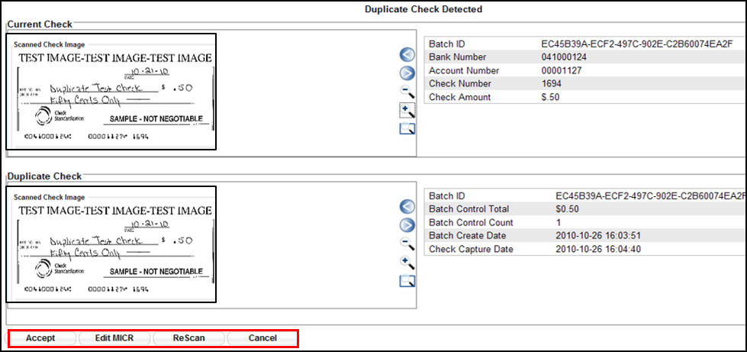
Application Tips

- The Email Address and Password dialog box only appears if a CCS or CCLO is accepting a duplicate check for a CCO. If a CCLO scanned the check, additional authorization is not required.
- A CCS or CCLO must authorize a MICR line code correction.
- As the CCS or CCLO, you can opt to make a MICR code line correction. If you do, look at the MICR line image closely to ensure all the characters are correctly entered in the code line Correction box.

- Select Cancel or Cancel All. A Transaction cancelled successfully dialog box appears.
Application Tip

Select Cancel to cancel the one duplicate check. Select Cancel All to cancel all pending checks in the batch.

- Select OK. The Check Scan – Perform Check Scan page appears.
Additional Buttons
- Select Previous to return to the previous page.
- Select Return to Home to return to the OTCnet Home page.

Topic 5 Void a Check
As a Check Capture Supervisor (CCS), you are the only authorized user who can void an erroneously scanned check or a batch of checks. Before voiding a check or a batch of checks, you must first search for the batch in which the check resides. Search for batches by OTC Endpoint, Created On Date, Batch ID, Cashier ID, and/or Batch Status. Voiding checks in batches can only be completed for OTC Endpoints that you have permission to access and only for items with an open or closed batch status.
Payments must only be entered for the amount of the item being processed. If a data-entry error is made in one of the user-defined fields, or amount entered for the check differs from the written amount of the check, two options are available:
- Void the check and rescan with the corrected information during the check capture process (requires CCS to sign in to approve).
- If a CCS is not available to approve the void while the operator has scanning in progress, the check must be voided via the Batch Management menu option. A CCS must sign in to Batch Management and change the incorrectly typed amount with the correct amount or update the user-defined field.
Other details to void a check include the following:
  - The minimum limit for reporting items that need to be adjusted by Treasury/Fiscal Service is $25.00. If the adjustment is $25.00 or more, the check is only corrected to the written dollar amount on the face of the check.
  - Voided items are not archived in the Central Image Retrieval Archive (CIRA) for long-term storage.
  - Do not scan the item a second time to process a second item for the amount difference. Doing so would create processing errors at Treasury/Fiscal Service as well as at the check writer’s financial institution.
  - If a file containing the wrong amount has already been transmitted, or if you ever encounter a processing issue and need assistance, please contact the Treasury OTC Support Center.
As a CCS, you are authorized to void a check. You run a search for batches and enter batch search conditions you would like to view. When an image and details of the check appear, you are authorized to select Void to the right of the check image.

Void a Check
To void a scanned check, complete the following steps:
- From the Check Processing tab, select Batch Management. The Search Batch page appears as shown in Figure 11.
Figure 11: Search Batch
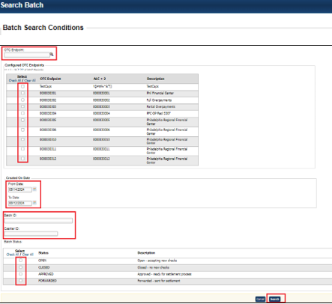
- In the search field, under Batch Search Conditions, enter an OTCnet Endpoint and select the magnifying glass icon (or the ENTER key) to retrieve a new set of results.
- Select the OTC Endpoint you want to Edit a batch for by checking the checkbox under the Select column.
- Under Created On Date, enter the From and To date range, as needed.
Application Tips

- There is an endpoint search restriction set based on user permissions (i.e., a CCLO, CCA user can only search for their Agency and any endpoints under their Agency.).
- The From and To Created On Date must be entered in MM/DD/YYYY format.
- When running a search with the default From and To Created On Date range values, the search results include the most recent 30 days of batches that you have access to view. If more than 1,000 batches are created within the 30 days, then only the most recent 1,000 batches appear.
- When running a search without specifying any criteria (with the exception of the Batch ID field), the search results include the most recent 30 days of batches that you have access to view. If more than 1,000 batches are created within 30 days, then only the most recent 1,000 batches appear.

  - Enter the Batch ID, optional.
  - Enter the Cashier ID, optional.
Application Tip

If the only search criteria entered is a valid Batch ID, then only a single result appears regardless of other search criteria specified.

Under Batch Status, optional
  - Select the Status you want to view by checking the Open or Closed box under the Select column.
- Select Search. The View Batch page appears.
- Select the Batch ID hyperlink. The View Checks page appears.
- Select the Item ID of the scanned check you would like to void. An image and details of the check appear in a window below.
- Select Void to the right of the check image to void the check as shown in Figure 12.
Figure 12. Check Image Details
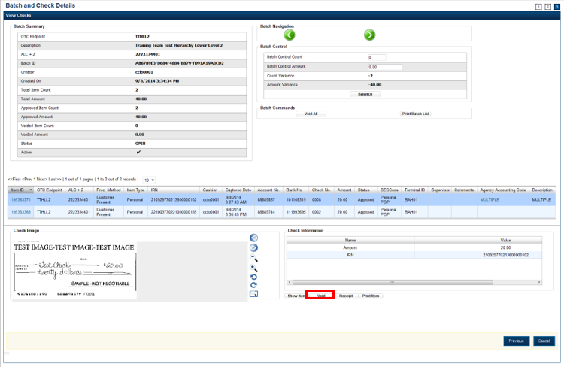
Application Tips

- If a check is voided and there is more than one check in the batch, and the ALC is designated to classify at the summary level, ensure that the combined accounting code subtotal is equal to the batch total prior to batch approval. If it does not, you must go back and re-validate your subtotal entries.
- If a check is voided and there is only one check in the batch, as a best practice it is recommended that the batch is deactivated so that it is not accidently forwarded for settlement. Deactivated batches are archived to the Historical Database.

- Select Confirm at the prompt, to void the check.
- Enter comments concerning the void request at the prompt and select OK.
- Select OK at the final prompt stating that the check is voided successfully.
Additional Buttons
- Select Cancel to return to the OTCnet Home Page. No data is saved.
- Select Previous to return to the previous page.
- Select Void All to void all items in the batch.
- Select Print Batch List to print the batch list.
- Select < to go to the first batch.
- Select > to go to the next batch.
- Select <<Image to return to the previous check.
- Select >>Image to view the next check.
- Select Zoom- to reduce the image size.
- Select Zoom+ to enlarge the image size.
- Select Rotate Left to turn the image to the left.
- Select Rotate Right to turn the image to the right.
- Select Show Item to view the check item details.
- Select Void to void a single check item.
- Select Receipt to print a receipt.
- Select Print Item to print a batch list report.

Void All Checks in a Batch
To void all scanned checks in a batch, complete the following steps:
- From the Check Processing tab, select Batch Management. The Search Batch page appears.
Application Tip

Only batches in Open status can have all checks voided at once.

- In the search field, under Batch Search Conditions, enter an OTCnet Endpoint and select the magnifying glass icon (or the ENTER key) to retrieve a new set of results.
- Select the OTC Endpoint you want to Edit a batch for by checking the checkbox under the Select column.
- Under Created On Date, enter the From and To date range, as needed.
Application Tips

- There is an endpoint search restriction set based on user permissions (i.e., a CCLO, CCA user can only search for their Agency and any endpoints under their Agency.).
- The From and To Created On Date must be entered in MM/DD/YYYY format.
- The Created On Date range cannot exceed 30 days. Additionally, if more than 1,000 batches are created within 30 days, then only the most recent 1,000 batches appear.
- When running a search with the default From and To Created On Date range values, the search results include the most recent 30 days of batches that you have access to view. If more than 1,000 batches are created within the 30 days, then only the most recent 1,000 batches appear.
- When running a search without specifying any criteria (with the exception of the Batch ID field), the search results include the most recent 30 days of batches that you have access to view. If more than 1,000 batches are created within 30 days, then only the most recent 1,000 batches appear.

  - Enter the Batch ID, optional.
  - Enter the Cashier ID, optional.
Application Tip

If the only search criteria entered is a valid Batch ID, then only a single result appears regardless of other search criteria specified.

Under Batch Status,
  - Select the Status you want to view by checking the Open or Closed box under the Select column.
- Select Search. The View Batch page appears.
- Select the Batch ID hyperlink. The View Checks page appears.
- Under Batch Commands, select Void All, as shown in Figure 13.
Figure 13. View Checks (Voiding)
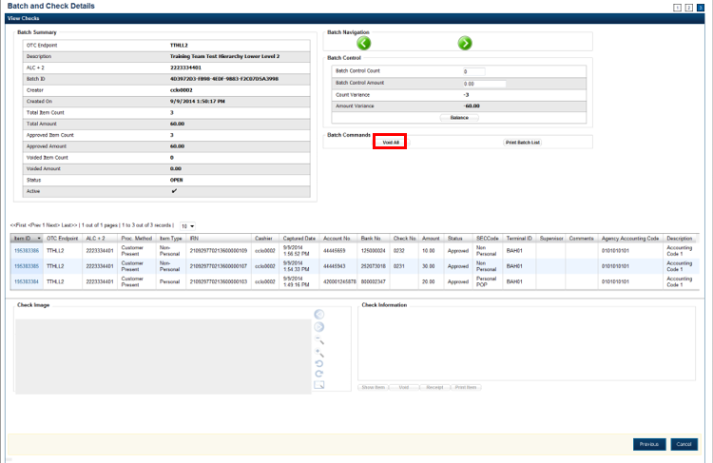
- Select Confirm at the prompt to void all checks.
- Enter comments concerning the void request at the prompt and select OK.
- Select OK at the final prompt stating that the checks in the batches have been voided successfully.
Application Tip

After an entire batch of checks is voided, as a best practice, it is recommended that the batch be deactivated so that it is not accidently forwarded for settlement. Deactivated batches are archived to the Historical Database after 18 months as all batches and their associated check items are archived regardless of the batch status.

Additional Buttons
- Select Cancel to return to the OTCnet Home Page. No data is saved.
- Select Previous to return to the previous page.
- Select Void All to void all items in the batch.
- Select Print Batch List to print the batch list.
- Select < to go to the first batch.
- Select > to go to the next batch.
- Select <<Image to return to the previous check.
- Select >>Image to view the next check.
- Select Zoom- to reduce the image size.
- Select Zoom+ to enlarge the image size.
- Select Rotate Left to turn the image to the left.
- Select Rotate Right to turn the image to the right.
- Select Show Item to view the check item details.
- Select Void to void a single check item.
- Select Receipt to print a receipt.
- Select Print Item to print a batch list report.

Topic 6 Override a Master Verification Database (MVD) Record
If an Agency chooses to use the Master Verification Database (MVD) feature, the Agency receives three types of check verification notifications: Blocked, Suspended, or D-Denied.
The CCS is the only authorized user who can override (if the transaction can be overridden) a blocked, suspended, or denied notification. When an override of a blocked check is performed, the override is a temporary, one-time event. The check remains blocked in the MVD database unless an authorized person (Master Verification Database Editor [MVDE] or CCS) clears the item out of the MVD database.
For the MVD override notification to appear, the check item must meet established criteria for blocked, suspended, or denied.
Blocked Check Notification
A blocked, suspended, or denied message appears after the CCLO or CCO scans the check, enters the details, and saves the transaction.
A blocked message displays if the item matches all data as it was input on the blocked record:
- Routing Transit/Account Number Data: If the blocked record is input with only the routing transit number and account number, that record is only flagged if the data matches
- Configurable Field Data: If the blocked record was input with only configurable field 1 data (e.g., Social Security Number or Driver’s License Number), then only configurable field 1 must match for the record
- Combination Data: If the blocked record input was for both pieces of information, it must match all combinations (i.e., routing transit and account along with configurable field 1)
Suspended or Denied Check Notification
The suspend or deny message displays if the item scanned matches the MVD information. This is either the match of the combination of both the routing number and account number, or a match against the configurable field 1.
Each OTC Endpoint that uses the MVD sets their policies to use certain return codes with a defined number of days within the suspension period. During that pre-determined period, if the check writer attempts to cash a check, a suspended notification appears on the OTCnet screen.
A typical check cashing policy may mandate that the check writer is suspended for 30 days upon their first offense, 60 days upon their second offense and 90 days upon their third offense. During the suspension period, they cannot cash a check at that OTC Endpoint. A denied item occurs when the check writer has exceeded all suspension periods. A typical suspension policy specifies that the check writer is suspended, as referenced in the paragraph above.
As a CCS, you are authorized to override a blocked, suspended, or denied check. The override is a temporary, one-time event. You must enter a reason why the check was approved for processing.

Override a MVD Record
To override a MVD Record, complete the following steps:
- Select Override to override the blocked, suspended, or denied check. An Override Check Denial dialog box appears as shown in Figure 14.
Figure 14. Override Check Denial Box
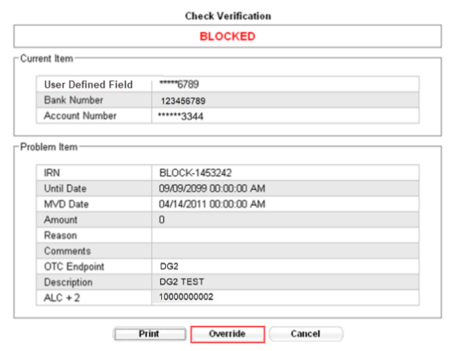
Application Tip

When an override of a blocked check is performed in check capture, the override is a temporary, one-time event. The check remains blocked in the MVD database unless an authorized person clears the item out of the MVD database.

- Select Print to print the Verification report as shown in Figure 15.
Figure 15. Verification Report
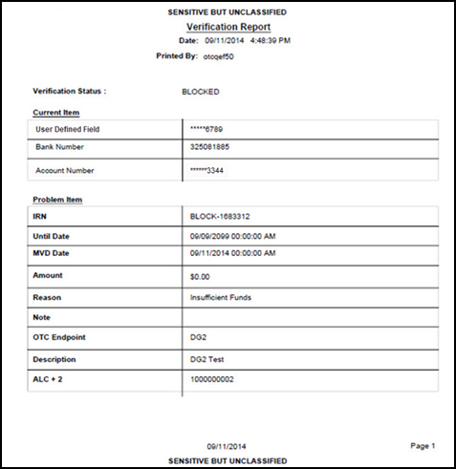
Application Tip

Select Cancel to close the Check Verification window. If Cancel is selected, return the check to the customer.

- Enter the Email Address and Password and select Login. A Comment dialog box appears.
Application Tip

A Check Capture Supervisor must authorize the overriding of the blocked, suspended, or denied check.

- Enter a reason why the check was approved for processing and select OK. A notification appears stating the override was successful.

Topic 7 Perform Batch Control and Batch Balancing
A CCA is authorized to configure the terminal for Batch Control as optional or mandatory on batch create, batch close, or both as an optional feature that your Agency can use as a batch balancing tool.
Batch Control is used to perform balancing on the number of checks that have been scanned and ensure their respective dollar amounts are accurately keyed. The Batch Control options are set up for each OTC Endpoint for which an Agency processes checks. If it is used, the feature applies to both processing modes (i.e., Single and Batch).
The batch control screen displays OTC Endpoint Information such as the OTC Endpoint short name, description, and ALC+2 for the OTC Endpoint. Configuration settings for batch control are established in Terminal Configuration.
If Batch Control is set at Batch Create, it can be either optional or mandatory, and the Batch control screen appears before scanning a batch of checks and when a new batch is created. Depending on the terminal configuration settings, the batch control fields can appear at the beginning of a batch (prior to scanning the check), just prior to closing a batch, or both.
If Batch Control is set to optional, the Defer button appears on the page. If set to mandatory for either Batch Create or Batch Close, the Defer button does not appear on the page and the user cannot start scanning a batch or close the unbalanced batch. If set to mandatory for both Batch Create and Batch Close, the Defer button appears during Batch Create, and a user must enter the batch control value during the Batch Close action.
Set to Appear on Batch Create
If the batch control is set to appear on batch create, OTCnet prompts the CCLO or CCO to enter the batch control total amount and count before scanning a check. If the batch control is set to optional on batch create, the operators can choose to select the Next button to bypass this step.
Set to Appear on Batch Close
If the batch control is set to appear on batch close, OTCnet prompts the CCO, CCLO or CCS to enter the batch control total amount and count. Batch control balancing only occurs when closing an open batch. If the batch control is set to optional on batch close, the operators, and CCS can choose to select to Defer to skip this step.
Batch Control Options
As a Check Capture Lead Operator (CCLO) or Check Capture Supervisor (CCS), you are authorized to set the batch control to appear on Batch Create or Batch Close. Enter the Batch Control Count and Batch Control Amount if Batch Control is set to mandatory.

Batch Control Options
To perform a Batch Create (Optional/ Mandatory), complete the following steps:
- From the Check Scan page,
Under Set Up New Batch,
  - Enter the Batch Control Count
  - Enter the Batch Control Amount
- Select Next as shown in Figure 16.
Figure 16. Batch Control Page (Batch Create)
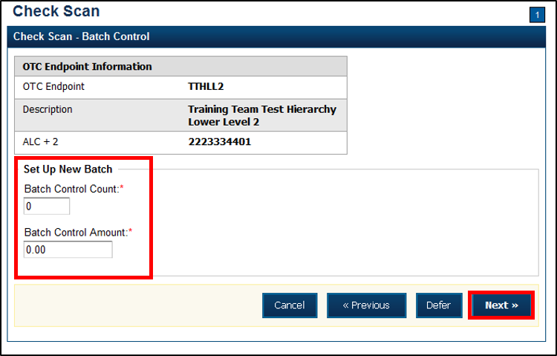
If Batch Control is set to mandatory, the CCLO or CCO must enter the Batch Control count and amount. The Batch Control count and amount cannot be zero.
If Batch Control is set to optional, the CCLO or CCO can select the Defer button.
- The Check Scan-Perform Check Scan page appears. Perform check scanning as needed.

On Batch Close (Optional/Mandatory)
As a CCLO, CCO, or CCS, you are authorized to enter the batch control total amount and count. You will close the batch and may print the PDF report or export the batch list report, regardless of whether the Close Batch or approve Batch checkboxes are checked or unchecked.

Perform Batch Control on Batch Close
To close a batch, complete the following steps:
- From the Batch Control page,
Under Batch Detail,
- Enter the Batch Control Count
- Enter the Batch Control Amount
- Select Next.
Application Tips

- If Batch Control is set to optional, the CCLO, CCO, or CCS can choose to select to Next button without entering the Batch Control count and amount.
- If the amount of a check item was incorrectly entered, select Cancel to return to the OTCnet Home Page. No data is saved.
- If you are a CCLO or CCO and discover that the amount of the check item was incorrectly entered, contact your CCS, and edit the check using the Show Item window.

- The Close Batch page appears. Select Print PDF Report or Export and select Confirm to close the batch. After Print PDF Report or Export is selected, the Confirm button is enabled as shown in Figure 17. The batch is not closed until Confirm is selected.
Figure 17. Print Batch List Report (Batch Close)
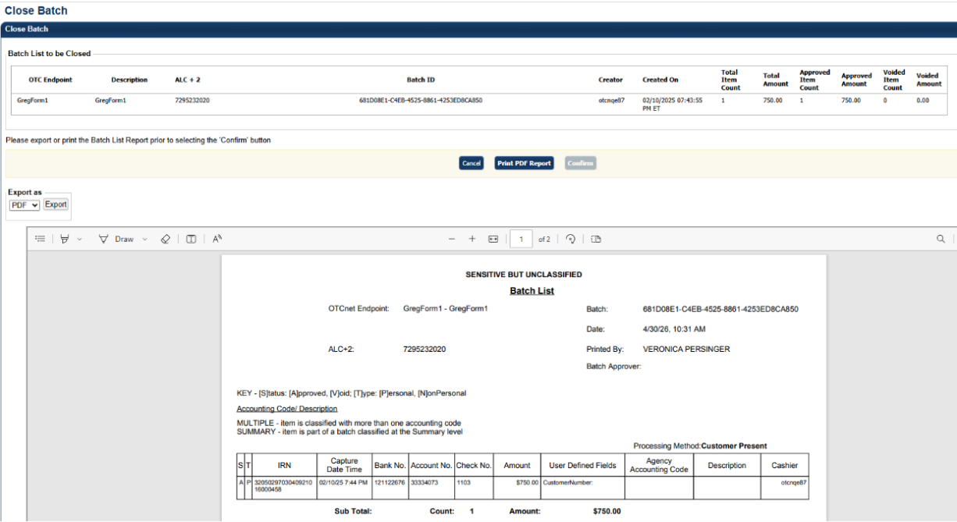
Application Tip

A user may print the PDF report or export the batch list report, regardless of whether the Close Batch and/or Approve Batch checkboxes are checked or unchecked. A CCS or CCA can specify the Batch List Report Print/Export Required During options under Advanced Administration.

Perform Batch Control on Batch Create
To perform batch control on Batch Create, complete the following steps:
- From the Check Scan page,
Under Set Up New Batch,
  - Enter the Batch Control Count
  - Enter the Batch Control Amount
Application Tips

- If Batch Control is set to mandatory, the Check Capture Lead Operator or Check Capture Operator must enter the batch control count and amount. The batch control count and amount cannot be zero.
- If Batch Control is set to optional, the Check Capture Lead Operator or Check Capture Operator can select the Defer button.

- Select Next. Perform Check Scan. The Check Scan-Perform Check Scan page appears.
- Scan check(s) as needed.
To perform batch control on Batch Close:
- From the Batch Control page,
Under Batch Detail,
  - Enter the Batch Control Count
  - Enter the Batch Control Amount
- Select Next. The Close Batch page appears.
Application Tips

- If Batch Control is set to optional, the Check Capture Lead Operator, Check Capture Operator, or Check Capture Supervisor can choose to select to Next button without entering the batch control count and batch control amount.
- When the amount of a check item is incorrectly entered, select Cancel to return to the OTCnet Home Page. No data is saved. If Check Capture Lead Operators or Check Capture Operators discover that the amount of the check item was incorrectly entered, contact your Check Capture Supervisor, and edit the check using the Show Item window.

- Continue the batch close process and print the batch list report.
Application Tip

A user may print the PDF report or export the batch list report, regardless of whether the Close Batch and/or Approve Batch checkboxes are checked or unchecked. A CCS or CCA can specify the Batch List Report Print/Export Required During options under Advanced Administration.

Batch Balancing
If the totals that are keyed into the Batch Control screen do not match what was keyed into the data entry screen, a Batch Balancing screen appears on batch close (as shown in Figure 17). This screen only appears if there is a discrepancy between the totals. To reconcile the discrepancy, the operator must discover where the issue exists.
The Batch Control (balancing) screen displays the Batch Detail. Open fields include the Batch Control Count and Batch Control Amount. If these fields do not match those which you see to the right of the Approved Item Count and Approved Amount, then an error displays; Failed to balance Batch (batch number), please check batch control (as shown in Figure 18).
If batch control is set to Mandatory and the batch is not balanced at this point (Batch Control Count and Batch Control Amount), a user may not proceed with closing a batch. However, if Batch Control is set to Optional, a user may select Next below, to continue closing the batch.
Figure 18. Batch Control (Failed to Balance)
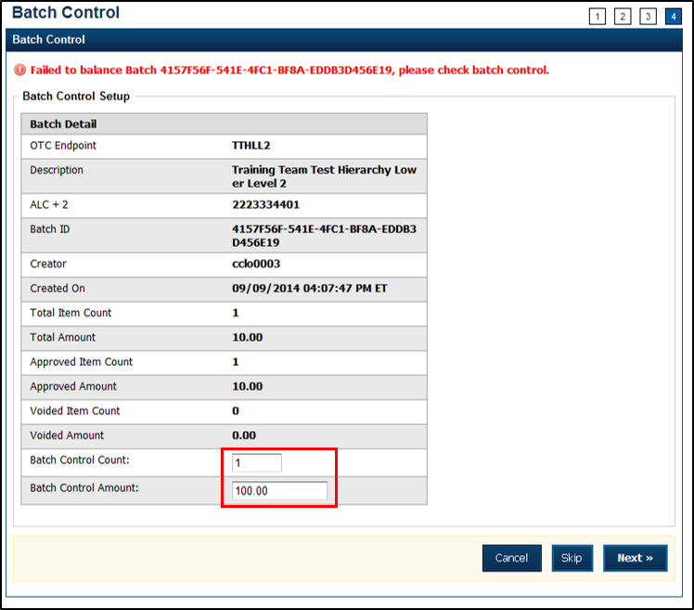
Below you will find Batch Detail descriptions:
- Total Item Count: The number of checks that have been scanned in OTCnet.
- Batch Control Count: The number of checks keyed into the Batch Control screen by the operator.
- Total Amount: The total dollar amount of the items as keyed into the Agency form data fields when scanning checks.
- Batch Control Total: The total dollar amount of the checks keyed into the Batch Control screen by the operator.
It must be determined if there is an erroneously scanned item, or if the batch contains both items. The operator must go back to the source documents for an answer. If it is determined that the batch contains both items, the operator would change the number in the Batch Control Count field and/or the dollar amount in the Batch Control Total.
If it has been determined that the batch does include an erroneously scanned item, follow these steps:
- Select on the erroneous amount.
- Select Void button.
- Enter comments concerning the void request and select Ok.
- Select OK to confirm the void request. The Confirmation message appears.
A CCS must log in at the prompt if the Void option is selected.

Topic 8 View and Print a Batch List/Item Detail Report
The CCS, CCLO, and CCO are authorized to view and print a Batch List report and an Item Detail report. An operator can print a Batch List for a deposit with any deposit status (i.e., Open, Closes, Approved, Forward). A Batch List consists of all transactions that are processed. A user can view batch lists based on the search criteria applied.
The printing of a Batch List is part of the batch close procedure. During batch close, the system prompts to make certain that the user acknowledges the printout of the Batch List. The Print PDF Report button defaults to print in PDF format; however, a user may also opt to download and save the report in an alternate format such as Word, HTML, Excel, etc.
From the Close Batch page, a user can perform several actions on the same screen (such as Activate/Deactivate, Close and Approve Batches), based on their permissions.

View and Print a Batch List Report
To view and print a Batch List report, complete the following steps:
- From the Check Processing tab, select Batch Management. The Search Batch page appears.
- In the search field, under Batch Search Conditions, enter an OTCnet Endpoint and select the magnifying glass icon (or the ENTER key) to retrieve a new set of results.
- Select the OTC Endpoint you want to Edit a batch for by checking the checkbox under the Select column.
- Under Created On Date, enter the From and To date range, as needed.
Application Tips

- There is an endpoint search restriction set based on user permissions (i.e., a CCLO, CCA user can only search for their Agency and any endpoints under their Agency.).
- The From and To Created On Date must be entered in MM/DD/YYYY format.
- The Created On Date range cannot exceed 30 days. Additionally, if more than 1,000 batches are created within 30 days, then only the most recent 1,000 batches appear.
- When running a search with the default From and To Created On Date range values, the search results include the most recent 30 days of batches that you have access to view. If more than 1,000 batches are created within the 30 days, then only the most recent 1,000 batches appear.
- When running a search without specifying any criteria (with the exception of the Batch ID field), the search results include the most recent 30 days of batches that you have access to view. If more than 1,000 batches are created within 30 days, then only the most recent 1,000 batches appear.

  - Enter the Batch ID, optional.
  - Enter the Cashier ID, optional.
Application Tip

If the only search criteria entered is a valid Batch ID then only a single result appears regardless of other search criteria specified.

Under Batch Status, optional
  - Select the Status you want to view by checking the Open or Closed box under the Select column.
- Select Search. The View Batches page appears.
- Select the Batch ID hyperlink. The Batch and Check Details page appears.
Application Tip

If a batch is in use and another user attempts to access the same batch, a Batch Lock message appears stating the batch is in use and he/she cannot access the batch.

- Select Print Batch List. The Batch List Report preview page appears as shown in
Figure 19.
Figure 19. Batch List Report
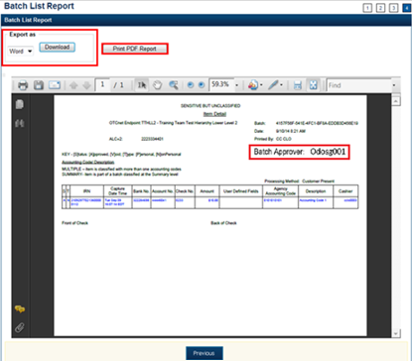
- Under Export as,
  - Select PDF, Word or Excel
  - Select Download
Or
  - Select Print PDF Report
Additional Button
- Select Previous to return to the previous page.

View and Print an Item Detail Report
To view and print an Item Detail report, complete the following steps:
- From the Check Processing tab, select Batch Management. The Search Batch page appears.
- In the search field, under Batch Search Conditions, enter an OTCnet Endpoint and select the magnifying glass icon (or the ENTER key) to retrieve a new set of results.
- Select the OTC Endpoint you want to Edit a batch for by checking the checkbox under the Select column.
- Under Created On Date, enter the From and To date range, as needed.
Application Tips

- There is an endpoint search restriction set based on user permissions. (i.e., a CCLO, CCA user can only search for their Agency and any endpoints under their Agency.).
- The From and To Created On Date must be entered in MM/DD/YYYY format.
- The Created On Date range cannot exceed 30 days. Additionally, if more than 1,000 batches are created within 30 days, then only the most recent 1,000 batches appear.
- When running a search with the default From and To Created On Date range values, the search results include the most recent 30 days of batches that you have access to view. If more than 1,000 batches are created within the 30 days, then only the most recent 1,000 batches appear.
- When running a search without specifying any criteria (with the exception of the Batch ID field), the search results include the most recent 30 days of batches that you have access to view. If more than 1,000 batches are created within 30 days, then only the most recent 1,000 batches appear.

  - Enter the Batch ID, optional.
  - Enter the Cashier ID, optional.
Application Tip

If the only search criteria entered is a valid Batch ID then only a single result appears regardless of other search criteria specified.

Under Batch Status, optional
  - Select the Status you want to view by checking the Open or Closed box under the Select column.
- Select Search. The View Batches page appears.
- Select the Batch ID hyperlink. The Batch and Item Details page appears.
- Select the Item ID of each scanned check. An image of the check and details of the check appear in the window below.
- Select Print Item. The Item Detail Report preview page appears as shown in Figure 20.
Figure 20. Item Detail Report
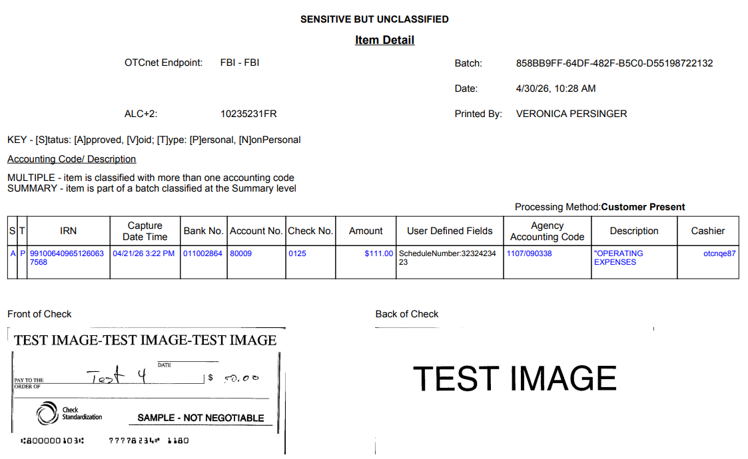
- Under Export as,
  - Select PDF, Word or Excel
  - Select Download
Or
  - Select Print PDF Report.
Additional Button
- Select Previous to return to the previous page.

Topic 9 Activate/Deactivate a Batch
A CCS is authorized to deactivate a batch if there is an issue with an item within the batch and further research is needed. Deactivating a batch prevents it from being closed or approved for settlement.
A deactivated batch must be activated before it can be closed or approved for settlement. Additionally, a batch currently in use cannot be deactivated. A deactivated batch is retained in the system indefinitely and can be searched for using Batch Management.
As a CCS, you are authorized to deactivate a batch if there is an issue with an item in the batch. You will enter the batch search conditions you would like to view.

Activate/Deactivate a Batch
To activate/deactivate a batch, complete the following steps:
- From the Check Processing tab, select Batch Management. The Search Batch page appears.
- In the search field, under Batch Search Conditions, enter an OTCnet Endpoint and select the magnifying glass icon (or the ENTER key) to retrieve a new set of results.
- Select the OTC Endpoint you want to Edit a batch for by checking the checkbox under the Select column.
- Under Created On Date, enter the From and To date range, as needed.
Application Tip

Only batches with an Open or Closed status can be activated/deactivated. Additionally, batches currently in use cannot be deactivated.

Application Tips

- There is an endpoint search restriction set based on user permissions (i.e., a CCLO, CCA user can only search for their Agency and any endpoints under their Agency.).
- The From and To Created On Date must be entered in MM/DD/YYYY format.
- The Created On Date range cannot exceed 30 days. Additionally, if more than 1,000 batches are created within 30 days, then only the most recent 1,000 batches appear.
- When running a search with the default From and To Created On Date range values, the search results include the most recent 30 days of batches that you have access to view. If more than 1,000 batches are created within the 30 days, then only the most recent 1,000 batches appear.
- When running a search without specifying any criteria (with the exception of the Batch ID field), the search results include the most recent 30 days of batches that you have access to view. If more than 1,000 batches are created within 30 days, then only the most recent 1,000 batches appear.

  - Enter the Batch ID, optional.
  - Enter the Cashier ID, optional.
Application Tip

If the only search criteria entered is a valid Batch ID, then only a single result appears regardless of other search criteria specified.

Under Batch Status, optional
  - Select the Status you want to activate/deactivate by checking the Open and/or Closed boxes under the Select column.
Application Tip

Only batches with an Open or Closed status can be activated/deactivated. Additionally, batches currently in use cannot be deactivated.

- Select Search. The Summary of Batches page appears.
- Check the checkbox of the Batch ID you want to activate or deactivate and select Activate/Deactivate. The Activate/Deactivate Batch page appears, as shown in Figure 21.
Figure 21. View Batches Page (Activate/Deactivate)
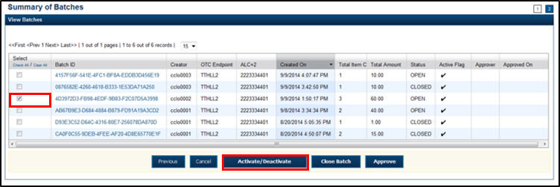
Application Tip

If a batch is activated or deactivated a check appears under the Active Flag column. If a batch is deactivated, the Active Flag column is blank.

- Select Confirm. A message appears stating the batch(es) have been activated/deactivated and the value under Active Status updates to Active/Inactive.
Additional Buttons
- Select Return to Batch Summary to return to the batch summary page.
- Select Return Home to return to the OTCnet homepage.

Topic 10 Classify a Batch
Before a batch is classified, an OTC Endpoint must be designated. You must classify a batch at the summary level with at least one accounting code or C-key. Additionally, if an OTC Endpoint is designated as a Central Accounting Reporting System (CARS)/Government-Wide Accounting (GWA) reporter, all batches (at the summary level) or items within a batch (at the item level) must be classified with at least one accounting code or C-key.
To classify a batch at the summary level, the CCLO or CCO first uses the Check Scan function, scans the check(s), enters the amount and any user defined field details, and saves the transaction. After the batch is saved, a CCS, CCLO, or CCO accesses Batch Management, selects View/Edit Classification and classifies the batch with an accounting code or C-key. Depending on your user privileges and batch status, you either have access to View/Edit Classification or a View Classification button.
The summary level (batch) classification process is independent of the batch close process. Therefore, a batch can be classified prior to closing a batch or after the batch is closed. Additionally, a CCS can classify a batch during Approve Batch.

Summary Level Classification
To classify or edit a batch at the summary level, select Batch Search Conditions including OTC Endpoint, Created On Date, Batch ID, Cashier ID and enter Batch Status as Open or Closed.
Select the Batch ID hyperlink, View/Edit Classification and select an Agency Accounting Code and Amount.

Summary Level Classification
To classify or edit a batch at the summary level, complete the following steps:
- From the Check Processing tab, select Batch Management. The Search Batch page appears.
- In the search field, under Batch Search Conditions, enter an OTCnet Endpoint and select the magnifying glass icon (or the ENTER key) to retrieve a new set of results.
- Select the OTC Endpoint you want to Edit a batch for by checking the checkbox under the Select column.
- Under Created On Date, enter the From and To date range, as needed.
Application Tips

- There is an endpoint search restriction set based on user permissions (i.e., a CCLO, CCA user can only search for their Agency and any endpoints under their Agency.).
- The From and To Created On Date must be entered in MM/DD/YYYY format.
- The Created On Date range cannot exceed 30 days. Additionally, if more than 1,000 batches are created within 30 days, then only the most recent 1,000 batches appear.
- If you run a search with the default From and To Created On Date range values, the search results include the most recent 30 days of batches that you have access to view. If more than 1,000 batches are created within the 30 days, then only the most recent 1,000 batches appear.
- If you run a search without specifying any criteria (with the exception of the Batch ID field), the search results include the most recent 30 days of batches that you have access to view. If more than 1,000 batches are created within 30 days, then only the most recent 1,000 batches appear.

    - Enter the Batch ID, optional.
    - Enter the Cashier ID, optional.
Application Tip

If the only search criteria entered is a valid Batch ID, then only a single result appears regardless of other search criteria specified.

Under Batch Status, optional
    - Select the Status you want to view by checking the Open or Closed box under the Select column.
Application Tip

Batches in Open or Closed status can be classified or edited at the summary level.

- Select Search. The View Batches page appears.
- Select the Batch ID hyperlink. The View Checks page appears.
- Select View/Edit Classification as shown in Figure 22. The Account Classification dialog box appears.
Figure 22. View Checks – View/Edit Classification
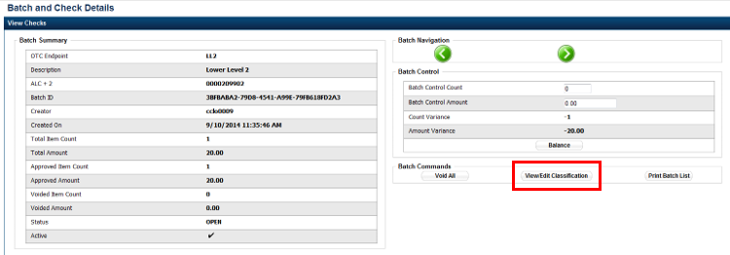
Application Tip

Depending on your user role and batch status, you will either see View/Edit Classification or View Classification. View/Edit Classification indicates that the user has view and edit permission. View Classification indicates the user has view classification permission and is not permitted to edit or delete a classification.

- Select Edit. The Account Classification dialog box refreshes.
- Enter or update the necessary account classification data.
    - Select an Agency Accounting Code.
Application Tips

- If an OTC Endpoint is associated with an Agency Location Code (ALC) that is designated as a Central Accounting Reporting System (CARS) Reporter, all check transactions must be classified with an accounting code. If an ALC is not a CARS Reporter, classifying it with an accounting code is optional.
- The Agency Accounting Codes drop-down list displays the full Agency Accounting Code value (up to 50 alphanumeric characters) and some portion of the Description (up to 15 alphanumeric characters).

    - Enter the Amount and select Add for each subtotal of the batch.
Application Tips

- The classified total and batch total can remain unbalanced until the batch is approved. However, the Variance must equal $0.00 before a batch can be approved. If it does not, you must go back and re-validate your subtotal entries.
- To delete or remove an accounting code, check the Remove check box next to the accounting code you want to delete and select Update.

    - Select Save.
Additional Buttons
- Select Cancel to return to the OTCnet Home Page. No data will be saved.
- Select Previous to return to the previous page.
- Select Void All to void all items in the batch.
- Select Print Batch List to print the batch list.
- Select < to go to the first batch.
- Select > to go to the next batch.
- Select <<Image to return to the previous check.
- Select >>Image to view the next check.
- Select Zoom- to reduce the image size.
- Select Zoom+ to enlarge the image size.
- Select Rotate Left to turn the image to the left.
- Select Rotate Right to turn the image to the right.
- Select Show Item to view the check item and perform update.
- Select Void to void a single check item.
- Select Receipt to print a receipt.
- Select Print Item to print an Item List report.
- Select -Front to return to the previous check.
- Select Back+ to view the next check.
- Select -Zoom to reduce the image size.
- Select Zoom+ to enlarge the image size.
- Select Rotate Left+ to turn the image to the left.
- Select Rotate Right+ to turn the image to the right.

Edit a Batch
As a CCS, CCLO, or CCO, you are authorized to classify or edit a batch at the summary level online. Batches in Open or Closed status can be edited at the summary level. You will enter or update the necessary account classification data and add the amount for each subtotal of the batch.

Edit a Batch
To classify or edit a batch at the summary level online, complete the following steps:
- From the Check Processing tab, select Batch Management. The Search Batch page appears.
- In the search field, under Batch Search Conditions, enter an OTCnet Endpoint and select the magnifying glass icon (or the ENTER key) to retrieve a new set of results.
- Select the OTC Endpoint you want to Edit a batch for by checking the checkbox under the Select column.
- Under Created On Date, enter the From and To date range, as needed.
Application Tips

- There is an endpoint search restriction set based on user permissions (i.e., a CCLO, CCA user can only search for their Agency and any endpoints under their Agency.).
- The From and To Created On Date must be entered in MM/DD/YYYY format.
- The Created On Date range cannot exceed 30 days. Additionally, if more than 1,000 batches are created within 30 days, then only the most recent 1,000 batches appear.
- When running a search with the default From and To Created On Date range values, the search results include the most recent 30 days of batches that you have access to view. If more than 1,000 batches are created within the 30 days, then only the most recent 1,000 batches appear.
- When running a search without specifying any criteria (with the exception of the Batch ID field), the search results include the most recent 30 days of batches that you have access to view. If more than 1,000 batches are created within 30 days, then only the most recent 1,000 batches appear.

  - Enter the Batch ID, optional.
  - Enter the Cashier ID, optional.
Application Tip

If the only search criteria entered is a valid Batch ID then only a single result appears regardless of other search criteria specified.

Under Batch Status, optional
  - Select the Status you want to view by checking the Open or Closed box under the Select column.
Application Tip

Batches in Open or Closed status can be classified or edited at the summary level.

- Select Search. The View Batches page appears.
- Select the Batch ID hyperlink. The View Checks page appears.
- Select View/Edit Classification, as shown in Figure 23. The Account Classification dialog box appears.
Figure 23. View Checks - View/Edit Classification
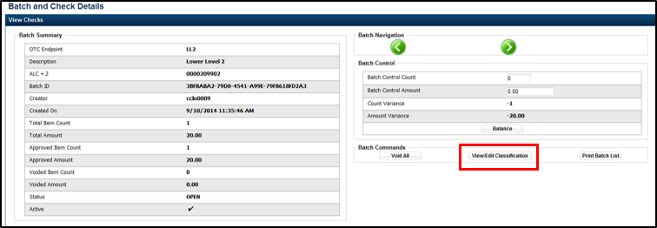
Application Tip

Depending on your user role and batch status you either have access to View/Edit Classification or View Classification. View/Edit Classification indicates that the user has view and edit permission. View Classification indicates the user has view classification permission and is not permitted to edit or delete a classification.

- Select Edit. The Account Classification dialog box refreshes.
- Enter or update the necessary account classification data.
  - Select an Agency Accounting Code
Application Tips

- If an OTC Endpoint is associated with an ALC that is designated as a Central Accounting Reporting System (CARS)/ Government-Wide Accounting (GWA) Reporter, all check transactions must be classified with an accounting code. If an ALC is not a CARS/GWA Reporter, classifying it with an accounting code is optional.
- The Agency Accounting Codes drop-down list displays the full Agency Accounting Code value (up to 50 alphanumeric characters) and some portion of the Description (up to 15 alphanumeric characters).

  - Enter the Amount and select Add for each subtotal of the batch.
Application Tips

- The classified total and batch total can remain unbalanced until the batch is approved. However, the Variance must equal $0.00 before a batch can be approved. If it does not, you must go back and re-validate your subtotal entries.
- To delete or remove an accounting code, check the Remove check box next to the accounting code you want to delete and select Update.

  - Select Save
Additional Buttons
- Select Cancel to return to the OTCnet Home Page. No data is saved.
- Select Previous to return to the previous page.
- Select Void All to void all items in the batch.
- Select Print Batch List to print the batch list.
- Select < to go to the first batch.
- Select > to go to the next batch.
- Select <<Image to return to the previous check.
- Select >>Image to view the next check.
- Select Zoom- to reduce the image size.
- Select Zoom+ to enlarge the image size.
- Select Rotate Left to turn the image to the left.
- Select Rotate Right to turn the image to the right.
- Select Show Item to view the check item and perform update.
- Select Void to void a single check item.
- Select Receipt to print a receipt.
- Select Print Item to print an Item List report.
Additional buttons on the Show Item page:
- Select -Front to return to the previous check.
- Select Back+ to view the next check.
- Select -Zoom to reduce the image size.
- Select Zoom+ to enlarge the image size.
- Select Rotate Left+ to turn the image to the left.
- Select Rotate Right+ to turn the image to the right.

Topic 11 Close a Batch
The CCS and CCLO are the only authorized users who can close a batch or multiple batches. You can only close batches for OTC Endpoints that you have permission to access.
OTCnet supports the following web browsers: Microsoft Edge and Google Chrome. For the PDF Documents Setting in Chrome: Disable the PDF Documents Setting within your browser to view PDFs in the PDF preview pane. If the PDF Documents Setting is enabled, reports can only be opened for download and do not display within the application. To view this option in a Chrome browser, navigate to:
Chrome browser > 3 vertical dots in upper right>Settings>Advanced>Site Settings (under “Privacy and security”)>PDF documents (under “Permissions”).
Before closing a batch or multiple batches, you must first search for the batch. Search batches by OTC Endpoint, Created On Date, Batch ID, Cashier ID, and/or Batch Status.
There are four batch status types, see Table 3 for details below.
Table 3. Batch Status Types
Open | Indicates the batch is open. Continue scanning checks to it.
Closed | Indicates the batch is closed and no new checks are accepted.
Approved | Indicates the batch is ready for settlement.
Forwarded | Indicates the batch has been sent to debit gateway to initiate the settlement process.
All batches with a Received Date older than 18 months, including batches with an Open or Closed status, are saved in the Historical database and cannot be changed. Therefore, it is important that you close and approve all batches in a timely manner.

Close Multiple Batches
As a CCS or CCLO, you are authorized to close multiple batches. Enter the batch search conditions you would like to view and select the batch you would like to close. You can also use the balancing feature for your OTC Endpoint if applicable. Print the PDF Report or Export and confirm the batches you want to close. A Close Batch page appears verifying the batches have been closed.

Close a Single or Multiple Batch(es)
To close a single or multiple batch(es), complete the following steps:
- From the Check Processing tab, select Batch Management. The Search Batch page appears.
- In the search field, under Batch Search Conditions, enter an OTCnet Endpoint and select the magnifying glass (or the ENTER key) icon to retrieve a new set of results.
- Select the OTC Endpoint you want to Edit a batch for by checking the checkbox under the Select column.
- Under Created On Date, enter the From and To date range, as needed.
Application Tips

- There is an endpoint search restriction set based on user permissions (i.e., a CCLO, CCA user can only search for their Agency and any endpoints under their Agency.).
- The From and To Created On Date must be entered in MM/DD/YYYY format.
- The Created On Date range cannot exceed 30 days. Additionally, if more than 1,000 batches are created within 30 days, then only the most recent 1,000 batches appear.
- When running a search with the default From and To Created On Date range values, the search results include the most recent 30 days of batches that you have access to view. If more than 1,000 batches are created within the 30 days, then only the most recent 1,000 batches appear.
- When running a search without specifying any criteria (with the exception of the Batch ID field), the search results include the most recent 30 days of batches that you have access to view. If more than 1,000 batches are created within 30 days, then only the most recent 1,000 batches appear.

  - Enter the Batch ID, optional.
  - Enter the Cashier ID, optional.
Application Tip

If the only search criteria entered is a valid Batch ID, then only a single result appears regardless of other search criteria specified.

Under Batch Status, optional
  - Select the Status you want to view by checking the Open box under the Select column.
- Select Search. The View Batches page appears.
- Select the Batch ID hyperlink. The View Checks page appears.
- Select the Item ID of each scanned check. An image of the check and details of the check appear in the window below.
- Select Previous to return to the View Batches page.
- Select the batch(es) you want to close by checking the boxes to the left of the Batch IDs.
- Select Close Batch. The Close Batch appears.
- Verify that you want to close the batches and select Confirm. The Batch Control page appears.
- Enter the Batch Control Count and Batch Control Amount, if applicable.
- Select Next. The Close Batch page appears.
- Select Print PDF Report or Export and select Confirm to close the batch(es).
Application Tips

- After Print PDF Report or Export is selected, the Confirm button is enabled. The batch(es) is(are) not closed until Confirm is selected.
- The system generates one report for all selected batches.
- If the CCS or CCA checked the Close Batch checkbox under Advanced Administration, then the user must print the PDF report or export the batch list report. Afterwards, the user can proceed to close the batch.
- If the user is closing multiple batches online and the Close Batch checkbox is checked at any OTCnet endpoint, then the user must print the PDF reports or export the batch list reports. The batch is not closed until Confirm is selected, which is enabled when the Print PDF Report or Export is selected.
- If the user is closing multiple batches online and the Close Batch checkbox is not checked, then the user can close multiple batches without printing the PDF reports or exporting the batch list reports. Confirm is enabled and the user can select to close the multiple batches.
- A user may print the PDF report or export the batch list report, regardless of whether the Close Batch and/or Approve Batch checkboxes are checked or unchecked. A CCS or CCA can specify the Batch List Report Print/Export Required During options under Advanced Administration.

- A Close Batch page appears verifying the batches have been closed.
- Select Return to Batch Summary. The View Batches page appears.
- Select Return Home to return to the OTCnet Homepage.
Application Tip

If a CCLO or CCO closes a batch, the batch status changes from Open to Closed. If a CCS closes a batch, the batch status changes from Open to Approved. If Skip is selected, the Status remains Open and the batch is not closed.

Topic 12 Approve a Batch
As a CCS, you are the only authorized user who can approve a batch or multiple batches. You can only approve batches for OTC Endpoints that you have permission to access. Approving a batch(es) indicates that the batch and check details are correct and that the batch(es) is/are ready for settlement.
Before approving a batch or multiple batches, you must first search for the batch. Batches can be searched by OTC Endpoint, Created On Date, Batch ID, Cashier ID, and/or Batch Status.
Additionally, a batch is only eligible for approval when the batch has a Closed status. After a batch is Approved and sent to Debit Gateway to initiate the settlement process, the status becomes Forwarded.
OTCnet supports the following web browsers: Microsoft Edge and Google Chrome. For the PDF Documents Setting in Chrome: Disable the PDF Documents Setting within your browser to view PDFs in the PDF preview pane. If the PDF Documents Setting is enabled, reports can only be opened for download and do not display within the application. To view this option in a Chrome browser, navigate to:
Chrome browser > 3 vertical dots in upper right >Settings> Advanced>Site Settings (under “Privacy and security”) >PDF documents (under “Permissions”).
Transactions processed before 9:30 p.m. EST are reflected on the next day’s deposit SF215. Batches must be approved and forwarded for settlement on the same business day on which the activity occurred in order to reflect on the SF215.
We recommend reviewing Batch Management to check the status of created batches. If batch statuses within Batch Management show them to be successfully forwarded, then the funds are included on the next day’s SF215 report.

Approve a Single Batch
As a CCS, you are authorized to approve a single batch or multiple batches. Enter the batch search conditions you would like to view. If a CCS closes a batch, it is automatically Approved. If a batch is closed by a CCO or a CCLO without approver permission, an approve button is available. Verify that you want to approve the batch and confirm approval.

Approve a Single Batch
To approve a single batch, complete the following steps:
- From the Check Processing tab, select Batch Management. The Search Batch page appears.
- In the search field, under Batch Search Conditions, enter an OTCnet Endpoint and select the magnifying glass icon (or the ENTER key) to retrieve a new set of results.
- Select the OTC Endpoint you want to Edit a batch for by checking the checkbox under the Select column.
- Under Created On Date, enter the From and To date range, as needed.
Application Tips

- There is an endpoint search restriction set based on user permissions (i.e., a CCLO, CCA user can only search for their Agency and any endpoints under their Agency.).
- The From and To Created On Date must be entered in MM/DD/YYYY format.
- The Created On Date range cannot exceed 30 days. Additionally, if more than 1,000 batches are created within 30 days, then only the most recent 1,000 batches appear.
- When running a search with the default From and To Created On Date range values, the search results include the most recent 30 days of batches that you have access to view. If more than 1,000 batches are created within the 30 days, then only the most recent 1,000 batches appear.
- When running a search without specifying any criteria (with the exception of the Batch ID field), the search results include the most recent 30 days of batches that you have access to view. If more than 1,000 batches are created within 30 days, then only the most recent 1,000 batches appear.

  - Enter the Batch ID, optional.
  - Enter the Cashier ID, optional.
Application Tip

If the only search criteria entered is a valid Batch ID then only a single result appears regardless of other search criteria specified.

Under Batch Status,
  - Select the Status you want to close by checking the Closed box under the Select column.
- Select Search. The View Batch page appears.
- Select the Batch ID hyperlink. The View Checks page appears.
- Select the Item ID of each scanned check. An image of the check and details of the check appear in the window below.
- Verify the details are correct and select Previous to return to the View Batch page.
- Select the batch you want to approve by checking the box to the left of the Batch ID.
- Select Approve as shown in Figure 24. The Approve Batch page appears.
Figure 24. Confirm Batches to Approve (Approve Single)
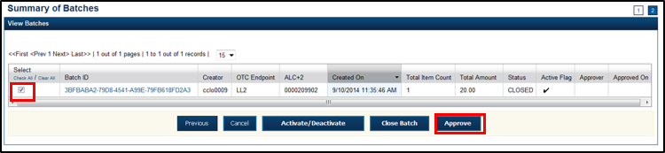
- Verify that you want to approve the batch and select Confirm. The Approve Batch page appears with the batch details.
- Select Print PDF Report or Export and select Confirm to approve the batch.
Application Tips

- After Print PDF Report or Export is selected, the Confirm button is enabled. The batch is not approved until Confirm is selected.
- If the CCS or CCA checked the Approve Batch checkbox under Advanced Administration, then the user must print the PDF report or export the batch list report. Afterwards, the user can proceed to approve the batch.
- If the user is approving multiple batches online and the Approve Batch checkbox is checked at any OTCnet endpoint, then the user must print the PDF reports or export the batch list reports. The batch is not approved until Confirm is selected, which is enabled when the Print PDF Report or Export is selected.
- If the user is approving multiple batches online and the Approve Batch checkbox is not checked, then the user can approve multiple batches without printing the PDF reports or exporting the batch list reports. Confirm is enabled and the user can select to approve the multiple batches.
- A user may print the PDF report or export the batch list report, regardless of whether the Close Batch and/or Approve Batch checkboxes are checked or unchecked. A CCS or CCA can specify the Batch List Report Print/Export Required During options under Advanced Administration.

- An Approve Batch page appears verifying the batch has been approved.
- Select Return to Batch Summary.
Application Tip

- After a batch is approved, its status changes from Closed to Approved, except under one of these two scenarios.
- First, if a batch has been designated for summary level classification and the batch classification is not balanced.
- Second, if a batch is designated to be classified at the summary level and it is a Central Accounting Reporting System (CARS)/ Government Wide Accounting (GWA) reporter, and the batch is not classified.
- Under these two scenarios the batch status is Closed. After the batch is classified and balanced, the batch can be approved.

Additional Buttons
- Select Cancel to return to the OTCnet Home Page. No data is saved.
- Select Previous to return to the previous page.
- Select Activate/Deactivate to activate or deactivate a batch.
- Select Close Batches to close a batch.
- Select <<First to go to the first page. (Only appears if there are several pages retrieved for the search results.)
- Select Next> to go to the next page. (Only appears if there are several pages retrieved for the search results.)
- Select Last>> to return to the last page. (Only appears if there are several pages retrieved for the search results.)
- Select <<Image to return to the previous check.
- Select >>Image to view the next check.
- Select Zoom- to reduce the image size.
- Select Zoom+ to enlarge the image size.
- Select Rotate Left to turn the image to the left.
- Select Rotate Right to turn the image to the right.
- Select Show Item to view and update the check item details.
- Select Void to void a single check item.
- Select Receipt to print a receipt.
- Select Print Item to print a batch list report.

Approve Multiple Batches
As a CCS, you are authorized to approve multiple batches. You will enter the batch search conditions you would like to view, choose the desired scanned check, verify the details are correct and repeat this for each batch you want to approve. Verify that you want to approve the batches and confirm.

Approve Multiple Batches
To approve multiple batches, complete the following steps:
- From the Check Processing tab, select Batch Management. The Search Batch page appears.
- In the search field, under Batch Search Conditions, enter an OTCnet Endpoint and select the magnifying glass icon (or the ENTER key) to retrieve a new set of results.
- Select the OTC Endpoint you want to Edit a batch for by checking the checkbox under the Select column.
- Under Created On Date, enter the From and To date range, as needed.
Application Tips

- There is an endpoint search restriction set based on user permissions (i.e., a CCLO, CCA user can only search for their Agency and any endpoints under their Agency.).
- The From and To Created On Date must be entered in MM/DD/YYYY format.
- The Created On Date range cannot exceed 30 days. Additionally, if more than 1,000 batches are created within 30 days then only the most recent 1,000 batches appear.
- When running a search with the default From and To Created On Date range values, the search results include the most recent 30 days of batches that you have access to view. If more than 1,000 batches are created within the 30 days, then only the most recent 1,000 batches appear.
- When running a search without specifying any criteria (with the exception of the Batch ID field), the search results include the most recent 30 days of batches that you have access to view. If more than 1,000 batches are created within 30 days, then only the most recent 1,000 batches appear.

  - Enter the Batch ID, optional.
  - Enter the Cashier ID, optional.
Application Tip

If the only search criteria entered is a valid Batch ID then only a single result appears regardless of other search criteria specified.

Under Batch Status,
  - Select the Status you want to approve by checking the Closed box under the Select column.
- Select Search. The View Batch page appears.
- Select the Batch ID hyperlink as shown in Figure 25. The View Checks page appears.
Figure 25. View Batches Page (Approve Multiple Batches)
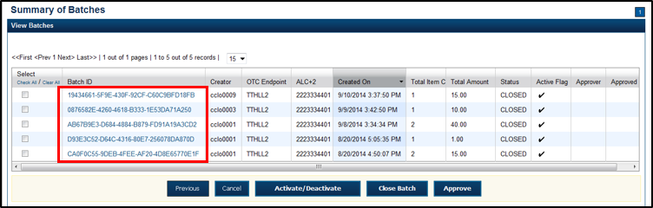
- Select the Item ID of each scanned check. An image of the check and details of the check appear in the window below.
- Verify the details are correct and select Previous to return to the View Batch page.
- Select the batches you want to approve by checking the boxes to the left of the Batch ID.
- Select Approve. The Approve Batch page appears.
- Verify that you want to approve the batches and select Confirm. The Approve Batch page appears with the batch details.
- Select Print PDF Report or Export and select Confirm to approve the batches.
Application Tips

- After Print PDF Report or Export is selected, the Confirm button is enabled. The batch is not approved until Confirm is selected.
- A user may print the PDF report or export the batch list report, regardless of whether the Close Batch and/or Approve Batch checkboxes are checked or unchecked. A Check Capture Supervisor (CCS) or Check Capture Administrator (CCA) can specify the Batch List Report Print/Export Required During options under Advanced Administration.
- If the CCS or CCA checked the Approve Batch checkbox under Advanced Administration, then the user must print the PDF report or export the batch list report. Afterwards, the user can proceed to approve the batch.
- If the user is approving multiple batches online and the Approve Batch checkbox is checked at any OTCnet endpoint, then the user must print the PDF reports or export the batch list reports. The batch is not approved until Confirm is selected, which is enabled when the Print PDF Report or Export is selected.
- If the user is approving multiple batches online and the Approve Batch checkbox is not checked, then the user can approve multiple batches without printing the PDF reports or exporting the batch list reports. Confirm is enabled and the user can select to approve the multiple batches.

- An Approve Batch page appears verifying the batches have been approved.
- Select Return to Batch Summary.
Application Tip

- After a batch is approved, the Status changes from Closed to Approved and the Approve Batch page appears with the batch details, except under one of these two scenarios.
- First, if a batch has been designated for summary level classification and the batch classification is not balanced.
- Second, if a batch is designated to be classified at the summary level and it is a Central Accounting Reporting System (CARS)/Government-Wide Accounting (GWA) reporter, and the batch is not classified.
- Under these two scenarios the batch status is Closed. After the batch is classified and balanced, the batch can be approved.

Additional Buttons
- Select Cancel to return to the OTCnet Home Page. No data is saved.
- Select Previous to return to the previous page.
- Select Activate/Deactivate to activate or deactivate a batch.
- Select Close Batches to close a batch.
- Select <<First to go to the first page. (Only appears if there are several pages retrieved for the search results.)
- Select Next> to go to the next page. (Only appears if there are several pages retrieved for the search results.)
- Select Last>> to return to the last page. (Only appears if there are several pages retrieved for the search results.)
- Select <<Image to return to the previous check.
- Select >>Image to view the next check.
- Select Zoom- to reduce the image size.
- Select Zoom+ to enlarge the image size.
- Select Rotate Left to turn the image to the left.
- Select Rotate Right to turn the image to the right.
- Select Show Item to view and update the check item details.
- Select Void to void a single check item.
- Select Receipt to print a receipt.
- Select Print Item to print a batch list report.

Topic 13 Print a Receipt
Receipts are available for printing if the CCA configures the terminal beforehand in OTCnet. If your Agency requires a specific receipt layout, contact your Deployment Specialist at fiscalservice.otcdeployment@citi.com or 703-377-5586. All receipts are printed in PDF format, as well as saved or attached to a new email message.
After the terminal is configured, CCOs, CCLOs, and CCSs can print a receipt in single mode or batch mode through the Check Scan and Batch Management functionality, as well as via the Show Item to print a receipt. Receipts are available for printing in OTCnet after the operators enter and save the pertinent details and can be either handed to or mailed to the customer.

Receipt Printing from Check Scan (Single/Batch Mode)
As a CCO, CCLO, or CCS, you are authorized to print a receipt in single mode or batch mode from Check Scan. You can scan the check, input, and save the pertinent details. Print and close the receipt. If you are printing in batch mode, repeat the process throughout the batch.

Print a Receipt from Check Scan
To print a receipt from Check Scan functionality: Single Mode, complete the following steps:
- Scan the check, input, and save the pertinent details.
- Under Scan Controls, select Receipt. A Printing…Please wait message appears and the receipt prints to the default printer.
Application Tip

You have eight seconds to select the Receipt button. If the Receipt button is not selected within the allotted time, the button grays out. If a receipt is still needed, access the Batch Management function.

- Select Receipt. The receipt appears as shown in Figure 26.
Figure 26. Receipt Print Image (Scan Check)
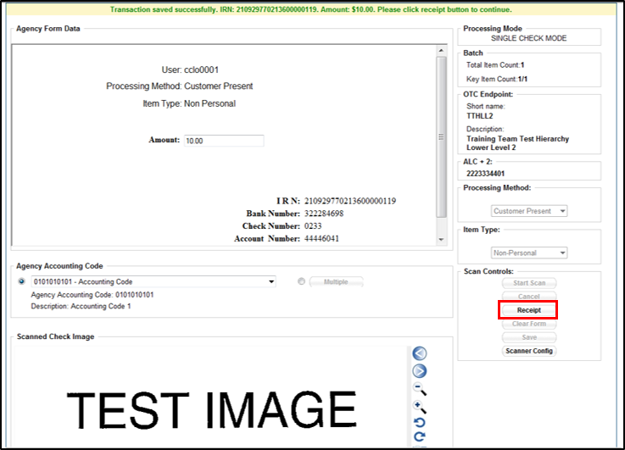
- Select Print to print the receipt.
- Select Close to close the receipt.
Application Tip

When printing a receipt in batch mode repeat steps 1-5 until finished.

Print a Receipt in Batch Management
To print a receipt using Batch Management, complete the following steps:
- From the Check Processing tab, select Batch Management. The Search Batch page appears.
- In the search field, under Batch Search Conditions, enter an OTCnet Endpoint and select the magnifying glass icon (or the ENTER key) to retrieve a new set of results.
- Select the OTC Endpoint you want to Edit a batch for by checking the checkbox under the Select column.
- Under Created On Date, enter the From and To date range, as needed.
Application Tips

- There is an endpoint search restriction set based on user permissions (i.e., a CCLO, CCA user can only search for their Agency and any endpoints under their Agency.).
- The From and To Created On Date must be entered in MM/DD/YYYY format.
- The Created On Date range cannot exceed 30 days. Additionally, if more than 1,000 batches are created within 30 days then only the most recent 1,000 batches appear.
- If you run a search with the default From and To Created On Date range values, the search results include the most recent 30 days of batches that you have access to view. If more than 1,000 batches are created within the 30 days then only the most recent 1,000 batches appear.
- If you run a search without specifying any criteria (with the exception of the Batch ID field), the search results include the most recent 30 days of batches that you have access to view. If more than 1,000 batches are created within 30 days then only the most recent 1,000 batches appear.

  - Enter the Batch ID, optional.
  - Enter the Cashier ID, optional.
Application Tip

If the only search criteria entered is a valid Batch ID then only a single result appears regardless of other search criteria specified.

Under Batch Status, optional
  - Select the Status you want to view by checking the Open or Closed box under the Select column.
- Select Search. The View Batch page appears.

- Select the Batch ID hyperlink. The View Checks page appears as shown in Figure 27.
Figure 27. View Checks Page (Receipt)
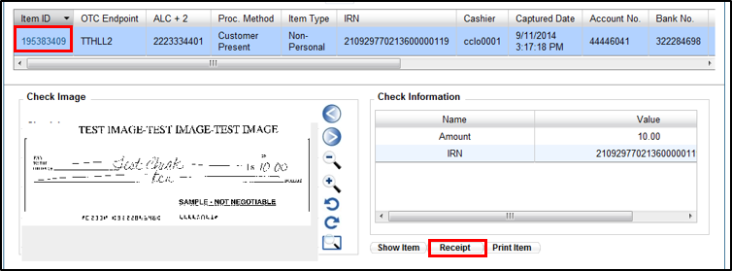
Application Tip

If a batch is in use and another user attempts to access the same batch, a Batch Lock message appears stating the batch is in use and he/she cannot access the batch.

- Select the Item ID of each scanned check. An image of the check and details of the check appear in the window below.
- Select Receipt. The receipt appears.
- Select Print to print the receipt.
Application Tip

Account numbers and User Defined Fields (UDFs) that are marked as Personally Identifiable Information (PII) are masked. If there are more than five characters, OTCnet masks all but the last four characters. If there are five characters or less, the system masks all but the last character.

- Select Close to close the receipt.
Application Tips

- Select Show Item to view more details about the check.
- Under Server Controls, select Receipt to print the receipt.

Summary
In this chapter you learned:
- The Purpose of Capturing and Managing Checks Online
- Capture a Check Online
- Manage Poor Check Image Quality
- Resolve a Duplicate Check
- Void a Check
- Override a Master Verification Record (MVD) Record
- Perform Batch Control and Batch Balancing
- View and Print a Batch List/Item Detail Report
- Activate/ Deactivate a Batch
- Classify a Batch
- Close a Batch
- Approve a Batch
- Print a Receipt

