

Chapter 9. Configuring Check Processing Settings
OTCnet Participant User Guide

Table of Contents
Overview, Topics, and Audience 1
Overview 1
Topics 1
Audience 1
Topic 1 Purpose of Configuring Check Processing Settings Online 2
Topic 2 Setting Up or Modifying a Terminal Configuration 3
Configuring a Check Capture Terminal Online 3
Configure a Check Capture Terminal Online 4
Viewing Terminal Configuration 9
View Terminal Configuration 10
Topic 3 Searching an Audit Log 11
Searching an Audit Log Online 11
Search an Audit Log Online 12
Topic 4 Downloading and Installing Firmware 15
Downloading Firmware 15
Download Firmware 16
Installing Firmware 18
Install Firmware 19
Topic 5 Creating Check Capture Override and Online Authentication 21
Creating Check Capture Override and Online Authentication Password 21
Create Check Capture Override and Online Authentication Password 22
Summary 24

List of Figures
Figure 1. Step 3 of 4: Update the Configured OTC Endpoints 8
Figure 2. View Terminal Configuration Page 10
Figure 3. Audit Log Output 13
Figure 4: Sample View Audit Log Details Page 14
Figure 5. Review Firmware Download 16
Figure 6. Destination Folder Dialog Box 19
Figure 7: Create Check Capture Override and Online Authentication Password 22
Figure 8: Confirmation Page (Check Capture Override/Online Authentication) 23

List of Tables
Table 1. Scanner Types 3
Table 2. Audit Log User Permissions 11
Table 3. Event Types 13

Glossary
Select this link to access the full OTCnet Glossary.

Overview, Topics, and Audience

Overview
Welcome to Configuring Check Processing Settings. In this chapter, you will learn:
- The purpose of configuring check capture settings
- How to set up or modify a terminal configuration
- How to view a terminal configuration
- How to search an audit log
- How to download and install firmware
- How to create check capture override and online authentication password

Topics
This chapter is organized by the following topics:
- Purpose of Configuring Check Processing Settings
- Set Up or Modify a Terminal Configuration
- Search an Audit Log
- Download and Install Firmware
- Create Check Capture Override and Online Authentication Password

Audience
The intended audience for the Configuring Check Processing Settings Participant User Guide includes:
View/Modify Configuration Functions
- Check Capture Administrator
- Check Capture Supervisor
View Configuration Only
- Check Capture Lead Operator
- Check Capture Operator

Topic 1 Purpose of Configuring Check Processing Settings Online
Only Check Capture Administrators (CCA) and Check Capture Supervisors (CCS) are authorized to configure the check processing settings for your Agency terminals. Depending on your user role, you may see all, or only specific check capture activities within your Agency.
Additionally, as a CCA, you can manually download or upgrade application software for a terminal (e.g., the OTCnet Local Bridge [OLB] Application) used to communicate between OTCnet and the check capture terminal.
To meet your check capturing for your location, each OTCnet terminal must have configuration settings individually applied. You can add or update the following:
- System Configuration: Used to define receipt printing
- Application Configuration: Used to define a Terminal ID and processing mode, specify a cashflow method, and to specify batch control and batch control prompts
- Devices Configuration: Used to specify the scanner type and communication channel, as well as enable franking
- Available OTC Endpoints: Used to add available OTC Endpoints for data entry
- Configured OTC Endpoints: Used to set a default OTC Endpoint, review already-configured OTC Endpoints or remove unused OTC Endpoints from the terminal

Topic 2 Setting Up or Modifying a Terminal Configuration
The CCA and CCS are authorized to configure a check capture terminal. To configure a check capture terminal online, enter your system configuration, add or update your OTC endpoints and verify the terminal configuration. The Card Administrator (CA) is authorized to configure a card terminal.
If you are configuring a check capture terminal, you must first start the OTCnet Local Bridge (OLB) application.
The Scanner Types table presents a list of the scanners supported by OTCnet. They can be configured to a check capture terminal.
Table 1. Scanner Types
RDM EC7000i | This scanner will automatically scan both sides of a check and can scan in single or batch mode (one or more checks in a batch)
RDM EC9100i | This scanner will automatically scan both sides of a check and can scan in single or batch mode (one or more checks in a batch)
RDM EC9600i | This scanner will automatically scan both sides of a check and can scan in single or batch mode (one or more checks in a batch)
RDM EC9700i | This scanner will automatically scan both sides of a check and can scan in single or batch mode (one or more checks in a batch)
Panini MyVision X | This scanner will automatically scan both sides of a check and can scan in single or batch mode (one or more checks in a batch)
Panini Vision X | This scanner will automatically scan both sides of a check and can scan in single or batch mode (one or more checks at a time)
Panini I: Deal | This scanner will automatically scan both sides of a check and can scan in single or batch mode (one or more checks at a time)

Configuring a Check Capture Terminal Online
To configure a check capture terminal online, enter your system configuration, including LVD Usage, Receipt Printing, Application Configuration and Devices Configuration and add or update your OTC endpoints, as needed. Verify the terminal configuration, including Configured OTC Endpoints, System Configuration, Application Configuration and Devices Configuration. You can also edit the information.

Configure a Check Capture Terminal Online
To configure a check capture terminal online, complete the following steps:
- From the Administration tab, select Manage Check Processing>Terminal Configuration>Modify. The Step 1 of 4: Gathering Terminal Information page may appear briefly. The Step 2 of 4: Update the Terminal Configuration page appears.
- Enter the system configuration and select Next. The Step 3 of 4: Update the Configured OTC Endpoints page appears.

Under System Configuration:
Set LVD Usage by, optional
- Checking or unchecking Personal Check and/or Non- Personal for Customer Present
- Checking or unchecking Personal Check and/or Non- Personal for Customer Not Present
Application Tip

If you are configuring a check capture terminal and have not started the OTCnet Local Bridge (OLB) application, you will receive the following message: Terminal detection failed. Please ensure that the OLB application is running.

Set Receipt Printing by, optional
- Checking Customer Present, optional
  - Selecting the Manual or Automatic radio button
    - Checking with preview
- Checking Customer Not Present, optional
  - Selecting the Manual or Automatic radio button
    - Checking with preview
Application Tips

- Leaving both the Customer Present and Customer Not Present fields unchecked results in the disabling of this option. If receipts are desired, select the appropriate box(es). When the Customer Present and/or Customer Not Present fields are selected, the default setting is Manual.
  - Select Manual to require the operator to take additional steps to print the receipt.
  - Select Automatic to print a receipt each time a transaction is entered.
  - Select with preview to allow the operator to see the receipt on the screen prior to the generation of the printout.
- When printing receipts, the system prints to the Windows default printer. All receipts print to the Windows default printer.

Under Application Configuration:
    - Enter the Terminal ID
    - Select Single or Batch for Processing mode
    - Select Settle Best Method or Truncate All Items for Cashflow
    - Check Back Office Processing Only
    - Select Optional or Mandatory for Batch Control
    - Select Prompt on Batch Create and/or Prompt on Batch Close for Batch Control Prompts
Application Tips

- The Terminal ID field is available for data entry during initial setup. After the Terminal ID is assigned, it is protected and cannot be changed.
- The Host Name field is automatically generated based on your computer’s registry and cannot be changed.
- The Single processing mode allows the user to scan only one check at a time. The Batch processing mode allows groups of checks to be scanned all at once, prior to the data entry for the items. The Batch processing mode is available for RDM EC7000i, EC9100i, EC9600i, EC9700i and Panini MyVision X, VisionX and I:Deal.
- The Settle Best Method is the default selection, and when selected exclusively on the configuration screen, all processing methods (Customer Present, Customer Not Present, and Back Office) are allowed for either personal or non-personal items on the Entry Screen. The Back Office processing method must be used by agencies that receive payments in person, then scan the checks at a later time in a controlled, back-office environment. If Truncate All Items is selected, only non-personal items are allowed (for all processing methods) on the entry screen.
- If the Batch Control is set to Optional, OTCnet prompts the user to use the batch control. If the Batch Control is set to Mandatory, OTCnet prompts for batch control totals.

Under Devices Configuration:
    - Select the Scanner model, required
    - Select USB Port or Serial Port, required
    - Select the Serial Port type
    - Check Franking Enabled, optional
Application Tips

- USB Port: RDM EC7000i, EC9100i, EC9600i, EC9700i, Panini MyVision, Panini VisionX, and Panini I: Deal scanners require a USB port communication channel. RDM EC7000i scanners support USB and Serial communication channels.
- Serial Port and COM dropdown: The user selects the serial port (i.e., COM port) where they have connected a serial scanner.
- USB-to-Serial adapters: USB-to-serial adapters are not supported. RDM EC7000i scanners support USB and Serial communication channels.
- A “No Serial Ports are available for configuration” message displays if a Serial Port is not available for the terminal. A “No Serial Ports are available for configuration” message does not display if the terminal has a COM port enabled or if there is a COM port enabled, and there is no physical Serial Port.
- The Franking Enabled option allows the scanner to automatically stamp the front of checks. Franking is available for RDM EC7000i, EC9100i, EC9600i, EC9700i, and Panini I: Deal scanners.

- Add or remove the OTCnet endpoint(s) that perform check scan, designate a default OTC Endpoint, and select Next as shown in Figure 1. The Step 4 of 4: Review the Terminal Configuration page appears.

Under Available OTC Endpoints:
- Select the OTC Endpoint(s) you want to Add by checking the box(es) under the Add column, and selecting Add
Under Configure OTC Endpoint:
- Select a Default OTC Endpoint, required
- Select the OTC Endpoint(s) you want to Delete by checking the box(es) under the Remove column, and selecting Remove, if applicable
Figure 1. Step 3 of 4: Update the Configured OTC Endpoints
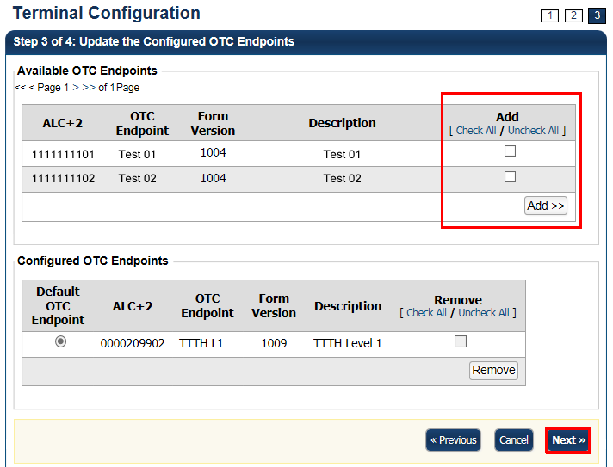
Application Tips

- The OTC Endpoints are permission-based and are only visible to users with the appropriate permissions. At least one Default OTC Endpoint is required per terminal. While a default is chosen, it does not prevent you from scanning against another configured OTC Endpoint.
- Selecting a Default OTC Endpoint determines which OTC Endpoint to use when performing Check Scan actions.
- Multiple OTC Endpoints can be selected, but only one can be set as a Default OTC Endpoint.

- Verify the Terminal Configuration is correct and select Submit. Select Edit to modify the information entered. A Confirmation page appears stating that the Terminal Configuration record has been updated.

Additional Buttons
- Select Cancel to return to the OTCnet Home Page. No data is saved.
- Select Previous to return to the previous page.
- Select Return Home to return to the OTCnet Home Page.

Viewing Terminal Configuration
The CCA, CCS, Check Capture Lead Operator (CCLO) and Check Capture Operator (CCO) are authorized to view check terminal configuration details for each terminal configured.
Terminal configuration details include the following:
- OTC Endpoint Configuration: OTC Endpoints and default OTC Endpoint
- System Configuration: Receipt printing
- Application Configuration: Terminal ID, host name, processing mode, cashflow method, batch control and batch control prompts
- Devices Configuration: Scanner type, communication channel, and franking
You can view the terminal configuration from the View Terminal Configuration page.

View Terminal Configuration
To view the terminal configuration, complete the following steps:
- From the Administration tab, select Manage Check Processing>Terminal Configuration> View.
- The View page appears as shown in Figure 2.
Figure 2. View Terminal Configuration Page
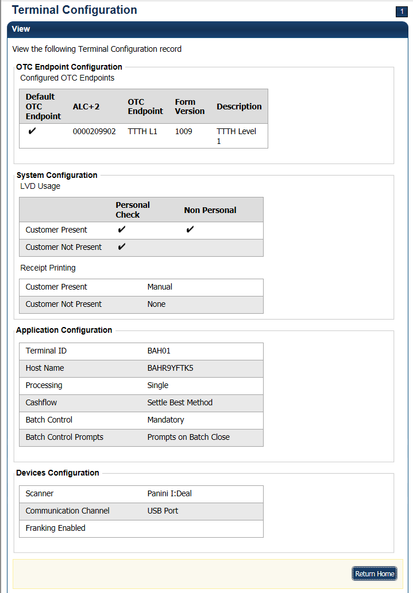
Additional Button
Select Return Home to go to the OTCnet Home page.

Topic 3 Searching an Audit Log
The audit log records are interactions between the user and OTCnet. They allow users to search and view audit log entries for the completed audit trail within OTCnet. The audit log is available for download to a Comma Separated Value (CSV) report and opened in a spreadsheet program or available to print in a formatted audit log report.
If the audit log records contain Personally Identifiable Information (PII), the data is masked in the Transaction Description. To view more details about a specific batch, including PII, access Batch Management.
The CCA, CCO, CCLO, and CCS are authorized to search audit logs related to check processing activities. The CA and Card Operator (CO) are authorized to search audit logs related to card processing activities. Depending on your role, you can search for and view only specific audit logs. See Table 2 for more details.
Table 2. Audit Log User Permissions
User Role | Audit Log Access
Check Capture Administrator (CCA) | Partial administration-related activities and all check capture-related activities
Check Capture Operator (CCO) | Own check capture-related activities
Check Capture Lead Operator (CCLO) | Own check capture-related activities
Check Capture Supervisor (CCS) | Partial check capture-related activities pertaining to own actions or actions taken by their CCO or CCLO
FS Viewer or Security Viewer | Administration-related, check capture-related, check processing-related, and deposit processing-related activities
Card Administrator  (CA) | Partial administration-related activities and all card-related activities
Card Operator  (CO) | Partial access to user’s own card-related activities
You can search audit logs by module, user, OTC Endpoint, and other search criteria (created on date, batch ID, event type, etc.). If you run a search without specifying any criteria, by default the search results include all activities in the system that you have access to view. If you run additional searches, the Search Results table repopulates with the results of the new search.

Searching an Audit Log Online
To search an audit log, enter your search criteria—including module options (Administration Check Capture and Check Processing), User, OTC Endpoint, From and To dates, Keyword (All or make your selection from the list, i.e., Application Exception, Batch Management, etc.) and Category Name (All or make your selection from the list, i.e., Accept Duplicate, Access, etc.), Terminal ID, Batch ID and Event Type (Error, Information and Warning), and Operation Mode (All, Online, or Offline).
Select your Audit Log ID hyperlink to view additional details for an individual audit log entry. Download and print your formatted audit log record, including the Audit Log Record Summary; Audit Log ID, Created On, Context, User Email Address, OTC Endpoint, Terminal ID, Batch ID, Transaction Description, Module and Event Type, Audit Log Attribute Info, User Name and Audit Log Field Info. You can also view your audit log details.

Search an Audit Log Online
To search an audit log, complete the following steps:
- From the Administration tab, select Audit. The Search Audit Logs page appears.
- Enter your search criteria.
Under Search Criteria, optional
    - Select a Module type
    - Enter a User
    - Select an OTC Endpoint
    - Enter the From and To date and time ranges, required
    - Select a Keyword, required
    - Select a Category Name, required
    - Enter the Terminal ID
    - Enter the Batch ID
    - Select an Event Type
    - Select an Operation Mode
Application Tips

- Module drop-down options vary by user role. Module options include Administration, Check Capture, Check Processing, Card Processing, and Deposit Processing.
- The From and To Created On Date must be entered in MM/DD/YYYY format and cannot exceed 30 days.
- The Keyword and Category Name drop-down options vary by user role.
- Operation Mode options include All, Online, or Offline.

Application Tip

Event Types are categories of events that are recorded by the audit log.
Table 3. Event Types
Event Type | Description
All | Includes all event types in the audit log
Error | Error entries are created when the system is unable to complete an action.
Informational | Information entries are general records of the activity that has happened while using OTCnet.
Warning | Warning entries are created to inform the user when events of note have taken place. This includes cancelling an action, deleting information from the system and inactive users.

- Select Search. The Search Results table appears as shown in Figure 3.
Figure 3. Audit Log Output
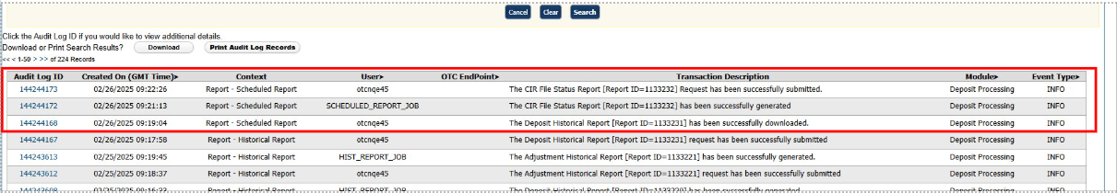
Application Tips

- Run a search (select a module type, FROM and TO dates, and a keyword).
  - The search results include all activities in the system that you have access to view.
  - Run additional searches. The Search Results table repopulates with the results of the new search.
- Select Download to download the search results.
- Select Print Audit Log Records to print a formatted audit log record.
- If the audit log records contain Personally Identifiable Information (PII), the data is masked.
- An entry in the audit log will appear each time a user submits a request to generate a CIR file status report asynchronously, when the scheduled report is successfully generated, and when the user successfully downloads the generated report.

- Select the Audit Log ID hyperlink to view additional details for an individual audit log entry. The View Audit Log Details page appears as shown in Figure 4.

Figure 4: Sample View Audit Log Details Page
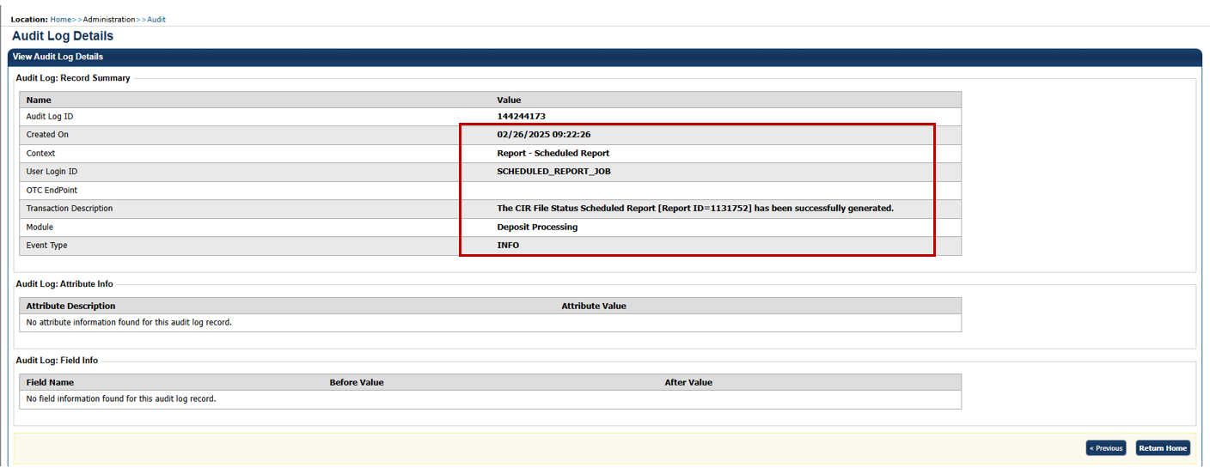
Additional Buttons
- Select Previous to return to the previous page.
- Select Return Home to the OTCnet Home Page.

Topic 4 Downloading and Installing Firmware

Downloading Firmware
If you are assigned the role of CCA, you are authorized to manually download check capture application firmware. The firmware “release” allows for the initial download or upgrades to the scanner software that enables a scanner to be used on a terminal. The firmware version you install also contains a series of other back-end installation files that must be used on a terminal to enable it to be used for Check Capture in OTCnet.
Prior to each firmware upgrade, the currently installed firmware must be uninstalled.
Additionally, firmware upgrades are operating system- (Windows 11 or Windows 10) and scanner- (e.g., RDM EC7000i, EC9100i, EC9600i, EC9700i, Panini I;Deal, Panini MyVision, or Panini Vision X) specific. Note: Firmware versions 4.3.0 and 4.4.0 are only compatible with OLB versions 2.3.0 and above. Firmware version 4.4.0 or higher is required for the RDM EC9600i and EC9700i scanner models.
Therefore, downloading and executing the correct firmware upgrades ensures that a terminal and scanner are functioning properly. To determine firmware upgrades by firmware version, scanner, and operating system, refer to the OTCnet System Requirements and Reference Guide at: otcnet-sys-req.pdf.
If an agency (OTC Endpoint) has multiple terminals and requires more than one firmware due to varying workstation requirements, download and execute the firmware for each terminal.
You must download firmware using Download Release, selecting Firmware and saving the file to your chosen location.

Download Firmware
To download firmware, complete the following steps:
- From the Administration tab, select Manage Centralized Deployment >Download Release.
- From the Application drop-down menu, select Firmware.
- Select Next. The Select Firmware for Download page appears.
Application Tips

- Prior to each firmware upgrade, the currently installed firmware version must be uninstalled.
- Firmware upgrades are operating system- (e.g., Windows 11 or Windows 10) and scanner- (e.g., EC7000i, EC9100i, EC9600i, EC9700i, Panini MyVision X) specific.
- Each firmware version has a corresponding terminal configuration that it supports (by scanner and by operating system). Determine the appropriate firmware upgrade by firmware version, scanner, and operating system before downloading.

- Select the Firmware hyperlink to download the firmware. The Review Firmware Download page appears.
- Select Download as shown in Figure 5. The Save Program dialog box appears.
Figure 5. Review Firmware Download
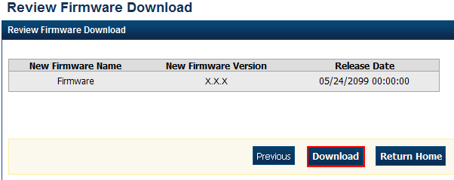
- Select Save or Cancel.
Application Tips

- Select Save to choose the location where you want to save the file.
- Select Cancel to return to the OTCnet Check Capture Application Download page without saving the file.

Additional Buttons
- Select Previous to return to the previous page.
- Select Return Home to return to the OTCnet Home page.

Installing Firmware
After the CCA downloads the firmware, the next step is to install the firmware (this must be done for each terminal). This can be completed by the CCA, CCS, CCLO, and CCO. However, before you install the firmware, consider the following information:
- You must have Windows Administrator privileges to install the firmware.
- Ensure the scanner is not connected to the terminal as it may cause scanner connectivity issues.
- If a previous version of firmware is installed, uninstall it before installing the new firmware version. See the Install OTCnet Firmware printable job aid for specific directions.
- Firmware version 4.3.0 supports the RDM EC7000i, RDM EC9100i, Panini MyVisionX, Panini Vision X, and Panini I: Deal scanners. Firmware version 4.4.0 supports the RDM EC9600i and RDM EC9700i scanners.
For Windows 11 and Windows 10:
- Access your Control Panel under Start > Window Systems > Control Panel
- Select Programs > Uninstall Programs
- In the Currently installed programs box, select OTCnetFirmware
- Select Remove
- Select Yes and wait while the Firmware uninstalls
Verify the OTCnetFirmware and Panini X.X.X Universal Installer automatically uninstalled.
For more information about the firmware version that matches the terminal settings, refer to the OTCnet System Requirements and Reference Guide at:
otcnet-sys-req.pdf.
To install firmware, install the firmware file (MSI file).

Install Firmware
To install OTCnet firmware, complete the following steps:
- Locate the folder where the firmware file (MSI file) resides and double-select the file to start the installation. The Welcome to the OTCnet Firmware Installation Wizard dialog box appears.
- Select Next. The User Information dialog box appears.
- Select Next. The Destination Folder dialog box appears as shown in Figure 6.
Figure 6. Destination Folder Dialog Box
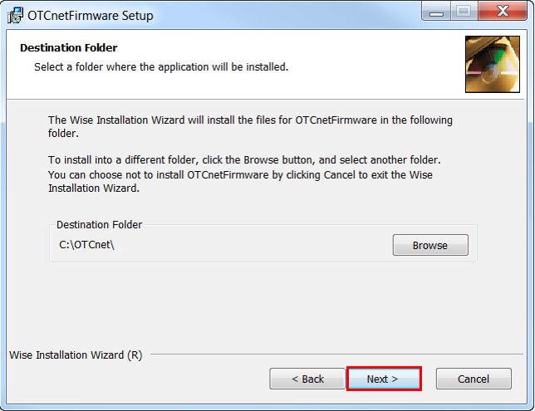
Application Tip

To install the firmware to another folder destination, select Browse to select a different folder. Select Cancel to exit the setup.

- Select Next. The Ready to Install the Application dialog box appears.
- Select Next. Wait a moment while the files install.
Application Tip

During the installation process for OTCnet Firmware, you can continue to use their workstations. However, OTCnet and all related activities are unavailable until the installation of the Firmware is complete.
The installation time can vary from workstation to workstation. Users can expect a duration of up to 30 minutes to complete full installation. Do not close the installation window until the installation is complete.

- The OTCnet Firmware has been successfully installed message appears. Select Finish.

Topic 5 Creating Check Capture Override and Online Authentication
In OTCnet, the following user roles can create check capture override and online authentication password:
- Check Capture Administrator (CCA)
- Check Capture Lead Operator (CCLO)
- Check Capture Supervisor (CCS)
The Primary/Local Security Administrator (P/LSA) must create the OTCnet online user identity.
Additionally, this user identity must also be successfully provisioned and approved, and a password must be provided.

Creating Check Capture Override and Online Authentication Password
From the Administration tab, select Manage Users>Create Check Capture Override and Online Authentication Password. Enter and confirm your password, then select the Submit button. A Confirmation page displays stating that you have successfully created your Check Capture Override and Online Authentication password. Select OK to return to the OTCnet homepage.

Create Check Capture Override and Online Authentication Password
To create check capture override and online authentication password, complete the following steps:
- From the Administration tab, select Manage Users>Create Check Capture Override and Online Authentication Password. The Create Password screen displays as shown in Figure 7.
- Enter and confirm your password.
Application Tip

The Check Capture Administrator, Check Capture Supervisor, and Check Capture Lead Operator can create an online authentication password. The password must satisfy the following requirements:
- Must be at least 12 characters long.
- Must not be longer than 64 characters.
- Must not have more than two repeating characters.
- Must not be a word in a language, slang, dialect, or jargon.
- Must not be related to personal identity, history, environment, or other personal associations.
- Must not be shared or displayed in plain view.

- Select the Submit button to process the data.
Figure 7: Create Check Capture Override and Online Authentication Password
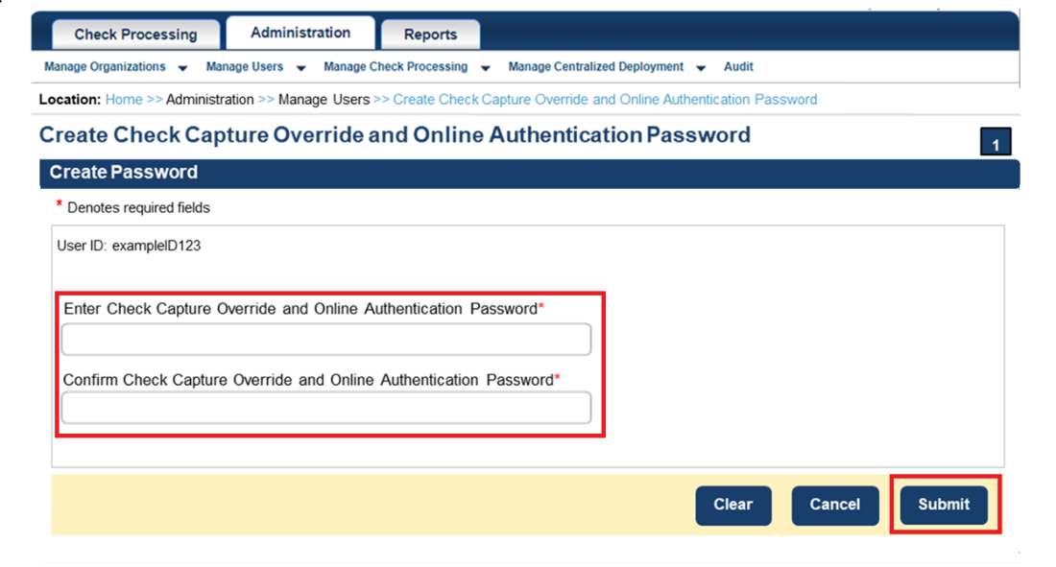
Additional Buttons
If your password does not comply with the Fiscal Service password policy requirements, you will get an error message to try again. The password requirements will be displayed on the screen.

- A Confirmation page displays, as show in Figure 8, stating that you have successfully created your Check Capture Override and Online Authentication Password.
- Select OK to return to the OTCnet Homepage.
Figure 8: Confirmation Page (Check Capture Override/Online Authentication)
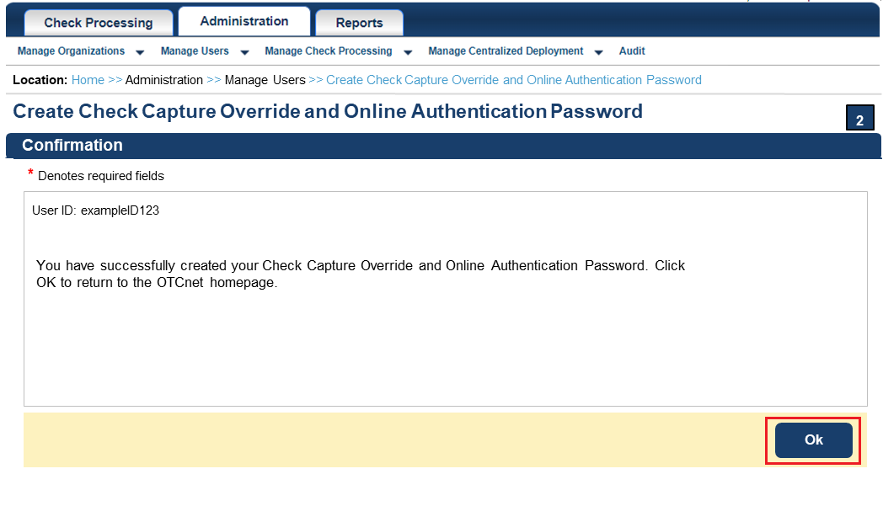

Summary
This chapter provided information on:
- The purpose of configuring check processing settings
- How to set up or modify a terminal configuration
- How to view a terminal configuration
- How to search an audit log
- How to download and install firmware
- How to create check capture override and online authentication password

