

Chapter 8. Configuring Card Terminal Processing Settings
OTCnet Participant User Guide

Table of Contents
Overview, Topics, and Audience 1
Overview 1
Topics 1
Audience 1
Topic 1 Purpose of Configuring Card Processing Settings 2
Topic 2 Setting Up or Modifying a Card Terminal Configuration 3
Registering a Card Terminal 3
Register a Card Terminal 4
Unregistering a Card Terminal 9
Unregister a Card Terminal 10
Viewing a Card Terminal Configuration 13
View Card Terminal Configuration 14
Topic 3 Searching an Audit Log 15
Search an Audit Log Online 16
Topic 4 Selecting an 80mm Card Receipt Printer 19
Select an 80mm Card Receipt Printer 20
Summary 22

List of Figures
Figure 1: Step 1 of 3 Select OTC Endpoint and Card Terminal Type Page 4
Figure 2: Terminal Registration, Enter Card Terminal IP Address 5
Figure 3: Step 2 of 3: Card Terminal Registration and Entering the Pairing Pin in the Card Terminal 6
Figure 4. Step 2 of 3: Terminal Registration, Comparing Merchant IDs message 6
Figure 5. Step 3 of 3: Review the Card Terminal Configuration 7
Figure 6: Card Terminal Registration, Enter IP Address 10
Figure 7: Step 2 of 3: Terminal Registration 11
Figure 8: Step 3 of 3: Review the Terminal Configuration 12
Figure 9: Card Terminal Configuration View 14
Figure 10. Audit Log Output 17
Figure 11: Sample View Audit Log Details Page 18
Figure 12. Start OTCnet Local Bridge Startup 20
Figure 13: Confirm the 80mm Printer 20

List of Tables
Table 1: Audit Log User Permissions 15
Table 2. Event Types 17

Glossary
Select this link to access the full OTCnet Glossary.

Overview, Topics, and Audience

Overview
Welcome to Configuring Card Processing Settings. In this chapter, you will learn:
- The purpose of configuring card processing settings
- How to set up or modify a card terminal configuration
- How to view a card terminal configuration
- How to search an audit log online
- How to select an 80mm Card Receipt Printer

Topics
This chapter is organized by the following topics:
- Purpose of Configuring Card Processing Settings
- Setting Up or Modifying a Card Terminal Configuration
- Searching an Audit Log
- Selecting the 80mm Card Receipt Printer

Audience
The intended audience for the Configuring Card Terminal Processing Settings Participant User Guide includes:
View / Modify Configuration Functions
- Card Administrator
- Check Capture Administrator
- Check Capture Supervisor
View Configuration Only
- Card Operator
- Check Capture Lead Operator
- Check Capture Operator

Topic 1 Purpose of Configuring Card Processing Settings
As a Card Administrator (CA), you are authorized to configure the card processing settings for your Agency’s card terminal. Additionally, as a CA, you are authorized to manually download or upgrade application software (e.g., the OTCnet Local Bridge Application [OLB]) which is used to communicate between OTCnet and a card terminal. You must register your card terminal.
For check processing, a Check Capture Administrator (CCA) can also download or upgrade the OLB.
To meet your agency’s card transaction needs, each card terminal must have configuration settings individually applied. The card terminal must be paired with OTCnet before the card terminal can be used for processing payments in OTCnet Online. The following is a list of data elements needed to pair the card terminal to OTCnet:
- Card Terminal Internet Protocol (IP) Address—an Internet Protocol address is a unique number or address that computing devices, (e.g., computers, laptops, tablets, etc.) connected to a computer network, use to identify themselves and communicate with other devices in an IP-based network (e.g., the Internet).
- OTC Endpoint Credit-Debit Card (CDC)—The endpoint (location) setup in OTCnet for CDC processing
- OTCnet-Generated Eight-Character Pairing Pin—A pairing pin is a unique eight-character OTCnet-generated number used to pair OTCnet and the card terminal. During card terminal setup, the card terminal prompts the user for the pairing pin.

Topic 2 Setting Up or Modifying a Card Terminal Configuration
As a Card Administrator (CA) you are authorized to register/configure a card terminal. To register a card terminal, you must select your OTC Endpoint and enter your Card Terminal Internet Protocol (IP) Address. You can also unregister a card terminal. For this you must begin the steps to re-register a card terminal. And you are authorized to view a card terminal. To configure a card terminal, start the OLB. If the OLB is not started, you cannot pair the card terminal with OTCnet.
Once the OLB is started, ensure the following:
- The card terminal must be ethernet connected to the Internet/network and ready for pairing with the OTCnet server
- The CA must use either a Static (Fixed Internet Protocol Address [IP]) or Dynamic Host Configuration Protocol (DHCP) when configuring the card terminal. A static IP address is recommended as it will not change.

Registering a Card Terminal
To register a card terminal, modify your Card Terminal Configuration, by selecting your OTC Endpoint and entering your Card Terminal IP Address. The system searches for and displays a pairing pin, which you will enter into the card terminal. The system compares Merchant IDs and communicates when the connection is successful.

Register a Card Terminal
To register/configure a card terminal, complete the following steps:
- From the Administration tab, select Manage Card Processing>Card Terminal Configuration>Modify. The Step 1 of 3: Select OTC Endpoint and Card Terminal Type page appears.
Application Tip

When configuring a card terminal, if you have not started the OLB application, you will receive the following message: “Card terminal detection failed. Ensure that the OLB application is running.”

- Select the OTC Endpoint. Select Add. The Endpoint appears under Configured OTC Endpoint.
- Select the Card Terminal Type from the dropdown at the bottom of the page. Then select Next as shown in Figure 1.
Figure 1: Step 1 of 3 Select OTC Endpoint and Card Terminal Type Page
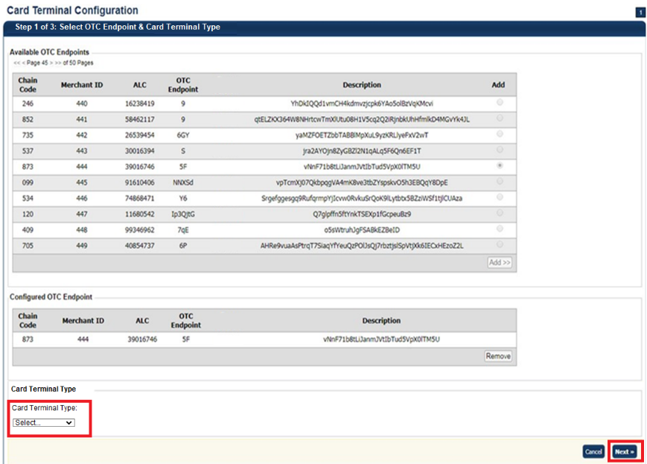

Application Tips

- You need to upgrade the OLB to a new version to avoid receiving an error when registering your device to OTCnet and using your M440 card terminal.
- If you are an existing MX925 user, you will also need to upgrade to the latest OLB to keep using the existing card terminals.

- The Step 2 of 3: Terminal Registration page appears, as shown in Figure 2. Enter the Card Terminal Internet Protocol (IP) Address and select Register.
Figure 2: Terminal Registration, Enter Card Terminal IP Address
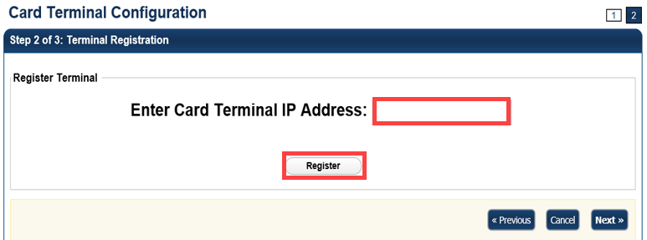
Application Tip

Internet Protocol (IP) Address is a unique number or address that computing devices (e.g., laptops, tablets, mobile phones, etc.) connected to a computer network, use to identify themselves and communicate with other devices in an IP-based network (e.g., the Internet). Please contact your deployment specialist to help you retrieve your IP address at: fiscalservice.otcdeployment@citi.com.

- The system searches for the pairing pin. A pairing pin displays.
- Enter the Pairing Pin on the card terminal, as shown in Figure 3. Press the green button. The green button indicates “OK” on the card terminal. The system compares Merchant IDs.
Figure 3: Step 2 of 3: Card Terminal Registration and Entering the Pairing Pin in the Card Terminal
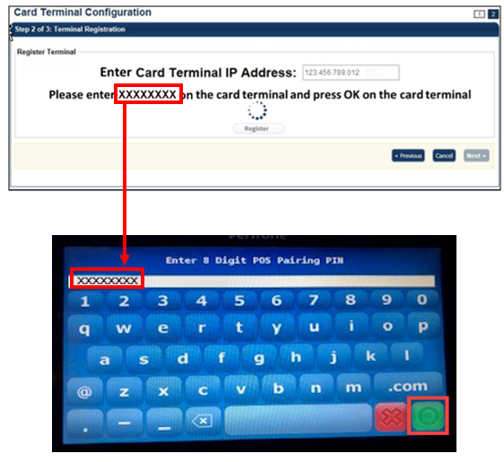
Application Tips

- A pairing pin is a unique eight-character OTCnet-generated number used to pair OTCnet and the card terminal.
- It may take 15-20 seconds to receive a pairing pin.
- The pairing pin number is entered on the card terminal.

- The system compares Merchant IDs as shown in Figure 4.
Figure 4. Step 2 of 3: Terminal Registration, Comparing Merchant IDs message
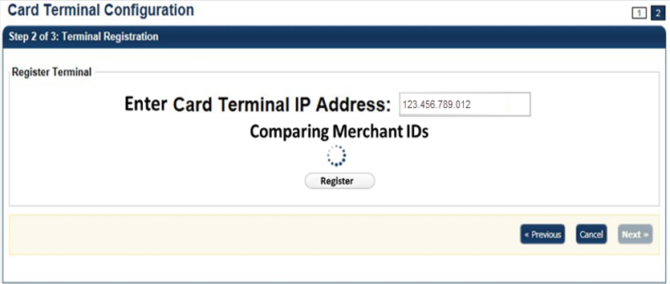

Application Tips

- A Merchant ID is a unique designator assigned by Worldpay to reflect the processing location.
- Each agency has several Merchant IDs under a single Chain Code, to distinguish which agency location processed card transactions.
- The Merchant ID is entered at the lower-level endpoint in OTCnet.

- The “Registration Successful!” message appears. Select Next.
- The “Connection successful!” message appears. Select Next.
- The Step 3 of 3: Review the Terminal Configuration page appears. Select Submit as shown in Figure 5.
Figure 5. Step 3 of 3: Review the Card Terminal Configuration
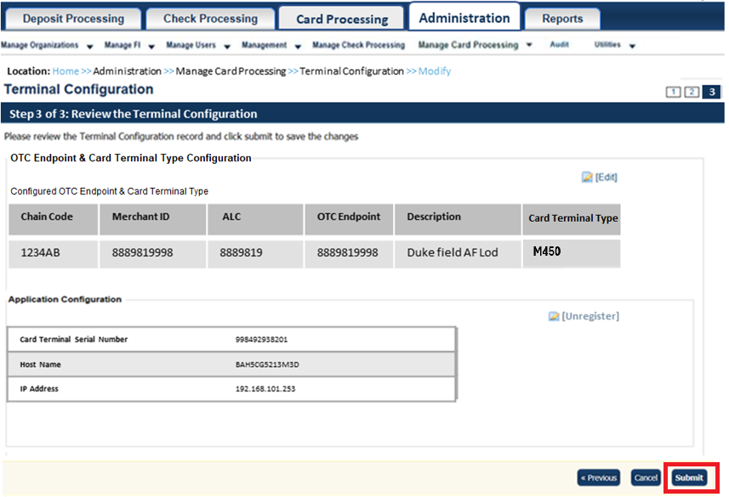
Application Tips

- Select the Edit hyperlink to modify the information entered.
- Select the Unregister hyperlink to unregister the terminal.

- The Confirmation page appears. View the card terminal configurations, they are automatically populated.
Additional Button
Select Return Home to return to the OTCnet Home Page.

Application Tips
- When you try to refund a transaction on the Card Transaction History Details page with a different card terminal than the configured card terminal, the following error displays at the top of the screen: “Registration was not found/valid, or the terminal is offline/busy.”
- When you try to perform a card transaction on the Process Payment page with a different card terminal than the configured card terminal, the following error displays at the top of the screen: “Registration was not found/valid, or the terminal is offline/busy.”
- If you have a terminal model saved in Card Terminal Configuration but have a different physical card terminal connected when going through Step 2 of 3 Terminal Registration, the registration will fail with the following error displayed at the top of the screen: “Card terminal Merchant ID does not match the Merchant ID of the configured endpoint or terminal type does not match the selected type. Please select Previous to restart Terminal Configuration.”

Unregistering a Card Terminal
As a CA you are authorized to unregister a card terminal after it has been paired with OTCnet, as needed. At times, you may need to unregister a terminal (i.e., you may want to add a different card terminal to an OTCnet terminal, or you may mistakenly register a terminal and wish to unregister it). First, you must begin the steps to re-register a card terminal before you can unregister it.
To unregister a card terminal, after it’s been paired with OTCnet, there are two options:
Option 1: Unregister from the Registration Successful! page.
Option 2: Unregister from the Review (Step 3 of 3: Review the Terminal Configuration) page.
For Option 1, you will modify your Card Terminal Configuration by selecting an OTC Endpoint and entering the card terminal IP Address for the card terminal you wish to register. You will enter the pairing pin in the card terminal. Once the “Registration Successful!” message appears, you can unregister the card terminal.
For Option 2, you will modify your Card Terminal Configuration by selecting an OTC Endpoint and entering the card terminal IP Address for the card terminal you wish to register. You will enter the pairing pin in the card terminal. Once the “Registration Successful!” message appears, and the Step 3 of 3: Review the Terminal Configuration page appears, you can unregister the card terminal.

Unregister a Card Terminal
To unregister a card terminal after it’s been paired with OTCnet, there are two options:
- Option 1: Unregister from the Registration Successful! page.
- Option 2: Unregister from the Review (Step 3 of 3: Review the Terminal
Configuration) page.
For Option 1, complete the following steps:
- From the Administration tab, select Manage Card Processing>Card Terminal Configuration>Modify. The Step 1 of 3: Select OTC Endpoint and Card Terminal Type page appears.
- Select an OTC Endpoint. Select Add.
- Select the Card Terminal Type and then select Next. The Step 2 of 3: Terminal Registration page appears.
- Enter the card terminal IP Address in the Enter Card Terminal IP Address text box for the card terminal you wish to register, as shown in Figure 6. Select Register.
Figure 6: Card Terminal Registration, Enter IP Address
- OTCnet searches for the pairing pin. Once the pairing pin appears in OTCnet, enter it into the card terminal and press the green button. The green button indicates “OK” on the card terminal.
Application Tip

It may take 15-20 seconds to receive a pairing pin.

- The “Registration Successful!” message appears. Select Unregister, as shown in Figure 7. Then select Next.

Figure 7: Step 2 of 3: Terminal Registration
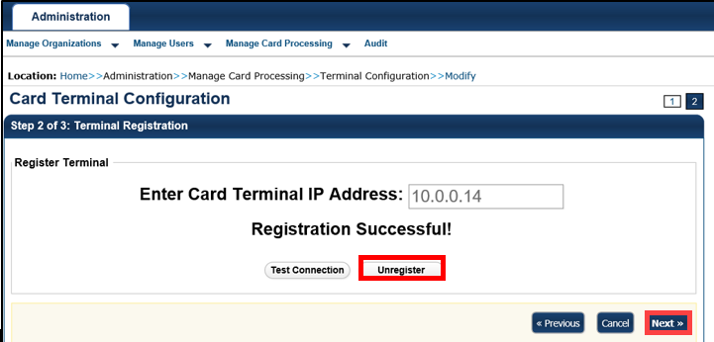
- The “Terminal unregistered” message appears.
Additional Buttons
- Select Test Connection to test the pairing connection between the card terminal and OTCnet.
- Select Unregister to unregister the card terminal.
- Select Cancel to terminal registration. A "Registration cancelled" message appears and the terminal registration stops.
- Select Previous to return to the previous page.
- Select Return Home to return to the OTCnet Home Page.

For Option 2, complete the following steps:
- From the Administration tab, select Manage Card Processing>Terminal Configuration>Modify. The Step 1 of 3: Select OTC Endpoint and Card Terminal Type page appears.
- Select an OTC Endpoint. Select Add.
- Select Card Terminal Type.
- Select Next. The Step 2 of 3: Terminal Registration page appears.
- Enter the Card Terminal IP Address for the card terminal you wish to register. Select Register. OTCnet searches for the pairing pin.
- Enter the pairing pin number that appears in OTCnet into the card terminal. Press the green button. The green button indicates “OK” on the card terminal.
Application Tip

It may take 15-20 seconds to receive a pairing pin.

- The “Registration Successful!” message appears. Select Next.
- The Step 3 of 3: Review the Terminal Configuration page appears, as shown in Figure 8. Select Unregister.
Figure 8: Step 3 of 3: Review the Terminal Configuration
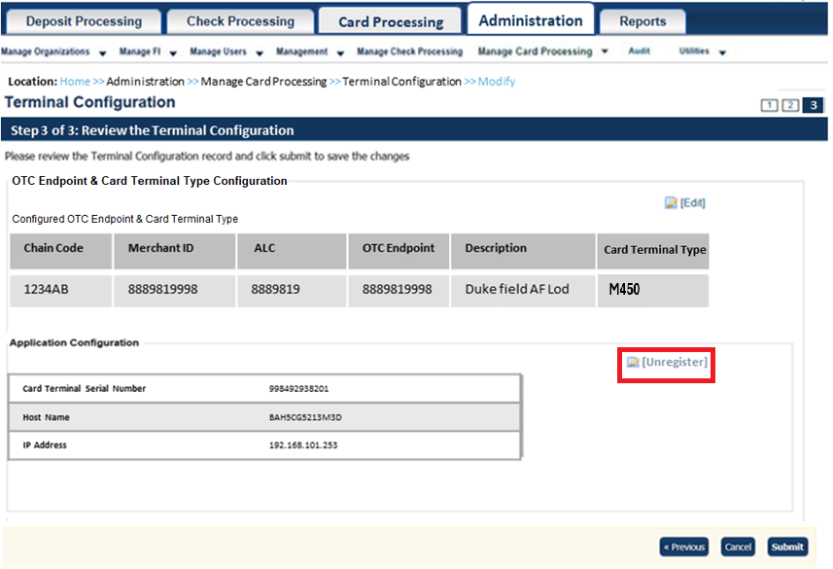
- The “Registration Successful!” page appears. Select Unregister.
- Select Next. The “Terminal unregistered” message appears.
Additional Buttons
- Select Edit to navigate to the Step 1 of 3: Select OTC Endpoint page and Card Terminal Type to remove an OTC endpoint or add another available OTC endpoint.
- Select Unregister to unregister the card terminal.
- Select Cancel to stop terminal registration. A "Registration cancelled" message
appears and the terminal registration ends.
- Select Previous to return to the previous page.
- Select Return Home to return to the OTCnet Home Page.

Viewing a Card Terminal Configuration
As a CA or CO, you are authorized to view a card terminal configuration.
From the View Card Terminal Configuration page, the following actions occur:
- OTCnet verifies your OLB connection and the card terminal configuration.
  - This typically takes about 10-15 seconds.
- The card terminal that has been configured appears.

View Card Terminal Configuration
To view a card terminal configuration, complete the following steps:
- From the Administration tab, select Manage Card Processing>Terminal Configuration>View.
- The Card Terminal Configuration View page appears, as shown in Figure 9.
- Select Return Home to return to the home page.
Figure 9: Card Terminal Configuration View
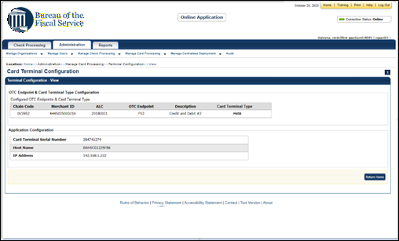

Topic 3 Searching an Audit Log
The audit log records are interactions between the user and OTCnet. They allow users to search and view audit log entries for the completed audit trail within OTCnet. The audit log is available for download to a Comma Separated Value (CSV) report. It opens in a spreadsheet program or can be printed in a formatted audit log report.
If the audit log records contain Personally Identifiable Information (PII), the data is masked in the Transaction Description.
The CA and Card Operator (CO) are authorized to search audit logs related to card processing activities. The CCA, Check Card Operator (CCO), Check Card Lead Operator (CCLO) and Check Card Supervisor (CCS) can search audit logs related to check processing activities. Depending on your role, you can search for and view only specific audit logs. See Table 1 for details.
Table 1: Audit Log User Permissions
User Role | Audit Log Access
Check Capture Administrator (CCA) | Partial administration-related activities and all check capture-related activities
Check Capture Operator (CCO) | Own check capture-related activities
Check Capture Lead Operator (CCLO) | Own check capture-related activities
Check Capture Supervisor (CCS) | Partial check capture-related activities pertaining to own actions or actions taken by their CCO or CCLO
FS Viewer or Security Viewer | Administration-related, check capture-related, check processing-related, and deposit processing-related activities
Card Administrator (CA) | Partial administration-related activities and all card-related activities
Card Operator (CO) | Partial access to user’s own card-related activities

You can search audit logs by module, user, OTC Endpoint and other search criteria. When running a search without specifying any criteria, by default, the search results include all activities in the system that you have access to view. When running additional searches, the Search Results table repopulates with the results of the new search.

Search an Audit Log Online
To search an audit log, complete the following steps:
- From the Administration tab, select Audit. The Search Audit Logs page appears.
- Enter your search criteria.
Under Search Criteria, optional
    - Select a Module type
    - Enter a User
    - Select an OTC Endpoint
    - Enter the From and To date and time ranges, required
    - Select a Keyword, required
    - Select a Category Name, required
    - Enter the Terminal ID
    - Enter the Batch ID
    - Select an Event Type
    - Select an Operation Mode
Application Tips

- Module drop-down options vary by user role. Module options include Administration, Check Capture, Check Processing, Card Processing, and Deposit Processing.
- The From and To Created On Date must be entered in MM/DD/YYYY format and cannot exceed 30 days.
- The Keyword and Category Name drop-down options vary by user role.
Operation Mode options include All, Online, or Offline.

Application Tip

Event Types are categories of events that are recorded by the audit log.

Table 2. Event Types
Event Type | Description
All | Includes all event types in the audit log
Error | Error entries are created when the system is unable to complete an action.
Informational | Information entries are general records of the activity that has happened while using OTCnet.
Warning | Warning entries are created to inform the user when events of note have taken place. This includes cancelling an action, deleting information from the system and inactive users.

- Select Search. The Search Results table appears as shown in Figure 10.
Figure 10. Audit Log Output
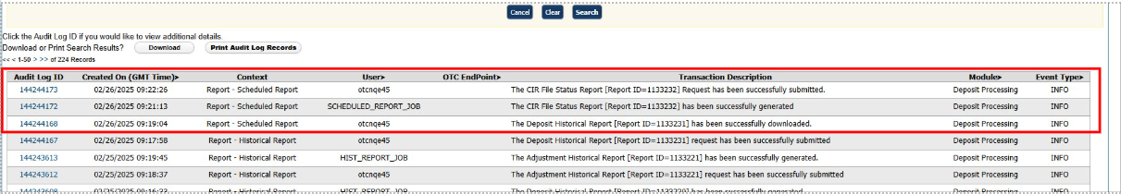
Application Tips

- Run a search (select a module type, FROM and TO dates, and a keyword).
- The search results include all activities in the system that you have access to view.
- Run additional searches. The Search Results table repopulates with the results of the new search.
- Select Download to download the search results.
- Select Print Audit Log Records to print a formatted audit log record.
- If the audit log records contain Personally Identifiable Information (PII), the data is masked.
- An entry in the audit log will appear each time a user submits a request to generate a CIR file status report asynchronously, when the scheduled report is successfully generated, and when the user successfully downloads the generated report.

- Select the Audit Log ID hyperlink to view additional details for an individual audit log entry. The View Audit Log Details page appears as shown in Figure 11.

Figure 11: Sample View Audit Log Details Page
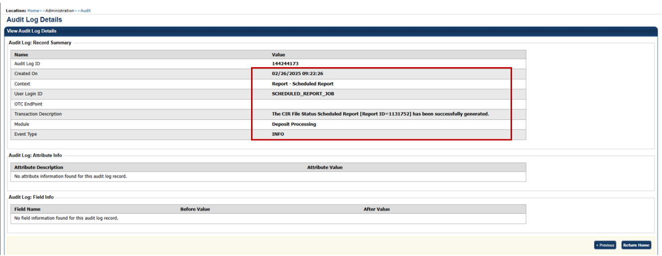
Additional Buttons
- Select Previous to return to the previous page.
- Select Return Home to the OTCnet Home Page.

Topic 4 Selecting an 80mm Card Receipt Printer
As a Card Operator (CO), you have the option to choose Select 80mm Card Receipt Printer. OTCnet offers the option to select an 80mm Card Receipt Printer for card processing receipts. Receipts are printed on 80mm (3.125 inch) paper.
Before selecting your 80mm printer, ensure that you verify the following:
- Your printer must be installed on your workstation or network. If you do not install the 80mm printer, card receipts are sent to your default Windows printer.
- The OLB is not started. If it is started, you will receive a message that the OLB is running and you cannot access the OLB menu until you stop the OLB.
- You must have the latest OLB version to select the 80mm printer.
If your agency uses check processing and/or deposit processing, check or deposit items print to the Windows default printer, not the 80mm printer.
For additional information about the 80mm printer driver installation process, review the system requirements document (otcnet-sys-req.pdf).

Select an 80mm Card Receipt Printer
To select the 80mm Card Receipt Printer, complete the following steps:
- Double-select the Start OTCnet Local Bridge icon located on the terminal’s desktop.
Or
Select Start>Programs>Start OTCnet Local Bridge.
- The OTCnet Local Bridge Startup window appears. Select the File menu, and select Select 80mm Card Receipt Printer, as shown in Figure 12.
Figure 12. Start OTCnet Local Bridge Startup
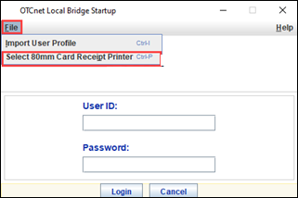
- The Select 80mm Card Receipt Printer window appears. Select a printer and select Confirm, as shown in Figure 13.
Figure 13: Confirm the 80mm Printer
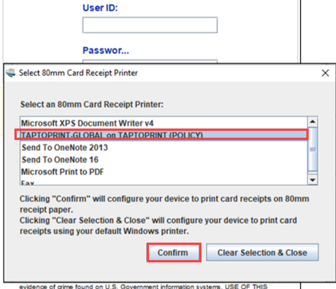

Application Tips

- To cancel your selection (Select 80mm Card Receipt Printer), select Clear Selection & Close to cancel and close the window.
- A “The Windows default printer, ‘Microsoft Print to PDF,’ is used as your card receipt printer” message appears.

- The “You have successfully chosen XXX Printer as your 80mm card receipt printer” message appears. Select OK to return to the OLB Login page.
Application Tips

- In the event that your 80mm printer is no longer available (if your printer drivers are removed from the Window’s list of managed printers), the “Your previously selected 80mm card receipt printer, ‘XXX Printer’, is no longer available. Card Receipt printing reverts back to using the Windows default printer. Please select an 80mm printer again to enable 80mm card receipt printing” message appears on the OLB login page.
- Select Ok.

Summary
In this chapter, you learned:
The purpose of configuring card processing settings
How to set up or modify a card terminal configuration
How to unregister a card terminal
How to view a card terminal configuration
How to search an audit log online
How to select the 80mm Card Receipt Printer

