

Chapter 7. OTCnet Local Bridge (OLB) Setup Guide
OTCnet Participant User Guide

Table of Contents
Overview, Topics, and Audience 1
Overview 1
Topics 1
Audience 1
Topic 1 Downloading and Installing the OTCnet Local Bridge (OLB) Application 3
Downloading the OTCnet Local Bridge (OLB) Application 3
Download the OTCnet Local Bridge (OLB) Application 4
Installing the OTCnet Local Bridge (OLB) Application 5
Install the OTCnet Local Bridge (OLB) Application 6
Upgrading the OTCnet Local Bridge (OLB) Application 9
Upgrade the OTCnet Local Bridge (OLB) Application 10
Topic 2 Creating the OTCnet Local Bridge (OLB) Profile 13
Create the OTCnet Local Bridge (OLB) Profile 14
Topic 3 Importing OTCnet Local Bridge (OLB) Credentials 17
Import OTCnet Local Bridge (OLB) Credentials 18
Summary 20

List of Figures
Figure 1. Download Release, OLB 4
Figure 2. OTCnet Local Bridge 6
Figure 3. Java message 7
Figure 4. Start and Stop OTCnet Local Bridge icons 8
Figure 5. Welcome to the OTCnet OLB Setup Dialog Box 10
Figure 6. Java message 12
Figure 7. Start and Stop OTCnet Local Bridge icons 12
Figure 8. Create Local Bridge and User Profile Radio Buttons and Password 14
Figure 9. Create Local Bridge and User Profile Save 15
Figure 10. Start OTCnet Local Bridge Startup 18

Glossary
Select this link to access the full OTCnet Glossary.

Overview, Topics, and Audience

Overview
Welcome to the OTCnet Local Bridge (OLB) Setup Guide. In this chapter, you will learn:
- How to download and install the OTCnet Local Bridge (OLB) application
- How to create your OLB profile
- How to import your OLB credentials

Topics
The topics in this chapter include the following:
- Downloading and Installing the OLB Application
- Creating the OLB Profile
- Importing the OLB Credentials

Audience
The intended audience for the OTCnet Local Bridge (OLB) Setup Participant User Guide includes:
Downloading and Installing the OLB Application
- Check Capture Administrator
- Card Administrator
Creating the OLB Profile
- Check Capture Administrator
- Card Administrator
- Check Capture Supervisor
- Check Capture Lead Operator
- Check Capture Operator
- Card Operator
Importing the OLB Credentials
- Check Capture Administrator
- Card Administrator
- Check Capture Supervisor
- Check Capture Lead Operator
- Check Capture Operator
- Card Operator

Topic 1 Downloading and Installing the OTCnet Local Bridge (OLB) Application

Downloading the OTCnet Local Bridge (OLB) Application
The Check Capture Administrator (CCA) and Card Administrator (CA) are authorized to download the OTCnet Local Bridge (OLB). The OLB is a stand-alone application that must be installed on all user workstations performing card processing, check capture, check processing and terminal configuration operations.
Windows Administrator privileges are required to install the OLB application on a workstation. Users may contact the CCA or the Agency’s IT team to complete this step. The OLB must be installed before proceeding to the steps below. The download release process was streamlined for ease and efficiency—as a result, we recommend you download the newest version of
the OLB.
OTCnet Firmware:
- For check processing workstations, the OLB application is installed before or after the OTCnet Firmware is installed.
- Both the OLB application and Firmware must be installed on the workstation.
  - The OLB application is required if you are using the Deployable Disbursing System (DDS) Interface (DoD only).
- For card processing workstations, Firmware is not required.
- Depending on your user role, you may not have access to both Manage Check Processing and Manage Card Processing functions.
OTCnet supports Microsoft Edge and Google Chrome browsers.
When using Microsoft Edge and Google Chrome:
- Ensure the latest version of the OLB is installed.
After the CCA or CA downloads the OLB application, users (CCA, Check Capture Supervisor [CCS], Check Capture Lead Operator [CCLO], Check Capture Operator [CCO], CA and Card Operator [CO]) complete the following steps in setting up the OLB application:
- Install the OLB application
- Create the OLB profile
- Start the OLB application

Download the OTCnet Local Bridge (OLB) Application
To download the OTCnet Local Bridge (OLB) application, complete the following steps:
- From Administration, select Manage Centralized Deployment>Download Release.
- The Download Release page appears. From the Application drop-down menu, select OTCnet Local Bridge. Select Next as shown in Figure 1.
Figure 1. Download Release, OLB
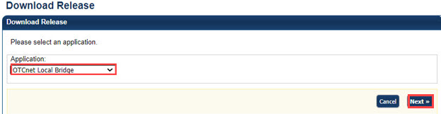
Application Tips

- By default, the Application drop-down menu is set to Firmware. Select OTCnet Local Bridge.
- The OLB application can be installed before or after Firmware is installed.
- However, both the OLB application and Firmware must be installed for workstation configuration.

- The Select OTCnet Local Bridge for Download page appears. Select the OTCnet Local Bridge hyperlink, for the newest version of the OLB, to download the OLB Zip file.
- The Review OTCnet Local Bridge Download page appears. Select Download. The zip file downloads to your workstation.
Application Tip

- Before you install the new OLB version, you must uninstall any older OLB version(s).
- Select Previous to return to the previous page.
- Select Return Home to return to the OTCnet Home page.

Installing the OTCnet Local Bridge (OLB) Application
After the CA or CCA downloads the OLB application, the next step is for the CA, CCA, CCS, CCLO, CCO, CA and CO to install the OLB application. To install the OLB application, you must have Windows Administrator privileges on each workstation.
Multiple versions of the OLB are available for download. Depending on your agency, you may choose to install the newest version, or an older version—the newest version is recommended.

Version information includes the following:
- OLB Installer
For OLB version 2.5.0.0 and newer, the bundled Java Runtime Environment (JRE) was removed from the OLB installer. The OLB installer now verifies whether Java is installed on the workstation, and if the Java version is one that OTCnet supports. If Java is not installed on the workstation, Windows Administrator privileges are required to install Java.
For additional information, and to verify that you meet system and configuration requirements, review the system requirements document:
otcnet-sys-req.pdf
Before you install the OLB application, and prior to each upgrade, the currently installed OLB application version must be uninstalled.
To uninstall a previous version of the OLB For Windows 10:
  - If running, stop the OLB application
  - Access your Control Panel under Start>Windows Settings>Control Panel
  - Double-click Add or Remove Programs
  - Select OTCnet OLB in the Currently installed programs box
  - Select Remove
  - Select Yes and wait while the OLB application uninstalls

Install the OTCnet Local Bridge (OLB) Application
To install the OLB application, complete the following steps:
- Locate the folder on the workstation where the OLB zip file resides, e.g., your Downloads folder. Double-click the zip file. Double-click the EXE file as shown in Figure 2 to start the installation.
Application Tip

The EXE must be launched and executed by a Windows Administrator.

Figure 2. OTCnet Local Bridge
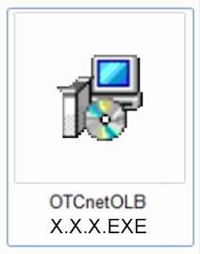

- The Welcome to the OTCnet OLB Setup program dialog box appears. Select Next.
Application Tip

- Select Cancel to cancel and exit the setup.

- The Destination Location dialog box appears. Select Next.
Application Tip

- It is recommended that you install the OLB application into the default destination folder (i.e., C:\Program Files\OTCnet_ olb).
- Select Cancel to cancel and exit the setup.
- Select Back to return to the previous dialog box.

- The Start Installation dialog box appears. Select Next.
- The Server Port Settings dialog box appears. Select Next. Wait a moment while the files install.
Application Tips

- It is recommended that you install the OLB application with the default list of fixed ports.
- If your agency has different server port settings or needs, contact Customer Support.

- Once the OTCnet Local Bridge has been successfully installed message appears, select Finish.
Application Tips

- The OLB Installer verifies that Java is installed on the workstation.
- If Java is not installed, you will receive a “Java X must be installed for the OLB to function. The JAVA_HOME environment variable must also be set pointing to the main Java installation folder” message as shown in Figure 3. A Windows Administrator must install Java.

Figure 3. Java message
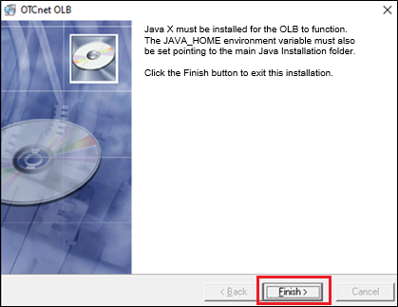
- The OTCnet OLB start and stop icons appear on the workstation desktop as shown in Figure 4.
Figure 4. Start and Stop OTCnet Local Bridge icons
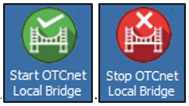

Upgrading the OTCnet Local Bridge (OLB) Application
The CCA and CA are authorized to upgrade the OLB.
As newer versions of the OTCnet OLB application become available, your Agency may choose to upgrade its workstations. Upgrade refers to installing an updated version of OTCnet OLB on a workstation that has a previous version of the OTCnet OLB installed.
Prior to initiating an OTCnet OLB application upgrade, consider the following information:
- Before uninstalling the OLB application, you must first stop the OLB application.
- If the OLB application is started on the workstation, ensure that it is stopped before uninstalling the application, or you will not be able to install the new OLB version.
- You must have Windows Administrator privileges to upgrade each computer.
- When upgrading to a newer OLB version, uninstall the previous OLB version and perform a new installation.
- If you previously created and imported your OLB credentials, you will not need to recreate and reimport your OLB credentials after upgrading to a newer OLB version.
- The OLB application is required for workstation detection and performing check capture and check processing operations.

Upgrade the OTCnet Local Bridge (OLB) Application
To upgrade the OTCnet Local Bridge (OLB) application, complete the following steps:
- Stop the OTCnet OLB application. From the desktop, double-click Stop OTCnet Local Bridge.
- Locate the folder where the OTCnet OLB application is installed and uninstall it.
- After downloading the latest version of the OTCnet OLB application, locate the folder on the workstation where the OLB zip file resides, e.g., your Downloads folder. Double-click the zip file. Double-click the .EXE file to start the installation.
- The Welcome to the OTCnet OLB Setup program dialog box appears as shown in Figure 5. Select Next.
Figure 5. Welcome to the OTCnet OLB Setup Dialog Box
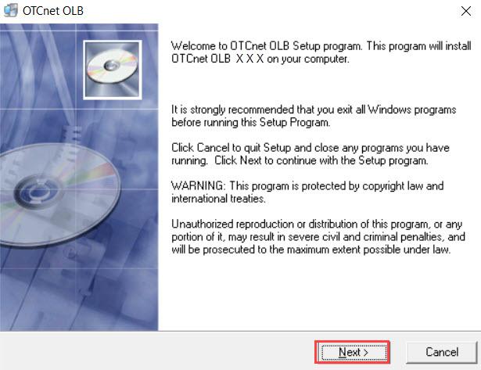
Application Tip

- Select Cancel to cancel and exit the setup.

- The Destination Location dialog box appears. Select Next.
Application Tip

As a best practice, it is recommended that the OLB application be installed in the default destination folder (i.e., C:\Program Files\OTCnet_olbC).


Additional Buttons
- Select Cancel to exit the setup.
- Select Back to return to the previous dialog box.

- The Start Installation dialog box appears. Select Next.
- The Server Port Settings dialog box appears. Select Next. Wait a moment while the files install.
Application Tip

- It is recommended that you install the OLB application with the default list of fixed ports.
- If your agency has different server port settings or needs, contact Customer Support.

- Once the OTCnet OLB has been successfully installed message appears, select Finish.
Application Tip

- The OLB Installer verifies that Java is installed on the workstation.
- If Java is not installed, you will receive a “Java X must be installed for the OLB to function. The JAVA_HOME environment variable must also be set pointing to the main Java installation folder” message as shown in Figure 6. A Windows Administrator must install Java.
- To upgrade your OLB version, you do not need to recreate or import your OLB credentials.

Figure 6. Java message

- The OTCnet OLB start and stop icons appear on the desktop of the workstation as shown in Figure 7.
Figure 7. Start and Stop OTCnet Local Bridge icons

Topic 2 Creating the OTCnet Local Bridge (OLB) Profile
After the CCA or CA downloads the OTCnet Local Bridge (OLB) application, the next step is to create the OLB profile.
If you are assigned the role of CCA, CCS, CCLO, CCO, CA or CO, you are authorized to create the OLB profile. The OLB profile is unique to each user role. Therefore, each of these user roles must create an OLB profile.
Before creating an OLB profile, consider the following information:
- Creating an OLB profile applies to all card processing and check processing users, including CCA, CCS, CCLO, CCO, CA and CO.
- The OLB application is required for the following:
  - Check capture workstation detection
  - The Deployable Disbursing System (DDS) Interface (DoD and Check Processing only)
  - Performing check processing and check capture operations and performing card processing operations and card workstation detection.
When creating a Local Bridge password, keep the following password criteria in mind. The password must contain:
- At least 12 characters
- No more than two repeating characters
The password must not be:
- A word in a language, slang, dialect, or jargon
- Related to personal identity, history, environment, or other personal associations
- Shared or displayed in plain view
The password criteria are displayed on the page when you enter and confirm your Local Bridge password.

Create the OTCnet Local Bridge (OLB) Profile
To create an OLB profile, complete the following steps:
- From Administration, select Manage Users>Create Local Bridge and User Profile.
- Select the relevant radio button for your version of the OLB.
Application Tips

Before you create your new profile, and if you downloaded and installed the newest version of the OLB, you must import the new OLB credentials file, required.

- Enter your Local Bridge Password and confirm your Local Bridge Password as shown in Figure 8. Select Submit.
Figure 8. Create Local Bridge and User Profile Radio Buttons and Password
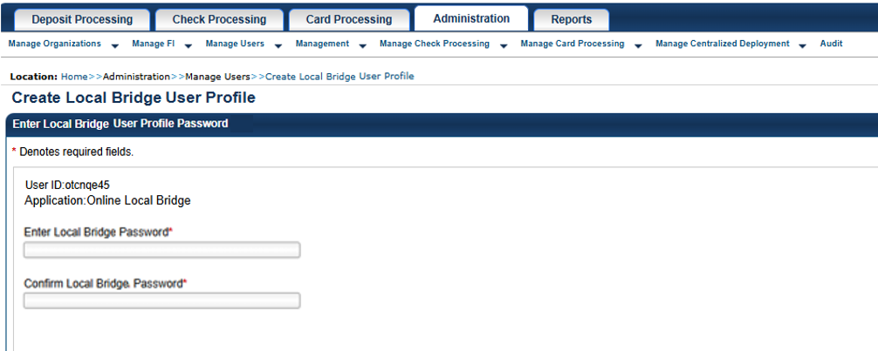
Application Tip

Select Submit and the system generates the credential file based on the application version selected.

Additional Buttons
- Select Clear to reset the password fields.
- Select Cancel to return to the OTCnet Home Page.

- A Do you want to open or save [file name].ini? dialog box appears. Select the Save drop-down arrow and select Save as.
Application Tips

- When saving the OLB credential file, do not rename the file as the file name must remain the same as it was when it was generated.
- If the file name is changed, the OLB application will not run.

Additional Buttons
- Select Open and the file opens in the Microsoft Notepad application.
- Select Cancel and the Do you want to open or save dialog box closes; you remain on the Create Local Bridge and User Profile page.

- The Save dialog box appears. Select Save as shown in Figure 9 or Cancel.
Figure 9. Create Local Bridge and User Profile Save
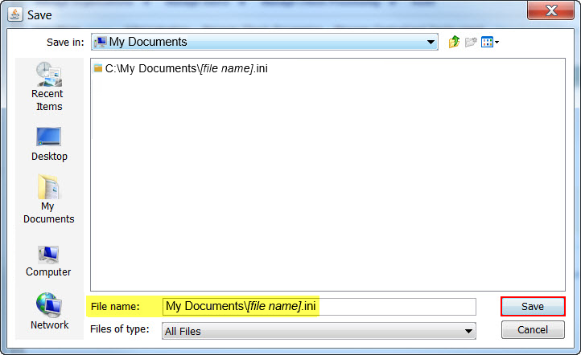

Application Tips

- Choose the location where you want to save the OLB credential file. Save the OLB credential file to any folder where you can save a file (e.g., My Documents folder, Desktop folder).
- The default location on the Save dialog box is the user’s My Documents folder.
- For a forgotten OLB password, or if you attempt to enter an incorrect password three times (or more), you must recreate an OLB credential file through the Create Local Bridge and User Profile page and save it again.
- You must also import your OLB credentials again, which is the next step in the OLB startup process.

Additional Button
Select Cancel to return to the Create Local Bridge and User Profile page without saving the file.

Topic 3 Importing OTCnet Local Bridge (OLB) Credentials
The OTCnet Local Bridge (OLB) application is required for OTCnet Online users performing workstation configuration, check processing, card processing and check capture operations. As a CCA, CCS, CCLO, CCO, CA or CO, you are required to import your OLB credentials to the workstation.
Additional version information includes the following:
- If upgrading your OLB version, in general, you do not need to recreate or re-import your OLB credentials.
- If upgrading your OLB version from a version older than 2.2.0.0, you must recreate and re-import your OLB credentials.
The only time you need to recreate an OLB password is if you forget your OLB password. After recreating your OLB password, OTCnet users must re-import OLB credentials.
Importing OLB credentials is unique to each user. Therefore, if there are multiple users on a workstation, each user must import their own OLB credentials.
Users are only required to import their OLB credentials once. After importing OLB credentials, users can successfully start the OLB application.
Before importing your OLB credentials, ensure the following steps have been completed in this order:
- The CCA or CA downloaded the OLB application.
- The OLB application is installed on the workstation.
- Each user has created an OLB profile, ensuring that the OLB credential file was not renamed (the file name remained the same as it was when generated).

Import OTCnet Local Bridge (OLB) Credentials
To import OTCnet Local Bridge (OLB) credentials, complete the following steps:
- Double-click the Start OTCnet Local Bridge icon located on the workstation desktop.

Or

Select Start>Programs>Start OTCnet Local Bridge.
Application Tips

If the icon does not reside in either location, contact your CCA or CA. They can help with:
- Completing the steps required to install the OLB application on the workstation
- Creating your OLB profile
- Importing your OLB credentials

- The OTCnet Local Bridge Startup window appears. Select the File menu.
- Select Import User Profile as shown in Figure 10.
Figure 10. Start OTCnet Local Bridge Startup
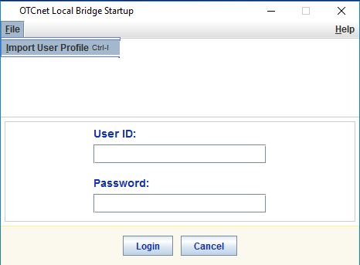

- The Select User Profile File window appears. Navigate to the location on the workstation where the OLB credential file was saved. Select the file and select Import.
Application Tip

The default location on the Select User Profile File window is the user’s My Documents folder.

- A Successfully imported user profile message appears. Select OK. Once you have successfully imported your OLB credentials, proceed with starting the OLB application on the workstation.

Summary
In this chapter, you learned:
- How to download and install the OTCnet Local Bridge (OLB) application
- How to create the OTCnet Local Bridge (OLB) profile
- How to import the OTCnet Local Bridge (OLB) credentials

