

Chapter 5. Configuring Administration and Card Processing Settings
OTCnet Participant User Guide

Table of Contents
Overview, Topics, and Audience 1
Overview 1
Topics 1
Audience 1
Topic 1 Managing Custom Labels 2
Define a Custom Label 3
Modify a Custom Label 5
View a Custom Label 6
Topic 2 Managing Processing Options 7
Modifying Processing Options 7
Modify a Processing Option 9
Viewing Processing Options 16
View Processing Options 17
Topic 3. Creating and Editing User Defined Fields (UDFs) 18
Creating a User Defined Field 18
Create a User Defined Field 19
Modifying a User Defined Field 22
Modify a User Defined Field 23
Deleting a User Defined Field 25
Delete a User Defined Field 26
Viewing a User Defined Field 27
View a User Defined Field 28
Summary 29

List of Figures
Figure 1. Step 1 of 2: Update Custom Labels 3
Figure 2. Step 2 of 2: Review Custom Labels 5
Figure 3. View Custom Labels 6
Figure 4. Step 2 of 3: Define Processing Options page with Accounting Classifications for Adjustments, Corrections and Returned Items expanded 10
Figure 5. Define Processing Options page with Correspondence expanded 12
Figure 6. Update Deposit Processing Options with Deposit Preparation expanded 14
Figure 7. Deposit Procession Options with Transaction History expanded 15
Figure 8. View Processing Options 17
Figure 9. Select 1 of 3: Select User Defined Field to Maintain 19
Figure 10. Review User Defined Fields page 21
Figure 11. Select User Defined Field to Maintain 23
Figure 12. Select 1 of 3: Select User Defined Field to Maintain 26
Figure 13. View User Defined Field 28

Glossary
Click this link to access the full OTCnet Glossary.

Overview, Topics, and Audience

Overview
Welcome to Configuring Administration and Card Processing Settings. In this chapter, you will learn:
- How to create, edit and delete custom labels
- How to set your options for processing and deposits
- How to create, edit and delete user defined fields (UDFs) specific to your agency

Topics
The topics in this chapter include the following:
- Managing Custom Labels
- Managing Processing Options
- Creating and Editing User Defined Fields (UDFs)

Audience
The intended audience for the Configuring Administration and Card Processing Settings Participant User Guide includes:
- Accounting Specialist
- Local Accounting Specialist
- Card Administrator

Topic 1 Managing Custom Labels
As an Accounting Specialist, you are authorized to define (create), modify and/or view a custom label. As part of your responsibility in managing your organization hierarchy, which includes entering the appropriate accounting codes, you can also customize the field labels in the deposit preparation page. These fields are called custom labels.
Customizing the labels for your organization’s Deposit Preparers and Deposit Approvers is useful when these roles are preparing and submitting deposits and/or reports. A custom label allows you to define a level in the organization hierarchy, the internal control number, or an agency accounting code. Performing this customization is optional.
Agency Accounting Code is the default name for the label; when you define the label, you are actually modifying its name. When referring to a custom label, the terms define and create are used interchangeably.
As an example, if your agency refers to Accounting Codes as Financial Numbers, you can modify the custom label to be Financial Number.
Once a custom label is defined, you may modify it. You can also view your custom labels from Manage Organizations, Custom Labels.

Define a Custom Label
To define (create) a custom label, complete the following steps:
- From the Administration tab, click Manage Organizations>Custom Labels>Modify. The Select OTC Endpoint page appears.
- Select the highest-level OTC Endpoint for which you want to modify custom labels. The Step 1 of 2: Update Custom Labels page appears.
- Update the custom label(s) for the organization hierarchy by completing the following steps as shown in Figure 1:
  - Enter a title for your Organization Hierarchy Labels.
  - Enter an agency accounting code title for the Accounting Code Definition Label.
  - Click Next.
Figure 1. Step 1 of 2: Update Custom Labels
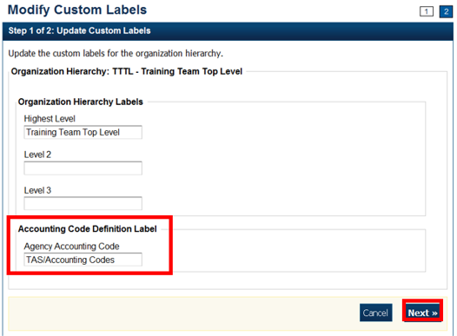

- The Step 2 of 2: Review Custom Labels page appears.

Application Tips

The Accounting Specialist is authorized to complete the following steps:
- Define a new Organization Hierarchy Label
- Update the existing label(s)
- Modify the label of the accounting code definition

- Verify the information is correct and click Submit. A Confirmation page appears presenting the custom labels modified for the organization hierarchy.

Additional Buttons
- Click Cancel to return to the OTCnet Home Page. No data is saved.
- Click Edit to make additional changes.
- Click Previous to return to the previous page.
- Click Submit to complete the process and display the Confirmation page.

Modify a Custom Label
To modify a custom field label, complete the following steps:
- From the Administration tab, click Manage Organizations>Custom Labels>Modify. The Select OTC Endpoint page appears.
- Select the organization endpoint for which you want to modify custom labels. The Step 1 of 2: Update Custom Labels page appears.
- Update the custom labels for the organization hierarchy and click Next. The Step 2 of 2: Review Custom Labels page appears as shown in Figure 2.
Figure 2. Step 2 of 2: Review Custom Labels
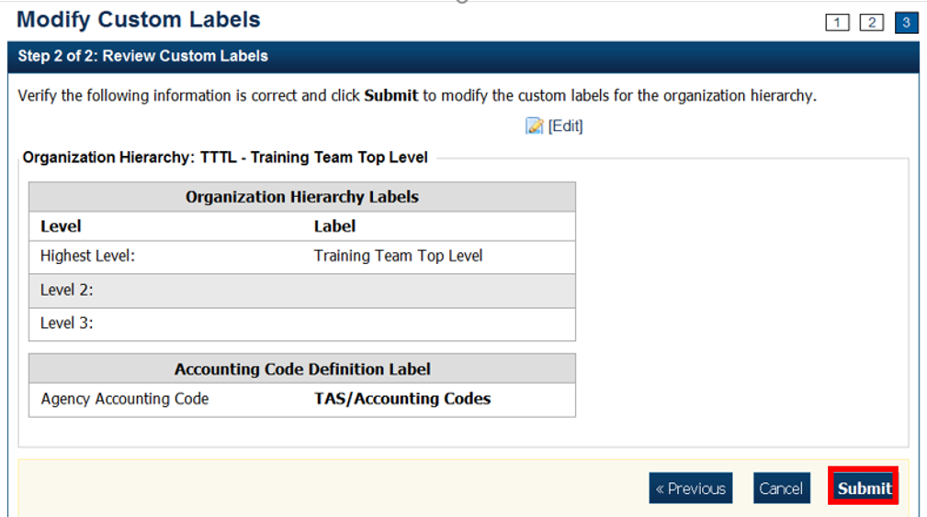
Application Tips

- If an Agency Accounting Code label is customized, it is displayed as the label above the imported or modified codes within the Maintain Accounting Codes module, according to the custom label that was defined for the highest-level organization.
- Within the rest of the application, custom labels apply to deposit processing functionalities, but are not extended to check processing functionalities.
- The default accounting code label is Agency Accounting Code.

- Verify the information is correct and click Submit.
A Confirmation page appears presenting the custom labels modified for the organization hierarchy.

View a Custom Label
To view a custom label, complete the following steps:
- From the Administration tab, click Manage Organizations>Custom Labels>View. The Select OTC Endpoint page appears.
- Select the highest-level organization for which you would like to view the custom labels. The View Custom Labels page appears showing the custom labels that are in effect for the organization hierarchy as shown in Figure 3
Figure 3. View Custom Labels
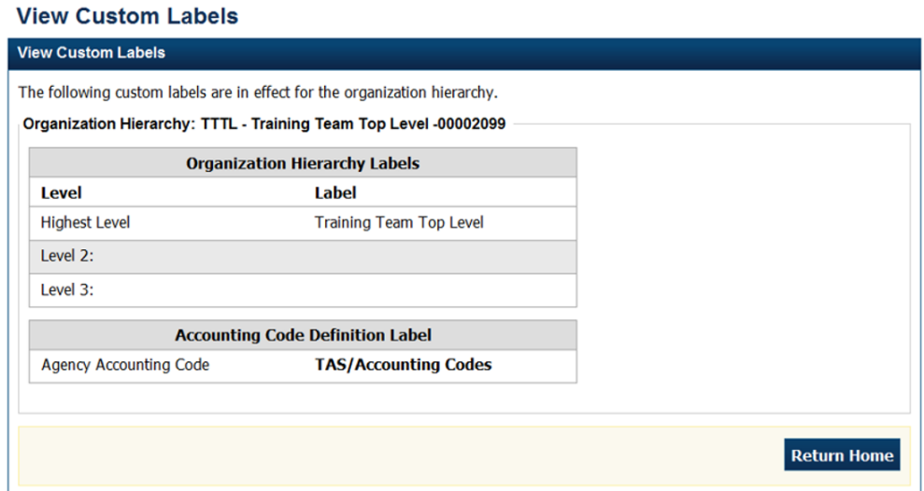.
Additional Buttons
- Click Cancel to return to the OTCnet Home Page. No data is saved.
- Click Return Home to return to the OTCnet Home Page.

Topic 2 Managing Processing Options
Managing your organization hierarchy includes defining your deposit processing options. Processing options are parameters for the deposit and adjustments process. For processing options, you must define the following:
- First, define processing options at the highest level of the organization, before defining lower-level options.
- For lower-level organizations, you must define these options, or the lower-level organizations will take on the options set for the next higher-level organization that does have the options set.
You must define processing options or your organization cannot create deposits. Define processing options at any level within your organization. View the processing options by OTC Endpoint report to manage processing options in your organization.
As an Accounting Specialist, you are authorized to modify the following processing options for your organization’s hierarchy:
- Accounting Classifications for Adjustments: Identifies the default accounting codes to which you want adjusted amounts credited and debited
- Correspondence: Provides the financial institution with address information for any correspondence, including returned item information
- Deposit Preparation: Sets default settings for deposit preparation to save time for Deposit Preparers
- Transaction History: Sets default settings for historical data about transactions

Modifying Processing Options
Accounting Specialists are authorized to modify processing options for the following:
- Accounting Classifications for Adjustments, Corrections, and Returned Items
- Correspondence
- Deposit Preparation
- Transaction History
When defining processing options, keep the following information in mind:
- To narrow an accounting code search, enter a partial or full accounting code.
- All accounting codes that meet your search criteria and that are not applied as a debit or credit adjustment to your OTC Endpoint are displayed on the page. You must enter search criteria, or all the accounting codes defined for the highest-level organization appear.
- By default, the first ten accounting codes display in the following order, by:
  - Ascending special character order
  - Numerical order
  - Ascending alphabetical order by accounting code
- If an organization has more than ten accounting codes, click the pagination menu above the section containing the existing accounting codes to view additional page results. The system only allows a user to view and apply active accounting codes not designated as Treasury Account Symbol (TAS), or those designated as TAS and that have been validated by Share Accounting Module (SAM).
- After an accounting code is assigned to debit or credit adjustment, it appears in the Adjustment Type table.

Modify a Processing Option
To modify a processing option, complete the following steps:
- From Administration, click Manage Organizations>Processing Options>Modify. The Step 1 of 3: Select Organization Endpoint page appears.
Application Tips

- Processing options must first be defined for the highest-level organization before any lower-level organization’s processing options can be defined.
- If the processing options are not defined for the highest-level organization, all lower-level organization links are disabled.

- Select the OTC Endpoint for which you want to modify a processing option. The Step 2 of 3: Define Processing Options page appears.
- Modify the processing option(s) and click Next.
To modify Accounting Classifications for Adjustments, Corrections, and Returned Items as shown in Figure 4, complete the following steps:
Update Default Accounting Codes by:
    - Selecting either Use parent’s values or Use my values
Or
    - Clicking Search (magnifying glass) to view accounting codes
Application Tip

- If selecting Use my values, enter the search criteria for the accounting code you would like to view and click Search (magnifying glass)
- To narrow an accounting code search, enter a partial or full accounting code

    - Selecting the accounting code to apply a credit and/or debit adjustment type and clicking Assign to Debit and/or Assign to Credit
    - Selecting Yes or No to allow changes by an organization lower in hierarchy

Application Tip

- An accounting code can be assigned to both a debit adjustment and credit adjustment
- After an accounting code is assigned to a debit or credit adjustment, it appears in the Adjustment Type table

Figure 4. Step 2 of 3: Define Processing Options page with Accounting Classifications for Adjustments, Corrections and Returned Items expanded
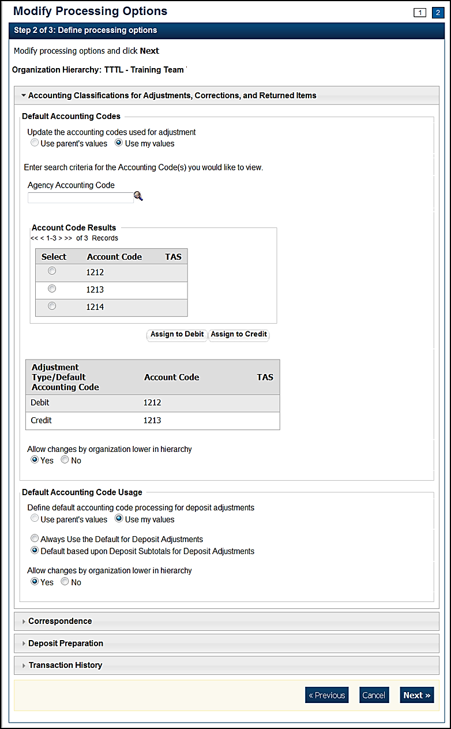

Update Default Accounting Code Usage by completing the following steps:
- Selecting either Use parent’s values or Use my values
- Selecting either Always Use the Default for Deposit Adjustments or Default based upon Deposit Subtotals for Deposit Adjustments
- Selecting Yes or No to allow changes by an organization lower in hierarchy

To modify Correspondence, complete the following steps as shown in Figure 5:
Update Returned Items by completing the following steps:
- Selecting Use parent’s values or Use my values
- Entering the corresponding address information that you would like to be displayed to a financial institution when a return item adjustment is created
- Selecting Yes or No to allow changes by an organization lower in hierarchy
Update Deposit Adjustment by completing the following steps:
- Selecting Use parent’s values or Use my values
- Entering the corresponding address information that you would like to be displayed to a financial institution when a deposit adjustment is created
- Selecting Yes or No to allow changes by an organization lower in hierarchy
Figure 5. Define Processing Options page with Correspondence expanded
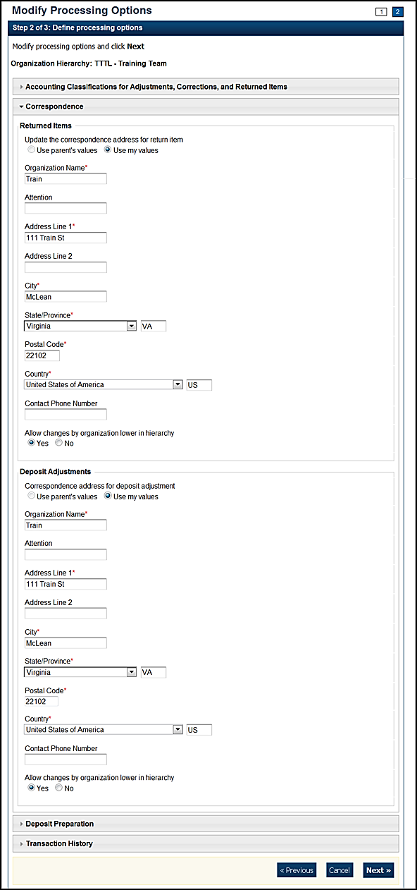

To modify Deposit Preparation, complete the following:

Update ITGA Deposit Creation by completing the following steps:
- Selecting Use parent’s values or Use my values
- Selecting Yes or No to allow the endpoint to create foreign deposits:
    - If the endpoint accepts foreign deposits, enter the Default foreign currency when creating deposits details
- Selecting Yes or No to allow changes by an organization lower in hierarchy
Update Subtotals and Cash Count by completing the following steps:
- Selecting Use parent’s values or Use my values
- Selecting Yes or No for each of the following options:
    - Include subtotals for checks/money orders and cash
    - Include currency count and subtotals by denomination
    - Include coin count and subtotals by denomination
    - Allow changes by an organization lower in hierarchy

Update Accounting Code Subtotals by completing the following steps:
- Selecting Use parent’s values or Use my values
- Selecting Yes or No for each of the following options:
    - Allow negative accounting code subtotals
    - Allow changes by an organization lower in hierarchy

Update Separation of Duties by completing the following steps as shown in Figure 6:
- Selecting Use parent’s values or Use my values
- Selecting Yes or No for each of the following options
    - Deposits must be prepared and approved by different employees
    - Allow changes by an organization lower in hierarchy

Figure 6. Update Deposit Processing Options with Deposit Preparation expanded
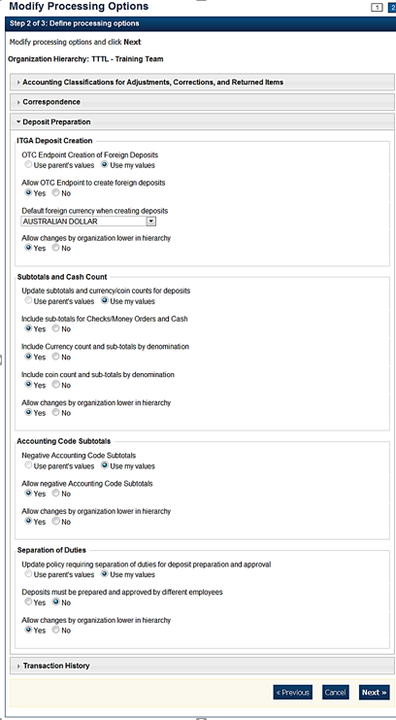

To modify Transaction History, complete the following steps as shown in Figure 7:
- Selecting Use parent’s values or Use my values
- Entering the Number of days displayed in the text box, if applicable
- Selecting Yes or No to allow changes by an organization lower in hierarchy
Figure 7. Deposit Procession Options with Transaction History expanded
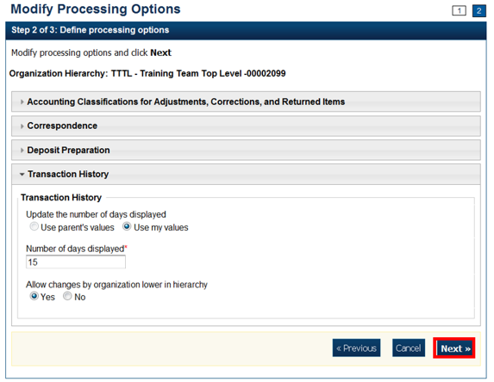
- The Step 3 of 3: Review the following processing options page appears. Verify the information is correct and click Submit.
- A Confirmation page appears showing which processing options were applied to the organization.

Viewing Processing Options
Accounting Specialists are authorized to view the following processing option details:
- Accounting Classifications for Adjustments, Corrections, and Returned Items
- Correspondence
- Deposit Preparation
- Transaction History
From the Viewing Processing Options page, you can view the custom labels that are in effect for your organization hierarchy.

View Processing Options
To view a processing option, complete the following steps:
- From the Administration tab, click Manage Organizations>Processing Options>View. The Select Organization Endpoint page appears.
- Select the highest-level organization or any lower-level OTC Endpoint for which you would like to view the processing options. A View Processing Options page appears, showing which custom labels are in effect for the organization hierarchy as shown in Figure 8.
Additional Button
Click Return Home to return to the OTCnet Home Page.

Figure 8. View Processing Options
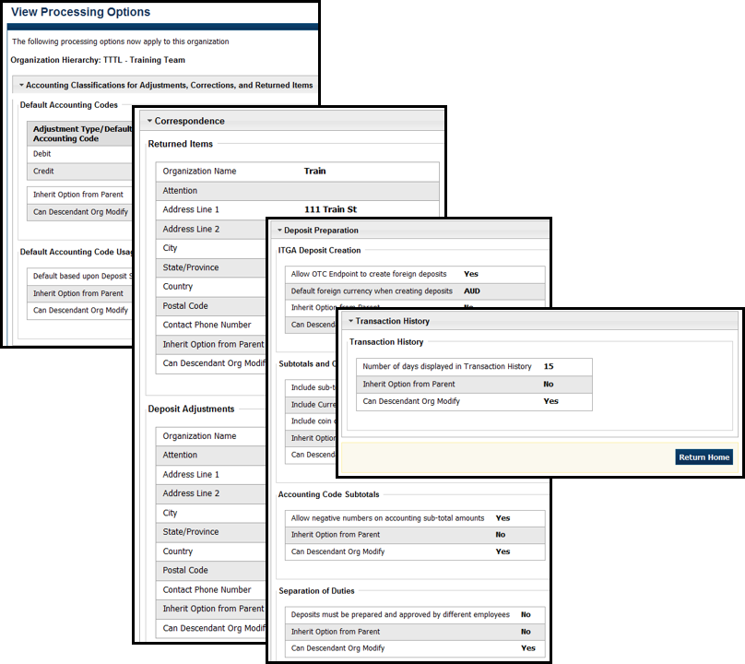

Topic 3. Creating and Editing User Defined Fields (UDFs)
As an Accounting Specialist and Card Administrator, you are authorized to create, modify and delete a UDF for your organization hierarchy. A UDF is an optional field for the Deposit Preparer and Card Operator to complete that describes a deposit activity or deposit accounting activity (e.g., a vendor number) or a card transaction, specific to your organization. Deposit Preparers use UDFs when entering deposit activity and accounting activity information during the deposit preparation process. Card Operators use UDFs when entering card payment details during card transaction processing.

Your organization may elect to use UDFs. If so, communicate this to each of your OTC Endpoints and identify the information to be included.
Accounting Specialists and Card Administrators perform the following tasks in working with UDFs:
- Create a UDF
- Modify a UDF
- Delete a UDF
- View a UDF
Deposit processing activities are disabled to read-only if an Accounting Specialist or Card Administrator has selected an endpoint that is both a Deposit Processing and a Card Processing Endpoint, and this endpoint has a deposit that is currently in progress. You cannot modify or delete any deposit processing UDFs at this endpoint. You can select the Create Card Processing activity.

Creating a User Defined Field
Accounting Specialists and Card Administrators are authorized to create up to four UDFs for deposit activity and three UDFs for card processing for your agency. Up to three UDFs for a Create Deposit UDF and up to two UDFs for the Create Deposit Subtotals UDF can be created.
To create a UDF, from the Select User Defined Field to Maintain page, click Create UDF. When the Step 2 of 3: Modify the User Defined Field page appears, add your UDF fields (i.e., Activity, Label, Description, Date Type, Maximum Input Length, Minimum Input length, Display Order Number, and Activity User Entry).

Create a User Defined Field
To create a UDF, complete the following steps:

- From the Administration tab, click Manage Organizations>User Defined Fields> Modify. The Select OTC Endpoint screen appears.
- Select the highest-level organization for which you want to modify UDFs. The Step 1 of 3: Select User Defined Field to Maintain page appears.
- Click Create UDF as shown in Figure 9. The Step 2 of 3: Modify the User Defined Field page appears.
Figure 9. Select 1 of 3: Select User Defined Field to Maintain
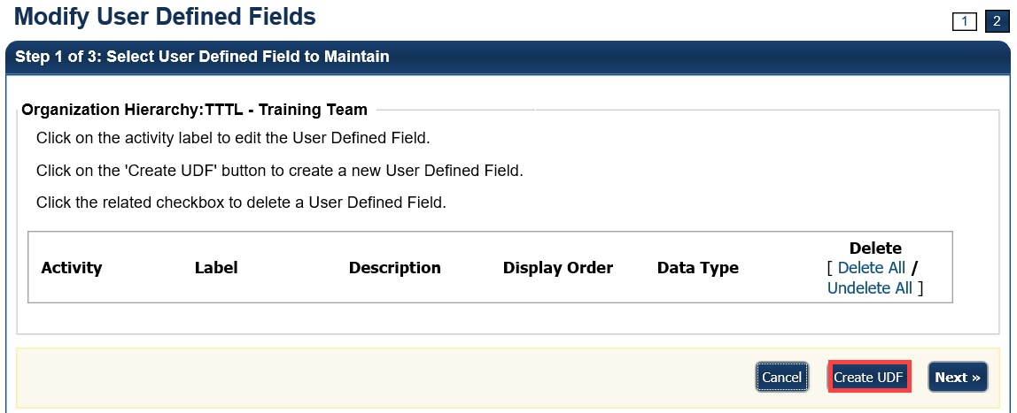
Application Tip

A message is displayed discouraging users from creating UDFs that request PII data.

- Add the UDF and click Done.
Add a UDF by:
  - Selecting the Activity type for the UDF
Application Tips

- There are two types of deposit processing activities (Create
Deposit and Create Deposit Subtotal) and one activity for card processing (Create Card Processing).
- For TGA/CDC Endpoints with active deposits, in the drop-down Activity menu, the deposit activities are disabled. In this case, Accounting Specialists and Card Administrators can only select the Create Card Processing activity

  - Entering the Label and Description
  - Selecting a Data Type
    - If the Drop Down List of Alphanumeric Values Data Type is selected, proceed to step 6.
    - If another Data Type is selected, continue entering in information for the fields below. Proceed to step 7.
  - Entering the
    - Maximum Input Length (Maximum length is 255)
    - Minimum Input Length
    - Display Order Number
  - Selecting Mandatory or Optional for Activity User Entry
Application Tips

- When a deposit is in progress at a TGA or CDC endpoint, a UDF cannot be modified or deleted if the deposit is in Draft or Awaiting Approval (AWAP) status.
- If the Accounting Specialist or Card Administrator selected an endpoint that is both a TGA and a CDC Endpoint, and this endpoint has a deposit that is currently in progress, the deposit processing activities are disabled to read-only.
- Only the Card Processing activity is active.
- The Card Administrator continues card processing activities when a deposit is in progress.

Application Tips

- If the Drop-Down List of Alphanumeric values data type is selected, a Permitted Values section appears.
- Click List Values. A Step 2 of 3 (Continued): Define Permitted Values page appears.
- Enter details for both the Value and Description.
- Click Done to return to the Step 2 of 3: Modify the User Defined Field page.

- The Step 1 of 3: Select User Defined Field to Maintain page appears again. Select Next.
- The Step 3 of 3: Review page appears. Verify the UDF information is correct. Select the plus sign next to the UDF to expand it.
- The Step 3 of 3: Review page appears. Verify the UDF information is correct and click Submit as shown in Figure 10.
Figure 10. Review User Defined Fields page
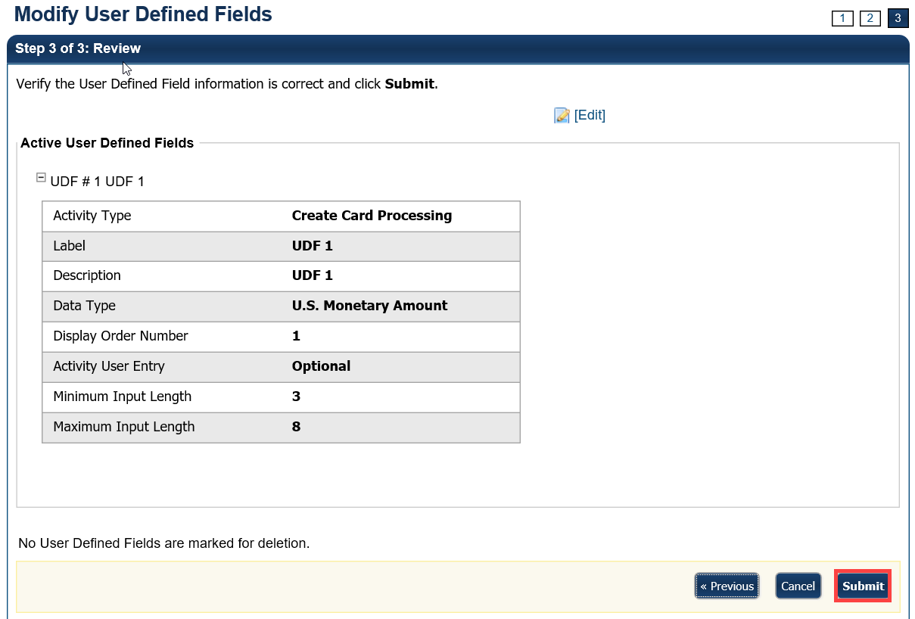
- A confirmation page appears presenting the UDF data that is saved to the database.
Additional Buttons
- Click Cancel to return to the OTCnet Home Page. No data is saved.
- Click Edit to make additional changes.
- Click Next to advance to the next page.
- Click Previous to return to the previous page.
- Click Return Home to return to the OTCnet Home Page

Modifying a User Defined Field
Accounting Specialists and Card Administrators are authorized to modify UDFs, as needed, to accommodate your organization’s changing needs.
For deposit processing, you cannot modify a UDF that is associated with a deposit that is still in Draft or awaiting approval (AWAP) status. Draft or AWAP deposits must be submitted to the Financial Institution before you modify any UDFs associated with them. Draft or AWAP status does not impact card processing.
When modifying a UDF, you can modify the following UDF fields:
- Activity
- Label
- Description
- Date Type
- Maximum Input Length
- Minimum Input length
- Display Order Number
- Activity User Entry

Modify a User Defined Field
To modify an existing UDF, complete the following steps:
- From the Administration tab, click Manage Organizations>User Defined Fields>Modify. The Select OTC Endpoint screen appears.
- Select the highest-level organization for which you want to modify a UDF. The Step 1 of 3: Select User Defined Field to Maintain page appears.
- Click the UDF Label hyperlink. The Step 2 of 3: Modify User Defined Field page appears.
Application Tip

A message is displayed discouraging users from creating UDFs that request personally identifiable information (DII) data.

- Make the changes to the UDF and click Done. The Step 1 of 3: Select User Defined Field to Maintain page appears as shown in Figure 11.
Figure 11. Select User Defined Field to Maintain
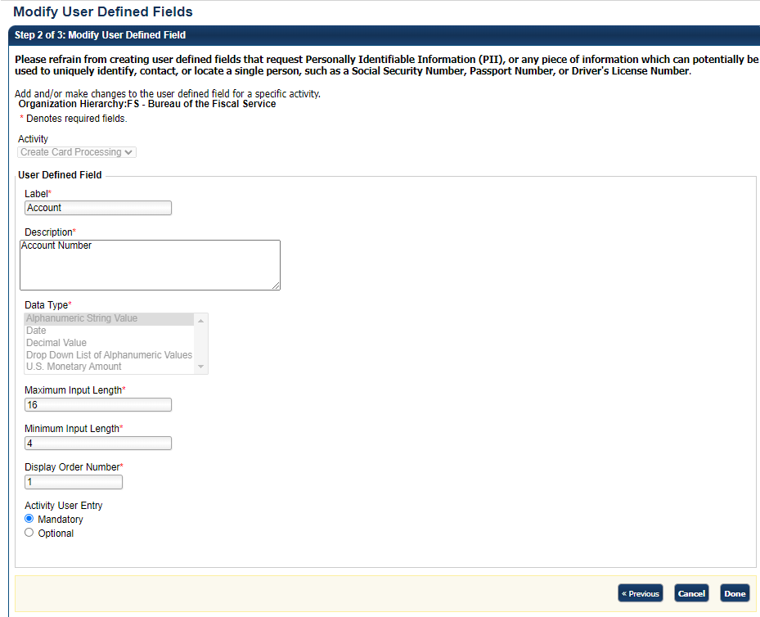
- Click Next. The Step 3 of 3: Review page appears.
- Verify the UDF information is correct and click Submit. A confirmation page appears presenting the UDF data that has been saved to the database.
Additional Buttons
- Click Cancel to return to the OTCnet Home Page. No data is saved.
- Click Create UDF to create a new UDF.
- Click Next to advance to the next page.
- Click Previous to return to the previous page.
- Click Edit to make additional changes to a UDF.
- Click Submit to complete the process and display the Confirmation page.
- Click Return Home to return to the OTCnet Home Page.

Deleting a User Defined Field
Accounting Specialists and Card Administrators are authorized to delete a user defined field (UDF). If a UDF isn’t needed, delete it to save labor for your Deposit Preparers and Card Administrators.
For deposit processing, you cannot modify a UDF that is associated with a deposit that is still in Draft or awaiting approval (AWAP) status. Draft or AWAP deposits must be submitted to the financial institution before you modify any UDFs associated with them. Draft or AWAP status does not impact card processing.

Delete a User Defined Field
To delete a UDF, complete the following steps:
- From the Administration tab, click Manage Organizations>User Defined Fields>Modify. The Select OTC Endpoint screen appears.
- Select the highest-level organization for which you want to delete the UDF. The Step 1 of 3: Select User Defined Field to Maintain page appears as shown in Figure 12.
- Click the Delete checkbox next to the appropriate field and click Next. The Step 3 of 3: Review page appears. Select the plus sign next to the UDF to expand it.
Figure 12. Select 1 of 3: Select User Defined Field to Maintain
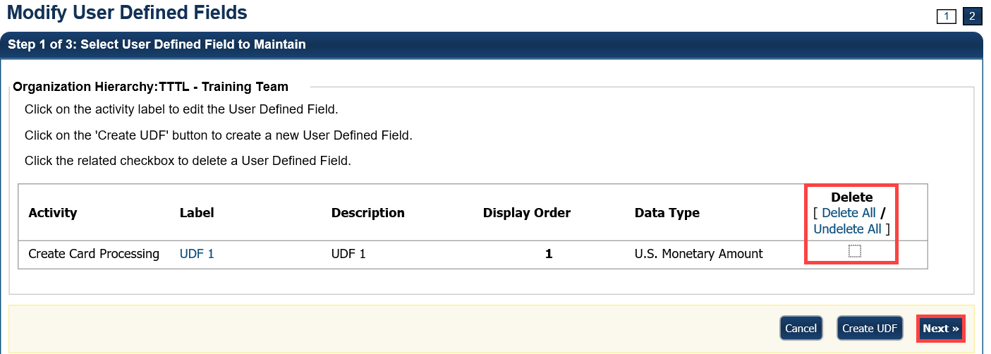

Application Tip

A UDF, during deposit processing, cannot be deleted if it is associated with a deposit that is in Draft or awaiting approval (AWAP) status. Only the Card Processing activity is active.

- Verify the correct information is marked for deletion and click Submit. A Confirmation page appears showing the UDF data is saved to the database.
Additional Buttons
- Click Cancel to return to the OTCnet Home Page. No data is saved.
- Click Create UDF to create a new UDF.
- Click Next to advance to the next page.
- Click Previous to return to the previous page.
- Click Edit to make additional changes to a UDF.
- Click Submit to complete the process and display the Confirmation page.
- Click Return Home to return to the OTCnet Home Page.

Viewing a User Defined Field
As an Accounting Specialist, Local Accounting Specialist, Viewer and Card Administrator, you are authorized to view the UDFs that exist for your organization.
To view a UDF, choose it in the View User Defined Field page. You can view the following characteristics:
- Activity Type
- Label
- Description
- Data Type
- Display Order Number
- Activity User Entry
- Minimum Input Length
- Maximum Input Length

View a User Defined Field
To view a UDF, complete the following steps:
- From the Administration tab, click Manage Organizations>User Defined Fields >View. The Select OTC Endpoint screen appears.
- Select the highest-level organization for which you would like to view a UDF. A View User Defined Field page appears.
- Click on any of the UDFs to view its characteristics (e.g., activity type, label, description, etc.). The characteristics appear as shown in Figure 13.
Figure 13. View User Defined Field
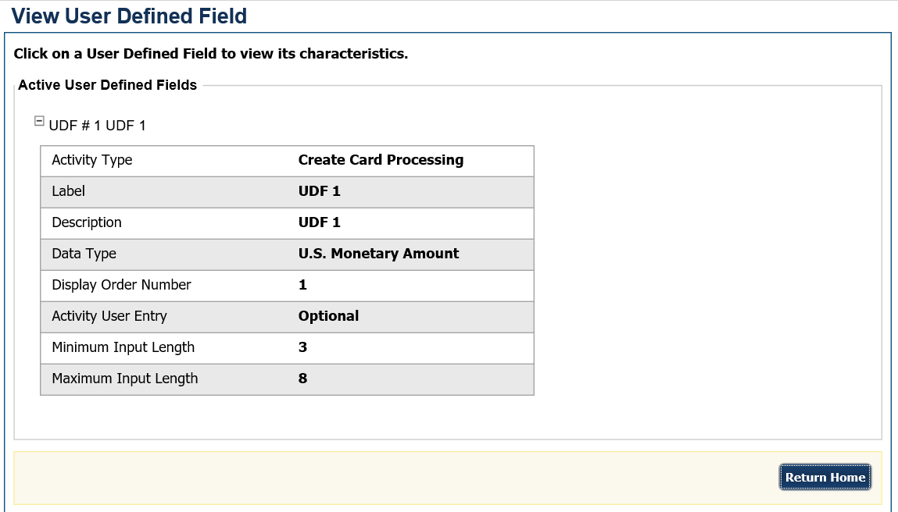

Summary
This chapter provided information on:
- How to create, edit and delete custom labels
- How to set your options for processing deposits
- How to create, edit and delete UDFs specific to your agency

