

Chapter 4. Managing Your Agency’s Hierarchy, Accounting Codes and Processing Options
OTCnet Participant User Guide

Table of Contents
Overview, Topics, and Audience 1
Overview 1
Topics 1
Audience 1
Topic 1 The Purpose of the Organizational Hierarchy 3
Topic 2 Creating an Organizational Hierarchy 4
Create an OTC Endpoint 4
Create an OTC Endpoint 5
Topic 3. Managing the Organizational Hierarchy 7
Add a Lower Level to an Existing OTC Endpoint 7
Add a Lower Level to an OTC Endpoint 8
Modify OTC Endpoint Information 10
Modify OTC Endpoint Information 13
Delete or Neutralize an OTC Endpoint 25
Delete or Neutralize an OTC Endpoint 26
View an OTC Endpoint 27
View an OTC Endpoint 28
Search for an OTC Endpoint 30
Search for an OTC Endpoint 31
Topic 4. Managing Accounting Codes 32
Modify Accounting Codes 32
Modify Accounting Codes 33
Import Accounting Codes 35
Import Accounting Codes 36
View Accounting Codes 38
View Accounting Codes 39
Modify Endpoint Mappings 40
Modify Endpoint Mappings 41
Topic 5. Managing Processing Options 44
Modify Processing Options 44
Modify Processing Options 45
View Processing Options 50
View Processing Options 51
Summary 52

List of Figures
Figure 1. Step 2 of 3: Update OTC Endpoint Information 5
Figure 2. Step 2 of 3: Short Name and Description for OTC Endpoint Information 8
Figure 3. Step 2 of 3: Update OTC Endpoint Information - Collapsed 13
Figure 4. Allow OTC Endpoint to create deposits for over-the-counter collections 15
Figure 5. Default Reason Codes 16
Figure 6. Enable Check Capture 19
Figure 7. Enable Card Processing Address, Signature Capture and Return Policy 21
Figure 8. Advanced Administration 23
Figure 9. Special Designation 23
Figure 10. Step 1 of 2: Select the OTC Endpoint(s) 26
Figure 11. View OTC Endpoint 28
Figure 12. Step 2 of 2: View OTC Endpoint 31
Figure 13. Step 2 of 3: Update Accounting Codes 33
Figure 14. Step 3 of 4: Select Accounting Codes 36
Figure 15. View Accounting Codes 39
Figure 16. Step 2 of 4 Continued: Search and Assign Accounting Codes 42
Figure 17. Update Deposit Processing Options with Deposit Preparation expanded 48
Figure 18. View Processing Options 51

Glossary
Select this link to access the full OTCnet Glossary.

Overview, Topics, and Audience

Overview
Welcome to Managing Your Agency’s Hierarchy. In this chapter, you will learn:
- The purpose of organizational hierarchy
- How to add lower-level endpoints to the highest level of an organization hierarchy
- How to add additional lower-level endpoints or a financial institution relationship to a hierarchy that was previously defined
- How to make changes to OTC endpoints
- How to delete or neutralize OTC endpoints
- How to view OTC endpoints
- How to modify accounting codes
- How to modify endpoint mappings
- How to modify processing options

Topics
The topics in this chapter include the following:
- The Purpose of the Organizational Hierarchy
- Creating an Organizational Hierarchy
- Managing the Organizational Hierarchy
- Managing Accounting Codes
- Managing Processing Options

Audience
The intended audience for the Managing Your Agency’s Hierarchy Participant User Guide varies by system:

Deposit Processing
- Accounting Specialist
- Local Accounting Specialist
- Viewer (Views the organization’s hierarchy endpoint only)

Check Capture and Check Processing
- Check Capture Administrator
- Check Capture Supervisor
- Check Capture Lead Operator

Card Processing
- Card Administrator
- Card Operator (Views the organization’s hierarchy endpoint only)

Topic 1 The Purpose of the Organizational Hierarchy
As your Agency’s Accounting Specialist (AS), Local Accounting Specialist (LAS), Check Capture Administrator (CCA), Check Capture Supervisor (CCS) and Card Administrator (CA) you are responsible for identifying and maintaining the organizational structure for your Agency’s deposits, check capture, and card processing settings. This organizational structure is called a hierarchy.
Creating a hierarchy accomplishes the following:
- Describes the relationships and reporting structures between OTC Endpoints (i.e., locations) within your organization that process check transactions, create deposits, submit deposits or process card transactions, in OTCnet.
- Defines the content of the reports that individuals may run based on their OTC Endpoints within the hierarchy.
- Enables staff to process check transactions, create deposits, submit deposits, process card transactions and pull reports on all appropriate OTC Endpoints within the organization.
Work with your management to determine your desired hierarchy. Use the OTCnet tools provided in this document to define your OTCnet hierarchy. The organizational hierarchy you create allows for the following:
- Deposit Preparers may create deposits from specific OTC Endpoints
- Check Capture Operators may scan checks
- Card Operators may process credit card, debit card and gift card payments
You are responsible for indicating which hierarchy locations are OTC Endpoints, and how deposits at OTC Endpoints should be handled. The following describes the label that appears next to the endpoint and the endpoint types in OTCnet.
- TGA – denotes a Deposit Processing endpoint
- CHK – denotes a Check Capture endpoint
- CDC – denotes a Card Processing endpoint
- M – denotes a Mapped Accounting Code

Topic 2 Creating an Organizational Hierarchy
Once your High-Level Agency Support (HLAS) has entered your organization into OTCnet, you are responsible for entering your organizational hierarchy. As part of your setup process, the HLAS creates the highest level of your hierarchy for you; you add to that hierarchy according to your organization’s needs.
The highest level of your organization cannot be a depositing endpoint. You may create multiple lower levels in your hierarchy, as needed, with multiple OTC Endpoints in each level.
You may edit your hierarchy as desired by updating the information for each OTC Endpoint you create. You may delete an OTC Endpoint from which no deposit, check transaction or card transaction has been made. You may not delete an OTC Endpoint once a deposit, check or card transaction has been made from that OTC Endpoint.
OTC Endpoints may not be deleted after a deposit, check or card transaction has been made because historical information about that deposit or check transaction would also be deleted, creating inaccurate reporting. However, you may neutralize an OTC Endpoint, if deposits or check transactions have been created. Card Processing Endpoints can also be neutralized.
Your organization’s hierarchy is accessible by selecting Administration and the Manage Organization menu option.

Create an OTC Endpoint
The Accounting Specialist, Local Accounting Specialist, Check Capture Administrator, Check Capture Supervisor and Card Administrators can add endpoints.
To add an OTC Endpoint from the highest level of an organizational hierarchy, select your organization’s OTC Endpoint and check the Add lower levels to this OTC Endpoint checkbox.
Information on Short Name and Description includes:
- The Short Name and Description fields provide an abbreviation and a full description, respectively, of the OTC Endpoint you are adding.
- Short names are user-defined text describing an organization. Short names must be unique within an organization hierarchy (e.g., Short Name: IRS; Description: Internal Revenue Service).
- Special characters are accepted in Short Name and Description fields; however, only use standard American Standard Code for Information Interchange (ASCII) characters. The standard ASCII range is 32-126. If non-standard ASCII characters (0-31, 127-255) are entered in the Short Name and Description fields, you cannot manage OTC Endpoints (select endpoints) in OTCnet Online. Instead, an error message appears suggesting you contact Customer Support.

Create an OTC Endpoint
To add an OTC Endpoint from the highest organization hierarchy, complete the following steps:
- From the Administration tab, select Manage Organization>Organization Hierarchy>Modify. The Step 1 of 3: Select an OTC Endpoint page appears.
- Select your OTC Endpoint from the list. The Step 2 of 3: Update OTC Endpoint Information page appears. View details for Add lower levels to this OTC Endpoint checkbox as shown in Figure 1.
- Check the Add lower levels to this OTC Endpoint checkbox.
- Enter the lower-level OTC Endpoint’s Short Name and Description and select Next.
Application Tip

- In the table that appears, add new OTC Endpoints that fall in the level under the current OTC Endpoint.
- Short names are user-defined text describing an organization. Short names must be unique within an organization hierarchy (e.g., Short Name: IRS; Description: Internal Revenue Service).

Figure 1. Step 2 of 3: Update OTC Endpoint Information
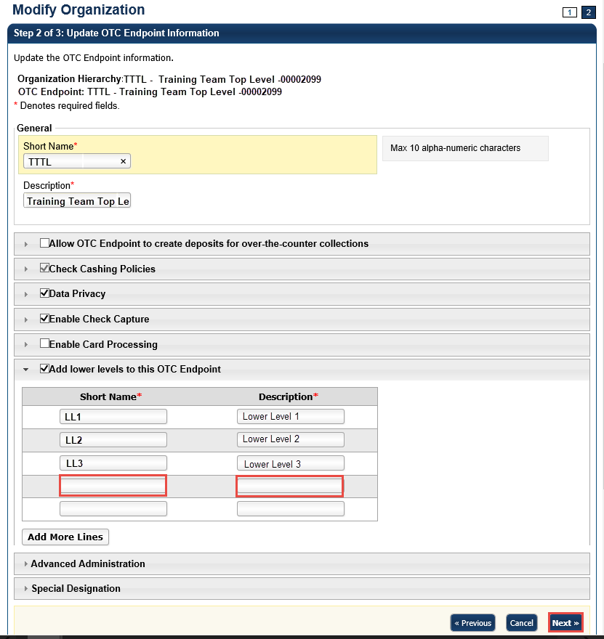

- In the Step 3 of 3: Review OTC Endpoint(s) page, review and verify the OTC Endpoint details and select Submit. A Confirmation page appears presenting the modified OTC Endpoint (and verifies the added lower-level OTC Endpoint).

Additional Buttons
- Select Add More Lines to add additional lower levels to this endpoint.
- Select Cancel to return to the OTCnet Home Page. No data is saved.
- Select Previous to return to the previous page.
- Select Return Home to return to the OTCnet Home Page.

Topic 3. Managing the Organizational Hierarchy
Once Accounting Specialists, Local Accounting Specialists, Check Capture Administrators, Check Capture Supervisors and Card Administrators have performed the initial setup of your organizational hierarchy, you can add to it and adjust it to suit your needs by performing the following tasks:
- Adding a lower level to an existing OTC Endpoint
- Modifying OTC Endpoint information
- Deleting an OTC Endpoint
- Viewing an OTC Endpoint
Before a user is provisioned to a deposit-processing OTC Endpoint (TGA), ensure the Allow OTC Endpoint to create deposits for over-the-counter collections checkbox is checked. Before a user is provisioned to a check capture OTC Endpoint (CHK), ensure the Enable Check Capture checkbox is checked. Before a user is provisioned to a card-processing OTC Endpoint (CDC), ensure the Enable Card Processing checkbox is checked.
Required fields for Enable Card Processing include Chain Code, Division, ALC, Merchant ID, Address, Signature Capture and Return Policy.
If the Allow OTC Endpoint to create deposits for over-the-counter collections checkbox, the Enable Check Capture checkbox and Enable Card Processing checkboxes are not checked when modifying OTC Endpoint information, you cannot provision the user to the appropriate OTCnet Endpoint.

Add a Lower Level to an Existing OTC Endpoint
Accounting Specialists, Local Accounting Specialists, Check Capture Administrators, Check Capture Supervisors and Card Administrators can add as many levels to your Agency hierarchy as needed, each with as many required OTC Endpoints.
To add a lower level to an existing OTC Endpoint, select your OTC Endpoint. Check the Add lower levels to this OTC Endpoint checkbox to add lower levels to the existing endpoint. Enter Short Name and Description fields for all OTC Endpoints in the next lower level. Verify the OTC Endpoint details are correct. Select Submit. A Confirmation page appears presenting the OTC Endpoint that has been modified (added). Verify that the OTC Endpoint details are correct.

Add a Lower Level to an OTC Endpoint
To add a lower level to an OTC Endpoint, complete the following steps:
- From the Administration tab, select Manage Organization>Organization Hierarchy>Modify. The Step 1 of 3: Select an OTC Endpoint page appears.
- Select an OTC Endpoint from the list that appears. The Step 2 of 3: Update OTC Endpoint Information page appears.
- Check the Add lower levels to this OTC Endpoint checkbox to add lower levels to the existing endpoint as shown in Figure 2. Short Name and Description text boxes appear.
- Enter a short name and description in the Short Name and Description fields for all the OTC Endpoints in the next lower level. When you have finished, select Next.
Figure 2. Step 2 of 3: Short Name and Description for OTC Endpoint Information
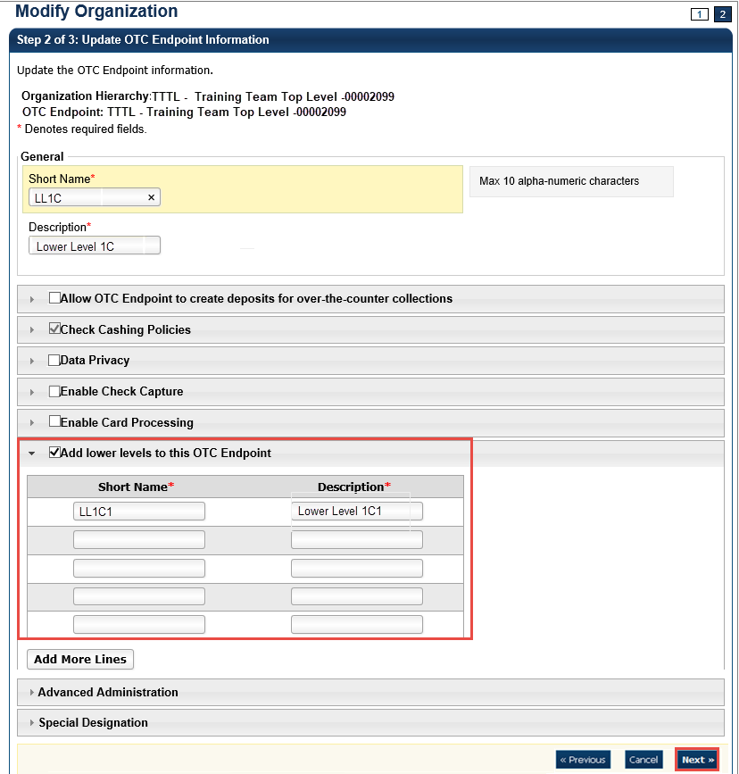
- Verify that the OTC Endpoint details are correct and select Submit. A Confirmation page appears presenting the modified OTC Endpoint.
Additional Buttons
- Select Add More Lines to add additional lower levels to this endpoint.
- Select Cancel to return to the OTCnet Home Page. No data is saved.
- Select Previous to return to the previous page.
- Select Return Home to return to the OTCnet Home Page.

Modify OTC Endpoint Information
Accounting Specialists, Local Accounting Specialists, Check Capture Administrators, Check Capture Supervisors and Card Administrators are authorized to modify the Short Name or Description of an existing OTC Endpoint, enable the OTC Endpoint to create deposits (indicated with TGA), capture checks (indicated with CHK), process card transactions (indicated with Card Debit Card or CDC), or add a lower level to the OTC Endpoint.
Similarly, any CDC endpoint that is also a TGA and/or CHK endpoint, requires a card processing role with permission to modify an organization (e.g., Card Administrator).
To modify endpoint information settings for an OTC Endpoint with TGA, CHK and CDC, the user must have Accounting Specialist, Check Capture Administrator, Check Capture Supervisor and Card Administrator privileges.
Additional Information for modifying the OTC Endpoint information includes:
- Special characters are accepted in Short Name and Description fields; however, only use standard American Standard Code for Information Interchange (ASCII) characters. The standard ASCII range is 32-126. If non-standard ASCII characters (0-31, 127-255) are entered in the Short Name and Description fields, you cannot manage OTC Endpoints (select endpoints) in OTCnet Online. Instead, an error message appears suggesting that you contact Customer Support.
- The Agency Assigned Suspensions - Days allows you to specify the number of calendar days an individual is unable to cash a check or pay by check. It is calculated from the date the system is aware of the return file. The Agency Assigned Suspensions - Occurrence allows you to specify the suspension level.
- Include Represented and Retired Check or Include Retired Check Only allows you to specify whether the verification record is generated on Represented or Retired items. Include Retired Check Only allows you to specify whether the verification record is generated on only Retired items.
- Include Expired indicates whether previous suspensions that have since expired are counted when accessing the suspension level to assign when the individual writes a check. Agency Verification Policies—Delete allows you to remove the check cashing policy for your OTC Endpoint. Once the check cashing policy is removed for the OTC Endpoint, the higher-level organization’s check cashing policy is automatically assigned to your OTC Endpoint.
- Data Privacy defines the extent to which users from other locations are able to view verification records. By default, Account, User Defined Field 1, Bank Routing Number, Note and Mask PII are checked as Blocked. If a checkbox is checked, it indicates that the OTC Endpoint information has been defined. For maximum data privacy, all fields would be marked as blocked, except for Short Name. However, there may be situations where it is acceptable for outside users to view certain fields in verification records.
- Enable Card Processing options are defined as the following:
  - A Chain Code is an alphanumeric designator (e.g., 0F123B) assigned by WorldPay to reflect unique channel of card processing. A Chain Code is required for initial setup with lower-level endpoints. Once the Chain Code is saved, it cannot be changed. An agency can have multiple Chain Codes, but no two agencies will have the same Chain Code.
  - A Division is a three-digit value assigned at lower-level endpoints under the chain code to designate unique lines of accounting. The Division code for all OTC Endpoints is any value from 001 to 999.
  - The Agency Location Code (ALC) is required for initial setup. Once the ALC is saved, it cannot be changed. If an endpoint adds card processing functionality to an existing TGA or CHK endpoint, the ALC will already be populated.
  - The Merchant ID is a unique alphanumeric designator, received from CAS, that reflects the card processing location. An ALC is associated with multiple merchant IDs; however, each merchant ID must be unique for each lower-level endpoint. The Merchant ID field may contain up to 13 characters.
Once the Chain Code, Division, ALC, and Merchant ID are saved, they will grey out and cannot be changed. If any of these details need to be changed, a new endpoint must be created, and the information will need to be added again.
- If the Signature Capture checkbox is checked, the customer’s signature and the message “I agree to pay the above total amount in accordance with the card issuer’s agreement” will appear on your agency’s sales receipts. For refunds, the customer’s signature and the message “I agree that I have received a refund for the amount stated above” will appear on your agency’s refund receipts. By default, the Signature Capture checkbox is unchecked.
- Return Policy indicates the agency’s return policy for card transactions. It is stored in the system and generated on receipts as mandated by the Treasury Financial Manual. The default return policy choice is None. Selecting Return Policy is optional and does not apply to all endpoints (e.g., a return policy is not required when the card user is not purchasing an item but only paying a fee or making a payment).
Return Policy choices include:
  - NO REFUND, ALL SALES FINAL – For any agency that does not accept merchandise in return or exchange and does not issue refunds to cardholders.
  - EXCHANGE ONLY – For any agency that only accepts merchandise in immediate exchange for similar merchandise of a price equal to the amount of the original transaction.
  - IN-STORE CREDIT ONLY – For any agency that accepts returned merchandise and delivers to the cardholder an in-store credit equal to the value of the merchandise returned that may be used only in the agency’s place(s) of business.
  - REFUNDS ONLY AVAILABLE WITHIN 30 DAYS OF SERVICE OR PURCHASE – For any agency that issues refunds to the original credit or debit card within 30 days of purchase or service.
  - Other – The agency is prompted to enter some descriptive text outlining their agency’s return policy.
  - None – Select if a return policy does not apply to an agency.
- Prior to specifying Debit Gateway, confirmation must be received from the OTCnet Deployment Team to set up each applicable OTCnet Endpoint.
  - No indicates that the Debit Gateway setup is not complete, and the OTC Endpoint is not ready to perform check capturing activities.
  - Yes indicates that the Debit Gateway setup is complete, and the OTC Endpoint is now ready to perform check capture activities. A notification message appears as a reminder to submit your Agency Site Profile (ASP) for all check capture endpoints. If the ASP is not submitted to the OTCnet Deployment Team, this can prevent transactions from processing. Select OK.
- By default, all agencies will have the Close Batch checkbox checked. To close the batch, the user must print the PDF report or export the batch list report.
  - If the Close Batch checkbox is unchecked, the user can close the batch without having to print the PDF report or export the batch list report.
- By default, all agencies will have the Approve Batch checkbox checked. In order to approve the batch, the user must print the PDF report or export the batch list report.
  - If the Approve Batch checkbox is unchecked, the user can approve the batch without having to print the PDF report or export the batch list report.
- If the user is closing or approving multiple batches online and the Close Batch or Approve Batch checkboxes are checked for any OTCnet endpoint, then the user must print the PDF reports or export the list reports. The batch is not closed or approved until Confirm is selected, which is enabled when the Print PDF Report or Export is selected.
  - If the user is closing and/or approving multiple batches online and the Close Batch or Approve Batch checkboxes are not checked for any OTCnet endpoint, then the user can close and/or approve multiple batches without printing the PDF reports or exporting the list reports. Confirm is enabled and the user can select to close and/or approve the multiple batches.
- If Special Designation is selected, a user is able to view which ALCs are CARS Reporters.
  - The CARS Reporter special designation information is read-only and displays for TGA and CHK endpoints. Only an HLAS can specify the Special Designation information.
  - Yes indicates that the OTC Endpoint is associated with an ALC that has been designated as a CARS Reporter. No indicates that the OTC Endpoint is not associated with an ALC that has been designated as a CARS Reporter. If an ALC is identified as a CARS Reporter, entering the Accounting Code information is mandatory. This will apply to all ALC+2 within the hierarchy of the ALC.

Modify OTC Endpoint Information
To modify an OTC Endpoint, complete the following steps:
- From the Administration tab, select Manage Organizations>Organization Hierarchy>Modify. The Step 1 of 3: Select an OTC Endpoint page appears.
Application Tip

To modify endpoint information settings for an OTC Endpoint with TGA, CHK and CDC, the user must have Accounting Specialist, Check Capture Administrator and Card Administrator privileges.

- Select your OTC Endpoint from the list that appears. The Step 2 of 3: Update OTC Endpoint Information page appears as shown in Figure 3.
- Update the OTC Endpoint Information.
To update the General details of an OTC Endpoint, complete the following:
  - Enter the Short Name and Description for the OTC Endpoint.
Figure 3. Step 2 of 3: Update OTC Endpoint Information - Collapsed
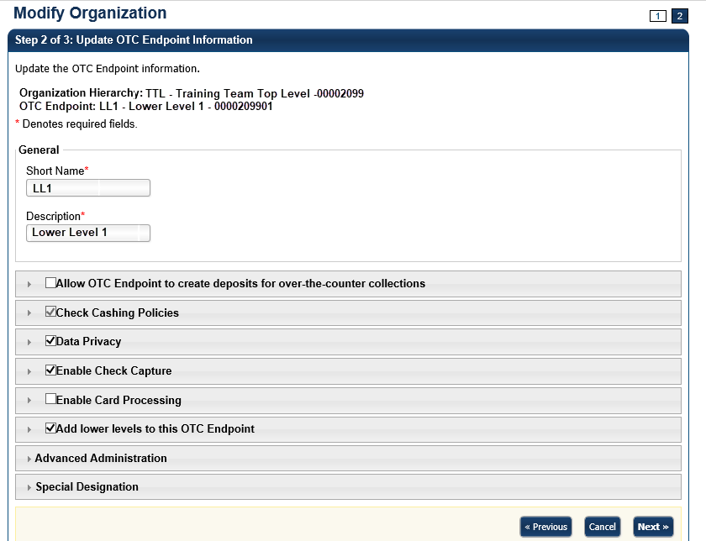

Application Tip

A short name must be entered to identify the OTC Endpoint that is being updated. If an OTC Endpoint exists, the data displayed in the text is available for update.

To allow the OTC Endpoint to create deposits, complete the following:
  - Select the Allow OTC Endpoint to create deposits for over-the-counter collections checkbox as shown in Figure 4.
Application Tip

Before a user is provisioned to a deposit-processing OTC Endpoint (TGA), ensure the Allow OTC Endpoint to create deposits for over-the-counter collections checkbox is checked.

  - Update Agency Location Code by completing the following step:
    - Entering the ALC
  - Update Address by completing the following step:
    - Entering the address details
  - Update Financial Institution Relationship(s) by completing the following steps:
    - Selecting both the Financial Institution and the associated Routing Transit Number (RTN)
    - Entering the Demand Deposit Account (DDA), retyping the DDA and selecting Add.
Application Tip

To delete the Financial Institution relationship, select the Delete checkbox(es) under the Delete column.

Figure 4. Allow OTC Endpoint to create deposits for over-the-counter collections
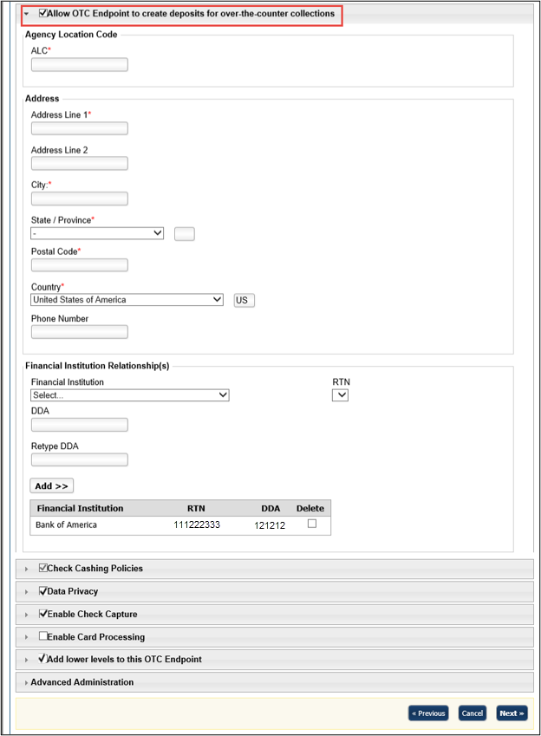

To specify the check cashing policies of the OTC Endpoint, complete the following:
  - Select the Check Cashing Policies checkbox as shown in Figure 5.
Application Tip

The Default Reason Codes allows you to specify the return reason codes relevant to your agency’s program. These codes represent the numeric codes used in ACH and paper return processing, which specify the reason for the return of the transaction and Check 21 codes.

Application Tip

If checkbox is checked and grayed out, it indicates that this OTC Endpoint is either inheriting the policies from the parent organization or its own information has already been defined, and the user does not have the privilege to make modifications. Only a CCA has privileges to modify the check cashing policies.

  - Add Default Reason Codes by completing the following steps:
    - Selecting a default reason code and selecting Add, optional. Repeat steps as necessary.
  - Delete Assigned Return Reason Code Filters by completing the following steps:
    - Checking Delete box(es) under the Delete column, optional
Application Tip

The Default Reason Codes allow you to specify the return reason codes relevant to your agency’s program. These codes represent the numeric codes used in ACH and paper return processing, which specify the reason for the return of the transaction and Check 21 codes.

Figure 5. Default Reason Codes
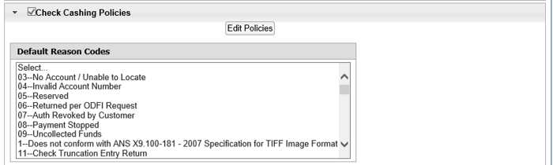

  - Update Agency Assigned Suspensions by completing the following steps, optional:
    - Entering the number of Days
    - Entering the Occurrence number
    - Selecting the Agency Assigned Suspensions you want to Delete by checking the boxes under the Delete column, if applicable
Application Tip

- To update the Agency Assigned Suspensions, select the applicable Default Reason Code in the box provided.
- The Agency Assigned Suspensions - Days allows you to specify the number of calendar days than an individual is unable to cash a check or pay by check and is calculated from the date the system is aware of the return file. The Agency Assigned Suspensions - Occurrence allows you to specify the suspension level.

  - Update Agency Verification Policy by completing the following steps, optional:
    - Selecting Include Represented and Retired Check or Include Retired Check Only
    - Checking Include Expired
    - Entering the number of Expired Days
    - Checking Agency Verification Policies—Delete
Application Tip

- Include Represented and Retired Check or Include Retired Check
Only allows you to specify whether the verification record is generated
on Represented or Retired items. Include Retired Check Only allows
you to specify whether the verification record is generated on only
Retired items.
- Include Expired indicates whether previous suspensions that have since expired are counted when accessing the suspension level to assign when the individual writes a check. Agency Verification Policies—Delete allows you to remove the check cashing policy for your OTC Endpoint. Once the check cashing policy is removed for the OTC Endpoint, the higher-level organization’s check cashing policy is automatically assigned to your OTC Endpoint.

To specify the data privacy of the OTC Endpoint, complete the following:
  - Select the Data Privacy checkbox.
  - Update Data Privacy:
    - Select the Data Privacy – Agency Available Attributes you want to block or unblock by checking the boxes under the Blocked column.
Application Tip

By default, Account, User Defined Field 1, Bank Routing Number, Note and Mask PII are checked as Blocked.

To enable the OTC Endpoint to capture checks, complete the following:
  - Select the Enable Check Capture checkbox.
  - Update Enable Check Capture by entering the Agency Location Code (ALC+2).
Application Tip

- Before a user is provisioned to a check capture OTC Endpoint (CHK), ensure the Enable Check Capture checkbox is checked.
- If checkbox is checked, it indicates that the OTC Endpoint information has been defined.
- The ALC+2 is required for initial setup. Once the ALC+2 is entered it cannot be updated.

  - Update OTC Verification Group by completing the following steps as shown in Figure 6:
    - Entering the Short Name (Starting With) and selecting Search
    - Selecting Yes or No for Queue Interface
    - Selecting the OTC Endpoint you want to add by checking the box under the Assign column and selecting Add Agency Group
Figure 6. Enable Check Capture
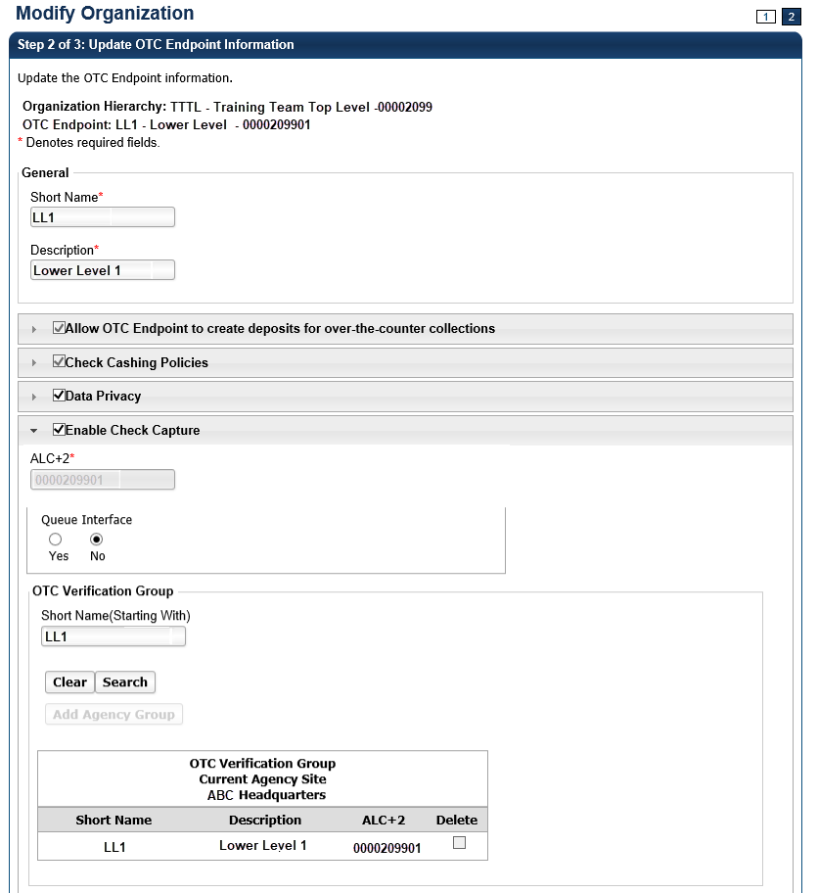

Application Tips

- By default, the OTC Endpoint Short Name displays. Add additional OTC Endpoints to the OTC Verification Group by selecting the Clear button to clear the Short Name and entering a Short Name, selecting Search and selecting Add Agency Group.
- Designating an OTC Verification Group allows for verification data to be shared among non-related OTC Endpoints. For example, Lower Level 1 and Lower Level 2 are siblings under the high-level organization, Training Team Top Level. Since there is no parent-child relationship between these two OTC Endpoints, users from one OTC Endpoint are isolated from the other’s verification data. By adding both unrelated locations to an OTC Verification Group, they are able to share information.
- The Queue Interface is used by military agencies that utilize the Deployable Disbursing System (DDS) database bridge.

    - Under OTC Verification Group, Current Agency Site,
      - Select the OTC Endpoint you want to delete by checking the box under the Delete column.
To enable the OTC Endpoint to process card payments, complete the following steps:
  - Select the Enable Card Processing checkbox
Application Tip

Before a user is provisioned to a card processing OTC Endpoint (CDC), ensure the Enable Card Processing checkbox is checked.

  - Update Enable Card Processing by completing the following steps as show in Figure 7:
  - Entering the Chain Code
  - Entering the Division
  - Entering the ALC
  - Entering the Merchant ID
  - Update the Address by entering the address details
  - Designate the Signature Capture by completing the following steps:
  - Checking the Signature Capture check box, optional
  - Select a Return Policy by completing the following steps:
  - Selecting the appropriate card transaction policy radio button for your organization, optional
Figure 7. Enable Card Processing Address, Signature Capture and Return Policy
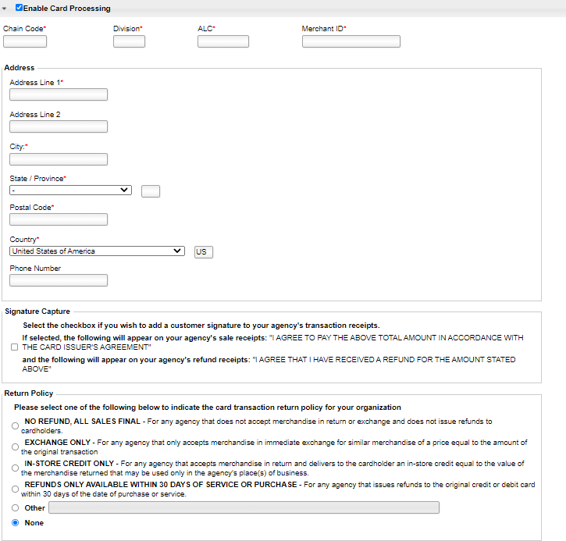
To add lower-level endpoints, complete the following:
- Select the Add lower levels to this OTC Endpoint checkbox.
- Update Add lower levels to this OTC Endpoint by completing the following steps:
- Entering the Short Name and Description.
- Selecting Add More Lines to add additional lower levels to this OTC Endpoint.
Application Tip

A short name must be entered to identify the OTC Endpoint that is being updated. If an OTC Endpoint exists, the data displayed in the text is available for update.

To specify the advanced administration, complete the following:
- Select Advanced Administration
- Specify Advanced Administration by completing the following:
- Selecting Yes or No for Debit Gateway
- Viewing or specifying the Forms Rendered Solution
- Viewing the Report Only Summary Level Data to CIR
- Viewing the Summary Level Classification
Application Tip

By default, all forms are set to be rendered and viewed in HTML. Under general circumstances, the ActiveX option does not need to be specified. The Forms Rendered Solution is read-only and only an HLAS can specify the option to switch between viewing and accessing forms in HTML or ActiveX.

Application Tips

- The Report Only Summary Level Data to CIR Information is read-only and only an HLAS can specify the information.
- A checked box indicates that detailed-level data will not be transmitted to Collections Information Repository (CIR) and only summary data is reported to CIR for all the check transactions that are processed under this OTC Endpoint (CHK) or ALC+2. This is mainly for the OTC Endpoints that are used to process tax data. An unchecked box indicates that detailed-level data is transmitted to CIR.
- The Summary Level Classification is read-only and only a High-Level Agency Support (HLAS), Check Capture Supervisor, and Check Lead Operator can specify the information.
- A checked box indicates that Check Capture Lead Operators and Check Capture Operators cannot classify individual checks. Instead, the classification of the batch will occur after all the checks have been scanned. An unchecked box indicates the Check Capture Operator will have to classify checks at the item level.

- Specify Batch List Print/Export Required During options by completing the following:
- Checking or unchecking the Close Batch checkbox
- Checking or unchecking the Approve Batch checkbox
- View or Specify Agency Comments
Figure 8. Advanced Administration
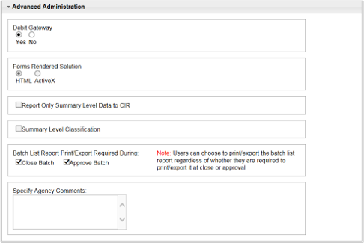
Application Tips

- A Check Capture Lead Operator, Check Capture Supervisor, and HLAS can add, edit, or remove Agency Comments. A Check Capture Administrator, Check Capture Operator, Agency Manager, and CIRA Viewer can view Agency Comments.
- The Specify Agency Comments field allows agencies to add, edit, or remove Agency comments that are sent to CIR as part of the check transmission.

To view the special designation, complete the following:
  - Select Special Designation as shown in Figure 9.
Figure 9. Special Designation
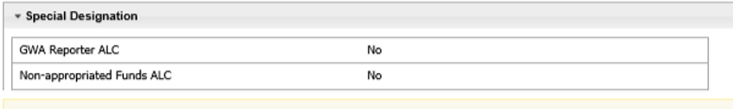
Application Tips

- The CARS Reporter special designation information is read-only
and displays for TGA and CHK endpoints. Only an HLAS can specify the Special Designation information.
- Yes indicates that the OTC Endpoint is associated with an ALC that has been designated as a CARS Reporter. No indicates that the OTC Endpoint is not associated with an ALC that has been designated as a CARS Reporter.

- Select Next. The Step 3 of 3: Review OTC Endpoint page appears.
- Verify the information is correct and select Submit. Select Edit, to modify the information entered and return to Step 4.
Additional Buttons
- Select Previous to return to the previous page.
- Select Cancel to return to the OTCnet Home Page. No data is saved.
- Select Return Home to return to the OTCnet Home Page.

Delete or Neutralize an OTC Endpoint
Accounting Specialists, Local Accounting Specialists, Check Capture Administrators, Check Capture Supervisors and Card Administrators are authorized to neutralize an OTC Endpoint or delete an OTC Endpoint.
Consider the following information on deleting an OTC Endpoint:
- You can delete an OTC Endpoint if no deposits or check transactions have been made to that endpoint.
- Deleting the OTC Endpoint deletes all information associated with the OTC Endpoint. This includes deleting deposit information that impacts the reports you run in OTCnet.
- Before deleting an OTC Endpoint, all user accounts must be removed from the OTCnet Deposit Processing Endpoint and OTCnet Check Processing Endpoint.
- The Agency Form Data must be removed. To remove the Agency Form Data, contact Customer Support at fiscalservice.otcchannel@citi.com.
Consider the following information on neutralizing an OTC Endpoint:
- You can neutralize an OTC Endpoint when deposits or check transactions have been created for that endpoint.
- Once the OTCnet Endpoint is neutralized, deposits or check transactions can no longer be created from that endpoint. The information from previously created deposits or check transactions can be accessed from OTCnet reporting.
- All user accounts must be removed from the OTCnet Deposit Processing Endpoint and OTCnet Check Processing Endpoint.
- The Agency Form Data must be removed. To remove the Agency Form Data, contact Customer Support at fiscalservice.otcchannel@citi.com.

Delete or Neutralize an OTC Endpoint
To delete or neutralize an OTC Endpoint, complete the following steps:
- From the Administration tab, select Manage Organizations>Organization Hierarchy>Delete. The Step 1 of 2: Select the OTC Endpoint(s) page appears.
- Select the OTC Endpoints you would like to Delete and select Next as shown in Figure 10.
Or
Select the OTC Endpoints you would like to Neutralize and select Next.
Figure 10. Step 1 of 2: Select the OTC Endpoint(s)
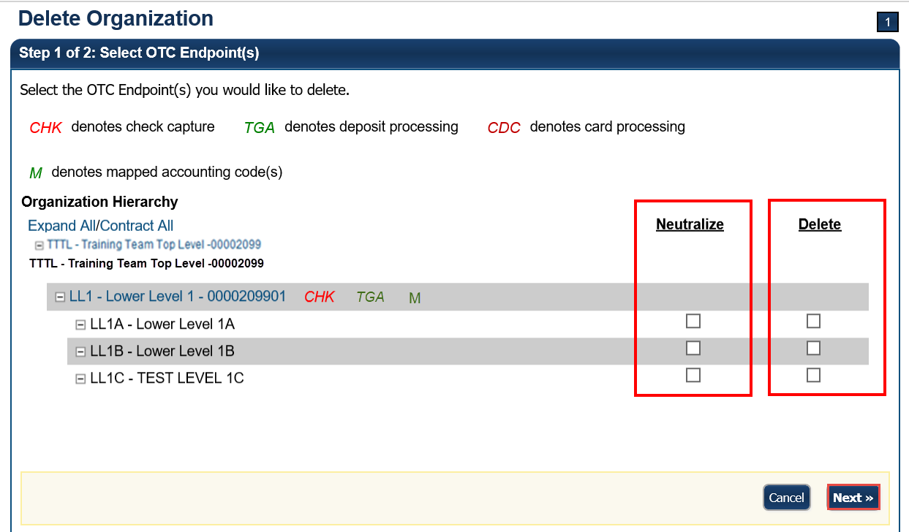
- The Step 2 of 2: Review OTC Endpoint(s) page appears. Verify that the correct endpoint is marked for deletion or neutralization and select Submit.
- A Confirmation page appears confirming the deletion or neutralization.

Additional Button
Select Return Home to return to the OTCnet Home Page.

View an OTC Endpoint
Accounting Specialists, Local Accounting Specialists, Check Capture Administrators, Check Capture Supervisors, Check Capture Lead Operators, Card Administrators and Card Operators are authorized to view an OTC Endpoint.
When the View OTC Endpoint page appears, you can verify the following information for the OTC Endpoint:
- General information including Short Name, Description, ALC and whether the endpoint is for check capture, deposit processing or card processing
- Address including Address details
- Financial Institution Relationships and Active Financial Institution Relationships including Financial Institution and RTN
- Check Cashing Policies including Assigned Return Reason Code Filters
- Agency Assigned Suspensions including Days and Occurrence
- Agency Verification Policies including Include Retired Check Only, Include Expired, Expired Days and Agency Verification Policies—Delete
- Data Privacy—Agency Available Attributes including Attribute Name (Short Name, Account, Mask PII, Bank Routing Number, User Defined Field 1 and Note) and whether it is Blocked
- Check Capture including the ALC+2 and Queue Interface
- OTC Verification Current Agency Site Lower Level I including the Short Name, Description and ALC+2 and whether it should be Deleted
- Card Processing including the Chain Code, Division and Merchant ID
- Lower Levels including the Short Name and Description
- Advanced Administration including Debit Gateway, Forms Rendered Solution, Report Only Summary Data to CIR, Summary Level Classification, Batch List Report Print/Export Required at Close Batch, Batch List Report Print/Export Required at Approve Batch and Specify Agency Comments
- Special Designation including GWA Reporter ALC and Non-appropriated Funds ALC

View an OTC Endpoint
To view an OTC Endpoint, complete the following steps:
- From the Administration tab, select Manage Organizations>Organization Hierarchy>View. The View Organization page appears.
- Select the OTC Endpoint you would like to view. The View OTC Endpoint page appears as shown in Figure 11.
Figure 11. View OTC Endpoint
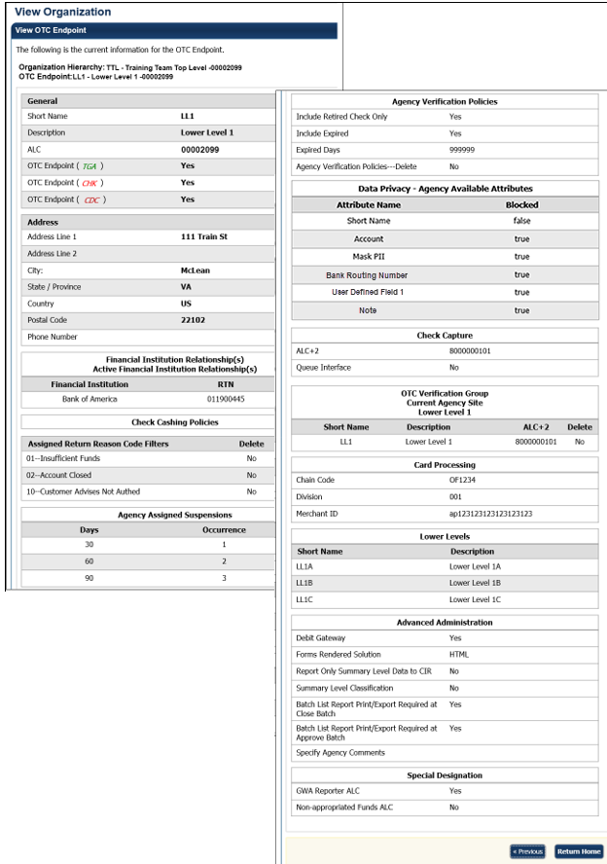


Additional Buttons
- Select Previous to return to the previous page.
- Select Return Home to return to the OTCnet Home Page.

Search for an OTC Endpoint
Accounting Specialists, Local Accounting Specialists, Check Capture Administrators, Check Capture Supervisors, Check Capture Lead Operators, Card Administrators and Card Operators can search for an OTC Endpoint.
When the View OTC Endpoint page appears, you can verify the following information for the OTC Endpoint:
- General information including Short Name, Description, ALC and whether the endpoint is for check capture, deposit processing or card processing
- Address
- Financial Institution Relationships and Active Financial Institution Relationships including Financial Institution and RTN
- Check Cashing Policies including Assigned Return Reason Code Filters
- Agency Assigned Suspensions including Days and Occurrence
- Agency Verification Policies including Include Retired Check Only, Include Expired, Expired Days and Agency Verification Policies—Delete
- Data Privacy—Agency Available Attributes including Attribute Name (Short Name, Account, Mask PII, Bank Routing Number, User Defined Field 1 and Note) and whether it is Blocked
- Check Capture including the ALC+2 and Queue Interface
- OTC Verification Current Agency Site Lower Level I including the Short Name, Description and ALC+2 and whether it should be Deleted
- Card Processing including the Chain Code, Division and Merchant ID
- Lower Levels including the Short Name and Description
- Advanced Administration including Debit Gateway, Forms Rendered Solution, Report Only Summary Data to CIR, Summary Level Classification, Batch List Report Print/Export Required at Close Batch, Batch List Report Print/Export Required at Approve Batch and Specify Agency Comments
- Special Designation including GWA Reporter ALC and Non-appropriated Funds ALC

Search for an OTC Endpoint
To search for an OTC Endpoint, complete the following steps:
- From the Administration tab, select Manage Organizations>Organization Hierarchy>Search. The View Organization page appears.
- Select the OTC Endpoint you would like to view. The View OTC Endpoint page appears as shown in Figure 12.
Figure 12. Step 2 of 2: View OTC Endpoint

Topic 4. Managing Accounting Codes
OTCnet provides enhanced check capture and deposit reporting functionalities to support the Central Accounting Reporting System (CARS). The CARS objectives include capturing classification information at the earliest possible time, streamlining central accounting and reporting, eliminating burdensome reconciliation, and providing timely Fund Balance with Treasury (FBWT) information to agencies.
OTCnet captures classification information for transactions (over-the-counter deposits) processed through the Deposit Reporting function and the Check Capture function to support the CARS requirement that all transactions capture standard classification information.
For OTCnet, standard classification information is accepted in the form of a Treasury Account Symbol (TAS) string or a Classification Key (C-Key), which is an internal Agency Accounting Code that is translated into a valid TAS.
OTCnet sends this C-Key information to CARS through the Collections Information Repository (CIR). CARS then communicates with the Shared Accounting Module (SAM) application to translate the C-Key into a valid TAS/BETC through the Cash Flow and Default Profiles that have been set up in SAM. Initially, classification of check transactions for non-CARS reporting agencies is optional.
To learn more about CARS, visit http://fms.treas.gov/CARS/index.html.

Modify Accounting Codes
The Check Capture Administrator, Check Capture Supervisor and Accounting Specialist are authorized to modify an accounting code. They can modify the classification code and description for an accounting code, indicate whether it’s a Treasury Account Symbol (TAS) and add and delete accounting codes.
If an Agency Accounting Code label is customized, it is displayed as the label above the imported codes, according to the custom label that was defined for the highest-level organization. This applies to OTC Endpoints that use the deposit processing and/or check processing functionalities. The default accounting code label is Agency Accounting Code.

Modify Accounting Codes
To modify an existing accounting code, complete the following steps:
- From the Administration tab, select Manage Organizations>Accounting Codes>Modify. The Step 1 of 3: Select OTC Endpoint page appears.
- Select the organization endpoint for the accounting codes you wish to modify. The Step 2 of 3: Update Accounting Codes page appears.
- Under the New Accounting Codes to be Added table, enter the accounting code details, and select Next.
Application Tip

If an Agency Accounting Code label is customized, it is displayed as the label above the imported or modified codes within the Maintain Accounting Codes module, according to the custom label that was defined for the highest-level organization. Within the rest of the application, custom labels apply to deposit processing functionalities, but are not extended to check processing functionalities. The default accounting code label is Agency Accounting Code.

Update the details by completing the following:
- Selecting the TAS checkbox to indicate that the accounting code is a Treasury Account Symbol (TAS), if applicable
- Entering details in both the Agency Accounting Code and Description text boxes as shown in Figure 13
- Checking the Skip Selected box to skip saving any of the imported accounting codes
Figure 13. Step 2 of 3: Update Accounting Codes
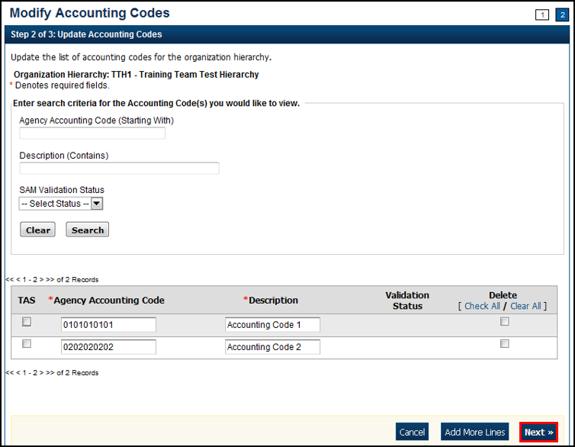

- The Step 3 of 3: Review Accounting Codes page appears. Verify the information is correct and select Submit.
- A Confirmation page appears presenting the imported accounting codes. Simultaneously, accounting codes flagged as TAS must be transmitted to the Shared Accounting Module (SAM) to confirm they are valid TAS strings.
Additional Button
Select Return Home to return to the OTCnet Home Page.

Import Accounting Codes
The Check Capture Administrator (CCA), Check Capture Supervisor (CCS) and Accounting Specialist (Acc Spec) are authorized to import accounting codes.
To import an accounting code, the CCA, CCS, or Acc Spec has several options. From the Import From File page, they can select the type of accounting code (e.g., CSV File, Fixed File, XML File) they want to import into the system, browse to its location and Import. Next, they can review the accounting codes to be imported into the system and update as needed. Another option is to remove accounting codes before submitting them, by marking them for removal and updating the list of codes.
Details are updated by selecting the TAS checkbox to indicate the accounting code is a Treasury Account Symbol (TAS), if applicable, entering the details in both the Agency Accounting Code and Description text boxes and/or checking the Skip Selected box to skip saving the imported accounting codes.
Once the accounting codes are successfully imported and the Confirmation page appears, simultaneously, the accounting codes flagged as TAS must be transmitted to SAM to confirm that they are valid TAS strings.

Import Accounting Codes
To import an accounting code, complete the following steps:
- From the Administration tab, select Manage Organizations>Accounting Codes>Import. The Step 1 of 4: Select OTC Endpoint page appears.
- Select the top-level organization endpoint for which you want to import accounting codes. The Step 2 of 4: Import from File page appears.
- Select the type of accounting code to import into the system and browse to its location and select Import. The Step 3 of 4: Select Accounting Codes page appears.
- Update the list of accounting codes that are imported into the system and select Next as shown in Figure 14.
Figure 14. Step 3 of 4: Select Accounting Codes
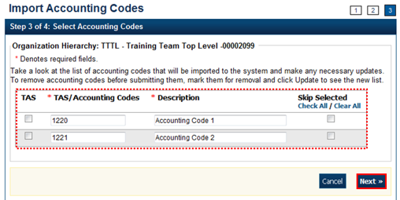
Update the details by completing the following steps:
  - Selecting the TAS checkbox to indicate that the accounting code is a Treasury Account Symbol (TAS), if applicable
Application Tip

Download Treasury Account Symbols (TAS), for import from the Shared Account Module (SAM) site at: https://www.sam.fms.treas.gov/sampublic/tasbetc.htm.

  - Entering the details in both the Agency Accounting Code and Description text boxes
  - Checking the Skip Selected box to skip saving any of the imported accounting codes
- The Step 4 of 4: Review page appears. Verify the information is correct and select Submit.
- A Confirmation page appears showing that the accounting codes have been imported. Simultaneously, accounting codes flagged as TAS will need to be transmitted to the Shared Accounting Module (SAM) to confirm that they are valid TAS strings.
Additional Button
Select Return Home to return to the OTCnet Home Page.

View Accounting Codes
The Accounting Specialist (Acc Spec), Local Accounting Specialist (LAS), Check Capture Administrator (CCA), and Check Capture Supervisor (CCS) are authorized to view the active accounting codes available for the organization hierarchy.
To view an accounting code, the Acc Spec, LAS, CCA or CCS selects the highest-level organization endpoint accounting code available to view.
If an Agency Accounting Code label is customized, it is displayed as the label above the imported codes, according to the custom label that was defined for the highest-level organization. This applies to OTC Endpoints that use the deposit processing and/or check processing functionalities. The default accounting code label is Agency Accounting Code.

View Accounting Codes
To view an accounting code, complete the following steps:
- From the Administration tab, select Manage Organizations>Accounting Codes>View. The View Accounting Codes page appears.
- Select the highest-level organization endpoint accounting codes available to view. The View Accounting Codes page appears as shown in Figure 15.
Figure 15. View Accounting Codes
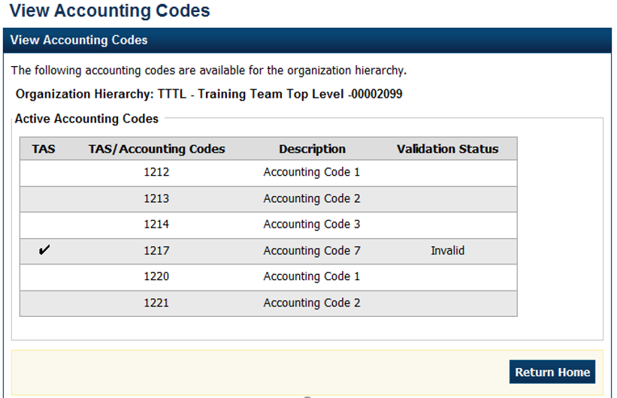
Application Tips

- Only active accounting codes available for deposit processing and check processing (if applicable) appear.
- Under the Active Accounting Code table, both Treasury Account Symbols (TAS) and accounting codes not identified as TAS display.
- If an accounting code is a TAS, a check mark displays under the TAS column, and the SAM validation status (Valid, Invalid or In Process) displays under the Validation Status column.

Additional Buttons
Select Return Home to return to the OTCnet Home Page.

Modify Endpoint Mappings
An endpoint mapping is the assignment of accounting codes to an agency’s OTC Endpoint, to which a deposit amount is allocated.
The accounting codes that display on the page are the codes that:
- Meet your search criteria.
- Are not assigned to your OTC Endpoint.
If you do not enter search criteria, all the accounting codes defined for the highest-level organization appear.
Additional information for modifying Endpoint Mapping includes the following:
- If an agency has identified accounting codes as TAS, only TAS identified as Valid by SAM will be available for mapping to an OTC Endpoint.
- To remove mappings for an accounting code, check the Remove box(es) and select Update.
- A mapped accounting code is not eligible for removal if a batch is associated with a transaction within an active batch that is Open, Closed, or Approved or a deposit that is in Draft or Awaiting Approval (AWAP) status. An error message is displayed to a user if this scenario occurs.

Modify Endpoint Mappings
To map accounting codes to OTC Endpoints, complete the following steps:
- From the Administration tab, select Manage Organizations>Accounting Codes>Modify OTC Endpoint Mappings. The Step 1 of 4: Select OTC Endpoint page appears.
- Select the OTC Endpoint for the accounting code endpoint mapping you would like to assign or remove. The Step 2 of 4: View Assigned Accounting Codes page appears.
Application Tip

If an Agency Accounting Code label is customized, it is displayed as the label above the imported or modified codes within the Maintain Accounting Codes module, according to the custom label that was defined for the highest-level organization. Within the rest of the application, custom labels apply to deposit processing functionalities but are not extended to check processing functionalities. The default accounting code label is Agency Accounting Code.

- Select Assign Mappings to assign an accounting code to an OTCnet Endpoint. The Step 2 of 4 Continued: Search and Assign Accounting Codes page appears.
Or
Select Remove Mappings to remove an accounting code from an OTCnet Endpoint. The Step 3 of 4: Remove Accounting Codes page appears.

- Assign or remove an accounting code to or from an OTCnet Endpoint as shown in Figure 16.
To Assign Mappings to an OTCnet Endpoint, complete the following:
- Enter the Accounting Code (Starting With) search criteria, optional
- Enter the Description (Contains) search criteria, optional
- Select Search, optional
- Check the Assign box(es) for the accounting codes you must assign
- Select Next (Proceed to Step 3 of 4: Assign Accounting Codes)
Or
To Remove Mappings from an OTCnet Endpoint, complete the following:
- Check the Remove box(es) for the accounting codes that you must remove
- Select Next (Proceed to Step 4 of 4: Review Accounting Codes from Endpoint)
Figure 16. Step 2 of 4 Continued: Search and Assign Accounting Codes
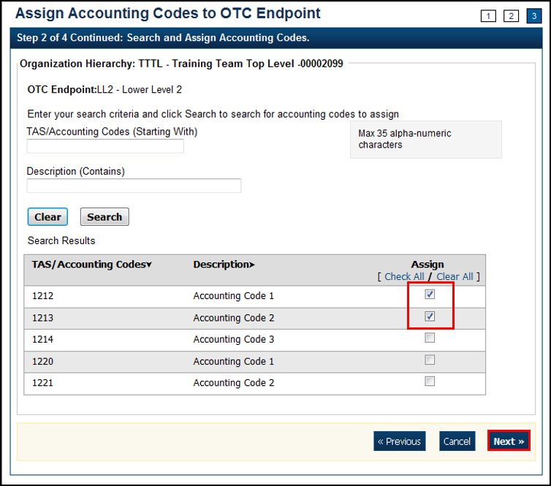
Application Tip

If an Agency has identified accounting codes as a Treasury Account Symbol (TAS), only a TAS identified as Valid by Shared Accounting Module (SAM) is available for mapping to an OTC Endpoint.

- The Step 3 of 4: Assign Accounting Codes page appears. Review and verify the accounting code(s) you would like to assign and select Next. (Proceed to Step 4 of 4: Review Accounting Codes to Endpoint)
Application Tips

- Check the Remove box(es) and select the Update button to delete the OTC Endpoint mapping for an accounting code.
- A mapped accounting code is not eligible for removal if a batch is associated with a transaction within an active batch that is Open, Closed or Approved, or a deposit that is in Draft or Awaiting Approval (AWAP) status. An error message is displayed to a user if this scenario occurs.

- The Step 4 of 4: Review Accounting Codes to Endpoint page appears. Confirm the information is correct and select Submit to assign the accounting code(s) to the OTC Endpoint.
OR
The Step 4 of 4: Review Accounting Codes to Endpoint page appears. Confirm the information is correct and select Submit to remove the accounting code(s) to the OTC Endpoint.
- A Confirmation page appears showing that the accounting codes have been assigned to or removed from the OTC Endpoint.
Additional Buttons
- Select Return Home to return to the OTCnet Home Page.
- Select Manage Additional to manage another accounting code.

Topic 5. Managing Processing Options
As part of managing your organization hierarchy, you need to define your deposit processing options. Processing options are parameters for the deposit and adjustments process. You must first define processing options at the highest level of the organization before defining lower-level options. For lower-level organizations, if you do not define these options, then the lower-level organizations will take on the options set for the next higher-level organization that does have the options set.
If you do not define processing options, your organization cannot create deposits or classify a batch at the summary level. You can define processing options at any level within your organization. You can also view the processing options by OTC Endpoint report to manage processing options in your organization.
As an Accounting Specialist, you are authorized to modify the following processing options for your organization’s hierarchy:
- Accounting Classifications for Adjustments, Corrections, and Returned Items: Identifies the default accounting codes to which you want adjusted amounts credited and debited. This also applies to credit and debit voucher ALC Account Switch Corrections, returned items, and batches classified at the summary level containing a failed item.
- Correspondence: Provides the financial institution with address information for any correspondence, including returned item information
- Deposit Preparation: Sets default settings for deposit preparation to save time for Deposit Preparers
- Transaction History: Sets default settings for historical data about transactions

Modify Processing Options
The Accounting Specialist and Local Accounting Specialist are authorized to modify Deposit Processing options. The Check Capture Supervisor and Check Capture Lead Operator are authorized to modify Check Processing options.
The page displays accounting codes:
- That are not applied as a debit or credit adjustment to your OTC Endpoint
- That meet your search criteria
If you do not enter search criteria, all accounting codes defined for the highest-level organization appear.

Modify Processing Options
To modify a processing option, complete the following steps:
- From the Administration tab, select Manage Organizations>Processing Options>Modify. The Step 1 of 3: Select Organization Endpoint page appears.
Application Tips

- Processing options must first be defined for the highest-level organization before any lower-level organization’s processing options are defined.
- If the processing options are not defined for the highest-level organization, all lower-level organization links are disabled.

- Select the OTC Endpoint for which you want to modify a processing option. The Step 2 of 3: Define Processing Options page appears.
- Modify the processing option(s) and select Next.
To modify Accounting Classifications for Adjustments, Corrections, and Returned Items, complete the following:
Application Tips

- An accounting code is assigned to both a debit adjustment and credit adjustment.
- Accounting classifications for adjustments apply to Accounting Specialists, Check Capture Supervisors and Check Capture Lead Operators. Accounting classifications for corrections and returned items apply to Check Capture Supervisors and Check Capture Lead Operators.

Update Default Accounting Codes by completing the following:
- Selecting either Use parent’s values or Use my values
- Entering the search criteria for the accounting code you would like to view and select Search (magnifying glass)
Application Tip

To narrow an accounting code search, enter a partial or full accounting code.

Or

- Selecting Search (magnifying glass) to view accounting codes
Application Tip

- All accounting codes that meet your search criteria and are not applied as
a debit or credit adjustment, correction or returned item to your OTC Endpoint are displayed on the page. If you do not enter search criteria, all the accounting codes defined for the highest-level organization appear.
- By default, the first ten accounting codes display, first by ascending special character order, then by numerical order and finally by ascending alphabetical order by accounting code.
- If the organization has more than ten accounting codes, select the pagination menu above the section containing the existing accounting codes to view additional pages of results. The system will only allow a user to view and apply active accounting codes not designated as TAS or those designated as TAS that have been validated by SAM.

- Selecting the accounting code to apply a credit and/or debit type and selecting Assign to Debit and/or Assign to Credit
Application Tip

- An accounting code is assigned to debit and credit adjustment, correction, and returned item types.
- After an accounting code is assigned to debit or credit adjustment, it appears in the Adjustment Type/Default Accounting Code table.

- Selecting Yes or No to allow changes by an organization lower in the hierarchy

Update Default Accounting Code Usage by completing the following steps:
- Selecting either Use parent’s values or Use my values
- Selecting either Always Use the Default for Deposit Adjustments or Default based upon Deposit Subtotals for Deposit Adjustments
- Selecting Yes or No to allow changes by an organization lower in the hierarchy

To modify Correspondence, complete the following steps:
Update Returned Items by completing the following steps:
- Selecting Use parent’s values or Use my values
- Entering the corresponding address information that you would like to be displayed to a financial institution when a return item adjustment is created
- Selecting Yes or No to allow changes by an organization lower in the hierarchy
Update Deposit Adjustment by completing the following steps:
- Selecting Use parent’s values or Use my values
- Entering the corresponding address information that you would like to be displayed to a financial institution when a deposit adjustment is created
- Selecting Yes or No to allow changes by an organization lower in the hierarchy

To modify Deposit Preparation, complete the following steps:
Update ITGA Deposit Creation by:
- Selecting Use parent’s values or Use my values
- Selecting Yes or No to allow an endpoint to create foreign deposits
- If the endpoint accepts foreign deposits, enter the Default foreign currency when creating deposits details
- Selecting Yes or No to allow changes by an organization lower in the hierarchy
Update Subtotals and Cash Count by completing the following steps:
- Selecting Use parent’s values or Use my values
- Selecting Yes or No for each of the following options:
    - Include subtotals for Checks/Money Orders and Cash
    - Include Currency count and subtotals by denomination
    - Include Coin count and subtotals by denomination
    - Allow changes by an organization lower in the hierarchy

Update Accounting Code Subtotals by completing the following steps:
- Selecting Use parent’s values or Use my values
- Selecting Yes or No for each of the following options:
- Allow negative accounting code subtotals
- Allow changes by an organization lower in the hierarchy

Update Separation of Duties as shown in Figure 17 by completing the following steps:
- Selecting Use parent’s values or Use my values
- Selecting Yes or No for each of the following options:
- Deposits must be prepared and approved by different employees
- Allow changes by an organization lower in the hierarchy
Figure 17. Update Deposit Processing Options with Deposit Preparation expanded
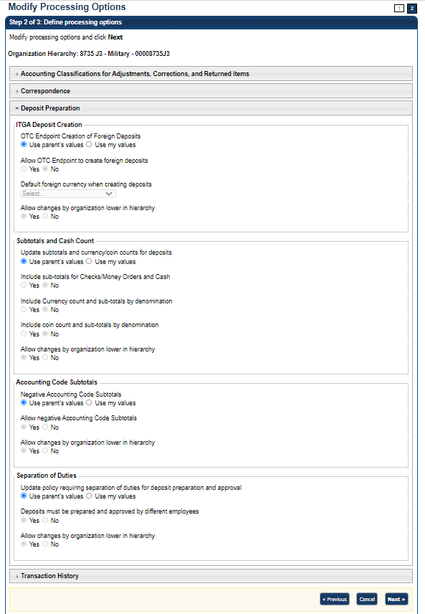

To modify Transaction History, complete the following steps:
- Select Use parent’s values or Use my values
- Enter the Number of days displayed in the text box, if applicable
- Select Yes or No to allow changes by an organization lower in the hierarchy
- The Step 3 of 3: Review the following processing options page appears. Verify the information is correct and select Submit.

- A Confirmation page appears, showing which processing options were applied to the organization.
Additional Buttons
- Select Cancel to return to the OTCnet Home Page. No data is saved.
- Select Edit to return to the previous page.
- Select Next to advance to the next page.
- Select Previous to return to the previous page.
- Select Submit to complete the process and display the Confirmation page.
- Select Return Home to return to the OTCnet Home Page.

View Processing Options
The Accounting Specialist and Local Accounting Specialist are authorized to view deposit processing options. The Check Capture Supervisor and Check Capture Lead Operator are authorized to view check processing options.
When the View Processing Options page appears, it presents the custom labels in effect for the organization hierarchy, including the following:
- Accounting Classifications for Adjustments, Corrections, and Returned Items
- Correspondence
- Deposit Preparation
- Transaction History

View Processing Options
To view a processing option, complete the following steps:
- From the Administration tab, select Manage Organizations>Processing Options>View. The Select Organization Endpoint page appears.
- Select the highest-level organization or any lower-level OTC Endpoint to view the processing options.
- A View Processing Options page appears, presenting the custom labels in effect for the organization hierarchy as shown in Figure 18.
Figure 18. View Processing Options
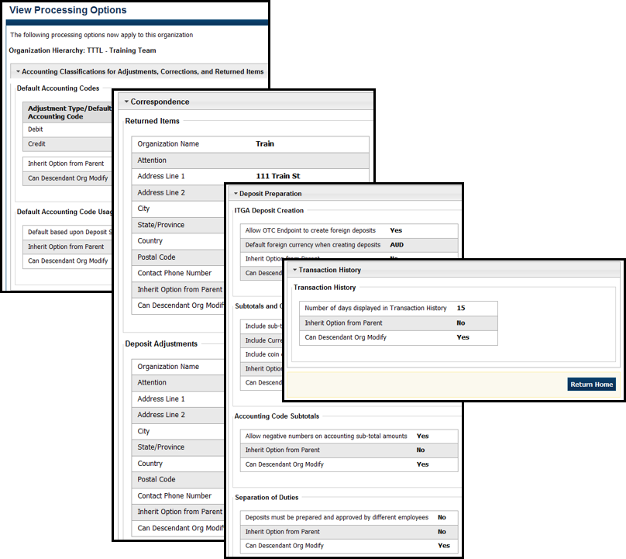

Additional Button
Select Return Home to return to the OTCnet Home Page.

Summary
In this chapter, you learned:
- The purpose of organizational hierarchy
- How to add lower-level endpoints to the highest level of an organization hierarchy
- How to add additional lower-level endpoints or a financial institution relationship to a hierarchy that was previously defined
- How to make changes to OTC Endpoints
- How to delete OTC Endpoints
- How to view OTC Endpoints
- How to modify accounting codes

