

Chapter 3. Managing User Accounts
OTCnet Participant User Guide

Table of Contents
Overview, Topics, and Audience 1
Overview 1
Topics 1
Audience 1
Topic 1 The Purpose of Managing User Accounts 2
Topic 2 Creating a User Identity in SailPoint IIQ 3
Create a User Identity in SailPoint IIQ 3
Create a User Identity in SailPoint IIQ 4
Topic 3 Adding or Removing User Access in SailPoint IIQ 7
Add User Access in SailPoint IIQ 7
Add User Access in SailPoint IIQ 8
Remove User Access in SailPoint IIQ 11
Remove User Access in SailPoint IIQ 12
Topic 4 Approving or Denying User Access Requests in SailPoint IIQ 15
Approve or Deny User Access Requests in SailPoint IIQ 15
Approve or Deny User Access Requests in SailPoint IIQ 16
Topic 5 Importing User Identity to OTCnet 18
Import User Identity to OTCnet 18
Import User Identity to OTCnet 19
Topic 6 Adding or Removing an Endpoint/Role for an OTCnet User 22
Add an Endpoint/Role for an OTCnet User 22
Add an Endpoint/Role for an OTCnet User 23
Remove an Endpoint/Role for an OTCnet User 26
Remove an Endpoint/Role for an OTCnet User 27
Topic 7 Approving or Rejecting an Endpoint/Role (or the Removal of an Endpoint/Role) 29
Approve or Reject an Endpoint/Role (or the Removal of an Endpoint/Role) 29
Approve or Reject an Endpoint/Role (or the Removal of an Endpoint/Role) 30
Summary 34

List of Figures
Figure 1: Creating Identity in SailPoint IIQ 4
Figure 2: Create Identity Screen 5
Figure 3: Create Identity Request Submitted 5
Figure 4: Manage Access/Manage User Access 8
Figure 5: Select Users Screen 9
Figure 6: Manage Access/Add Access Screen 9
Figure 7: Review and Submit Add Access Screen 10
Figure 8: Search Users Screen 12
Figure 9: Remove User Access Screen 13
Figure 10: Review and Submit Remove Access Screen 13
Figure 11: Approval Awaiting the Approver's Action Screen 16
Figure 12: Approve or Deny Screen 16
Figure 13: Import OTCnet User Identity 19
Figure 14: Enter User’s Email Address to Import User 19
Figure 15: Import User Identity Confirmation Screen 20
Figure 16: Search User Directory Screen 23
Figure 17: Manage User Account Screen 23
Figure 18: Add Endpoint/Role Screen 24
Figure 19: Confirmation Screen on Adding Endpoint/Role Request Submitted 25
Figure 20: Manage User Account Screen 27
Figure 21: Select an Endpoint and Role to Remove Screen 28
Figure 22: Confirmation Screen on Removing Endpoint/Role Request Submitted 28
Figure 23: Manage OTCnet Users Screen 30
Figure 24: Access Approval Request Screen 31
Figure 25: Confirmation Screen on Approval/Rejection of the Access Request 32

Glossary
Select this link to access the full OTCnet Glossary.

Overview, Topics, and Audience

Overview
Welcome to Managing User Accounts. In this chapter, you will learn how to:
- Manage user accounts
- Create an identity for a user in SailPoint IIQ
- Add or remove user access in SailPoint IIQ
- Approve or deny user access requests in SailPoint IIQ
- Import a user identity to OTCnet
- Add or remove an endpoint/role for an OTCnet user
- Approve or reject an endpoint/role (or the removal of an endpoint/role) in OTCnet

Topics
The topics in this chapter include the following:
- The Purpose of Managing User Accounts
- Creating an Identity for a User in SailPoint IIQ
- Adding or Removing User Access in SailPoint IIQ
- Approving or Denying User Access Requests in SailPoint IIQ
- Importing a User Identity to OTCnet
- Adding or Removing an Endpoint/Role for an OTCnet User
- Approving or Rejecting an Endpoint/Role (or the Removal of an Endpoint/Role) in OTCnet

Audience
The intended audience for the Managing User Accounts Participant User Guide includes:
- Primary Local Security Administrator (PLSA)
- Local Security Administrator (LSA)

Topic 1 The Purpose of Managing User Accounts
As the Primary Local Security Administrator (PLSA) or Local Security Administrator (LSA) for your organization, you are authorized to manage the users who have access to OTCnet. Before a user can access OTCnet, they must have an identity and account created in SailPoint IIQ.
The PLSAs/LSAs assist with creating an identity for a user and/or requesting a High-Level Organization (HLO) or role access for them in SailPoint IIQ. This is the preferred method of registration for users in SailPoint IIQ, while the self-registration functionality is available to users as needed.
Managing a user’s account involves (in order):
- Registering users by creating an identity for a user in SailPoint IIQ
- Adding or removing user access in SailPoint IIQ
- Approving or denying user access requests in SailPoint IIQ
- Importing a user identity to OTCnet
- Adding or removing an endpoint/role for a user in OTCnet
- Approving or rejecting an endpoint/role (or the removal of an endpoint/role) for a user in OTCnet
The User Provisioning workflow includes the following high-level action steps:
- The PLSA or LSA receives an authorized/approved request to add a new user (from their organization) to OTCnet.
- The PLSA or LSA logs in to SailPoint IIQ, selects Manage User Access, and searches for the email address of the new user from the request in step 1.
  - If the email address is not found, the PLSA or LSA selects Manage Identity and Create Identity from the menu options. They enter the authorized user’s email address and select Submit.
  - If the email address is found, the PLSA or LSA continues with step 3.
- The PLSA or LSA adds the authorized role/HLO or role/Financial Institution (FI) combinations to the identity.
- Another PLSA or LSA approves (or denies) the request in SailPoint.
- The PLSA or LSA imports the email address of a new user to OTCnet so that the user can be added to the OTCnet database. Then the PLSA or LSA assigns the authorized endpoint(s) and role(s) to the user.
- Another PLSA or LSA approves (or rejects) the request in OTCnet. Then the user is informed that their OTCnet provisioning is complete.

Topic 2 Creating a User Identity in SailPoint IIQ
SailPoint IIQ is an identity management solution utilized by the Department of the Treasury. It is being phased in through the Common Approach to Identity Assurance project, commonly referred to as CAIA.

Create a User Identity in SailPoint IIQ
The PLSAs and LSAs assist with creating an identity for a user and/or requesting an HLO or role access for them in SailPoint IIQ. This is the preferred method for registering users and requesting HLO and role access for users in SailPoint IIQ.
To create a user identity, select Create Identity from the menu at the top left of the SailPoint IIQ application under Manage Identity. Then enter their email address and select the Submit button.
Two notification emails will be sent out once an identity is created:
- One to the new identity holder, and
- One to the person who created the identity.
New users, not registered in SailPoint IIQ, will not be able to access OTCnet. Their identity will not be recognized. They may get a message that the email and/or password they entered is incorrect.

Create a User Identity in SailPoint IIQ
To create a user identity, complete the following steps:
- At the top left of the SailPoint IIQ application, select the Hamburger Menu to display the available menu options.
- Select the Manage Identity option, then select Create Identity as shown in Figure 1.
Figure 1: Creating Identity in SailPoint IIQ
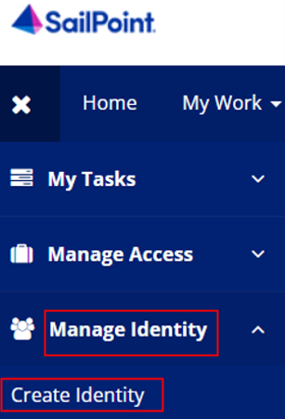
- SailPoint IIQ will route to the Create Identity screen as shown in Figure 2.
Application Tip

- There will be two fields available to fill out, Identity Name and Email.
- The Identity Name will be prepopulated as it is a unique identifier required by SailPoint IIQ.

- Enter an email address for the identity you want to create and select Submit at the bottom of the page.
Figure 2: Create Identity Screen
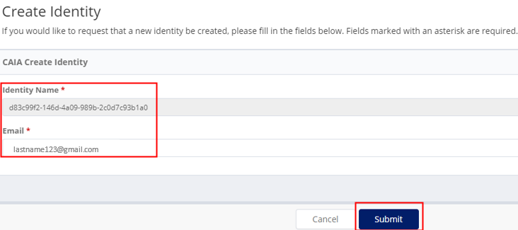
Application Tip

SailPoint IIQ will notify you if an identity with the email you provided already exists.

- Once submitted, SailPoint IIQ will display the home page with a success message as shown in Figure 3.
Figure 3: Create Identity Request Submitted
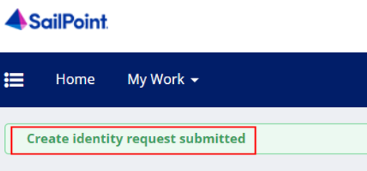
Application Tip

- Due to system design, it may take up to a minute for the identity to be processed in SailPoint IIQ.
- Two notification emails will be sent out once an identity is created, one to the new identity holder and one to the person who created the identity.

Topic 3 Adding or Removing User Access in SailPoint IIQ
There are two system administrator groups inside SailPoint IIQ, requestors and approvers.
- Requestors can request (or add access) on behalf of someone else. They can also remove user access.
- Approvers can approve or deny those requests. The application approvers will receive notification that there is an access request available to review.
After a PLSA or LSA requests access for a user, the application looks for other approvers for the organizational HLO or role selection and notifies them of the pending request.
In SailPoint IIQ, approvers are determined based on the HLO selections (approvers are security administrators with the same HLO assignments).

Add User Access in SailPoint IIQ
To request/add OTCnet user access, select Manage Access from the main menu, then select Manage User Access. Search for the user by typing their email address and selecting the Search button. Then select the checkmark to the left of the user's email address in the returned search result and select Next.
Make sure that Add Access is selected. In the search field, enter the HLO or role name to be assigned to the user. To select the HLO or role in the search results, select the checkmark to the left of the HLO or role name, then select Next. Review the requested role(s) and select the Submit button.

Add User Access in SailPoint IIQ
To request/add OTCnet user access, complete the following steps:
- At the top left of left of the application, select the Hamburger Menu to display the options.
- Select the Manage Access option, then select Manage User Access as shown in Figure 4.
Figure 4: Manage Access/Manage User Access
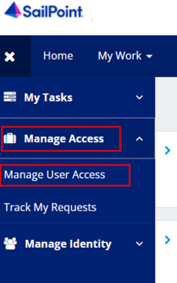
- Search for the user (recipient of the access) by typing their email address and selecting the Search button (blue magnifying glass) as shown in Figure 5.
- Select the checkmark to the left of the user's email address in the returned search result, then select Next at the bottom of the page.
Figure 5: Select Users Screen
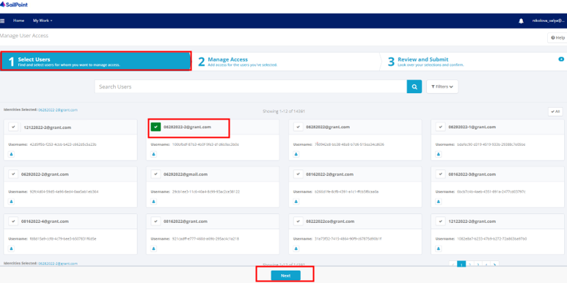
- Select Add Access as shown in Figure 6. In the search field, enter part or all of the HLO or role name to be assigned to the user. For example, enter “customer.”

Application Tip

If you are unsure of the HLO or role name, simply select the Magnifying Glass button to return all roles that you as a requestor are authorized to provision to users.

- Select an HLO or role by selecting the checkmark to the left of the HLO or role name. Select Next at the bottom of the page.
Figure 6: Manage Access/Add Access Screen
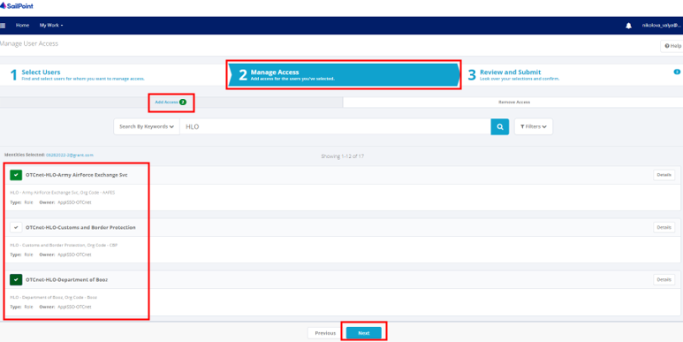
Application Tip

Multiple HLOs or roles can be selected.

- Review the requested HLOs or role(s) as shown in Figure 7. Select the voice bubble on the right side to add any comments on the HLO or role, as needed. Then select the Submit button when finished.
Figure 7: Review and Submit Add Access Screen
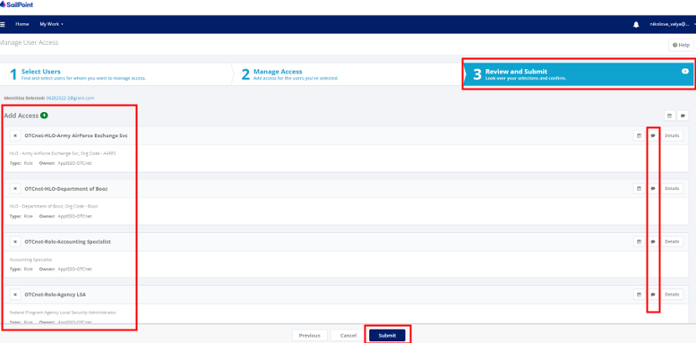
- A confirmation message will appear. You will also receive an email confirmation. The request is now pending approval.

Remove User Access in SailPoint IIQ
To remove user’s access, select Manage Access from the main menu, then select Manage User Access. Search for the user by typing their email address and selecting the Search button. Then select the checkmark to the left of the user's email address in the returned search result and select Next.
Make sure Remove Access is selected and then select the Magnifying Glass Icon to the right of the text box to return all currently assigned HLOs or roles for the selected user. If everything is correct, select the Submit button to confirm the changes. If the information is incorrect, select the Previous button to modify the removal.

Remove User Access in SailPoint IIQ
To remove OTCnet user access, complete the following steps:
- At the top left of the application, select the Hamburger Menu to display the options.
- Select the Manage Access option, then select Manage User Access.
- Search for the user by typing their email address and selecting the Search button (blue magnifying glass) as shown in Figure 8.
- Select the checkmark to the left of the user's email address in the returned search result, then select Next at the bottom of the page.
Figure 8: Search Users Screen
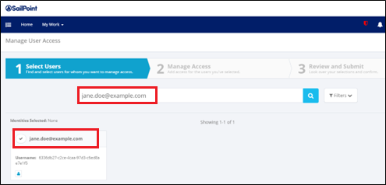
- Select Remove Access as shown in Figure 9. Then select the Magnifying Glass icon to the right of the text box to return all currently assigned HLOs or roles for the selected user. Select Next.
Figure 9: Remove User Access Screen
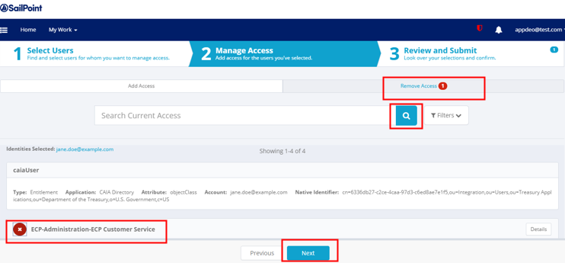
Application Tip

The requestor will only be able to remove HLOs or roles that they are authorized to manage.

- Review the information to confirm the removal as shown in Figure 10. You may add any comments using the voice bubble on the right side. Then select the Submit button to confirm the changes.
Figure 10: Review and Submit Remove Access Screen
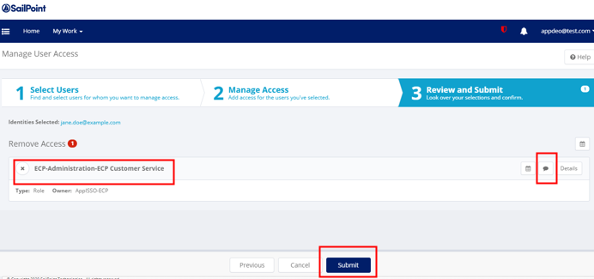
Application Tip

If the information is incorrect, select the Previous button to modify the removal.

Topic 4 Approving or Denying User Access Requests in SailPoint IIQ
A PLSA or LSA assigns HLOs or roles to a user; approvers of these requests are determined based on the HLO org selections. They are security administrators with the same HLO assignments. An approver logs in to SailPoint IIQ and approves (or denies) the request(s).
Most actions within SailPoint IIQ will require at least one level of approval.

Approve or Deny User Access Requests in SailPoint IIQ
To approve or deny user access requests, first notice a red number notification next to the Bell icon in the upper right-hand corner of the main SailPoint IIQ dashboard. Select the Approvals (or Notifications) box or the Approvals option under the Bell icon.
On the right side of the screen containing the details about the request, you will have the option to approve or deny the request. Select Approve or Deny and you will see a confirmation pop-up window.

Approve or Deny User Access Requests in SailPoint IIQ
To approve or deny user access requests, complete the following steps:
- Notice a red number notification next to the Bell icon in the upper right-hand corner of the main SailPoint IIQ dashboard as shown in Figure 11.
Application Tip

You may also receive an email notification about the approval request.

- Select the Approvals (or Notifications) box, or the Approvals option under the Bell icon on the home page.
Figure 11: Approval Awaiting the Approver's Action Screen
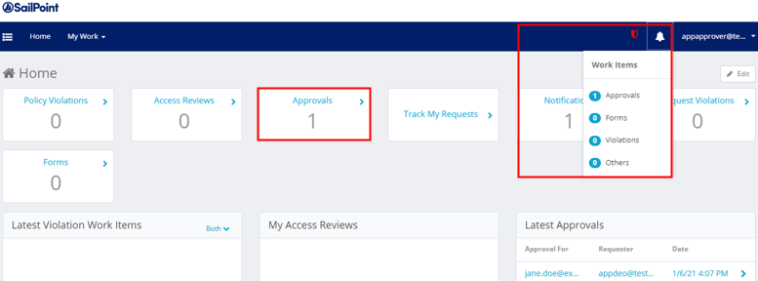
- You will be redirected to a screen containing the details about the request as shown in Figure 12.
- Add any comments using the voice bubble on the right side of the screen. Then select the Approve or Deny button. A confirmation pop-up window will appear.
Figure 12: Approve or Deny Screen
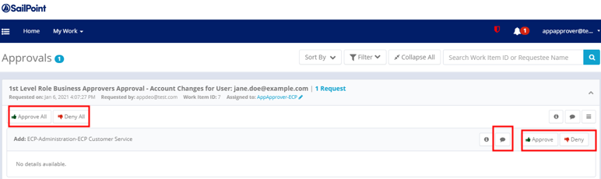
Application Tip

You may select the Approve All or Deny All button on the left if you want to approve or deny multiple requests.

Application Tip

If the first-level approver denies the request, any additional levels of approval will not occur.

Topic 5 Importing User Identity to OTCnet
Security administrators (PLSAs and LSAs) will import the email address of a new user to OTCnet so that the user can be added to the OTCnet database without having to wait for the user to log in.

Import User Identity to OTCnet
PLSAs/LSAs can import the user identity to OTCnet:
- After creating an identity for a user and requesting user access for them in SailPoint, and
- After the user access request is approved by another PLSA/LSA.
Then the PLSA or LSA will add the authorized endpoint(s) and role(s) to the user in OTCnet.
To import a user identity to OTCnet: from the OTCnet Home page>Administration>Manage Users, select the Import OTCnet User Identity tab. On the Import OTCnet User Identity page, enter one or more email addresses (separated by a space, comma, semicolon, or a new line) of the user whose identity will be imported. Select the Import User button.
A confirmation page displays, alerting you that the user identity has been imported and/or if there are errors. Select the OK button on the confirmation page to return to the OTCnet home page or the Fix Errors and Reimport button to navigate back to the Import OTCnet User Identity page to fix the errors.

Import User Identity to OTCnet
To import an OTCnet user identity to OTCnet, complete the following steps:
- From the OTCnet Home page>Administration>Manage Users, select the Import OTCnet User Identity tab as shown in Figure 13.
Figure 13: Import OTCnet User Identity
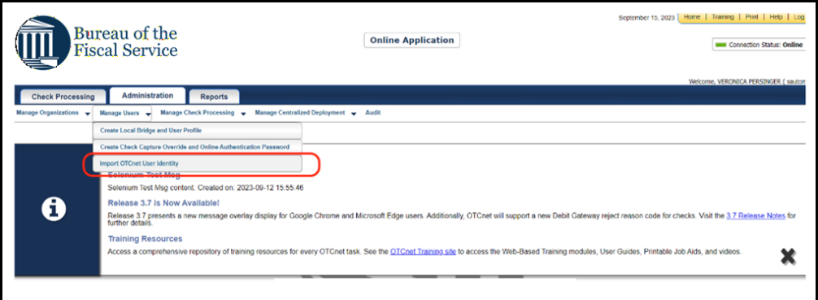
- On the Import OTCnet User Identity page, enter one or more email addresses (separated by a space, comma, semicolon, or a new line) of the user whose identity will be imported.
- Select the Import User button as shown in Figure 14.
Figure 14: Enter User’s Email Address to Import User
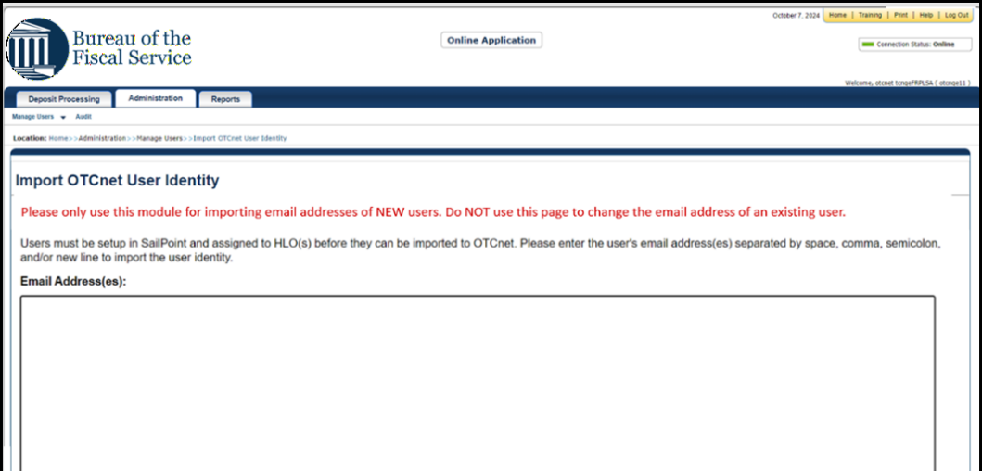
Application Tips

- Please only use this module for importing emails for NEW users. Do NOT use this screen to update an email for an existing user.
- If you select the Import User button without entering an email address, an error message will display, notifying you that at least one email address should be entered.
- When you select the Cancel button, you will be returned to the home page.

- A confirmation page displays, alerting you that the user identity has been imported and/or if there are errors as shown in Figure 15.
- Select the OK button on the confirmation page to return to the OTCnet home page or the Fix Errors and Reimport button to navigate back to the Import OTCnet User Identity page to fix the errors.
Figure 15: Import User Identity Confirmation Screen
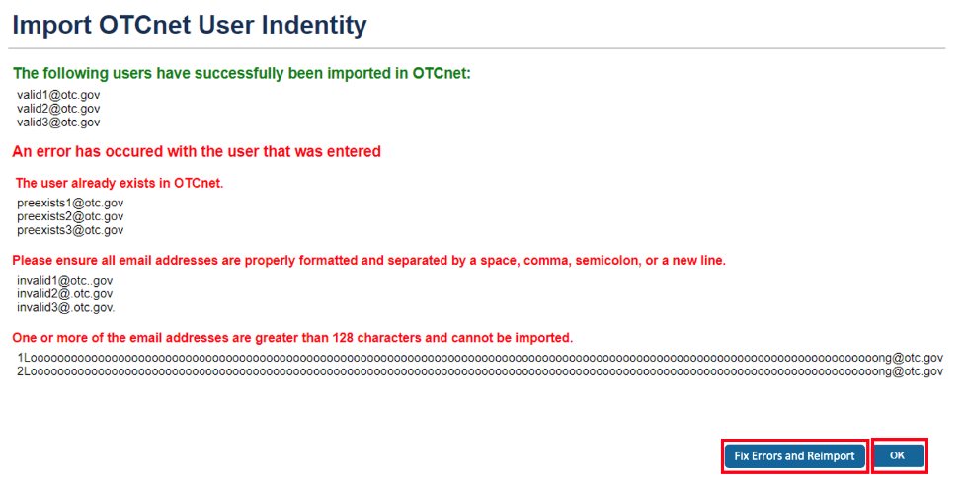

Application Tips

Error messages may include:
- The email address already exists in the OTCnet database.
- The email address has an invalid format. Ensure all email addresses are properly formatted and separated by a space, comma, semicolon, or a new line.
- The email address is greater than 128 characters and cannot be imported.
Ensure that you enter the correct email address for the user. If you import an incorrect email address, another entry in the database will be created and the user will not be able to access the application.

Application Tip

- OTCnet automatically recognizes when an existing user logs in with a new email address. The database is updated to reflect the user’s new email address, preventing them from receiving a blank screen upon login.
- As a reminder, PLSAs and LSAs are responsible for updating the user email associated with the user's identity in SailPoint and verifying that the user is assigned the correct roles and endpoints associated with their new email address in SailPoint.

Topic 6 Adding or Removing an Endpoint/Role for an OTCnet User
There are two types of user provisioning access requests in OTCnet:
- Adding an endpoint/role
- Removing an endpoint/role
In OTCnet, PLSA/LSA users log in to select specific endpoint(s)/role(s) for fine-grained access under the HLO(s) and role(s) selected and approved in SailPoint IIQ for a user.

Add an Endpoint/Role for an OTCnet User
To add an endpoint/role for an OTCnet user, select the Search User Directory button from the OTCnet Home page>Administration>Manage Users>Manage OTCnet Users screen. In the search field, type the user email address. Then under Manage User Account, select View Account.
From the Manage User Account screen, select the Add Endpoint/Role button. From the Add Endpoint/Role screen, select a role from the Choose a Role dropdown. Then select the associated level(s) from the dropdown options. There can be many levels to select depending on the HLO/endpoint hierarchy. Finally, select the Submit button to submit your request. Review the confirmation page that appears and select the OK button to return to the Manage OTCnet Users home screen.

Add an Endpoint/Role for an OTCnet User
To add an endpoint/role for an OTCnet user, complete the following steps:
- From the OTCnet Home page>Administration>Manage Users>Manage OTCnet Users screen, select the Search User Directory button.
- In the search field, type the user’s email address.
- Under Manage User Account, select View Account for the desired user as shown in Figure 16.
Figure 16: Search User Directory Screen
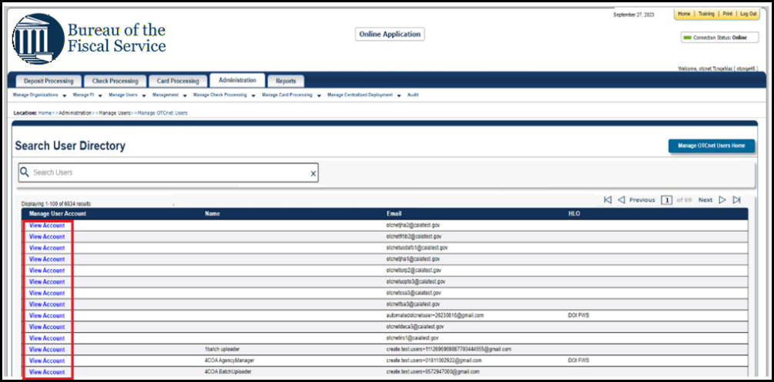
- The Manage User Account screen displays as shown in Figure 17.
- Review the read-only information, including the current endpoint/role assignments listed for the user. Select the Add Endpoint/Role button.
Figure 17: Manage User Account Screen
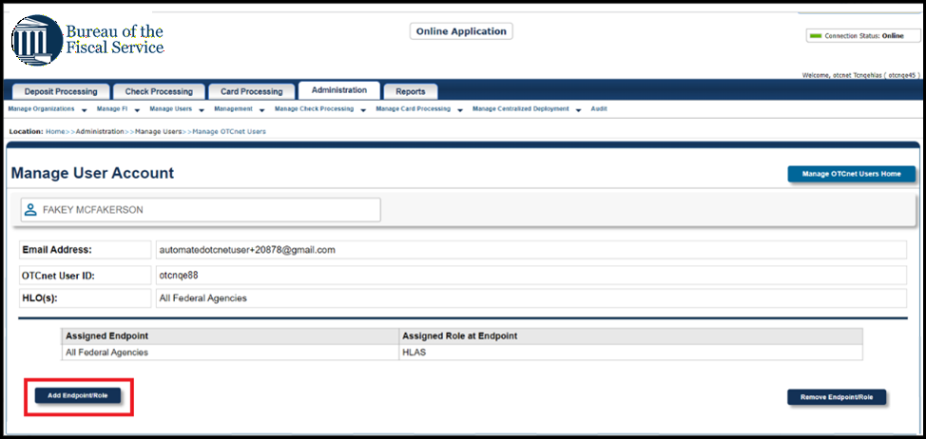
- The Add Endpoint/Role screen displays as show in Figure 18.
- Select a role from the Choose a Role dropdown, choosing from the options provisioned for the specific OTCnet user.
- Then select the associated level(s) from the dropdown options (each one is based on the previous selection and may be prepopulated). There can be many levels to select depending on the HLO/endpoint hierarchy.
- As needed, use the Add Role button to select additional roles. Once you select a role, it will be added to the Selected Role at Endpoint field as illustrated in Figure 18.
Application Tips

- You can select up to 10 roles per request. After 10 role additions, the Add Role button is disabled. To add additional roles, you must repeat the process by submitting a new request.
- If a user changes their email address, security administrators should verify that the user is assigned the correct roles and endpoints associated with their new email address through the Manage OTCnet Users module.

Figure 18: Add Endpoint/Role Screen
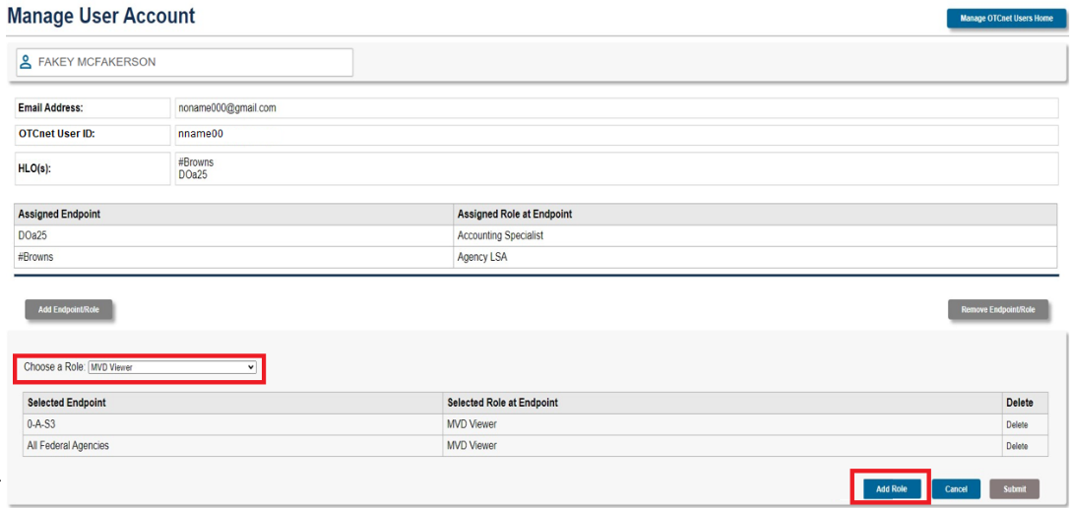
- Once you have selected all necessary roles, select the Submit button to submit your request.
- The confirmation page appears as shown in Figure 19.
- Select the OK button to return to the Manage OTCnet Users screen.
Figure 19: Confirmation Screen on Adding Endpoint/Role Request Submitted
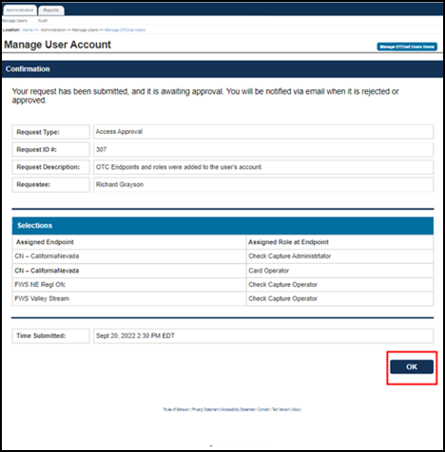
Application Tip

You will be notified via email when the request is approved or rejected by another PLSA/LSA.

Application Tip

- Ensure that users log in to OTCnet at least once every 120 days (or four months). After the four-month period of inactivity, the user’s OTCnet entitlements will be systematically removed from their SailPoint identity.
  - To restore their account, users must contact the Customer Support Team to begin the process.
  - Customer Support will reach out to PLSAs and LSAs and require permission to restore the user’s account.
  - PLSA/LSAs must confirm all the previously assigned roles that were associated with the user’s identity before they can be added back.

Remove an Endpoint/Role for an OTCnet User
To remove an endpoint/role for an OTCnet user, select the Search User Directory button from the OTCnet Home page>Administration>Manage Users>Manage OTCnet Users screen. In the search field, type the user’s email address. Then under Manage User Account, select View Account.
From the Manage User Account screen, select the Remove Endpoint/Role button. From the Select an Endpoint and Role to Remove screen, select the Delete checkbox next to the specific Assigned Endpoint or Assigned Role at Endpoint item. Then select the Submit button to submit your request. Review the confirmation page that appears and select the OK button to return to the Manage OTCnet Users home screen.

Remove an Endpoint/Role for an OTCnet User
To remove an endpoint/role for an OTCnet user, complete the following steps:
- From the OTCnet Home page>Administration>Manage Users>Manage OTCnet Users screen, select the Search User Directory button.
- From the Search User Directory screen, type the user’s email address in the search field.
- Under Manage User Account, select View Account.
- The Manage User Account screen displays as shown in Figure 20. Review the read-only information, including the current endpoint/role assignments listed for the user.
- Select the Remove Endpoint/Role button.
Figure 20: Manage User Account Screen
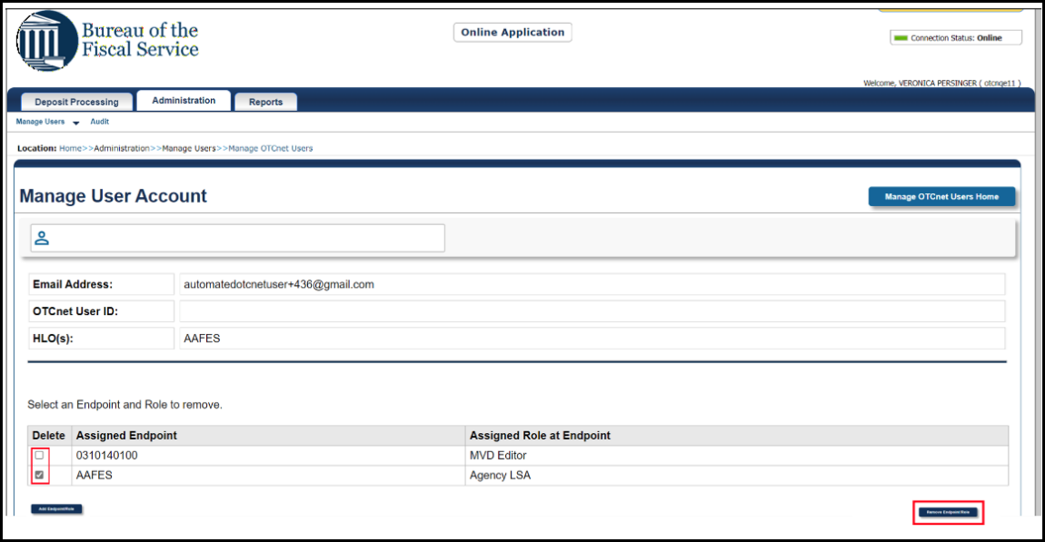
- The Select an Endpoint and Role to Remove screen displays as show in Figure 21.
- Select the Delete checkbox next to the specific Assigned Endpoint or Assigned Role at Endpoint item.
Application Tip

You can select multiple checkboxes to remove multiple assigned endpoints/roles.

- Then select the Submit button to submit your request.
Figure 21: Select an Endpoint and Role to Remove Screen
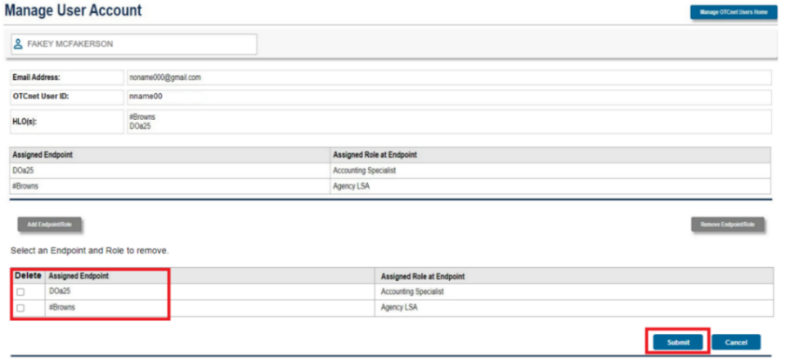
- The confirmation page appears as shown in Figure 22.
- Select the OK button to return to the Manage OTCnet Users screen.
Figure 22: Confirmation Screen on Removing Endpoint/Role Request Submitted
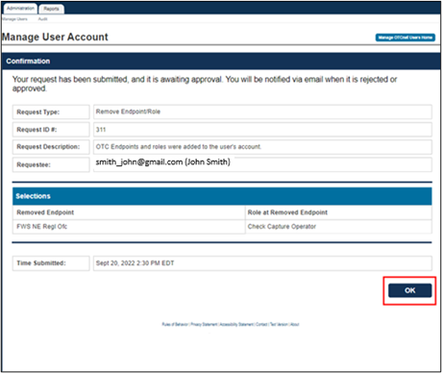
Application Tips

- You will be notified via email when the request is approved or rejected by another PLSA/LSA.
- When a role is successfully removed it is logged in the Audit log.

Topic 7 Approving or Rejecting an Endpoint/Role (or the Removal of an Endpoint/Role)
In OTCnet, approvers are determined based on the endpoint selections.
- An access request is sent to all PLSAs and LSAs at the same level or above the selected endpoints within the same hierarchy.
- An approver logs in and approves (or rejects) the submitted request.
As a PLSA or LSA you are authorized to approve or reject an endpoint/role (or to remove an endpoint/role) for an OTCnet user. You can approve or reject a request after another PLSA or LSA within the same OTC endpoint or hierarchy generates the request (adds or removes an endpoint/role for a user in OTCnet).
After the request is approved, the user to whom the OTCnet request applies receives an email notification containing information about the approval of the request. If you reject the request, the PLSA or LSA who created the request receives a notification of the rejection.
For new users who have not logged in to OTCnet yet, both the User Name and User ID values will be empty in the database and displayed as blank values on the screen.

Approve or Reject an Endpoint/Role (or the Removal of an Endpoint/Role)
To approve or reject an endpoint/role, log in to OTCnet and select Administration>Manage Users>Manage OTCnet Users from the home page. You will notice your Pending Requests list. Select the View Details link to view a specific request. Review the read-only information and enter any approval or rejection comments in the Approver Comments field. Select the Approve or Reject button. Review the read-only information on the confirmation page and select OK to return to the Manage OTCnet Users page.
To approve or reject a removal of an endpoint/role, follow the same process and steps as for approving or rejecting an endpoint/role request, starting with selecting the View Details link from the Manage OTCnet Users page for a Remove Endpoint/Role type of request.

Approve or Reject an Endpoint/Role (or the Removal of an Endpoint/Role)
To approve an endpoint/role for an OTCnet user, complete the following steps:
- Log in to OTCnet and from the Administration tab, select Manage Users, and then Manage OTCnet Users.
- From the Manage OTCnet Users screen, notice the Pending Requests list (Your To-Do list) as shown in Figure 23.
Application Tips

- You will receive an email notification regarding a new user provisioning request awaiting review when a provisioning request is made and added to your pending requests list, to alert you when a user needs your verification.
- For each request, notice the Request Type, Time Due, and Requestee.
- Notice two request types, for Access Approval and Remove Endpoint/Role. Each selection will take you to the appropriate workflow for access approval or access removal, respectively.

- Select the View Details link for a specific access approval request.
Figure 23: Manage OTCnet Users Screen
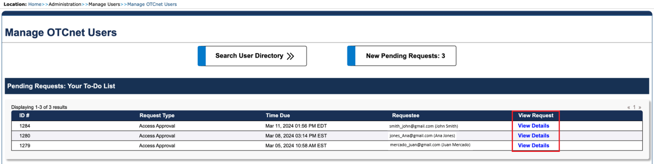
- The Access Approval Request screen displays as shown in Figure 24.
- Review the read-only information and enter any approval or rejection comments in the Approver Comments field.

Application Tips

- If you reject the request, you must provide comments in the specified field. Otherwise, you will get an error message and will not be able to continue until you provide comments.
- You can enter a maximum amount of 4000 characters.

- Select the Approve or Reject button.
Figure 24: Access Approval Request Screen
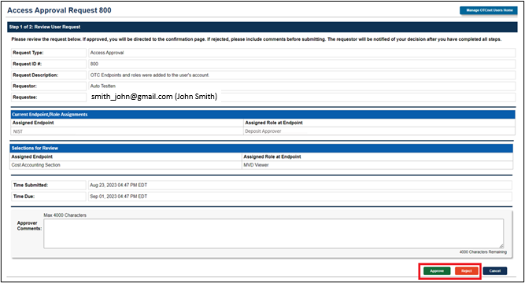

Application Tip

- Selecting Cancel will cancel the approval process.
- If you select Reject, you will get a notification: “Are you sure if you want to reject this request?” Select Reject or Cancel.

- A confirmation page about the approval/rejection of the access request will display as shown in Figure 25.
- Review the read-only information and select OK to return to the Manage OTCnet Users page.
Figure 25: Confirmation Screen on Approval/Rejection of the Access Request
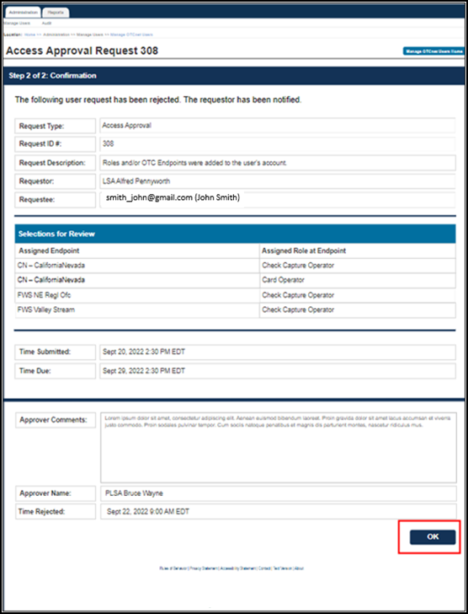

Application Tip
Requestors will be notified via email when a request is approved or rejected.

Application Tip
- To approve or reject a removal of an endpoint/role, follow the same process and steps as for approving or rejecting an endpoint/role request.
- Start with selecting the View Details link from the Manage OTCnet Users page for a Remove Endpoint/Role request.

Summary
In this chapter, you learned how to:
- Manage user accounts
- Create an identity for a user in SailPoint IIQ
- Add or remove user access in SailPoint IIQ
- Approve or deny user access requests in SailPoint IIQ
- Import a user identity to OTCnet
- Add or remove an endpoint/role for an OTCnet user
- Approve or reject an endpoint/role (or the removal of an endpoint/role) in OTCnet

