

OTCnet Participant User Guide

Table of Contents

Overview, Topics, and Audience 1

Overview 1

Topics 1

Audience 1

Topic 1 Viewing Deposits 2

View a Deposit 2

View a Deposit 4

Summary 6

List of Figures

Figure 1. View Deposits Page 4

List of Tables

Table 1. Deposit Status 2

Glossary

Click this [link](https://www.fiscal.treasury.gov/otcnet/training/wbt/content/course_OTC/glossary.htm) to access the full OTCnet Glossary.

## Overview, Topics, and Audience

### Overview

Welcome to *Viewing Deposits*. In this chapter, you will learn:

* The purpose of viewing deposits
* How to view a deposit draft
* How to view a deposit awaiting approval
* How to view a submitted deposit
* How to view a confirmed deposit
* How to view a deposit adjustment
* How to view a rejected deposit detail

### Topics

This chapter includes information on viewing deposits.

### Audience

The intended audience for the *Viewing Deposits* Participant User Guide includes:

* Deposit Preparer
* Deposit Approver
* Deposit Confirmer
* Viewer

## Topic 1 Viewing Deposits

As a **Deposit Preparer**, **Deposit Approver**, **Deposit Confirmer**, or **Viewer**, you are authorized to view deposit vouchers. You may view deposits to locate deposits in process or to verify deposit transactions belonging to others in the organization.

Depending on your user role, you may have permission to view only certain deposits. The **Deposit Status** types are included in Table 1.

Table 1. Deposit Status

| Deposit Status | Description |
| --- | --- |
| Draft | A deposit that is saved for modification at a later date by a Deposit Preparer |
| Awaiting Approval | A deposit that is waiting for deposit confirmation by a Deposit Approver |
| Submitted | A deposit that is submitted and waiting deposit confirmation by a Deposit Confirmer |
| Confirmed | A deposit that has been reviewed and confirmed by a financial institution (FI) or federal reserve bank (FRB) |
| Rejected | A deposit that is returned by a Financial Institution or FRB to the Deposit Preparer to create a new deposit |

### View a Deposit

To view a deposit, select **My Deposits in Process**, **Adjustments in Error**, **Deposits in Error**, or **Deposits Within My Organization.** Click the voucher number of the deposit you would like to view and change the number of records displayed per page, from the drop-down menu options next to record count.

* **My Deposits in Process**: Displays deposits that require addition action (e.g. Draft, Awaiting Approval, Submitted, Rejected, and Confirmed) based on user permissions.

If the user only has an FI Viewer or FRB Viewer role and selects this page, it returns no results. If the user is a Deposit Confirmer or FRB Confirmer, the table displays the column indicating the Confirm option to allow for multiple confirmations at the same time. For all other user roles, this column is hidden.

* **Adjustments in Error**: Displays adjustments that have validation errors awaiting acknowledgement by the financial institution that the error has been resolved.

The **Adjustments in Error** page displays any CA$HLINK II validation errors that need acknowledgment by the financial institution that the error has been resolved. No results appear if there are not any CA$HLINK II validation errors. To document why the error occurred and how the error was resolved, select the Voucher Number link is selected. This page only returns results for the **Deposit Confirmer** and **FI Viewer** roles. Other roles have the ability to select this page from the dropdown but do not see no results. Vouchers displayed in this section are also displayed in the History section of the page with the appropriate deposit status (Confirmed).

* **Deposits in Error**: Displays deposits that have validation errors awaiting acknowledgement by the financial institution that the error is resolved. With **Deposit Confirmer** or **FI Viewer** privileges, the **Deposits in Error** details appears.

The **Deposits in Error** page displays any CA$HLINK II validation errors that need acknowledgment by the financial institution that the error has been resolved. No results appear if there are not any CA$HLINK II validation errors. To document why the error occurred and how the error was resolved, select the Voucher Number link is selected. This page only returns results for the **Deposit Confirmer** and **FI Viewer** roles. Other roles have the ability to select this page from the dropdown but do not see results. Vouchers displayed in this section are also displayed in the History section of the page with the appropriate deposit status (Confirmed).

* **Deposits Within My Organization**: Displays a list of deposits that have been entered in the system, based on the agency endpoint or financial institution to which the user has access. With **Deposit Confirmer** or **FI Viewer** privileges, the **Deposits Within My Organization** details appears.
* The **Deposits Within My Organization** page displays voucher dates in reverse chronological order (including future dated deposits) and the status within (i.e. Draft, Submitted, Rejected, and Confirmed). The number of deposits displayed is based upon the display days processing options defined for the OTC Endpoint that the agency user has permission to view. If the user has permission for more than one OTC Endpoint, the processing option with the greatest number of days is used. If the user is an **FI Viewer** or an **FS Viewer**, the number of display days is set at 45.

View a Deposit

To view a deposit, complete the following steps:

1. From the **Deposit Processing** tab, click **View Deposits**. The *View Deposit* page appears.
2. From the **Select Display** drop-down menu, select **My Deposits in Process**, **Adjustments in Error**, **Deposits in Error**, or **Deposits Within My Organization**.
3. Click the **Voucher Number** of the deposit you need to view as shown in Figure 1.

Figure 1. View Deposits Page

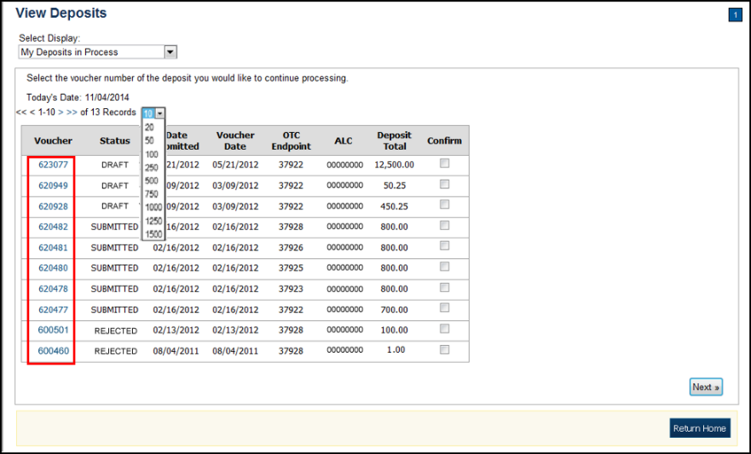

Application Tips



* By default, up to 10 records are displayed per page. To change the number of records displayed per page, select from the drop-down menu options next to the record count.
* When your Financial Institution makes an adjustment to a deposit, it appears in the **Adj**. column of the **Deposit Transactions** section of the table.
* To view additional details, click the appropriate **Voucher Number**.
* The *View Confirmed Deposit* page appears. Under **Adjustment Information**, click the **Voucher Number** to view the deposit adjustment details.

Additional Buttons



* Click **Cancel** to return to the OTCnet Home Page. No data   
  is saved.
* Click **Confirm** to confirm a deposit (Visible if a user has   
  Deposit Confirmer privileges).
* Click **Clear** to clear all data fields and reset to the default selections.
* Click **Delete** to eliminate the deposit. (Visible if a user has Deposit
* Preparer privileges.)
* Click **Print Deposit Ticket** to print a formatted deposit ticket.
* Click **View Voucher Event Log** to view the history of the   
  deposit voucher.
* Click **Voucher Event State** to view voucher details.
* Click **Next** to advance to the next page. (Visible only in My Deposits in Process view).
* Click **Previous** to return to the previous page.
* Click **Return Home** to return to the OTCnet Home Page.
* Click **Reject** to reject a deposit (Visible if a user has Deposit Confirmer privileges.)
* Click **Adjust** to adjust a deposit (Visible if a user has Deposit Confirmer privileges.)
* Click **Save as Draft** to save the information without submitting the deposit. (Visible if a user has Deposit Preparer privileges.)
* Click **Submit** to complete the process and display the Confirmation   
  page. (Visible if a user has Deposit Approver privileges.)
* Click **Update CAN**/**ACCT Key** to update the account number assigned to a deposit. (Visible if a user has Deposit Confirmer privileges.)
* Click **Add Adjustment** to adjust a deposit. (Not visible for Foreign Check Items.)

## Summary

In this chapter, you learned:

* The purpose of viewing deposits
* How to view a deposit draft
* How to view a deposit awaiting approval
* How to view a submitted deposit
* How to view a confirmed deposit
* How to view a deposit adjustment
* How to view a rejected deposit detail