

OTCnet Participant User Guide

Table of Contents

Overview, Topics, and Audience 1

Overview 1

Topics 1

Audience 1

Topic 1 Purpose of Searching Adjustments 2

Topic 2 Searching Adjustments Using Select Criteria 3

Search and View an Adjustment 3

Search and View an Adjustment 4

Topic 3 Downloading Adjustments 6

Download Search Results for a Deposit 6

Download Search Results for a Deposit 7

Summary 8

List of Figures

Figure 1. Additional Search Criteria 4

Figure 2. Download Button 7

List of Tables

Table 1. Search Criteria Fields 2

Glossary

Click this [link](https://www.fiscal.treasury.gov/otcnet/training/wbt/content/course_OTC/glossary.htm) to access the full OTCnet Glossary.

## Overview, Topics, and Audience

### Overview

Welcome to *Searching Adjustments*. In this chapter, you will learn:

* The purpose of searching adjustments
* How to search and locate adjustments using one or more search criteria
* How to download adjustment voucher(s) as an XML or CSV file

### Topics

This chapter is organized by the following topics:

1. Purpose of Searching Adjustments
2. Searching Adjustments Using Select Criteria
3. Downloading Adjustments

### Audience

The intended audience for the *Searching Adjustments* Participant User Guide includes:

* Deposit Preparer
* Deposit Approver
* Deposit Confirmer
* Viewer

## Topic 1 Purpose of Searching Adjustments

As a **Deposit Preparer**, **Deposit Approver**, **Deposit Preparer/Approver**, **Deposit Confirmer**, or **Viewer**, you are authorized to search for and view adjustments and download and save the searched adjustment voucher(s) as an XML or CSV file. You may review adjustments to understand why a deposit is adjusted and the corrections that were made.

To search for an adjustment to a **US Currency** or **Foreign Check Items** deposit, click the **Search Adjustments** function. The **Search Adjustments** function enables you to search for a deposit voucher using one or more criteria.

If you do not specify any criteria, the search results includes all deposits in the system that you have access to view. If you run additional searches, the Search Results table repopulates with the results of the new search. See Table 1 for search criteria fields.

Table . Search Criteria Fields

| Search Criteria Groupings | Search Criteria Fields |
| --- | --- |
| Search Conditions | * Organization * OTC Endpoint * ALC * Adjustment Category * Voucher Number * Adjustment Type * Prepared By * Adjustment Reason |
| Voucher Date | * Date Range |
| Adjustment Amount | * Total Range |
| Deposit Date | * Date Range |
| Original Deposit Date | * Date Range |
| Financial Institution Information | * Routing Number * Demand Deposit Account * CA$HLINK II Account Number * FRB Account Key * FRB Cost Center Work Unit |

## Topic 2 Searching Adjustments Using Select Criteria

**Search Adjustments**—for this function, if you run a search without specifying any criteria, the search results include all deposits in the system that you have access to view.

### Search and View an Adjustment

To search adjustments using select criteria, you will enter your specific search criteria under **Search Conditions**, e.g., select an **Organization** or an **Endpoint**, etc. and click the **Voucher Number** for the adjustment that you need to view.

**Search and View an Adjustment**

To search for and view an adjustment, complete the following steps:

1. Click **Deposit Processing**, click **Search Adjustments**. The *Search Adjustments* page appears.
2. Enter the search criteria and click **Search**.

Under **Search Conditions**, *optional*

* + Select an **Organization**
  + Select an **OTC Endpoint**
  + Enter an **ALC (Agency Location Code)**
  + Select an **Adjustment Category**
  + Enter a **Voucher #**
  + Select an **Adjustment Type**
  + Enter the **Prepared by** name
  + Select an **Adjustment Reason**
  + Enter the **From**: and **To**: Voucher Dates
  + Enter the **From**: and **To**: Adjustment Amount
  + Enter the **From**: and **To**: Deposit Date
  + Enter the **From**: and **To**: Original Deposit Date

Additional search criteria is displayed as shown in Figure 1.

Figure . Additional Search Criteria

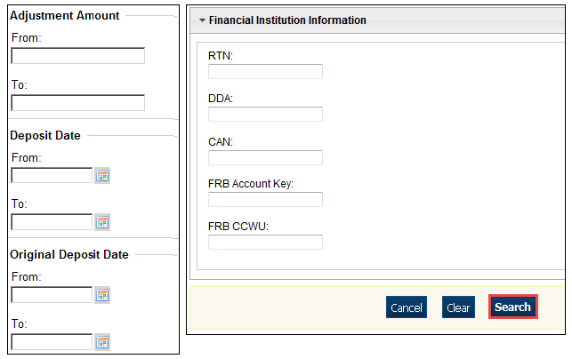

Application Tip



**Voucher From** date must be five years or less prior to the current date. Vouchers more than five years old can be viewed from the **Historical Reports** menu.

1. *The Search Results* table appears. Click the **Voucher Number** of the adjustment for the details you need to view.

Application Tip



Values do not display in the **Adjustment Amount** column for unconfirmed foreign check item deposits that were entered with a Country of Deposit of **Other**.

Application Tip



Click **Download** to save the adjustment results as an **XML o**r **CSV** file.

Additional Buttons



* Click **Previous** to return to the previous page.
* Click **Return Home** to return to the OTCnet Home Page.
* Click **View Voucher Event Log** to view the history of the deposit voucher.

## Topic 3 Downloading Adjustments

To download your search results, first use the **Search Adjustments** function. After searching for your adjusted deposit, you can download the information you retrieve.

### Download Search Results for a Deposit

To download your search results for a deposit, enter the search criteria for your adjusted deposit, enter the optional search criteria for the adjusted deposit you need to view and search for it. Download your results, select your file format e.g., **XML file** or **CSV file**. Verify the attributes that you want to download and submit. Open the file or save it.

**Download Search Results for a Deposit**

To download the search results of a deposit, complete the following steps:

1. The Search Results table appears, click **Download** as shown in Figure 2. The *Download Deposits* page appears.

Figure . Download Button

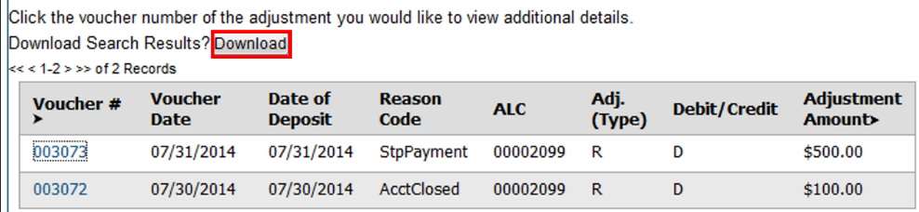

1. Select either the **XML file** or **CSV file** format.
2. Check the desired attributes that you need to download for:
   * **Deposit Information**
   * **Financial Institution Information**
   * **Agency Information**
   * **Accounting Subtotals and User Defined Data**
   * **Foreign Deposit Information**
3. Click **Submit**. The File Download dialog box appears.
4. Click **Open** or **Save**.

Application Tips



* Click **Open** and the content of the file appears.
* Click **Save** to choose the location where you will save the file.

Additional Button



Click **Cancel** to return to the OTCnet Home Page. No data is saved.

## Summary

In this chapter you learned:

* The purpose of searching adjustments
* How to search for and locate adjustments using one or more search criteria
* How to download adjustment voucher(s) as an XML or CSV file