

OTCnet Participant User Guide

Table of Contents

Overview, Topics, and Audience 1

Overview 1

Topics 1

Audience 1

Topic 1 Reasons for Creating a Returned Item Adjustment 2

Create a Returned Item Adjustment for US Currency 3

Create a Returned Item Adjustment for Foreign Check Item 6

Summary 8

List of Figures

Figure 1. Define Returned Item Adjustment 5

Figure 2. Step 1 of 2: Define Returned Item Adjustment Information 8

Glossary

Click this [link](https://www.fiscal.treasury.gov/otcnet/training/wbt/content/course_OTC/glossary.htm) to access the full OTCnet Glossary.

## Overview, Topics, and Audience

### Overview

Welcome to *Creating Adjustments*. In this chapter, you will learn:

* The reasons for creating a returned item adjustment
* How to create a returned item adjustment for US Currency and Foreign Check Items

### Topics

This chapter is organized by the following topics:

* Reasons for Creating a Returned Item Adjustment

### Audience

The intended audience for the *Creating Adjustments* Participant User Guide includes:

* Deposit Confirmer

## Topic 1 Reasons for Creating a Returned Item Adjustment

As a **Deposit Confirmer**, you are authorized to create a returned item adjustment for US Currency Check Items and Foreign Check Items.

If an item is received that must be returned to the agency, a *return item adjustment* must be created. Only deposits with a **Submitted** status can be returned. Examples of reasons for adjustments include:

* Checks returned for insufficient funds
* Closed account
* Stop payment
* Uncollected funds

**Create a Returned Item Adjustment for US Currency**

To create a returned item adjustment for US Currency, complete the following steps:

1. From the **Deposit Processing** tab, select **Create Returned Item Adjustment**>**US Currency**. The *Step 1 of 2: Define Returned Item Adjustment Information* page appears.
2. Enter the information to prepare the returned item adjustment and click **Next**. The *Step 2 of 2: Review Item Adjustment* appears as shown in Figure 1.

Under **Adjustment Information, complete the following:**

* + Select the **ALC (Agency Location Code)**
  + Select the **CAN/Acct Key (CA$HLINK II Account Number/Account Key)**
  + Select the **RTN – DDA (Route Transit Number – Demand Deposit Account)**
  + Enter the **Date of Deposit**
  + Enter the **Voucher Date**
  + Enter the **Amount of Returned Item**
  + Select a **Reason for Returned Item**
  + Enter the **Returned Item(s) Count**
  + Select an **OTC Endpoint**
  + Enter **Adjustment Comments**

Figure . Define Returned Item Adjustment

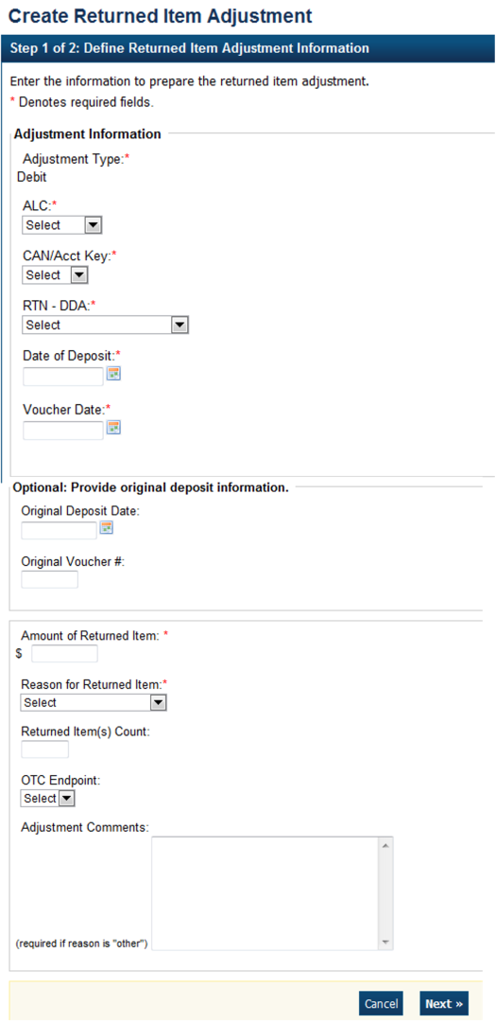

Application Tip



* The **CCWU** is for FRB deposits only.
* **Adjustment Comments** are required if the reason for the returned item is **Other**.

Under **Optional: Provide original deposit information,** *optional*

* + Select the **Original Deposit Date**
  + Enter the **Original Voucher #**

1. Verify the information is correct and click **Submit**. Click **Edit** to make changes to the information entered. A *Confirmation* page appears stating that the returned item adjustment was created.

Additional Buttons



* Click **Cancel** to return to the OTCnet Home Page. No data is saved.
* Click **Previous** to return to the previous page.
* Click **Return** Home to return to the OTCnet Home Page.

Create a Returned Item Adjustment for Foreign Check Item

To create a returned item adjustment for Foreign Check Items, complete the following steps:

1. From the **Deposit Processing** tab, select **Create Returned Item Adjustment**>**Foreign Check Item**. The *Step 1 of 2: Define Returned Item Adjustment Information* page appears.
2. Enter the information to prepare the returned item adjustment and click **Next**. The Step 2 of 2: Review Item Adjustment page appears as shown in Figure 2 below.
   * Select the **ALC (Agency Location Code), CAN/Acct Key (CA$HLINK II Account Number/Account Key)** and **RTN-DDA (Routing Transit Number- Demand Deposit Account)** from their drop-down lists
   * Enter the **Date of Deposit, Voucher Date**, and **Foreign Currency Amount**
   * Select the **Original Deposit Date** and enter the **Original #**, *optional*
   * Select the **Country of Deposit**

If the name of the country is not listed, select **Other**. The Currency Code and Exchange Rate will automatically populate based on the Country of Deposit selection

* + Enter the **Amount of Returned Item (USE)**
  + Select a **Reason for Returned Item** and **OTC Endpoint**
  + Enter **Adjustment Comments**, *required* if the reason for the returned item is “other”

Figure . Step 1 of 2: Define Returned Item Adjustment Information

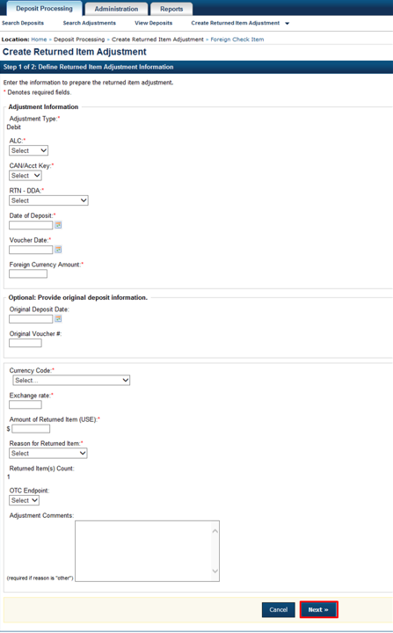

1. Verify the information is correct and click **Submit**. Click **Edit** to make changes to the information entered.
2. A *Confirmation* page appears stating that the returned item adjustment was created.

Additional Buttons



* Click **Cancel** to return to the OTCnet Home Page. No data is saved.
* Click **Previous** to return to the previous page.
* Click **Return Home** to return to the OTCnet Home Page.

## Summary

In this chapter, you learned:

* The reasons for creating a returned item adjustment
* How to create a returned item adjustment for US Currency and Foreign Check Items