

OTCnet Participant User Guide

Table of Contents

Overview, Topics, and Audience 1

Overview 1

Topics 1

Audience 1

Topic 1 Purpose of Confirming, Rejecting or Adjusting a Deposit 2

Confirm a Single Deposit or Multiple Deposits 2

Confirm a Single Deposit 3

Confirm Multiple Deposits 7

Topic 2 Rejecting Deposits 10

Reject a Deposit 11

Topic 3 Adjusting Deposits 14

Create a Credit/Debit Adjustment 14

Create a Credit/Debit Adjustment 15

Summary 18

List of Figures

Figure 1. Confirming, Rejecting or Adjusting Deposits Process Flow 2

Figure 2. View Deposits 3

Figure 3. Step 1 of 2: Define Information for Deposit Confirmation 4

Figure 4. View Deposits 7

Figure 5. Step 1 of 2: Confirm Deposits for Multiple Deposits 8

Figure 6. Reject Deposit 11

Figure 7. Enter Rejection Comments 12

Figure 8. Adjust Deposit 15

Glossary

Click this [link](https://www.fiscal.treasury.gov/otcnet/training/wbt/content/course_OTC/glossary.htm) to access the full OTCnet Glossary.

## Overview, Topics, and Audience

### Overview

In this chapter, you will learn:

* The purpose of confirming or rejecting a deposit
* The criteria for confirming a deposit
* How to confirm a deposit
* How to reject a deposit
* How to create a credit/debit adjustment

### Topics

1. Purpose of Confirming, Rejecting or Adjusting a Deposit
2. Rejecting Deposits
3. Adjusting Deposits

### Audience

The intended audience for the Confirming, Rejecting or Adjusting Deposits chapter is:

* Deposit Confirmer

## Topic 1 Purpose of Confirming, Rejecting or Adjusting a Deposit

After a **Deposit Approver** submits a deposit for confirmation, the **Deposit Confirmer** at the Financial Institution confirms, adjusts or rejects the deposit. Only deposits that are saved with a **Submitted** status by the agency’s **Deposit Approver** can be confirmed, rejected or adjusted. Review the process flow for confirming, rejecting, or adjusting a deposit as shown in Figure 1.

When confirming a deposit as a **Deposit Confirmer**, the deposit status is **Confirmed**. When rejecting a deposit, the deposit status is **Rejected**.

A **Deposit Confirmer** at a Financial Institution may reject deposits if there are duplicate voucher submissions, items missing, funds not received, etc. After a deposit is adjusted, it is searchable using the **Search Adjustments** or **Search Deposits** function.

Figure . Confirming, Rejecting or Adjusting Deposits Process Flow

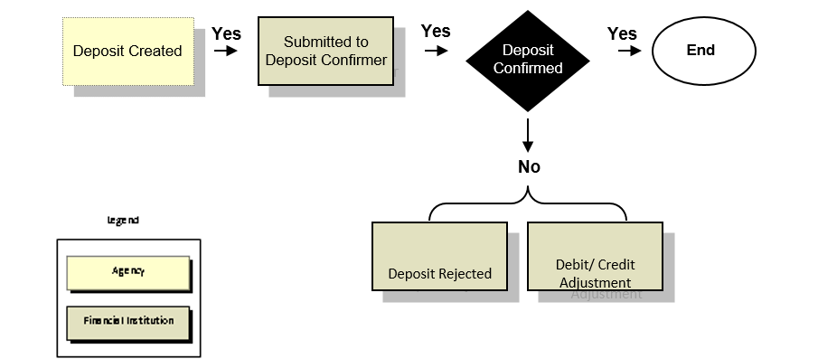

### Confirm a Single Deposit or Multiple Deposits

To confirm a single deposit or multiple deposits simultaneously, the deposit must have a **Submitted** status. To locate deposits with a **Submitted** status, use the **View Deposits** or **Search Deposits** function. After locating the deposit, confirm the deposit preparation information. Once a deposit is confirmed, it is saved with a **Confirmed** status.

Confirm a Single Deposit

To confirm a single deposit, complete the following steps:

1. From the **Deposit Processing** tab, click **View Deposits**. The *View Deposits* page displays.

Application Tip



To locate deposits, you can also click **Search Deposits**.

1. From the Select Display drop-down menu, select **My Deposits in Process**.
2. Click the **Voucher Number** for the deposit whose details you want to process, as shown in Figure 2. The *View Submitted Deposit* page displays.

Figure . View Deposits

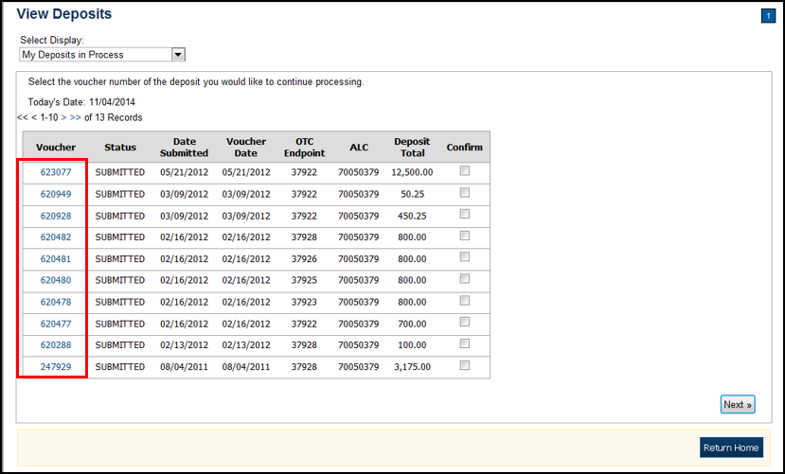

Application Tip



Depending on your user role, the **My Deposits in Process** page displays your current deposits. If you only have the **Viewer** role, the **My Deposits in Process** does not display any deposits.

1. Click **Confirm**. The *Step 1 of 2: Define Information for Deposit Confirmation* page displays.
2. Enter the deposit information and click **Next**, as shown in Figure 3. The *Step 2 of 2: Review Information for Deposit Confirmation* page displays.

Figure . Step 1 of 2: Define Information for Deposit Confirmation

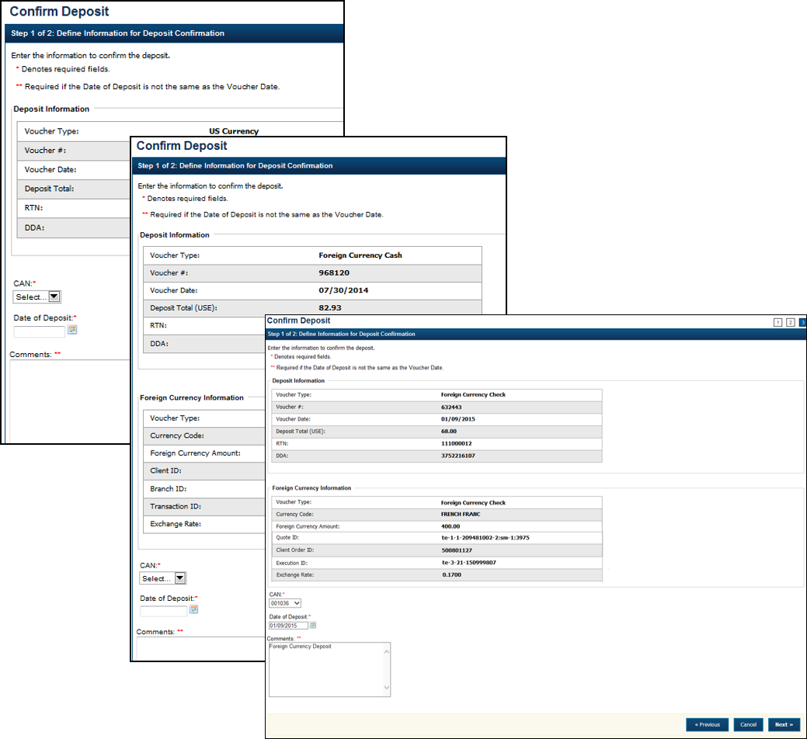

**US Currency Deposits** (both cash and check)

* + Select the **CAN/ACCT Key (CA$HLINK II Account Number/Account Key)**
  + Enter the **Date of Deposit**
  + Enter **Comments**, *if applicable and/or required*
  + Enter the **CCWU (Cost Center Work Unit Number)**
  + Enter the **1 Day Deferred**
  + Enter the **2 Day Deferred**

Application Tips



* When confirming a deposit ticket, ensure you confirm the deposit on the date received. Due to transit times, Fiscal Service is aware that deposits may not be confirmed on the **Voucher Date** entered by the Agency. Fiscal Service can adjust the value of funds, if needed, to account for these discrepancies.
* The **CCWU**, **1 Day Deferred**, and **2 Day Deferred** are for FRB deposits only.

**Foreign Currency Cash**

* + Select the **CAN/ACCT Key (CA$HLINK II Account Number/Account Key)**
  + Enter the **Date of Deposit**
  + Enter **Comments**, *if applicable and/or required*

**Foreign Check Items**

* + Enter the **Exchange Rate** under **Foreign Currency Information**
  + Select the **CAN/ACCT Key (CA$HLINK II Account Number/Account Key)**
  + Select the **Date of Deposit**
  + Enter the **Deposit Total (USE) (US Dollar Equivalent)**
  + Enter **Comments**, *if applicable and/or required*

Application Tips



* The **Date of Deposit** cannot be less than the FRB CA$HLINK process date. If the **Date of Deposit** is different from the **Voucher Date**, enter an explanation for the difference in the **Comments** box.
* When confirming a deposit ticket, ensure you confirm the deposit on the date received. Due to transit times, Fiscal Service is aware that deposits may not be confirmed on the **Voucher Date** entered by the Agency. Fiscal Service can adjust the value of funds, if needed, to account for these discrepancies.

1. Verify the information is correct and click **Submit**. Click **Edit** to modify the data entered. A *Confirmation* page displays stating that the deposit has been confirmed.

Additional Buttons



* Click **Adjust** to adjust a deposit.
* Click **Cancel** to return to the OTCnet Home Page. No data is saved.
* Click **Confirm** to confirm a deposit.
* Click **Edit** to return to the previous page.
* Click **View Voucher** Event Log to view the history of the deposit voucher.
* Click **Next** to advance to the next page.
* Click **Previous** to return to the previous page.
* Click **Return Home** to return to the OTCnet Home Page.
* Click **Reject** to reject a deposit.

Confirm Multiple Deposits

To confirm multiple deposits simultaneously, complete the following steps:

1. From the **Deposit Processing** tab, click **View Deposits**. The *View Deposits* page displays.
2. From the Select Display drop-down menu, select **My Deposits in Process**.
3. Select the **Voucher** **Numbers** you want to confirm by checking the boxes under the **Confirm** column, as shown in Figure 4.

Figure . View Deposits

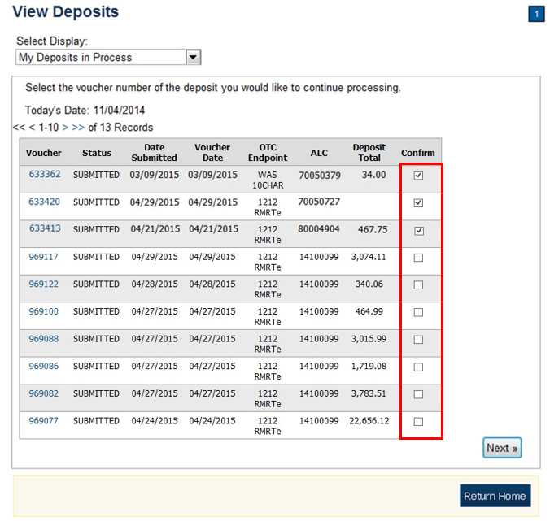

Application Tip



Depending on your user role, the **My Deposits in Process** page displays your current deposits. If you only have the **Viewer** role, the **My Deposits in Process** does not display any deposits.

1. Click **Next**. The *Step 1 of 2: Confirm Deposits* page displays.
2. Enter the deposit information. Click **Next** as shown in Figure 5.

Figure . Step 1 of 2: Confirm Deposits for Multiple Deposits

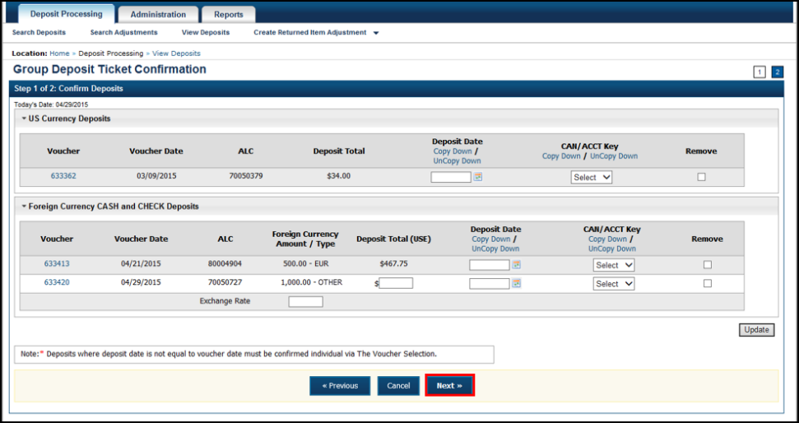

**US Currency Deposits** (checks and cash):

* + Select the **Date of Deposit**
  + Select the **CAN/ACCT Key (CA$HLINK II Account Number/Account Key)**
  + Enter the **CCWU (Cost Center Work Unit Number)**
  + Enter the **1 Day Deferred**
  + Enter the **2 Day Deferred**

**Foreign Currency Cash** and **Check Deposits**:

* + Select the **Date of Deposit**
  + Select the **CAN/ACCT Key (CA$HLINK II Account Number/Account Key)**
  + If **Other** was selected for Country of Deposit during deposit creation, enter **Deposit Total (USE)** and **Exchange Rate**.

Application Tips



* When confirming a deposit ticket, ensure you confirm the deposit on the date received. Due to transit times, Fiscal Service is aware that deposits may not be confirmed on the **Voucher Date** entered by the Agency. Fiscal Service can adjust the value of funds, if needed, to account for these discrepancies.
* The **Date of Deposit** must equal the **Voucher Date**.
* To use the same date for all deposits listed, click the **Copy Down** hyperlink in the **Date of Deposit** column.
* To use the same **CAN** or **Account Key** used for all deposits listed, click the **Copy Down** hyperlink in the **CAN**/ **Acct Key** column.
* To remove vouchers from the group being confirmed, select the **Voucher Numbers** you wish to remove by checking the boxes under the **Remove** column and click **Update**.

1. Click **Next**. The *Step 2 of 2: Review Information for Deposit Confirmation* page displays.
2. Verify the information is correct and click **Submit**.
3. A *Confirmation* page displays stating that the deposits are confirmed.

Additional Buttons



* Click **Adjust** to adjust a deposit.
* Click **Cancel** to return to the OTCnet Home Page. No data is saved.
* Click **Confirm** to confirm a deposit.
* Click **Edit** to return to the previous page.
* Click **View Voucher** Event Log to view the history of the deposit voucher.
* Click **Next** to advance to the next page.
* Click **Previous** to return to the previous page.
* Click **Return Home** to return to the OTCnet Home Page.
* Click **Reject** to reject a deposit.
* Click **Update** to remove the selected voucher(s) that are being confirmed.

## Topic 2 Rejecting Deposits

To reject a deposit, it must have a **Submitted** status. To locate a deposit with a **Submitted** status, use the **View Deposits** or **Search Deposits** function. After locating the deposit, you can reject the deposit preparation information. Once a deposit is rejected, it is saved with a **Rejected** status.

Only deposits saved with a **Submitted** status by the agency’s **Deposit Approver** can be confirmed, rejected, or adjusted. As a best practice, Fiscal Service recommends that the **Deposit Confirmer** confirms, adjusts or rejects deposits as part of their daily activities. In addition, it is recommended that all deposits (except those issued from foreign checks) are confirmed no later than 30 days from the Voucher Date.

Reject a Deposit

To reject a deposit, complete the following steps:

1. From the **Deposit Processing** tab, click **View Deposits**. The *View Deposits* page displays.

Application Tip



To locate deposits, you can also select **Search Deposits** and click the **Voucher Number** of the deposit you would like to continue processing.

1. From the **Select Display** drop-down menu, select **My Deposits in Process**.
2. Click the **Voucher Number** of the deposit you would like to continue processing.   
   The *View Submitted Deposit* page displays, as shown in Figure 6.

Figure . Reject Deposit

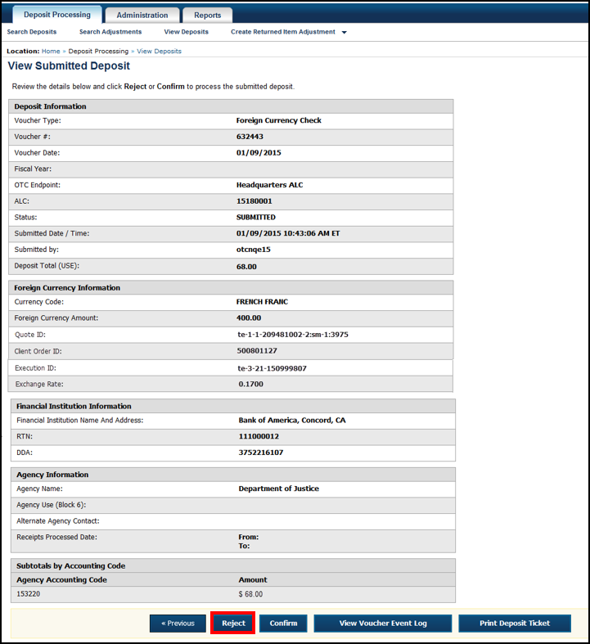

1. Click **Reject**. The *Step 1 of 2: Define Information for Deposit Rejection* displays.

Application Tip



**Deposit Total** is not displayed on the *Define Information for Deposit Rejection* page for a foreign check deposit with **Other** selected for the country of deposit.

1. Enter **Comments** describing the reason you are rejecting the deposit, as shown in Figure 7.

Figure . Enter Rejection Comments

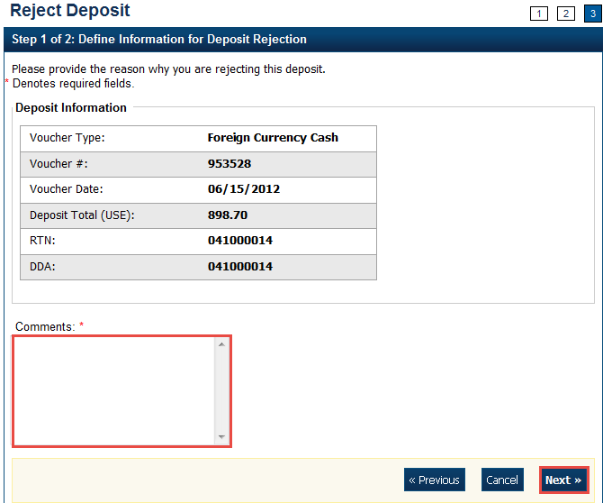

1. Click **Next**. The *Step 2 of 2: Review Information for Deposit Rejection* page displays.

Application Tip



**Deposit Total** is not displayed on the *Review Information for Deposit Rejection* page for a foreign check deposit with **Other** selected for the country of deposit.

1. If the information is correct, click **Submit**. Click **Edit** to modify the comment.
2. A *Confirmation* page displays stating that the deposit is rejected.

Additional Buttons



* Click **Adjust** to adjust a deposit.
* Click **Cancel** to return to the OTCnet Home Page. No data is saved.
* Click **Confirm** to confirm a deposit.
* Click **View Voucher Event Log** to view the history of the deposit voucher.
* Click **Previous** to return to the previous page.
* Click **Return Home** to return to the OTCnet Home Page.

## Topic 3 Adjusting Deposits

As a **Deposit Confirmer**, you are authorized to create a credit or debit adjustment for a deposit. Only **US Currency** and **Foreign Currency Cash** deposits with **Submitted** or **Confirmed** status can be credited or debited.

To locate a deposit with a **Submitted** or **Confirmed** status, use the **View** **Deposits** or **Search** **Deposits** function. After the deposit is located, the deposit preparation information can be adjusted. Once the adjustment is applied, the deposit status is saved with a **Confirmed** status and an asterisk appears in the **Adj**. (Adjustment) column of the **Deposit** **Transactions** table. After a deposit is adjusted, search for adjustments using the **Search** **Adjustments** or **Search** **Deposits** function.

Your Financial Institution may have internal business processes related to creating an adjustment for a credit or debit. Part of those practices may include contacting the agency if there is a discrepancy, prior to performing the adjustment.

A credit adjustment is applied when the voucher deposit total indicated exceeds the actual deposit voucher amount. A debit adjustment is applied when the voucher deposit total indicated is less than the actual deposit voucher amount.

As a best practice, Fiscal Service recommends that the **Deposit Confirmer** confirms, adjusts or rejects deposits as part of their daily activities. In addition, it is recommended that all deposits (except those issued from foreign checks) are confirmed no later than 30 days from the Voucher Date.

### Create a Credit/Debit Adjustment

To create a credit/debit adjustment, select a deposit in process and the corresponding voucher number and define the deposit adjustment information.

Create a Credit/Debit Adjustment

To create a credit/debit adjustment, complete the following steps:

1. From the **Deposit Processing** tab, click **View Deposits**. The *View Deposits* page displays.

Application Tip



To locate deposits, you can also click **Search Deposits**.

1. From the **Select Display** drop-down menu, select **My Deposits in Process**.
2. Click the **Voucher** **Number** for the deposit whose details you want to process. The *View Submitted Deposit* page displays, as shown in Figure 8.

Figure . Adjust Deposit

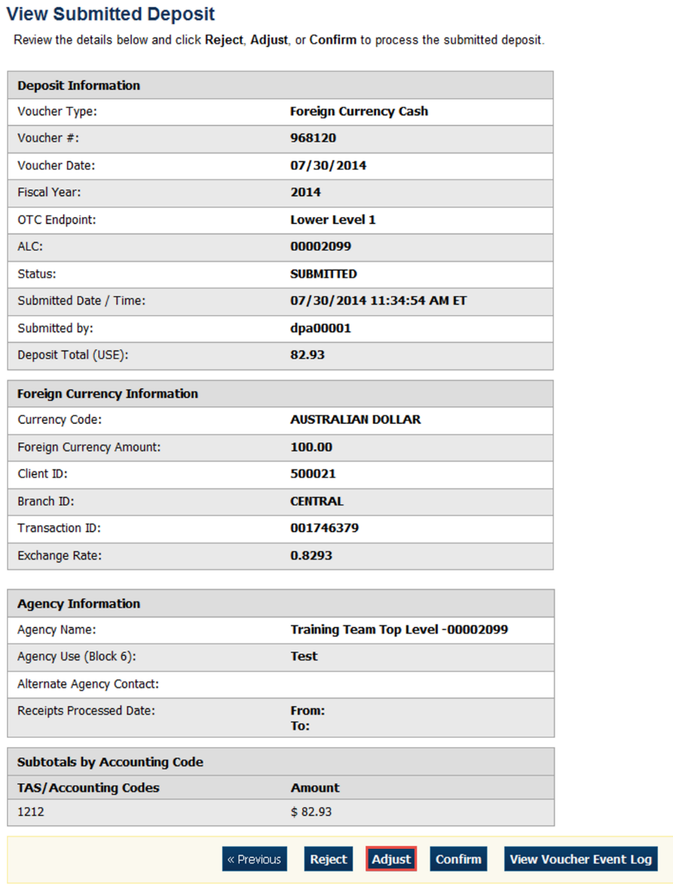

Application Tip



Depending on your user role, the **My Deposits in Process** page displays your current deposits. If you only have the **Viewer** role, the **My Deposits in Process** does not display any deposits.

1. Click **Adjust**. The *Step 1 of 2: Define Information for Deposit Adjustment* page displays.

Application Tip



You can only create adjustments for **US Currency** and **Foreign Currency Cash** deposits with **Submitted** or **Confirmed** status.

1. Enter the adjustment information and click **Next**.
   * Select the CAN/ACCT Key **(CA$HLINK II Account Number/Account Key)**
   * Enter the **Date of Deposit**
   * Enter **Comments**, *if applicable and/or required*
   * Enter the **CCWU (Cost Center Work Unit Number)**
   * Enter the **1 Day Deferred**
   * Enter the **2 Day Deferred**
   * Select **Debit** or **Credit** for **Adjustment Type**
   * Enter the **Adjustment Amount**
   * Select the **Adjustment Reason**
   * Enter **Adjustment Comments**

Application Tips



* The **CCWU**, **1 Day Deferred Amount**, and **2 Day Deferred Amount** are for FRB deposits only.
* **Adjustment Comments** are required if the reason is **Other**.

1. The *Step 2 of 2: Review Information for Deposit Adjustment* page displays. Verify the information is correct and click **Submit**. Click **Edit**, to modify the adjustment information and review the information again.
2. A *Confirmation* page displays stating the deposit was adjusted.

Additional Buttons



* Click **Cancel** to return to the OTCnet Home Page. No data is saved.
* Click **Confirm** to confirm a deposit.
* Click **View Voucher Event Log** to view the history of the deposit voucher
* Click **Previous** to return to the previous page.
* Click **Return Home** to return to the OTCnet Home Page.
* Click **Reject** to reject a deposit.

## Summary

In this chapter, you learned:

* The purpose of confirming or rejecting a deposit
* The criteria for confirming a deposit
* How to confirm a deposit
* How to reject a deposit
* How to create a credit/ debit adjustment