

OTCnet Participant User Guide

Table of Contents

Overview, Topics, and Audience 1

Overview 1

Topics 1

Audience 1

Topic 1 Purpose of Approving Deposits or Returning a Deposit to Draft 2

Topic 2 Approving Deposits 3

Topic 3 Returning Deposits to Draft 4

Approve or Return a Deposit to Draft 5

Summary 9

List of Figures

Figure 1: Approving Deposits or Returning a Deposit to Draft 2

Figure 2. Return Deposit to Draft Status 6

Figure 3. Submit Deposit 7

Glossary

Click this [link](https://www.fiscal.treasury.gov/otcnet/training/wbt/content/course_OTC/glossary.htm) to access the full OTCnet Glossary.

## Overview, Topics, and Audience

### Overview

Welcome to *Approving Deposits or Returning Deposits to Draft*. In this chapter, you will learn:

* The purpose of approving a deposit or returning a deposit to draft
* How to approve deposits
* How to return a deposit to draft

### Topics

This chapter is organized by the following topics:

1. Purpose of Approving Deposits or Returning a Deposit to Draft
2. Approving Deposits
3. Returning Deposits to Draft

### Audience

The intended audience for the *Approving Deposits or Returning Deposits to Draft* Participant User Guide includes:

* Deposit Approver
* Deposit Preparer and Deposit Approver

## Topic 1 Purpose of Approving Deposits or Returning a Deposit to Draft

An organization may find it necessary to enforce a separation of duties, where a designated user is responsible for approving deposits that were already prepared. When a deposit is approved, it is sent to your Financial Institution for confirmation. You cannot modify a deposit after it is approved (submitted) and awaiting confirmation from your Financial Institution.

You may be assigned the **Deposit Approver** role, or both the **Deposit Preparer** and **Deposit Approver** roles. As a **Deposit Approver**, you are authorized to approve (submit) or return a deposit to draft status. Only deposits that are saved with an **Awaiting Approval (AWAP)** status can be approved (submitted) or returned to draft status.

When a deposit is returned to **Draft** status, a **Deposit Preparer** modifies and resubmits the deposit. The deposit is returned to **Draft** status if information is found to be inaccurate (e.g., incorrect currency denominations, incorrect total deposit, etc.) See Figure 1 for the process flow when approving deposits or returning a deposit to draft status.

Figure : Approving Deposits or Returning a Deposit to Draft

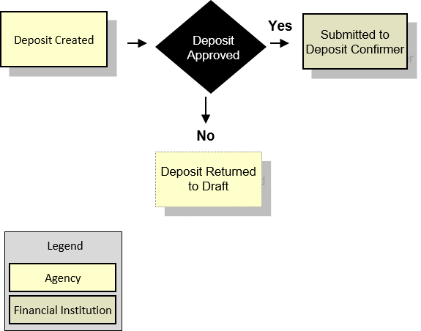

## Topic 2 Approving Deposits

As a **Deposit Preparer** and **Deposit Approver without an enforced separation of duties**, you have the ability to approve (submit) a deposit.

As a **Deposit Preparer** and **Deposit Approver with an enforced separation of duties**, you have the ability to approve (submit) a deposit if the deposit was created by another user.

To approve (submit) a deposit, the deposit must be saved with **AWAP** status. To locate deposits with **AWAP** status, use the **View Deposits** function. After locating the deposit, you can approve (submit) the deposit for confirmation by your financial Institution.

To approve a deposit, either search your deposits or view deposits. Select your deposits in process and your voucher number. The other items displayed are **Status**, **Date Submitted**, **Voucher Date**, **OTC Endpoint**, **ALC** and **Deposit Total**. Review your details and submit them to process the deposit awaiting approval.

## Topic 3 Returning Deposits to Draft

As a **Deposit Preparer** and **Deposit Approver** without an enforced separation of duties, you have the ability to return a deposit to **Draft** status.

As a **Deposit Preparer** and **Deposit Approver** **with an enforced separation of duties**, you have the ability to return a deposit to **Draft** status, if another user created the deposit. Return a deposit to **Draft** status when inaccuracies appear on the deposit ticket.

As a **Deposit Preparer**, you can modify and resubmit deposits returned to Draft status. To return a deposit to draft, the deposit must first have **AWAP** status. To locate deposits with **AWAP** status, use the **View Deposits** function. After you locate the deposit, return it to **Draft** status.

To return a deposit to draft, click either **View Deposits** or **Search Deposits** to locate deposits. Select **My Deposits in Process**. Select your **Voucher Number**. Review the deposit details, e.g., **Voucher Type**, **Voucher #**, **Voucher Date**, **Fiscal Year**, **OTC Endpoint**, **ALC**, **Status**, **Submitted Time/Date**, **Submitted By**, **Checks & Money** **Order Subtotal**, **Currency Subtotal**, **Deposit Total**, **Currency Denominations**, **Financial Institution Information**, **Agency Information** and **Subtotals by Accounting Code**. Review the details and return to draft.

Approve or Return a Deposit to Draft

To approve a deposit or return a deposit to draft, complete the following steps:

1. From the **Deposit Processing** tab, click **View Deposits**. The *View Deposits* page appears.

Application Tip



To locate deposits, you can also select **Search Deposits**.

1. From the **Select Display** drop-down menu, select **My Deposits in Process**.
2. Click the **Voucher Number** for the deposit details you want to process.

Application Tips



* There are two sections on the *View Deposits* page. The **My Deposits in Process** section displays your current deposits.
* The **Deposit Transactions** section displays your deposit history.
* Depending on your user role, the page displays deposits on the **My Deposits in Process** page.
* For the **Viewer** only role, the **My Deposits in Process** does not appear.

1. Review the details and click **Return to Draft**, as shown in Figure 2 or **Submit** as shown in Figure 3 to process the deposit awaiting approval. The *Confirmation* page appears, confirming the deposit was submitted to your Financial Institution.

Figure . Return Deposit to Draft Status

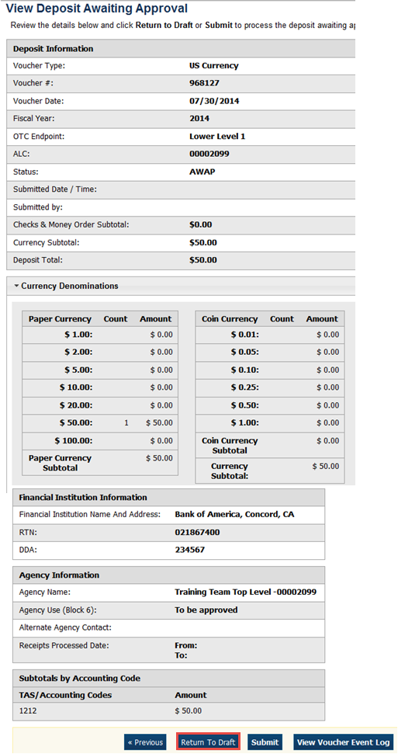

Figure . Submit Deposit

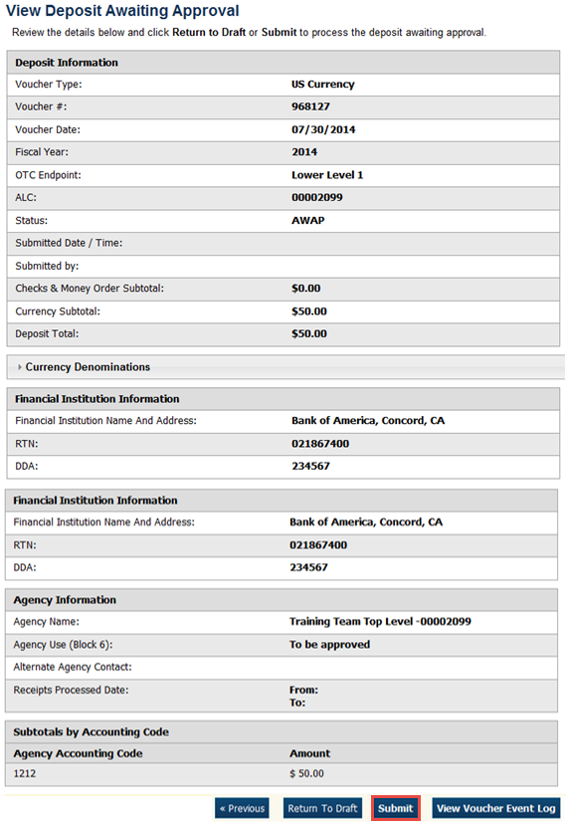

Application Tips



* Click **Return to Draft**—the deposit voucher returns to **Draft** status. A **Deposit Preparer** can modify the deposit.
* Click **Submit.** The deposit is submitted to your Financial Institution and the OTCnet Deposit Ticket displays, followed by the **Print** dialog box—it prompts you to print your deposit ticket.
* Ensure the deposit ticket is printed and included with the items sent to the bank for deposit.
* You cannot modify a deposit after it is submitted. Only a **Deposit Confirmer** from a Financial Institution can modify deposits by creating adjustments.

Additional Buttons



* Click **Adjust** to adjust a deposit.
* Click **Cancel** to return to the OTCnet Home Page. No data is saved.
* Click **Confirm** to confirm a deposit.
* Click **Next** to advance to the next page.
* Click **Print Deposit Ticket** to print a formatted deposit ticket.
* Click **Previous** to return to the previous page.
* Click **Return Home** to return to the OTCnet Home Page.
* Click **Reject** to reject a deposit (visible if a user has **Deposit Confirmer** privileges) .
* Click **View Voucher Event Log** to view the history of the deposit voucher.

## Summary

In this chapter, you learned:

* The purpose of approving a deposit or returning a deposit to draft
* How to approve deposits
* How to return a deposit to draft