

OTCnet Participant User Guide

Table of Contents

Overview, Topics, and Audience 1

Overview 1

Topics 1

Audience 1

Topic 1 Searching for Deposits 2

Search for a Deposit 3

Topic 2 Downloading Deposit Information 5

Download Search Results for a Deposit 6

Summary 9

List of Figures

Figure 1. Search Results Table 4

Figure 2. Download Button 6

Figure 3. Download Attributes Selection 7

List of Tables

Table 1. Search Criteria Fields 2

Table 2. Search Results Deposit Statuses 2

Glossary

Click this [link](https://www.fiscal.treasury.gov/otcnet/training/wbt/content/course_OTC/glossary.htm) to access the full OTCnet Glossary.

## Overview, Topics, and Audience

### Overview

In this chapter, you will learn:

* How to search for and locate deposits using one or more search criteria
* How to download deposit voucher(s) as an
* XML or CSV file

### Topics

This chapter is organized by the following topics:

1. Searching for Deposits
2. Downloading Deposit Information

### Audience

The intended audience for *Search for Deposits* Participant User Guide includes:

* Deposit Preparer
* Deposit Approver
* Deposit Confirmer
* Viewer

## Topic 1 Searching for Deposits

As a **Deposit Preparer**, **Deposit Approver**, **Deposit Preparer and Approver**, **Deposit Confirmer**, or **Viewer**, you are authorized to search for a deposit voucher and download and save the searched deposit voucher(s) as an XML or CSV file.

To search for a deposit, select the **Search Deposits** function. The **Search Deposits** function enables you to search for a deposit voucher using one or more criteria. If you do not specify any criteria, the search results will include all deposits in the system that you have access to view. You can run additional searches; the Search Results table that appears is cleared and re-populated with the results of the new search. See Table 1 for search criteria fields.

Table . Search Criteria Fields

| Search Criteria Groupings | Search Criteria Fields |
| --- | --- |
| Search Conditions | * Organization * OTC Endpoint * ALC * Prepared by * Voucher Number * Deposit Status * Agency Block 6 * Deposit Type |
| Voucher Date | * From and To Date |
| Deposit Date | * From and To Date |
| Deposit Total | * From and To Total |
| Financial Institution Information | * Routing Transit Number * Demand Deposit Account * CA$HLINK II Account Number * FRB Account Key * FRB Cost Center Work Unit |

Under the **Search Deposits** function, if you run a search without specifying any criteria, the search results include all deposits in the system that you have access to view (see Table 2).

Table . Search Results Deposit Statuses

|  |  |
| --- | --- |
| Draft | A deposit that is saved for modification at a later date by a Deposit Preparer |
| Awaiting Approval | A deposit that is waiting for deposit confirmation by a Deposit Approver |
| Submitted | A deposit that is submitted and waiting deposit confirmation by a Deposit Confirmer |
| Confirmed | A deposit that has been reviewed and confirmed by a Financial Institution or FRB |
| Rejected | A deposit that is returned by a Financial Institution or FRB to the Deposit Preparer to create a new deposit |

Search for a Deposit

To search for a deposit, complete the following steps:

1. From the **Deposit** **Processing** tab, click **Search** **Deposit**. The *Search* *Deposit* page appears.
2. Enter the search criteria for the deposit you would like to view and click **Search**. The *Search Results* table appears.

Under Search Conditions, *optional*

* Select the **Organization**
* Select the **OTC Endpoint**
* Enter the **ALC (Agency Location Code)**
* Enter **Prepared by** details
* Enter the **Voucher #**
* Select the **Deposit Status**
* Enter **Agency Use (Block 6)** details
* Select the **Deposit Type**
* Enter the **From** and **To** Voucher Date
* Enter the **From** and **To** Deposit Date
* Enter the **From** and **To** Deposit Total

Application Tip



Voucher From date must be five years or less from the current date. Vouchers more than five years old are viewed from the **Historical Reports** menu.

Under **Financial Institution Information**, *optional*

* Enter the **RTN (Routing Transit Number)**
* Enter the **DDA (Demand Deposit Account)**
* Enter the **CAN (CA$HLINK II Account Number)**
* Enter the **FRB Account Key (Federal Reserve Bank Account Key)**
* Enter the **FRB CCWU (Federal Reserve Bank Cost Center Work Unit)**

Under **User Defined Field Information**, *if applicable*, *optional*

* Enter the **Deposit UDF (User Defined Fields)**
* Enter the **Accounting Subtotal UDF details**

Application Tips



* User Defined Fields (UDFs) only display to users who have access to an organization that has previously defined UDFs.
* UDFs appear at the bottom of the page.
* Up to three UDFs can be displayed for **Deposit** and two for **Accounting Subtotal.**

1. Click the **Voucher Number** of the deposit whose details you would like to view as shown in Figure 1.

Figure . Search Results Table

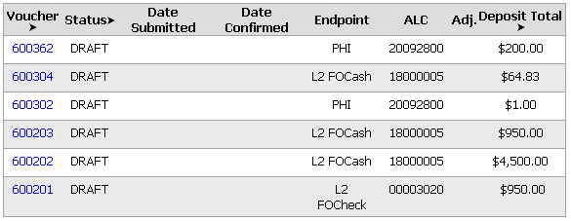

Application Tips



* Deposit totals are not displayed for unconfirmed foreign check items for which **Other** was selected as the country of deposit during deposit creation.
* Click **Download** to save the search deposit results as an XML or CSV file.

Additional Buttons



* Click **Edit** to modify the deposit draft. (Visible if a user has **Deposit Preparer** privileges.)
* Click **Previous** to return to the previous page.
* Click **Print Deposit Ticket** to print a formatted deposit ticket.
* Click **Return Home** to return to the OTCnet Home Page.
* Click **View Voucher Event Log** to view the history of the   
  deposit voucher events.

## Topic 2 Downloading Deposit Information

After searching for your deposit, you can download the retrieved information. To download the results of a deposit, first use the **Search Deposits** function.

To download search results, enter the optional search criteria for the deposit you would like to view and click **Search**. Search criteria under **Search Conditions**, including **Voucher**, **Status**, **Date Submitted**, **Date Confirmed**, **OTC Endpoint**, **ALC**, **Adj.**, and **Deposit Total**.

Search criteria under **Financial Institution Information** and enter **User Defined Field Information** details.

You can also download your results by selecting the **XML file** or **CSV file** format. Check the desired attributes that you want to download for **Deposit Information**, **Financial Institution Information**, **Agency Information**, **Accounting Subtotals and User Defined Data**, and **Foreign Deposit Information.** Open or save your file.

Download Search Results for a Deposit

To download the search results for a deposit, complete the following steps:

1. Click **Download** from the *Search Results* table. The *Download Deposits* page appears as shown in Figure 2.

Figure . Download Button

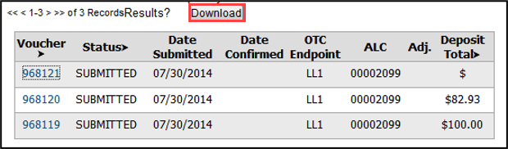

Application Tip



The *Search Results* table does not display **Deposit Total** values for unconfirmed Foreign Check Item deposits associated with a Country of Deposit selection of **Other**.

1. Select **XML file** or **CSV file** as the file format.
2. Check the desired attributes that you want to download for the following:
   * **Deposit Information**
   * **Financial Institution Information**
   * **Agency Information**
   * **Accounting Subtotals and User Defined Data**
   * **Foreign Deposit Information**
3. Click **Submit** as shown in Figure 3. The *File Download* dialog box appears.

Figure . Download Attributes Selection

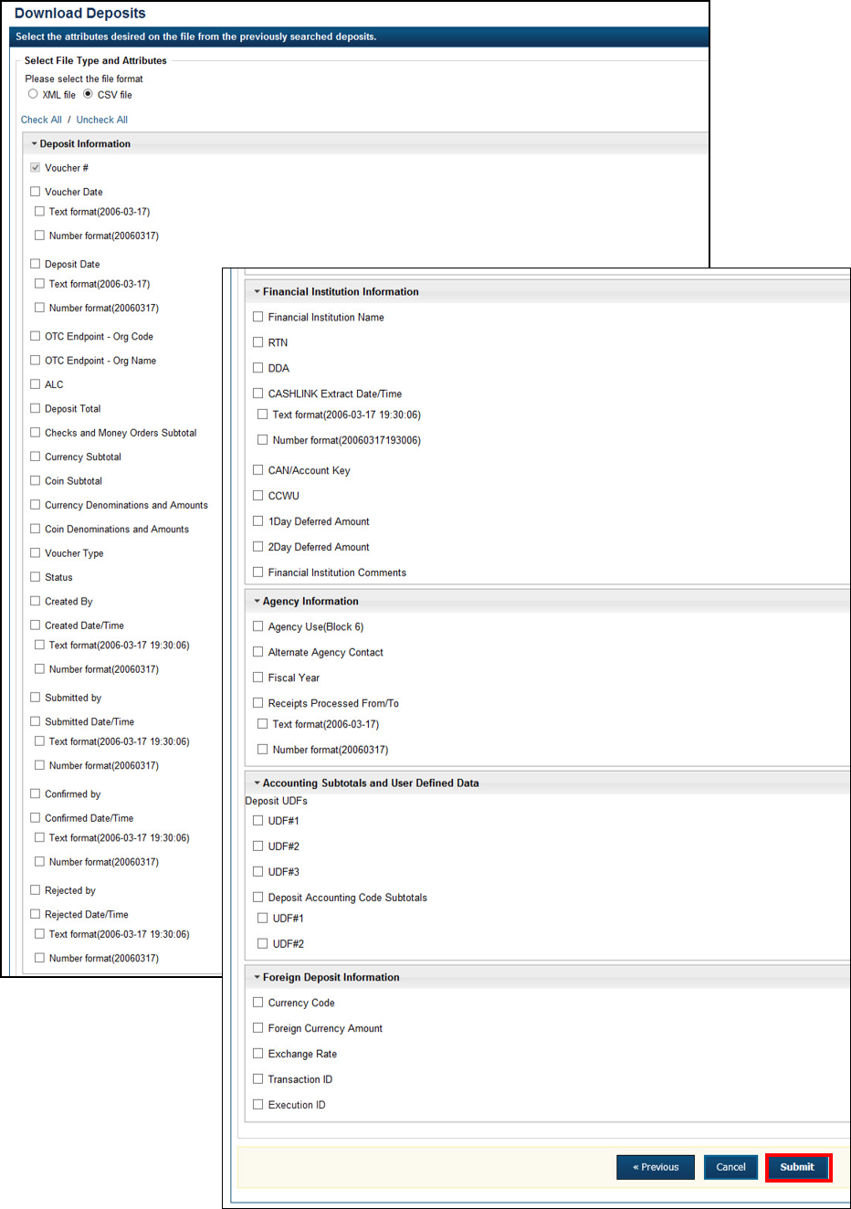

1. Click **Open** or **Save.**

Application Tips



* Click **Open** and the content of the file displays.
* Click **Save** to choose the location where you want to save the file.

Additional Buttons



* Click **Cancel** to return to the OTCnet Home Page. No data is saved.
* Click **Clear** to clear all data fields and reset to the default selections.
* Click **Download** to download the search results.
* Click **Previous** to return to the previous page.
* Click **Print Deposit Ticket** to print a formatted deposit ticket.
* Click **Search** to display the deposits that match the search criteria.
* Click **Return Home** to return to the OTCnet Home Page.

## Summary

In this chapter, you learned:

* How to search for and locate deposits using one or more search criteria
* How to download deposit voucher(s) as an XML or CSV file.