

# Chapter 3. Creating and Modifying Deposits

OTCnet Participant User Guide

Table of Contents

Overview, Topics, and Audience 1

Overview 1

Topics 1

Audience 1

Topic 1 Purpose of Creating and Modifying a Deposit 2

Topic 2 Creating a Deposit and Confirming or Submitting for Approval 4

Create a Deposit for US Currency 4

Create a Deposit for U.S. Currency 5

Create a Deposit for Foreign Currency Cash 9

Create a Deposit for Foreign Currency Cash 10

Create a Deposit for a Foreign Check Item 14

Create a Deposit for a Foreign Check Item 15

Topic 3 How to Modify a Deposit 20

Modify a Deposit 20

Modify a Deposit 21

Summary 26

List of Figures

Figure 1. Step 2 of 3: Define Subtotals by Accounting Code or TAS for US Currency 7

Figure 2. Step 2 of 3: Define Subtotals by Accounting Code or TAS 11

Figure 3. Step 2 of 3: Define Subtotals by Accounting Code or TAS for Foreign Check Item in which Country of Deposit was Set to a Country Name 17

Figure 4. Edit Draft Deposit 22

Figure 5. 1 of 3: Update Deposit Preparation Information for Foreign Currency Cash 23

List of Tables

Table 1. Deposit Processing Options Based on User Roles and Processing Option When Current Deposit Status is Draft 2

Table 2. Deposit Processing Options Based on User Roles and Processing Option When Current Deposit Status is AWAP 3

Glossary

Click this [link](https://www.fiscal.treasury.gov/otcnet/training/wbt/content/course_OTC/glossary.htm) to access the full OTCnet Glossary.

## Overview, Topics, and Audience

### Overview

Welcome to *Creating and Modifying Deposits*. In this chapter, you will learn:

* The purpose of creating and modifying a deposit
* How to create a deposit for US Currency
* How to create a deposit for Foreign Currency Cash
* How to create a deposit for Foreign Check Items
* How to save a deposit as a draft
* How to submit a deposit for approval
* How to submit a deposit for confirmation
* How to modify a deposit

### Topics

This chapter is organized by the following topics:

1. Purpose of Creating and Modifying a Deposit
2. Creating a Deposit and Confirming or Submitting for Approval
3. Modifying a Deposit

### Audience

The intended audience for the *Creating and Modifying Deposits Participant* User Guide includes:

* Deposit Preparer
* Deposit Preparer and Deposit Approver

## Topic 1 Purpose of Creating and Modifying a Deposit

The purpose of creating a deposit is to help you find the information needed quickly and easily to successfully complete deposits for your organization. The ability to modify those deposits ensures accurate deposits are made.

You may be assigned the **Deposit Preparer** role, the **Deposit Approver role** or both the **Deposit Preparer** and **Deposit Approver** roles.

As a **Deposit Preparer**, you can create deposits, save them as draft or save for approval, modify draft deposits and search for and view deposits.

As a **Deposit Approver**, you can submit (to your financial institution) or reject deposits saved for approval and to search for and view deposits.

As a **Deposit Preparer** and **Deposit Approver**, you have the ability to create deposits, submit deposits, modify draft deposits and search for and view deposits.

If your organization's **Accounting Specialist** has enforced separation of duties, you are not allowed to submit a deposit that you have created. A separation of duties means that a user does not have the ability to create and submit a deposit in OTCnet. This is enforced to ensure checks and balances.

Depending on your deposit status, role, and if there is an enforced separation of duties, you have certain deposit-processing options available to you (see Table 1).

Table 1. Deposit Processing Options Based on User Roles and Processing Option When Current Deposit Status is Draft

| Option | Deposit Preparer  Without  Separation of Duties Enforced | Deposit Preparer/ Deposit Approver (user assigned both roles)  Without Separation of Duties Enforced | Deposit Preparer With Separation of Duties Enforced | Deposit Preparer/ Deposit Approver (user assigned both roles)  With Separation of Duties Enforced |
| --- | --- | --- | --- | --- |
| Delete | Yes | Yes | Yes | Yes |
| Save As Draft | Yes | Yes | Yes | Yes |
| Save For Approval | Yes | Yes | Yes | Yes |
| Submit | No | Yes | No | No1 / Yes2 |
| Edit (Modify) | Yes | Yes | Yes | Yes |

1 assuming that this user created a deposit

2 assuming that a deposit has been created by another user

Table 2. Deposit Processing Options Based on User Roles and Processing Option When Current Deposit Status is AWAP

| Option | Deposit Preparer  Without  Separation of Duties Enforced | Deposit Approver  Without  Separation of Duties Enforced | Deposit Preparer/ Deposit Approver  (user assigned both roles)  Without  Separation of Duties Enforced | Deposit Preparer  With  Separation of Duties Enforced | Deposit  Approver  With  Separation of Duties Enforced | Deposit Preparer/ Deposit Approver  (user assigned both roles)  With  Separation of Duties Enforced |
| --- | --- | --- | --- | --- | --- | --- |
| Submit | No | Yes | Yes | No | Yes | No1 / Yes2 |

1 assuming that this user created a deposit

2 assuming that a deposit has been created by another user

## Topic 2 Creating a Deposit and Confirming or Submitting for Approval

As a **Deposit Preparer** or **Deposit Preparer and Approver** you authorized to create deposits and modify deposits for:

* US Currency
* Foreign Currency Cash
* Foreign Check Item

### Create a Deposit for US Currency

To create a deposit for U.S. currency, use the **US Currency** function to create a deposit for US cash, coins, checks, and money orders. Select your endpoint and your **Deposit Information** (deposit total and voucher date), **Financial Institution Information**, and **Agency Information**. Depending on your role, deposit status, and if there is an enforced separation of duties, you may have only certain processing options available to you.

Select an **Accounting Code** or **Treasury Account Symbol (TAS)**, and enter the **Amount**. The combined accounting code subtotals must be equal to the deposit total before proceeding to the next step. Verify your deposit information and submit the deposit.

Create a Deposit for U.S. Currency

To create a deposit for US Currency, complete the following steps:

1. From the **Deposit Processing** tab, select **Create Deposit**>**US Currency**. The *Select OTC Endpoint* page appears.

Application Tip



1. Select an OTC Endpoint to create a deposit. The *Step 1 of 3: Define Deposit Preparation Information* page appears.
2. Enter the information relevant to preparing the deposit.

Application Tip



For data security a message displays discouraging users from entering Personally Identifiable Information (PII) in user Defined Fields (UDFs).

Under **Deposit Information**:

* + Enter the **Deposit Total**
  + Select the **Voucher Date**

Application Tips



* When creating an OTCnet deposit ticket or deposit voucher, enter the **Voucher Date** for when the ***deposit is created***, not the date you expect it to arrive to the Financial Institution.
* **Do not post-date the voucher date, even if you mail or send the deposit by courier.**
* If the deposit arrives before the date entered on the voucher, your Financial Institution cannot confirm your deposit in a timely fashion.
* Select the **Fiscal Year**, *optional*

Under **Financial Institution Information**

* Select a **Financial Institution**

Under **Agency Information**, *optional*

* + Enter comments in **Agency Use (Block 6)**
  + Enter the dates the receipts are processed in **From:** and **To:**
  + Enter the name of the **Alternate Agency Contact**
  + Enter the **User Defined Field (UDF)** details

Application Tip



When completing the **Alternate Agency Contact** field, include the following:

* Name
* Email Address
* Phone Number

The entry cannot exceed 400 characters

Under **Currency Denomination**, *if applicable*

* Enter the **Paper Currency Count**
* Enter the **Coin Currency Count**

Under **Totals**, *if applicable*

* Enter the **Checks and Money Orders Subtotal**
* Enter the **Currency Subtotal**
* Enter the **Coin Currency Subtotal**
* Click **Calculate $** to determine the Deposit Variance.

Application Tip



The Deposit Variance must equal $0.00 before proceeding to the next step. If it does not, you must go back and re-validate your subtotal entries.

1. Click **Next**. The *Step 2 of 3: Define Subtotals by Accounting Code or TAS* page appears as shown in Figure 1.

Figure 1. Step 2 of 3: Define Subtotals by Accounting Code or TAS for US Currency

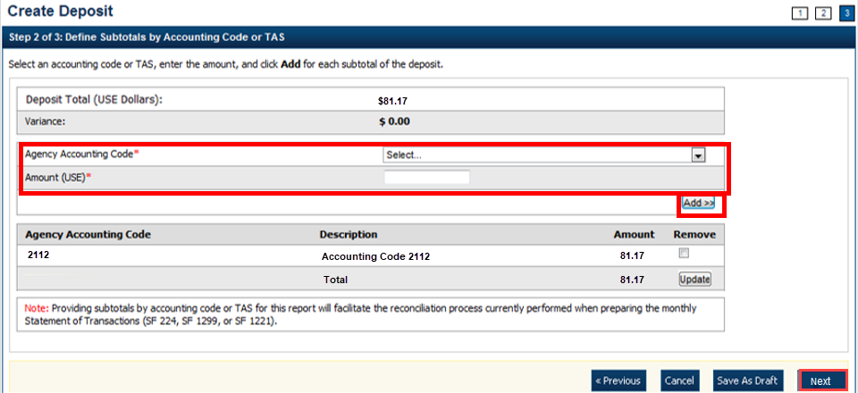

1. Select an **Agency Accounting Code**, enter the **Amount**, and click **Add** for each subtotal of the deposit.

Application Tips



* If the **Agency Accounting Code** label has been customized at the organization level, the custom label displays instead of the default label of **Agency Accounting Code**
* At least one accounting code entry is required. Additional lines are optional
* The combined accounting code subtotal must be equal to the deposit total before proceeding to the next step. If it does not, you must go back and re-validate your subtotal entries

Application Tip



Accounting codes are listed in the drop-down menu:

* If they *are not* identified as TAS

or

* If they *are* identified as TAS and designated by SAM as “Valid”

Accounting codes are not listed in the drop-down menu if they are identified as TAS and are in the process of being validated by SAM.

If no accounting codes are listed, contact your **Accounting Specialist** or **Local Accounting Specialist** for assistance.

1. Click **Next**. The *Step 3 of 3: Review Deposit Preparation Information* page appears.
2. Verify the deposit information and click **Save as Draft**, **Save for Approval**, or **Submit**.

Application Tips



* Click **Save as Draft** an *Acknowledgement* page appears showing the Voucher Number of the deposit and a message confirming that the deposit information has been saved with **Draft** status.
* Click **Save for Approval** an *Acknowledgement* page appears showing the Voucher Number of the deposit and a message confirming that the deposit information has been saved with **Awaiting Approval** status.
* Click **Submit** a *Confirmation* page appears showing the deposit information detail. The OTCnet deposit ticket will also generate at that time.

Additional Buttons



* Click **Cancel** to return to the OTCnet Home Page. No data is saved.
* Click **Edit** to modify the deposit draft. (Visible if a user has Deposit  
  Preparer privileges.)
* Click **Previous** to return to the previous page.
* Click **Return Home** to return to the OTCnet Home Page.
* Click **Update** to remove any accounting code subtotal date from the accounting code subtotal summary table

### Create a Deposit for Foreign Currency Cash

To create a deposit for foreign currency cash, select the endpoint where you need to make a **Foreign Currency Cash** deposit and define the relevant deposit preparation information. You will receive the “*Currency conversion service is not available*” message if the conversion service is not available.

Define your subtotals by **Accounting Code** or **Treasury Account Symbol (TAS)**, enter your **Amount** and **Add** the deposit. Verify your deposit information is correct and save or submit it.

Create a Deposit for Foreign Currency Cash

To create a deposit for Foreign Currency Cash, complete the following steps:

1. From the **Deposit Processing** tab, select **Create Deposit**>**Foreign Currency Cash**.
2. From the *Select OTC Endpoint* page, select an OTC Endpoint. The *Step 1 of 3: Define Deposit Preparation Information* page displays.
3. Enter the deposit preparation information. The *Step 2 of 3: Define Subtotals by Accounting Code or TAS* page appears.

Application Tip



For data security, a message displays discouraging users from entering **Personally Identifiable Information (PII)** in User Defined Fields (UDFs).

If the currency conversion service is not available, “*Currency conversion service is not available*” is displayed on the page. If you receive this message you may continue preparing your deposit by completing the steps in section **A** below and clicking **Next**. If you do not receive the message indicating the service is unavailable follow the steps in section **B**.

**A. Currency conversion service is not available:**

* + Enter the **Deposit Total (USE Dollars)** in **US Equivalent dollars**, **Currency Code**, **Foreign Currency Amount** and **Transaction ID**.
  + (Optional) Under **Agency Information**: enter comments in **Agency Use (Block 6)**, enter the **From** and **To** dates of the receipts processed, select the **Fiscal Year**, enter the **Alternate Agency Contact**, and, if applicable, enter the **User Defined Field** details.
  + Click **Next**.

**B. Currency conversion service is available:**

* + Select the **Currency Code**, enter the **Foreign Currency Amount** and select a **Financial Institution**.
  + (Optional) Under **Agency Information**: enter comments in **Agency Use (Block 6)**, enter the **From** and **To** dates of the receipts processed, select the Fiscal Year, enter the **Alternate Agency Contact**, and, if applicable, enter the **User Defined Field** details.
  + Click **Next**.

Application Tip



When completing the **Alternate Agency Contact** field, include the following:

* Name
* Email address
* Phone Number

**The entry cannot exceed 400 characters.**

1. Select an **Accounting Code or Treasury Account Symbol (TAS)**, enter the **Amount**, and click **Add** for each subtotal of the deposit as shown in Figure 2.

Figure 2. Step 2 of 3: Define Subtotals by Accounting Code or TAS

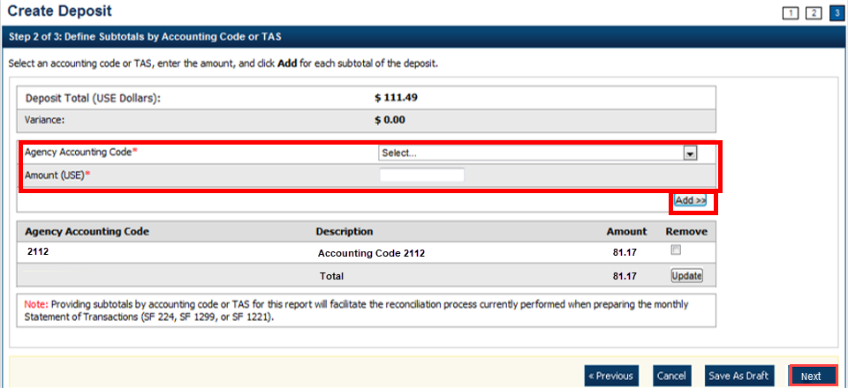

Application Tips



* If the **Agency Accounting Code** label is customized at the organization level, the custom label is displayed, instead of the default label of “**Agency Accounting Code**.”
* At least one accounting code entry is required. Additional entries are optional.
* The combined accounting code subtotal must be equal to the deposit total before proceeding to the next step. If it is not, re-validate your subtotal entries.

Application Tip



Accounting codes are listed in the drop-down menu:

* If they *are not* identified as TAS or
* If they *are* identified as TAS and designated by SAM as **Valid**

Accounting codes are not listed in the drop-down menu if they are identified as TAS and are in the process of being validated by SAM.

If no accounting codes are listed, contact your **Accounting Specialist** or **Local Accounting Specialist** for assistance.

1. Click **Next**. The *Step 3 of 3: Review Deposit Preparation Information* page appears.
2. Verify the deposit information is correct and click **Save as Draft**, **Save for Approval**, or **Submit**.

Application Tips



* Click **Save as Draft** an *Acknowledgement* page appears showing the Voucher Number of the deposit and a message confirming that the deposit information has been saved with **Draft** status.
* Click **Save for Approval** an *Acknowledgement* page appears showing the Voucher Number of the deposit and a message confirming that the deposit information has been saved with **Awaiting Approval** status.
* Click **Submit** a *Confirmation* page appears showing the deposit information detail. Your OTCnet deposit ticket generates at that time.

The Deposit Ticket *and* Foreign Currency Cash—send immediately to Bank of America**:**

* For **foreign currency cash under $5,000 USD value** mail to:   
  Bank of America GBN-LA   
  Mail Code: CA9-924-01-11   
  2706 Media Center Drive   
  Los Angeles, CA 90065-1733
* For **foreign currency cash over $5,000 USD value**:   
  Call Bank of America's banknote trading desk number (800-387-1012) for an armored courier pick up.
* For **foreign checks:**

All foreign exchange check deposits for Clearing—send to the following mailing address:

Bank of America

Attn: Foreign Transit Items

GA 4-004-02-02

6000 Feldwood Rd

College Park, GA 30349

Foreign exchange check deposits for Clearing:

* Checks drawn on foreign banks and made payable in foreign currency, and where the name of the Country of Deposit is listed in the dropdown within OTCnet are processed in OTCnet as foreign check items.
* Checks drawn on foreign banks and made payable in US Dollars are processed in OTCnet as foreign check items and users should select ‘Other’ for the Country of Deposit.
* These items are treated as cash letter items. Cash letter items are immediately cleared and granted provisional credit within two business days, following the day the financial agent receives the check. A separate deposit must be created for each type of foreign currency.
  + Send all **foreign exchange check deposits for Collections** to the following address:

Bank of America

Foreign Transit Items

GA 4-004-02-02

6000 Feldwood Road

College Park, GA 30349

Foreign exchange check deposits for Collections:

* Checks drawn on foreign banks and made payable in foreign currency, and where the name of the Country of Deposit *is not* listed in the dropdown within OTCnet, is treated as collection items. Users should select ‘Other’ for items where the Country of Deposit is not listed. Collection items are forwarded to the foreign banks where the checks are drawn on for clearance, prior to credit being granted. This collection process takes approximately six to eight weeks to complete.

Additional Buttons



* Click **Cancel** to return to the OTCnet Home Page. No data is saved.
* Click **Previous** to return to the previous page.
* Click **Return Home** to return to the OTCnet Home Page.
* Click **Update** to remove any accounting code subtotal date from the accounting code subtotal summary table.

### Create a Deposit for a Foreign Check Item

To create a deposit ticket for foreign checks only, use **Foreign Check Item**. You are asked to enter your deposit preparation information. Select an **Agency Accounting Code** and enter the **Amount**. Review your deposit information and save or submit it.

Create a Deposit for a Foreign Check Item

To create a deposit for a Foreign Check Item, complete the following steps:

1. From the **Deposit Processing** tab, select **Create Deposit**>**Foreign Check Item**. The *Select OTC Endpoint* page appears.
2. Select an OTC Endpoint to create a deposit. The *Step 1 of 3: Define Deposit Preparation* Information page appears.
3. Enter the information to prepare the deposit and click **Next**. The *Step 2 of 3: Define Subtotals by Accounting Code or TAS* page appears.

Application Tip



For data security, a message displays discouraging users from entering Personally Identifiable Information (PII) in User Defined Fields (UDFs).

Under **Deposit Information**:

* + Select the **Country of Deposit**

If the name of the country of deposit is not listed, select “**Other**”. Once the **Country of Deposit** is selected the currency code for the selected country is displayed automatically in the **Currency Code** field.

* + - For a check drawn on a Singaporean bank and stamped “Non-transferable,” you must set the Country of Deposit to “Other”.
  + Enter the **Foreign Currency Amount**

Under **Financial Institution Information**:

* + Select a Financial Institution

(Optional) **Under Agency Information**:

* + Enter comments in **Agency Use (Block 6)**
  + Enter or select the **From**: and **To**: dates the receipts were processed
  + Select the **Fiscal Year** from the drop-down menu
  + Enter the name of the **Alternate Agency Contact**

Application Tip



When completing the **Alternate Agency Contact** field, including the following:

* Name
* Email Address
* Phone Number

The entry cannot exceed 400 characters.

1. Select an Accounting Code or **Treasury Account Symbol (TAS)**, enter the **Amount**, and click **Add** for each subtotal of the deposit (at least one accounting code entry is required).

Application Tips



* If the Agency Accounting Code label is customized at the organization level, the custom label is displayed instead of the default label of **Agency Accounting Code**.
* If the **Country of Deposit** selected in Step 1 was set to **Other**, amounts are displayed in foreign currency values. Otherwise, if a country name was selected, amounts are displayed in US Equivalent (USE) dollar values.
* The combined accounting code subtotal must be equal to the deposit total before proceeding to the next step. If it does not, re-validate the subtotal entries.

Application Tip



Accounting codes are listed in the **Agency Accounting Code** drop-down menu:

* If they are not identified as TAS or
* If they are identified as TAS and designated by SAM as **Valid**

Accounting codes are not listed in the drop-down menu if they are identified as TAS and are in the process of being validated by SAM.

If no accounting codes are listed, contact your **Accounting Specialist** or **Local Accounting Specialist** for assistance.

1. Click **Next**. The *Step 3 of 3: Review Deposit Preparation Information* page appears as shown in Figure 3.

Figure 3. Step 2 of 3: Define Subtotals by Accounting Code or TAS for Foreign Check Item in which Country of Deposit was Set to a Country Name

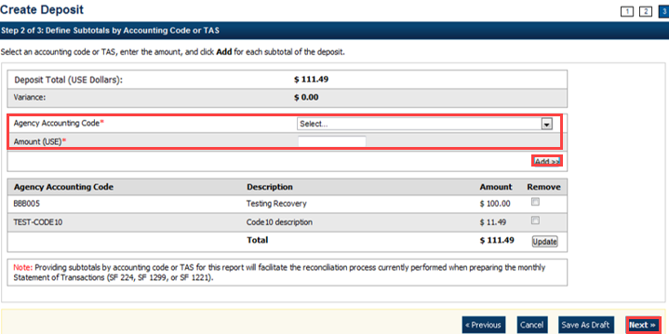

1. Verify the deposit information is correct. Click **Save as Draft**, **Save for Approval**, or **Submit**.

Application Tips



* The processing options available to each user depends on your system role, the status of the deposit and the system settings that enforce the separation of duties.
* Click **Save as Draft** an *Acknowledgement* page appears showing the Voucher Number of the deposit and a message confirming that the deposit information has been saved with **Draft** status.
* Click **Save for Approval** an *Acknowledgement* page appears showing the Voucher Number of the deposit and a message confirming that the deposit information has been saved with **Awaiting Approval** status.
* Click **Submit** a *Confirmation* page appears showing the deposit information detail. Your OTCnet deposit ticket generates at that time.
  + Mail or send the **Deposit Ticket**, together with Foreign Currency Cash, immediately to Bank of America:
    - For **foreign currency cash under $5,000 USD** value mail to:   
      Bank of America GBN-LA   
      Mail Code: CA9-924-01-11   
      2706 Media Center Drive   
      Los Angeles, CA 90065-1733
    - For **foreign currency cash over $5,000 USD** value:   
      Call Bank of America's banknote trading desk number (800-387-1012) for an armored courier pick up.
  + For **foreign checks**:
    - Send all foreign exchange check deposits for Clearing to the following mailing address:

Bank of America

Attn: Foreign Transit Items

GA 4-004-02-02

6000 Feldwood Rd

College Park, GA 30349

**Foreign exchange** **check deposits for Clearing** information is as follows:

* Checks drawn on foreign banks and made payable in foreign currency, and where the name of the Country of Deposit is listed in the dropdown within OTCnet are processed in OTCnet as foreign check items.
* Checks drawn on foreign banks and made payable in US Dollars are processed in OTCnet as foreign check items and users should select ‘Other’ for the Country of Deposit.
* These items are treated as cash letter items. Cash letter items are immediately cleared and granted provisional credit within two business days, following the day the financial agent receives the check. A separate deposit must be created for each type of foreign currency.
  + Send all **foreign exchange check deposits for Collections** to the following address:

Bank of America

Attn: Foreign Transit Items

GA 4-004-02-02

6000 Feldwood Rd

College Park, GA 30349

**Foreign** **exchange check deposits for Collections** information is as follows:

* Checks drawn on foreign banks and made payable in foreign currency, and where the name of the Country of Deposit is not listed in the dropdown within OTCnet, are treated as collection items. Users should select ‘Other’ for items where the Country of Deposit is not listed. Collection items are forwarded to the foreign banks where the checks are drawn on for clearance, prior to credit being granted. This collection process takes approximately six to eight weeks to complete.

Application Tip



The processing options available to each user depends on their system role, the status of the deposit and the system settings that enforce the separation of duties.

Additional Buttons



* Click **Cancel** to return to the OTCnet Home Page. No data is saved.
* Click **Previous** to return to the previous page.
* Click **Return Home** to return to the OTCnet Home Page.
* Click **Update** to remove any accounting code subtotal date from the accounting code subtotal summary table.

## Topic 3 How to Modify a Deposit

A **Deposit Preparer,** or **Deposit Preparer** and **Approver,** is authorized to create deposits and modify deposits for:

* US Currency
* Foreign Currency Cash
* Foreign Check Item

The modify deposit’s function allows you to modify the deposit preparation information required to properly account for, track and direct the deposit transaction. Deposit preparation information can be modified if a deposit’s status is **Save As Draft**. Changing the endpoint of a deposit requires that the deposit be deleted and a new one be created.

### Modify a Deposit

To retrieve a deposit for modification, select your deposits in process and click the **Voucher** number of the deposit you would like to view. You can edit your deposit, update the deposit preparation information and update the subtotals by **Accounting Code** or **Treasury Account Symbol (TAS).** Verify your deposit information is correct and either save or submit the deposit.

Modify a Deposit

To modify a deposit, complete the following steps:

1. From the **Deposit Processing** tab, click **View Deposits**. The *View Deposits* page appears.

Application Tip



You can also select **Search** **Deposits** to locate deposits.

1. From the **Select Display** drop-down menu, select **My Deposits in Process**.
2. Click the **Voucher** number of the deposit you would like to view from the list displayed.

Application Tip



To modify the number of records displayed per page, select from the drop-down menu options next to the record count.

1. The *View Draft Deposit* page appears. Click **Edit** as shown in Figure 4.

Figure 4. Edit Draft Deposit

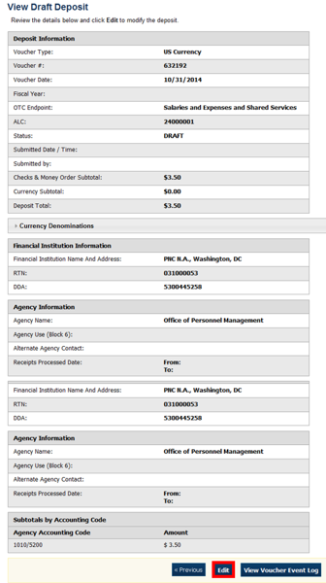

1. The *View Submitted Deposit* page appears. Click **Edit**. The *Step 1 of 3: The Update Deposit Preparation Information* page appears as shown in Figure 5.

Figure 5. 1 of 3: Update Deposit Preparation Information for Foreign Currency Cash

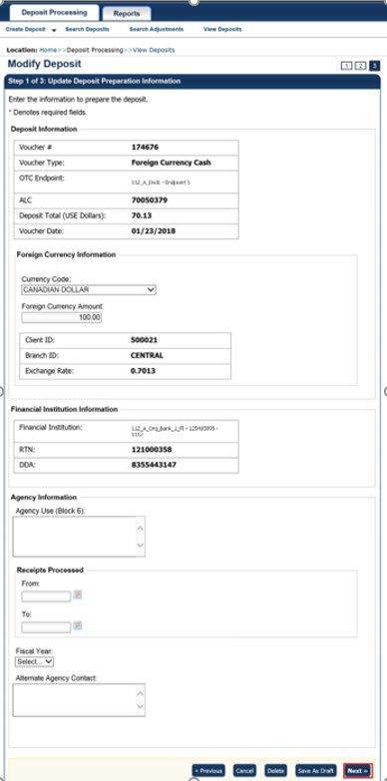

1. Update the deposit preparation information for the type of currency for the deposit, per the instructions provided below, and click **Next**. The *Step 2 of 3: Update Subtotals by Accounting Code or TAS* page appears.

| For US Currency | For Foreign Currency Cash | For Foreign Check Items |
| --- | --- | --- |
| **Deposit Information:**   * Enter the Deposit Total * Select the Voucher Date * Select the Fiscal Year, *optional*   **Agency Information, (*optional*):**   * Enter comments in Agency Use (Block 6) * Enter the date the From: and To: dates the receipts were processed * Enter the name, email address, and phone number of the Alternate Agency Contact * Enter the User Defined Field details   **Currency Denomination,  (*if applicable*):**   * Enter the Paper Currency Count * Enter the Coin Currency Count   **Totals, (*if applicable*):**   * Enter the Checks and Money Orders Subtotal * Click Calculate $ to determine the Deposit Variance. The Deposit Variance must equal $0.00 before proceeding to the next step. If it does not, you must go back and re-check your subtotal entries. | **Foreign Currency Information:**   * Select the Currency Code * Enter the Foreign Currency Amount   **Agency Information, (*optional*):**   * Enter comments in Agency Use (Block 6) * Enter the date the From: and To: dates the receipts were processed * Enter the name, email address, and phone number of the Alternate Agency Contact * Enter the User Defined Field details | **Foreign Currency Information:**   * Select the Country of Deposit * Enter the Foreign Currency Amount   **Agency Information, (*optional*):**   * Enter comments in Agency Use (Block 6) * Enter the date the From: and To: dates the receipts were processed * Enter the name, email address, and phone number of the Alternate Agency Contact * Enter the User Defined Field details |

1. Update the subtotals by **Accounting Code** or **Treasury Account Symbol (TAS)** and click **Add**. The combined accounting code subtotals must be equal to the deposit total before proceeding to the next step. If it does not, re-validate the subtotal entries. The *Step 3 of 3: Review Deposit Preparation Information* page appears.

Application Tips



* If the Agency Accounting Code label is customized at the organization level, the custom label is displayed instead of the default label of **Agency Accounting Code**.
* If the **Country of Deposit** selected in Step 1 was **Other**, amounts are displayed as foreign currency values. Otherwise, if a country name was selected, amounts are displayed as US Equivalent (USE) dollar values.

Application Tip



Accounting codes are listed in the **Agency Accounting Code** drop-down menu:

* If they *are not* identified as TAS or
* If they *are* identified as TAS and designated by SAM as “Valid”

Accounting codes are not listed in the drop-down menu if they are identified as TAS and are in the process of being validated by SAM.

If no accounting codes are listed, contact your **Accounting Specialist** or **Local Accounting Specialist** for assistance.

1. Verify the deposit information and click **Save as Draft**, **Save for Approval** or **Submit.**

Application Tips



* Click **Delete** an *Acknowledgment* page appears stating the Voucher Number has been deleted.
* Click **Save as Draft** or **Save for Approval** an *Acknowledgement* page appears showing the Voucher Number.
* Click **Submit** a *Confirmation* page appears.

Additional Button



Click **Return Home** to return to the OTCnet Home Page.

## Summary

In this chapter, you learned:

* The purpose of creating and modifying a deposit
* How to create a deposit for US Currency
* How to create a deposit for Foreign Currency Cash
* How to create a deposit for Foreign Check Item
* How to save a deposit as a draft
* How to submit a deposit for approval
* How to submit a deposit for confirmation
* How to modify a deposit