

OTCnet Participant User Guide

Table of Contents

Overview, Topics, and Audience 1

Overview 1

Topic 1

Audience 1

Topic 1 Queue Interface Overview 2

Queue Interface Purpose 2

Queue Interface Configuration 3

Queue Interface Configuration 4

Summary 5

List of Figures

Figure 1. Queue Interface 4

Glossary

Click this [link](https://www.fiscal.treasury.gov/otcnet/training/wbt/content/course_OTC/glossary.htm) to access the full OTCnet Glossary.

## Overview, Topics, and Audience

### Overview

In this guide, you will learn how to configure the Queue Interface.

### Topic

This guide contains one topic: Queue Interface Overview

### Audience

The intended audiences for this guide are:

* Agencies using Queue Interface
* Check Capture Administrators

## Topic 1 Queue Interface Overview

### Queue Interface Purpose

The purpose of the Queue Interface is to enable interaction between Over the Counter Channel Application (OTCnet) and military agencies’ internal systems. The Queue Interface will be used by military agencies that utilize the Deployable Disbursing System (DDS) database bridge. It provides a single transaction input point and prevents data entry errors and discrepancies between both systems. Additional information includes:

* OTCnet feeds data one way to the Queue Interface
* Data is sent to the Queue when the following actions occur:
  + A scanned check is saved
  + A check is updated
  + A check is voided
  + A batch is created
  + A batch is closed
  + A batch is approved
  + A batch is uploaded (for the OTCnet Offline check capture application)
  + An updated batch total appears
  + OTCnet logs any action that has been successfully sent to the Queue Interface
  + After a batch is closed or data is changed within a batch, the updated batch data and the updated item data are transmitted to the Queue
  + Once an agency’s Queue Interface is enabled for an OTC Endpoint, all transactions processed after enablement are assumed to be sent to the Queue for Agency access
  + If a batch is retransmitted, no items will be sent to the Queue
  + Only successfully processed check and batch transactions will be sent to the Queue
  + When a successful check transaction is completed to the Queue interface, the following message displays on the page, *DDS Transmission Completed!*
  + Unsuccessful transactions with the Queue Interface do not prohibit check and batch processing in OTCnet; however, the following warning message is displayed to the user, *DDS Transaction failed. Invalid DDS data*
  + The OTCnet audit log includes Queue transaction status information

### Queue Interface Configuration

Only **Check Capture Administrators** and **Check Capture Supervisors** are authorized to set up a link, or bridge, to Queue Interface.

To configure the Queue Interface, you must select the endpoint you wish to link to Queue Interface. You must enable **Check Capture** and **Queue Interface**. You also must complete the OTCnet and DDS interface configuration by performing some additional actions, found in the DDS Interface Setup Standard Operating Procedure (SOP).

Queue Interface Configuration

To configure the queue interface, complete the following steps:

1. From the **Administration** tab, select **Manage Organization**>**Organization Hierarchy** >**Modify.**
2. The *Step 1 of 3: Select Organization Endpoint* page appears. Expand the hierarchy to select the OTC Endpoint that you wish to link to the Queue Interface.

Application Tip



You must use an active OTC endpoint.

1. The *Step 2 of 3: Define Processing Options* page appears. Check **Enable Check Capture and** click **Yes** for Queue Interface as shown in Figure 1.

Figure 1. Queue Interface

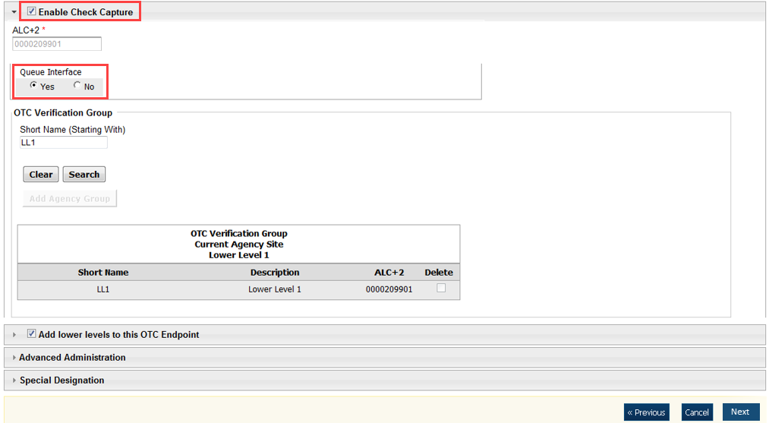

1. Click **Next**.
2. Click **Submit** to save your changes.

Application Tips



* Once your changes are submitted, the OTC Endpoint is configured with the Queue Interface.
* You can only configure the Queue Interface for OTC Endpoints that you are authorized to access.

## Summary

In this chapter, you learned how to configure the Queue Interface.