

OTCnet Participant User Guide

Table of Contents

Overview, Topics, and Audience 1

Overview 1

Topics 1

Audience 2

Topic 1 Purpose of Accessing Check Processing Reports 3

Guidance for Handling OTCnet Reports Marked with Sensitive But Unclassified 4

Topic 2 View a CIRA Query 5

Item Status 6

View a CIRA Record 7

View a CIRA Record 8

Topic 3 Business Reports 15

CIRA CSV Report 16

CIRA CSV Report 18

Check Image Report 23

Check Image Report 24

Agency CIRA Report 26

Agency CIRA Report 27

LVD Contents Report 29

LVD Contents Report 30

Organization Hierarchy Report 32

Organization Hierarchy Report 33

215 Deposit Ticket Report 34

215 Deposit Ticket Report 35

5515 Debit Voucher Report 37

5515 Debit Voucher Report 38

ACR Activity Report 40

ACR Activity Report 41

Topic 4 Administration Reports 43

CIRA Transmission Summary Report 44

View CIRA Transmission Summary Report 45

CIRA Transmission (Detailed) Summary Report 47

CIRA Transmission Summary Report 48

Statistical Report 50

Statistical Report 51

View CIR Transmission Status for Check Processing 53

View CIR Transmission Status for Check Processing 54

Topic 5 Historical Reports 55

CIRA CSV Historical Report 56

CIRA CSV Historical Report 58

Previously Generated Historical Reports 62

View Previously Generated Historical Reports 63

Summary 65

List of Figures

Figure 1: Item Status Process Flow 6

Figure 2: CIRA Query Results Showing Count and IRN Table 12

Figure 3: CIRA Details Page 13

Figure 4: File Download Dialog Box: Open/Save or Download 21

Figure 5: Click Submit to View Check Image 25

Figure 6: Agency CIRA Report Parameters Page 27

Figure 7: LVD Contents Report Preview Page 31

Figure 8: Organization Hierarchy Report Preview Page 33

Figure 9: 215 Deposit Ticket Report Preview Page 36

Figure 10: 5515 Debit Voucher Report Preview Page 39

Figure 11: ACR Activity Report Preview Page 42

Figure 12: CIRA Transmission Summary Report Preview Page 46

Figure 13: CIRA Transmission (Detailed) Summary Report 49

Figure 14: Statistical Report Preview Page 52

Figure 15: CIR Transmission Status Export/Print Report Page 54

Figure 16: CIRA CSV- Request Successfully Submitted 61

Figure 17: View Previously Generated Reports 63

List of Tables

Table 1: Report Types and Descriptions 4

Table 2: Business Reports (1st column) and Access Type (1st row) 15

Table 3: Administration Reports (1st column) and Access Type (1st row) 43

Glossary

Click this [link](https://www.fiscal.treasury.gov/otcnet/training/wbt/content/course_OTC/glossary.htm) to access the full OTCnet Glossary.

## Overview, Topics, and Audience

### Overview

Welcome to *Reporting on Scanned Checks*. In this chapter, you will learn:

* The purpose of accessing check processing reports
* How to view a CIRA Query
* How to view and download a CIRA CSV Report
* How to view and print a Check Image Report
* How to view and print an Agency CIRA Report
* How to view and print a LVD Contents Report
* How to view and print an Organizational Hierarchy Report
* How to view and print a 215 Deposit Ticket Report
* How to view and print a 5515 Debit Voucher Report
* How to view and print an ACR Activity Report
* How to view and print a CIRA Transmission Summary Report
* How to view and print a CIRA Transmission (Detailed) Summary Report
* How to view and print a Statistical Report
* How to view CIR Transmission Status for Check Processing Report
* How to view and download Historical Reports

### Topics

The topics in this chapter include the following:

1. The purpose of accessing check processing reports
2. CIRA Query
3. Business Reports

* CIRA CSV Report
* Check Image Report
* Agency CIRA Report
* LVD Contents Report
* Organizational Hierarchy Report
* 215 Deposit Ticket Report
* 5515 Debit Voucher Report
* ACR Activity Report

1. Administration Reports

* CIRA Transmission Summary Report
* CIRA Transmission (Detailed) Summary Report
* Statistical Report
* View CIR Transmission Status for Check Processing

1. Historical Reports

* CIRA CSV Historical Report
* View Previously Generated Historical Reports

### Audience

The intended audience for the *Reporting on* *Scanned Checks* Participant User Guide includes:

* Agency Manager
* CIRA Viewer
* MVD Editor
* MVD Viewer
* FMS Viewer
* FMS Security
* View Reports

## Topic 1 Purpose of Accessing Check Processing Reports

In this guide you will learn how to: run and print Check Processing reports, query using the View CIRA functionality, and query and download Historical reports. Based on your user role, you are authorized to 1) access one or more of the Check Processing reports, 2) view a CIRA record, and 3) view and download Historical reports available in OTCnet. The following roles are authorized to access reports:

* Agency Manager
* Check Capture Administrator
* MVD Editor/MVD Viewer
* FMS Viewer/FMS Security
* Report Viewer

The following are the reports a user may have access to view and download/print (see Table 1).

Table : Report Types and Descriptions

| Business Report | Allows you to… |
| --- | --- |
| CIRA CSV | Export data based on a query to a comma separated value (CSV) report. The exported data can be used to import into other applications within an agency. |
| Check Image | View the front and back images of the checks for IRNs requested. |
| Agency CIRA | View the batch level transaction activity for a specified OTC Endpoint. A user can filter the report by Received Date, Capture Date, Batch ID, or Check Capture Operator. |
| LVD Contents | View the contents of a Local Verification Database (LVD) for a given OTC Endpoint. |
| Organization Hierarchy | View the structure of a Federal Program Agency as defined in OTCnet. |
| 215 Deposit Ticket | View transaction information presented to a financial institution by a U.S. government agency with checks and other payment instruments to make a manual deposit. This report is auto-generated for Check Capture. The report is searchable using a date range of up to 45 days. Data for the report is available for a duration of one year. |
| 5515 Debit Voucher | View transaction information used to debit the Treasury General Account (TGA) to decrease the amount of a deposit made to that account. This report auto-generated for Check Capture. The report is searchable using a date range of up to 45 days. Data for the report is available for a duration of one year. |
| ACR Activity Report | View detailed information about transactions that were adjusted, corrected, or reversed/rescinded. |

| Administration Report | Allows you to… |
| --- | --- |
| CIRA Transmission Summary | View the list of transactions sent to Debit Gateway. |
| CIRA Transmission (Detailed) Summary | View the detailed information about transactions sent to Debit Gateway. |
| Statistical | View statistical details for an OTC Endpoint. The report includes statistical information regarding the total transactions, overall success rate, total returns sent back to the agency, and total returns received. The report is searchable using a date range of up to 15 days. |
| View CIR Transmission Status for Check Processing | View the status of CIR files that have been processed by CIR or are ready for CIR processing. |

### Guidance for Handling OTCnet Reports Marked with Sensitive But Unclassified

OTCnet users must safeguard reports generated from OTCnet that are marked as sensitive but unclassified (SBU) and only share these on a need-to-know basis. OTCnet reports marked as SBU must be safely destroyed (i.e., shredded or electronically deleted) when no longer needed.

Users must avoid transferring reports generated from OTCnet that are marked as SBU. If it is necessary to transfer an SBU OTCnet report, users must adhere to the “need-to-know” principle and perform the transfer in a secure fashion, encrypting the data before transferring it electronically and providing the encryption key to the recipient using a separate medium from the transfer method (e.g. by phone if the document is sent by email or by email if the document is sent using a secure transfer utility). The encryption algorithm used must be NIST-approved (e.g. AES-256).

## Topic 2 View a CIRA Query

The **Central Image and Research Archive (CIRA)** is the image archive component of the OTCnet system from which authorized users are able to view transactions and images of all items processed. Users can perform searches and view groups of specific checks that have been archived. Access to the CIRA must be limited to authorized users due to the confidential nature of the items.

The CIRA contains an archive of all check images processed by participating agencies and locations. Once a batch has been approved, transactions are available for viewing shortly thereafter (volume and system activity affects the amount of time it takes to view the batch in CIRA).

As a **CIRA Viewer**, **MVD Editor**, **MVD Viewer** or **FMS Viewer** you are authorized to locate and view seven years of historical check data including check images and agency-entered information using the CIRA Query function. The CIRA provides batch level transaction activity for a specified OTC Endpoint.

You can filter by **Received Date**, **Capture Date**, **Batch ID**, or **Check Capture Operator**. Search for checks by **OTC Endpoint**, **Individual Reference Number (IRN)**, first four **User Defined Fields**, **Suspension Status** and other search criteria. When running a search without specifying criteria other than the OTC Endpoint, the search results return all checks that your access will permit you to view.

Search Criteria Includes:

* OTC Endpoint
* Include Subordinates
* Retrieve Mobile Check Transactions Only
* Form Name
* Deploy Date
* User Defined Fields
* Account
* Bank Routing Number
* Item Reference Number (IRN)
* Check Number
* Check Amount
* Settlement Status
* 5515/ Debit Voucher Number
* 215/ Deposit Ticket Number
* Cashier ID
* Batch ID
* Received Date (filter)
* Capture Date (filter)
* Settlement Date (filter)
* Return Settlement Date (filter)

### Item Status

In OTCnet, there is a status to indicate the current state of a transaction throughout the collection process (see Figure 1). Inquiries related to the status can aid with the research and troubleshooting of a particular transaction.

Figure : Item Status Process Flow

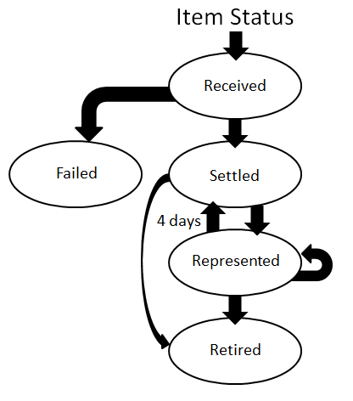

**Received** - The agency has sent this transaction through OTCnet. No settlement has been performed for this transaction yet.

**Failed** - The item was unable to be processed and/or settled by Treasury/Bureau of the Fiscal Service (BFS). These are items that could not be collected such as foreign items or possible duplicate items. These items are not included on your 215 Report.

**Settled** - This transaction is completed, and the funds have been credited to the agency’s CA$HLINK account. The effective date of the deposit and the 215 Deposit Ticket Report deposit ticket number are provided.

**Represented** - This transaction was returned with a reason code that allows for another collection attempt to be made. Depending on an agency’s policy, the item is reprocessed in an attempt to collect the funds from the check writer. Items with this status are in-process of collection.

**Retired** - This transaction was unable to be collected. The Agency receives a SF5515 Report Debit Voucher report with a debit processed to Debit Gateway, the effective date and debit voucher number is provided. The offset to the agency’s debit was an ACH return or a paper return (Check 21) received from the check writer’s financial institution. This transaction cannot be processed again through OTCnet.

### View a CIRA Record

To view a CIRA record, from the **CIRA Query**, you will enter the search criteria for the report you would like to view, search for a transaction, search the ACR transaction. The *CIRA Details* page appears, presenting the **Check Details**, **User Defined Fields**, **Check Image** and **Check History** details or CIRA Details page showing ACR Transaction details.

View a CIRA Record

To view a CIRA record, complete the following steps:

1. From the **Check Processing** tab click **CIRA Query**. The *CIRA Query* page appears.
2. Enter your search criteria.

* Select an **OTC Endpoint**, *required*

Application Tip



If you do not know the full name of the OTC Endpoint, enter a partial name search (as few as one letter) in the **Starts with** text box and click the **Select From List** icon (magnifying glass). The configured OTC Endpoints appear according to the user’s access. Click the appropriate OTC Endpoint radio button.

* Check/uncheck the **Include Subordinates** check box
* Check/uncheck the **Retrieve Mobile Check Transactions Only** check box
* Select a **Form Name**
* Select a **Deploy Date**

Application Tips



* By default, the **Include Subordinates** check box is checked. Add a check mark to generate a report that contains data for the subordinate OTC Endpoints. Remove the check mark to generate a report that contains data only for the selected OTC Endpoint.
* By default, the **Retrieve** **Mobile Check Transactions Only** check box is unchecked. Data for **Retrieve** **Mobile Check Transactions Only** is not yet available and will be included in a future release.
* By default, the most recent **Deploy Date** and **Form Version** will populate the **Deploy Date** field, once the **Form Name** is selected.

1. To search for a transaction:
   1. Using the CIRA Query search criteria, complete the following steps:

* Under **CIRA Query**,
  + Select a **Form Name**
  + Select a **Deploy Date**
* Under **User Defined Fields**,
* Enter **User Defined Field 1**
* Enter **User Defined Field 2**
* Enter **User Defined Field 3**
* Enter **User Defined Field 4**

Application Tips



* By default, the **CIRA Query** screen is expanded. If the **CIRA Query** screen is expanded, the **Search ACR Transaction** screen is collapsed.
* By default, the most recent **Deploy Date** and **Form Version** will populate the **Deploy Date** field once the **Form Name** is selected.
* The **User Defined Fields** are visible based on the selected OTC Endpoint **Form Name** and **Deploy Date**.
* Enter the **Account number**
* Enter the **Bank Routing Number**
* Enter the **IRN (Individual Record Number)**
* Enter the **Check Number**
* Under **Check Amount**
* Select the appropriate drop-down field
* Enter the check amount
* Select a **Settlement Status**
* Enter the **5515/Debit Voucher Number**
* Enter the **215/Deposit Ticket Number**

Application Tips



* If an **IRN** or **Batch ID** and a date range (**Received Date**, **Capture Date**, **Settlement Date**, and **Return Settlement Date**) are entered, OTCnet ignores the date range.
* The **5515/Debit Voucher Numbe**r represents items returned to an agency due to unsuccessful collection efforts.
* The **215/Deposit Ticket Number** represents items credited into FRB CA$HLINK for a given agency on a given day.
* Enter the **Cashier ID**
* Enter the **Batch ID**
* Click the **Received Date:** radio button
* Select **From** and **To** Received Date range

Or

* Select the **On** Received Date

Or

* Click the **Check Capture Date**: radio button
* Select **From** and **To** Check Capture Date range

Or

* Select the On Check Capture Date

Application Tips



* **Received Date (From)** and **(To)** represents the date range the check was received into OTCnet. **Received Date (On)** represents the single specific date the check was received into OTCnet.
* If the **Received Date** radio button is selected, OTCnet does not validate any other date range values (**Capture Date**, **Settlement Date** or **Return Settlement Date**).
* **Check Capture Date (From)** and **(To)** represents the date range the check was processed by the **Check Capture Lead Operator** or **Check Capture Operator**. **Check Capture Date (On)** represents the single specific end date the check was processed by the **Check Capture Lead Operator** or **Check Capture Operator**.
* If the **Check Capture Date** radio button is selected, OTCnet does not validate any other date range values (**Received Date**, **Settlement Date** or **Return Settlement Date**).

Or

* Click the **Settlement Date**: radio button
* Select **From** and **To** Settlement Date range

Or

* Select the **On** Settlement Date

Application Tips



* **Settlement Date (From)** and **(To)** represents the date range when the payment amount was debited from the check writer’s account. **Settlement Date (On)** represents the single specific date when the payment amount was debited from the check writer’s account.
* If the **Settlement Date** radio button is selected, OTCnet does not validate any other date range values (**Received Date**, **Capture Date** or **Return Settlement Date**).

Or

* Click the **Return Settlement Date**: radio button
* Select the **From/On** Date range
* Select the **To** Date range

Application Tips



* **Return Settlement Date (From)** and **(To)** represents the date range when the check item was returned. **Return Settlement Date (On)** represents the single specific date the check item was returned.
* When the **Return Settlement Date** radio button is selected, OTCnet does not validate any other date range values (**Received Date**, **Capture Date** or **Settlement Date**).
* By default, the **CIRA Query** screen is expanded. If the CIRA Query screen is expanded, the screen Search ACR Transaction collapsed.

Or

* 1. To query for an ACR transaction, complete the following steps:
* Click **Search ACR Transaction** to expand the screen
* Select an **ACR Type**
* Select an **ACR Reason Code**
* Enter an **ACR Voucher Number**
* Enter the **From** and **To** ACR Settlement range

Application Tips



* By default, the **Search ACR Transaction** screen is collapsed. If the **Search ACR Transaction** screen is expanded, the **CIRA Query** screen is collapsed.
* **Search ACR Transaction** options include **All ACR**, **Adjustment**, **Correction**, and **Rescission**.
* **ACR Reason Code** options include **Duplicate Transaction Processed**, **Non-Cash Item**, **Transaction Amount Correction**, **Representment**, **Warranty Indemnity Claim**, **Voucher Date Change**, **Voucher Number Change**, **Account Switch**, **Transaction Account Switch,** and **ACH Reversal**.
* The maximumnumeric characters value for **ACR Voucher Number** is six.
* The maximum date range for the **From** and **To** **ACR Settlement** range is 90 days.

1. Click **Search** to initiate the search.
2. The *Count* table and *Search Results* table appears as shown in Figure 2. Click the **IRN** for the check details you would like to view.

Figure : CIRA Query Results Showing Count and IRN Table

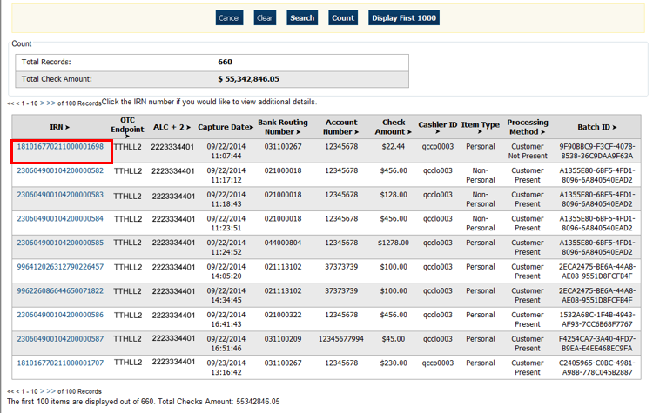

1. The *CIRA Details* page appears showing the **Check Details**, **User Defined Fields**, **Check Image** and **Check History** details as shown in Figure 3.

Figure : CIRA Details Page

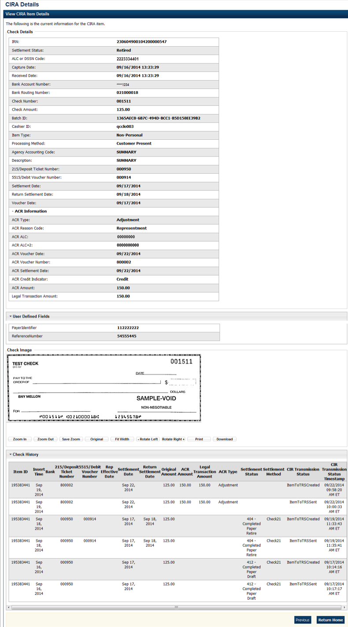

Application Tip



The CIRA Query details page is configured to display a maximum of 90 days of search results. This range parameter applies when a user searches using **Received Date**, **Check Capture Date**, **Settlement Date**, **Return Settlement Date** or **ACR Settlement date**. The system will display an error message if you search for results beyond the configured range.

Additional Buttons



* Click **Cancel** to return to the OTCnet Home Page. No data will be saved.
* Click **Clear** to clear all data fields and reset to the default selections.
* Click **Count** to display the total number of check transactions and the total check amount for the specified search criteria.
* Click **Display First 1000** to retrieve the first 1000 records
* Click **Verification Detail** to view the corresponding MVD record for the check item. (Visible only if is a corresponding MVD record exists.)

Additional buttons exclusive to the *View CIRA Item Details* page:

* Click **Zoom In** to zoom in on the check image.
* Click **Zoom Out** to zoom out on the check image.
* Click **Save Zoom** to save the zoom percentage for the current session.
* Click **Original** to return the check image to the original display settings.
* Click **Fit Width** to fit the check image to the width of the open window.
* Click **Rotate Left** to rotate the check image counterclockwise 90 degrees.
* Click **Rotate Right** to rotate the check image clockwise 90 degrees.
* Click **Print** to the check image.
* Click **Download** to the check image.
* Click **Previous** to return to the previous page.
* Click **Return Home** to the OTCnet Home Page.

## Topic 3 Business Reports

There are eight Business Reports that you may have access to, depending on your role. To print a report output, right click using your mouse and select *Print.*

Table : Business Reports (1st column) and Access Type (1st row)

| Business Reports | Agency Manager | Check Capture Administrator | MVD Viewer | MVD  Editor | FMS  Viewer | View  Reports |
| --- | --- | --- | --- | --- | --- | --- |
| CIRA CSV | X | X | X | X | X | blank |
| Check Image | X | X | X | X | X | X |
| Agency CIRA | X | X | X | X | X | X |
| LVD Contents | X | X | X | X | X | X |
| Organization Hierarchy | X | X | X | X | X | X |
| 215 Deposit Ticket | X | X | X | X | X | X |
| 5515 Debit Voucher | X | X | X | X | X | X |
| ACR Activity | X | X | X | X | X | X |

Legend: *Blank* = N/A & X = Access

### CIRA CSV Report

The **CIRA CSV** report is a business report that allows you to export data based on a query to a Comma Separated Value (CSV) report. The exported data can be used to import into other applications within an agency. From **Check Processing Reports**, select **CIRA CSV Report**. Enter the search criteria for the report you would like to view and search for a transaction and download the CSV file.

When clicking the **Received Date** radio button, consider the following information for the **Received Date (From) and (To):**

* If the **Received Date** radio button is selected, OTCnet does not validate any other date range values (**Capture Date**, **Settlement Date** or **Return Settlement Date**).
* **Received Date (From)** and **(To)** represents the date range the check was received into OTCnet. **Received Date (On)** represents the single specific date the check was received into OTCnet.
* If **both** the **(From)** and **(To)** **Received Date** are more than 18 months from the current date, an error message appears stating “*Check transactions with a Received Date older than 18 months have been archived to the archive database according to the Fiscal Service data retention policy. These transactions are viewable through the CIRA CSV Historical Report via Home>> Reports>> Historical Reports*.” Any results that match the search parameters and have a Received Date older than 18 months from the current date are displayed.
* If the **(From) or (To)** **Received Date** is less than 18 months from the current date, the results that match the search parameters are displayed.

When clicking the **Check Capture Date** radio button, consider the following information for the **Check Capture Date (From) and (To):**

* If the **Check Capture Date** radio button is selected, OTCnet does not validate any other date range values (**Received Date**, **Settlement Date**, or **Return Settlement Date**).
* **Check Capture Date (From)** and **(To)** represents the date range  
   the check was processed by the **Check Capture Lead Operator**   
  or **Check Capture Operator**. **Check Capture Date (On)** represents the single specific end date the check was processed by the **Check Capture Lead Operator** or **Check Capture Operator**.
* If **both** the **Check Capture Date (From)** and **(To)** are more than 18 months from the current date, an error message appears stating “*Check transactions with a Received Date older than 18 months have been archived to the archive database according to the Fiscal Service data retention policy. These transactions are viewable through the CIRA CSV Historical Report via Home>> Reports>> Historical Reports*.” Any results that match the search parameters and are with a Received Date older 18 months from the current date are displayed.
* If **the (From) or (To) Check Capture Date** is less than 18 months from the current date, the results that match the search parameters are displayed.

When clicking the **Settlement Date** radio button, consider the following information for the **Settlement (From) and (To):**

* If the **Settlement Date** radio button is selected, OTCnet does not validate any other date range values (**Received Date, Capture Date or Return Settlement Date**).
* If both the **Settlement Date (From)** and **(To)** are more than 18 months from the current date, an error message appears stating “Check transactions with a Received Date older than 18 months have been archived to the archive database according to the Fiscal Service data retention policy. These transactions are viewable through the CIRA CSV Historical Report via Home>> Reports>> Historical Reports.” Any results that match the search parameters and are with a Received Date older 18 months from the current date are displayed.
* If the **(From) or (To) Settlement Date** is less than 18 months from the current date, the results that match the search parameters are displayed.

When clicking the **Return** **Settlement Date** radio button, consider the following information for the **Return Settlement (From) and (To):**

* If the **Return Settlement Date** radio button is selected, OTCnet does not validate any other date range values (**Received Date, Capture Date or Settlement Date**).
* If **both** the **Return Settlement Date (From)** and **(To)** are more than 18 months from the current date, an error message appears stating “Check transactions with a Received Date older than 18 months have been archived to the archive database according to the Fiscal Service data retention policy. These transactions are viewable through the CIRA CSV Historical Report via Home>> Reports>> Historical Reports.” Any results that match the search parameters and are with a Received Date older 18 months from the current date are displayed.
* If the **(From) or (To) Return Settlement Date** is less than 18 months from the current date, the results that match the search parameters are displayed.

To access the report, from **Check Processing Reports**, **Business Reports**, click **Check Image Report.**

CIRA CSV Report

To view a CIRA CSV report, complete the following steps:

1. From the **Reports** tab, click **Check Processing** Reports. The *View Check Processing Reports* page appears.
2. Under **Business Reports**, click **CIRA CSV Report**. The *CIRA CSV Report* page appears.
3. Enter the search criteria for the report you would like to view.

* Select an **OTC Endpoint**, *required*
* Check/uncheck the **Include Subordinates** check box
* Check/uncheck **Retrieve** **Mobile Check Transactions Only** check box

Application Tips



* If you do not know the full name of OTC Endpoint, enter a partial name search (as few as one letter) in the **Starts with** text box and click the **Select From List** icon (magnifying glass). The configured OTC Endpoints appear according to the user’s access. Click the appropriate OTC Endpoint radio button.
* By default, the **Include Subordinates** check box is checked. Add a check mark to generate a report that contains data for the subordinate OTC Endpoints. Remove the check mark to generate a report that contains data only for the selected OTC Endpoint.
* By default, the **Retrieve** **Mobile Check Transactions Only** check box is unchecked. Data for **Retrieve** **Mobile Check Transactions Only** is not yet available and will be included in a future release.

1. To search for a transaction:
   1. Using the CIRA CSV Report search criteria, complete the following steps:

* Select a **Form Name**
* Select a **Deploy Date**

Application Tips



* By default, the **CIRA CSV Report** screen is expanded. If the **CIRA CSV Historical Report** screen is expanded, the **CIRA CSV Report** **- ACR** screen is collapsed.
* The **Form Name** is the name/list of available forms available for the selected OTC Endpoint. The **Deploy Date** is the date, time and version number of the selected form.
* By default, the most recent **Deploy Date** and **Form Version** will populate the **Deploy Date** field once the **Form Name** is selected.
* Under **User Defined Fields**,
  + Enter **User Defined Field 1**
  + Enter **User Defined Field 2**
  + Enter **User Defined Field 3**
  + Enter **User Defined Field 4**
* Enter the **Account number**
* Enter the **Bank Routing Number**
* Enter the **IRN (Individual Record Number)**
* Enter the **Check Number**
* Under **Check Amount**,
  + Select the appropriate drop-down field
  + Enter the check amount
    - Select a **Settlement Status**
    - Enter the **5515/Debit Voucher Number**
    - Enter the **215/Deposit Ticket Number**

Application Tips



* The **User Defined Fields** are visible based on the selected OTC Endpoint **Form Name** and **Deploy Date**.
* If an **IRN** or **Batch ID** and a date range (**Received Date**, **Capture Date**, **Settlement Date**, and **Return Settlement Date**) are entered, OTCnet ignores the date range.
* The **5515/Debit Voucher Number** represents items returned to agency due to unsuccessful collection efforts.
* The **2515/Deposit Ticket Number** represents items credited into FRB CA$HLINK for a given agency on a given day.
  + - * Enter the **Cashier ID**
      * Enter the **Batch ID**
      * Click the **Received Date**: radio button
      * Select **From** and **To** Received Date range

Or

* + - * Select the **On** Received Date

Or

* Click the **Check Capture Date**: radio button
* Select **From** and **To** Check Capture Date range

Or

* Select the **On** Check Capture Date

Or

* Click the **Settlement Date**: radio button
  + Select **From** and **To** Settlement Date range

Or

* + Select the **On** Settlement Date

Or

* Click the **Return Settlement Date**: radio button
  + Select the **From/On** Date range
  + Select the **To** Date range
  1. To query for a CIRA CSV Report - ACR transaction, complete the following steps:
* Click **Search ACR Transaction** to expand the screen
* Select an **ACR Type**
* Select an **ACR Reason Code**
* Enter an **ACR Voucher Number**
* Enter the **From** and **To** ACR Settlement range, *required*

Application Tips



* By default, the **Search ACR (Adjustment, Correction, and Rescission)** **Transaction** screen is collapsed. If the Search ACR Transaction screen is expanded, the CIRA Query screen is collapsed.
* **Search ACR Transaction** options include **All ACR**, **Adjustment**, **Correction**, and **Rescission**.
* **ACR Reason Code** options include **Duplicate Transaction Processed, Non-Cash Item, Transaction Amount Correction, Representment, Warranty Indemnity Claim, Voucher Date Change, Voucher Number Change, Account Switch, Transaction Account Switch**, and **ACH Reversal**.
* The maximumnumeric characters value for **ACR Voucher Number** is six.
* The **From** and **To** **ACR Settlement** fields are searchable for a duration up to 90 days. Additionally, the **From** and **To ACR Settlement** dates must be older than 18 months from the current date.
* Click **Download CSV File**. The *File Download* dialog box appears as shown in Figure 4.

Figure : File Download Dialog Box: Open/Save or Download

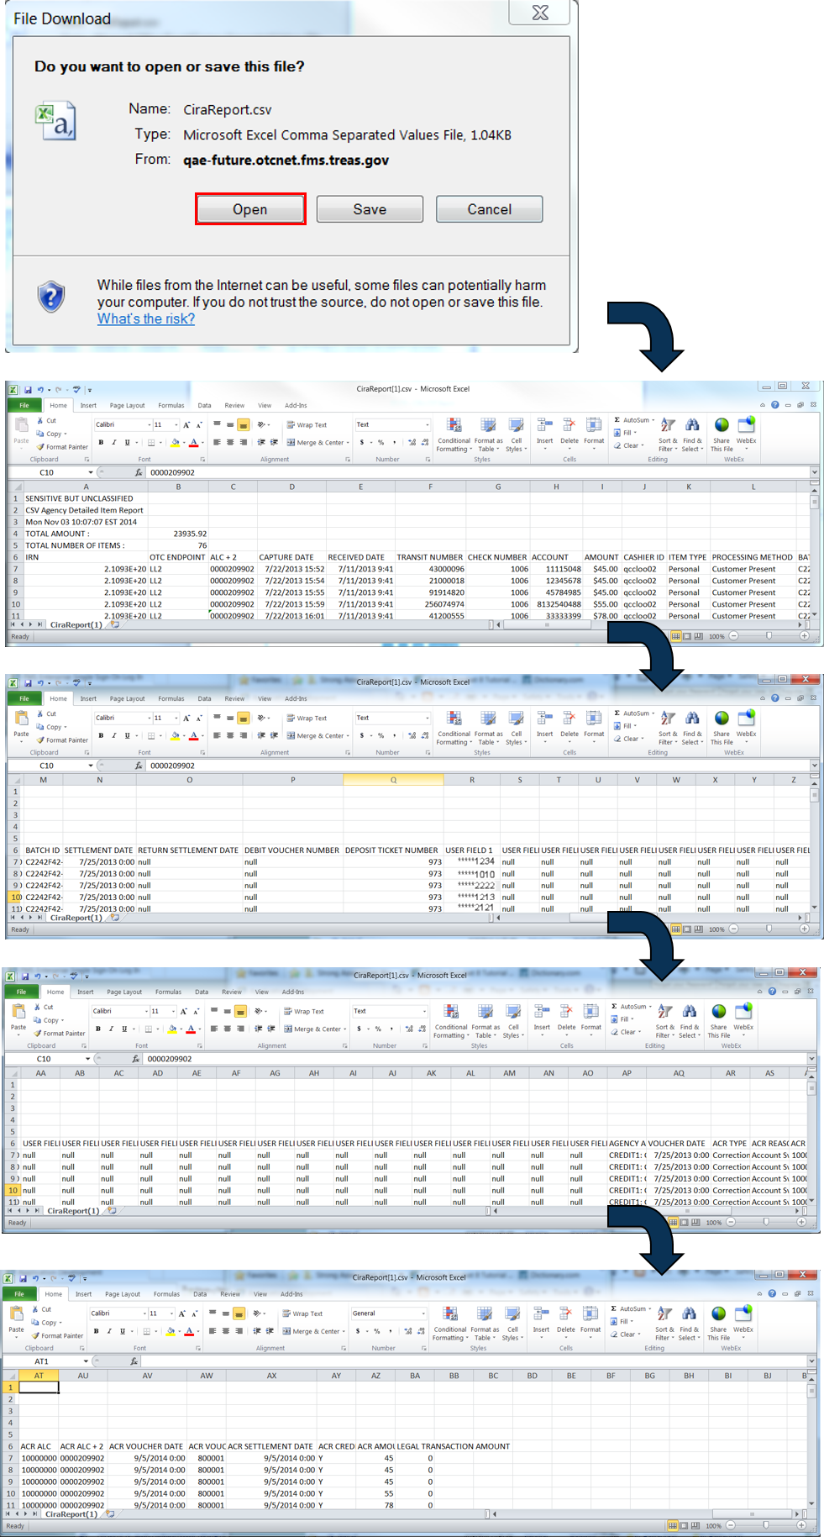

Application Tip



The CIRA CSV Report page is configured to download a maximum of 90 days of search results. This range parameter applies when a user searches using **Received Date**, **Check Capture Date**, **Settlement Date**, **Return Settlement Date** or **ACR Settlement Date**. The system will display an error message to you if you search for results beyond the configured range.

* Click **Open** or **Save**

Additional Buttons



* Click **Cancel** to return to the OTCnet Home Page. No data is saved.
* Click **Clear** to clear all data fields and reset to the default selections.
* Click **Count** to display the total number of check transactions and the total check amount for the specified search criteria.

### Check Image Report

The **Check Image Report** allows you to view the front and back images of a check for an Individual Reference Number (IRN) that you request.

IRNs associated with a received date older than the minimum data retention period, as specified by Fiscal Service, may not be displayed on the report as these transactions are eligible to be deleted. As a result, this check image will no longer be accessible. An error message occurs stating that the IRN has not been found or has been deleted.

To access the report, from **Check Processing Reports, Business Reports**, click **Check Image Report.**

Check Image Report

To view a Check Image report, complete the following steps:

1. From the **Reports** tab, click **Check Processing Reports**. The *View Check Processing Reports* page appears.
2. Under **Business Reports**, click **Check Image Report**. The *Check Image Report* page appears.
3. Enter the search criteria for the report you would like to view.

* Under **Add IRNs to the list**, enter the IRN(s) for the checks you would like to view.

Application Tips



* IRNs are between 20 and 32 alphanumeric characters in length and can contain the following characters:
  + The special characters of **'**, **_**, **#**, **@**, and **-**, surrounded by only alpha characters
  + The special characters of **$** and **|**, surrounded by alphanumeric characters
* To enter multiple IRNs, separate each IRN by a space and/or comma.
* Check images for IRNs belonging to neutralized OTC Endpoints can be retrieved in the Check Image Report. These images can be retrieved by Agency Managers, Check Capture Administrators, View Reports, MVD Editors, or MVD Viewers who are provisioned to:
  + An OTC Endpoint level higher than the neutralized OTC Endpoint associated with the images
  + The highest level OTC Endpoints associated with the images

1. Click **Add to IRN List**.
2. Under **List of IRNs**, check the check box(es) of the IRN(s) you would like to submit.
3. Click **Submit**. Check image(s) appear on the same page as shown in Figure 5.

Figure : Click Submit to View Check Image

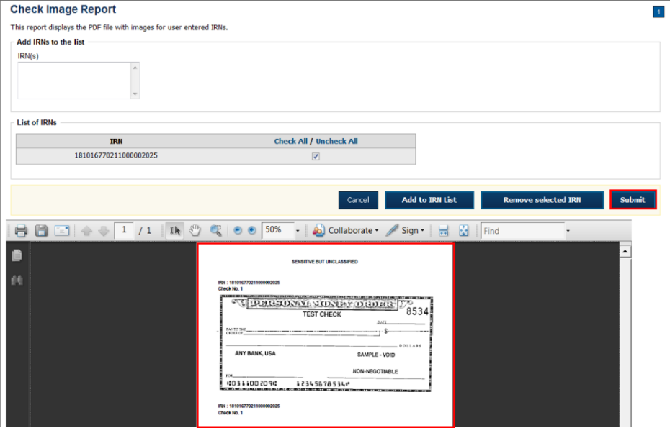

Additional Buttons



* Click **Clear** to clear all data fields and reset to the default selections.
* Click **Cancel** to return to the OTCnet Home Page. No data will be saved.

### Agency CIRA Report

The **Agency CIRA Report** allows you to view the batch activity for specified OTC Endpoint and supplies, the sending OTC Endpoint receive date, item count and dollar amounts.

When clicking the **Received Date** radio button, consider the following information for the **Received Date (From) and (To):**

* If the **Received Date** radio button is selected, OTCnet does not validate any other date range values (**Capture Date**).
* **(From)** and **(To)** **Received Date** represents the date range the check was received into OTCnet.
* If **both** the **(From)** and **(To)** **Received Date** are more than 18 months from the current date, an error message appears stating “*Check transactions with a Received Date older than 18 months have been archived to the archive database according to the Fiscal Service data retention policy. These transactions are viewable through the CIRA CSV Historical Report via Home>> Reports>> Historical Reports*.” Any results that match the search parameters and have a Received Date older than 18 months from the current date are displayed.
* If the **(From) or (To)** **Received Date** is less than 18 months from the current date, the results that match the search parameters are displayed.

When clicking the **Check Capture Date** radio button, consider the following information for the **Received Date (From) and (To):**

* **(From)** and **(To) Check Capture Date** represents the date range the check was processed by the Check Capture Lead Operator or Check Capture Operator.
* If **both** the **(From) and (To)** **Check Capture Date** are more than 18 months from the current date, an error message appears stating “*Check transactions with a Received Date older than 18 months have been archived to the archive database according to the Fiscal Service data retention policy. These transactions are viewable through the CIRA CSV Historical Report via Home>> Reports>> Historical Reports*.” results that match the search parameters and have a Received Date older than 18 months from the current date are displayed.

To access the reports, from **Check Processing Reports, Business Reports**, click **Agency CIRA Report** **Check Processing Reports.**

Agency CIRA Report

To view an Agency CIRA report, complete the following steps:

1. From the **Reports** tab, click **Check Processing Reports**. The *View Check Processing Reports* page appears.
2. Under **Business Reports**, click **Agency CIRA Report**. The *Agency CIRA Report* parameterspage appears as shown in Figure 6.

Figure : Agency CIRA Report Parameters Page

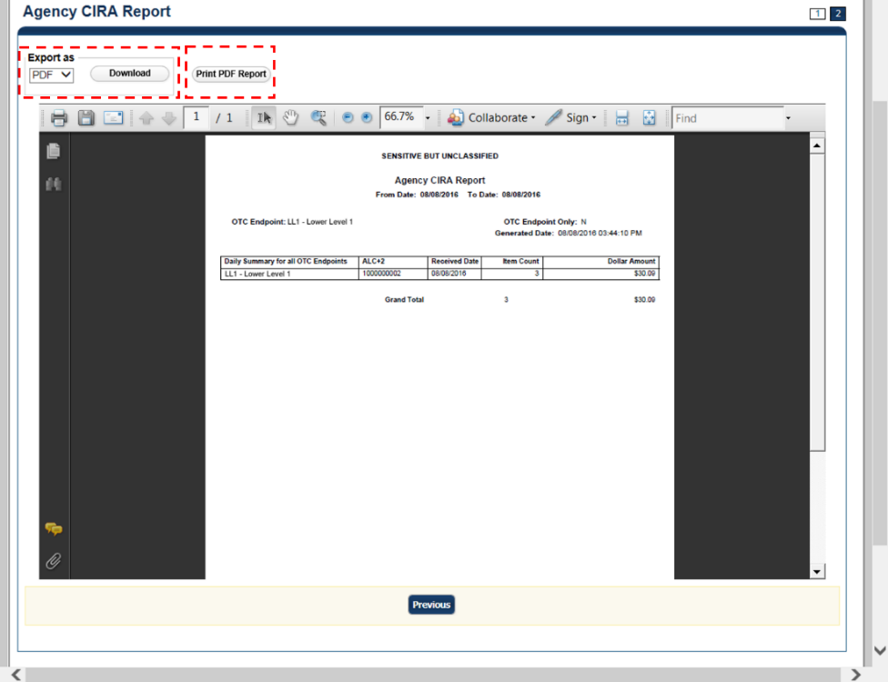

1. Enter the search criteria for the report you would like to view.

Under **Report Filters**,

* Select the **Date From** date
* Select the **Date To** date
* Click **Received Date** or **Captured Date**
* Enter the **Batch ID**
* Enter the **Cashier ID**
* Click **Yes** or **No** to Include Subordinate OTC Endpoints

Application Tip



* Click **Yes** to generate a report that contains data for the selected OTC Endpoint as well as all of the lower level OTC Endpoints.
* Click the **No** option to generate a report that contains data only for the selected OTC Endpoint.

1. Click an OTC Endpoint to initiate the report. The *Agency CIRA Report* preview page appears.

Application Tip



**CHK** denotes a check capture OTC Endpoint; **TGA** denotes a deposit processing OTC Endpoint; **M** denotes a mapped accounting code; an open lock unlock-clipart2denotes access permission; and a closed lock lock-clipart2denotes no access permission.

1. Under Export as,

* Select a **PDF**, **Excel** or **Word**
* Click **Download**

Or

* Click **Print PDF Report**

Additional Button



* Click **Previous** to return to the previous page.

### LVD Contents Report

The **LVD Contents Report** allows you to view the contents of a Local Verification Database (LVD) for a given OTC Endpoint. To access the report, from **Check Processing Reports Business Reports**, click **LVD Contents Report.**

LVD Contents Report

To view an LVD Contents report, complete the following steps:

1. From the **Reports** tab, click **Deposit Processing Reports**. The *View Reports* page appears.
2. Under **Business Reports**, click **LVD Contents Report**. The *LVD Contents Reports* parameters page appears.
3. Enter the search criteria for the report you would like to view.

Under **Report Filters**,

* Select a **Transaction Type**
* Select a **Trade Status**
* Click **Received Date** or **Captured Date**
* Enter **For Account**
* Enter the **User Defined Field 1**
* Enter the **Bank Routing Number**

Application Tips



* Trade Status represents the status of the verification records (All, Cleared, Dynamic, Suspend, Denied, Blocked).
* **CHK** denotes a check capture OTC Endpoint; **TGA** denotes a deposit processing OTC Endpoint; **M** denotes a mapped accounting code; an open lock unlock-clipart2denotes access permission; and a closed lock lock-clipart2denotes no access permission.

1. Click an OTC Endpoint to initiate the report. The *LVD Contents* Report preview page appears in a new window as shown in Figure 7.

Figure : LVD Contents Report Preview Page

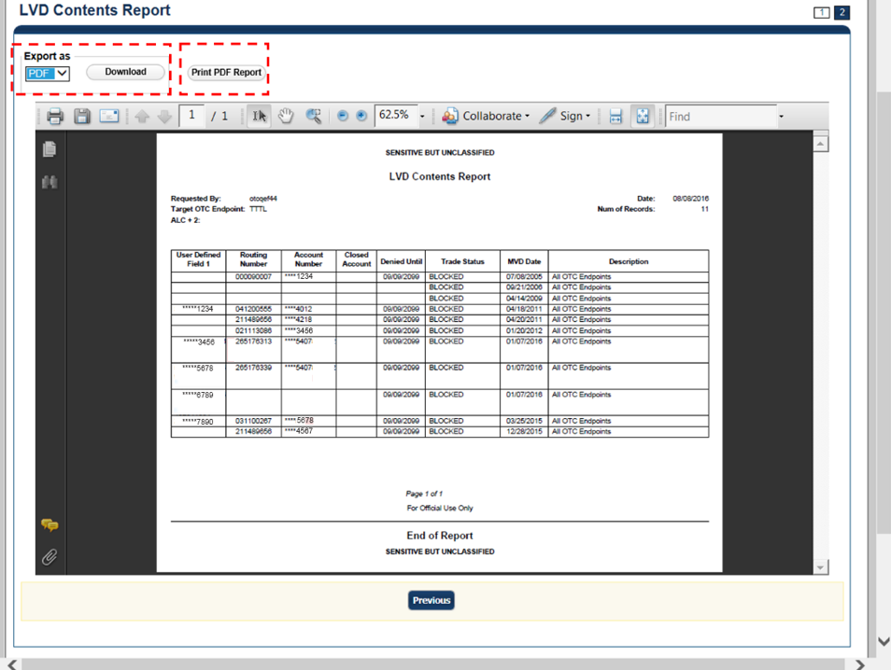

1. Under Export as,

* Select a **PDF**, **Excel** or **Word**
* Click **Download**

Or

Click **Print PDF Report**

Additional Button



* Click **Previous** to return to the previous page.

### Organization Hierarchy Report

The **Organization Hierarchy Report** allows you to view the target OTC Endpoint within the context of the current OTC Endpoint. The OTC Endpoints listed in the hierarchy tree are based on the user’s given access permission. Additionally, any endpoint displayed in the hierarchy is designated as a check capture endpoint or isnot designated as check capture endpoint but is an endpoint that is associated with at least one check transaction.

To access the report, from **Check Processing Reports, Business Reports**, click **Organization Hierarchy Report.**

Organization Hierarchy Report

To view an Organization Hierarchy report, complete the following steps.

1. From the **Reports** tab, click **Check Processing Reports**. The *View Reports* page appears.
2. Under **Business Reports**, click **Organization Hierarchy Report**. The *Organization Hierarchy Report* parameters page appears.
3. Click an OTC Endpoint to initiate the report. The *Organization Hierarchy* report preview page appears as shown in Figure 8.

Figure : Organization Hierarchy Report Preview Page

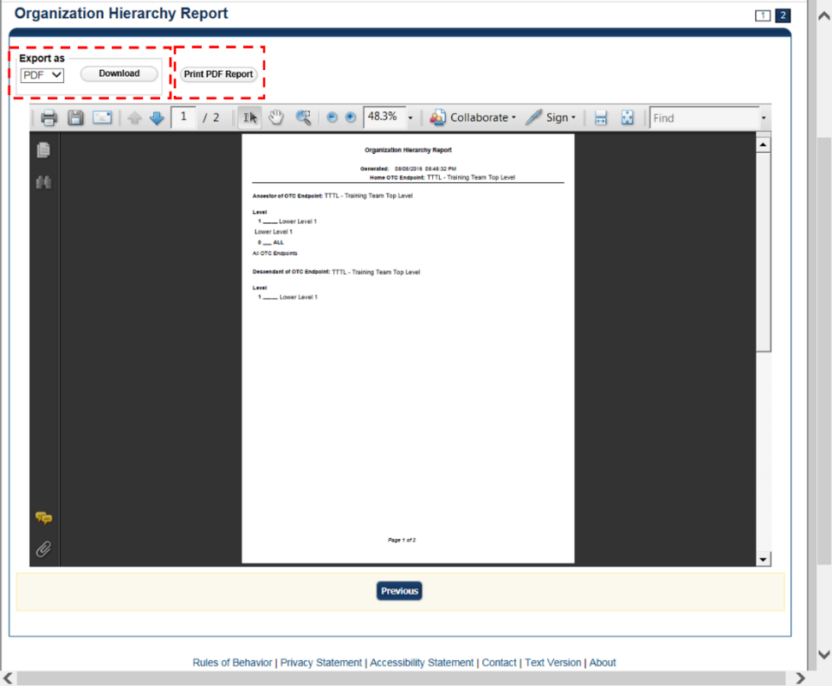

1. Under Export as,

* Select a **PDF**, **Excel** or **Word**
* Click **Download**

Or

* Click **Print PDF Report**

Additional Button



* Click **Previous** to return to the previous page.

### 215 Deposit Ticket Report

The **215 Deposit Ticket Report**, also known as the SF215, is a daily report that includes all items deposited and processed into Collections Information Repository (CIR) within the preceding 24 hours. The report is searchable for a duration of up to 45 days. Data for the report is available for a duration of one year.

To access the report, from **Check Processing Reports, Business Reports**, click **215 Deposit Ticket Report.**

215 Deposit Ticket Report

To view a 215 Deposit Ticket report, complete the following steps:

1. From the **Reports** tab, click **Check Processing Reports**. The *View Check Processing Reports* page appears.
2. Under **Business Reports**, click **215 Deposit Ticket Report**. The *215 Deposit Ticket* parameters page appears.
3. Enter the search criteria for the report you would like to view.

Under **Report Filters**,

* Select a **From** and **To** Start Date range
* Click **Yes** to Include Subordinate OTC Endpoint

Application Tips



* The **From** and **To** **Start Date** range is searchable for a duration of up to 45 days. Data for the report is available for a duration of one year.
* Click the **Yes** option to generate a report that contains data for lower level OTC Endpoints.

1. Under **Expand All/Contract All**, click the **Plus Sign** Plus sign symbol to expand the list of OTC Endpoints and locate the appropriate OTC Endpoint.

Application Tip



**CHK** denotes a check capture OTC Endpoint; **TGA** denotes a deposit processing OTC Endpoint; **M** denotes a mapped accounting code; an open lock unlock-clipart2denotes access permission; and a closed lock lock-clipart2denotes no access permission.

1. Click an OTC Endpoint to initiate the report. The ***215 Deposit Ticket Report*** preview page appears as shown in Figure 9.

Figure : 215 Deposit Ticket Report Preview Page

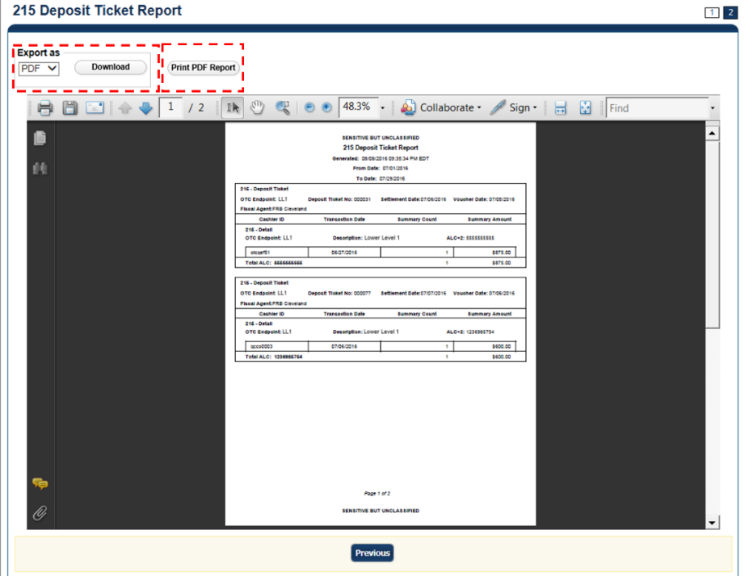

Application Tip



A **215 Deposit Ticket** **report** will not generate for any day that is deemed a holiday during Monday - Friday hours.

1. Under Export as,

* Select **PDF**, **Word**, or **Excel** format
* Click **Download**

Or

* Click **Print PDF Report**

Additional Button



Click **Previous** to return to the previous page.

### 5515 Debit Voucher Report

The 5515 Debit Voucher Report, also known as the SF5515 is a daily report that includes all retired items processed within the preceding 24 hours. The report searchable for a duration of up to 45 days and will not generate for any day that is deemed a holiday during Monday-Friday hours. Data for the report is available for a duration of one year.

The 5515 report contains the debit voucher number for each item that is retired by the Federal Reserve Bank. The report provides detailed information on the Unique Transaction ID (or IRN number) for easy research in OTCnet.

To access the report, from **Check Processing Reports, Business Reports**, click **5515 Debit Voucher Report.**

5515 Debit Voucher Report

To view a 5515 Debit Voucher report, complete the following steps:

1. From the **Reports** tab, click **Deposit Processing Reports**. The *View Reports* page appears.
2. Under **Business Reports**, click **5515 Debit Voucher Report**. The *5515 Debit Voucher* parameters page appears.
3. Enter the search for the report you would like to view.

Under **Report Filters**,

* Select a **From** and **To** Start Date range
* Click **Yes** or **No** to Include Subordinate OTC Endpoints.

Application Tips



* The **From** and **To** Start Date range is searchable for a duration of up to 45 days. Data for the report is available for a duration of one year.
* Click the **Yes** option to generate a report that contains data for the selected OTC Endpoint as well as all of the lower level OTC Endpoints. Click the **No** option to generate a report that contains data only for the selected OTC Endpoint.
* CHK denotes a check capture OTC Endpoint; TGA denotes a deposit processing OTC Endpoint; M denotes a mapped accounting code; an open lock unlock-clipart2denotes access permission; and a closed lock lock-clipart2denotes no access permission.

1. Click an **OTC Endpoint** to initiate the report. The *5515 Debit Voucher* preview page appears as shown in Figure 10.

Figure : 5515 Debit Voucher Report Preview Page

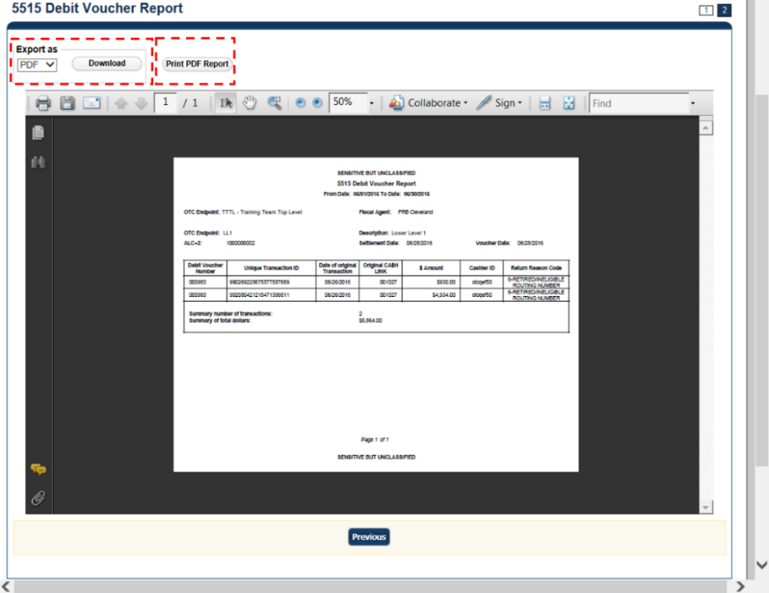

Application Tip



A 5515 Debit Voucher report will not generate for any day that is deemed a holiday during Monday-Friday hours.

1. Under Export as,

* Select **PDF**, **Excel** or **Word format**
* Click **Download**

Or

* Click **Print PDF Report**

Additional Button



* Click **Previous** to return to the previous page.

### ACR Activity Report

The **ACR Activity Report**, or Adjustment, Correction and Rescission Report, is a report that displays the detailed information about transactions that were adjusted, corrected, or reversed/rescinded. Users can generate a report that covers a maximum period of 45 calendar days.

To access the report, from **Check Processing Reports**, **Business Reports**, click **ACR Activity Report**.

ACR Activity Report

To search for ACR transactions, complete the following steps:

1. From the **Reports** tab, click **Check Processing Reports** and click **ACR Activity Report**. The *ACR Activity Report* page appears.
2. Enter the search criteria you would like to view.

* Enter the **From** and **To** ACR Settlement date range
* Select a **Report Type**
* Select an **ACR Type**
* Select an **ACR Reason Code**

Application Tips



* The maximum date range for the **From** and **To ACR (Adjustment, Correction, and Rescission) Settlemen**t range is 45 days.
* **Report Type** options include **Credit/Debit** **- ACR, Credit - ACR**, and   
  **Debit - ACR**.
* **Search ACR Transaction** options include **All ACR, Adjustment, Correction**, and **Rescission**.
* **ACR Reason Code** options **include Duplicate Transaction Processed, Non-Cash Item, Transaction Amount Correction, Representment, Warranty Indemnity Claim, Voucher Date Change, Voucher Number Change, Account Switch, Transaction Account Switch,** and **ACH Reversal**.

1. Click the **Yes** or **No** radio button to **Include Subordinates**
2. Click an **OTC Endpoint** to initiate the report. The *ACR* Activity *Report* preview page appears as shown in Figure 11.

Figure : ACR Activity Report Preview Page

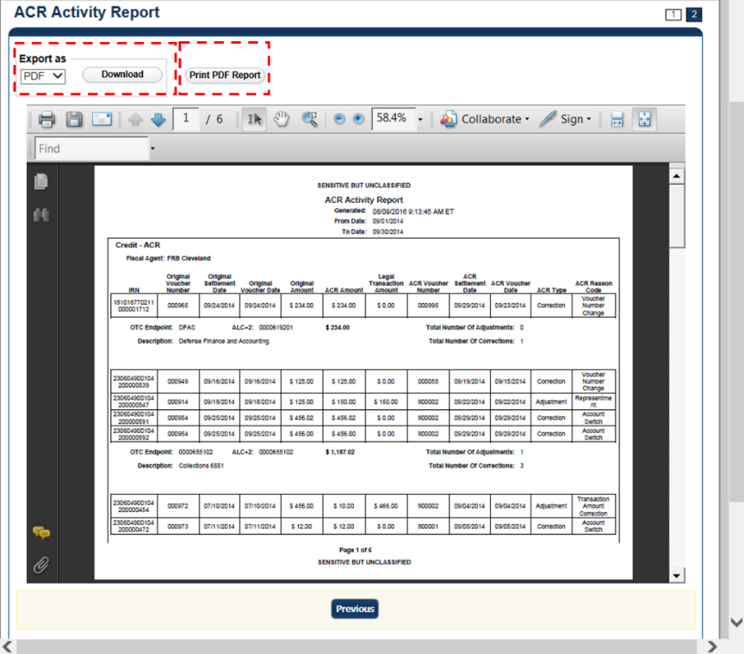

1. Under **Export as**,

* Select a **PDF**, **Excel** or **Word**
* Click **Download**

Or

* Click **Print PDF Report**

Additional Button



* Click **Previous** to return to the previous page.

## Topic 4 Administration Reports

There are three Administration reports that you may have access to, depending on your role. As an **FMS Viewer**, you are authorized to access the **CIRA Transmission Summary**, **CIRA Transmission (Detailed) Summary**, **Statistical**, and **View CIR Transmission Status for Check Processing** Administration reports (see Table 3 for details). To print a report output, right click using your mouse and select *Print.*

Table : Administration Reports (1st column) and Access Type (1st row)

| Business Reports | Agency Manager | Check Capture Administrator | MVD Viewer | MVD  Editor | FMS  Viewer | View  Reports |
| --- | --- | --- | --- | --- | --- | --- |
| CIRA Transmission Summary Report | blank | blank | blank | blank | X | blank |
| CIRA Transmission (Detailed) Summary Report | blank | blank | blank | blank | X | blank |
| Statistical | blank | blank | blank | blank | X | blank |
| View CIR Transmission Status for Check Processing | blank | blank | blank | blank | X | blank |

Legend: *Blank* = N/A & X = Access

### CIRA Transmission Summary Report

The **CIRA Transmission Summary Report** allows you to view a list of transactions sent to Debit Gateway. To access the report, from **Check Processing Reports**, **Administration**, click **CIRA Transmission Summary Report.**

View CIRA Transmission Summary Report

To view a CIRA Transmission Summary report, complete the following steps:

1. From the **Reports** tab, click **Check Processing Reports**. The *View Check Processing Reports* page appears.
2. Under **Administration Reports**, click **CIRA Transmission Summary Report**. The *CIRA Transmission Summary Report* page appears.
3. Enter the search criteria for the report you would like to view.

Under **Report Filters**, complete the following:

* Select a **Date**
* Click **Submit Request***.* The *Transmission Files* table for the selected date appears.
* Click **Yes** or **No** to Include Subordinate OTC Endpoints

Application Tips



* The *Transmission Files* table lists all the transmissions for the selected date.
* Click the **Yes** option to generate a report that contains data for the selected OTC Endpoint as well as all of the lower level OTC Endpoints.   
  Click the **No** option to generate a report that contains data only for the selected OTC Endpoint
* CHK denotes a check capture OTC Endpoint; TGA denotes a deposit processing OTC Endpoint; M denotes a mapped accounting code; an open lock unlock-clipart2denotes access permission; and a closed lock lock-clipart2denotes no access permission.

1. Click an **OTC Endpoint** to initiate the report. The *CIRA Transmission Summary Report* preview page appears as shown in Figure 12.

Figure : CIRA Transmission Summary Report Preview Page

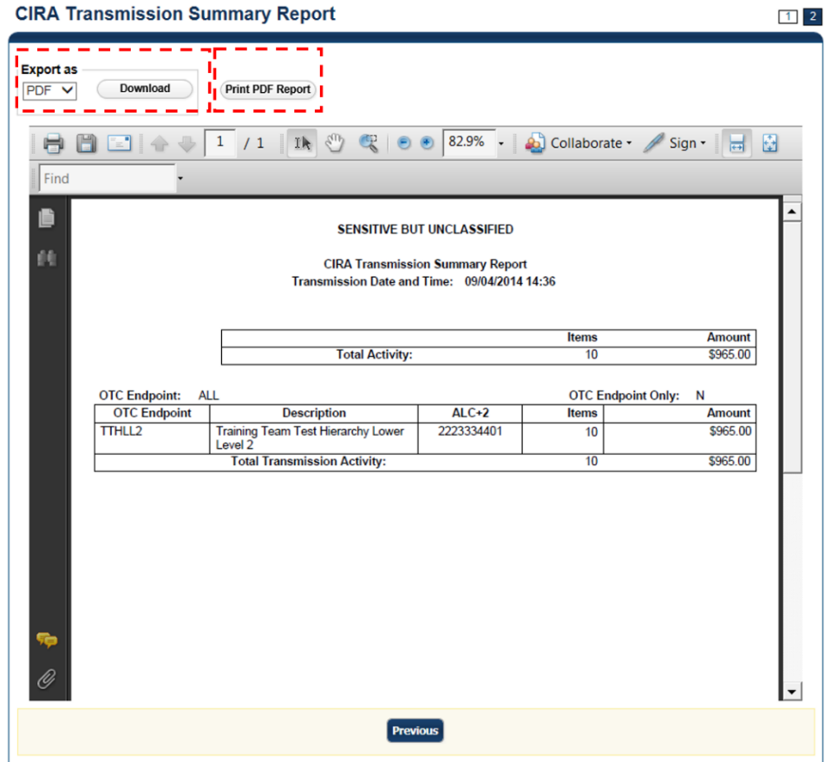

1. Under Export as,

* Select a **PDF**, **Excel** or **Word**
* Click **Download**

Or

* Click **Print PDF Report**

Additional Button



* Click **Previous** to return to the previous page.

### CIRA Transmission (Detailed) Summary Report

The **CIRA Transmission (Detailed) Summary Report** allows you to view the detailed information about transactions sent to Debit Gateway. To access it, from **Check Processing Reports**, **Administration Reports**, click **CIRA Transmission (Detailed) Summary Report.**

CIRA Transmission Summary Report

To view a CIRA Transmission (Detailed) Summary report, complete the following steps:

1. From the **Reports** tab, click **Check Processing Reports**. The *View Check Processing Reports* page appears.
2. Under **Administration Reports**, click **CIRA Transmission (Detailed) Summary Report**. The *CIRA Transmission (Detailed) Summary Report* parameters page appears.
3. Enter the search criteria for the report you would like to view.

Under **Report Filters**,

* Select a **Date**
* Click **Submit Request***.* The *Transmission Files* table for the selected date appears.
* Click **Yes** or **No** to Include Subordinate OTC Endpoints

Application Tips



* The *Transmission Files* table lists all the transmissions for the selected date.
* Click the **Yes** option to generate a report that contains data for   
  the selected OTC Endpoint as well as all of the lower level OTC Endpoints.   
  Click the **No** option to generate a report that contains data only for the selected OTC Endpoint.
* **CHK** denotes a check capture OTC Endpoint; **TGA** denotes a deposit processing OTC Endpoint; **M** denotes a mapped accounting code; an open lock unlock-clipart2denotes access permission; and a closed lock lock-clipart2denotes no access permission.

1. Click an **OTC Endpoint** to initiate the report. The *CIRA Transmission (Detailed) Summary Report* preview page appears as shown in Figure 13.

Figure : CIRA Transmission (Detailed) Summary Report

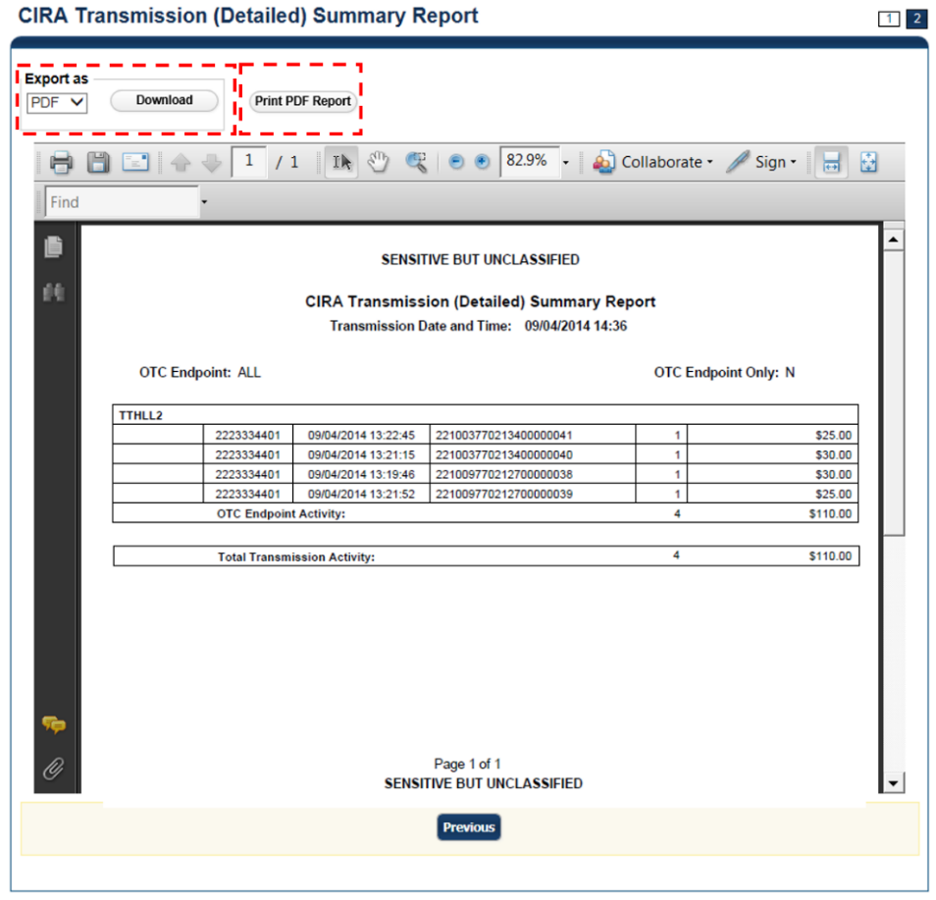

1. Under Export as,

* Select a **PDF**, **Excel** or **Word**
* Click **Download**

Or

* Click **Print PDF Report**

Additional Button



Click **Previous** to return to the previous page.

### Statistical Report

The Statistical Report allows you to view statistical details for an OTC Endpoint. The report includes statistical information regarding the total transactions, overall success rate, total returns sent back to an agency, and total returns received. The report is available for 15 rolling days.

To access the report, click **Check Processing Reports**, **Administration Reports**, and **Statistical Report.**

Statistical Report

To view a Statistical report, complete the following steps:

1. From the **Reports** tab, click **Check Processing Reports**. The *View Reports* page appears.
2. Under **Administration Reports**, click **Statistical Report.** The *Statistical Report* page appears.
3. Enter the search criteria for the report you would like to view.

Under **Report Filters**,

* Select a **From** and **To** Start Date range
* Click the **Personal, Non Personal** or **Both** radio button for Item Type
* Click the **Present, Not Present** or **Both** radio button for Processed At
* Click the **ACH, Paper Items** or **Both** radio button for Process Type
* Click **Yes** or **No** to Include Subordinate OTC Endpoints

Application Tip



* The **From** and **To** Start Date range is searchable using a date range of up to 15 days.
* Click the **Yes** option to generate a report that contains data for the selected OTC Endpoint as well as all of the lower level OTC Endpoints.   
  Click the **No** option to generate a report that contains data only for the selected OTC Endpoint.
* **CHK** denotes a check capture OTC Endpoint**; TGA** denotes a deposit processing OTC Endpoint; **M** denotes a mapped accounting code; an open lock unlock-clipart2denotes access permission; and a closed lock lock-clipart2denotes no access permission.

1. Click an **OTC Endpoint** to initiate the report. The *Statistical Report* preview page appears as shown in Figure 14.

Figure : Statistical Report Preview Page

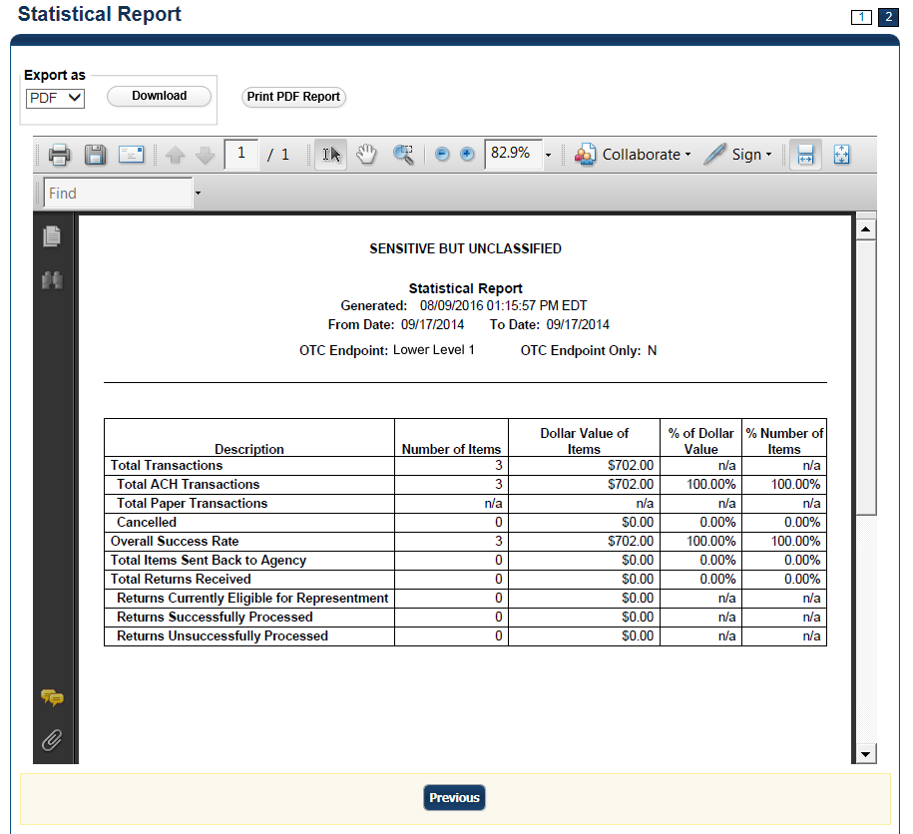

1. Under **Export as**,

* Select a **PDF, Excel** or **Word**
* Click **Download**

Or

* Click **Print PDF Report**

Additional Button



* Click **Previous** to return to the previous page.

### View CIR Transmission Status for Check Processing

The **View CIR Transmission Status for Check Processing** report allows you to view the status of CIR files that have been processed by CIR or are ready for CIR processing. The *View CIR Transmission Status for Check Processing* page is divided into two sections: Top section displays the check transmissions that have not been successfully processed by CIR. The bottom section displays all the check transmissions that have been sent to CIR regardless of their status.

To access the report, from **Check Processing Reports, Administration Reports**, click **View CIR Transmission Status for Check Processing**.

View CIR Transmission Status for Check Processing

To generate a View **CIR Transmission Status** for a Check Processing report, complete the following steps:

1. From the **Reports** tab, click **Check Processing Reports**. The *View Reports* page appears.
2. Under **Administration Reports**, click **View CIR Transmission Status for Check Processing**. The *View CIR Transmission Status for Check Processing* parameters page appears.
3. Click the **Transmission ID** to view the CIR transmission details or processing errors.
4. The CIR Transmission Status Export/Print Report preview page appears as shown in Figure 15.

Figure : CIR Transmission Status Export/Print Report Page

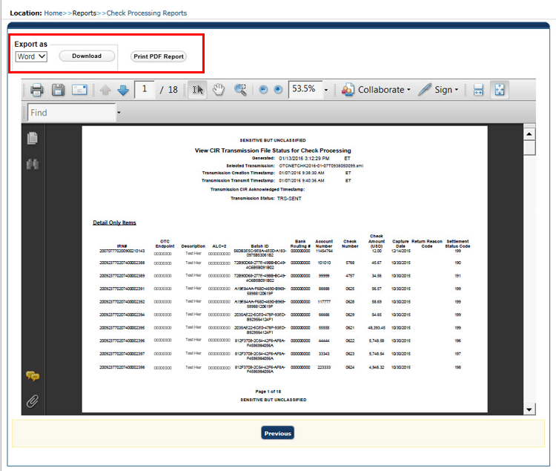

Under **Export as**,

* Select a **PDF**, **Excel** or **Word**
* Click **Download**

Or

* Click **Print PDF Report**

Additional Button



Click **Previous** to return to the previous page.

## Topic 5 Historical Reports

**Check Processing Historical** reports are used to query check records that are associated with batches that have a Received Date older than 18 months. All batches including batches with an **Open** or **Closed** status with a Received Date older than 18 months are saved in the Historical database.

Here are some items to keep in mind for Historical Reports:

* Check Transactions with a received date older than the minimum data retention period, as specified by Fiscal Service, may not be displayed on the report as these transactions are eligible to be deleted. As a result, this queried check information may not be accessible and will be removed from the archival database.
* They are generated asynchronously (not occurring at the same time), allowing you to continue to use OTCnet.
* Depending on the volume of data requested, it can take between five to 20 minutes for the report to generate. As an [**Agency Manager**](javascript:openGlossary('agency%20manager'))**,** [**Check Capture Administrator**](javascript:openGlossary('check%20capture%20administrator')), [**MVD Editor**](javascript:openGlossary('mvd%20editor')), [**MVD Viewer**](javascript:openGlossary('mvd%20viewer')), or [**FS Viewer**](javascript:openGlossary('viewer')), you are authorized to query and download CIRA CSV Historical reports.
* You can search for check records by [OTC Endpoint](javascript:openPopupWindow('glossary.htm#otc endpoint')), [User Defined Fields](javascript:openPopupWindow('glossary.htm#user defined field (udf)')), Account Number, [Bank Routing Number](javascript:openGlossary('routing%20transit%20number%20(rtn)%20')), [Individual Reference Number (IRN)](javascript:openGlossary('individual%20reference%20number%20(irn)%20')), and other search criteria. Running a search without specifying any criteria other than an OTC Endpoint, will result in a search that includes all checks in the system that you have access to view.
* When the report request is submitted, its status is set to ***Submitted***. Afterthe report is successfully generated, the status is set to **Completed** and the report is available for download in CSV format.
* Previously generated reports are available for seven days and can be downloaded using the *View Previously Generated Reports* function. Duplicate report requests based on identical search parameters cannot be made within the same 7-day period; however, after 7 days the same report request can be submitted.
* OTCnet does not limit the number of rows that can be downloaded in a CIRA CSV historical report. However, for Microsoft Excel 2010 or higher, you are authorized to view all records returned in a CIRA CSV historical file up to approximately 1 million rows. For Microsoft Excel 2003, to generate a CIRA CSV Historical report, any rows after 65,000 rows will not be displayed because Microsoft Excel 2003 has a 65,000 row limit.

### CIRA CSV Historical Report

The CIRA CSV Historical Report allows you to review past exported data based on a query to a Comma Separated Value (CSV) report. To access the report, from **Historical Reports**, click **Generate Historical Reports, Check Processing Historical Reports**, click **CIRA CSV Historical Report.**

When clicking the **Received Date** radio button, consider the following information for the **Received Date (From)** and **(To)**:

* If the **Received Date** radio button is selected, OTCnet does not validate any other date range values (**Capture Date**, **Settlement Date** or **Return Settlement Date**).
* **Received Date (From)** and **(To)** represents the date range the check was received into OTCnet. **Received Date (On)** represents the single specific date the check was received into OTCnet.
* The **Received Date (From)** and **(To)** fields are searchable for a duration up to 31 days.
* The **Received Date (From)** and **(To)** datesmust be older than 18 months from the current date.

When clicking the **Check Capture Date** radio button, consider the following information for the **Check Capture (From)** and **(To)**:

* If the **Check Capture Date** radio button is selected, OTCnet does not validate any other date range values (**Received Date**, **Settlement Date**, or **Return Settlement Date**).
* **Check Capture Date (From)** and **(To)** represents the date range the check was processed by the **Check Capture Lead Operator** or **Check Capture Operator**. **Check Capture Date (On)** represents the single specific end date the check was processed by the **Check Capture Lead Operator** or **Check Capture Operator**.
* The **Check Capture Date (From)** and **(To)** fields are searchable for a duration up to 31 days.
* The **Check Capture Date (From)** and **(To)** datesmust be older than 18 months from the current date.

When clicking the **Settlement Date** radio button, consider the following information for the **Settlement (From)** and **(To)**:

* If the **Settlement Date** radio button is selected, OTCnet does not validate any other date range values (**Received Date**, **Capture Date** or **Settlement Date**).
* If the **Settlement Date** radio button is selected, OTCnet does not validate any other date range values (**Received Date**, **Capture Date** or **Settlement Date**).
* **Settlement Date (From)** and **(To)** represents the date range when the check item was returned. **Settlement Date (On)** represents the single specific date the check item was returned.
* The **Settlement Date (From)** and **(To)** fields are searchable for a duration up to 31 days.
* The **Settlement Date (From)** and **(To)** datesmust be older than 18 months from the current date.

When clicking the **Return Settlement Date** radio button, consider the following information for the **Return Settlement (From)** and **(To)**:

* If the **Return Settlement Date** radio button is selected, OTCnet does not validate any other date range values (**Received Date**, **Capture Date** or **Settlement Date**).
* **Return Settlement Date (From)** and **(To)** represents the date range when the check item was returned. **Return Settlement Date (On)** represents the single specific date the check item was returned.
* The **Return Settlement Date (From)** and **(To)** fields are searchable for a duration up to 31 days.
* The **Return** **Settlement Date (From)** and **(To)** dates must be older than 18 months from the current date.

CIRA CSV Historical Report

To view a CIRA CSV historical report, complete the following steps:

1. From the **Reports** tab, select **Historical Reports.**
2. Click **Generate Historical Reports**.
3. Under **Check Processing Historical Reports**, select **CIRA CSV Historical Report.** The *CIRA CSV Historical Report* page appears.

Application Tip



The CIRA CSV historical report is generated asynchronously (not occurring at the same time) allowing you to continue using the OTCnet application. Depending on the volume of data queried it can take between 5 and 20 minutes to generate the report.

1. Enter the search criteria for the report you would like to view.

* Select an **OTC Endpoint**, *required*
* Check/uncheck the **Include Subordinates** check box

Application Tips



* If you do not know the full name of the OTC Endpoint, enter a partial name search (as few as one letter) in the **Starts with** text box and click the **Select From List** icon (magnifying glass). The configured OTC Endpoints appear according to the user’s access. Click the appropriate OTC Endpoint radio button.
* By default, the **Include Subordinates** check box is checked. Add a check mark to generate a report that contains data for the subordinate OTC Endpoints. Remove the check mark to generate a report that contains data only for the selected OTC Endpoint.

1. To search for a transaction:
   1. Using the **CIRA CSV Historical Report** search criteria, complete the following steps:

Under **CIRA CSV Historical Report**,

* Select a **Form Name**
* Select a **Deploy Date**

Application Tips



* By default, the **CIRA CSV Historical Report** screen is expanded. If the **CIRA CSV Historical Report - ACR** screen is expanded, the CIRA CSV Historical Report screen is collapsed.
* The **Form Name** is the name/list of available forms available for the selected OTC Endpoint. The **Deploy Date** is the date, time and version number of the selected form.
* By default, the most recent **Deploy Date** and **Form Version** will populate the Deploy **Date** field, once the **Form Name** is selected.

Under **User Defined Fields**,

* Enter **User Defined Field 1**
* Enter **User Defined Field 2**
* Enter **User Defined Field 3**
* Enter **User Defined Field 4**
* Enter the **Account number**
* Enter the **Bank Routing Number**
* Enter the **IRN (Individual Record Number)**
* Enter the **Check Number**

Application Tips



* The **User Defined Fields** are visible based on the selected OTC Endpoint **Form Name** and **Deploy Date**.
* If an **IRN** and a date range (**Received Date**, **Capture Date**, **Settlement Date**, and **Return Settlement Date**) are entered, OTCnet ignores the date range during report generation.

Under **Check Amount**,

* Select the appropriate drop-down field
* Enter the check amount
* Select a **Settlement Status**
* Enter the **5515/Debit Voucher Number**
* Enter the **215/Deposit Ticket Number**
* Enter the **Cashier ID**
* Enter the **Batch ID**

Application Tips



* The **5515/Debit Voucher Number** represents items returned to agency due to unsuccessful collection efforts.
* The **2515/Deposit Ticket Number** represents items credited into FRB CA$HLINK for a given agency on a given day.
* If a **Batch ID** and a date range (**Received Date**, **Capture Date**, **Settlement Date**, and **Return Settlement Date**) are entered, OTCnet ignores the date range during report generation.

Click the **Received Date**: radio button

* Select **From** and **To** Received Date range

Or

* Select the **On** Received Date

Or

Click the **Check Capture Date**: radio button

* Select **From** and **To** Check Capture Date range

Or

* Select the **On** Check Capture Date

Or

Click the **Settlement Date:** radio button

* Select **From** and **To** Settlement Date range

Or

* Select the **On** Settlement Date

Or

Click the **Return Settlement Date**: radio button

* Select the **From/On** Date range
* Select the **To** Date range

Or

* 1. To query for an ACR transaction, complete the following steps:
* Click **CIRA CSV Historical Report - ACR** to expand the screen
* Select an **ACR Type**
* Select an **ACR Reason Code**
* Enter an **ACR Voucher Number**
* Enter the **From** and **To** ACR Settlement Range, *Required*

Application Tips



* By default, the **CIRA CSV Historical Report** - **ACR (Adjustment, Correction, and Rescission)** screen is collapsed. If the Search ACR Transaction screen is expanded, the **CIRA CSV Historical Report** screen is collapsed.
* **Search ACR Transaction** options include **All ACR, Adjustment, Correction**, and **Rescission**.
* **ACR Reason Code** options include **Duplicate Transaction Processed, Non-Cash Item, Transaction Amount Correction, Representment, Warranty Indemnity Claim, Voucher Date Change, Voucher Number Change, Account Switch**, and **ACH Reversal**.
* The maximum numeric characters value for **ACR Voucher Number** is six.
* The **From** and **To** **ACR Settlement** fields are searchable for a duration up to 90 days. Additionally, the **From** and **To ACR Settlement** dates must be older than 18 months from the current date.
* Click **Submit Request**. A “*Your report request has been successfully received”* message appears as shown in Figure 16.

Figure : CIRA CSV- Request Successfully Submitted

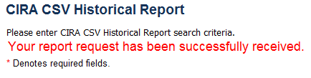

Additional Buttons



* Click **Cancel** to return to the OTCnet Home Page. No data will be saved.
* Click **Clear** to clear all data fields and reset to the default selections.

### Previously Generated Historical Reports

**Previously Generated Historical** reports are used to query records associated with batches that have a Received Date older than 18 months. Access these reports from Historical Reports, and select **View Previously Generated Reports.**

Consider the following information when generating a Historical Report:

* When a report request is submitted, its status is **Submitted**.
* When a report is successfully generated, the status is **Completed**and available for download.
* When a report request is submitted and the Historical Database is unavailable, an informational message appears stating, “*Historical Database is currently unavailable. All reports in Submitted status will be processed when the Historical Database is available.*” Report requests that are in **Submitted** status will remain in **Submitted** status until the database is available and the report is generated. After the report is generated a **Completed** status is displayed.
* When a report request is submitted and the report could not generate (e.g. code error), its status is **Error**. Resubmit your report request to ensure your report is generated. If a report displays an **Error** status, the request can be resubmitted at any time without receiving a duplicate request message.

View Previously Generated Historical Reports

To view previously generated historical reports, complete the following steps:

1. From the **Reports** tab, select **Historical Reports** and click **View Previously Generated Reports**. The *View Previously* *Generated Reports* page appears as shown in Figure 17.

Figure : View Previously Generated Reports

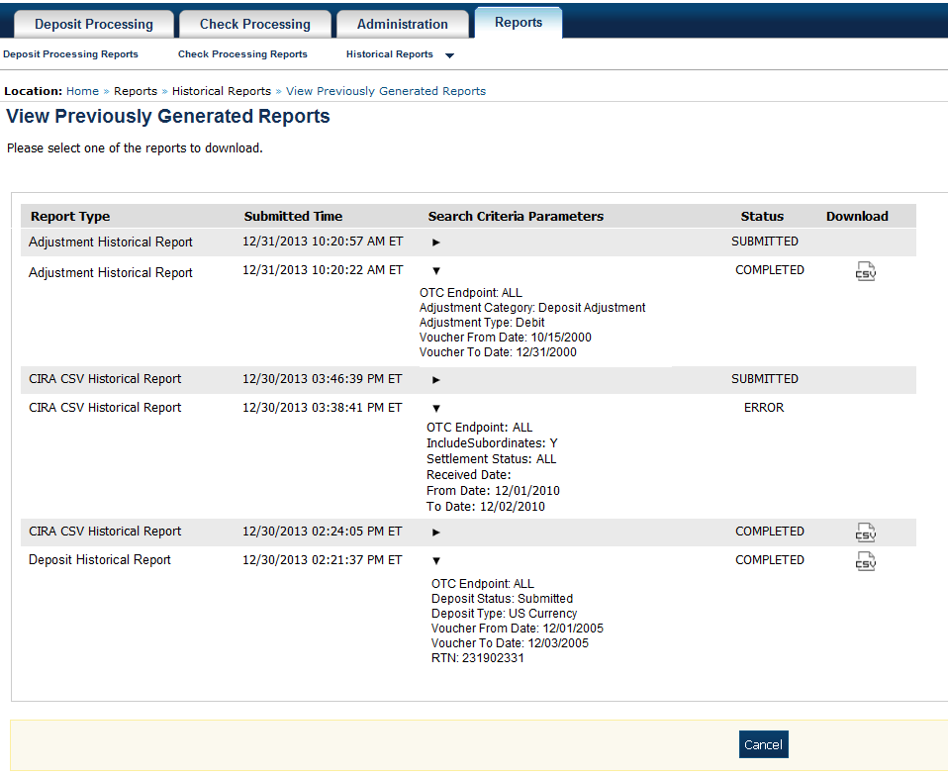

1. Select one of the reports to download and under the **Download** column, click OTCnet CSV Logo **Download**. The *File Download* dialog box appears.

Application Tips



* Once the CSV file is downloaded, it can be opened using Excel or Notepad.
* Previously generated reports are available for 30 days. Duplicate report requests based on identical report parameters cannot be made within the same 7-day period; however, after 7 days a duplicate report request can be submitted. Report requests are user specific and are not viewable by other users.
* The CIRA CSV Historical Report page is configured to download a maximum of 31 days of search results. This range parameter applies when a user searches using **Received Date, Check Capture Date, Settlement Date** or **Return Settlement Date**. The system will display an error message to you when searching for results beyond the configured range.

1. Click **Open**, **Save**, or **Cancel**.

Additional Button



* Click **Open** and the file content displays.
* Click **Save** and choose the location for saving the file.
* Click **Cancel** and the dialog box closes. No data is saved.
* Click **Cancel** again to return to the OTCnet Home Page. No data is saved.

## Summary

In this chapter, you learned:

* The purpose of accessing check processing reports
* How to view a CIRA Query
* How to view and download a CIRA CSV Report
* How to view and print a Check Image Report
* How to view and print an Agency CIRA Report
* How to view and print an LVD Contents Report
* How to view and print an Organizational Hierarchy Report
* How to view and print a 215 Deposit Ticket Report
* How to view and print a 5515 Debit Voucher Report
* How to view and print an ACR Activity Report
* How to view and print a CIRA Transmission Summary Report
* How to view and print a CIRA Transmission (Detailed) Summary Report
* How to view and print a Statistical Report
* How to view and download Historical Reports