

OTCnet Participant User Guide

Table of Contents

Overview, Topics, and Audience 1

Overview 1

Topics 1

Audience 2

Topic 1 Purpose of Capturing and Managing Checks Offline 3

Topic 2 Capture a Check Offline 5

Introduction to Capturing a Check 5

Types of Acceptable and Unacceptable Checks 6

Batch Processing Modes 7

Processing Methods 8

Item Types 8

Accounting Codes 9

Check Scanner Types and Check Placement 9

Check Capture Acceptance 12

Capture a Check Offline 12

Capture a Check Offline 13

Topic 3 Manage Poor Check Image Quality 18

Manage a Check with Poor Image Quality 19

Topic 4 Resolve a Duplicate Check 21

Resolve a Duplicate Check 22

Topic 5 Void a Check in OTCnet Offline 24

Void a Check in OTCnet Offline 25

Void All Checks in a Batch in OTCnet Offline 28

Void All Checks in a Batch in OTCnet Offline 29

Topic 6 Local Verification Database (LVD) Record 32

Override a LVD Record 33

Topic 7 Perform Batch Control and Batch Balancing 35

Batch Control Options 36

On Batch Close (Optional/ Mandatory) in OTCnet Offline 36

Perform Batch Control on Batch Create 37

Perform Batch Control on Batch Close 39

Batch Balancing 41

Topic 8 View and Print a Batch List/ Item Detail Report 43

Item Detail Report 44

View and Print a Batch List Report 46

View and Print an Item Detail Report 48

Topic 9 Activate/Deactivate a Batch 50

Activate/Deactivate a Batch 51

Topic 10 Classify a Batch 54

Summary Level Classification 54

Summary Level Classification 55

Topic 11 Close a Batch 58

Close a Single Batch 58

Close a Single Batch 59

Close Multiple Batches 62

Close Multiple Batches 63

Topic 12 Approve a Batch 66

Approve a Single Batch 66

Approve a Single Batch 67

Approve Multiple Batches 70

Approve Multiple Batches 71

Topic 13 Upload a Batch 75

Upload a Batch in OTCnet Offline 76

Topic 14 Acknowledge a Batch 78

Acknowledge a Batch 78

Acknowledge a Batch 79

Topic 15 Print a Receipt 80

Receipt Printing from Check Scan (Singe/Batch Mode) 80

Receipt Printing from Batch Management (Single/Batch Mode) 80

Print a Receipt in Single Mode or Batch Mode 81

Print a Receipt in Batch Management 82

Summary 84

List of Figures

Figure 1. EC 7000i Scanner 10

Figure 2. EC 9100i Scanner 10

Figure 3. Panini Scanner 11

Figure 4. Panini I: Deal Scanner 11

Figure 5. Check Scan – Perform Check Scan Page 14

Figure 6. Poor Image Quality 19

Figure 7. Image Quality Failed Message 19

Figure 8. Check Image/ Details 26

Figure 9. View Checks (Voiding) 30

Figure 10. Override Check Denial Box 33

Figure 11. Verification Report 34

Figure 12. Batch Control Page (Batch Close) 39

Figure 13. Print Batch List Report (Batch Close) 40

Figure 14. Batch Control (Failed to Balance) 41

Figure 15. Item Detail Report 45

Figure 16. Batch List Report Page 47

Figure 17. View Batches Page (Activate/Deactivate) 53

Figure 18. View Checks – View/Edit Classification 56

Figure 19. Check Scan- Select Batch Page 60

Figure 20. Select to Close Batch 60

Figure 21. View Batches Page (Approve Single) 68

Figure 22. View Batches Page (Approve Multiple) 72

Figure 23. Upload Batch – Summary of Batches 76

Figure 24. Select Batches to Acknowledge 79

Figure 25. Receipt Print Image (Scan Check) 81

Figure 26. View Checks Page (Receipt) 83

List of Tables

Table 1. Check Capture/Processing and Batch Permission Matrix 4

Table 2. Scanner Types 9

Table 3. FedACH and Check 21 Item Types 15

Table 4. Batch Status Types 58

Glossary

Click this [link](https://www.fiscal.treasury.gov/otcnet/training/wbt/content/course_OTC/glossary.htm) to access the full OTCnet Glossary.

Double click to open the footer, then replace the word **Category** with the correct User Guide Category

## Overview, Topics, and Audience

### Overview

Welcome to *Capturing and Managing Checks Offline*. In this chapter, you will learn:

* The purpose of capturing and managing checks offline
* How to capture a check offline
* How to manage poor check image quality
* How to resolve a duplicate check
* How to void a check
* How to override a Local Verification Record (LVD)
* How to perform batch control and batch balancing
* How to view and print a batch list/item
* How to activate/deactivate a batch
* How to classify a batch
* How to close a batch
* How to approve a batch
* How to upload a batch
* How to acknowledge a batch
* How to print a receipt

### Topics

The topics in this chapter include the following:

1. Purpose of Capturing and Managing Checks Offline
2. Capture a Check Offline
3. Manage Poor Check Image Quality
4. Resolve a Duplicate Check
5. Void a Check in OTCnet Offline
6. Local Verification Database (LVD) Record
7. Perform Batch Control and Batch Balancing
8. View and Print a Batch List /Item Detail Report
9. Activate/Deactivate a Batch
10. Classify a Batch
11. Close a Batch
12. Approve a Batch
13. Upload a Batch
14. Acknowledge a Batch
15. Print a Receipt

### Audience

The intended audience for the *Capturing and Managing Checks Offline* Participant User Guide includes:

* Check Capture Operator (CCO) (Batch Approver/ Batch Uploader)
* Check Capture Lead Operator (CCLO) (Batch Approver/ Batch Uploader)
* Check Capture Supervisor (CCS)

## Topic 1 Purpose of Capturing and Managing Checks Offline

The Check Processing functionality is primarily used to capture images of a check and transaction data. There are two components under this tab within OTCnet. They include the **Scan Check** and **Batch Management** functionality. Once the images and data are collected under **Scan Check**, a user may access **Batch Management** to perform certain tasks prior to forwarding the batch for settlement.

During check scanning, you may opt to use the **Batch Control** functionality which allows you to balance your batch. If this option is configured to be optional or mandatory for your Agency, the *Batch Control* page appears during check processing.

As the **Check Capture Operator (CCO)** or **Check Capture Lead Operator (CCLO)**, you are the only authorized users who can capture a check offline.

As a **CCO**, you are authorized to scan checks into a Batch, change Processing Method (Customer Present / Customer Not Present), change an Accounting Code, change Item Type (Personal / Non-Personal checks), close a batch, and view a batch list.

As a **CCLO**, you are authorized to conduct the same actions as the **CCO** stated above, and balance batch and enter batch control values (total check count and total amount), accept duplicates, make MICR code line corrections or accept checks with poor quality without approval (see Table 1 for details).

As a **Batch Approver**, you have the authorization to approve a batch either prior to batch upload from OTCnet Offline or when a batch is uploaded/submitted to OTCnet Online but not yet approved. The **Batch Approver** permission must be applied to either a **CCLO** or **CCO** roles and allows the operators to approve batches that they have created. This role must be granted in limited cases at sites where there is a need for the operator to perform this function without a **Check Capture Supervisor (CCS)** present.

As a **Batch Uploader**, you are authorized to upload a batch from OTCnet Offline to the online database. The **Batch Uploader** permission must be applied to either a **CCLO** or **CCO** role and allows the operators to auto-upload the batch upon close (if terminal is configured to do so) or upload approved batches. This role must be granted in limited cases at sites where there is a need for the operator to perform this function without a **CCS** present.

Table 1. Check Capture/Processing and Batch Permission Matrix

| Task | Check Capture Operator (CCO) | Check Capture Lead Operator (CCLO) | Check Capture Supervisor  (CCS) |
| --- | --- | --- | --- |
| Scan checks into a batch | • | • | BLANK |
| Change Processing Method (Customer Present / Customer Not Present / Back Office) | • | • | BLANK |
| Change Accounting Codes | • | • | • |
| Change Item Type (Personal/Non-Personal checks) | • | • | BLANK |
| Make MICR code line corrections | BLANK | • | • |
| Resolve a duplicate check | BLANK | • | • |
| Accept checks with poor image quality | BLANK | • | • |
| View a batch list | • | • | • |
| Balance batch amount (total check count and total amount) | BLANK | • | • |
| Enter batch control during batch closing | BLANK | • | • |
| Classify a batch | • | • | • |
| Close a batch | • | • | • |
| Approve a batch | 1 | 1 | • |
| Upload a batch | 2 | 2 | • |
| Acknowledge a batch | 2 | 2 | • |
| Edit a batch | BLANK | • | • |
| Activate/Deactivate a batch | BLANK | BLANK | • |
| Void a check | BLANK | BLANK | • |

•= User can perform task, 1= requires additional Batch Approver permission, 2= requires additional Batch Uploader permission

## Topic 2 Capture a Check Offline

### Introduction to Capturing a Check

As a **CCO** or **CCLO**, you are authorized to capture a check in two modes, single or batch check mode. Once a **Check Capture Administrator (CCA)** sets up your Terminal Configuration settings, you can scan a check in Single or Batch check mode. There are many other settings that your **CCA** may also institute for your location, many of which will be visible as you begin the check scanning process.

**Logical Processing Order for Scanning a Check**

When creating a batch, it is important that the proper steps be taken to ensure that the batch reaches our system. Below is an outline of the logistics for creating a batch:

* **Batch Control** – This function may or may not appear, based on the computer’s configuration settings. If used, key in total dollar amount of checks and the total number of checks to be scanned. This function can be setup in the configuration as disabled, optional, or mandatory by the **CCA**. If this option is disabled, the Batch control screen does not appear. If optional, the Batch control screen can be skipped.

If mandatory at Batch Create or Batch Close only, the user must enter the Batch Control values. However, if a user selects to set Batch Control value at both Batch Create and Batch Close, then it can only be deferred at the beginning of the batch. Batch control is required prior to closing a batch in this case.

* **Scan the check** (or checks if processing in batch mode).
* **Key in amount, configurable field data, and select accounting code information** for each check, if accounting codes are set up.
* **Cancel transactions while performing data entry**, used only if necessary, i.e., image of the check is not legible.
* **Print the receipt** – Just after the item information is keyed into the data entry screen, press **Enter**, then click the **Receipt** button to print a receipt of the item or items.
* **Void items** – Used to delete invalid items only if necessary, prior to closing a batch if a **CCS** is available to authorize the void. Once data entry has been performed and the **Enter** key is pressed on a user’s keyboard, the item can no longer be cancelled and must be voided.
* **Print the Batch list** – A printout of the batch listing can be done prior to closing a batch.
* **Pre-balance** – Use the batch list that was just printed to reconcile all activity for this batch of work. If reconciling with cash drawers, count and reconcile to ensure activity is accurate.
* **Batch Balancing** – This screen only appears if the totals that are keyed into the Batch Control screen do not match with what was actually keyed into the data entry screen, or if the number of checks scanned does not match the number keyed into the Batch Control screen.
* **Close** – Closes the batch from further checks and prepared the batch for processing.
* **Approve** – Indicates that the batch is ready for the settlement process. Once the batch is approved the batch status then becomes **Sent**.
* **Upload** – Indicated that the batch(es) selected in the Batch Upload menu in OTCnet Offline have been successfully to the OTCnet Online server.
* **Acknowledge** – Indicates the batch was transmitted and fully processed by the OTCnet Online server, without error.

An Agency may have multiple OTC Endpoints to process checks for. Each OTC Endpoint is unique, and batches can include items for multiple OTC Endpoints, however during the configuration set up, one OTC Endpoint is chosen to be the default. The default OTC Endpoint appears each time the **CCO** or **CCLO** begins the scanning process. However, they may select an alternate OTC Endpoint before scanning begins.

### Types of Acceptable and Unacceptable Checks

All of the items listed below can be processed through the OTCnet Check Processing Functionality. The following check items must be processed as **Non-personal**:

* + US Treasury Checks
  + Traveler's Checks
  + Money Orders (including Postal Money Orders)
  + Third-party Checks (even if drawn on a personal account)
  + State and Local Government Checks
  + Credit card Checks
  + 'Do not ACH' Checks
  + Official Checks
  + Business Checks7
  + Cashier’s Checks
  + Other US Government Checks
  + Payroll Checks

If a customer chooses to ‘opt out’ and does not want their checks to be processed via ACH, the customer’s personal check must be processed as a non-personal item. This allows the check to clear their financial institution as a Check 21 item.

Personal/Consumer Checks must be processed as **Personal** check Items.

The following ineligible item(s) cannot be processed using the OTCnet Check Processing functionality and can be processed through the **Deposit Processing** tab within OTCnet instead:

* + Foreign items drawn on non-US Financial Institutions
  + Check payable in non-US currency

Apply any necessary stamps in a location that does not interfere with the dollar amount, financial institution information, or the signature. Since these items are not deposited at your bank, there is no need to stamp “For Deposit Only” on the back of the check. FRB-Cleveland becomes the bank of first deposit for all the OTCnet Check Processing items scanned and forwarded for settlement.

### Batch Processing Modes

**Single vs. Batch Processing Mode**

Agencies can choose to process their checks in one of two processing modes. The **Single** check mode allows checks to be processed one at a time, and **Batch** processing mode allows for batches of checks to be scanned prior to data entry. The **Batch** processing mode is available for EC7000i, EC9100i, and all Panini scanners.

When scanning in **Batch Processing Mode**, ensure that the entire check image is visible on the screen and the dollar amount must be legible (a check may successfully scan even though the item was folded going into the device). If the image is not legible, click **Cancel** under **Scanner Controls** and re-scan the check.

A best practice approach while scanning in Batch mode is to scan a smaller quantity of items. For example, instead of scanning 150 items, scan 75. Next, perform the data input. Scan the second group of 75 and perform the data input. Using the keyboard after the 75 items are scanned may eliminate the system inactivity logout during batch processing.

As the keyboard and mouse are typically not touched during the scanning process, the system interprets this as inactivity and an auto logout takes place. To avoid this situation, move the mouse every so often to simulate system activity during the scanning process. The default setting is 15 minutes so the operator must move the mouse every 10 minutes or so to keep the system active.

The maximum number of items that can be included in one batch is 3,000 items, and the maximum dollar amount per batch is $99,999,999.99. The max number of items is also limited by the TIFF file.

All processing method types can exist within a batch, although usually Back Office processing types would be processed independently of other types. Not all agencies utilize all modes. Furthermore, a site may choose not to use all modes every day, due to fluctuation in check volume.

### Processing Methods

Operators are able to choose the **Processing** **Method** to which they would like to scan checks. This option indicates the mode of operation. They include **Customer** **Present**, **Customer** **Not** **Present**, or **Back** **Office**.

The **Customer Present** method is used when the person is present, i.e., standing in front the operator with their check. The **Customer Not Present** method is used when the writer of the check is not present, i.e. when checks are received through the mail as payments.

The **Back** **Office** processing method allows Agencies to convert payments received at the point-of-sale locations to ACH entries in a controlled, back-office environment.

The default is to allow all Processing Methods and Item Types, but restrictions can be setup to allow only the **Back Office** processing method or **Non-personal** items only. Operators must ensure that they are selecting the proper choices for each item to avoid returned payments from the check writer’s financial institution.

Prior to scanning, checks must be pre-sorted by **Customer Present**, **Customer Not Present**, and **Back Office**. All processing method types can exist within a batch, although usually back offices processing types would be processed independently of other types. Not all agencies utilize all methods. Furthermore, your site may choose not to use all methods every day, due to fluctuation in check volume scanning a check.

### Item Types

Before or after the check is scanned in Single mode, the user must choose the Item Type. For Batch mode scanning, a user cannot manually select **Personal** or **Non Personal**, the system will use the default (previously established in the configurations). During the scanning process, if the system detects an Item Type other than the established default, it will prompt the user for confirmation.

The choices are **Personal** or **Non Personal**. This indicates the type of item to be processed. When the operator clicks **Personal**, the Agency Form data entry screen displays, *Check*: *Personal*.

If the operator clicks **Non Personal**, the Agency Form data entry screen displays, *Check: Non* *Personal*. OTCnet can process both personal and non personal checks within a batch. The operator must ensure selecting the proper choices for each item. Presort all items into two groups (Personal and Non Personal) prior to scanning to avoid the pop-up message indicating that it detected a different item type for the check. While most business checks are typically larger in size, business checks can look the same as personal checks.

Using the OTCnet Terminal Configuration functionality, authorized users can limit the Item Type to Non Personal Only. When Non Personal Only is chosen under Terminal Configuration, the Item Type Personal is no longer available for the operator to choose from the drop-down options. This can be set up for Agencies who never process personal checks.

### Accounting Codes

By default, the **Agency Accounting Code** drop-down field displays a blank value. An accounting code can be selected for a check transaction before or after scanning a check.

The **Agency Accounting Codes** drop-down list displays the full **Agency Accounting Code** value (up to 50 alphanumeric characters) and some portion of the **Description** (up to 15 alphanumeric characters).

**Accounting Codes** are displayed in the drop-down field if they are mapped or inherited from the higher level OTC Endpoint. Additionally, accounting codes that are designated as **Treasury Account Symbols (TASs)** by the Agency are displayed if they are and have been validated by **Shared Account Module (SAM)**.

If no accounting codes are available for selection and the Agency is a Central Accounting Reporting System (CARS) Reporter, an operator cannot scan a check. If no accounting codes are available for selection, and the Agency is not a CARS Reporter, an operator can still scan a check.

If an OTC Endpoint is associated with an ALC that is designated as a CARS Reporter, all check transactions must be classified with an accounting code. If an ALC is not a CARS Reporter, classifying it with an accounting code is optional.

The same accounting code is displayed after it is selected for the first time. The selected accounting code is “sticky” (remains the same) between transactions, between batches within the same check scanning session and prior to the next user login.

### Check Scanner Types and Check Placement

Your Agency may scan checks using one of nine scanner types (see Table 2). Some scanners are designed to scan only in Batch mode, whereas others may only scan in Single mode. The EC7000i, EC9100i, Panini MyVision X, Panini Vision X, and Panini I: Deal, however, can scan checks in both modes.

Table 2. Scanner Types

|  |  |
| --- | --- |
| EC7000i | This scanner will automatically scan both sides of a check and can scan in single or batch mode (one or more checks in a batch) |
| EC9100i | This scanner will automatically scan both sides of a check and can scan in single or batch mode (one or more checks in a batch) |
| Panini MyVision X | This scanner will automatically scan both sides of a check and can scan in single or batch mode (one or more checks in a batch) |
| Panini Vision X | This scanner will automatically scan both sides of a check and can scan in single or batch mode (one or more checks in a batch) |
| Panini I: Deal | This scanner will automatically scan both sides of a check and can scan in single or batch mode (one or more checks in a batch) |

**EC7000i Scanners**

Place the check in the scanner with the MICR line of the check aligned with the right side of the scanner (as shown in Figure 1). Gently push the check forward to allow the scanner to grasp the check. Guide the left side of the check with your finger to prevent the document from being skewed. The scanner automatically pulls the check through to begin the scan.

Figure 1. EC 7000i Scanner

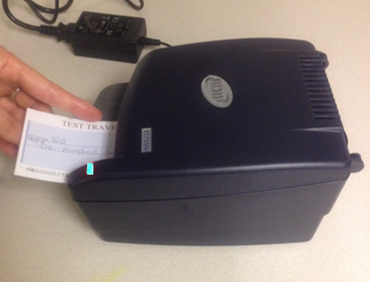

With the EC7000i scanner, both the front and the back of the check are scanned automatically.

**EC9100i Scanner**

Place the check in the scanner with the MICR line of the check at the bottom and facing towards the outside of the scanner (as shown in Figure 2). Adjust the exit extension or the pocket stop to fit the check that you are scanning. The scanner automatically pulls the check through to begin the scan.

Figure 2. EC 9100i Scanner

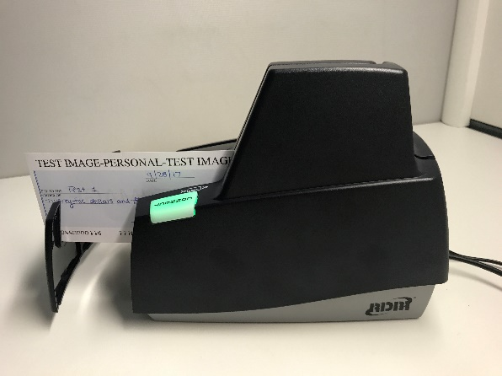

With the EC9100i scanner, both the front and the back of the check are scanned automatically.

**Panini Vision X and Panini MyVision X Scanners**

A user needs to ensure that the check or checks are already in the hopper of the scanner, front of the checks facing (as shown in Figure 4). The first green light on the scanner begins to flash (if applicable).

Once the hopper is empty, the *Hopper Empty* message appears; the user can add more checks to the hopper then click **Yes** to continue adding items to the batch, or click **No** if there are no more checks to scan. When **No** is clicked, the system switches to the data entry phase and the first check that was scanned appears on the screen.

Figure 3. Panini Scanner

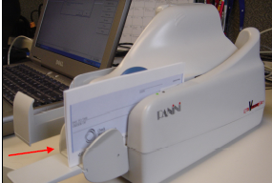

Use caution when clicking the **Stop** button during batch mode processing. Pressing too quickly (before the scanner has a chance to catch up to the system) may cause the loss of the last transaction.

**Panini I: Deal Scanner**

Place the check face up with the MICR line aligned to the right side of the scanner (as shown in in Figure 4). The scanner automatically detects the check and begins feeding. If the check is not aligned, the scanner will automatically align the check to the proper position. When using the franking feature, the Panini I: Deal scanner will frank the check as soon as it is scanned, rather than waiting until the operator has saved the transaction. This is a change in process from the EC7000i series scanners.

Figure 4. Panini I: Deal Scanner

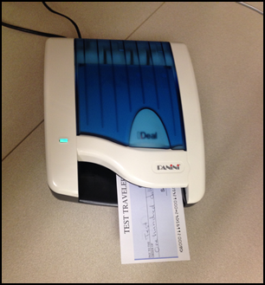

As the document is fed into the device, the scanner will detect if the document was not automatically aligned correctly. If the document is skewed, the scanner will prevent further processing, will stop the document and will flash a red light. The check can be removed and reinserted.

### Check Capture Acceptance

Once a user has successfully logged in to OTCnet Offline, selected the appropriate OTC Endpoint to scan a batch to, chosen the correct processing method and Item Type, the next step is to scan the check.

Click the **Start Scan** under **Scan Controls** options (scanner light may turn green depending on the type of scanner you have indicating that the scanner is ready to accept a check). Scan the check and click **Save** under **Scan Controls** options. The bottom of the *Agency Form* entry screen displays *Scan front of Check*.

A Batch Control screen may appear, based on the Agency’s configuration settings.

### Capture a Check Offline

To capture a check offline, you must scan a checkand select the OTC endpoint for the check you would like to scan.

To select a single or multiple accounting codes from the drop down list provided, **Agency Accounting Code** and **Multiple** radio buttons will be presented. Upon scanning the check, the **Individual Reference Number (IRN)**, **Check Number**, **Account Number**, **Date & Time fields** automatically populates. Additionally, **Scanner Config** presents details regarding your scanner configurations.

Capture a Check Offline

To capture a check in offline mode, complete the following steps:

1. From the **Check Processing** tab, click **Check Scan**. The *Check Scan-Select Open Batch* page appears.

Application Tips



* If there is internet connectivity and the terminal’s Local Verification Database (LVD) is out of date, a message appears asking, “*The Check Verification Database is out of date, would you like to update the database now*?”
* If **Yes** is clicked, the Download LVD task initiates and the latest copy of the LVD downloads to the terminal. After the download is complete, click **Close**.
* If **No** is clicked, a message appears asking whether to use the existing database.
  + - If **Yes** is clicked, the out-of-date LVD is used.
    - If **No** is clicked, a **Check Capture Supervisor** must enter his/her online credentials and authorize the use of the out-of-date LVD.

1. Under **Select Open Batch**, if applicable, click **Select** for the relevant OTC Endpoint to scan a check(s).

Application Tips



* When a batch is in use and another user attempts to access the same batch, a Batch Lock message appears, stating the batch is in use and that you cannot access the batch.
* During the scanning process, if an operator only has access to scan against a single OTC Endpoint, the system will not prompt the user to select an OTC Endpoint.
* If an operator has OTC Endpoint has an **Open** batch, the batch details (**Void Count**, **Approved Count**, and **Amount**) are displayed.
* If an Agency is associated with an OTC Endpoint that is designated as a Central Accounting Reporting System (CARS) Reporter and accounting codes are not available for selection, an error message appears and the operator *cannot* scan a check.
* If an Agency is associated with an OTC Endpoint that is not a CARS Reporter, the operator can scan checks. Selecting an accounting code is optional.

1. Click **Next**. The *Check Scan* page appears as shown in Figure 5.

Figure 5. Check Scan – Perform Check Scan Page

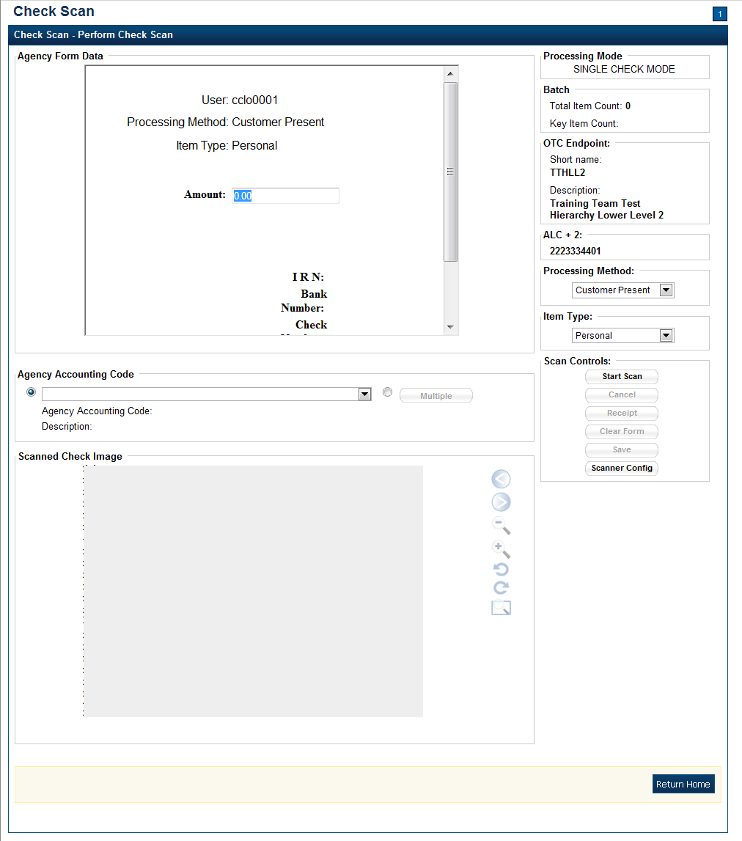

Under **ALC+2** (Agency Location Code +2),

* + Verify the **OTC Endpoint**. To change the OTC Endpoint, click **Previous** and return to Step 2

Under **Processing Method**,

* + Select the **Customer Present, Customer Not Present**, or **Back Office**

Under **Item Type,**

* + Select the **Personal** or **Non-personal**

Table 3. FedACH and Check 21 Item Types

| FedACH | Check 21 |
| --- | --- |
| * Direct Deposit of payroll, Social Security and other government benefits, and tax refunds * Direct Payment of consumer bills such as mortgages, loans, utility bills and insurance premiums * Business-to-business payments * E checks * E commerce payments * Federal, state and local tax payments | * Business Checks * Money Orders * Treasury Checks * Credit Card Checks * Traveler’s Checks * Cashier’s Checks * Official Checks * Third-party Checks * Payroll Checks * Checks drawn on state or local government |

Under Scan Controls,

* + Click **Start Scan**, to scan a check
  + Insert the check in the scanner

Application Tip



* The maximum number of check items allowed to be scanned per batch is 3,000.
* Recapture an image of a check if it is inserted upside down; appears skewed; or the image is illegible. Click **Cancel** and reinsert the check in the scanner. Click **Start Scan** and re-enter the necessary data.

Additional Buttons



* Click **Cancel** to cancel the transaction. No data will be saved.
* Click **Receipt** to access a receipt for review or printing. This is only available once the initial check is scanned.
* Click **Clear Form** to clear the data entered.
* Click **Save** to save the transaction.
* Click **Scanner Config** to provide scanner and processing method configuration information.

Under **Scanned Check Image**, *optional*

* + Click **<** to view the front of the check
  + Click **>** to view the back of the check
  + Click **-** to reduce the image of the check
  + Click **+** to increase the image of the check
  + Click **Left Rotate** to turn the image to the left
  + Click **Right Rotate** to turn the image to the right

Under **Agency Form Data**, enter the check data in the field(s) provided

* + Enter the **Amount**, *required*

Application Tip



OTCnet accepts two different **Amount** entry formats:

* If the deposit amount is for thirty-five dollars and fifteen cents, enter 35.15.
* If no decimal point is entered, OTCnet will add a decimal and two zeroes at the end and save it as 3515.00 (three thousand five hundred and fifteen dollars).
* The **Agency Form Data** form is customizable and can include fields beyond the **Amount** field (e.g., Social Security Number). If your Agency has additional fields, they are displayed under the **Amount** field. Your Agency may deem the field(s) either mandatory or optional for you to complete an entry.
* If your Agency requires additional fields, contact your Deployment Specialist at 703-377-5586 or [fiscalservice.otcdeployment@citi.com](mailto:fiscalservice.otcdeployment@citi.com).
* Ensure that you type in the data rather than copying and pasting from another source. Data that has been copied and pasted may result in an error.

Application Tip



Consider the following with Batch Mode:

* + If you use an **EC7000i** or **EC9100i** to scan checks in Batch mode, a *READY FOR BATCH SCAN, Waiting for check* dialog box appears. Insert the checks one at a time. The dialog box shows the item count after each scan. When finished scanning, click **Stop**.
  + If you use a **Panini I: Deal**, **Panini MyVision X**, or **Panini Vision X** to scan checks in Batch mode, a *READY FOR BATCH SCAN, Waiting for check* dialog box appears. Insert the checks in the hopper. The dialog box shows the item count after each scan. When the hopper is empty or when finished scanning, click **Stop**.

Under **Agency Accounting Code**, *if applicable*

* + Click the **Agency Accounting Code** radio button and select a single accounting code from the drop-down list

Or

* + Click the **Multiple** radio button. The *Account Classification* dialog box appears.
    - Select an **Accounting Code**, enter the **Amount**, and click **Add** for each subtotal of the deposit
    - Click **Save**

1. Click **Save** to save the image of the check and the data you entered. A message appears stating the transaction was successfully saved along with the Individual Reference Number (IRN) and check amount.

Application Tip



While scanning a check, use enter on your keyboard to finalize. Notice that the **IRN**, **Bank Number**, **Check Number**, **Account Number**, **Date & Time fields** automatically populates (located in the frame of the **Agency Form Data**).

Additional Button



Click **Return Home** to return to the OTCnet Home Page.

## Topic 3 Manage Poor Check Image Quality

There are instances when the image of a scanned check is not captured successfully. OTCnet Image quality tests are performed on each check, as soon as the check is captured, and the image is available. If a check passes the image quality tests, the item processing continues. If the check fails the image quality tests, an Image Quality Failed message is displayed.

The check must be fully visible and legible. The image that is on the screen is the image that is submitted to the payor bank for collection. It is also stored in the archives for future retrieval purposes once the check is returned to the customer or destroyed. If we are unable to collect on the Agency’s behalf with the image that has been submitted, the debit reverts back to the Agency and collection becomes the Agency’s responsibility.

If an *Image Quality Failed* message is displayed during the check scanning process and the check image is skewed, illegible, or upside down, an operator may consider the following options:

* + **Rescan** the check (recommended to perform as many times as necessary)
  + **Cancel** the check and opt to use the Deposit Processing functionality within OTCnet to deposit the check
  + **Accept** the check (requires a **CCS** or **CCLO** to Log in to OTCnet to authorize)

A **CCS** or **CCLO** can choose to override a poor image. The following examples are of a poor image scan and an image of good quality. Agencies must be aware that overriding a poor image may result in a returned item, depending upon the paying financial institution.

To manage a check with poor image quality, you must accept the image of the check, which requires **CCS** or **CCLO** to login in the *Login ID and Password* dialog box and enter the check item details on the *Perform Check Scan* page.

Manage a Check with Poor Image Quality

To manage a check with poor image quality as shown in Figure 6, complete the following steps:

1. From the *Check Scan – Perform Check Scan* page, the *Image Quality Failed* message appears as shown in Figure 7. Click one of the following:
   * **Rescan** to rescan the check

Application Tip



Click **Rescan** if the check image is skewed, illegible, or upside down

Or

* + **Cancel** to completely cancel the transaction

Or

* + **Accept** to accept the check image (requires **CCS** to log in). The *Login ID and Password* dialog box appears. Enter the **Login ID** and **Password** and click **Login**.

Figure 6. Poor Image Quality

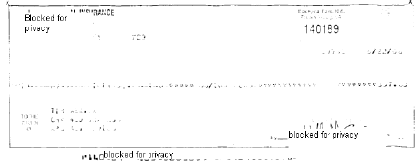

Figure 7. Image Quality Failed Message

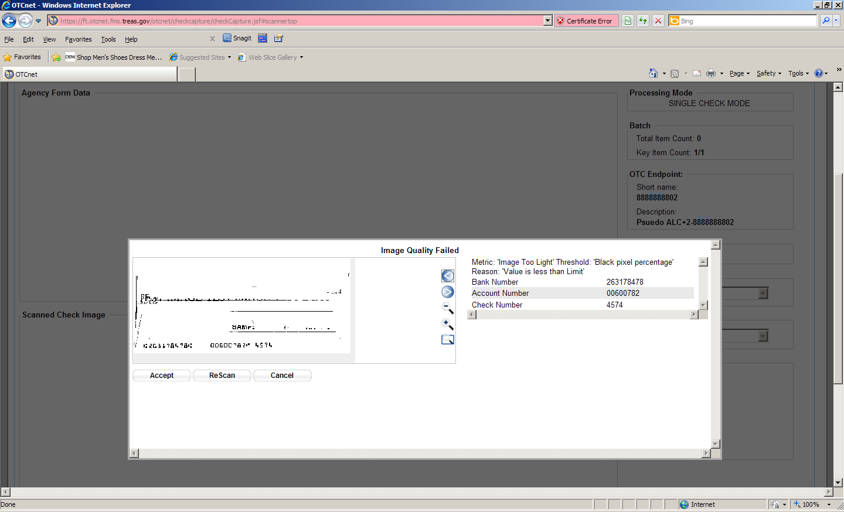

Application Tips



* If a **Check Capture Lead Operator (CCLO)** or **Check Capture Operator (CCO)** scanned the check, OTCnet will prompt the operator for authorization.
* Only a **Check Capture Supervisor (CCS)** can approve a check with poor image quality. The **CCS** must key in his/her Login ID and Password before approving the check.

1. Resume check scanning tasks and enter the check item details into the form fields.
2. Click **Save** to save the image of the check and the data you entered.

Application Tip



Upon scanning the check and using enter on your keyboard to finalize, the **Individual Reference Number (IRN)**, **Bank Number**, **Check Number**, **Account Number**, **Date & Time fields** automatically populates located in the frame of the **Agency Form Data**).

Additional Buttons



* Click **Cancel** to return to the OTCnet Home Page. No data will be saved.
* Click **Previous** to return to the previous page.
* Click **Return Home** to Return to the OTCnet Home Page.

## Topic 4 Resolve a Duplicate Check

If a duplicate check is detected, a *Duplicate Check Detected* prompt appears requesting that the user resolve the issue. OTCnet determines and detects duplicate checks based on a match of the MICR code line and the check amount. The system will automatically compare the check to those scanned in the last 30 days.

If a check is scanned twice and the information entered is for the *same amount*, OTCnet displays an error message containing both scanned images and requests confirmation. If the check is scanned twice and information is entered for a *different amount*, OTCnet does not catch the error and will allow the duplicate entry. However, the financial institution will later reject one of the duplicate checks.

To prevent duplicate processing of checks, checks may be hand stamped (e.g., *Electronically Presented*) after the transaction is complete and the check has been scanned.

During terminal configuration, the **Franking Enabled** option can be selected. This option allows the scanner to automatically stamp the front of checks. Franking is available for EC7000i, EC9100i, and Panini I: Deal scanners.

If the MICR line was misread by the scanner leading the system to believe that the check is a duplicate, it can be edited. To determine if the MICR line was misread, compare the two images in the window. The top image depicts the current check, and the bottom image depicts the most recently scanned check that is being deemed a duplicate by the system. Also, compare the MICR line on the bottom check with the source document. If it has been determined to be a misread of the MICR line that needs to be corrected, a **CCS** or **CCLO** can click the **Edit MICR** button at the bottom of the window.

If a *Duplicate Check Detected* prompt is displayed during the check scanning process, an operator may consider the following options:

* + **Rescan** the check (recommended to perform as many times as necessary)
  + **Edit MICR** to correct the MICR line
  + **Accept** the check (requires a **CCS** or **CCLO** to log in to OTCnet to authorize)
  + **Cancel** the check

A **CCS** and **CCLO** are the only authorized users who can accept a duplicate check. Therefore, before a **CCO** can accept a duplicate check, a **CCS** or **CCLO** must log in to authorize it. If a **CCLO** scanned the check, additional authorization is not required. The *Login ID and Password* dialog box only appears if a **CCS** or **CCLO** is accepting a duplicate check for a **CCO**.

To resolve a duplicate check, you are presented with the option to cancel the transaction by selecting either **Cancel** or **Cancel All.**  Enter login details on *Login ID and Password* dialog box ( for CCS/CCLO login only). Print a receipt and continue scanning checks as necessary.

Resolve a Duplicate Check

To resolve a duplicate check, complete the following steps:

1. Click **Cancel** to cancel the duplicate check. A *Login ID and Password* dialog box appear.
2. Click **Accept** to continue processing the check.

Application Tip



The *Login ID and Password* dialog box only appear if a **Check Capture Supervisor (CCS)** or **Check Capture Lead Operator (CCLO)** is accepting a duplicate check for a **Check Capture Operator (CCO)**. If a **CCLO** scanned the check, additional authorization is not required.

1. Click **Edit MICR** to correct the MICR line.

Application Tips



* A **CCS** or **CCLO** must authorize a MICR line code correction.
* As a **CCS** or **CCO,**  when you make a MICR code line correction, you review the MICR line image closely to ensure all the characters are correctly entered in the code line correction box.

1. Click **Cancel** or **Cancel All**. A *Transaction cancelled successfully d*ialog box appears.

Application Tip



Click **Cancel** to cancel the one duplicate check. Click **Cancel All** to cancel all pending checks in the batch.

1. Click **OK**. The Check Scan – Perform Check Scan page appears.

Application Tip



After the duplicate check is accepted, the **CCO** or **CCLO** can print a receipt, if they choose, and continue scanning checks.

Additional Buttons



* Click **Previous** to return to the previous page.
* Click **Return to Home** to return to the OTCnet Home page.

## Topic 5 Void a Check in OTCnet Offline

As a **CCS**, or a **CCLO** with **Batch Approver** permission, you are the only authorized users who can void an erroneously scanned check or a batch of checks. Before voiding a check or a batch of checks, you must first search for the batch in which the check resides. Search for batches by **OTC Endpoint**, **Created On Date**, **Batch ID**, **Cashier ID**, and/or **Batch Status**. You can only void checks in batches for OTC Endpoints that you have permission to access and only for items with an open or closed batch status.

Payments must only be entered for the amount of the item being processed. If a data-entry error is made in one of the user-defined fields, or amount entered for the check differs from the written amount of the check, two options are available:

* Void the check and rescan with the corrected information during the check capture process (requires **CCS** to sign in to approve).
* If a **CCS** is not available to approve the void while the operator has scanning in progress, the check must be voided via the **Batch Management** menu option. A **CCS** will need to sign on to **Batch Management** and change the incorrectly typed amount with the correct amount or update the user-defined field.
* Additional items to consider include the following:
* The minimum limit for reporting items that must be adjusted by Treasury/Fiscal Service is $25.00. If the adjustment is $25.00 or more, the check is only corrected to the written dollar amount on the face of the check
* Voided items are not archived in the **Central Image Retrieval Archive (CIRA)** for long-term storage.
* Do not scan the item a second time to process a second item for the amount difference. Doing so would create processing errors at Treasury/Fiscal Service as well as at the check writer’s financial institution.
* If a file containing the wrong amount has already been transmitted or if you ever encounter a processing issue and need assistance, contact the Treasury OTC Support Center.

To void a check, select **Batch Search Conditions** including **OTC Endpoint**, **Created On Date**, **Batch ID**, **Cashier ID** and enter **Batch Status**.

Select the **Batch ID** hyperlink or **Item ID** of the check you would like to void and enter comments concerning the void request in the *Comment Dialog Box.*

Void a Check in OTCnet Offline

To void a scanned check, complete the following steps:

1. From the **Check Processing** tab, click **Batch Management**. The *Search Batch* page appears.
2. Select or enter the batch search conditions you would like view.

Under **Batch Search Conditions**, *optional*

* + - Select the **OTC Endpoint** you want to **Edit** a batch for by checking the under the **Select** column

Under **Created On Date**, *optional*

* + - Enter the **From** and **To** date range

Application Tips



* The **From** and **To Created On Date** must be entered in MM/DD/YYYY format.
* The **Created On Date** range cannot exceed 30 days. Additionally, if more than a 1,000 batches are created within 30 days, then only the most recent 1,000 batches appear.
* If you run a search with the default **From** and To **Created On Date** range values, the search results include the most recent 30 days of batches that you have access to view. If more than 1,000 batches are created within the 30 days, then only the most recent 1,000 batches appear.
* If you run a search **without** specifying any criterion (with the exception of the **Batch ID** field), the search results include the most recent 30 days of batches that you have access to view. If more than 1,000 batches are created within 30 days, then only the most recent 1,000 batches appear.
  + Enter the **Batch ID**, *optional*

Application Tip



If the only search criteria entered is a valid Batch ID, then only a single result appears regardless of other search criteria specified.

* + Enter the **Cashier ID**, *optional*

Under **Batch Status**, *optional*

* + Select the **Status** you want to view by checking the **Open** or **Closed** box under the **Select** column

1. Click **Search**. The *View Batch* page appears.
2. Click the **Batch ID** hyperlink. The *View Checks* page appears.
3. Click the **Item ID** of the scanned check you would like to void. An image and details of the check appear in the window.
4. Click **Void** to the right of the check image to void the check as shown in Figure 8.

Application Tips



* If a check is voided and there is more than one check in the batch, and the Agency Location Code (ALC) is designated to classify at the summary level, ensure that the combined accounting code subtotal is equal to the batch total prior to batch approval. If it does not, you must go back and re-validate your subtotal entries.
* If a check is voided and there is only one check in the batch, as a best practice it is recommended that the batch is deactivated so that it is not accidently forwarded for settlement. Deactivated batches will still be archived to the Historical Database.

Figure 8. Check Image/ Details

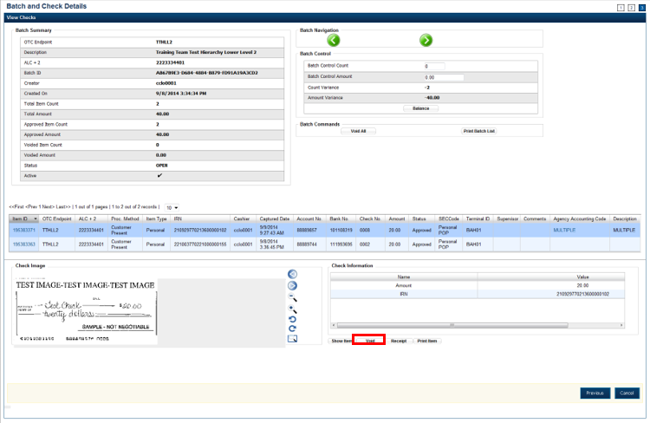

1. Click **Confirm** at the prompt.
2. Enter comments concerning the void request at the prompt. Click **OK**.
3. Click **OK** at the final prompt stating that the check is voided successfully.

Additional Buttons



* Click **Cancel** to return to the OTCnet Home Page. No data will be saved.
* Click **Previous** to return to the previous page.
* Click **Void All** to void all items in the batch.
* Click **Print Batch List** to print the batch list.
* Click **<** to go to the first batch.
* Click **>** to go to the next batch.
* Click **<<Image** to return to the previous check.
* Click **>>Image** to view the next check.
* Click **Zoom-** to reduce the image size.
* Click **Zoom+** to enlarge the image size.
* Click **Rotate Left** to turn the image to the left.
* Click **Rotate Right** to turn the image to the right.
* Click **Show Item** to view the check item details.
* Click **Void** to void a single check item.
* Click **Receipt** to print a receipt.
* Click **Print** **Item** to print a batch list report.

### Void All Checks in a Batch in OTCnet Offline

To void all checks in a batch, enter Batch Search Conditions including **OTC Endpoint**, **Created On Date**, **Batch ID**, **Cashier ID** and enter Batch Status.

Select the **Batch ID** hyperlink or **Item ID** of the check you would like to void. You will select **Void All** and enter comments concerning the void request in the *Comment Dialog Box*.

Void All Checks in a Batch in OTCnet Offline

To void all scanned checks in a batch, complete the following steps:

1. From the **Check Processing** tab, click **Batch Management**. The *Search Batch* page appears.
2. Select or enter the batch search conditions.

Application Tip



You can only void all checks at once in batches with an **Open** status.

Under **Batch Search Conditions**, optional

* + - Select the **OTC Endpoint** you want to void a check for by checking the box under the **Select** column

Under **Created On Date**, *optional*

* + - Enter the **From** and **To** date range

Application Tips



* The **From** and **To Created On Date** must be entered in MM/DD/YYYY format.
* The **Created On Date** range cannot exceed 30 days. Additionally, if more than a 1,000 batches are created within 30 days, then only the most recent 1,000 batches appear.
* If you run a search with the default **From** and To **Created On Date** range values, the search results include the most recent 30 days of batches that you have access to view. If more than 1,000 batches are created within the 30 days, then only the most recent 1,000 batches appear.
* If you run a search **without** specifying any criterion (with the exception of the **Batch ID** field), the search results include the most recent 30 days of batches that you have access to view. If more than 1,000 batches are created within 30 days, then only the most recent 1,000 batches appear.
  + - Enter the **Cashier ID**, *optional*

Under **Batch Status**,

* + - Select the **Status** you want to view by checking the **Open or Closed** box under the **Select** column

1. Click **Search**. The *View Batch* page appears.
2. Click the **Batch ID** hyperlink. The *View Checks* page appears.
3. Under Batch Commands, click **Void All** as shown in Figure 9.

Figure 9. View Checks (Voiding)

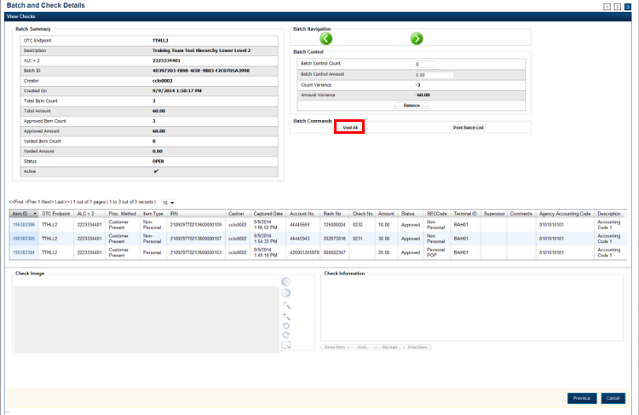

1. Click **Confirm** at the prompt asking if you want to void all checks.
2. Enter comments concerning the void, at the prompt, and click **OK**.
3. Click **OK** at the final prompt stating that the checks in the batches have been voided successfully.

Application Tip



After an entire batch of checks is voided, it is recommended that the batch be deactivated so that it is not accidently forwarded for settlement. Deactivated batches will still be archived to the Historical Database after 18 months as all batches and their associated check items are archived regardless of the batch status.

Additional Buttons



* Click **Cancel** to return to the OTCnet Home Page. No data will be saved.
* Click **Previous** to return to the previous page.
* Click **Void All** to void all items in the batch.
* Click **Print Batch** List to print the batch list.
* Click **<** to go to the first batch.
* Click **>** to go to the next batch.
* Click **<<Image** to return to the previous check.
* Click **>>Image** to view the next check.
* Click **Zoom-** to reduce the image size.
* Click **Zoom+** to enlarge the image size.
* Click **Rotate** **Left** to turn the image to the left.
* Click **Rotate** **Right** to turn the image to the right.
* Click **Show** **Item** to view the check item details.
* Click **Void** to void a single check item.
* Click **Receipt** to print a receipt.
* Click **Print** Item to print a batch list report.

## Topic 6 Local Verification Database (LVD) Record

When an Agency elects to use the LVD feature, the Agency receives three types of check verification notifications if a check is identified as blocked, suspended, or denied. The check verification notifications are Blocked, Suspended, or Denied.

The **CCS** is the only authorized user who can override (if the transaction can be overridden) a blocked, suspended, or denied notification. When an override of a blocked check is performed, the override is a temporary, one-time event. The check remains blocked in the LVD database unless an authorized person (Master Verification Database Editor [MVDE] or CCS) clears the item out of the LVD database.

For the LVD Verification override notification to appear the check item must meet established criteria for blocked, suspended, or denied.

**Blocked Check Notification**

A blocked notification displays if the check item matches all data as it was input on the blocked record. If the block record is only input with the routing transit number and account number, then that record is only flagged if the data matches. If the blocked record was input with only user defined field 1 data (e.g., Social Security Number or Driver’s License Number), then only the user defined field 1 must match for the record. If the blocked record input has both pieces of information, then it must match all combinations (e.g., routing transit and account along with user defined field 1).

**Suspended or D-Denied Check Notification**

The suspended or denied notification displays if the check item scanned matches the MVD information. A match occurs when a combination of both the routing number and account number matches, or there is a match against the user defined field 1.

Each OTC Endpoint that uses the LVD sets their policies to use certain return codes with a defined number of days within the suspension period. During that pre-determined period, if the check writer attempts to cash a check, a suspended notification appears on the OTCnet screen. A typical check cashing policy may mandate that the check writer is suspended for 30 days upon their first offense, 60 days upon their second offense, and 90 days upon their third offense. During the suspension period, they cannot cash a check at that OTC Endpoint. A denied item occurs when the check writer has exceeded all suspension periods. A typical suspension policy may specify that the check writer is suspended as referenced in the paragraph above.

The check cashing policies described above are only examples. Check cashing policies are set up according to each Agency’s requirements.

To override a LVD Record, you are presented with an *Override Check Denial* dialog box and you enter comments concerning the override request.

Override a LVD Record

To override a LVD Record, complete the following steps:

1. Click **Override** to override the blocked, suspended, or denied check as shown in Figure 10. An *Override Check Denial* dialog box appears.

Figure 10. Override Check Denial Box

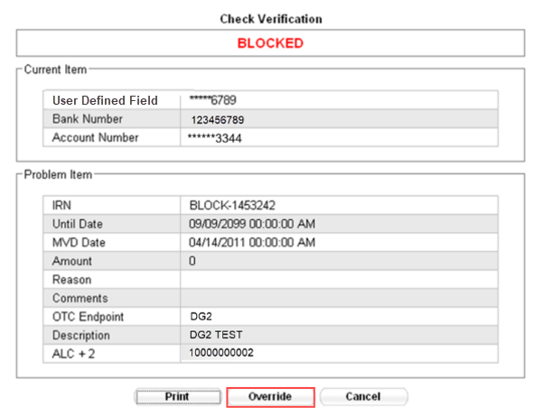

Application Tips



* When an override of a blocked check is performed in check capture, the override is a temporary, one-time event. The check remains blocked in the MVD database unless an authorized person clears the item out of the MVD database.
* Click **Cancel** to close the Check Verification window, and return the check to the customer. Click **Print** to print the Verification report as shown in Figure 11.

Figure . Verification Report

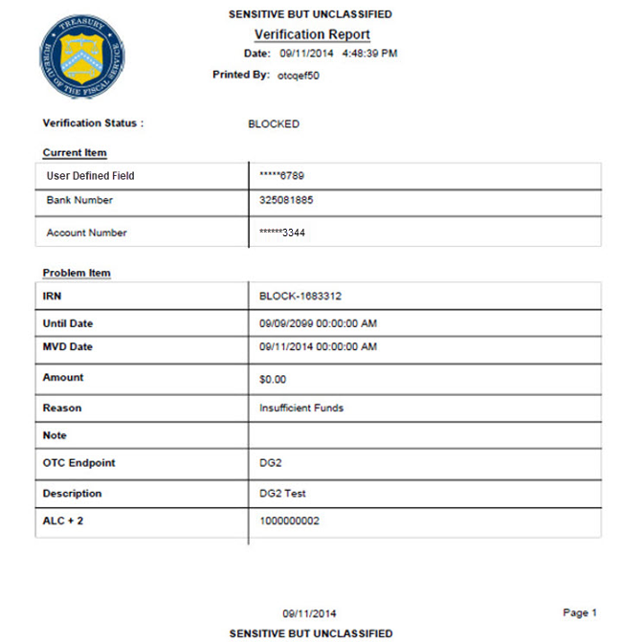

Application Tip



Click **Cancel** to close the Check Verification window. If Cancel is clicked, return the check to the customer.

1. Enter the **Login ID** and **Password** and click **Login**. A **Comment** dialog box appears.

Application Tip



A **Check Capture Supervisor (CCS)** must authorize the overriding of the blocked, suspended, or denied check.

1. Enter a reason why the check was approved for processing and click **OK**. A notification appears stating the override was successful.

## Topic 7 Perform Batch Control and Batch Balancing

A **CCA** can configure the terminal for **Batch Control** as *optional* or *mandatory* on batch create, batch close, or both are an optional feature that your Agency can use as a batch balancing tool.

**Batch Control** can be used to perform balancing on the number of checks that have been scanned and ensure their respective dollar amounts have been accurately keyed. The **Batch** **Control** options can be set up for each **OTC Endpoint** which an Agency processes. If it is used, the feature applies to both processing modes, i.e., Single and Batch.

The batch control screen displays the **OTC Endpoint** Information such as the **OTC Endpoint** short name, Description, and ALC+2 for the **OTC Endpoint**. Configuration settings for batch control are established in the **Terminal Configuration**.

If **Batch Control** is set at the Batch Create either optional or mandatory, then the **Batch** **control** screen will appear before scanning a batch of check and when a new batch is created. Depending on the terminal configuration settings, the batch control fields can appear at the beginning of a batch (prior to scanning the check), just prior to closing a batch, or both.

If **Batch Control** is set to *optional*, the **Defer** button appears on the page. If set to *mandatory for either Batch Create or Batch Close*, the **Defer** button does *not* appear on the page and the user cannot start scanning a batch or close the unbalanced batch. If set to mandatory for both Batch Create and Batch Close, then the Defer button will appear during Batch Create, but a user must enter the batch control value during the Batch Close action.

**Set to Appear on Batch Create**

If the batch control is set to appear on batch create, OTCnet prompts the **CCLO** or **CCO** to enter the batch control total amount and count *before* scanning a check. If the batch control is set to *optional* on batch create, the operators can choose to click the **Next** button to bypass this step.

**Set to Appear on Batch Close**

If the batch control is set to appear on batch close, OTCnet prompts the **CCO**, **CCLO** or **CCS** to enter the batch control total amount and count. Batch control balancing only occurs when closing an open batch. If the batch control is set to *optional* on batch close, the operators, and **CCS** can choose to click to **Defer** to skip this step.

### Batch Control Options

To use the batch control options on batch create, the *Check Scan Perform Check Scan* page appears. Perform check scanning as needed.

### On Batch Close (Optional/ Mandatory) in OTCnet Offline

To use the batch control options on batch close, verify batch (es) to close and confirm. You are presented with **Print PDF Report** or **Export** prior to selecting Confirm, which is recommended as a best practice selection to close the batch.

Perform Batch Control on Batch Create

To perform batch control on batch create, complete the following steps:

1. From the *Check Scan* page,

Under **Set Up New Batch**,

* + - Enter the Batch Control Count
    - Enter the Batch Control Amount

Application Tips



* If Batch Control is set to mandatory, the **Check Capture Lead Operator (CCLO)** or **Check Capture Operator (CCO)** must enter the batch control count and amount. The batch control count and amount cannot be zero.
* If Batch Control is set to optional, the **CCLO** or **CCO** can click the **Defer** button.

1. Click **Next**. Perform **Check** **Scan**. The *Check Scan-Perform Check Scan* page appears.
2. Scan check(s) as needed.

To perform batch control on batch close:

1. From the *Batch Control* page,

Under **Batch Detail**,

* + - Enter the Batch Control Count
    - Enter the Batch Control Amount

1. Click **Next**. The *Close Batch* page appears. Continue the batch close process.

Application Tips



* If Batch Control is set to optional, the **CCLO**, **CCO**, or **Check Capture Supervisor (CCS)** can choose to click to **Next** button without entering the batch control count and batch control amount.
* If the amount of a check item was incorrectly entered, click **Cancel** to return to the OTCnet Home Page. No data is saved.
* If you are a **CCLO** or **CCO** and discover that the amount of the check item was incorrectly entered, contact your **CCS**, and edit the check using the Show Item window.
* For offline, the user can close the batch without needing to print the PDF report or export the batch list report, regardless if the **Close Batch** and/or **Approve Batch** checkboxes are checked or unchecked. The **Confirm** button is enabled. The user click **Confirm** to close the batch. As a best practice, export or print the Batch List Report prior to clicking the **Confirm** button.

Perform Batch Control on Batch Close

To use the batch control options on batch close, complete the following steps:

1. From the *Batch Control* page

Under **Batch Detail**,

* Enter the **Batch Control Count**
* Enter the **Batch Control Amount**

1. Click **Next** as shown in Figure 12.

Figure 12. Batch Control Page (Batch Close)

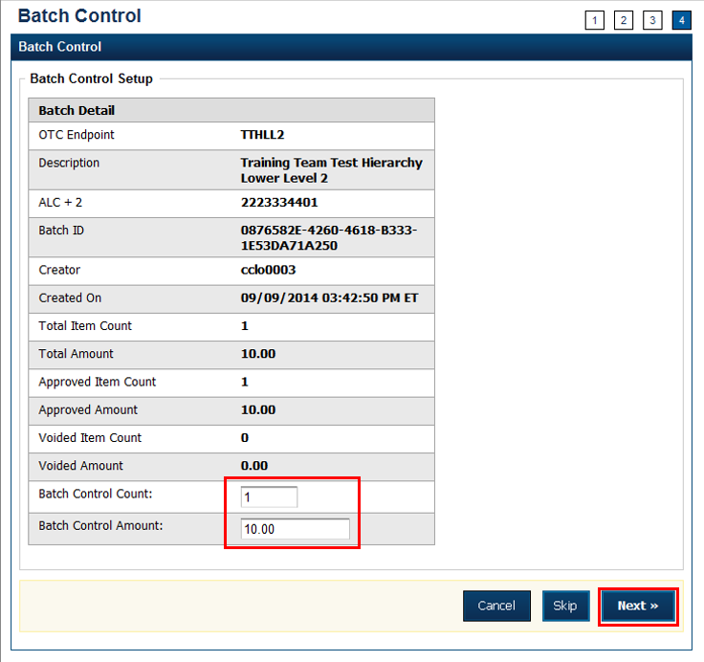

If **Batch Control** is set to optional, the **Check Capture Lead Operator (CCLO)**, **Check Capture Operator (CCO)**, or **Check Capture Supervisor (CCS)** can choose to click to **Next** button without entering the **Batch Control** count and amount.

If the amount of a check item was incorrectly entered, click **Cancel** to return to the OTCnet Home Page. No data is saved. If you are a **CCLO** or **CCO** and discover that the amount of the check item was incorrectly entered, contact your **CCS**, and edit the check using the *Show Item* window.

1. The *Close Batch* page appears. Verify the batch (es) to close and click **Confirm**. In OTCnet, a user can close one or multiple batches at a time.

The **Confirm** button is enabled. The batch is not closed until **Confirm** is clicked. As a best practice, click **Print PDF Report** or **Export** prior to clicking **Confirm** to close the batch as shown in Figure 13.

Figure 13. Print Batch List Report (Batch Close)

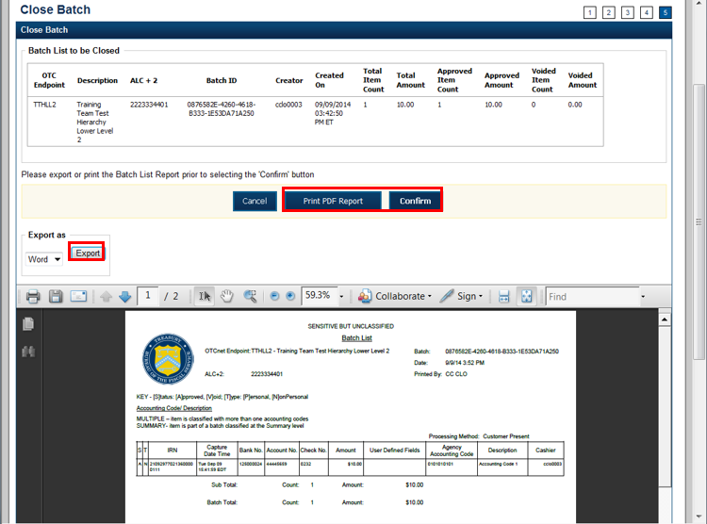

### Batch Balancing

If the totals that are keyed into the **Batch Control** screen do not match what was keyed into the data entry screen, a **Batch Balancing** screen appears on batch close. This screen only appears if there is a discrepancy between the totals. To reconcile the discrepancy, the operator must discover where the issue exists.

The **Batch Control** (balancing) screen displays the **Batch Detail**. Open fields include the Batch Control Count and Batch Control Amount. If these fields do not match those which you see to the right of the Approved Item Count and Approved Amount, then an error will display; *Failed to balance Batch (batch number), please check batch control* as shown in Figure 14.

If batch control is set to *Mandatory* and the batch is not balanced at this point (Batch Control Count and Batch Control Amount), a user may not proceed with closing a batch. However, if **Batch Control** is set to *Optional*, a user may click **Next** below, to continue closing the batch.

Figure 14. Batch Control (Failed to Balance)

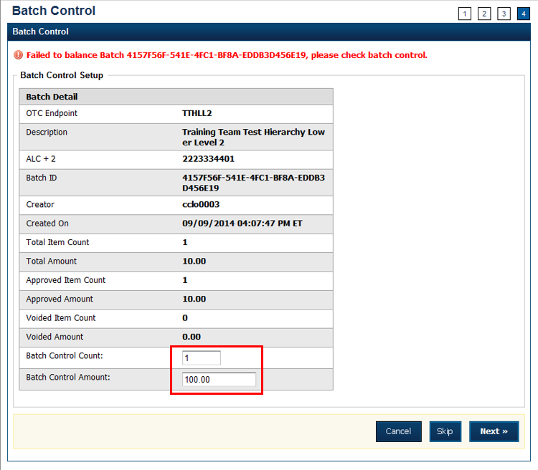

Some important **Batch Detail** descriptions are below:

* + **Total Item Count**: The number of checks that have been scanned in OTCnet.
  + **Batch Control Count**: The number of checks keyed into the **Batch Control** screen by the operator.
  + **Total Amount**: The total dollar amount of the items as keyed into the Agency form data fields when scanning checks.
  + **Batch Control Total**: The total dollar amount of the checks keyed into the Batch Control screen by the operator.

It must be determined if there is an erroneously scanned item, or if the batch should contain both of the items. The operator needs to go back to the source documents for an answer. If it is determined that the batch should contain both items, the operator would change the number in the **Batch Control Count** field and/or the dollar amount in the **Batch Control Total**.

If it has been determined that the batch does include an erroneously scanned item, follow these steps:

* + Click on the erroneous amount.
  + Click **Void**. A **CCS** must log in at the prompt, if **Void** is clicked.
  + Enter comments concerning the Void request.
  + Click **OK** to confirm the void request.
  + The *Confirmation* message appears.

## Topic 8 View and Print a Batch List/ Item Detail Report

As a **CCS**, **CCLO**, and **CCO**, you are authorized to view and print a **Batch List** report and an **Item Detail** report. An operator can print a **Batch List** for any deposits with any deposit status (i.e. Open, Closes, Approved, Forward). A **Batch List** consists of all transactions that have been processed by OTCnet. A user can view batch lists based on the search criteria applied.

Additional information for a Batch List Report includes the following:

* The printing of a **Batch List** is part of the batch close procedure. During batch close, the system prompts to verify that the user acknowledges the printout of the **Batch List**.
* The **Print** **PDF Report** button defaults to print in PDF format; however, a user may also opt to download and save the report in an alternate format such as Word, HTML, Excel, etc.
* From the *Close Batch* page, a user can perform several actions on the same screen (such as Activate/Deactivate, Close and Approve Batches), based on their permissions.
* To view a Batch List Report, enter Batch Search Conditions including **OTC Endpoint**, **Created On Date**, **Batch ID**, **Cashier ID**. Enter Batch Status as **Open** or **Closed**.
* Select the Batch ID hyperlink and select **Print Batch List** and export, download or print the report.

Additional information for an Item Detail Report includes the following:

* To view an item detail report, enter **Batch Search Conditions,** including **OTC Endpoint**, **Created On Date**, **Batch ID**, **Cashier ID**. Enter **Batch Status** and select the **Batch ID** hyperlink.

Item Detail Report

To run an item detail report, complete the following steps:

1. Click the **Check Processing** tab and click **Batch Management**.
2. The *Search Batch* page appears. Select or enter the batch search conditions you would like view then click **Search**.

Application Tips



* If you run a search with the default **From** and To **Created On Date** range values, the search results include the most recent 30 days of batches that you have access to view. If more than 1,000 batches are created within the 30 days, then only the most recent 1,000 batches appear.
* If you run a search **without** specifying any criterion (with the exception of the **Batch ID** field), the search results include the most recent 30 days of batches that you have access to view. If more than 1,000 batches are created within 30 days, then only the most recent 1,000 batches appear.

Under **Batch Search Conditions**, *optional*

* + - Select the **OTC Endpoint** you want to **Edit** a batch for by checking the under the **Select** column

Under **Created On Date**, *optional*

* + Enter the **Created On Date** by entering the **From** and **To** date range

Application Tip



The **Created On Date** range cannot exceed 30 days. Additionally, if more than a 1,000 batches are created within 30 days, then only the most recent 1,000 batches appear.

* + Enter the **Batch ID**, *optional*

Application Tip



If the only search criteria entered is a valid **Batch ID**, then only a single result appears regardless of other search criteria specified.

* + Enter the **Cashier ID**

Under **Batch Status**, *optional*

* + Select the **Status** you want to view by checking the **Open** or **Closed** box under the **Select** column, then click **Search**

1. The View Batches page appears. Click the Batch ID hyperlink.
2. The *Batch and Item Details* page appears. Click the **Item ID** of each scanned check, then click **Print Item** for the specific check item you want to print. If a batch is in use and another user attempts to access the same batch, a Batch Lock message appears stating the batch is in use and he/she cannot access the batch.
3. The Item Detail Report appears as shown in Figure 15.

Figure 15. Item Detail Report

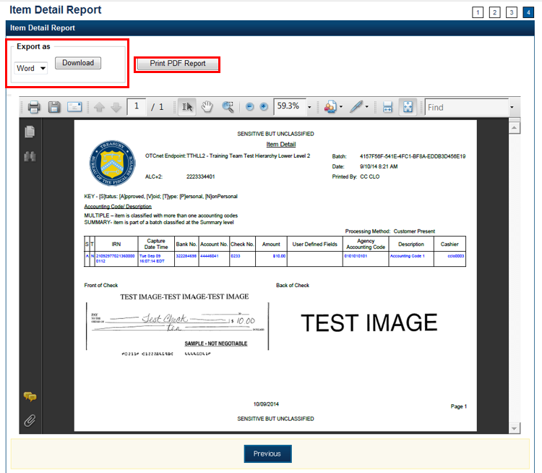

Under **Export as**,

* + Select **Word**, **Excel**, **RTF**, or **PDF**
  + Click **Download**

Or

* + Click **Print PDF Report**

View and Print a Batch List Report

To view and print a Batch List report, complete the following steps:

1. From the **Check Processing** tab, click **Batch Management**. The *Search Batch* page appears.
2. Select or enter the batch search conditions you would like to view.

Under **Batch Search Conditions**, *optional*

* + - Select the **OTC Endpoint** you want to **Edit** a batch for by checking the under the **Select** column

Under **Created On Date**, *optional*

* + - Enter the **From** and **To** date range

Application Tips



* The **From** and **To Created On Date** must be entered in MM/DD/YYYY format.
* The **Created On Date** range cannot exceed 30 days. Additionally, if more than a 1,000 batches are created within 30 days, then only the most recent 1,000 batches appear.
* If you run a search with the default **From** and To **Created On Date** range values, the search results include the most recent 30 days of batches that you have access to view. If more than 1,000 batches are created within the 30 days, then only the most recent 1,000 batches appear.
* If you run a search **without** specifying any criterion (with the exception of the **Batch ID** field), the search results include the most recent 30 days of batches that you have access to view. If more than 1,000 batches are created within 30 days, then only the most recent 1,000 batches appear.
  + - Enter the **Batch ID**, *optional*

Application Tip



If the only search criteria entered is a valid Batch ID, then only a single result appears regardless of other search criteria specified.

* + - Enter the **Cashier ID**, *optional*

Under **Batch Status**, *optional*

* + - Select the **Status** you want to view by checking the **Open** or **Closed** box under the **Select** column

1. Click **Search**. The *View Batches* page appears.
2. Click the **Batch ID** hyperlink. The *Batch and Check Details* page appears.
3. Click **Print Batch List**. The *Batch List Report* page appears as shown in Figure 16.

Under **Export as**,

* + - * Select **Word**, **Excel**, **RTF**, or **PDF**
      * Click **Download**

Or

* + - * Click **Print PDF Report**.

Figure 16. Batch List Report Page

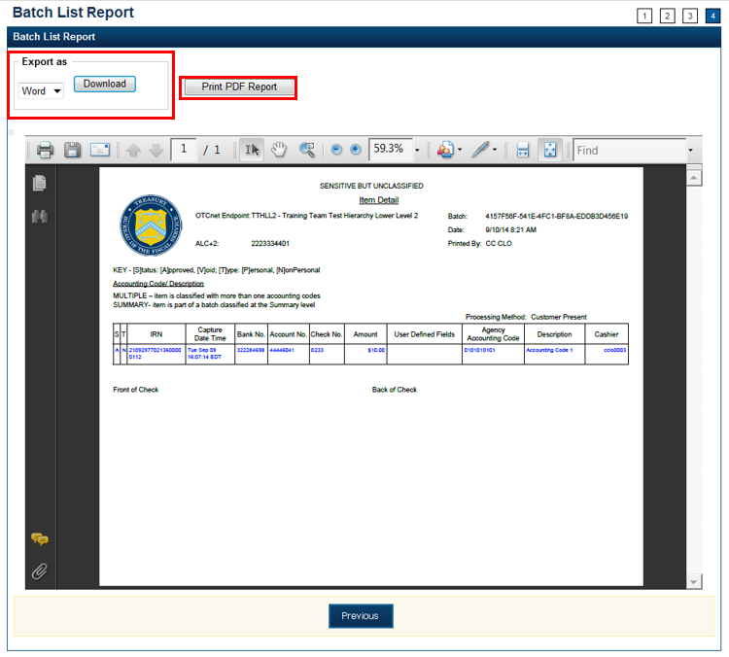

Additional Buttons



* Click **Previous** to return to the previous page.
* Click **Cancel** to cancel the transaction. No data will be saved.

View and Print an Item Detail Report

To view and print an Item Detail report, complete the following steps:

1. From the **Check Processing** tab, click **Batch Management**. The *Search Batch* page appears.
2. Select or enter the batch search conditions you would like to view.

Under **Batch Search Conditions**, optional

* + - Select the **OTC Endpoint** you want to **Edit** a batch for by checking the under the **Select** column

Under **Created On Date**, *optional*

* + - Enter the **From** and **To** date range

Application Tips



* The **From** and **To Created On Date** must be entered in MM/DD/YYYY format.
* The **Created On Date** range cannot exceed 30 days. Additionally, if more than a 1,000 batches are created within 30 days, then only the most recent 1,000 batches appear.
* If you run a search with the default **From** and To **Created On Date** range values, the search results include the most recent 30 days of batches that you have access to view. If more than 1,000 batches are created within the 30 days, then only the most recent 1,000 batches appear.
* If you run a search **without** specifying any criterion (with the exception of the **Batch ID** field), the search results include the most recent 30 days of batches that you have access to view. If more than 1,000 batches are created within 30 days, then only the most recent 1,000 batches appear.
  + - Enter the **Batch ID**, *optional*

Application Tip



If the only search criteria entered is a valid Batch ID, then only a single result appears regardless of other search criteria specified.

* + - Enter the **Cashier ID**, *optional*

Under **Batch Status**, *optional*

* + - Select the **Status** you want to view by checking the **Open** or **Closed** box under the **Select** column

1. Click **Search**. The *View Batches* page appears.
2. Click the **Batch ID** hyperlink. The *Batch and Item Details* page appears.
3. Click the **Item ID** of each scanned check. An image of the check and details of the check appear in the window.
4. Click **Print Item**. The *Item Detail Report* appears.
5. Under Export as,
   * + - Select **Word**, **Excel**, **RTF**, or **PDF**
       - Click **Download**

Or

* + - * Click Print PDF Report

Additional Buttons



* Click **Previous** to return to the previous page.
* Click **Cancel** to cancel the transaction. No data will be saved.

## Topic 9 Activate/Deactivate a Batch

A **CCS** is authorized to deactivate a batch if there is an issue with an item within the batch and further research is needed. Deactivating a batch prevents it from being closed or approved for settlement. A deactivated batch must be activated before it can be closed or approved for settlement.

The deactivated batch is retained for as long as the configuration settings allow. The default setting is 14 days, though the **Check Capture Administrator** can configure the default setting to accommodate the agency’s business process. Only batches that are in an open or closed state can be deactivated or activated. A batch currently in use cannot be deactivated.

To activate or deactivate a batch, enter **Batch Search Conditions** including **OTC Endpoint**, **Created On Date**, **Batch ID**, **Cashier ID** and enter **Batch Status**.

Activate/Deactivate a Batch

To activate/deactivate a batch, complete the following steps:

1. From the **Check Processing** tab, click **Batch Management**. The *Search Batch* page appears.

Application Tips



* Before you activate/deactivate batches offline, you must first access the **OTCnet Offline** icon on your terminal’s desktop and enter your User ID and password. Once you have successfully logged on, search for the batch.
* To determine if your terminal is connected to the online OTCnet server, refer to the Connection Status indicator located on the top-right of the page. If the Connection Status is green, the terminal is connected to the online OTCnet server. If the Connection Status indicator is red, the terminal is not connected to the online OTCnet server.

1. Select or enter the batch search conditions you would like to view.

Under **Batch Search Conditions**, *optional*

* Select the **OTC Endpoint** you want to activate/deactivate a batch for by checking the box under the **Select** column

Application Tip



Only batches with an **Open** or **Closed** status can be activated/deactivated. Additionally, batches currently in use cannot be deactivated.

Under **Created On Date**, *optional*

* + - Enter the **From** and **To** date range

Application Tips



* The **From** and **To Created On Date** must be entered in MM/DD/YYYY format.
* The **Created On Date** range cannot exceed 30 days. Additionally, if more than a 1,000 batches are created within 30 days, then only the most recent 1,000 batches appear.
* If you run a search with the default **From** and To **Created On Date** range values, the search results include the most recent 30 days of batches that you have access to view. If more than 1,000 batches are created within the 30 days, then only the most recent 1,000 batches appear.
* If you run a search **without** specifying any criterion (with the exception of the **Batch ID** field), the search results include the most recent 30 days of batches that you have access to view. If more than 1,000 batches are created within 30 days, then only the most recent 1,000 batches appear.
  + - Enter the **Batch ID**, *optional*

Application Tip



If the only search criteria entered is a valid **Batch ID**, then only a single result appears regardless of other search criteria specified.

* + - Enter the **Cashier ID**, *optional*

Under **Batch Status**, *optional*

* + - Select the **Status** you want to activate/deactivate by checking the **Open** or **Closed** box under the **Select** column

Application Tip



Only batches with an **Open** or **Closed** status can be activated/deactivated.

1. Click **Search**. The *Summary of Batches* page appears.
2. Check the checkbox of the **Batch ID** to activate or deactivate and click **Activate**/**Deactivate**. The *Activate/Deactivate Batch* page appears as shown in Figure 17.

Figure 17. View Batches Page (Activate/Deactivate)

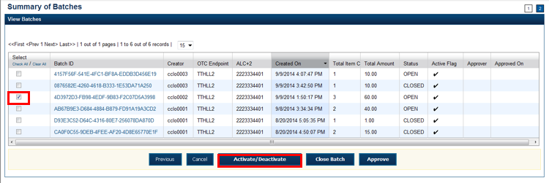

Application Tip



When a batch is activated or deactivated a check appears under the **Active Flag** column. When a batch is deactivated, the **Active Flag** column is blank.

1. Click **Confirm**. A message appears stating the batch(es) have been activated/deactivated and the value under **Active Status** updates to Active/Inactive.

Additional Buttons



* Click **Return to Batch Summary** to return to the batch summary page.
* Click **Return Home** to return to the OTCnet homepage.

## Topic 10 Classify a Batch

Before a batch can be classified, an OTC Endpoint must be designated as being able to classify a batch at the summary level with at least one accounting code or C-key. Additionally, if an OTC Endpoint is designated as a CARS reporter, all batches (at the summary level) or items within a batch (at the item level) must be classified with at least one accounting code or C-key.

To classify a batch at the summary level, the **CCLO** or **CCO** first uses the Check Scan function, scans the check(s), enters the amount and any user defined field details, and saves the transaction. After the batch is saved, a **CCS**, **CCLO**, or **CCO** accesses Batch Management, clicks View/Edit Classification and classifies the batch with an accounting code or C-key. Depending on your user privileges and batch status, you will see either a View/Edit Classification or a View Classification button.

The summary level (batch) classification process is independent of the batch close process. Therefore, a batch can be classified prior to closing a batch or after the batch is closed. Additionally, a CCS can classify a batch during Approve Batch.

### Summary Level Classification

To classify or edit a batch at the summary level, select **Batch Search Conditions** including **OTC Endpoint**, **Created On Date**, **Batch ID**, **Cashier ID** and enter **Batch Status** as **Open** or **Closed**.

Select the **Batch ID** hyperlink, **View/Edit Classification** andselect an **Agency Accounting Code** and **Amount.**

Summary Level Classification

To classify or edit a batch at the summary level, complete the following steps:

1. From the **Check Processing** tab, click **Batch Management**. The *Search Batch* page appears.
2. Select or enter the batch search conditions.

Under **Batch Search Conditions**, *optional*

* Select the **OTC Endpoint** you want to classify or edit a batch for by checking the box under the **Select** column

Under **Created On Date**, *optional*

* + Enter the **From** and **To** date range

Application Tips



* The **From** and **To Created On Date** must be entered in MM/DD/YYYY format.
* The **Created On Date** range cannot exceed 30 days. Additionally, if more than a 1,000 batches are created within 30 days, then only the most recent 1,000 batches appear.
* If you run a search with the default **From** and To **Created On Date** range values, the search results include the most recent 30 days of batches that you have access to view. If more than 1,000 batches are created within the 30 days, then only the most recent 1,000 batches appear.
* If you run a search **without** specifying any criterion (with the exception of the **Batch ID** field), the search results include the most recent 30 days of batches that you have access to view. If more than 1,000 batches are created within 30 days, then only the most recent 1,000 batches appear.
  + - Enter the **Batch ID**, *optional*

Application Tip



If the only search criteria entered is a valid Batch ID, then only a single result appears regardless of other search criteria specified.

* + - Enter the **Cashier ID**, *optional*

Under **Batch Status**, *optional*

* + - Select the **Status** you want to view by checking the **Open** or **Closed** box under the **Select** column

Application Tip



Batches in **Open** or **Closed** status can be classified or edited at the summary level.

1. Click **Search**. The View Batches **page appears**.
2. Click the **Batch ID** hyperlink. The View Checks **page appears**.
3. Click **View/Edit Classification** as shown in Figure 18.The *Account Classification* **dialog box appears**.

Figure 18. View Checks – View/Edit Classification

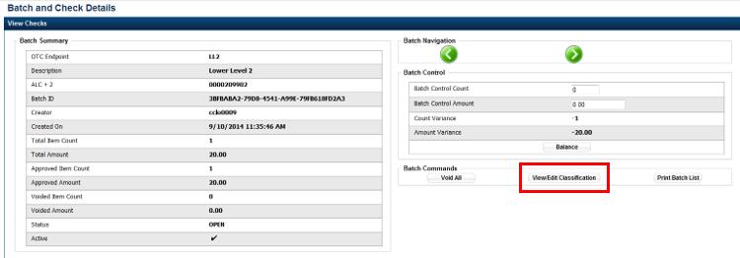

Application Tip



Depending on your user role and batch status, you will either see **View/Edit Classification** or **View Classification**. **View/Edit Classification** indicates that the user has view and edit permission. **View Classification** indicates the user has view classification permission and is not permitted to edit or delete a classification.

1. Click **Edit**. The *Account Classification* dialog box refreshes.
2. Enter or update the necessary account classification data.
   * + Select an **Agency Accounting Code**

Application Tips



* If an OTC Endpoint is associated with an Agency Location Code (ALC) that is designated as a Central Accounting Reporting System (CARS) Reporter, all check transactions must be classified with an accounting code. If an ALC is not a CARS Reporter, classifying it with an accounting code is optional.
* The **Agency Accounting Codes** drop-down list displays the full **Agency Accounting Code** value (up to 50 alphanumeric characters) and some portion of the **Description** (up to 15 alphanumeric characters).
  + - Enter the **Amount** and click **Add** for each subtotal of the batch

Application Tips



* The classified total and batch total can remain unbalanced until the batch is approved. However, the **Variance** must equal $0.00 before a batch can be approved. If it does not, you must go back and re-validate your subtotal entries.
* To delete or remove an accounting code, check the **Remove** check box next to the accounting code you want to delete and click **Update**.
  + - Click **Save**

Additional Buttons



* Click **Cancel** to return to the OTCnet Home Page. No data will be saved.
* Click **Previous** to return to the previous page.
* Click **Void All** to void all items in the batch.
* Click **Print Batch List** to print the batch list.
* Click **<** to go to the first batch.
* Click **>** to go to the next batch.
* Click **<<Image** to return to the previous check.
* Click **>>Image** to view the next check.
* Click **Zoom-** to reduce the image size.
* Click **Zoom+** to enlarge the image size.
* Click **Rotate Left** to turn the image to the left.
* Click **Rotate Right** to turn the image to the right.
* Click **Show Item** to view the check item and perform update.
* Click **Void** to void a single check item.
* Click **Receipt** to print a receipt.
* Click **Print Item** to print an Item List report.
* Click **-Front** to return to the previous check.
* Click **Back+** to view the next check.
* Click **-Zoom** to reduce the image size.
* Click **Zoom+** to enlarge the image size.
* Click **Rotate Left+** to turn the image to the left.
* Click **Rotate Right+** to turn the image to the right.

## Topic 11 Close a Batch

As the **CCS**, **CCO** or **CCLO**, you are the only authorized users who can close a batch or multiple batches. You can only close batches for **OTC Endpoints** you have permission to access.

Before closing a batch or multiple batches, you must first search for the batch. Search for batches by **OTC Endpoint**, **Created On Date**, **Batch ID**, **Cashier ID**, and/or **Batch** **Status**. If you run a search without specifying any criteria, the search results can include all batches in the system that you have access to view. There are seven batch status types, see Table 4 for details below.

Table 4. Batch Status Types

|  |  |
| --- | --- |
| Open | Indicates the batch is open. Continue scanning checks to it |
| Closed | Indicates the batch is closed and no new checks are accepted |
| Approved | Indicates the batch is ready for upload and settlement |
| Sent | Indicates the batch was uploaded online without error |
| Acknowledged | Indicates the batch was transmitted and fully processed by OTCnet server without error |
| Send Error | Indicates the batch upload experienced system errors and the batch was not successfully uploaded, or a user selected to cancel the batch upload and the system halted the upload |
| Acknowledged Error | Indicates the acknowledge batch process experienced system errors and the acknowledgment was unsuccessful, or a user selected to cancel the batch acknowledgment which resulted in a batch being updated to Acknowledgment Error. Batches that are in Acknowledged Error state have the ability to be re-uploaded |

All batches with a Received Date older than 18 months, including batches with an **Open** or **Closed** status, are saved in the Historical database and cannot be changed. Therefore, it is important that you close and approve all batches in a timely manner.

If a batch, already successfully sent and processed (but not yet acknowledged), is selected to be acknowledged, and connectivity is lost, the batch will be given an “ACK ERROR” status. A batch will **ACK ERROR** is eligible for re-upload. However, the batch is re-uploaded and is already successfully processed in Online, the batch will appear as a Duplicate in Transmission history, and the scenario must be handled by Customer Service.

### Close a Single Batch

To close a single batch, select **Batch Search Conditions** including **OTC Endpoint**, **Created On Date**, **Batch ID**, **Cashier ID**, enter **Batch Status,** select the **Batch ID** hyperlink and the **Item ID** of each scanned check and enter the **Batch Control Count** and **Batch Control Amount**.

**Close a Single Batch**

To close a single batch in OTCnet Offline, complete the following steps:

1. From the **Check Processing** tab, click **Batch Management**. The *Search Batch* page appears.

Application Tips



* Before closing a batch or multiple batches offline, you must first access the **OTCnet Offline** icon on your terminal’s desktop and enter your User ID and password. After you have successfully logged on, search for the batch.
* To determine if your terminal is connected to the online OTCnet server, refer to the Connection Status indicator located on the top-right of the page. If the Connection Status is green, the terminal is connected to the online OTCnet server. If the Connection Status indicator is red, the terminal is not connected to the online OTCnet server.

1. Select or enter the batch search conditions.

Under **Batch Search Conditions**, *optional*

* Select the **OTC Endpoint** you want to **Close** a batch for by checking the box under the **Select** column

Under **Created On Date**, *optional*

* + Enter the **From** and **To** date range

Application Tips



* The **From** and **To Created On Date** must be entered in MM/DD/YYYY format.
* The **Created On Date** range cannot exceed 30 days. Additionally, if more than a 1,000 batches are created within 30 days, then only the most recent 1,000 batches appear.
* If you run a search with the default **From** and To **Created On Date** range values, the search results include the most recent 30 days of batches that you have access to view. If more than 1,000 batches are created within the 30 days, then only the most recent 1,000 batches appear.
* If you run a search **without** specifying any criterion (with the exception of the **Batch ID** field), the search results include the most recent 30 days of batches that you have access to view. If more than 1,000 batches are created within 30 days, then only the most recent 1,000 batches appear.
  + - Enter the **Batch ID**, *optional*

Application Tip



If the only search criteria entered is a valid Batch ID, then only a single result appears regardless of other search criteria specified.

* + - Enter the **Cashier ID**, *optional*

Under **Batch Status**, *optional*

* + - Select the **Status** you want to **Close** by checking the **Open** or **Closed** box under the **Select** column

Application Tip



Batches in Open or Closed status can be classified or edited at the summary level.

1. Click **Search**. The View Batches page appears as shown in Figure 19.

Figure 19. Check Scan- Select Batch Page

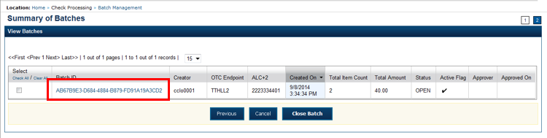

1. Click the **Batch ID** hyperlink. The *View Checks* page appears.
2. Click the **Item ID** of each scanned check. An image of the check and details of the check appear in the window.
3. Verify the details are correct and click **Previous** to return to the *View Batches* page.
4. Select the batch you want to close by checking the box to the left of the **Batch** **ID**.
5. Click **Close Batch** as shown in Figure 20. The *Close Batch* page appears.

Figure 20. Select to Close Batch

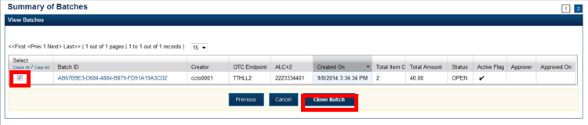

1. Verify that you want to close the batch and click **Confirm**. The *Batch Control* page appears with the batch details.
2. Enter the **Batch Control** **Count** and **Batch Control Amount**, if your terminal is configured for this action on batch close.
3. Click **Next**. The *Close Batch* page appears.
4. Click **Confirm** to close the batch.

Application Tips



* The **Confirm** button is enabled. As a best practice, export or print the Batch List Report prior to clicking the **Confirm** button.
* For offline, the user can close the batch without needing to print the PDF report or export the batch list report, regardless if the **Close Batch** and/or **Approve Batch** checkboxes are checked or unchecked. The **Confirm** button is enabled.
* If the user is closing and/or approving multiple batches offline, **Confirm** is enabled and the user can close and/or approve multiple batches without needing to print the PDF reports or export the batch list reports. As a best practice, print the PDF reports or export the batch lists prior to closing and approving multiple batches

1. A *Close Batch* page appears verifying the batch has been closed.
2. Click **Return to Batch Summary**. The *View Batches* page appears.
3. Click **Return Home** to return to the OTCnet Homepage.

Application Tip



If a **Check Capture Lead Operator (CCLO)** or **Check Capture Operator (CCO)** closes a batch, the batch status changes from **Open** to **Closed**. If a **Check Capture Supervisor (CCS)** closes a batch, the batch status changes from **Open** to **Approved**. If **Skip** is clicked, the **Status** remains **Open** and the batch is not closed.

### Close Multiple Batches

To close multiple batches, enter **Batch Search Conditions** including **OTC Endpoint**, **Created On Date**, **Batch ID**, **Cashier ID**, enter **Batch Status,** select the **Batch ID** hyperlink and **Item ID** of each scanned check. You will select the batches you want to close and enter **Batch Control Count** and **Batch Control Amount**.

Close Multiple Batches

To close multiple batches in OTCnet Offline, complete the following steps:

1. From the **Check Processing** tab, click **Batch Management**. The *Search Batch* page appears.

Application Tips



* Before closing a batch or multiple batches offline, you must first access the **OTCnet Offline** icon on your terminal’s desktop and enter your User ID and password. After you have successfully logged on, search for the batch.
* To determine if your terminal is connected to the online OTCnet server, refer to the Connection Status indicator located on the top-right of the page. If the Connection Status is green, the terminal is connected to the online OTCnet server. If the Connection Status indicator is red, the terminal is not connected to the online OTCnet server.

1. Select or enter the batch search conditions you would like to view.

Under **Batch Search Conditions**,

* Select the **OTC Endpoint** you want to **Close** a batch for by checking the **Open** boxes under the **Select** column

Under **Created On Date**, *optional*

* + Enter the **From** and **To** date range

Application Tips



* The **From** and **To Created On Date** must be entered in MM/DD/YYYY format.
* The **Created On Date** range cannot exceed 30 days. Additionally, if more than a 1,000 batches are created within 30 days, then only the most recent 1,000 batches appear.
* If you run a search with the default **From** and To **Created On Date** range values, the search results include the most recent 30 days of batches that you have access to view. If more than 1,000 batches are created within the 30 days, then only the most recent 1,000 batches appear.
* If you run a search **without** specifying any criterion (with the exception of the **Batch ID** field), the search results include the most recent 30 days of batches that you have access to view. If more than 1,000 batches are created within 30 days, then only the most recent 1,000 batches appear.
  + - Enter the **Batch ID**, *optional*

Application Tip



If the only search criteria entered is a valid **Batch ID**, then only a single result appears regardless of other search criteria specified.

* + - Enter the **Cashier ID**, *optional*

Under **Batch Status**, *optional*

* + - Select the **Status** you want to close by checking the **Open** or **Closed** box under the **Select** column

Application Tip



Batches in **Open** or **Closed** status can be classified or edited at the summary level.

1. Click **Search**. The View Batches **page appears**.
2. Click the **Batch ID** hyperlink. The *View Checks* page appears.
3. Click the **Item ID** of each scanned check. An image of the check and details of the check appear in the window.
4. Click **Previous** to return to the *View Batches* page.
5. Select the batches you want to close by checking the boxes to the left of the **Batch** **IDs**.
6. Click **Close Batch**. The *Close Batch* page appears.
7. Verify that you want to close the batches and click **Confirm**. The *Batch Control* page appears.
8. Enter the **Batch Control** **Count** and **Batch Control Amount**, if your terminal is configured for this action on Batch Close.
9. Click **Next**. The *Close Batch* page appears.
10. Click **Confirm** to close the batches.

Application Tips



* The **Confirm** button is enabled. As a best practice, export or print the Batch List Report prior to clicking the **Confirm** button.
* For offline, the user can close the batch without needing to print the PDF report or export the batch list report, regardless if the **Close Batch** and/or **Approve Batch** checkboxes are checked or unchecked. The **Confirm** button is enabled.
* If the user is closing and/or approving multiple batches offline, **Confirm** is enabled and the user can close and/or approve multiple batches without needing to print the PDF reports or export the batch list reports. As a best practice, print the PDF reports or export the batch lists prior to closing and approving multiple batches
* The system generates one report for all selected batches.

1. A *Close Batch* page appears verifying the batches have been closed.
2. Click **Return to Batch Summary**. The *View Batches* page appears.
3. Click **Return Home** to return to the OTCnet Homepage.

Application Tip



If a **Check Capture Lead Operator (CCLO)** or **Check Capture Operator (CCO)** closes a batch, the batch status changes from **Open** to **Closed**. If a **Check Capture Supervisor (CCS)** closes a batch, the batch status changes from **Open** to **Approved**. If **Skip** is clicked, the **Status** remains **Open** and the batch is not closed.

## Topic 12 Approve a Batch

As a **CCS**, you are the only authorized user who, by default, can approve a batch or multiple batches. A **CCO** or **CCLO** may also approve a batch if granted the Batch Approver permission. You can only approve batches for **OTC Endpoints** that you have permission to access. Approving a batch(es) indicates that the batch and check details are correct and that the batch(es) is/are ready for upload.

Before approving a batch or multiple batches, you must first search for the batch. Search for batches by **OTC Endpoint**, **Created On Date**, **Batch ID**, **Cashier ID**, and/or **Batch Status**. If you run a search without specifying any criteria, the search results include all batches in the system that you have access to view.

Additionally, a batch is only eligible for approval when the batch has a **Closed** status. After a batch is **Approved** it then is considered in **Sent** status.

### Approve a Single Batch

To approve a single batch, enter **Batch Search Conditions** including **OTC Endpoint**, **Created On Date**, **Batch ID**, **Cashier ID**, enter **Batch Status**

Select the **Batch ID** hyperlink and the **Item ID** of each scanned check. You will select the batch you want to approve and print or export it. **Print PDF Report** or **Export** prior to selecting Confirm, which is recommended as a best practice selection to approve the batch. The Status will change from **Closed** to **Approved**.

Approve a Single Batch

To approve a batch, complete the following steps:

1. From the **Check Processing** tab, click **Batch Management**. The *Search Batch* page appears.

Application Tips



* Before approving a batch or multiple batches in offline mode, you must first access the **OTCnet Offline** icon on your terminal’s desktop and enter your User ID and password. After you have successfully logged on, search for the batch.
* To determine if your terminal is connected to the online OTCnet server, refer to the Connection Status indicator located on the top-right of the page. If the Connection Status is green, the terminal is connected to the online OTCnet server. If the Connection Status indicator is red, the terminal is not connected to the online OTCnet server.

1. Select or enter the batch search conditions you would like to view.

Under **Batch Search Conditions**,

* Select the **OTC Endpoint** you want to **Approve** by checking the checkbox under the **Select** column

Under **Created On Date**, *optional*

* + Enter the **From** and **To** date range

Application Tips



* The **From** and **To Created On Date** must be entered in MM/DD/YYYY format.
* The **Created On Date** range cannot exceed 30 days. Additionally, if more than a 1,000 batches are created within 30 days, then only the most recent 1,000 batches appear.
* If you run a search with the default **From** and To **Created On Date** range values, the search results include the most recent 30 days of batches that you have access to view. If more than 1,000 batches are created within the 30 days, then only the most recent 1,000 batches appear.
* If you run a search **without** specifying any criterion (with the exception of the **Batch ID** field), the search results include the most recent 30 days of batches that you have access to view. If more than 1,000 batches are created within 30 days, then only the most recent 1,000 batches appear.
  + - Enter the **Batch ID**, *optional*

Application Tip



If the only search criteria entered is a valid **Batch ID**, then only a single result appears regardless of other search criteria specified.

* + - Enter the **Cashier ID**, *optional*

Under **Batch Status**, *optional*

* + - Select the **Status** you want to approve by checking the **Closed** box under the **Select** column

1. Click **Search**. The *View Batches* page appears as shown in Figure 21.

Figure 21. View Batches Page (Approve Single)

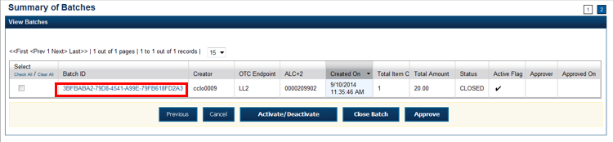

1. Click the **Batch ID** hyperlink. The *View Checks* page appears.
2. Click the **Item ID** of each scanned check. An image of the check and details of the check appear in the window.
3. Verify the details are correct and click **Previous** to return to the *View Batch* page.
4. Select the batch you want to approve by checking the box to the left of the **Batch ID**.
5. Click **Approve**. The *Approve Batch* page appears.
6. Verify that you want to approve the batch and click **Confirm**. The *Approve Batch* page appears with the batch details.
7. Click **Confirm** to approve the batch.

Application Tips



* The **Confirm** button is enabled. As a best practice, export or print the Batch List Report prior to clicking the **Confirm** button.
* For offline, the user can approve the batch without needing to print the PDF report or export the batch list report, regardless if the **Close Batch** and/or **Approve Batch** checkboxes are checked or unchecked. The **Confirm** button is enabled.
* If the user is closing and/or approving multiple batches offline, **Confirm** is enabled and the user can close and/or approve multiple batches without needing to print the PDF reports or export the batch list reports. As a best practice, print the PDF reports or export the batch lists prior to closing and approving multiple batches

1. An *Approve Batch* page appears verifying the batch has been approved.
2. Click **Return to Batch Summary**.

Application Tip



After a batch is approved, its status changes from **Closed** to **Approved**.

Additional Buttons



* Click **Cancel** to return to the OTCnet Home Page. No data will be saved.
* Click **Previous** to return to the previous page.
* Click **Activate**/**Deactivate** to activate or deactivate a batch.
* Click **Close Batches** to close a batch.
* Click **<<First** to go to the first page. (Only appears if there are several pages retrieved for the search results.)
* Click **Next>** to go to the next page. (Only appears if there are several pages retrieved for the search results.)
* Click **Last>>** to return to the last page. (Only appears if there are several pages retrieved for the search results.)
* Click **<<Image** to return to the previous check.
* Click **>>Image** to view the next check.
* Click **Zoom-** to reduce the image size.
* Click **Zoom+** to enlarge the image size.
* Click **Rotate Left** to turn the image to the left.
* Click **Rotate Right** to turn the image to the right.
* Click **Show Item** to view and update the check item details.
* Click **Void** to void a single check item.
* Click **Receipt** to print a receipt.
* Click **Print Item** to print a batch list report**.**

### Approve Multiple Batches

To approve multiple batches, enter **Batch Search Conditions** including **OTC Endpoint**, **Created On Date**, **Batch ID**, **Cashier ID**, enter **Batch Status**.

Select the **Batch ID** hyperlink and the **Item ID** of each scanned check and repeat for each batch you intend to approve. Select the batches you want to approve and confirm.

Approve Multiple Batches

To approve multiple batches, complete the following steps:

1. From the **Check Processing** tab, click **Batch Management**. The *Search Batch* page appears.

Application Tips



* Before approving a batch or multiple batches in offline mode, you must first access the **OTCnet Offline** icon on your terminal’s desktop and enter your User ID and password. After you have successfully logged on, search for the batch.
* To determine if your terminal is connected to the online OTCnet server, refer to the Connection Status indicator located on the top-right of the page. If the Connection Status is green, the terminal is connected to the online OTCnet server. If the Connection Status indicator is red, the terminal is not connected to the online OTCnet server.

1. Select or enter the batch search conditions you would like to view.

Under **Batch Search Conditions**,

* Select the **OTC Endpoint** you want to **Approve** by checking the check box under the **Select** column

Under **Created On Date**, optional

* + Enter the **From** and **To** date range

Application Tips



* The **From** and **To Created On Date** must be entered in MM/DD/YYYY format.
* The **Created On Date** range cannot exceed 30 days. Additionally, if more than a 1,000 batches are created within 30 days, then only the most recent 1,000 batches appear.
* If you run a search with the default **From** and To **Created On Date** range values, the search results include the most recent 30 days of batches that you have access to view. If more than 1,000 batches are created within the 30 days, then only the most recent 1,000 batches appear.
* If you run a search **without** specifying any criterion (with the exception of the **Batch ID** field), the search results include the most recent 30 days of batches that you have access to view. If more than 1,000 batches are created within 30 days, then only the most recent 1,000 batches appear.
  + - Enter the **Batch ID**, *optional*

Application Tip



If the only search criteria entered is a valid **Batch ID**, then only a single result appears regardless of other search criteria specified.

* + - Enter the **Cashier ID**, *optional*

Under **Batch Status**,

* + - Select the **Status** you want to approve by checking the **Closed** box(es) under the **Select** column

1. Click **Search**. The *View Batches* **page** appears as shown in Figure 22.

Figure 22. View Batches Page (Approve Multiple)

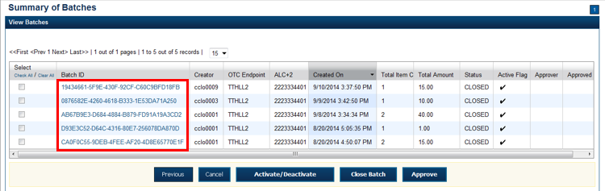

1. Click the **Batch ID** hyperlink. The *View Checks* page appears.
2. Click the **Item ID** of each scanned check. An image of the check and details of the check appear in the window.
3. Click **Previous** to return to the *View Batches* page.
4. Select the batches you want to approve by checking the box to the left of the **Batch ID**.
5. Click **Approve**. The *Approve Batch* page appears.
6. Verify that you want to approve the batch and click **Confirm**. The *Approve Batch* page appears with the batches details.
7. Click **Confirm** to approve the batches.

Application Tips



* The **Confirm** button is enabled. As a best practice, export or print the Batch List Report prior to clicking the **Confirm** button.
* For offline, the user can approve the batch without needing to print the PDF report or export the batch list report, regardless if the **Close Batch** and/or **Approve Batch** checkboxes are checked or unchecked. The **Confirm** button is enabled.
* If the user is closing and/or approving multiple batches offline, **Confirm** is enabled and the user can close and/or approve multiple batches without needing to print the PDF reports or export the batch list reports. As a best practice, print the PDF reports or export the batch lists prior to closing and approving multiple batches

1. An *Approve Batch* page appears verifying the batch has been approved.
2. Click **Return to Batch Summary**.

Application Tips



* After a batch is approved, its status changes from **Closed** to **Approved**, except under one of these two scenarios.
* First, if a batch has been designated for summary level classification and the batch classification is not balanced.
* Second, if a batch is designated to be classified at the summary level and it is a CARS reporter, and the batch is not classified
* Under these two scenarios the batch status is Closed. After the batch is classified and balanced, the batch can be approved.

Additional Buttons



* Click **Cancel** to return to the OTCnet Home Page. No data will be saved.
* Click **Previous** to return to the previous page.
* Click **Activate**/**Deactivate** to activate or deactivate a batch.
* Click **Close Batches** to close a batch.
* Click **<<First** to go to the first page. (Only appears if there are several pages retrieved for the search results.)
* Click **Next>** to go to the next page. (Only appears if there are several pages retrieved for the search results.)
* Click **Last>>** to return to the last page. (Only appears if there are several pages retrieved for the search results.)
* Click **<<Image** to return to the previous check.
* Click **>>Image** to view the next check.
* Click **Zoom-** to reduce the image size.
* Click **Zoom+** to enlarge the image size.
* Click **Rotate Left** to turn the image to the left.
* Click **Rotate Right** to turn the image to the right.
* Click **Show Item** to view and update the check item details.
* Click **Void** to void a single check item.
* Click **Receipt** to print a receipt.
* Click **Print Item** to print a batch list report**.**

## Topic 13 Upload a Batch

As a **CCS**, **CCO**/**CCLO** with **Batch Uploader** privileges, you are the only authorized users who can upload a batch or multiple batches in OTCnet Offline. Uploading a batch ensures the batch is closed and processed into the OTCnet Online database. If the batch was already approved in the OTCnet Offline application, it will be forwarded for processing and settlement upon successful upload and acknowledgment. If the batch was closed, but not approved, before it was uploaded to OTCnet Offline, it will be made available for approval in Batch Management of OTCnet Online.

Before you can upload a batch or multiple batches from OTCnet Offline to OTCnet online, you must first access the OTCnet Offline icon on your terminal desktop (or via your Start Menu under Programs) and enter your User ID and password. Additionally, the secondary storage (configured during Terminal Configuration) must be accessible, and connectivity to the OTCnet Online server is required to upload a batch in Offline mode. Upon selecting Upload Batch and verification of the secondary storage, are prompted to enter your online credentials (if you haven’t already done so) to establish connectivity to OTCnet Online.

In OTCnet Offline, a **CCS**, or a **CCLO**/**CCO** with **Batch Uploader** permissions can close and upload batches. When a CCS closes a batch(es) in Offline mode, the batch automatically changes to Approved status, and is therefore eligible to upload to OTCnet Online, where it is forwarded for processing. However, when a **CCLO**/**CCO** with **Batch Uploader** permission closes and uploads a batch, the batch will remain is a Closed status. In this scenario, a **CCS** must approve a batch in Batch Management of OTCnet Online. This approach is used when an Agency prefers to use the online approval process, and the terminal is configured to allow for uploading batches that have not yet been approved by a **CCS**. Unless granted a **Batch** **Approver**/**Batch Uploader** permission as a **CCO** or **CCLO**, approving and uploading batches in offline mode can only be performed by a **CCS**.

Based on the permissions granted, a user can only view the batches that they have been granted access to. If a terminal is configured to allow for uploading batches, and **Supervisor** approval is not required, active batches that are in Closed, Approved, Sent, and Send Error will display. If a terminal is configured to require **Supervisor** approval for the terminal, then only batches with Approved or Send Error status will be displayed and are eligible for upload.

Upload a Batch in OTCnet Offline

To upload a batch(es), complete the following steps:

1. From the **Check Processing** tab, click **Upload Batch**. An *Online Authentication* dialog box appears.

Application Tip



The *Online Credentials* dialog box appears if connectivity with OTCnet Online has not been established. If connectivity is not established or the correct online credentials are not entered batches cannot be uploaded.

1. Enter **Online Password** Treasury Web Application Infrastructure (TWAI) and click **Login**, *if applicable*. The *Select Batch(es) to Upload* page appears.

Application Tip



If **Cancel** is clicked batches cannot be uploaded.

1. Select the batch(es) you want to upload by checking the box (es) under the **Select** column.
2. Click **Upload Batch**. The *Review the Batch(es) to be Uploaded* page appears as shown in Figure 23.

Figure 23. Upload Batch – Summary of Batches

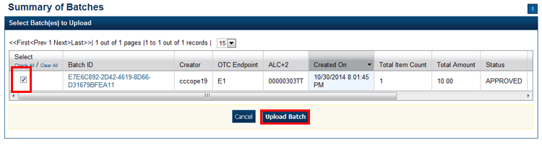

1. Verify that you want to upload the batch(es) and click **Submit**. The *Batch Upload* dialog box appears.
2. Click **Close**. The *Upload Batch Confirmation* page appears with the batch details of which batches successfully/failed to upload.

Application Tip



* It is highly recommended that the **Cancel** button is not clicked instead wait for the **Close** button to ensure the batch is successfully uploaded.

Additional Button



Click **Return Home** to the OTCnet Home Page.

## Topic 14 Acknowledge a Batch

As a **CCS**, **CCO**, **CCLO**, or **CCO** with **Batch Uploader** privileges you are the only authorized users who have access to the Acknowledge Batch task in OTCnet Offline. Active batches that are in Sent, Acknowledge Error (ACK ERROR (Closed)) and Acknowledge Error (ACK ERROR (APPROVE)) state display on the Summary of Batches page.

Acknowledging a batch allows you to request confirmation from the OTCnet Online application that the batch transmission was successfully received and processed into the online database, where it will be available in Batch Management for Approval (if batch is Closed) or forwarded for processing (if the batch is Approved already).

Before you can acknowledge a batch or multiple batches in OTCnet Offline, you must first access the Start OTCnet Offline icon on your terminal’s desktop or access your Start Menu under Programs and enter your User ID and password.

Your secondary storage (configured during Terminal Configuration) must be accessible. Additionally, connectivity to OTCnet Online is required to acknowledge a batch in OTCnet Offline. Upon selecting Upload Batch, are prompted to enter in your Online Credentials (if you haven’t already done so) to establish connectivity to OTCnet Online.

### Acknowledge a Batch

To acknowledge a batch offline, you can acknowledge a batch from the *Select Batches to Acknowledge* page And submit the correct batches to be acknowledged.

Acknowledge a Batch

To upload a batch(es), complete the following steps:

1. From the **Check Processing** tab, click **Upload Batch**. An *Online Authentication* dialog box appears.

Application Tip



Determine if your terminal is connected to the online OTCnet server, refer to the Connection Status indicator located on the top-right of the page. If the Connection Status is green, the terminal is connected to the online OTCnet server. If the Connection Status indicator is red, the terminal is not connected to the online OTCnet server.

1. Select the batch(es) you want to acknowledge by checking the box(es) under the **Select** column as shown in Figure 24.

Figure 24. Select Batches to Acknowledge

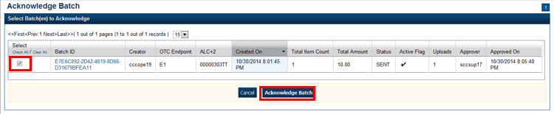

1. Click **Acknowledge Batch**. The *Review the Batch(es) to be Acknowledged* page appears.
2. Verify that you want to receive acknowledgement for the selected batch(es) and click **Submit**. The *Batch Acknowledgement* dialog box appears.
3. Click **Close**. The *Acknowledge Batch Confirmation* page appears with the batch details of which batches successfully/failed to receive acknowledgement.

## Topic 15 Print a Receipt

Receipts are available for printing if the **CCA** configures the terminal beforehand in OTCnet. If your Agency requires a specific receipt layout, contact your Deployment Specialist at [fiscalservice.otcdeployment@citi.com](mailto:fiscalservice.otcdeployment@citi.com) or 703-377-5586. All receipts are printed in PDF format, as well as saved or attached to a new email message.

After the terminal is configured, **CCO**, **CCLOs**, and **CCSs** can print a receipt in single mode or batch mode through the **Check Scan** and **Batch Management** functionality, as well as via the **Show Item** to print a receipt. Receipts are available for printing in OTCnet after the operators enter and save the pertinent details and can be either handed to or mailed to the customer.

### Receipt Printing from Check Scan (Singe/Batch Mode)

To print a receipt from batch management, select **Receipt** in Scan Controls and print the receipt.

### Receipt Printing from Batch Management (Single/Batch Mode)

To print a receipt from batch management, select or enter batches conditions including **OTC Endpoint**, **Created On Date**, **Batch ID**, **Cashier ID**, enter **Batch Status** and select the **Batch ID** hyperlink and the **Item ID** of each scanned check.

Print a Receipt in Single Mode or Batch Mode

To print a receipt from the *Check Scan* functionality: *Single Mode,* complete the following steps:

1. Scan the check, input, and save the pertinent details.
2. Under **Scan Controls**, click Receipt as shown in Figure 25. A *Printing…Please wait* message appears and the receipt prints to the default printer.

Figure 25. Receipt Print Image (Scan Check)

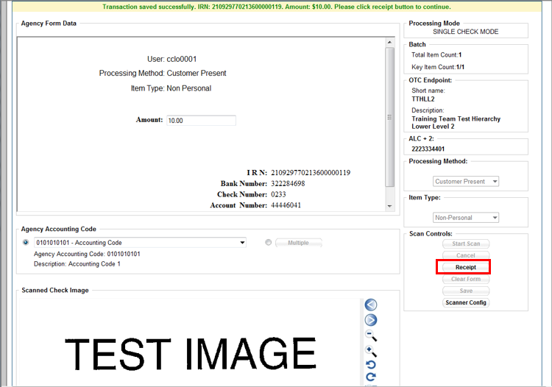

Application Tip



You have eight seconds to click the **Receipt** button. If the **Receipt** button is not clicked within the allotted time, the button grays out. If a receipt is still needed, access the **Batch Management** function.

1. Click **Receipt**. The receipt appears.
2. Click **Print** to print the receipt.
3. Click **Close** to close the receipt.

Application Tip



If you are printing a receipt in batch mode repeat steps 1-5 until finished.

Print a Receipt in Batch Management

To print a receipt from the *Batch Management* functionality: *Batch Mode*, complete the following steps:

1. From the **Check Processing** tab, click **Batch Management**. Select or enter your preferred batch search conditions.

Under **Batch Search Conditions**, *optional*

* + - Select the **OTC Endpoint** you want to **Edit** a batch for by checking the under the **Select** column

Under **Created On Date**, *optional*

* + - Enter the **From** and **To** date range

Application Tips



* The **From** and **To Created On Date** must be entered in MM/DD/YYYY format.
* The **Created On Date** range cannot exceed 30 days. Additionally, if more than a 1,000 batches are created within 30 days, then only the most recent 1,000 batches appear.
* If you run a search with the default **From** and To **Created On Date** range values, the search results include the most recent 30 days of batches that you have access to view. If more than 1,000 batches are created within the 30 days, then only the most recent 1,000 batches appear.
* If you run a search **without** specifying any criterion (with the exception of the **Batch ID** field), the search results include the most recent 30 days of batches that you have access to view. If more than 1,000 batches are created within 30 days, then only the most recent 1,000 batches appear.
  + - Enter the **Batch ID**, *optional*

Application Tip



If the only search criteria entered is a valid **Batch ID**, then only a single result appears regardless of other search criteria specified.

* + - Enter the **Cashier ID**, *optional*

Under **Batch Status**, optional

* + - Select the **Status** you want to view by checking the **Open** or **Closed** box under the **Select** column

1. Click **Search**. The View Batch **page appears**.
2. Click the **Batch ID** hyperlink. The *View Checks* page appears.

Application Tip



If a batch is in use and another user attempts to access the same batch, a Batch Lock message appears stating the batch is in use and he/she cannot access the batch.

1. Click the **Item ID** of each scanned check. An image of the check and details of the check appear as shown in Figure 26.

Figure 26. View Checks Page (Receipt)

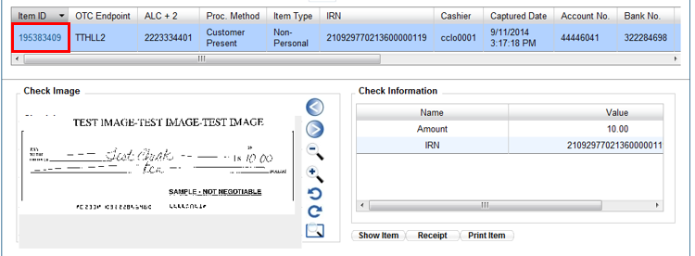

1. Click **Receipt**. The receipt appears.
2. Click **Print** to print the receipt.

Application Tip



Account numbers and User Defined Fields (UDFs) that are marked as Personally Identifiable Information (PII) are masked. If there are more than five characters, OTCnet masks all but the last four numbers. If there are five characters or less, the system will mask all but the last character.

1. Click **Close** to close the receipt.

Application Tip



Click **Show Item** to view more details about the check. Under **Server** **Controls**, click **Receipt** to print the receipt.

## Summary

In this chapter, you learned:

* The purpose of capturing and managing checks offline
* How to capture a check offline
* How to manage poor check image quality
* How to resolve a duplicate check
* How to void a check
* How to override a Local Verification Database (LVD) Record
* How to perform batch control and batch balancing
* How to view and print a batch list / item detail report
* How to activate/deactivate a batch
* How to classify a batch
* How to close a batch
* How to approve a batch
* How to upload a batch
* How to acknowledge a batch
* How to print a receipt