

# Chapter 5. Managing Verification Records

OTCnet Participant User Guide

Table of Contents

Overview, Topics, and Audience 1

Overview 1

Topics 1

Audience 1

Topic 1 Purpose of Managing Verification Records (MVD/LVD) 2

Topic 2 Create an MVD Record 6

Create an MVD Record 7

Topic 3 Search an MVD Record 9

Search an MVD Record 10

Topic 4 Edit an MVD Record 12

Edit an MVD Record 13

Topic 5 Download an LVD 15

Download an LVD 16

Topic 6 Reset an LVD 17

Reset an LVD 18

Summary 19

List of Figures

Figure 1: MVD Lifecycle 3

Figure 2: LVD Lifecycle 4

Figure 3: Define the MVD Record 7

Figure 4: Search MVD Records 10

Figure 5. Edit Verification Record 13

Figure 6: Download LVD 16

Figure 7: Reset LVD 18

List of Tables

Table 1: MVD/LVD Record Trade Status 2

Table 2: Special Character Handling 5

Table 3: Search Results 9

Table 4: OTCnet Offline Versions Requiring LVD Reset 17

Glossary

Click this [link](https://www.fiscal.treasury.gov/otcnet/training/wbt/content/course_OTC/glossary.htm) to access the full OTCnet Glossary.

## Overview, Topics, and Audience

### Overview

Welcome to *Managing Verification Records (MVD/LVD).* In this chapter, you will learn:

* The purpose of managing verification records
* How to create a Master Verification Database (MVD) record
* How to search for a MVD record
* How to edit a MVD record
* How to download a Local Verification Database (LVD) record
* How to reset an LVD record

### Topics

The topics in this chapter include the following:

1. Purpose of Managing Verification Records, Master Verification Database (MVD and Local Verification Database (LVD)
2. Create an MVD Record
3. Search for an MVD Record
4. Edit an MVD Record
5. Download an LVD
6. Reset an LVD

### Audience

The intended audience for the *Managing Verification Records Participant User Guide* includes:

* MVD Editor
* MVD Viewer
* Check Capture Administrator (CCA)
* Check Capture Supervisor (CCS)

## Topic 1 Purpose of Managing Verification Records (MVD/LVD)

The **Master Verification Database (MVD)** aids the agency in determining the history of a particular check writer. The verification database is an optional Online database that maintains the agency hierarchy check cashing policy, dishonored check information, and manually entered blocked items—based on Agency policy.

The **MVD** provides the OTCnet application information to ensure a presented check is acceptable. The **MVD** is a *negative* Online database, specific to an agency that contains *return* information on:

* Checks and accounts that have failed to clear in a previous OTCnet transaction attempt
* Blocked accounts/routing numbers or individuals that have been identified where future transactions are not desired

The **Local Verification Database (LVD)** is a verification database that resides locally on each terminal. The information in the **LVD** prevents checks from being cashed on accounts, or other Agency-specified criteria, that are in violation of Agency policy. Verification information is available for download.

Verification records are derived from returns of previously processed payments originated through the OTCnet application and manually entered records (i.e., a blocked, suspended, or denied record). The bad check information is accumulated in the **MVD** as agencies start to process checks through Check Capture.

If an item is identified as a red flag item, you have the ability to set an MVD/LVD Record Trade Status as seen in Table 1.

Table 1: MVD/LVD Record Trade Status

|  |  |
| --- | --- |
| **Suspend** | Indicates that an individual’s record is set to a predetermined suspension period. During this time, the OTCnet system prevents an individual form cashing a check through OTCnet. The individual’s database record has a Trade Status of Suspend and the expiration date is set until a specific date |
| **Denied** | Indicates that an individual’s record is set to a permanent deny date of 9/09/2099. The OTCnet system permanently denies this person from cashing a check through OTCnet |
| **Blocked** | Indicates a manual entry by authorized person into the MVD rather than the result of a failed transaction. If desired, authorized users can edit the transaction record to a clear status |

As an **MVD Editor**, you can create, search, and edit **MVD** records. As an **MVD** **Viewer**, you can search and view **MVD** records only.

**How Does the MVD Work?**

Verification records are derived from returns of previous processed payments originated through OTCnet and manually-entered records (i.e., a blocked, suspended, or denied record). Blocked, suspended, or denied data is entered manually by an authorized person from an agency location, region or even the Treasury OTC Support Center.

By default, an OTC Endpoint receives all blocked, suspended, and denied records created at the location; all blocked, suspended, and denied records of the OTC Endpoint’s subordinate sites; all blocked records created at all Parent Level OTC Endpoints: and any blocked, suspended, or denied records from any **OTC Endpoint** and their subordinates in the requesting organization’s OTC Verification Group. An OTC Verification Group typically includes OTC Endpoints from the hierarchy of respective OTC Endpoint’s agency. See Figure 1 for the MVD lifecycle.

Figure 1: MVD Lifecycle

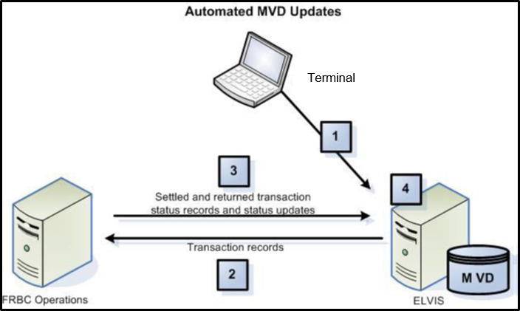

The MVD Lifecycle includes the following steps:

1. Check transactions are processed in OTCnet.
2. Check transaction data is sent from OTCnet to the Treasury/Bureau of the Fiscal Service (BFS).
3. The negative returns on check transactions are sent from the Treasury/BFS operations to the MVD.
4. T HE verification record is completed with information from the original payment transaction.

**How does the LVD Work?**

Blocked, suspended, or denied data is entered manually, Online, by an authorized person from a site, a region, an agency, or even the Treasury OTC Support Center. By default, a location receives all blocked, suspended and denied records created at the location; all blocked, suspended, and denied records of the location’s subordinate sites; all blocked records created at all direct ancestors above the location; and any blocked, suspended, or denied records from any location and their subordinates in the requesting location’s location group.

The LVD Download task allows a user to download updates to the Local Verification Database (LVD), if the agency uses this optional feature. This task can be set up to execute at either the point of application *Start up* or *Close Batch*. The default is set to execute on *Close Batch*. When the LVD Download task selection is active, an additional field appears. This field allows the Agency to choose the number of days the old LVD is allowed to become before an override is required from a supervisor. The default is 30 days with a maximum allowed period of 100 days.

After the LVD has reached its override age, it is considered to be stale and a new LVD must be downloaded. The operator is prompted to download an updated LVD. If the operator chooses to use the existing LVD without an update, the system requires a supervisor to approve (override) by supplying their email address and password each time the application is launched.

If an agency is utilizing the check verification process through the LVD download, there are occasions where a new LVD is required. LVD downloads contain only new items received by the MVD. If there is a change in the location’s policy, an entire new LVD must be obtained and must be requested manually. In order to accurately recognize red flags, the LVD must be up to date.

Figure 2: LVD Lifecycle

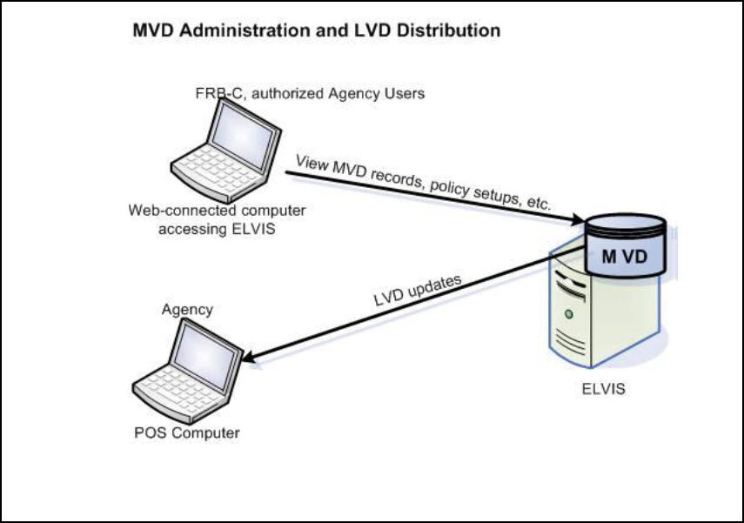

**OTC Verification Group Management**

An OTC Verification Group represents a listing of any OTC Endpoints outside the requesting OTC Endpoint’s hierarchy that share records. The MVD restricts the display of data based on the OTC Endpoint of the user. A user only sees records which are associated with OTC Endpoints at or below the user’s OTC Endpoint in the hierarchy or at OTC Endpoints specified in the OTC Verification Group. Depending on the type of data being requested, different rules apply, as appropriate.

**What is Included in an OTC Endpoint’s Policy?**

An OTC Endpoint’s policy helps automate an agency’s check cashing/collection policy. The OTC Endpoint policy is based upon the agency's overall program or policy to ensure a consistent application of an agency-wide check verification, including returned reason codes, suspension periods, and the inclusion of expired items. As part of the agency’s participation in the OTCnet program, the agency provides the Treasury OTC Support Center, via the Agency Site Profile (ASP), their check collection policy regarding:

* Number of returns permissible by the agency
* Length of time for each suspension period

Generate Verification records based on:

* The inclusion of Represented and Retired checks
* The inclusion of Retired checks only
* The number and timing of representments

An agency chooses when MVD records are created, either:

* With any return item

Or

* When items are retired to the agency

The final piece of information required in an OTC Endpoint policy is which other OTC Endpoints are included in the *OTC Verification Group*. The OTC Verification Group typically includes OTC Endpoints from the hierarchy of the respective higher level organization.

The OTC Endpoint policy is established during the set-up of an OTC Endpoint in the MVD system. Treasury OTC Support Center administers the set-up of all endpoints based on the agency’s and the OTC Endpoint’s ASP. Treasury OTC Support Center administers all edits or modifications to an OTC Endpoint, including the OTC Endpoint’s policy.

**Special Character Handling (when creating, searching or editing an MVD record)**

Table 2: Special Character Handling

| Special Characters | Handling |
| --- | --- |
| ‘ _ - @ # | Valid if surrounded by alpha characters.  *Exception*: The hyphen (dash) is only permitted for the fields associated with the MICR, Raw MICR, account number, routing number, and check number. The hyphen shall be permitted in the Batch ID field if surrounded by alphanumeric characters. The hyphen and/or underscore special characters shall be permitted in the I R N field in the Verification Query. The hyphen shall be permitted in the first configurable field of verification and CIRA records. Two consecutive hyphens are not allowed. |
| | $ | Valid if surrounded by alpha or numeric characters. |
| . / : _ | Allowed wherever a URL must be entered. The forward slash is also permitted for use in a date entry field. The period is also permitted for use in free text fields if the period is preceded by an alpha or numeric character. The amount field only accepts numeric characters and one period. |
| All Other Special Characters | If a character was not specifically mentioned, it is not permitted at all. Passwords are exempt from these special character handling rules. |

## Topic 2 Create an MVD Record

Agencies can add suspended, denied, or blocked records. This function is used to add manual records beyond the records automatically created from returned transactions. For example, your agency may be aware of individuals for whom you do not want to accept checks.

An agency has the option of adding a *manual suspend record* to prevent that check writer from cashing a check, from the current day through a defined *suspend until* date. Agencies also have the option of adding a manually denied or blocked record, which denies the check writer from cashing a check indefinitely.

Once these records are added, transactions that match the information on the manual records display a pop-up message to the operator, advising them of the suspend/blocked/denied record.

Manually-added records are not handled the same as dynamically calculated records. The manual records are not used for calculations of the number of offenses against the check writer, nor do they count as another offense against the agency’s policy.

If an item is identified as a red flag item, you have the ability to set an MVD Record’s Trade Status. The Trade Status types include:

* **Suspend**: Indicates that an individual’s record is set to a predetermined suspension period. During this time, the OTCnet system prevents an individual from cashing a check through OTCnet. The individual’s database record has a Trade Status of Suspend and the expiration date is set until a specific date.
* **Denied**: Indicates that an individual’s record is set to a permanent deny date of 9/09/2099. The OTCnet system permanently denies this person from cashing a check through OTCnet.
* **Blocked**: Indicates a manual entry by authorized persons into the MVD rather than the result of a failed transaction. If desired, an authorized user can edit the transactional record to a clear status.

Create an MVD Record

To create an Master Verification Database (MVD) Record, complete the following steps:

1. From the **Check Processing** tab, select **Manage Verification**>**Create MVD Record**. *The Step 1 of 2: Define the MVD Record* page appears as shown in Figure 3.

Figure 3: Define the MVD Record

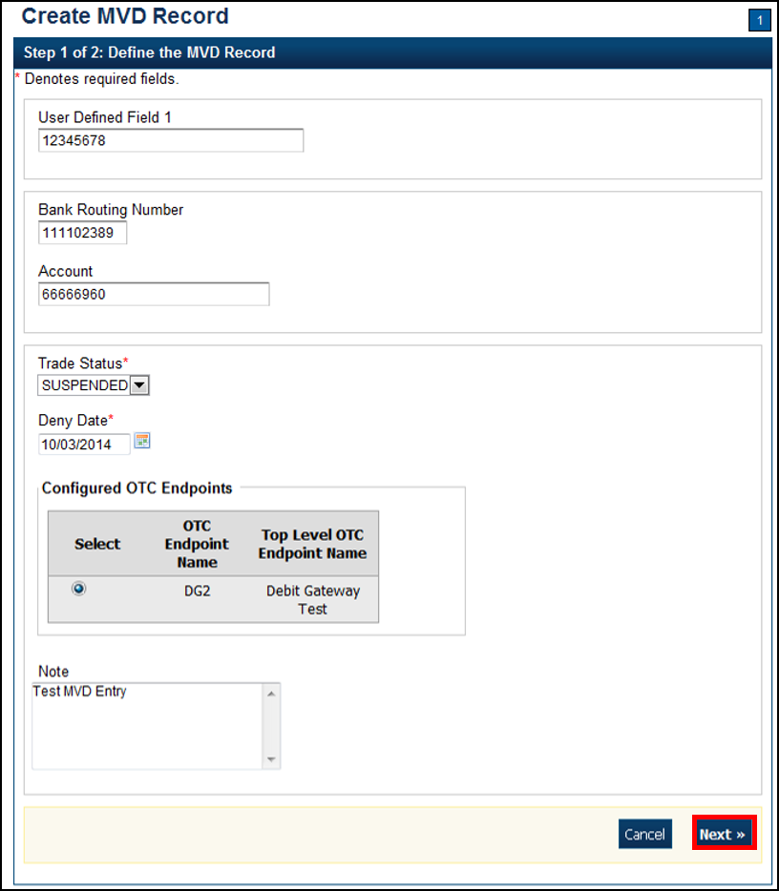

1. Enter the MVD details and click **Next**.
   * Enter the **User Defined Field** details
   * Select the **Search Type**
   * Enter the **Bank Routing Number**, *required*
   * Enter the **Account** number
   * Select the **Trade Status**, *required*
   * Enter the **Deny Date**, *required*
   * Select the **OTC Endpoint**, *required*
   * Enter comments in the **Note**

Application Tips



* A trade status of **Blocked** or **Denied** automatically defaults to **the Deny Date** of 9/09/2099 and the date cannot be modified.
* The **Deny Date** indicates the date when the suspension period ends. The **Deny Date** must be greater than or equal to today's date.

1. The *Step 2 of 2: Create MVD Record* page appears. Verify the information is correct and click **Submit**. Click **Edit** to modify the information entered.
2. A *Confirmation* page appears stating that the MVD Record has been created.

Additional Buttons



* Click **Cancel** to return to the OTCnet Home Page. No data is saved.
* Click **Clear** to clear all data fields and reset to the default selections.
* Click **Previous** to return to the previous page.
* Click **Return Home** to the OTCnet Home Page.

## Topic 3 Search an MVD Record

As an **MVD Editor** or **MVD Viewer**, you are authorized to search for MVD records. The MVD supports the agency by determining the history of a particular check writer. The verification database is an optional online database that maintains the agency hierarchy check cashing policy, dishonored check information, and manually entered blocked items based on an agency’s policy.

Since the MVD can potentially contain thousands of records, the ability to clearly define your search results provides better system results. Search for data by OTC Endpoint, Individual Reference Number (IRN), and other search criteria. If you run a search without specifying any criteria other than OTC Endpoint, the search results include all records in the system that you have access to view. To limit a search, enter the search criteria as shown in Table 3.

Table 3: Search Results

|  |
| --- |
| OTC Endpoint |
| Individual Reference Number (IRN) |
| User Defined Field |
| Search Type |
| Bank Routing Number |
| Account Number |
| Trade Status (Blocked, Denied, Suspended, Cleared, D-Suspended) |
| From and To MVD Date |

Search an MVD Record

To search an Master Verification Database (MVD) Record, complete the following steps:

1. From the **Check Processing** tab, select **Manage Verification**>**Search MVD Record**. The *Step 1 of 4: Search MVD Record* page appears as shown in Figure 4.

Figure 4: Search MVD Records

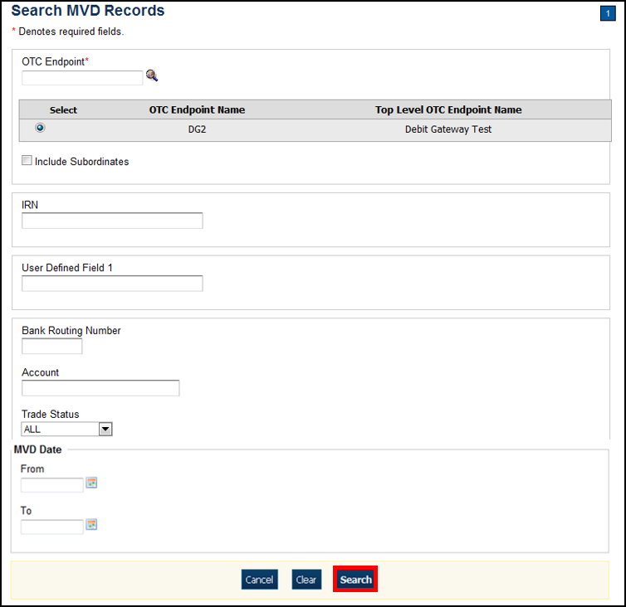

1. Enter the MVD search criteria and click **Search**.

* Enter the **OTC Endpoint**, *required*
* Check **Include Subordinates**
* Enter the **IRN** (Individual Record Number)
* Enter the **User Defined Field** information
* Select the **Search Type**
* Enter the **Bank Routing Number**
* Enter the individual’s **Account** number
* Select the **Trade Status**
* Enter the **From** and **To** MVD Date

Application Tip



The **From** and **To** MVD Date is the date that the returned record was created in the MVD.

1. Click **Search** to initiate the search. The records appear in a table.
2. Click the **IRN** link of the check details you would like to view. The *Step 2 of 4: Review the MVD Record* page appears.
3. Review the verification record details. Click **Edit** to modify the MVD record.

Additional Buttons



* Click **Cancel** to return to the OTCnet Home Page. No data is saved.
* Click **CIRA Detail** to display CIRA details (Visible only if is a CIRA record exists.)
* Click **Edit** to update the MVD record.
* Click **Previous** to return to the previous page.
* Click **Return Home** to the OTCnet Home Page.

## Topic 4 Edit an MVD Record

As an MVD **Editor**, you can edit MVD records. Before editing an MVD record, you must first search for the record. Once the record is located, you can edit or update the following for a verification record:

* **Trade Status** (Cleared, Suspended, Denied, Blocked)
* **Deny Date**
* **Return Reason Code**
* **Note** (reason for suspending, denying, or blocking)

You are also authorized to clear a record’s Trade Status. A **Clear Trade Status** indicates that prior restrictions on the individual check payments are removed.

Edit an MVD Record

To edit an Master Verification Database (MVD) record, complete the following steps:

1. From the **Check Processing** tab, select **Manage Verification**>**Search MVD Record**. The *Step 1 of 4: Search MVD Record* page appears.
2. Enter the MVD search criteria and click **Search**.

* Enter the **OTC Endpoint**, *required*
* Check Include **Subordinates**, *optional*
* Enter the **IRN** (Individual Record Number)
* Enter the **User Defined Field**, *optional*
* Select the **Search Type**, *optional*
* Enter the **Bank Routing Number**, *optional*
* Enter the individual’s **Account** number, *optional*
* Select the **Trade Status**, *optional*
* Enter the **From** and **To** MVD Date, *optional*

Application Tip



The **From** and **To** MVD Date is the date that the returned record was created in the MVD.

1. Click **Search** to initiate the search. The records appear in a table.
2. Click the **IRN** hyperlink for the check whose details you would like to view. The *Step 2 of 4: Review the MVD Record* page appears.
3. Click **Edit** to edit the MVD record. The *Step 3 of 4: Edit the MVD Record* page appears as shown in Figure 5. Edit the appropriate details.

Figure 5. Edit Verification Record

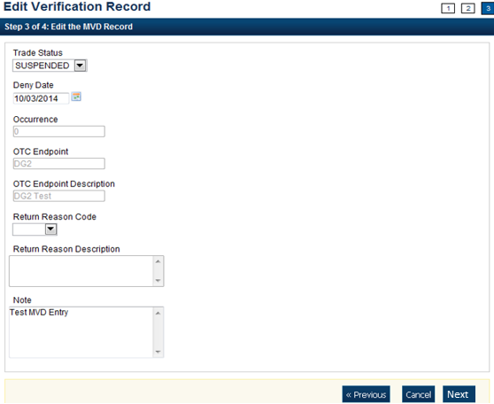

1. Click **Next**.

* Select the **Trade Status**

Application Tip



A **Cleared Trade Status** removes the **Deny Date** from the verification record and accepts the record into the system.

* Enter the **Deny Date**

Application Tips



* The **Deny Date** indicates the date when the suspension period ends.
* The **Deny Date** must be greater or equal to today's date and is mandatory for a **Suspend Trade Status**.
* The **Deny Date** for a **Denied** and **Blocked** trade status defaults to 9/09/2099.
* Select a **Return Reason Code**

Application Tip



The **Return Reason Description** is not editable and appears after a **Return Reason Code** is selected.

* Enter a **Note** referencing the reason for suspending, denying, or blocking the record.

1. The *Step 4 of 4: Review* the edited MVD Record. Verify the verification record information is correct and click **Submit**. Click **Edit** to modify the information entered.
2. A *Confirmation* page appears stating that the MVD record has been updated.

Additional Buttons



* Click **Cancel** to return to the OTCnet Home Page. No data is saved.
* Click **CIRA Detail** to display CIRA details. (Visible only if is a CIRA record exists.)
* Click **Edit** to update the MVD record.
* Click **Previous** to return to the previous page.
* Click **Return Home** to the OTCnet Home Page.

## Topic 5 Download an LVD

As a **Check Capture Administrator (CCA)** or **Check Capture Supervisor (CCS)** you are the only users that can download a Local Verification Database (LVD). Before downloading an LVD, you must log in using the OTCnet Offline icon on your terminal’s desktop, or access your Start Menu under Programs, and enter your credentials. Internet connection is required to download LVD records from the Master Verification Database (MVD).

When the Download LVD function is used, all changes and new records are downloaded, making the LVD current. If no previous LVD exists in the local database, a full LVD is downloaded to the Offline terminal. LVD Download can be configured to occur automatically at application startup or at batch close. Additionally, at the point of creating a batch in Check Scan, if the system detects an out of date LVD, the system provides the option to the user to download/update the LVD at that time.

Based on the override setting (the number of days the old LVD is allowed before an override is required from a **CCS**), the **Check Capture Lead Operator (CCLO**) or **Check Capture Operator (CCO)**, is prompted to download an updated LVD. If the operator chooses to use the existing LVD without an update, the system requires a **CCS** to approve (override) by supplying their email address and password each time the Check Capture application is launched. The default for LVD Download is set to execute on Close Batch.

Download an LVD

To download an Local Verification Database (LVD), complete the following steps:

1. From the **Check Processing** tab, select **Manage Verification**>**Download LVD**. The *Download LVD* page appears.

Application Tips



* Prior to downloading an LVD, you must log in using the **OTCnet Offline** icon on your terminal desktop or access your Start Menu under Programs and enter your credentials.
* Internet connection is required to download LVD records from the Master Verification Database (MVD).

1. Click **Submit**. The *Download LVD* dialog box appears as shown in Figure 6.

Figure 6: Download LVD

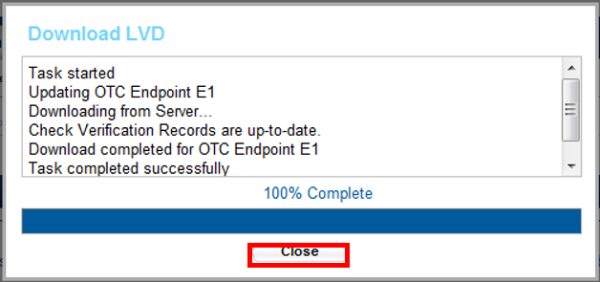

Application Tip



Wait until the display percent completion reaches 100% before clicking **Close**.

1. Click **Close**. A *Confirmation* page appears stating that the verification records are updated.

Additional Button



Click **Return Home** to the OTCnet Home Page.

## Topic 6 Reset an LVD

As a **Check Capture Administrator (CCA)** or **Check Capture Supervisor (CCS)**, you are the only users who can reset an LVD. Before you reset an LVD, you must log in using the OTCnet Offline icon on your terminal desktop, or access the Start Menu under Programs, and enter your credentials. Internet connection is not required to reset an LVD.

It is recommended that the Reset LVD function be used when there have been changes to an OTC Endpoint check cashing policy, or a terminal is re-deployed to a new location. The Reset LVD function removes everything on the LVD in anticipation of a full replacement with new LVD Records (see Download LVD). If an LVD is reset without downloading the new LVD, the verification of the checks presented does not occur.

Resetting the LVD is a mandatory step for agencies upgrading from a pre-1.3.2 OTCnet Offline Check Capture software version to a 1.3.2 OTCnet Offline Check Capture software version or above. If an LVD is reset without downloading the new LVD, the verification of the checks presented does not occur. See Table 4 for all combinations of upgrades that require LVD reset.

Table 4: OTCnet Offline Versions Requiring LVD Reset

| OTCnet Offline  Version | Upgrade to OTCnet Offline Version | Reset LVD  Required |
| --- | --- | --- |
| 1.2.3.A | 1.2.4 | No |
| 1.2.3.A | 1.3.2 | Yes |
| 1.2.4 | 1.2.5 | No |
| 1.2.4 | 1.4 | Yes |
| 1.2.5 | 1.3 | No |
| 1.2.5 | 1.3.2 | Yes |
| 1.3 | 1.3.2 | Yes |
| 1.3 | 1.4 and above | Yes |
| 1.3.2 and above | 1.4 and above | No |

Reset an LVD

To reset a Local Verification Database (LVD), complete the following steps:

1. From the **Check Processing** tab, select **Manage Verification**>**Reset LVD**. The *Review LVD* Reset page appears as shown in Figure 7.

Figure 7: Reset LVD

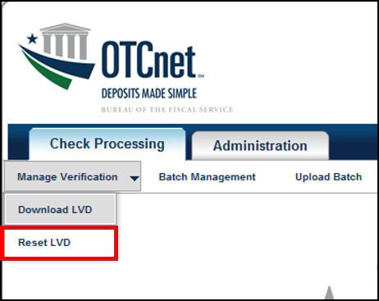

Application Tips



* The Reset LVD function removes everything on the LVD in anticipation of a full replacement with new LVD records. If an LVD is reset without downloading the new LVD, the verification of the checks presented does not occur.
* Resetting the LVD is a mandatory step for agencies upgrading from a pre-1.3.2 OTCnet Offline Check Capture software version to a 1.3.2 OTCnet Offline Check Capture software version or above.
* Before resetting an LVD, you must log in using the OTCnet Offline icon on your terminal’s desktop or access your Start Menu under Programs and enter your credentials. Internet connection is not required to reset an LVD.

1. Click **Submit**. The *LVD Reset* dialog box appears.
2. Click **Submit**. A *Confirmation page* appears stating that the verification records have been deleted.

Additional Button



Click **Return Home** to the OTCnet Home Page.

## Summary

In this chapter, you learned:

* The purpose of managing verification records (MVD/LVD) records
* How to create an MVD record
* How to search for an MVD record
* How to edit an MVD record
* How to download an LVD record
* How to reset an LVD record