

OTCnet Participant User Guide

Table of Contents

Overview, Topics, and Audience 1

Overview 1

Topics 1

Audience 2

Topic 1 The Purpose of Capturing and Managing Checks Online 3

Topic 2 Capture a Check Online 5

Introduction to Capturing a Check 5

Types of Acceptable and Unacceptable Checks 7

Batch Processing Modes 8

Processing Methods 8

Item Types 9

Accounting Codes 9

Check Scanner Types and Check Placement 10

Check Capture Acceptance 13

Capture a Check Online 14

Capture a Check Online 16

Topic 3 Manage Poor Check Image Quality 20

Manage a Check with Poor Image Quality 21

Topic 4 Resolve a Duplicate Check 23

Resolve a Duplicate Check 24

Topic 5 Void a Check 26

Void a Check 27

Void All Checks in a Batch 30

Topic 6 Override a Master Verification Database (MVD) Record 33

Override a MVD Record 34

Topic 7 Perform Batch Control and Batch Balancing 36

Batch Control Options 37

On Batch Close (Optional/Mandatory) 38

Perform Batch Control on Batch Close 39

Perform Batch Control on Batch Create 41

Batch Balancing 43

Topic 8 View and Print a Batch List/Item Detail Report 45

View and Print a Batch List Report 46

View and Print an Item Detail Report 48

Topic 9 Activate/Deactivate a Batch 50

Activate/Deactivate a Batch 51

Topic 10 Classify a Batch 53

Edit a Batch 53

Edit a Batch 54

Topic 11 Close a Batch 57

Close Multiple Batches 57

Close a Single or Multiple Batch(es) 58

Topic 12 Approve a Batch 60

Approve a Single Batch 60

Approve a Single Batch 61

Approve Multiple Batches 64

Approve Multiple Batches 65

Topic 13 Print a Receipt 68

Receipt Printing from Check Scan (Single/Batch Mode) 68

Print a Receipt from Check Scan 69

Print a Receipt in Batch Management 70

Summary 72

List of Figures

Figure 1. EC 7000i Scanner 10

Figure 2. EC 9100i Scanner 11

Figure 3. EC 9600i Scanner 11

Figure 4. EC 9700i Scanner 12

Figure 5. Panini Scanner 12

Figure 6. Panini I: Deal Scanner 13

Figure 7. Agency Form Data Entry Fields 17

Figure 8. Poor Image Quality 20

Figure 9. Image Quality Failed Message 21

Figure 10. Duplicate Check Detected 24

Figure 11. Check Image Details 28

Figure 12. View Checks (Voiding) 31

Figure 13. Override Check Denial Box 34

Figure 14. Verification Report 35

Figure 15. Batch Control Page (Batch Create) 37

Figure 16. Print Batch List Report (Batch Close) 39

Figure 17. Batch Control (Failed to Balance) 43

Figure 18. Batch List Report 47

Figure 19. Item Detail Report 49

Figure 20. View Batches Page (Activate/Deactivate) 52

Figure 21. View Checks - View/Edit Classification 55

Figure 22. Confirm Batches to Approve (Approve Single) 62

Figure 23. View Batches Page (Approve Multiple Batches) 66

Figure 24. Receipt Print Image (Scan Check) 69

Figure 25. View Checks Page (Receipt) 71

List of Tables

Table 1. Check Capture/Processing and Batch Permission Matrix 4

Table 2. Scanner Types 10

Table 3. Batch Status Types 57

Glossary

Click this [link](https://www.fiscal.treasury.gov/otcnet/training/wbt/content/course_OTC/glossary.htm) to access the full OTCnet Glossary.

## Overview, Topics, and Audience

### Overview

Welcome to *Capturing and Managing Checks Online*. In this chapter, you will learn:

* The purpose of capturing and managing checks online
* How to capture a check online
* How to manage failed image quality
* How to resolve a duplicate check
* How to void a check
* How to override a Master Verification Record (MVD) Record
* How to perform batch control and batch balancing
* How to view and print a batch list/item detail item
* How to activate/deactivate a batch
* How to classify a batch
* How to close a batch
* How to approve a batch
* How to print a receipt

### Topics

The topics in this chapter include the following:

1. The Purpose of Capturing and Managing Checks Online
2. Capture a Check Online
3. Manage Poor Check Image Quality
4. Resolve a Duplicate Check
5. Void a Check
6. Override a Master Verification Record (MVD) Record
7. Perform Batch Control and Batch Balancing
8. View and Print a Batch List/Item Detail Report
9. Activate/ Deactivate a Batch
10. Classify a Batch
11. Close a Batch
12. Approve a Batch
13. Print a Receipt

### Audience

The intended audience for the *Capturing and Managing Checks Online* Participant User Guide includes:

* + Check Capture Operator (CCO)
  + Check Capture Lead Operator (CCLO)
  + Check Capture Supervisor (CCS)

## Topic 1 The Purpose of Capturing and Managing Checks Online

The Check Processing functionality is primarily used to capture check images and transaction data. There are two components under this tab within OTCnet. They include the **Scan Check** and **Batch Management** functionality. Once the images and data are collected under **Scan Check**, a user may access **Batch Management** to perform certain tasks prior to forwarding the batch for settlement.

During check scanning, you may opt to use the **Batch Control** functionality, which allows you to balance your batch. If this option is configured to be optional or mandatory for your agency, the *Batch Control* page appears during the processing of the check.

**Check Capture Operators (CCO)** or **Check Capture Lead Operators (CCLO)**, are the only authorized users who can capture a check.

As a **CCO**, you are authorized to scan checks into a Batch, change Processing Method (Customer Present / Customer Not Present), change an Accounting Code, change Item Type (Personal / Non-Personal checks), close a batch, and view a batch list.

As a **CCLO**, you are authorized to conduct the same actions as the **CCO** stated above, and you can balance batch and enter batch control values (total check count and total amount), accept duplicates, make magnetic ink character recognition (MICR) code line corrections, and accept checks with poor quality without approval (as shown in Table 1).

Table 1. Check Capture/Processing and Batch Permission Matrix

| Task | Check Capture Operator  (CCO) | Check Capture Lead Operator (CCLO) | Check Capture Supervisor  (CCS) |
| --- | --- | --- | --- |
| Scan checks into a batch | ● | ● | blank |
| Change Processing Method (Customer Present / Customer Not Present / Back Office) | ● | ● | blank |
| Change Accounting Codes | ● | ● | ● |
| Change Item Type (Personal/Non-Personal checks) | ● | ● | blank |
| Make MICR code line corrections | blank | ● | ● |
| Resolve a duplicate check | blank | ● | ● |
| Accept checks with poor image quality |  | ● | ● |
| View a batch list | ● | ● | ● |
| Balance batch amount (total check count and total amount) | ● | ● | ● |
| Enter batch control during batch closing | ● | ● | ● |
| Classify a batch | ● | ● | ● |
| Close a batch | ● | ● | ● |
| Approve a batch | ●1 | ●1 | ● |
| Upload a batch | ●2 | ●2 | ● |
| Acknowledge a batch | ●2 | ●2 | ● |
| Edit a batch | blank | ● | ● |
| Activate/Deactivate a batch | blank | black | ● |
| Void a check | blank | blank | ● |

1 = requires additional Batch Approver permission 2 = requires additional Batch Uploader permission

## Topic 2 Capture a Check Online

### Introduction to Capturing a Check

As a **CCO** or **CCLO**, you are authorized to capture a check in two modes, single or batch. Once a **Check Capture Administrator (CCA)** sets up your **Terminal Configuration** settings, you can scan a check in **Single** or **Batch** check mode. There are other settings that your **CCA** may have also instituted for your location, many of which are visible as you begin the check scanning process.

**Logical Processing Order for Scanning a Check**

When creating a batch, it is important that the proper steps be taken to ensure that the batch reaches our system. Below is an outline of the logistics for creating a batch:

* + **Batch Control** – This function may or may not appear, based on the computer’s configuration settings. If used, key in total dollar amount of checks and the total number of checks to be scanned. This function can be setup in the configuration as disabled, optional, or mandatory by the **CCA**. If this option is disabled, the **Batch Control** screen does not appear. If optional, the **Batch Control** screen can be skipped.
    - * If mandatory, at **Batch Create** or **Batch Close** only, the user must enter the Batch Control values. However, if a user selects to set A **Batch Control** value at both Batch Create and Batch Close, then it can only be deferred at the beginning of the batch. Batch control is required prior to closing a batch in this case.
  + **Scan the check** (or checks if processing in batch mode).
  + **Key in amount, configurable field data, and select accounting code information** for each check, if accounting codes are set up.
  + **Cancel transactions while performing data entry**, used only if necessary, i.e., image of the check is not legible.
  + **Print the receipt** – Just after the item information is keyed into the data entry screen, press **Enter**, then click the **Receipt** button to print a receipt of the item or items.
  + **Void items** – Used to delete invalid items only if necessary, prior to closing a batch if a **CCA** is available to authorize the void. Once data entry has been performed and the **Enter** key is pressed on a user’s keyboard, the item can no longer be cancelled and must be voided.
  + **Print the Batch list** – A printout of the batch listing must be done prior to closing a batch.
  + **Pre-balance** – Use the batch list that was just printed to reconcile all activity for this batch of work. If reconciling with cash drawers, count and reconcile to ensure activity is accurate.
  + **Batch Balancing** – This screen only appears if the totals that are keyed into the Batch Control screen do not match with what was actually keyed into the data entry screen, or if the number of checks scanned does not match the number keyed into the Batch Control screen.
  + **Close** – Closes the batch from further checks and prepared the batch for processing.
  + **Approve** - Indicates that the batch is ready for the settlement process. Once the batch is approved, it is then sent to **Debit Gateway** to initiate the settlement process. The batch status then becomes **Forwarded**.

An Agency may have multiple **OTC Endpoints** to process checks for. Each **OTC Endpoint** is unique, and batches can include items for multiple **OTC Endpoints**, however during the configuration set up, one **OTC Endpoint** is chosen to be the default. The default **OTC Endpoint** appears each time the **CCO** or **CCLO** begins the scanning process. However, they may select an alternate **OTC Endpoint** before scanning begins.

### Types of Acceptable and Unacceptable Checks

**Checks that CAN be processed through the OTCnet Check Processing Functionality**

All of the items listed below can be processed through the OTCnet Check Processing Functionality.

The following check items must be processed as **Non-personal**:

* + US Treasury Checks
  + Traveler's Checks
  + Money Orders (including Postal Money Orders)
  + Third-party Checks (even if drawn on a personal account)
  + State and Local Government Checks
  + Credit card Checks
  + *Do not ACH* Checks
  + Official Checks
  + Business Checks
  + Cashier’s Checks
  + Other US Government Checks
  + Payroll Checks

If a customer chooses to *opt out* and does not want their checks processed via ACH, the customer’s personal check must be processed as a non-personal item. This allows the check to clear the financial institution as a Check 21 item.

The following item(s) must be processed as **Personal** check Items:

* + Personal/Consumer Checks

The list of Items that CANNOT be processed through the OTCnet Check Processing Functionality include the following:

* + Foreign items drawn on non-US Financial Institutions
  + Check payable in non-US currency

These items may need to be processed through the **Deposit Processing** tab within OTCnet.

In regard to stamps, it is recommended that you apply any necessary stamps in a location that does not interfere with the dollar amount, financial institution information, or the signature. Since these items are not deposited at your bank, there is no need to stamp *For Deposit Only* on the back of the check. FRB-Cleveland becomes the bank of first deposit for all the OTCnet Check Processing items scanned and forwarded for settlement.

### Batch Processing Modes

Keep the following in mind for Single vs. Batch Processing Mode:

* Agencies must choose to process checks in one of two processing modes. The **Single** check mode allows checks to be processed one at a time. **Batch** processing mode allows for check batches to be scanned prior to data entry. The **Batch** processing mode is available for RDM EC7000i, EC9100i, EC9600i, and EC9700i, and Panini VisionX.
* When scanning in **Batch Processing Mode**, ensure that the entire check image is visible on the screen and the dollar amount must be legible (a check may successfully scan though the item was folded going into the device). If the image is not legible, click **Cancel** under **Scanner Controls** and re-scan the check.
* It is recommended, while scanning in **Batch** mode, to scan a smaller quantity of items.
  + For example, instead of scanning 150 items, scan 75. Then, perform the data input.
  + Scan the second group of 75 and perform the data input. Using the keyboard after the 75 items are scanned may eliminate the system inactivity logout during batch processing.
  + Because the keyboard and mouse are typically not touched during the scanning process, the system interprets this as inactivity and an auto logout takes place. To avoid this situation, move the mouse every so often to simulate system activity during the scanning process.
  + The default setting is 15 minutes. Move the mouse every 10 minutes or so to keep the system active.
* The maximum number of items to include in one batch is 3,000 items. The maximum dollar amount per batch is $99,999,999.99. The max number of items is also limited by the TIFF file.
* All processing method types can exist within a batch, although typically **Back Office** processing types are processed independently of other types. Not all agencies utilize all modes. Furthermore, a site may choose not to use all modes every day, due to fluctuation in check volume.

### Processing Methods

Operators choose the **Processing Method** where they would like to scan checks. This option indicates the mode of operation. They include **Customer Present**, **Customer Not Present**, or **Back Office**.

The **Customer Present** method is used when the person is present, i.e., standing in front the operator with a check. The **Customer Not Present** method is used when the check writer is not present, i.e., when checks are received through the mail or an unmanned drop box.

The **Back Office** processing method allows Agencies to convert received payments at the point-of-sale locations to ACH entries in a controlled, back-office environment.

The default is to allow all Processing Methods and Item Types, though restrictions can be set to allow only the **Back Office** processing method or **Non-personal** items. Operators must ensure they are selecting the proper choices for each item to avoid returned payments from the check writer’s financial institution.

Prior to scanning, checks must be pre-sorted by **Customer present**, **Customer Not Present**, and **Back Office**. All processing method types can exist within a batch, although typically back offices processing types are processed independently of other types. Not all agencies utilize all methods. And, your site may choose not to use all methods daily, due to fluctuation in check volume scanning a check.

### Item Types

Before or after the check is scanned in **Single** mode, the user must choose the **Item Type**. For Batch mode scanning, a user cannot manually select **Personal** or **Non Personal**, the system uses the default (previously established in the configurations). During the scanning process, if the system detects an **Item Type** other than the established default, it prompts the user for confirmation.

The choices are **Personal** or **Non Personal**. This indicates the type of item to be processed. When the operator clicks **Persona**l, the *Agency Form* data entry screen displays, *Check: Personal*.

If the operator clicks **Non Persona**l, the *Agency Form* data entry screen displays, *Check: Non Personal*. OTCnet can process both personal and non-personal checks within a batch. The operator must ensure they are selecting the proper choices for each item. Presort all items into two groups (**Personal** and **Non Personal**) prior to scanning to avoid the pop-up message indicating that it detected a different item type for the check. While most business checks are typically larger in size, business checks can look the same as personal checks.

Using the OTCnet **Terminal Configuration** functionality, authorized users can limit the **Item Type** to **Non Personal** only. When **Non Personal Only** is chosen under **Terminal Configuration**, the **Item Type: Personal** is no longer available for the operator to choose from the drop-down options. This can be set up for Agencies who never process personal checks.

### Accounting Codes

By default, the **Agency Accounting Code** drop-down field displays a blank value. An accounting code is selected for a check transaction before or after scanning a check.

The **Agency Accounting Codes** drop-down list displays the full **Agency Accounting Code** value (up to 50 alphanumeric characters) and some portion of the **Description** (up to 15 alphanumeric characters).

**Accounting Codes** are displayed in the drop-down field if they are mapped or inherited from the higher level OTC Endpoint. Additionally, accounting codes that are designated as **Treasury Account Symbols (TASs)** by the Agency are displayed if they are and have been validated by **Shared Account Module (SAM**).

If no accounting codes are available for selection and the Agency is a Central Accounting Reporting System (CARS)/Government Wide Accounting (GWA) Reporter, an operator cannot scan a check. If no accounting codes are available for selection, and the Agency is not a CARS/GWA Reporter, an operator can still scan a check.

If an OTC Endpoint is associated with an ALC that is designated as a CARS/GWA Reporter, all check transactions must be classified with an accounting code. If an ALC is not a CARS/GWA Reporter, classifying it with an accounting code is optional.

The same accounting code is displayed after it is selected for the first time. The selected accounting code is “sticky” (remains the same) between transactions, between batches within the same check scanning session and prior to the next user login.

### Check Scanner Types and Check Placement

Your Agency may scan checks using one of five scanner types (see Table 2). Some scanners are designed to scan only in **Batch** mode, whereas others may only scan in **Single** mode. The RDM EC7000i, EC9100i, EC9600i, and EC9700i, Panini MyVision X, Panini Vision X, and Panini I: Deal, however, can scan checks in both modes.

Table 2. Scanner Types

|  |  |
| --- | --- |
| **EC7000i** | This scanner will automatically scan both sides of a check and can scan in single or batch mode (one or more checks in a batch) |
| **EC9100i** | This scanner will automatically scan both sides of a check and can scan in single or batch mode (one or more checks in a batch) |
| **EC9600i** | This scanner will automatically scan both sides of a check and can scan in single or batch mode (one or more checks in a batch) |
| **EC9700i** | This scanner will automatically scan both sides of a check and can scan in single or batch mode (one or more checks in a batch) |
| **Panini MyVision X** | This scanner will automatically scan both sides of a check and can scan in single or batch mode (one or more checks in a batch) |
| **Panini Vision X** | This scanner will automatically scan both sides of a check and can scan in single or batch mode (one or more checks in a batch) |
| **Panini I: Deal** | This scanner will automatically scan both sides of a check and can scan in single or batch mode (one or more checks in a batch) |

**RDM EC7000i Scanner**

Place the check in the scanner with the MICR line of the check aligned with the right side of the scanner (shown in Figure 1). Gently push the check forward to allow the scanner to grasp the check. Guide the left side of the check with your finger to prevent the document from being skewed. The scanner automatically pulls the check through to begin the scan.

Figure 1. RDM EC 7000i Scanner

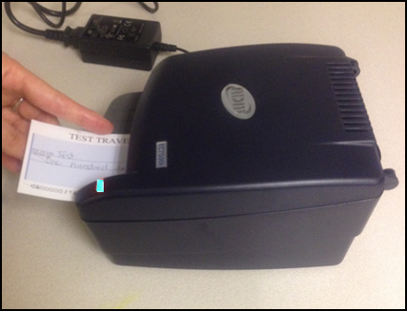

With the RDM EC7000i scanner, both the front and the back of the check are scanned automatically.

**RDM EC9100i Scanner**

Place the check in the scanner with the MICR line of the check at the bottom and facing towards the outside of the scanner (shown in Figure 2). Adjust the exit extension or the pocket stop to fit the check that you are scanning. The scanner automatically pulls the check through to begin the scan.

Figure 2. RDM EC 9100i Scanner

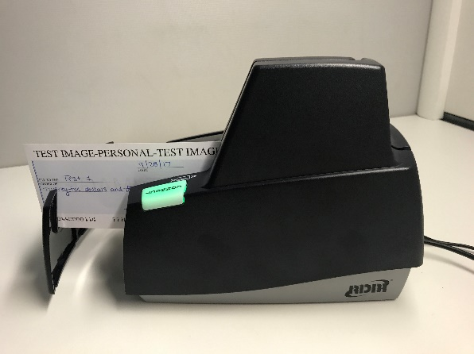

With the RDM EC9100i scanner, both the front and the back of the check are scanned automatically.

**RDM EC9600i Series Scanner**

Place the check in the scanner with the MICR line of the check at the bottom and facing towards the outside of the scanner (shown in Figure 3). Adjust the exit extension or the pocket stop to fit the check that you are scanning. The scanner automatically pulls the check through to begin   
the scan.

Figure . RDM EC 9600i Scanner

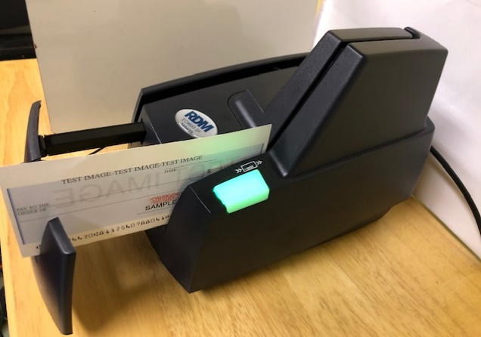

With the RDM EC9600i series scanner, both the front and the back of the check are scanned automatically.

**RDM EC9700i Series Scanner**

Place the check in the scanner with the MICR line of the check at the bottom and facing towards the outside of the scanner (shown in Figure 4). Adjust the exit extension or the pocket stop to fit the check that you are scanning. The scanner automatically pulls the check through to begin the scan.

Figure . RDM EC 9700i Scanner

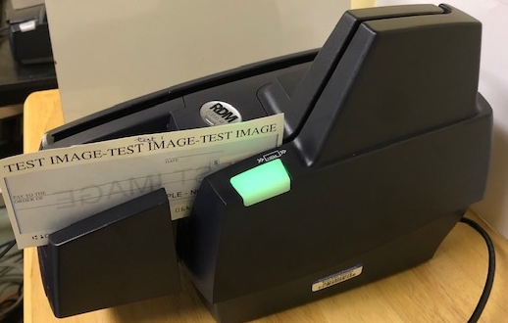

With the RDM EC9700i series scanner, both the front and the back of the check are scanned automatically.

**Panini Vision X and MyVision X Scanners**

Ensure that the check or checks are already in the hopper of the scanner, with the front of the check(s) facing (as shown in Figure 5) out. The first green light on the scanner begins to flash (if applicable).

Once the hopper is empty, the *Hopper Empty* message appears; the user can add more checks to the hopper. Click **Yes** to continue adding items to the batch. Click **No** if there are no more checks to scan. When **No** is clicked, the system switches to the data entry phase and the first check that was scanned appears on the screen.

Figure 5. Panini Scanner

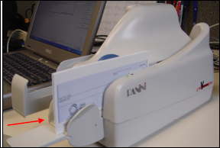

Use caution when clicking the **Stop** button during batch mode processing. Pressing too quickly (before the scanner has a chance to catch up to the system) may cause the last transaction to be lost.

**Panini I: Deal Scanner**

Place the check face up with the MICR line aligned to the right side of the scanner (as shown in in Figure 6). The scanner automatically detects the check and begins feeding. If the check is not aligned, the scanner automatically aligns the check to the proper position. When using the franking feature, the Panini I: Deal scanner franks the check as soon as it is scanned, rather than waiting until the operator has saved the transaction. This is a change in process from the EC7000i series scanner.

Figure 6. Panini I: Deal Scanner

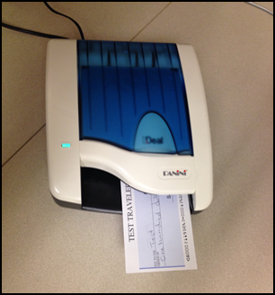

As the document is fed into the device, the scanner detects if the document was not automatically aligned correctly. If the document is skewed, the scanner prevents further processing, stops the document, and l flash a red light. The check can be removed and reinserted.

### Check Capture Acceptance

Once a user has successfully logged in to OTCnet, selected the appropriate **OTC Endpoint** to scan a batch to, chosen the correct processing method and Item Type, the next step is to scan the check.

Click **Start Scan** under **Scan Controls** options (scanner light may turn green depending on the type of scanner you have, indicating that the scanner is ready to accept a check). Scan the check and click **Save** under **Scan Controls** options. The bottom of the *Agency Form* entry screen displays *Scan front of Check*.

A *Batch Control* screen may appear, based on the Agency’s configuration settings.

### Capture a Check Online

The **Check Capture Operator** and **Check Capture Lead Operator** are authorized to capture a check. In order to capture a check online, you must first start the OTCnet Local Bridge (OLB) application.

For the **RDM EC7000****i, EC9100i,** **EC9600i** or **EC9700i** to scan checks in Batch mode, a *READY FOR BATCH SCAN Waiting for check* dialog box appears. Insert the checks one at a time. The dialog box presents the item count after each scan. When finished scanning, click **Stop**.

For the **Panini I: Deal**, **Panini MyVision X**, or **Panini Vision X,** to scan checks in Batch mode, a *READY FOR BATCH SCAN Waiting for check* dialog box appears. Insert the checks in the hopper. The dialog box shows the item count after each scan. When the hopper is empty or you finish scanning, click **Stop**.

Under Agency Form Data, complete the following:

* Enter the **Amount**, *required*
* Enter the check data in the field(s) provided, *if applicable*

Keep the following items in mind when capturing a check online:

* OTCnet accepts two different **Amount** entry formats. If the deposit amount is thirty-five dollars and fifteen cents, enter 35.15. If no decimal point is entered, OTCnet adds a decimal and two zeroes at the end and save it as 3515.00 (three thousand five hundred and fifteen dollars).
* Ensure that you type in the data rather than copying and pasting from another source. Data that has been copied and pasted may result in an error. Use the **Tab** key on the keyboard to navigate to the next data field for entry.
* After saving the data, a message appears stating the transaction was successfully saved along with the Individual Reference Number (IRN) and check amount.
* Only numbers need input. For example, entering in 1290 would equal $12.90, and 56321 would be equal to $563.21. The maximum dollar amount that can be keyed into the data entry screen is 99,999,999.99. The minimum amount is .01.
* The **Agency Form Data** form is customizable and can include fields beyond the **Amount** field (e.g., Social Security Number). If your agency has additional fields, they display under the **Amount** field. Your Agency may deem the field(s) either mandatory or optional for you to complete an entry. If your Agency requires additional fields, contact your Deployment Specialist at 703-377-5586 or [fiscalservice.otcdeployment@citi.com](mailto:fiscalservice.otcdeployment@citi.com).
* Since the configuration field requirements are established by each Agency, minimum/maximum requirements may exist for certain fields. If the operator does not satisfy those minimum/maximum field requirements, an error message is displayed in the middle of the screen and corrections must be made to the field before the transaction is accepted.
* Recapture an image of a check if it is inserted upside down; appears skewed; or the image is illegible. Click **Cancel** and reinsert the check in the scanner. Then click **Start Scan** and re-enter the necessary data.
* Upon scanning the check and using enter on your keyboard to finalize, the **IRN**, **Bank Number**, **Check Number**, **Account Number**, **Date & Time fields** automatically populates located in the frame of the **Agency Form Data).** For details regarding your scanner configurations, click on **Scanner Config**, under Scan Controls.
* If there aren’t any accounting codes available for selection and the Agency is a CARS/GWA Reporter, an operator cannot scan a check. If there are not any accounting codes available for selection, and the Agency is not a CARS/GWA Reporter, an operator can still scan a check.
* If an OTC Endpoint is associated with an ALC that is designated as a CARS/GWA Reporter, all check transactions must be classified with an accounting code. If an ALC is not a CARS/GWA Reporter, classifying it with an accounting code is optional.
* The same accounting code is displayed after it is selected for the first time. The selected accounting code is “sticky” (remains the same) between transactions, between batches within the same check scanning session and prior to the next user login.
* The single Agency Accounting Code and Multiple accounting code options are available if checks are scanned against an OTC Endpoint designated for Item Level Classification. If an ALC is designated for Summary Level Classification, the Agency Accounting Code and Multiple accounting codes options are disabled.

Capture a Check Online

To capture a check in OTCnet Online, complete the following steps:

1. From the **Check Processing** tab, Click **Check Scan.** The *Check Scan-Select Batch* page appears.

Under Select **Open Batch**, *if applicable*

* Click **Select** for the *OTC Endpoint* for which you want to scan one or more checks
* Click **Next**

Application Tips



* If an operator has an OTC Endpoint with an **Open** batch, the batch details (Void Count, Approved Count, and Amount) are displayed.
* If a batch is in use and another user attempts to access the same batch, a Batch Lock message appears stating the batch is in use and he/she cannot access the batch.

1. The *Check Scan – Perform Check Scan* page appears as shown in Figure 7.

Figure 7. Agency Form Data Entry Fields

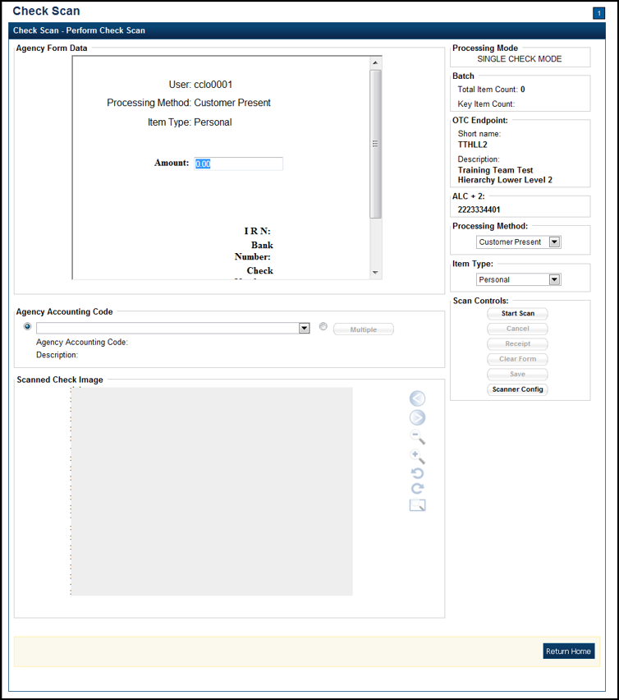

Under **ALC+2** (Agency Location Code +2),

* Verify the **OTC Endpoint**. To change the OTC Endpoint, click **Previous** and return to Step 2

Under **Processing Method**,

* Select the **Customer Present,** **Customer Not Present,** or **Back Office**

Under **Item Type**,

* Select **Personal** or **Non-personal**

1. Click **Start Scan**, under **Scan Controls** to scan a check.

Application Tip



If communication with the OLB application is not active, the **Start Scan** button is disabled. The OLB communication status ***must*** be active in order to scan a check. Determine if OLB communication is active by looking at the *OLB Communication* indicator, located in the upper right-hand corner of the screen, under the *Connection Status* indicator. The indicator is either green and shows **Active**, or red and shows **Inactive**.

1. Insert the check into the scanner.

Application Tip



Recapture a check image if it is inserted upside down, appears skewed, or the image is illegible. Click **Cancel** and reinsert the check in the scanner. Click **Start Scan** and re-enter the necessary data.

Additional Buttons



Under **Scanned Check Image***, optional*

* Click **Cancel** to cancel the transaction. No data is saved.
* Click **Receipt** to access a receipt for review or printing. This is only available once the initial check is scanned.
* Click **Clear Form** to clear the data entered.
* Click **Save** to save the transaction.
* Click **<** to view the front of the check
* Click **>** to view the back of the check
* Click **-** to reduce the image of the check
* Click **+** to increase the image of the check
* Click **Left Rotate** to turn the image to the left
* Click **Right Rotate** to turn the image to the right

1. Enter the Amount under **Agency Form Data** and enter the check data in the field(s) provided.

Application Tips



* OTCnet accepts two different **Amount** entry formats. If the deposit amount is for thirty-five dollars and fifteen cents, enter 35.15. If no decimal point is entered, OTCnet adds a decimal and two zeroes at the end and save it as 3515.00 (three thousand five hundred and fifteen dollars).
* Use the **Tab** key on the keyboard to navigate to the next data field for entry.

Click the **Agency Accounting Code**, *if applicable*

* Click the **Agency Accounting Code** radio button, and select a single accounting code from the drop-down list

Or

* Click the **Multiple** radio button and from the *Account Classification* dialog box, select an **Agency Accounting Code**, enter the **Amount**, and click **Add** for each subtotal of the deposit. Then click **Save**.

1. Click **Save** to save the check image and the data you entered. A message appears stating the transaction, Individual Reference Number (IRN) and check amount were successfully saved.

Application Tip



Upon scanning the check and clicking enter on your keyboard to finalize, the Individual Reference Number (IRN), **Bank Number**, **Check Number**, **Account Number**, and **Date & Time fields** automatically populate (located in the frame of the **Agency Form Data**).

Additional Button



Click **Return Home** to return to the OTCnet Home Page.

## Topic 3 Manage Poor Check Image Quality

There are instances when the image of a scanned check is not captured successfully. OTCnet image quality tests are performed on each check, as soon as the check is captured and the image is available. If a check passes the image quality tests, the item processing continues. If the check fails the image quality tests, an *Image Quality Failed* message is displayed.

It is vitally important that the check be fully visible and legible. The image that is on the screen is the image that is submitted to the payor bank for collection. It is also stored in the archives, for future retrieval purposes once the check is returned to the customer or destroyed. If collection is not possible on the Agency’s behalf with the image that has been submitted, the debit reverts back to the Agency and collection becomes the Agency’s responsibility.

If an *Image Quality Failed* message is displayed during the check scanning process and the check image is skewed, illegible, or upside down, an operator may consider the following options:

* **Rescan** the check (recommended to perform as many times as necessary)
* **Cancel** the check and opt to use the Deposit Processing functionality within OTCnet to deposit the check
* **Accept** the check (requires a **CCS** or **CCLO** to log in to OTCnet to authorize)

A **CCS** or **CCLO** can choose to override a poor image in hopes that it processes. The following example is of a poor image scan as shown in Figure 8. Agencies must be aware that overriding a poor image may result in a returned item, depending upon the paying financial institution.

Figure 8. Poor Image Quality

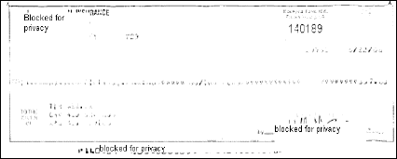

Manage a Check with Poor Image Quality

To manage a check with poor image quality, complete the following steps:

1. From the *Check Scan–Perform Check Scan* page, the *Image Quality Failed* message appears, as shown in Figure 9. Click:
   * + **Rescan** to rescan the check

Or

* + **Cancel** to completely cancel the transaction

Or

* + **Accept** to accept the image of the check (requires **CCS** to log in). The *Login ID and Password* dialog box appears. Enter the **Login ID** and **Password** and click **Login**.

Figure 9. Image Quality Failed Message

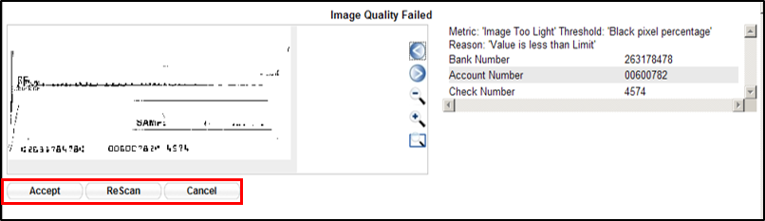

Application Tips



* Click **Rescan** if the check image is skewed, illegible, or upside down.
* If a **Check Capture Lead Operator (CCLO)** or **Check Capture Operator (CCO)** scanned the check, OTCnet prompts the operator for authorization.
* Only a **Check Capture Supervisor (CCS)** can approve a check with poor image quality. The **CCS** must key in his/her Login ID and Password before approving the check.

1. Resume check scanning tasks and enter the check item details into the form fields.
2. Click **Save** to save the image of the check and the data you entered.

Application Tip



Upon scanning the check, select **Enter** on your keyboard to finalize the **Individual Reference Number (IRN), Bank Number, Check Number, Account Number, Date & Time** fields. They automatically populate in the frame of the **Agency Form Data**.

Additional Buttons



* Click **Cancel** to return to the OTCnet Home Page. No data is saved.
* Click **Previous** to return to the previous page.
* Click **Return Home** to Return to the OTCnet Home Page.

## Topic 4 Resolve a Duplicate Check

If a duplicate check is detected, a *Duplicate Check Detected* prompt appears requesting that the user resolve the issue. OTCnet determines and detects duplicate checks based on a match of the MICR and the check amount. The system automatically compares the check to those scanned in the last 30 days.

If a check is scanned twice and the information entered is for the *same amount*, OTCnet displays an error message containing both scanned images and requests confirmation. If the check is scanned twice and information entered is for a *different amount*, OTCnet does not catch the error and allows the duplicate entry. However, the financial institution later rejects one of the duplicate checks.

To prevent duplicate processing of checks, checks may be hand stamped (e.g., *Electronically Presented*) after the transaction is complete and the check has been scanned.

During terminal configuration, select the **Franking Enabled** option to allow the scanner to automatically stamp the front of checks. Franking is available for RDM EC7000i, EC9100i, EC9600i, EC9700i and Panini I: Deal scanners.

If the MICR line was misread by the scanner leading the system to believe that the check is a duplicate, it can be edited. To determine if the MICR line was misread, compare the two images in the window. The top image depicts the current check, and the bottom image depicts the most recently scanned check that is being deemed a duplicate by the system. Also, compare the MICR line on the bottom check with the source document. If it has been determined to be a misread of the MICR line, that must be corrected. A **CCS** or **CCLO** can click the **Edit MICR** button at the bottom of the window.

If a *Duplicate Check Detected* prompt is displayed during the check scanning process, an operator may consider the following actions:

* **Rescanning** the check (recommended to perform as many times as necessary)
* **Editing MICR** to correct the MICR line
* **Accepting** the check (requires a **CCS** to log in to OTCnet to authorize)
* **Canceling** the check (recommended action)

A **CCS** and **CCLO** are the only authorized users who can accept a duplicate check. Therefore, before a **CCO** can accept a duplicate check, a **CCS** or **CCLO** must log in to authorize it. If a **CCLO** scanned the check, additional authorization is not required. The *Login* *ID and Password* dialog box only appears if a **CCS** or **CCLO** is accepting a duplicate check for a **CCO**.

As a **Check Capture Lead Operator (CCLO)** or **Check Capture Supervisor (CCS)**, you are authorized to accept a duplicate check. You are also authorized to edit a MICR line, rescan a check, or completely cancel the transaction. A **CCLO** or **CCS** must authorize a MICR line correction.

Resolve a Duplicate Check

To resolve a duplicate check, complete the following steps:

1. Click **Cancel** to cancel the duplicate check. A *Login ID and Password* dialog box appears.
2. Click **Accept** to continue processing the check. Click **Edit MICR** to correct the MICR line as shown in Figure 10.

Figure 10. Duplicate Check Detected

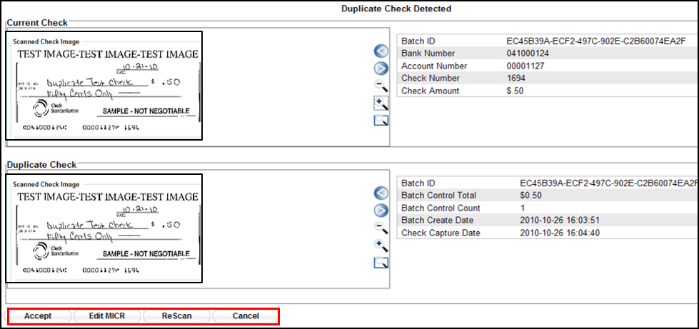

Application Tips



* The *Login* *ID and Password* dialog box only appears if a **CCS** or **CCLO** is accepting a duplicate check for a **CCO**. If a **CCLO** scanned the check, additional authorization is not required.
* A **CCS** or **CCLO** must authorize a MICR line code correction.
* As the **CCS** or **CCLO**, you can opt to make a MICR code line correction. If you do, look at the MICR line image closely to ensure all the characters are correctly entered in the code line Correction box.

1. Click **Cancel** or **Cancel All**. A *Transaction cancelled successfully* dialog box appears.

Application Tip



Click **Cancel** to cancel the one duplicate check. Click **Cancel All** to cancel all pending checks in the batch.

1. Click **OK**. The *Check Scan – Perform Check Scan* page appears.

Additional Buttons



* Click **Previous** to return to the previous page.
* Click **Return to Home** to return to the OTCnet Home page.

## Topic 5 Void a Check

As a **CCS**, you are the only authorized user who can void an erroneously scanned check or a batch of checks. Before voiding a check or a batch of checks, you must first search for the batch in which the check resides. Search for batches by **OTC Endpoint, Created On Date, Batch ID, Cashier ID**, and/or **Batch Status**. Voiding checks in batches can only be completed for OTC Endpoints that you have permission to access and only for items with an open or closed batch status.

Payments must only be entered for the amount of the item being processed. If a data-entry error is made in one of the user-defined fields, or amount entered for the check differs from the written amount of the check, two options are available:

1. Void the check and rescan with the corrected information during the check capture process (requires **CCS** to sign in to approve).
2. If a **CCS** is not available to approve the void while the operator has scanning in progress, the check must be voided via the **Batch Management** menu option. A **CCS** must sign in to **Batch Management** and change the incorrectly typed amount with the correct amount or update the user-defined field.

**Other details to void a check include the following:**

* + The minimum limit for reporting items that need to be adjusted by Treasury/Fiscal Service is $25.00. If the adjustment is $25.00 or more, the check is only corrected to the written dollar amount on the face of the check.
  + Voided items are not archived in the Central Image Retrieval Archive (CIRA) for long-term storage.
  + Do not scan the item a second time to process a second item for the amount difference. Doing so would create processing errors at Treasury/Fiscal Service as well as at the check writer’s financial institution.
  + If a file containing the wrong amount has already been transmitted, or if you ever encounter a processing issue and need assistance, please contact the Treasury OTC Support Center.

As a **Check Capture Supervisor (CCS)**, you are authorized to void a check. You run a search for batches and enter batch search conditions you would like to view. When an image and details of the check appear, you are authorized to click **Void** to the right of the check image.

Void a Check

To void a scanned check, complete the following steps:

1. From the **Check Processing** tab, click **Batch Management**. The *Search Batch* page appears.
2. Select or enter the batch search conditions you would like to view.

Under **Batch Search Conditions**, *optional*

* + Select the **OTC Endpoint** you want to **Edit** a batch for by checking the under the **Select** column

Under **Created On Date**, *optional*

* + Enter the **From** and **To** date range

Application Tips



* The **From** and **To Created On Date** must be entered in MM/DD/YYYY format.
* When running a search **with** the default **From** and **To Created On Date** range values, the search results include the most recent 30 days of batches that you have access to view. If more than 1,000 batches are created within the 30 days, then only the most recent 1,000 batches appear.
* When running a search ***without*** specifying any criterion (with the exception of the **Batch ID** field), the search results include the most recent 30 days of batches that you have access to view. If more than 1,000 batches are created within 30 days, then only the most recent 1,000 batches appear.
  + Enter the **Batch ID**, *optional*

Application Tip



If the only search criteria entered is a valid **Batch ID**, then only a single result appears regardless of other search criteria specified.

* + Enter the **Cashier ID**, *optional*

Under **Batch Status**, *optional*

* + Select the**Status** you want to view by checking the **Open** or **Closed** box under the **Select** column

1. Click **Search**. The *View Batch* page appears.
2. Click the **Batch ID** hyperlink. The *View Checks* page appears.
3. Click the **Item ID** of the scanned check you would like to void. An image and details of the check appear in a window below.
4. Click **Void** to the right of the check image to void the check as shown in Figure 11.

Figure 11. Check Image Details

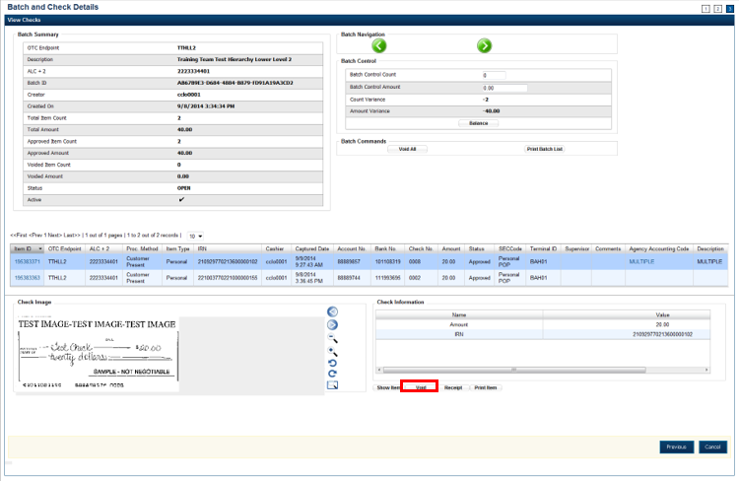

Application Tips



* If a check is voided and there is more than one check in the batch, and the ALC is designated to classify at the summary level, ensure that the combined accounting code subtotal is equal to the batch total prior to batch approval. If it does not, you must go back and re-validate your subtotal entries.
* If a check is voided and there is only one check in the batch, as a best practice it is recommended that the batch is deactivated so that it is not accidently forwarded for settlement. Deactivated batches are archived to the Historical Database.

1. Click **Confirm** at the prompt, to void the check.
2. Enter comments concerning the void request at the prompt and click **OK**.
3. Click **OK** at the final prompt stating that the check is voided successfully.

Additional Buttons



* Click **Cancel** to return to the OTCnet Home Page. No data is saved.
* Click **Previous** to return to the previous page.
* Click **Void All** to void all items in the batch.
* Click **Print Batch List** to print the batch list.
* Click **<** to go to the first batch.
* Click **>** to go to the next batch.
* Click **<<Image** to return to the previous check.
* Click **>>Image** to view the next check.
* Click **Zoom-** to reduce the image size.
* Click **Zoom+** to enlarge the image size.
* Click **Rotate Left** to turn the image to the left.
* Click **Rotate Right** to turn the image to the right.
* Click **Show Item** to view the check item details.
* Click **Void** to void a single check item.
* Click **Receipt** to print a receipt.
* Click **Print Item** to print a batch list report.

Void All Checks in a Batch

To void all scanned checks in a batch, complete the following steps:

1. From the **Check Processing tab**, click **Batch Management**. The *Search Batch* page appears.

Application Tip



Only batches in **Open** status can have all checks voided at once.

1. Select or enter the batch search conditions you would like view.

Under **Batch Search Conditions**, *optional*

* + Select the **OTC Endpoint** you want to void a check for by checking the box under the **Select** column

Under **Created On Date**, *optional*

* + Enter the **From** and **To** date range

Application Tips



* The **From** and **To Created On Date** must be entered in MM/DD/YYYY format.
* The **Created On Date** range cannot exceed 30 days. Additionally, if more than 1,000 batches are created within 30 days, then only the most recent 1,000 batches appear.
* When running a search **with** the default **From** and **To Created On Date** range values, the search results include the most recent 30 days of batches that you have access to view. If more than 1,000 batches are created within the 30 days, then only the most recent 1,000 batches appear.
* When running a search ***without*** specifying any criterion (with the exception of the **Batch ID** field), the search results include the most recent 30 days of batches that you have access to view. If more than 1,000 batches are created within 30 days, then only the most recent 1,000 batches appear.
  + Enter the **Batch ID**, *optional*

Application Tip



If the only search criteria entered is a valid **Batch ID**, then only a single result appears regardless of other search criteria specified.

* + Enter the Cashier ID, *optional*

Under **Batch Status**,

* + Select the**Status** you want to view by checking the **Open** or **Closed** box under the **Select** column

1. Click **Search**. The *View Batch* page appears.
2. Click the **Batch ID** hyperlink. The *View Checks* page appears.
3. Under Batch Commands, click **Void All**, as shown in Figure 12.

Figure 12. View Checks (Voiding)

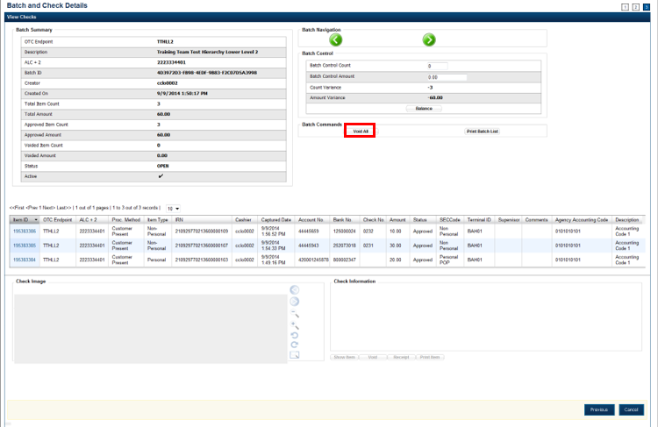

1. Click **Confirm** at the prompt to void all checks.
2. Enter comments concerning the void request at the prompt and click **OK**.
3. Click **OK** at the final prompt stating that the checks in the batches have been voided successfully.

Application Tip



After an entire batch of checks is voided, as a best practice, it is recommended that the batch be deactivated so that it is not accidently forwarded for settlement. Deactivated batches are archived to the Historical Database after 18 months as all batches and their associated check items are archived regardless of the batch status.

Additional Buttons



* Click **Cancel** to return to the OTCnet Home Page. No data is saved.
* Click **Previous** to return to the previous page.
* Click **Void All** to void all items in the batch.
* Click **Print Batch List** to print the batch list.
* Click **<** to go to the first batch.
* Click **>** to go to the next batch.
* Click **<<Image** to return to the previous check.
* Click **>>Image** to view the next check.
* Click **Zoom-** to reduce the image size.
* Click **Zoom+** to enlarge the image size.
* Click **Rotate Left** to turn the image to the left.
* Click **Rotate Right** to turn the image to the right.
* Click **Show Item** to view the check item details.
* Click **Void** to void a single check item.
* Click **Receipt** to print a receipt.
* Click **Print Item** to print a batch list report.

## Topic 6 Override a Master Verification Database (MVD) Record

If an Agency chooses to use the **Master Verification Database (MVD)** feature, the Agency receives three types of check verification notifications: **Blocked**, **Suspended**, or **D-Denied**.

The **CCS** is the only authorized user who can override (if the transaction can be overridden) a blocked, suspended, or denied notification. When an override of a blocked check is performed, the override is a temporary, one-time event. The check remains blocked in the MVD database unless an authorized person (**Master Verification Database Editor [MVDE**] or **CCS**) clears the item out of the MVD database.

For the MVD override notification to appear, the check item must meet established criteria for blocked, suspended, or denied.

**Blocked Check Notification**

A blocked, suspended, or denied message appears after the **CCLO** or **CCO** scans the check, enters the details, and saves the transaction.

A blocked message displays if the item matches all data as it was input on the blocked record:

* **Routing Transit/ Account Number Data:** If the blocked record is input with only the routing transit number and account number, that record is only flagged if the data matches
* **Configurable Field Data:** If the blocked record was input with only configurable field 1 data (e.g., Social Security Number or Driver’s License Number), then only configurable field 1 must match for the record
* **Combination Data:** If the blocked record input was for both pieces of information, it must match all combinations, i.e., routing transit and account along with configurable field 1

**Suspended or Denied Check Notification**

The suspend or deny message displays if the item scanned matches the MVD information. This is either the match of the combination of both the routing number and account number, or a match against the configurable field 1.

Each OTC Endpoint that uses the MVD sets their policies to use certain return codes with a defined number of days within the suspension period. During that pre-determined period, if the check writer attempts to cash a check, a suspended notification appears on the OTCnet screen.

A typical check cashing policy may mandate that the check writer is suspended for 30 days upon their first offense, 60 days upon their second offense and 90 days upon their third offense. During the suspension period, they cannot cash a check at that OTC Endpoint. A denied item occurs when the check writer has exceeded all suspension periods. A typical suspension policy specifies that the check writer is suspended, as referenced in the paragraph above.

As a **CCS**, you are authorized to override a blocked, suspended, or denied check. The override is a temporary, one-time event. You must enter a reason why the check was approved for processing.

Override a MVD Record

To override a MVD Record, complete the following steps:

1. Click **Override** to override the blocked, suspended, or denied check. An *Override Check Denial* dialog box appears as shown in Figure 13.

Figure 13. Override Check Denial Box

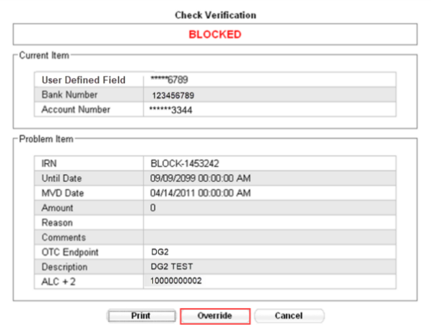

Application Tip



When an override of a blocked check is performed in check capture, the override is a temporary, one-time event. The check remains blocked in the MVD database unless an authorized person clears the item out of the MVD database.

1. Click **Print** to print the Verification report as shown in Figure 14.

Figure 14. Verification Report

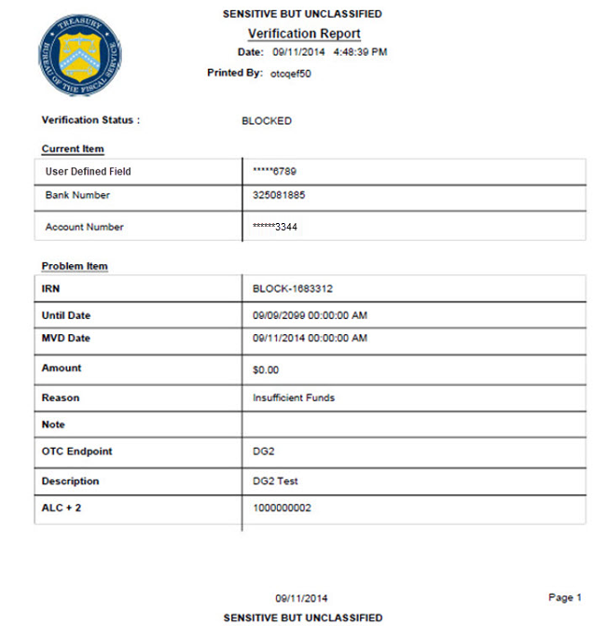

Application Tip



Click **Cancel** to close the Check Verification window. If **Cancel** is clicked, return the check to the customer.

1. Enter the **Login ID** and **Password** and click **Login**. A **Comment** dialog box appears.

Application Tip



A **Check Capture Supervisor** must authorize the overriding of the blocked, suspended, or denied check.

1. Enter a reason why the check was approved for processing and click **OK**. A notification appears stating the override was successful.

## Topic 7 Perform Batch Control and Batch Balancing

A **CCA** is authorized to configure the terminal for **Batch Control** as *optional* or *mandatory* on batch create, batch close, or both as an optional feature that your Agency can use as a batch balancing tool.

**Batch Control** is used to perform balancing on the number of checks that have been scanned and ensure their respective dollar amounts are accurately keyed. The **Batch Control** options are set up for each **OTC Endpoint** for which an Agency processes checks. If it is used, the feature applies to both processing modes, i.e., Single and Batch.

The batch control screen displays **OTC Endpoint** Information such as the **OTC Endpoint** short name, description, and ALC+2 for the **OTC Endpoint**. Configuration settings for batch control are established in **Terminal Configuration**.

If **Batch Control** is set at Batch Create, it can be either optional or mandatory, and the **Batch control** screen appears before scanning a batch of checks and when a new batch is created. Depending on the terminal configuration settings, the batch control fields can appear at the beginning of a batch (prior to scanning the check), just prior to closing a batch, or both.

If **Batch Control** is set to *optional*, the **Defer** button appears on the page. If set to *mandatory for either Batch Create or Batch Close,* the **Defer** button does *not* appear on the page and the user cannot start scanning a batch or close the unbalanced batch. If set to mandatory for both Batch Create and Batch Close, the **Defer** button appears during Batch Create, and a user must enter the batch control value during the Batch Close action.

**Set to Appear on Batch Create**

If the batch control is set to appear on batch create, OTCnet prompts the **CCLO** or **CCO** to enter the batch control total amount and count *before* scanning a check. If the batch control is set to *optional* on batch create, the operators can choose to click the **Next** button to bypass this step.

**Set to Appear on Batch Close**

If the batch control is set to appear on batch close, OTCnet prompts the **CCO**, **CCLO** or **CCS** to enter the batch control total amount and count. Batch control balancing only occurs when closing an open batch. If the batch control is set to *optional* on batch close, the operators, and **CCS** can choose to click to **Defer** to skip this step.

**Batch Control Options**

As a As a **Check Capture Lead Operator (CCLO)** or **Check Capture Supervisor (CCS)**, you are authorized to set the batch control to appear on Batch Create or Batch Close. Enter the Batch Control Count and Batch Control Amount if Batch Control is set to mandatory.

Batch Control Options

To perform a Batch Create (Optional/ Mandatory), complete the following steps:

1. From the *Check Scan* page,

Under **Set Up New Batch,**

* + Enter the **Batch Control Count**
  + Enter the **Batch Control Amount**

1. Click **Next** as shown in Figure 15.

Figure 15. Batch Control Page (Batch Create)

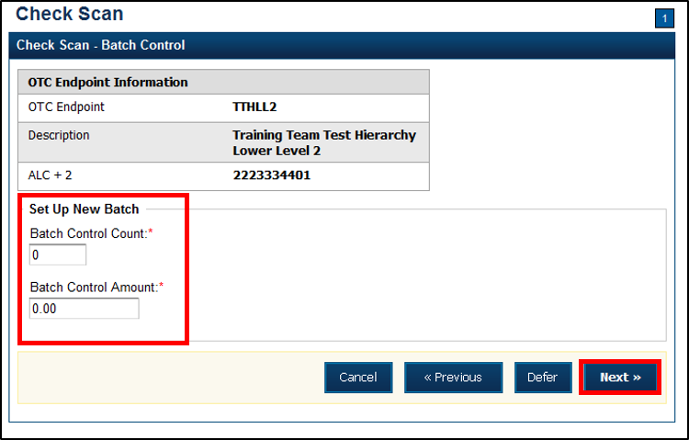

If **Batch Control** is set to mandatory, the **CCLO** or **CCO** must enter the **Batch Control** count and amount. The Batch Control count and amount cannot be zero.

If **Batch Control** is set to optional, the **CCLO** or **CCO** can click the **Defer** button.

1. The *Check Scan-Perform Check Scan* page appears*.* Perform check scanning as needed.

### On Batch Close (Optional/Mandatory)

As a **CCLO**, **CCO**, or CCS, you are authorized to enter the batch control total amount and count. You will close the batch and may print the PDF report or export the batch list report, regardless of whether the Close Batch or approve Batch checkboxes are checked or unchecked.

Perform Batch Control on Batch Close

To close a batch, complete the following steps:

1. From the *Batch Control* page,

Under **Batch Detail**,

* Enter the **Batch Control Count**
* Enter the **Batch Control Amount**

1. Click **Next**.

Application Tips



* If **Batch Control** is set to optional, the **CCLO**, **CCO**, or **CCS** can choose to click to **Next** button without entering the **Batch Control** count and amount.
* If the amount of a check item was incorrectly entered, click **Cancel** to return to the OTCnet Home Page. No data is saved.
* If you are a **CCLO** or **CCO** and discover that the amount of the check item was incorrectly entered, contact your **CCS**, and edit the check using the *Show Item* window.

1. The *Close Batch* page appears. Click **Print PDF Report** or **Export** and click **Confirm** to close the batch. After **Print PDF Report** or **Export** is clicked, the **Confirm** button is enabled as shown in Figure 16. The batch is not closed until **Confirm** is clicked.

Figure 16. Print Batch List Report (Batch Close)

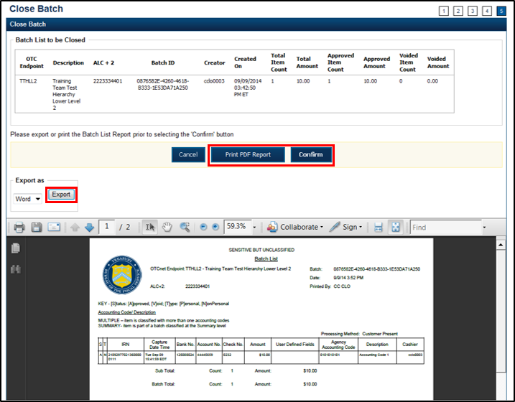

Application Tip



A user may print the PDF report or export the batch list report, regardless of whether the **Close Batch** and/or **Approve Batch** checkboxes are checked or unchecked. A **CCS** or **CCA** can specify the **Batch List Report Print/Export Required During** options under **Advanced Administration**.

Perform Batch Control on Batch Create

To perform batch control on **batch create**, complete the following steps:

1. From the *Check Scan* page,

Under **Set Up New Batch**,

* + Enter the **Batch Control Count**
  + Enter the **Batch Control Amount**

Application Tips



* If Batch Control is set to mandatory, the **Check Capture Lead Operator** or **Check Capture Operator** must enter the batch control count and amount. The batch control count and amount cannot be zero.
* If Batch Control is set to optional, the **Check Capture Lead Operator** or **Check Capture Operator** can click the **Defer** button.

1. Click **Next**. Perform **Check Scan**. The *Check Scan-Perform Check Scan* page appears*.*
2. Scan check(s) as needed.

To perform batch control on **batch close:**

1. From the *Batch Control* page,

Under **Batch Detail**,

* + Enter the **Batch Control Count**
  + Enter the **Batch Control Amount**

1. Click **Next**. The *Close Batch* page appears.

Application Tips



* If Batch Control is set to optional, the **Check Capture Lead Operator**, **Check Capture Operator**, or **Check Capture Supervisor** can choose to click to **Next** button without entering the batch control count and batch control amount.
* When the amount of a check item is incorrectly entered, click **Cancel** to return to the OTCnet Home Page. No data is saved. If **Check Capture Lead Operators** or **Check Capture Operators** discover that the amount of the check item was incorrectly entered, contact your **Check Capture Supervisor**, and edit the check using the Show Item window.

1. Continue the batch close process and print the batch list report.

Application Tip



A user may print the PDF report or export the batch list report, regardless of whether the **Close Batch** and/or **Approve Batch** checkboxes are checked or unchecked. A **CCS** or **CCA** can specify the **Batch List Report Print/Export Required During** options under **Advanced Administration**.

### Batch Balancing

If the totals that are keyed into the **Batch Control** screen do not match what was keyed into the data entry screen, a **Batch Balancing** screen appears on batch close (as shown in Figure 14). This screen only appears if there is a discrepancy between the totals. To reconcile the discrepancy, the operator must discover where the issue exists.

The **Batch Control** (balancing) screen displays the **Batch Detail**. Open fields include the Batch Control Count and Batch Control Amount. If these fields do not match those which you see to the right of the Approved Item Count and Approved Amount, then an error displays; *Failed to balance Batch (batch number), please check batch control* (as shown in Figure 17).

If batch control is set to *Mandatory* and the batch is not balanced at this point (Batch Control Count and Batch Control Amount), a user may not proceed with closing a batch. However, if **Batch Control** is set to *Optiona*l, a user may click **Next** below, to continue closing the batch.

Figure 17. Batch Control (Failed to Balance)

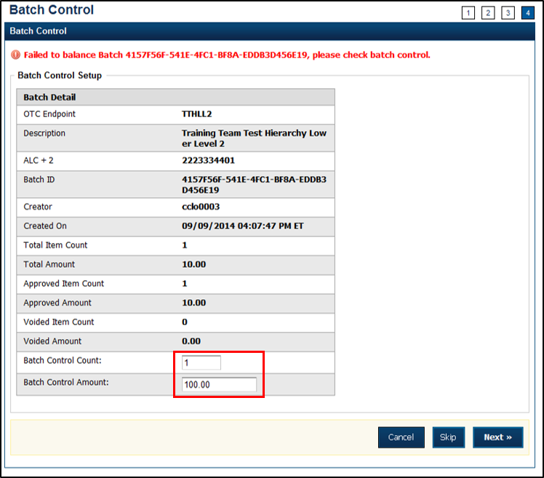

Below you will find **Batch Detail** descriptions:

* **Total Item Count:** The number of checks that have been scanned in OTCnet.
* **Batch Control Count**: The number of checks keyed into the **Batch Contro**l screen by the operator.
* **Total Amount:** The total dollar amount of the items as keyed into the Agency form data fields when scanning checks.
* **Batch Control Total**: The total dollar amount of the checks keyed into the Batch Control screen by the operator.

It must be determined if there is an erroneously scanned item, or if the batch contains both items. The operator must go back to the source documents for an answer. If it is determined that the batch contains both items, the operator would change the number in the **Batch Control Count** field and/or the dollar amount in the **Batch Control Total.**

If it has been determined that the batch does include an erroneously scanned item, follow these steps:

1. Click on the erroneous amount.
2. Click **Void** button.
3. Enter comments concerning the void request and click **Ok**.
4. Click **OK** to confirm the void request. The *Confirmation* message appears.

A **CCS** must log in at the prompt if the **Void** option is clicked.

## Topic 8 View and Print a Batch List/Item Detail Report

The **CCS**, **CCLO**, and **CCO** are authorized to view and print a **Batch List** report and an **Item Detail** report. An operator can print a **Batch List** for a deposit with any deposit status (i.e., Open, Closes, Approved, Forward). A **Batch List** consists of all transactions that are processed. A user can view batch lists based on the search criteria applied.

The printing of a **Batch List** is part of the batch close procedure. During batch close, the system prompts to make certain that the user acknowledges the printout of the **Batch List**. The **Print PDF Report** button defaults to print in PDF format; however, a user may also opt to download and save the report in an alternate format such as Word, HTML, Excel, etc.

From the *Close Batch* page, a user can perform several actions on the same screen (such as Activate/Deactivate, Close and Approve Batches), based on their permissions.

View and Print a Batch List Report

To view and print a Batch List report, complete the following steps:

1. From the **Check Processing** tab, click **Batch Management**. The *Search Batch* page appears.
2. Select or enter the batch search conditions you would like view.

Under **Batch Search Conditions**, *optional*

* + Select the **OTC Endpoint** you want to **Edit** a batch for by checking the under the   
    **Select** column

Under **Created On Date**, *optional*

* + Enter the **From** and **To** date range

Application Tips



* The **From** and **To Created On Date** must be entered in MM/DD/YYYY format.
* The **Created On Date** range cannot exceed 30 days. Additionally, if more than 1,000 batches are created within 30 days, then only the most recent 1,000 batches appear.
* When running a search ***with*** the default **From** and **To Created On Date** range values, the search results include the most recent 30 days of batches that you have access to view. If more than 1,000 batches are created within the 30 days, then only the most recent 1,000 batches appear.
* When running a search ***without*** specifying any criteria (with the exception of the **Batch ID** field), the search results include the most recent 30 days of batches that you have access to view. If more than 1,000 batches are created within 30 days, then only the most recent 1,000 batches appear.
  + Enter the **Batch ID**, *optional*

Application Tip



If the only search criteria entered is a valid **Batch ID** then only a single result appears regardless of other search criteria specified.

Under **Batch Status**, *optional*

* + Select theStatus you want to view by checking the Open or Closed box under the **Select** column

1. Click **Search**. The *View Batches* page appears.
2. Click the **Batch ID** hyperlink. The *Batch and Check Details* page appears.

Application Tip



If a batch is in use and another user attempts to access the same batch, a Batch Lock message appears stating the batch is in use and he/she cannot access the batch.

1. Click **Print Batch List**. The *Batch List Report* preview page appears as shown in   
   Figure 18.

Figure 18. Batch List Report

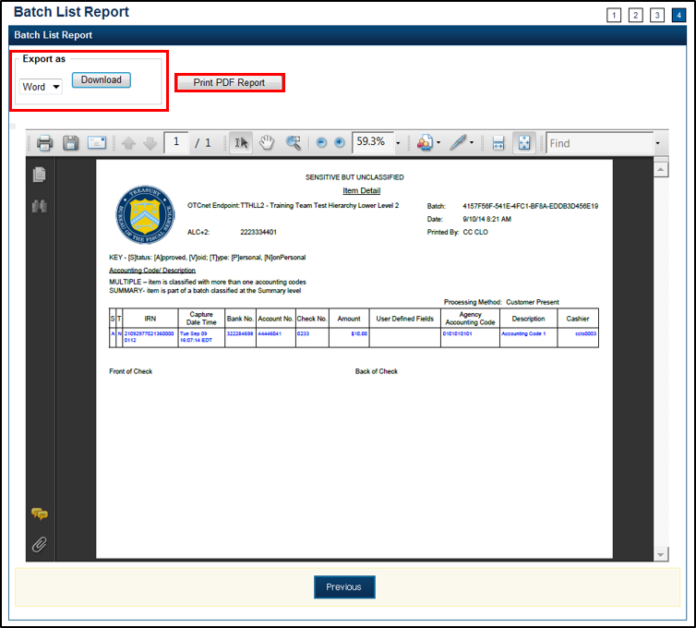

1. Under **Export as**,
   * Select **PDF**, **Word** or **Exce**l
   * Click **Download**

Or

* + Click **Print PDF Report**

Additional Button



* Click **Previous** to return to the previous page.

View and Print an Item Detail Report

To view and print an Item Detail report, complete the following steps:

1. From the **Check Processing** tab, click **Batch Management**. The *Search Batch* page appears.
2. Select or enter the batch search conditions you would like view.

Under **Batch Search Conditions**, *optional*

* + Select the **OTC Endpoint** you want to **Edit** a batch for by checking the under the   
    **Select** column

Under **Created On Date**, *optional*

* + Enter the **From** and **To** date range

Application Tips



* The **From** and **To Created On Date** must be entered in MM/DD/YYYY format.
* The **Created On Date** range cannot exceed 30 days. Additionally, if more than 1,000 batches are created within 30 days, then only the most recent 1,000 batches appear.
* When running a search ***with*** the default **From** and **To Created On Date** range values, the search results include the most recent 30 days of batches that you have access to view. If more than 1,000 batches are created within the 30 days, then only the most recent 1,000 batches appear.
* When running a search ***without*** specifying any criteria (with the exception of the **Batch ID** field), the search results include the most recent 30 days of batches that you have access to view. If more than 1,000 batches are created within 30 days, then only the most recent 1,000 batches appear.
  + Enter the **Batch ID**, *optional*

Application Tip



If the only search criteria entered is a valid **Batch ID** then only a single result appears regardless of other search criteria specified.

* + Enter the **Cashier ID**, *optional*

Under **Batch Status**, *optional*

* + Select the**Status** you want to view by checking the **Open** or **Closed** box under the **Select** column

1. Click **Search**. The *View Batches* page appears.
2. Click the **Batch ID** hyperlink. The *Batch and Item Details* page appears.
3. Click the **Item ID** of each scanned check. An image of the check and details of the check appear in the window below.
4. Click **Print Item**. The *Item Detail Report* preview page appears as shown in Figure 19.

Figure 19. Item Detail Report

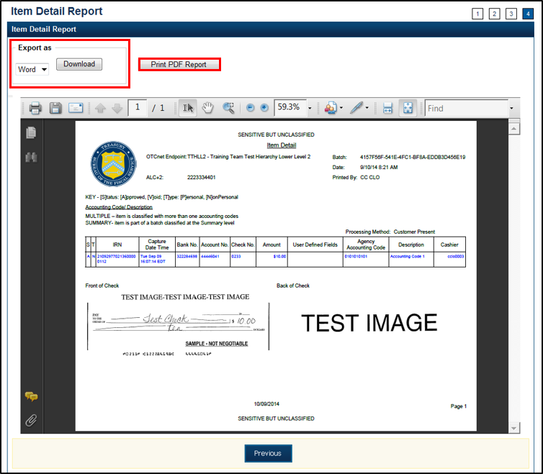

1. Under **Export as**,
   * Select **PDF**, **Word** or **Excel**
   * Click **Download**

Or

* + Click **Print PDF Report.**

Additional Button



* Click **Previous** to return to the previous page.

## Topic 9 Activate/Deactivate a Batch

A **CCS** is authorized to deactivate a batch if there is an issue with an item within the batch and further research is needed. Deactivating a batch prevents it from being closed or approved for settlement.

A deactivated batch must be activated before it can be closed or approved for settlement. Additionally, a batch currently in use cannot be deactivated. A deactivated batch is retained in the system indefinitely and can be searched for using Batch Management.

As a **CCS**, you are authorized to deactivate a batch if there is an issue with an item in the batch. You will enter the batch search conditions you would like to view.

Activate/Deactivate a Batch

To activate/deactivate a batch, complete the following steps:

1. From the **Check Processing** tab, click **Batch Management**. The *Search Batch* page appears.
2. Select or enter the batch search conditions you would like view.

Under **Batch Search Conditions**, *optional*

* + Select the **OTC Endpoint** you want to activate/deactivate a batch for by checking   
    the box under the **Select** column

Application Tip



Only batches with an **Open** or **Closed** status can be activated/deactivated. Additionally, batches currently in use cannot be deactivated.

Under **Created On Date**, *optional*

* + Enter the **From** and **To** date range

Application Tips



* The **From** and **To Created On Date** must be entered in MM/DD/YYYY format.
* The **Created On Date** range cannot exceed 30 days. Additionally, if more than 1,000 batches are created within 30 days, then only the most recent 1,000 batches appear.
* When running a search ***with*** the default **From** and **To Created On Date** range values, the search results include the most recent 30 days of batches that you have access to view. If more than 1,000 batches are created within the 30 days, then only the most recent 1,000 batches appear.
* When running a search ***without*** specifying any criteria (with the exception of the **Batch ID** field), the search results include the most recent 30 days of batches that you have access to view. If more than 1,000 batches are created within 30 days, then only the most recent 1,000 batches appear.
  + Enter the **Batch ID**, *optional*

Application Tip



If the only search criteria entered is a valid **Batch ID,** then only a single result appears regardless of other search criteria specified.

* + Enter the **Cashier ID**

Under **Batch Status**, *optional*

* + Select the **Status** you want to activate/deactivate by checking the **Open** and/or **Closed** boxes under the **Select** column

Application Tip



Only batches with an **Open** or **Closed** status can be activated/deactivated. Additionally, batches currently in use cannot be deactivated.

1. Click **Search**. The *Summary of Batches* page appears.
2. Check the checkbox of the **Batch ID** you want to activate or deactivate and click **Activate/Deactivate**. The *Activate/Deactivate Batch* page appears, as shown in

Figure 20.

Figure 20. View Batches Page (Activate/Deactivate)

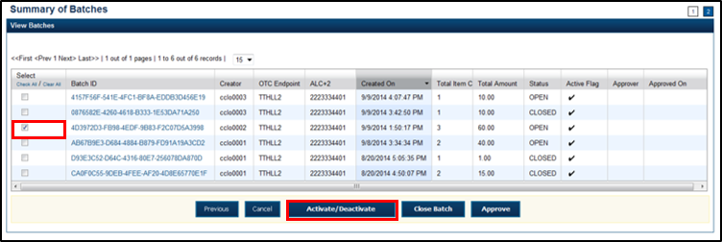

Application Tip



If a batch is activated or deactivated a check appears under the **Active Flag** column. If a batch is deactivated, the **Active Flag** column is blank.

1. Click **Confirm**. A message appears stating the batch(es) have been activated/deactivated and the value under **Active Status** updates to Active/Inactive.

Additional Buttons



* Click **Return to Batch Summary** to return to the batch summary page.
* Click **Return Home** to return to the OTCnet homepage.

## Topic 10 Classify a Batch

Before a batch is classified, an OTC Endpoint must be designated. You must classify a batch at the summary level with at least one accounting code or C-key. Additionally, if an OTC Endpoint is designated as a Central Accounting Reporting System (CARS)/Government-Wide Accounting (GWA) reporter, all batches (at the summary level) or items within a batch (at the item level) must be classified with at least one accounting code or C-key.

To classify a batch at the summary level, the **CCLO** or **CCO** first uses the Check Scan function, scans the check(s), enters the amount and any user defined field details, and saves the transaction. After the batch is saved, a **CCS**, **CCLO**, or **CCO** accesses Batch Management, clicks View/Edit Classification and classifies the batch with an accounting code or C-key. Depending on your user privileges and batch status, you either have access to **View/Edit Classification** or a **View Classification button**.

The summary level (batch) classification process is independent of the batch close process. Therefore, a batch can be classified *prior to* closing a batch or *after* the batch is closed. Additionally, a **CCS** can classify a batch during Approve Batch.

### Edit a Batch

As a **CCS**, **CCLO**, or **CCO**, you are authorized to classify or edit a batch at the summary level online. Batches in Open or Closed status can be edited at the summary level. You will enter or update the necessary account classification data and add the amount for each subtotal of the batch.

Edit a Batch

To classify or edit a batch at the summary level online, complete the following steps:

1. From the **Check Processing** tab, click **Batch Management**. The *Search Batch* page appears.
2. Select or enter the batch search conditions you would like to view.

Under **Batch Search Conditions**, *optional*

* + Select the **OTC Endpoint** you want to classify or edit a batch for by checking the under the **Select** column

Under **Created On Date**, *optional*

* + Enter the **From** and **To** date range

Application Tips



* The **From** and **To Created On Date** must be entered in MM/DD/YYYY format.
* The **Created On Date** range cannot exceed 30 days. Additionally, if more than 1,000 batches are created within 30 days, then only the most recent 1,000 batches appear.
* When running a search ***with*** the default **From** and **To Created On Date** range values, the search results include the most recent 30 days of batches that you have access to view. If more than 1,000 batches are created within the 30 days, then only the most recent 1,000 batches appear.
* When running a search ***without*** specifying any criteria (with the exception of the **Batch ID** field), the search results include the most recent 30 days of batches that you have access to view. If more than 1,000 batches are created within 30 days, then only the most recent 1,000 batches appear.
  + Enter the **Batch ID**, *optional*

Application Tip



If the only search criteria entered is a valid **Batch ID** then only a single result appears regardless of other search criteria specified.

* + Enter the **Cashier ID**, *optional*

Under **Batch Status**, *optional*

* + Select the**Status** you want to view by checking the **Open** or **Closed** box under the **Select** column

Application Tip



Batches in Open or Closed status can be classified or edited at the summary level.

1. Click **Search**. The *View Batches* page appears.
2. Click the **Batch ID** hyperlink. The *View Checks* page appears.
3. Click **View/Edit Classification**, as shown in Figure 21. The *Account Classification* dialog box appears.

Figure 21. View Checks - View/Edit Classification

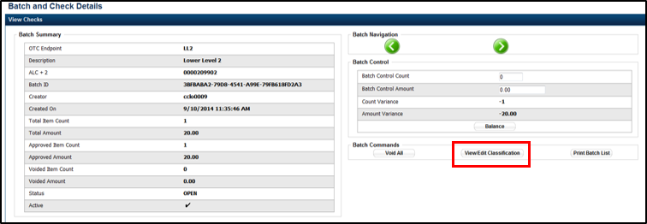

Application Tip



Depending on your user role and batch status you either have access to **View/Edit Classification** or **View Classification**. **View/Edit Classification** indicates that the user has view and edit permission. **View Classification** indicates the user has view classification permission and is not permitted to edit or delete a classification.

1. Click **Edit**. The *Account Classification* dialog box refreshes.
2. Enter or update the necessary account classification data.
   1. Select an **Agency Accounting Code**

Application Tips



* If an OTC Endpoint is associated with an ALC that is designated as a Central Accounting Reporting System (CARS)/ Government-Wide Accounting (GWA) Reporter, all check transactions must be classified with an accounting code. If an ALC is not a CARS/GWA Reporter, classifying it with an accounting code is optional.
* The **Agency Accounting Codes** drop-down list displays the full **Agency Accounting Code** value (up to 50 alphanumeric characters) and some portion of the **Description** (up to 15 alphanumeric characters).
  1. Enter the **Amount** and click **Add** for each subtotal of the batch

Application Tips



* The classified total and batch total can remain unbalanced until the batch is approved. However, the **Variance** must equal $0.00 before a batch can be approved. If it does not, you must go back and re-validate your subtotal entries.
* To delete or remove an accounting code, check the **Remove** check box next to the accounting code you want to delete and click **Update**.
  1. Click **Save**

Additional Buttons



* Click **Cancel** to return to the OTCnet Home Page. No data is saved.
* Click **Previous** to return to the previous page.
* Click **Void All** to void all items in the batch.
* Click **Print Batch List** to print the batch list.
* Click **<** to go to the first batch.
* Click **>** to go to the next batch.
* Click **<<**Image to return to the previous check.
* Click **>>**Image to view the next check.
* Click **Zoom-** to reduce the image size.
* Click **Zoom+** to enlarge the image size.
* Click **Rotate Left** to turn the image to the left.
* Click **Rotate Right** to turn the image to the right.
* Click **Show Item** to view the check item and perform update.
* Click **Void** to void a single check item.
* Click **Receipt** to print a receipt.
* Click **Print Item** to print an Item List report.

Additional buttons on the *Show Item* page:

* Click **-Front** to return to the previous check.
* Click **Back+** to view the next check.
* Click **-Zoom** to reduce the image size.
* Click **Zoom+** to enlarge the image size.
* Click **Rotate Left+** to turn the image to the left.
* Click **Rotate Right+** to turn the image to the right.

## Topic 11 Close a Batch

The **CCS** and **CCLO**, are the only authorized users who can close a batch or multiple batches. For OTC Endpoints, only batches that you have permission to access, can be closed.

OTCnet supports the following web browsers: Microsoft Edge and Google Chrome.For the PDF Documents Setting in Chrome: Disable the PDF Documents Setting within your browser to view PDFs in the PDF preview pane. If the PDF Documents Setting is enabled, reports can only be opened for download and do not display within the application. To view this option in a Chrome browser, navigate to:

**Chrome browser > 3 vertical dots in upper right>Settings>Advanced>Site Settings** (under “Privacy and security”)**>PDF documents** (under “Permissions”).

Before closing a batch or multiple batches, you must first search for the batch. Search batches by **OTC Endpoint**, **Created On Date**, **Batch ID**, **Cashier ID**, and/or **Batch Status**.

There are four batch status types, see Table 3 for details below.

Table 3. Batch Status Types

|  |  |
| --- | --- |
| **Open** | Indicates the batch is open. Continue scanning checks to it. |
| **Closed** | Indicates the batch is closed and no new checks are accepted. |
| **Approved** | Indicates the batch is ready for upload and settlement. |
| **Forwarded** | Indicates the batch has been sent to debit gateway to initiate the settlement process. |

All batches with a Received Date older than 18 months, including batches with an **Open** or **Closed** status, are saved in the Historical database and cannot be changed. Therefore, it is important that you close and approve all batches in a timely manner.

### Close Multiple Batches

As a CCS or CCLO, you are authorized to close multiple batches. Enter the batch search conditions you would like to view and select the batch you would like to close. You can also use the balancing feature for your OTC Endpoint if applicable. Print the PDF Report or Export and confirm the batches you want to close. A *Close Batch* page appears verifying the batches have been closed.

Close a Single or Multiple Batch(es)

To close a single or multiple batch(es), complete the following steps:

1. From the **Check Processing** tab, click **Batch Management**. The *Search Batch* page appears.
2. Select or enter the batch search conditions you would like view.

Under **Batch Search Conditions**, *optional*

* + Select the **OTC Endpoint** you want to **Close** a batch for by checking the under the **Select** column

Under **Created On Date**, *optional*

* + Enter the **From** and **To** date range

Application Tips



* The **From** and **To Created On Date** must be entered in MM/DD/YYYY format.
* The **Created On Date** range cannot exceed 30 days. Additionally, if more than 1,000 batches are created within 30 days, then only the most recent 1,000 batches appear.
* When running a search ***with*** the default **From** and **To Created On Date** range values, the search results include the most recent 30 days of batches that you have access to view. If more than 1,000 batches are created within the 30 days, then only the most recent 1,000 batches appear.
* When running a search ***without*** specifying any criteria (with the exception of the **Batch ID** field), the search results include the most recent 30 days of batches that you have access to view. If more than 1,000 batches are created within 30 days, then only the most recent 1,000 batches appear.
  + Enter the **Batch ID**

Application Tip



If the only search criteria entered is a valid **Batch ID** then only a single result appears regardless of other search criteria specified.

* + Enter the **Cashier ID**

Under **Batch Status**, *optional*

* + Select the**Status** you want to view by checking the **Open** box under the **Select** column

1. Click **Search**. The *View Batches* page appears.
2. Click the **Batch ID** hyperlink. The *View Checks* page appears.
3. Click the **Item ID** of each scanned check. An image of the check and details of the check appear in the window below.
4. Click **Previous** to return to the *View Batches* page.
5. Select the batch(es) you want to close by checking the boxes to the left of the **Batch IDs**.
6. Click **Close Batch**. The *Close Batch* appears.
7. Verify that you want to close the batches and click **Confirm**. The *Batch Control* page appears.
8. Enter the **Batch Control Count** and **Batch Control Amount**, if applicable.
9. Click **Next**. The *Close Batch* page appears.
10. Click **Print PDF Report** or **Export** and click **Confirm** to close the batch(es).

Application Tips



* After **Print PDF Report** or **Export** is clicked, the **Confirm** button is enabled. The batch(es) is(are) not closed until **Confirm** is clicked.
* The system generates one report for all selected batches.
* If the CCS or CCA checked the **Close Batch** checkbox under **Advanced Administration**, then the user must print the PDF report or export the batch list report. Afterwards, the user can proceed to close the batch.
* If the user is closing multiple batches online and the **Close Batch** checkbox is checked at any OTCnet endpoint, then the user must print the PDF reports or export the batch list reports. The batch is not closed until **Confirm** is clicked, which is enabled when the **Print PDF Report** or **Export** is clicked.
* If the user is closing multiple batches online and the **Close Batch** checkbox is not checked, then the user can close multiple batches without printing the PDF reports or exporting the batch list reports. **Confirm** is enabled and the user can click to close the multiple batches.
* A user may print the PDF report or export the batch list report, regardless of whether the **Close Batch** and/or **Approve Batch** checkboxes are checked or unchecked. A CCS or CCA can specify the **Batch List Report Print/Export Required During** options under **Advanced Administration**.

1. A *Close Batch* page appears verifying the batches have been closed.
2. Click **Return to Batch Summary**. The *View Batches* page appears.
3. Click **Return Home** to return to the OTCnet Homepage.

Application Tip



If a **CCLO** or **CCO** closes a batch, the batch status changes from **Open** to **Closed**. If a **CCS** closes a batch, the batch status changes from **Open** to **Approved**. If **Skip** is clicked, the **Status** remains **Open** and the batch is not closed.

## Topic 12 Approve a Batch

As a **CCS**, you are the only authorized user who can approve a batch or multiple batches. You can only approve batches for **OTC Endpoints** that you have permission to access. Approving a batch(es) indicates that the batch and check details are correct and that the batch(es) is/are ready for settlement.

Before approving a batch or multiple batches, you must first search for the batch. Batches can be searched by **OTC Endpoint**, **Created On Date**, **Batch ID**, **Cashier ID**, and/or **Batch Status**.

Additionally, a batch is only eligible for approval when the batch has a Closed status. After a batch is **Approved** and sent to **Debit Gateway** to initiate the settlement process, the status becomes Forwarded.

OTCnet supports the following web browsers: Microsoft Edge and Google Chrome.For the PDF Documents Setting in Chrome: Disable the PDF Documents Setting within your browser to view PDFs in the PDF preview pane. If the PDF Documents Setting is enabled, reports can only be opened for download and do not display within the application. To view this option in a Chrome browser, navigate to:

**Chrome browser > 3 vertical dots in upper right >Settings>** **Advanced>Site Settings** (under “Privacy and security”) **>PDF documents** (under “Permissions”).

Transactions processed before 9:30 p.m. EST are reflected on the next day’s deposit SF215. Batches must be approved and forwarded for settlement on the same business day on which the activity occurred in order to reflect on the SF215.

We recommend reviewing **Batch Management** to check the status of created batches. If batch statuses within **Batch Management** show them to be successfully forwarded, then the funds are included on the next day’s SF215 report.

### Approve a Single Batch

As a **CCS**, you are authorized to approve a single batch or multiple batches. Enter the batch search conditions you would like to view. If a **CCS** closes a batch, it is automatically Approved. If a batch is closed by a **CCO** or a **CCLO** without approver permission, an approve button is available. Verify that you want to approve the batch and confirm approval.

Approve a Single Batch

To approve a single batch, complete the following steps:

1. From the **Check Processing** tab, click **Batch Management**. The *Search Batch* page appears.
2. Select or enter the batch search conditions you would like view.

Under **Batch Search Conditions**, *optional*

* + Select the **OTC Endpoint** you want to **Close** a batch for by checking the box under the **Select** column

Under **Created On Date**, *optional*

* + Enter the **From** and **To** date range

Application Tips



* The **From** and **To Created On Date** must be entered in MM/DD/YYYY format.
* The **Created On Date** range cannot exceed 30 days. Additionally, if more than 1,000 batches are created within 30 days, then only the most recent 1,000 batches appear.
* When running a search ***with*** the default **From** and **To Created On Date** range values, the search results include the most recent 30 days of batches that you have access to view. If more than 1,000 batches are created within the 30 days, then only the most recent 1,000 batches appear.
* When running a search ***without*** specifying any criteria (with the exception of the **Batch ID** field), the search results include the most recent 30 days of batches that you have access to view. If more than 1,000 batches are created within 30 days, then only the most recent 1,000 batches appear.
  + Enter the **Batch ID**

Application Tip



If the only search criteria entered is a valid **Batch ID** then only a single result appears regardless of other search criteria specified.

* + Enter the **Cashier ID**

Under **Batch Status**,

* + Select the **Status** you want to close by checking the **Closed** box under the **Select** column

1. Click **Search**. The *View Batch* page appears.
2. Click the **Batch ID** hyperlink. The *View Checks* page appears.
3. Click the **Item ID** of each scanned check. An image of the check and details of the check appear in the window below.
4. Verify the details are correct and click **Previous** to return to the *View Batch* page.
5. Select the batch you want to approve by checking the box to the left of the **Batch ID**.
6. Click **Approve** as shown in Figure 22. The *Approve Batch* page appears.

Figure 22. Confirm Batches to Approve (Approve Single)

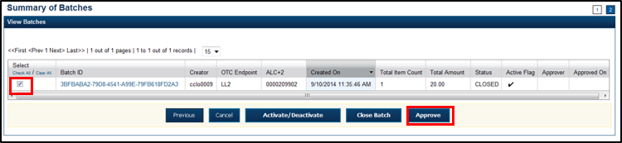

1. Verify that you want to approve the batch and click **Confirm**. The *Approve Batch* page appears with the batch details.
2. Click **Print PDF Report** or **Export** and click **Confirm** to approve the batch.

Application Tips



* After **Print PDF Report** or **Export** is clicked, the **Confirm** button is enabled. The batch is not approved until **Confirm** is clicked.
* If the CCS or CCA checked the **Approve Batch** checkbox under **Advanced Administration**, then the user must print the PDF report or export the batch list report. Afterwards, the user can proceed to approve the batch.
* If the user is approving multiple batches online and the **Approve Batch** checkbox is checked at any OTCnet endpoint, then the user must print the PDF reports or export the batch list reports. The batch is not approved until **Confirm** is clicked, which is enabled when the **Print PDF Report** or **Export** is clicked.
* If the user is approving multiple batches online and the **Approve Batch** checkbox is not checked, then the user can approve multiple batches without printing the PDF reports or exporting the batch list reports. **Confirm** is enabled and the user can click to approve the multiple batches.
* A user may print the PDF report or export the batch list report, regardless of whether the **Close Batch** and/or **Approve Batch** checkboxes are checked or unchecked. A CCS or CCA can specify the **Batch List Report Print/Export Required During** options under **Advanced Administration**.

1. An *Approve Batch* page appears verifying the batch has been approved.
2. Click **Return to Batch Summary**.

Application Tip



After a batch is approved, its status changes from **Closed** to **Approved**, except under one of these two scenarios. First, if a batch has been designated for summary level classification and the batch classification is not balanced. Second, if a batch is designated to be classified at the summary level and it is a CARS/GWA reporter, and the batch is not classified Under these two scenarios the batch status is **Closed**. After the batch is classified and balanced, the batch can be approved.

Additional Buttons



* Click **Cancel** to return to the OTCnet Home Page. No data is saved.
* Click **Previous** to return to the previous page.
* Click **Activate/Deactivate** to activate or deactivate a batch.
* Click **Close Batches** to close a batch.
* Click **<<First** to go to the first page. (Only appears if there are several pages retrieved for the search results.)
* Click **Next>** to go to the next page. (Only appears if there are several pages retrieved for the search results.)
* Click **Last>>** to return to the last page. (Only appears if there are several pages retrieved for the search results.)
* Click **<<Image** to return to the previous check.
* Click **>>Image** to view the next check.
* Click **Zoom-** to reduce the image size.
* Click **Zoom+** to enlarge the image size.
* Click **Rotate Left** to turn the image to the left.
* Click **Rotate Right** to turn the image to the right.
* Click **Show Item** to view and update the check item details.
* Click **Void** to void a single check item.
* Click **Receipt** to print a receipt.
* Click **Print Item** to print a batch list report.

### Approve Multiple Batches

As a CCS, you are authorized to approve multiple batches. You will enter the batch search conditions you would like to view, choose the desired scanned check, verify the details are correct and repeat this for each batch you want to approve. Verify that you want to approve the batches and confirm.

Approve Multiple Batches

To approve **multiple batches**, complete the following steps:

1. From the **Check Processing** tab, click **Batch Management**. The *Search Batch* page appears.
2. Select or enter the batch search conditions you would like view.

Under **Batch Search Conditions**, *optional*

* + Select the **OTC Endpoint** you want to **Close** a batch for by checking the box under the **Select** column

Under **Created On Date**, *optional*

* + Enter the **From** and **To** date range

Application Tips



* The **From** and **To Created On Date** must be entered in MM/DD/YYYY format.
* The **Created On Date** range cannot exceed 30 days. Additionally, if more than 1,000 batches are created within 30 days then only the most recent 1,000 batches appear.
* When running a search **with** the default **From** and **To Created On Date** range values, the search results include the most recent 30 days of batches that you have access to view. If more than 1,000 batches are created within the 30 days, then only the most recent 1,000 batches appear.
* When running a search ***without*** specifying any criteria (with the exception of the **Batch ID** field), the search results include the most recent 30 days of batches that you have access to view. If more than 1,000 batches are created within 30 days, then only the most recent 1,000 batches appear.
  + Enter the **Batch ID**

Application Tip



If the only search criteria entered is a valid **Batch ID** then only a single result appears regardless of other search criteria specified.

* + Enter the **Cashier ID**

Under **Batch Status**,

* + Select the **Status** you want to approve by checking the **Closed** box under the **Select** column

1. Click **Search**. The *View Batch* page appears.
2. Click the **Batch ID** hyperlink as shown in Figure 23. The *View Checks* page appears.

Figure 23. View Batches Page (Approve Multiple Batches)

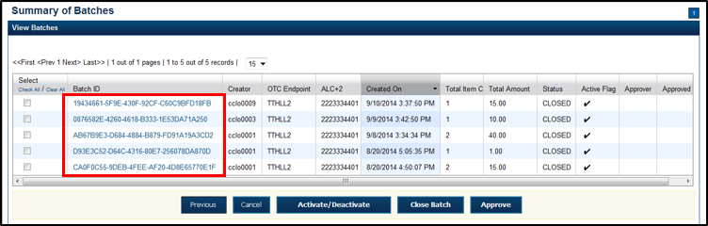

1. Click the **Item ID** of each scanned check. An image of the check and details of the check appear in the window below.
2. Verify the details are correct and click **Previous** to return to the *View Batch* page.
3. Select the batches you want to approve by checking the boxes to the left of the **Batch ID**.
4. Click **Approve**. The *Approve Batch* page appears.
5. Verify that you want to approve the batches and click **Confirm**. The *Approve Batch* page appears with the batch details.
6. Click **Print PDF Report** or **Export** and click **Confirm** to approve the batches.

Application Tips



* After **Print PDF Report** or **Export** is clicked, the **Confirm** button is enabled. The batch is not approved until **Confirm** is clicked.
* A user may print the PDF report or export the batch list report, regardless of whether the **Close Batch** and/or **Approve Batch** checkboxes are checked or unchecked. A Check Capture Supervisor (CCS) or Check Capture Administrator (CCA) can specify the **Batch List Report Print/Export Required During** options under **Advanced Administration**.
* If the **CCS** or **CCA** checked the **Approve Batch** checkbox under **Advanced Administration**, then the user must print the PDF report or export the batch list report. Afterwards, the user can proceed to approve the batch.
* If the user is approving multiple batches online and the **Approve Batch** checkbox is checked at any OTCnet endpoint, then the user must print the PDF reports or export the batch list reports. The batch is not approved until **Confirm** is clicked, which is enabled when the **Print PDF Report** or **Export** is clicked.
* If the user is approving multiple batches online and the **Approve Batch** checkbox is not checked, then the user can approve multiple batches without printing the PDF reports or exporting the batch list reports. **Confirm** is enabled and the user can click to approve the multiple batches.

1. An *Approve Batch* page appears verifying the batches have been approved.
2. Click **Return to Batch Summary**.

Application Tip



After a batch is approved, the Status changes from **Closed** to **Approved** and The *Approve Batch* page appears with the batch details, except under one of these two scenarios. First, if a batch has been designated for summary level classification and the batch classification is not balanced. Second, if a batch is designated to be classified at the summary level and it is a CARS/GWA reporter, and the batch is not classified. Under these two scenarios the batch status is **Closed**. After the batch is classified and balanced, the batch can be approved.

Additional Buttons



* Click **Cancel** to return to the OTCnet Home Page. No data is saved.
* Click **Previous** to return to the previous page.
* Click **Activate/Deactivate** to activate or deactivate a batch.
* Click **Close Batches** to close a batch.
* Click **<<First** to go to the first page. (Only appears if there are several pages retrieved for the search results.)
* Click **Next>** to go to the next page. (Only appears if there are several pages retrieved for the search results.)
* Click **Last>>** to return to the last page. (Only appears if there are several pages retrieved for the search results.)
* Click **<<Image** to return to the previous check.
* Click **>>Image** to view the next check.
* Click **Zoom-** to reduce the image size.
* Click **Zoom+** to enlarge the image size.
* Click **Rotate Left** to turn the image to the left.
* Click **Rotate Right** to turn the image to the right.
* Click **Show Item** to view and update the check item details.
* Click **Void** to void a single check item.
* Click **Receipt** to print a receipt.
* Click **Print Item** to print a batch list report.

## Topic 13 Print a Receipt

Receipts are available for printing if the **CCA** configures the terminal beforehand in OTCnet. If your Agency requires a specific receipt layout, contact your Deployment Specialist at [fiscalservice.otcdeployment@citi.com](mailto:fiscalservice.otcdeployment@citi.com) or 703-377-5586. All receipts are printed in PDF format, as well as saved or attached to a new email message.

After the terminal is configured, **CCOs**, **CCLOs**, and **CCSs** can print a receipt in single mode or batch mode through the **Check Scan** and **Batch Management** functionality, as well as via the **Show Item** to print a receipt. Receipts are available for printing in OTCnet after the operators enter and save the pertinent details and can be either handed to or mailed to the customer.

### Receipt Printing from Check Scan (Single/Batch Mode)

As a **CCO**, **CCLO**, or **CCS**, you are authorized to print a receipt in single mode or batch mode from Check Scan. You can scan the check, input, and save the pertinent details. Print and close the receipt. If you are printing in batch mode, repeat the process throughout the batch.

Print a Receipt from Check Scan

To print a receipt from *Check Scan* functionality: *Single Mode*, complete the following steps:

1. Scan the check, input, and save the pertinent details.
2. Under **Scan Controls**, click **Receipt**. A *Printing…Please wait* message appears and the receipt prints to the default printer.

Application Tip



You have eight seconds to click the **Receipt** button. If the **Receipt** button is not clicked within the allotted time, the button grays out. If a receipt is still needed, access the Batch Management function.

1. Click **Receipt**. The receiptappears as shown in Figure 24*.*

Figure 24. Receipt Print Image (Scan Check)

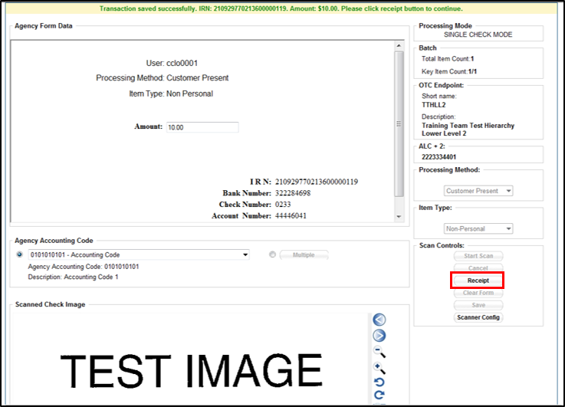

1. Click **Print** to print the receipt.
2. Click **Close** to close the receipt.

Application Tip



When printing a receipt in batch mode repeat steps 1-5 until finished.

Print a Receipt in Batch Management

To print a receipt using Batch Management, complete the following steps:

1. From the **Check Processing** tab, click **Batch Management**.
2. Select or enter the batch search conditions you would like view.

Under **Batch Search Conditions**, *optional*

* + Select the **OTC Endpoint** you want to **Edit** a batch for by checking the under the   
    **Select** column

Under **Created On Date**, *optional*

* + Enter the **From** and **To** date range

Application Tips



* The **From** and **To Created On Date** must be entered in MM/DD/YYYY format.
* The **Created On Date** range cannot exceed 30 days. Additionally, if more than 1,000 batches are created within 30 days then only the most recent 1,000 batches appear.
* If you run a search *with* the default From and To Created On Date range values, the search results include the most recent 30 days of batches that you have access to view. If more than 1,000 batches are created within the 30 days then only the most recent 1,000 batches appear.
* If you run a search ***without*** specifying any criteria (with the exception of the **Batch ID** field), the search results include the most recent 30 days of batches that you have access to view. If more than 1,000 batches are created within 30 days then only the most recent 1,000 batches appear.
  + Enter the **Batch ID**, *optional*

Application Tip



If the only search criteria entered is a valid **Batch ID** then only a single result appears regardless of other search criteria specified.

* + Enter the **Cashier ID**, *optional*

Under **Batch Status**, *optional*

* + Select the**Status** you want to view by checking the **Open** or **Closed** box under the **Select** column

1. Click **Search**. The *View Batch* page appears.
2. Click the **Batch ID** hyperlink. The *View Checks* page appears as shown in Figure 25.

Figure 25. View Checks Page (Receipt)

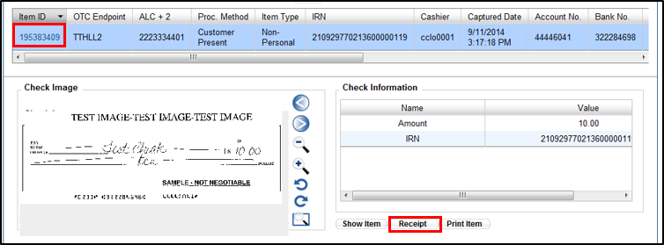

Application Tip



If a batch is in use and another user attempts to access the same batch, a Batch Lock message appears stating the batch is in use and he/she cannot access the batch.

1. Click the **Item ID** of each scanned check. An image of the check and details of the check appear in the window below.
2. Click **Receipt**. The receiptappears*.*
3. Click **Print** to print the receipt.

Application Tip



Account numbers and User Defined Fields (UDFs) that are marked as Personally Identifiable Information (PII) are masked. If there are more than five characters, OTCnet masks all but the last four characters. If there are five characters or less, the system masks all but the last character.

1. Click **Close** to close the receipt.

Application Tips



* Click **Show Item** to view more details about the check.
* Under **Server Controls**, click **Receipt** to print the receipt.

## Summary

In this chapter you learned:

* The Purpose of Capturing and Managing Checks Online
* Capture a Check Online
* Manage Poor Check Image Quality
* Resolve a Duplicate Check
* Void a Check
* Override a Master Verification Record (MVD) Record
* Perform Batch Control and Batch Balancing
* View and Print a Batch List/Item Detail Report
* Activate/ Deactivate a Batch
* Classify a Batch
* Close a Batch
* Approve a Batch
* Print a Receipt