

OTCnet Participant User Guide

Table of Contents

Overview, Topics, and Audience 1

Overview 1

Topics 1

Audience 1

Topic 1 Query Card Transaction History 2

Query Card Transaction History 3

Topic 2 Card Refunds 5

Credit Card Refunds 5

Credit Card Refunds 6

Debit Card and Gift Card Refunds 8

Debit Card and Gift Card Refunds 9

Summary 11

List of Figures

Figure 1: Card Processing – Query Card Transaction History, Transaction Status 4

Figure 2: View Card Transaction History Details, Click Refund Transaction 6

Figure 3: View Card Transaction History Details, Refund With Cash 9

Glossary

Click this [link](https://www.fiscal.treasury.gov/otcnet/training/wbt/content/course_OTC/glossary.htm) to access the full OTCnet Glossary.

## Overview, Topics, and Audience

### Overview

Welcome to *Reporting on Card Transactions*. In this chapter, you will learn to:

* Query Card Transaction History
* Complete a Card Refund

### Topics

* Query Card Transaction History
* Card Refunds

### Audience

The intended audience for the *Reporting on Card Transactions* Participant User Guide includes:

* Card Operators

## Topic 1 Query Card Transaction History

**Query Card Transaction History** allows for the following:

* Querying card transaction history
* Refunding a transaction
* Printing a receipt for a refund
* Reprinting a sales receipt

When a query is run, OTCnet validates and retrieves the items that meet the query criteria and displays the results, if validation passes. OTCnet displays selected transaction record details. To run a query, the OTCnet Local Bridge must be started.

As a **Card Operator,** you are authorized to query card transaction history. Search card transactions by **Chain Code**, **Division**, **ALC**, **Merchant ID**, **Invoice ID**, **Date**, and **Transaction Status**. You can also query card transaction history against only one Endpoint selection. If the criteria entered does not generate any card processing transaction records, OTCnet displays the error message, “*No card processing transaction records found.”*

The *Query Card Transaction History* page allows you to select a transaction record and view the details from your search results. The search results include card transactions that have been processed in OTCnet and the kiosk card transmission file. The search results also include the **Total Records** and the **Total Card Amount** of the transactions returned by the query. When a transaction status is not selected:

* **Total Records** displays the total number of records that are displayed from the query results.
  + **Total Records** = Captured + Refunded
* **Total Card Amount** displays the total amount value for all the card transactions that are displayed from the query search results.
  + **Total Card Amount** = Capture – Refunded

Refunded amounts are subtracted from the **Total Card Amount**. However, they are still included in the **Total Records** count. The search for *Query Card Transaction History* is case sensitive.

Query Card Transaction History

To complete a card transaction query, complete the following steps:

1. From the Card Processing tab, click **Card Transaction Query**.
2. The *Card Processing – Query Card Transaction History* page appears. Enter your search criteria.

* Under Search Criteria,
  + Enter an Endpoint*, optional*
  + Enter the Chain Code*, optional*
  + Enter Division*, optional*
  + Enter ALC*, optional*
  + Enter Merchant ID*, optional*
  + Enter Invoice ID*, optional*
  + Select a From and To Date range*, optional*
  + Under **Transaction Status**, click the **Processed** or **Refund** radio button*, optional*

Application Tips



* The maximum Date range is 30 days.
* A **Processed** payment is a completed payment.
* A **Refunded** payment is a payment that has been credited back to a customer.

1. Click **Search**. The Search Results table appears, as shown in Figure 1. Click **Count** to display the **Total Records** and **Total Card Amount.**

Application Tips



**Total Records** are displays showing the total number of records that are displayed from the query results.

* **Total Records** = Captured + Refunded

**Total Card Amount** displays the total amount value for all the transactions that are displayed from the query search results.

* **Total Card Amount** = Capture – Refunded

Figure : Card Processing – Query Card Transaction History, Transaction Status

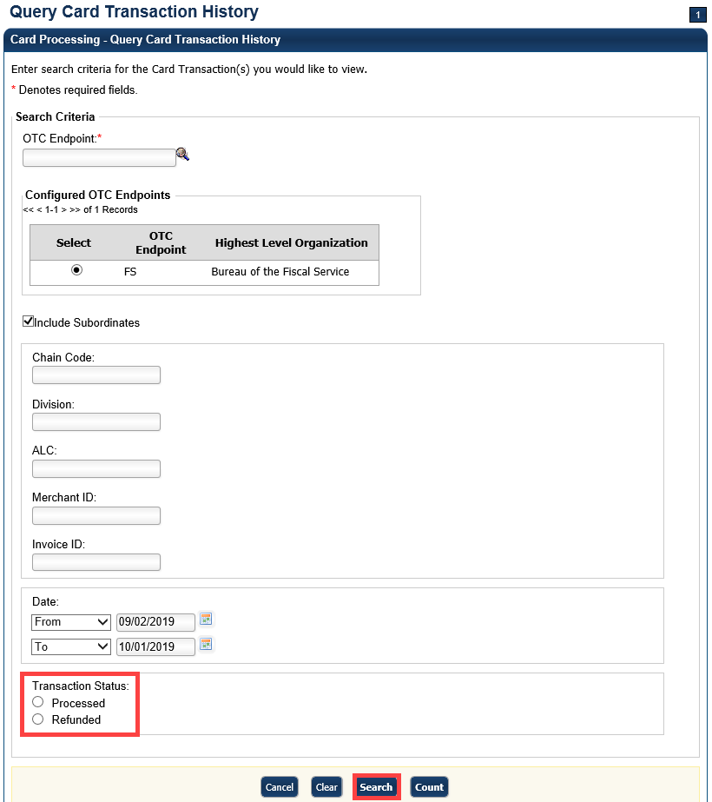

1. Click the **Invoice ID** hyperlink of the card transaction details you wish to view. The *View Card Transaction History Details* page displays. Review the details of the selected transaction record.
2. Refund a credit or gift card transaction by clicking **Refund Transaction**.
3. Refund a debit card transaction with cash by clicking **Refund With Cash.** Click **Print Sale Receipt** to print a paper receipt.

Additional Buttons



* Click **Refund Transaction** to refund a card transaction.
* Click **Print Sale Receipt** to print a paper receipt.
* Click **Previous** to return to the previous page.
* Click **Return Home** to return to the OTCnet Home Page.

## Topic 2 Card Refunds

### Credit Card Refunds

**Card Operators** have the authority to refund card transactions. A refund is a transaction that returns a card payment to the customer. For credit card refunds, the return is credited back to the customer’s card. Gift card refunds and debit card refunds are paid in cash, by the Agency. All refunds are processed through the *Card Transaction Query*page.

To complete a credit card refund, the OTCnet Local Bridge (OLB) must be started and you must have completed your card terminal setup.

Agencies are responsible for reconciling all transaction data. For card transactions, data reconciliation can be conducted using the source system, merchant card processor, and the Department of Treasury’s reporting repository. Card transactions processed via OTCnet are viewed within the OTCnet application, Worldpay from FIS iQ portal, and Collections Information Repository (CIR). CIR provides the summary and detailed transaction data for settled transactions.

When reconciling, CIR has Card Reports that provide the user with all reporting information associated with the selected card transaction(s). These transactions auto pull from the Card Acquiring Service (CAS) and Pay.gov.

Additional information includes the following:

* Refunds are recorded in the **Audit Log**.
* Refunds are recorded as separate transactions from card payments.
* You cannot refund a previously refunded transaction. Once a refund is successfully processed, **Refund Transaction** is no longer shown on the *View Card Transaction History Details* page. If the transaction selected is for a sale transaction that has already been refunded, **Refund Transaction** does not display.

Credit Card Refunds

To complete a credit card refund, complete the following steps:

1. Click **Card Processing**>**Card Transaction Query**.
2. The *Card Processing—Query Card Transaction History* page appears. Enter your search criteria. Click **Search**.
3. The Search Results table appears. Click the **Invoice ID** hyperlink of the card transaction details you wish to view.
4. The *View Card Transaction History Details* page displays the card transaction history details as shown in Figure 2. Review the details of the selected transaction record. Click **Refund Transaction**.

Figure : View Card Transaction History Details, Click Refund Transaction

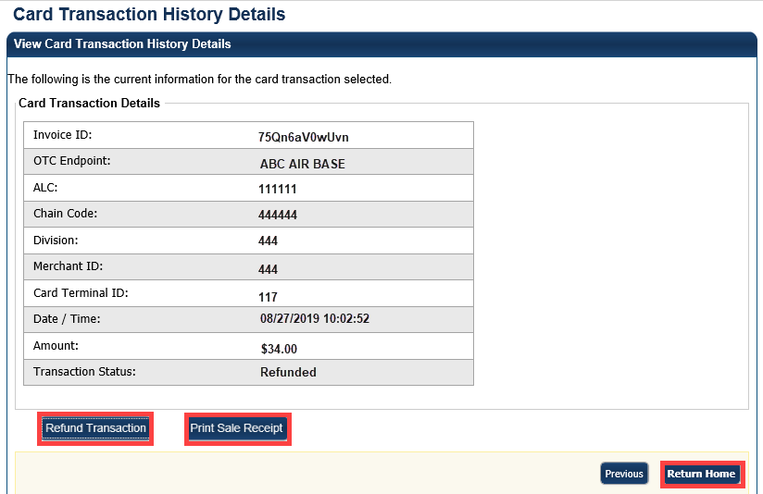

Application Tip



Click **Print Sale Receipt** to print a receipt for the original transaction.

1. A *Refund Transaction* dialog box appears. Click **OK.** On the *View Card Transaction History Details* page, the **Refund in Progress** message appears.
2. The **Refund Transaction** dialog box appears, stating the transaction was successful. Click **Close.**

Application Tips



* If a customer requests a receipt, click **Print Refund Receipt** before clicking **Close**.
* Once the transaction is refunded, **Refund Transition** is no longer visible on the *View Card Transaction History Details* page.
* Once a refund has been issued, the customer cannot reprint a receipt for the original sale transaction, from this screen. You can query the transaction again, search for **Processed** transactions and **Print Sale Receipt**.

Additional Buttons



* Click **Print Sales Receipt** to print a paper receipt.
* Click **Previous** to return to the previous page.
* Click **Return Home** to return to the OTCnet Home Page.

1. To reprint an approved payment receipt for credit and gift cards, click **Print Refund Receipt** from the *View Card Transaction History Details* page.

### Debit Card and Gift Card Refunds

**Card Operators** have the authority to refund a debit card or a gift card transaction. Both refunds are provided in cash, by the Agency, and processed through the **Card Transaction Query**.

Debit card and gift card transactions are recorded as separate transactions in OTCnet. OTCnet does not send any data to Worldpay as a debit card refund will not be applied to a customer’s card, when using a PIN number. The Agency documents the transaction as an offline process. OTCnet captures the transaction data for the cash refund.

You *do not* need the OLB or card terminal for debit card or gift refunds. An exception is, debit card payments processed using PIN Bypass on the card terminal. These payments are refunded back to the debit card, as they are recorded as credit card payments. You may refund a debit transaction from any workstation.

PIN Bypass is when the customer chooses to bypass entering a PIN number on the card terminal. When bypassing the PIN number entry, the debit card is run as a credit card payment. These payments can be refunded back to the debit card, as they are recorded as credit card payments.

Debit Card and Gift Card Refunds

To complete a debit card or gift card refund, complete the following steps:

1. Click **Card Processing**>**Card** **Transaction Query.**
2. The *Card Processing—Query Card Transaction History* page appears. Enter the search criteria you wish to query. Click **Search**.
3. The Search Results table appears. Click the **Invoice ID** hyperlink of the card transaction details you wish to view.
4. From the *View Card Transaction History Details* page, click **Refund with Cash** as shown in Figure 3.

Figure : View Card Transaction History Details, Refund With Cash

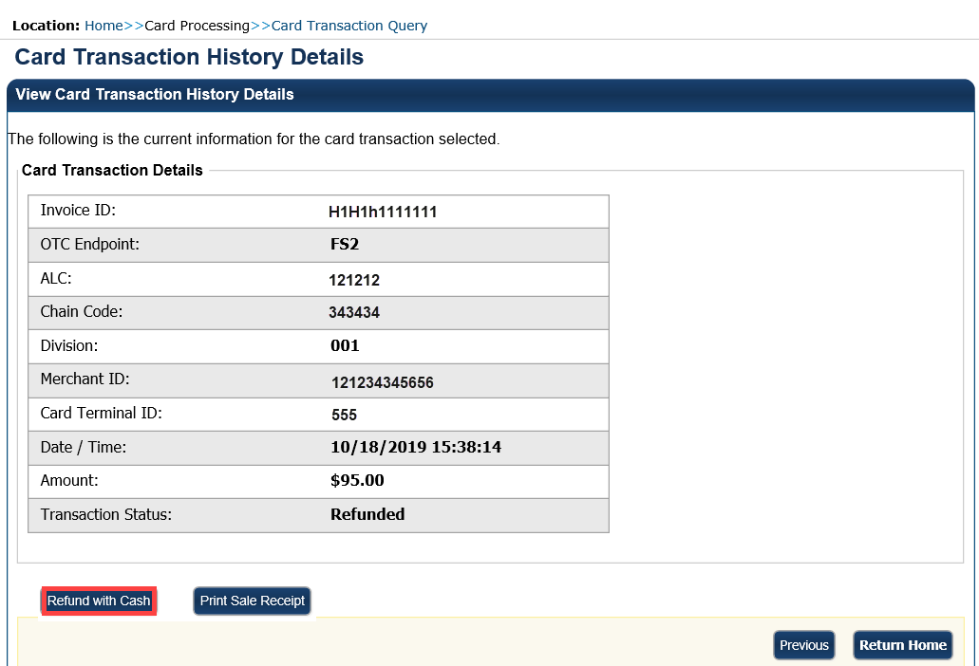

Application Tip



A card terminal is not required for debit or gift card cash refunds. You may refund a debit or gift card transaction from any workstation.

1. The **Refund Transaction** dialog box appears. Provide the customer the cash refund for the debit card or gift card transaction. Click **OK**.

Application Tip



Once the transaction is listed as refunded, **Refund Transaction** is no longer visible.

1. The **Refund Transaction** dialog box appears. Provide the customer the cash refund and click **Close.**

Application Tips



* If a customer requests a receipt, click **Print Cash Refund Receipt** before clicking **Close**.
* Once the transaction is refunded, **Refund with Cash** is no longer visible on the *View Card Transaction History Details* page.

1. To reprint an approved payment receipt for debit or gift cards, click the **Print Cash Refund Receipt.**

Additional Buttons



* Click **Print Cash Refund** to print the paper receipt.
* Click **Previous** to return to the previous page.
* Click **Return Home** to return to the OTCnet Home page.

## Summary

In this chapter, you learned:

* Query Card Transaction History
* Card Refunds