

OTCnet Participant User Guide

Table of Contents

Overview, Topics, and Audience 1

Overview 1

Topics 1

Audience 1

Topic 1 Purpose of Managing Card Transactions 2

Topic 2 Process a Card Payment 4

Card Terminal 5

Types of Acceptable Cards 7

Cancel a Card Payment 13

Credit and Debit Card Collections Transactions 16

Topic 3 Print a Paper Receipt 17

Print a Receipt From the Card Capture—Perform Card Transaction Page 18

Print a Receipt From Card Transaction Query 19

Reprint a Paper Receipt 20

Summary 21

List of Figures

Figure 1. Card terminal, initial screen 5

Figure 2. Card Capture – Perform Card Transaction, enter dollar amount of card payment in OTCnet 6

Figure 3. Card Terminal, payment amount, insert card 6

Figure 4. Card Capture – Perform Card Transaction, enter Amount and Process Payment 9

Figure 5. Card Capture – Perform Card Transaction, enter Amount and click Manual Card Entry 11

Figure 6. Card Capture - Perform Card Transaction, cancel card payment 14

Figure 7. Card Processing Card Capture – Perform Card Transaction, Print Receipt 18

**Figure 8. View Card Transaction History Details, Print Sale Receipt** 19

List of Tables

Table 1. Card Processing Tasks 3

Glossary

Click this [link](https://www.fiscal.treasury.gov/otcnet/training/wbt/content/course_OTC/glossary.htm) to access the full OTCnet Glossary.

## Overview, Topics, and Audience

### Overview

Welcome to *Capturing and Managing Card Transactions*. In this chapter, you will learn:

* The purpose of managing card transactions
* How to process a card transaction
* How to process a receipt from the card terminal

### Topics

This chapter is organized by the following topics:

* Purpose of Managing Card Transactions
* Process a Card Transaction
* Process a Receipt

### Audience

The intended audience for the *Capturing and Managing Card Transactions* Participant User Guide includes:

* Card Operators

## Topic 1 Purpose of Managing Card Transactions

There are two components under the **Card Processing** tab within OTCnet. They include **Process Card Payment** and **Card Transaction Query**. The **Card Processing** functionality is used to capture and manage credit, debit and gift card transactions. As a **Card Operator**, you are authorized to process card payments and refunds. The card transaction information is then stored in the OTCnet application.

A successful card transaction is saved in the OTCnet database with the following fields populated:

* Card Transaction Status
* Card Entry Mode
* Card Payment Network
* Card Processing Method
* Source
* Card Transaction Amount
* Refund Indicator (Y or N)
* Card Timestamp
* Card Time zone
* Chain Code
* Division
* Merchant ID
* Card Terminal ID
* Card Invoice ID

When processing card transactions in OTCnet, OTCnet prevents duplicate debit and credit card transactions by using a (Card) Invoice ID as a unique identifier. When a card is declined, OTCnet does not record declined card transactions in OTCnet.

OTCnet does not apply refunds to debit or gift cards. The agency may offer one of the following:

* Distribute a cash refund for debit card and gift card transactions
* Relay to customers that refunds can only be made to credit cards

Once the card transaction data is collected, a user may query card transaction data (e.g., for processed and refunded card payments).

Below is the list of responsibilities for the **Card Administrator** and **Card Operator**. Some responsibilities overlap and others do not. The **Card Administrator** can modify organization hierarchy and user defined fields (UDFs), manage card processing, and download the OTCnet Local Bridge, for example. **Card Operator** responsibilities include, though are not limited to: processing card payments, printing receipts and performing card transaction queries.

Table . Card Processing Tasks

| Card Processing Task | Card Operator | Card Administrator | Card Uploader* |
| --- | --- | --- | --- |
| Manage Own Account |  |  |  |
| OTCnet Logon and Homepage |  |  |  |
| Modify Organization Hierarchy | BLANK |  |  |
| Delete Organization Hierarchy | BLANK |  |  |
| View Organization Hierarchy |  |  |  |
| Search Organization |  |  |  |
| Process Card Payments |  | BLANK |  |
| Process Card Refunds |  |  |  |
| Print Receipts |  |  |  |
| Card Transaction Query |  | BLANK |  |
| Modify User Defined Fields (UDF) |  |  |  |
| View User Defined Fields (UDF) |  |  |  |
| Manage Card Process – Modify Terminal Configuration |  |  |  |
| Manage Card Process – View Terminal Configuration |  |  |  |
| Download OTCnet Local Bridge | BLANK |  |  |
| Create OTCnet Local Bridge OLB Credentials |  |  |  |
| Import OTCnet Local Bridge OLB Credentials |  |  |  |
| Read/View Audit Admin – (Partial) | BLANK |  |  |
| Read/View Audit Card Module – (All) | BLANK |  |  |
| Read/View Audit Card Module – (Partial – Access User's Own Activities Only) |  | BLANK |  |
| Card Web Service | BLANK | BLANK |  |

* The Card Uploader is a self-service kiosk-server system role that is authorized to transmit card data from an external kiosk system to OTCnet. This role requests acknowledgement of the data transmitted; the system account with this role has no other permissions.

## Topic 2 Process a Card Payment

As a **Card Operator**, you are authorized to capture a customer’s credit, debit and gift card payments. Once a **Card Administrator** sets up your card terminal configuration settings, you can process a card payment.

**Card Administrators** are authorized to create UDFs for card processing. UDFs are custom fields created to capture information on specific data fields in OTCnet. These UDFs display for the **Card Operator** on the*Card Capture – Perform Card Transaction*page. UDFs can be configured to be either required or optional. The maximum number of UDFs for card processing is three.

There are two ways to process a card payment:

1. Process Payment
2. Manual Card Entry

**Logical Order for Capturing a Card Payment**

To capture a card payment and ensure the batch reaches OTCnet and WorldPay, follow these steps:

* **Verify the OLB connection**
  + If the OLB is connected, the system proceeds to validate that your card terminal is registered. If the OLB is not connected, you receive an error message. If the OLB is not online, you cannot make a card payment.
  + The OLB Communication Indicator, in the upper right-hand corner of the screen, communicates whether the OLB connection is active (green) or inactive (red).
  + If the OLB is online, OTCnet validates that the terminal is registered and displays the message “*Validating registration*…”.
    - If a registered terminal is found, the “*Registration found*!” message displays.
    - If a registered terminal is not found, or a terminal is offline, the error message “*The Card Terminal could not be detected. Please verify that your terminal is connected (plugged in) and/or configured to the OTCnet application*” displays.
    - If the OLB is inactive, the Card Processing page is blank and error message “*Terminal detection failed. Please ensure that the OLB application is running”* displays.
    - If the OLB connection is lost at any time during card payment, check the OLB connection and restart the card payment workflow from the beginning.
* **Validate that your card terminal is registered** – it must be set up and turned on.
* **Capture the card payment** – The **Card Operator** enters the payment amount and requested field data for the card payment and clicks **Process Payment**. This prompts the customer to pay with a credit, debit or gift card on the terminal to complete the transaction.
* **Cancel payments while performing data entry** – This is used only if necessary, i.e., customer changes his/her mind about making a card payment.
* **Print a receipt** – This is used after the item information is keyed into the data entry screen. Click **Process Payment** and click **Receipt** to print a receipt for the transaction.

### Card Terminal

OTCnet agencies use the card terminal for card processing as shown in Figure 1. The **Card Operator** enters the dollar amount of the card payment in OTCnet as shown in see Figure 2. A message displays at the top of the *Card Capture – Perform Card Transaction* page discouraging users from entering Personally Identifiable Information (PII) data in any UDF.

The customer inserts the card, at the bottom of the terminal as shown in Figure 3, swipes the magnetic strip of a card on the right side of the card terminal, or taps a contactless card, for payment with the card terminal. The card terminal also performs refunds and voids transactions.

Once the card terminal is set up, the initial screen may vary. Typically, a *Welcome*, *Thank You for shopping with us*, or *Have a nice day* screen appears.

Figure . Card terminal, initial screen

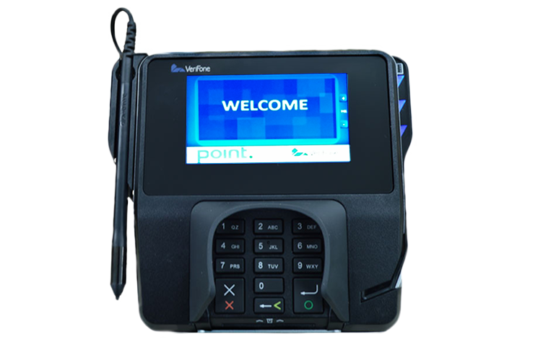

Figure . Card Capture – Perform Card Transaction, enter dollar amount of card payment in OTCnet

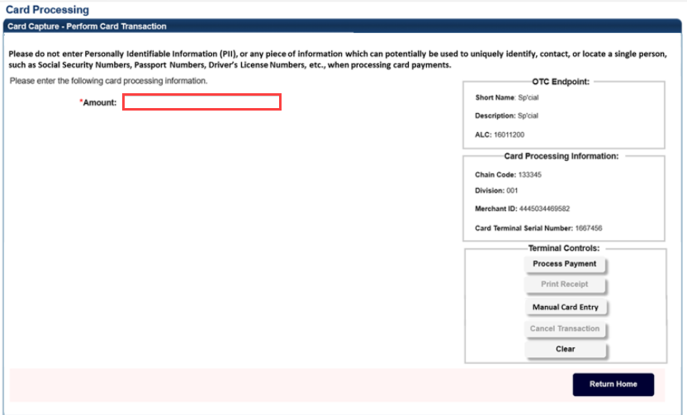

Figure . Card Terminal, payment amount, insert card

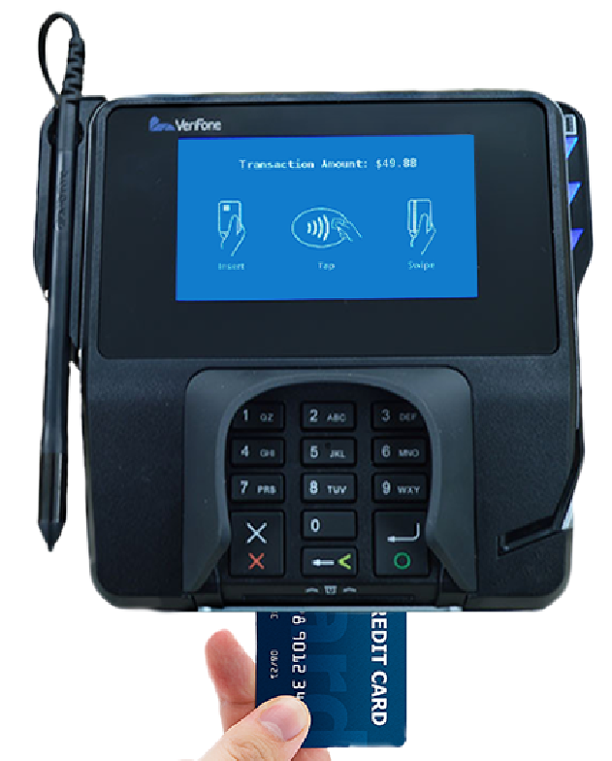

### Types of Acceptable Cards

The acceptable credit, debit and gift cards that can be processed through the OTCnet card processing functionality are listed below. If a customer tries to use a different type of card, the payment is declined and you receive the message, “*The card was declined. Please inform the customer to try an acceptable card*.” Acceptable cards include the following major label cards:

* Visa
* MasterCard
* American Express
* Discover

**Process a Card Payment – Process Payment**

To capture a card payment with Process Payment, complete the following steps:

1. From the **Card Processing** tab, click **Process Card Payment**. The *Card Capture – Perform Card Transaction* page appears.

Application Tip



OTCnet verifies the OLB connection. Next, OTCnet validates card terminal registration, the “*Registration found!*” message appears.

1. Under **Transaction Data**, enter the **Amount** of the card payment.

Application Tips



* An amount must be entered (it displays in the **Amount** field) or the **Card Operator** receives the message,“*Please enter an amount*.”
* Enter the amount using two decimal places e.g., for a $25.00 payment, enter: “25.00”.
* When entering an amount, only two decimal places can be entered and no alpha characters.
* When entering characters in the **Amount** field, the only symbol accepted is a “.” **Card Operators** receive an “*Invalid character entered in the transaction amount field*” message if any other characters are entered.
* The amount entered must be greater than $0.00 and less than $24,999.99. An amount must be entered, or the **Card Operator** receives a message to “*Please enter an amount*. *Please inform the customer to try again. Then click the* ***Process Payment*** *button*.” The amount displays in the **Amount** field (see Figure 8). Click **Process Payment**.
* When digits are entered in the **Amount** field that are less than 0.01, the **Card Operator** receives the message, “*The transaction amount entered cannot be less than 0.01*.”

1. Under Terminal Controls, click **Process Payment** as shown inFigure 4. Press **Clear** to clear the Amount field. The customer is presented with the *Transaction Amount* screen. The customer makes a card payment by inserting the card into the chip insert slot, tapping a contactless card on the screen, or swiping the magnetic strip of a card on the right side of the card terminal. The card terminal begins to process the payment.

Figure . Card Capture – Perform Card Transaction, enter Amount and Process Payment

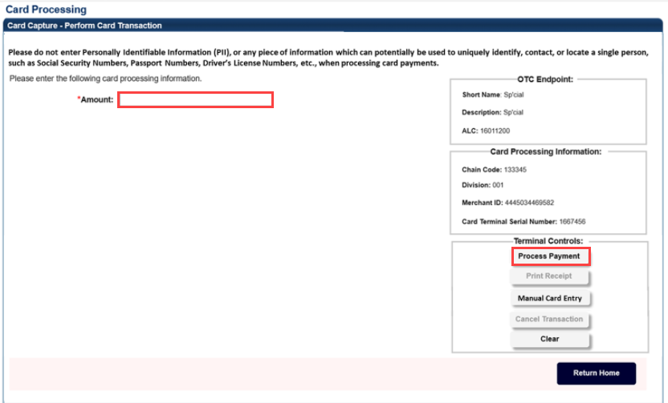

Application Tip



Once you click **Process Payment**, **Cancel Transaction** is enabled, and you can cancel the transaction.

1. On the card terminal, the *Your Total is* screen appears, with the dollar amount of the payment. The customer presses the **Pay Now** button.
2. The card terminal responds: *Press Enter PIN or Press Green Enter to Bypass Pin*. The customer presses the green (O) button. The card terminal completes the payment process.

Application Tips



* When making a card payment using a debit card, the customer must enter the card pin. If the pin is not entered, you receive this message in OTCnet: “*The card was declined. Please inform the customer to try again. Then click the 'Process Payment' button*.”
* Dual Interface debit cards can bypass pin entry, non-dual interface debit cards cannot. A debit card is non-dual interface if there is no major payment network logo on the card (i.e., Visa or Mastercard). When a non-dual debit card is used and the customer chooses to bypass pin entry, the payment is declined, because a signature is required for these payments. Card terminals are configured not to accept signatures. If the card is a dual interface debit card, and the customer chooses to bypass pin entry, the payment will be processed as a credit.
* On the card terminal, a number of messages may appear for the customer, depending on whether the customer inserts or swipes a card or taps a contactless card. After the customer completes the payment, OTCnet displays the “Transaction was processed successfully. Card invoice ID XXXXXXXXXXXX, Amount $XX.00” message.
* The A**mount** field is cleared out. **Process Payment** and **Print Receipt** are enabled. To print a receipt, you have 4-6 seconds to click Print Receipt. If Print Receipt is not clicked within the allotted time, it grays out. If a receipt is still needed, access Topic 3: Process a Paper Receipt from the Card Terminal in this user guide.
* When the terminal is in a busy state (i.e., currently being used by another Point of Sale [POS]), the terminal displays this message: Card terminal is busy when the Card Operator clicks Process Payment.
* Typically, the customer only waits a few seconds. When a card is declined, you receive the message, “The card was declined. Please inform the customer to try again.”

**Process a Card Payment – Manual Card Entry**

To capture a card payment with Manual Card Entry, complete the following steps:

1. Under Terminal Controls, click **Manual Card Entry** as shown in Figure 5 **.** Press **Clear** to clear the **Amount** field.

Figure . Card Capture – Perform Card Transaction, enter Amount and click Manual Card Entry

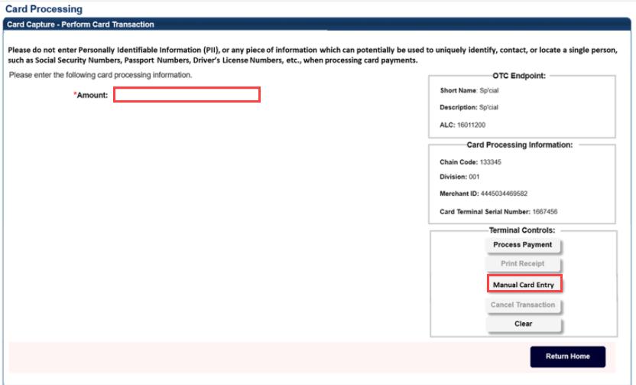

Application Tips



* Use **Manual Card Entry** only when the customer’s card is not properly read when the card is inserted, swiped, or tapped on the card terminal.
* When you select the **Manual Card Entry** button, a message appears, “*Manual card entry should only be used as a contingency when other card payment methods do not work. Debit cards cannot be used for manual card entry. Are you sure you want to manually enter the customer’s card to complete this payment*?”
* Once you click **Manual Card Entry, Cancel Transaction** alsobecomes enabled, and you can cancel the transaction.
* The latest version of the OLB must be installed to use Manual Card Entry.

1. Click **Yes** in response to the Manual Card Entry verification to proceed.

Application Tip



If you do not wish to proceed, click **No** to the Manual Card Entry verification. The screen returns to normal and the **Process Payment, Manual Card Entry**, and **Clear** buttons are clickable.

1. On the card terminal, the customer is presented with the *Please Enter Card Number* screen. The customer uses the card terminal buttons to enter the card number and presses the green (O) button.
2. The *Please Enter Expiry Date (MM/YY)* screen appears. The customer uses the card terminal buttons to enter the card’s expiration date and presses the green (O) button.
3. The *Please Enter CCV Number* screen appears. The customer uses the card terminal buttons to enter the card’s CCV number and presses the green (O) button.
4. The *Pay Now* screen appears. The customer presses either the green (O) button or the Pay Now button.

Application Tips



* On the card terminal, a number of messages may appear for the customer. After the customer completes the payment, you see the message, “*Transaction was processed successfully. Card invoice ID XXXXXXXXXXXX, Amount $XX.00.*”
* The **Amount** field is cleared out. **Process Payment** and **Print Receipt** are enabled. To print a receipt, you have 4-6 seconds to click **Print Receipt**. If **Print Receipt** is not clicked within the allotted time, it grays out.

### Cancel a Card Payment

The **Card Operator** is authorized to cancel a payment in OTCnet after a payment amount is entered for payment processing. Cancelling a card payment means that the amount of the payment is credited back to the customer. A payment may be canceled for various reasons, for example: you may begin the payment process too soon and the customer isn’t ready, or the customer may realize he/she does not have a card available for payment.

There are three ways to cancel a card payment using OTCnet and the card terminal:

1. In OTCnet, you can cancel the payment by clicking **Process Payment**.For Process Payment, the customer must have either inserted the card into the slot on the bottom of the card terminal, tapped a contactless card on the card terminal screen, or swiped the magnetic strip of a card on the right side of the card terminal, and the customer cannot have provided additional input**.** 
   * Additional input may include typing in a Pin or clicking the green (O) button. Next, click **Cancel Transaction**. You have **Cancel** **Transaction** in the Terminal Controls area. When you click **Cancel** **Transaction**, the payment is canceled. The customer receives a “*Canceled”* message on the card terminal. You can print a **Canceled Receipt**.
   * Once a customer has used a card on the card terminal, the payment data is sent to WorldPay (in-flight) and cannot be canceled by the customer or by you. In this scenario, a **Canceled Receipt** does not apply.
2. In OTCnet, you can cancel the payment by clicking **Manual Card Entry**. Once you have entered the card number in the card terminal, click **Cancel Transaction**. When you click Cancel Transaction, the payment is canceled. The customer receives a “*Canceled*” message on the card terminal. You can print a Canceled Receipt. If you have not entered the card number, you do not need to click Cancel Transaction.
3. On the card terminal, the customer cancels the payment. The customer clicks on the red button (X) on the card terminal. In OTCnet, you receive a message on the *Card Capture – Perform a Card Transaction* screen that the payment is canceled. Provide instructions, to the customer, on how to perform another payment.

**Cancel a Card Payment**

In **option one**, to cancel a card payment with Process Payment, complete the following steps:

1. From the *Card Capture—Perform Card Transaction* page, enter the pertinent card details using **Process Payment.** Click **Cancel Transaction** as shown inFigure 6to cancel the payment.

Figure . Card Capture - Perform Card Transaction, cancel card payment

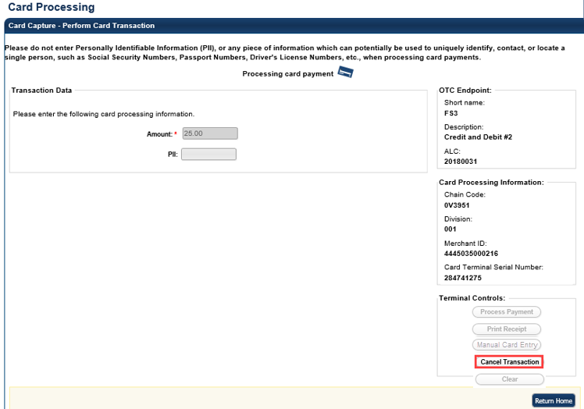

Application Tip



It takes about 6-8 seconds to process a payment. To cancel a payment, you must click **Cancel Transaction** during this time. On the card terminal, customers receive a message communicating that the transaction has been canceled.

The system prints a receipt with “Result = Canceled”. Select **Return Home** to go to the OTCnet homepage.

Application Tip



The receipt is printed to your default Windows receipt printer. **Print Receipt** stays enabled to allow you to print multiple copies of a receipt.

In **option two**, to cancel a card payment with Manual Card Entry, complete the following steps:

1. From the *Card Capture—Perform Card Transaction* page, enter the pertinent card details, using **Manual Card Entry**. Click **Cancel Transaction** to cancel the payment.
2. The system prints a receipt with “Result = Canceled”. Select **Return Home** to go to the OTCnet homepage.

In **option three**, to cancel a card payment, follow this step:

1. The customer is presented with the “*Transaction Amount*” screen. The customer clicks the **red button (X**) twice.

Application Tips



* A customer can cancel a card payment at any time during the payment process.
* The customer must press the red button (X) twice to cancel the payment.
  + The first time the customer presses the red button (X) it cancels PIN entry.
  + The second time the customer presses the red button (X) it cancels the transaction.

### Credit and Debit Card Collections Transactions

According to the Treasury Financial Manual, debit and credit (Card) acquiring services are provided by a financial institution, designated by the Bureau of the Fiscal Service (Fiscal Service), as its Financial Agent. The Financial Agent credits and debits participating agencies for all Card transactions initiated by agencies for collection of obligations. The Financial Agent may use the services of a merchant acquirer, or processor, for card authorization, transaction processing and other services on behalf of the Financial Agent.

The role of the Agencies in credit and debit card collections includes the following, they must:

* Obtain authorization for each sales transaction for the total amount of the transaction. An authorization code indicates availability of a cardholder’s credit, or funds, upon authorization. If a sales transaction is not authorized, the agency must not complete the sale. Declined sales transactions are initiated from the bank that issued the Card. The Financial Agent is authorized to credit and debit an agency for any sums due to and from the agency. An agency must deposit only transaction receipts that result from cardholder transactions with that agency.
* Review all card collection processes. Ensure that personnel assigned as business line (Chain) and location level (Merchant Identification Number) points of contact are properly trained to accommodate Visa, Mastercard, American Express, Discover, and debit cards, as appropriate.
* Limit their daily credit card collections; individual transactions are no more than $24,999.99. You will receive messages from OTCnetduring card payment and via OTCnet when specific actions occur.

## Topic 3 Print a Paper Receipt

You are authorized to print paper receipts for card transactions using **Process Card Payment** or **Card Transaction Query**. Once you have processed a payment successfully, print an **Approved Receipt**. You may also print a **Declined Receipt** for a declined payment or a **Canceled Receipt** for a canceled payment. You may print multiple copies of a receipt.

A paper receipt is generated for approved, declined and canceled credit, debit or gift card payments. The receipt(s) prints out to your default Windows printer (on 8.5 x 11 letter-sized paper). The receipt is custom to the result of the transaction.

The return/refund policy at the bottom of the **Approved Receipt** template is selected by the organization. If refunds are not issued because the transaction is not for a service or purchase, no policy is shown. The receipt includes: **Address Line 1**, **Address Line 2**, **City**, **State**, **ZipCode**, and the **Telephone** number where the credit, debit or gift card payment is made.

When printing a receipt, keep the following information in mind:

1. The **Approved Receipt** is the same receipt, whether printed from the *Card Capture-Perform Card Transaction* page or from the *Card Transaction Query* page.
2. OTCnet captures an audit record of all print receipts.
3. On the card terminal, a signature is not required for all card types. Some agencies may require a signature on a printed receipt. Other agencies do not. This is determined by the agency.
4. Only American Express cards require a receipt be printed for declined and canceled payments. Visa, Mastercard and Discover cards do not require a receipt for canceled transactions. Declined and canceled payment receipts are printed for all card brands for consistency.

**Print a Receipt From the Card Capture—Perform Card Transaction** Page

To print a paper receipt from Card Processing, the *Card Capture—Perform Card Transaction* page, complete the following steps:

1. Enter the pertinent card details to process a card payment.
2. Under Terminal Controls, click **Print Receipt** as shown inFigure 7. An **Approved Receipt** prints for the approved transaction.

Figure . Card Processing Card Capture – Perform Card Transaction, Print Receipt

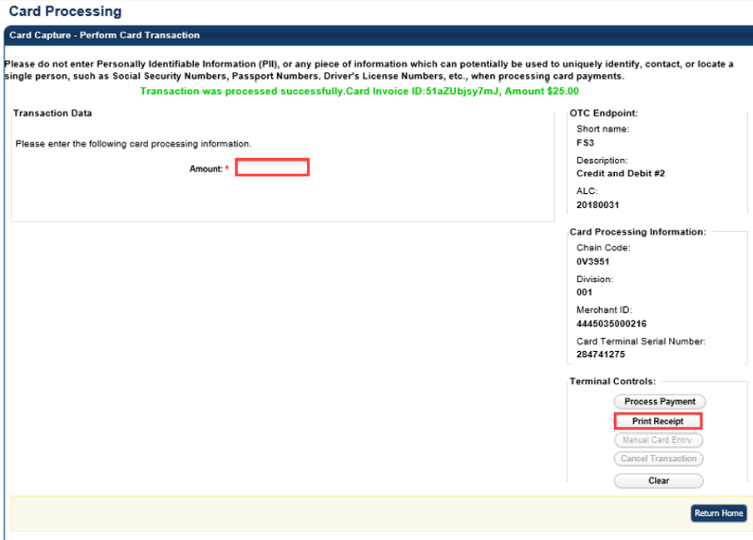

Application Tips



* **Print Receipt** remains enabled to allow you to print additional receipts.
* You haveabout 4-6 seconds to click **Print** **Receipt**.
* If **Print Receipt** is not clicked within the allotted time, it grays out. If a receipt is still needed, access the **Card Transaction Query** function.

Print a Receipt From Card Transaction Query

To print a paper receipt from the *Card Transaction Query* page, complete the following steps:

1. Enter the pertinent card details to process a card payment.
2. The *View Card Transaction History Details* page displays. Click **Print Sale Receipt** as shown inFigure 8 to print a paper receipt. Click **Return Home**.

**Figure 8. View Card Transaction History Details, Print Sale Receipt**

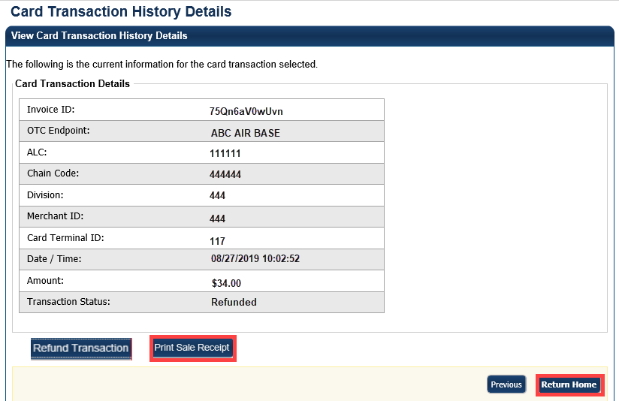

Additional Buttons



* **Previous** enables you to return to the previous page.
* **Refund Transaction** is also enabled. An **Approved Receipt** prints for the approved transaction.
* **Print Sale Receipt** remains enabled so that you can reprint additional receipts as needed.

Reprint a Paper Receipt

To reprint a paper receipt, complete the following steps.

1. From the *Card Capture—Perform Card Transaction* page, enter the pertinent card details to process a card payment.
2. Under Terminal Controls, click **Print Receipt**. An **Approved Receipt** prints for the approved transaction.

Application Tips



* **Print Receipt** remains enabled to allow you to print additional receipts.
* You haveabout 4-6 seconds to click **Print** **Receipt.**
* If **Print Receipt** is not clicked within the allotted time, it grays out.
* If **Print Receipt** is not clicked within the allotted time, it grays out.
* If a receipt is still needed, access the **Card Transaction Query** function.

1. From the *Card Transaction Query* page, enter the pertinent card details to process a card payment.
2. The *View Card Transaction History* Details page displays. Click **Print Sale Receipt** to print a paper receipt. Click **Return Home**.

Application Tips



* **Previous** enables you to return to the previous page.
* **Refund Transaction** is also enabled. An **Approved Receipt** prints for the approved transaction.
* **Print Sale Receipt** remains enabled so that you can reprint additional receipts as needed.

## Summary

In this chapter, you learned:

* The purpose of managing card transactions
* How to process a card transaction
* How to print a receipt from the card terminal