

OTCnet Participant User Guide

Table of Contents

Overview, Topics, and Audience 1

Overview 1

Topics 1

Audience 1

Topic 1 View a Financial Institution 2

View a Financial Institution 3

Summary 5

List of Figures

Figure 1. View FRB Detail 3

Figure 2. View Financial Institution Detail 4

Glossary

Click this [link](https://www.fiscal.treasury.gov/otcnet/training/wbt/content/course_OTC/glossary.htm) to access the full OTCnet Glossary.

## Overview, Topics, and Audience

### Overview

Welcome to *Viewing Financial Institutions.* In this chapter, you will learn:

* How to view a Financial Instruction

### Topics

The topic in this chapter is: Viewing Financial Institutions

### Audience

The intended audience for the *Viewing Financial Institutions* Participant User Guide includes:

* Financial Institution (FI) Confirmer
* Federal Reserve Bank (FRB) Confirmer
* FI Viewer
* FRB Viewer

## Topic 1 View a Financial Institution

**Financial Institution** (**FI) Confirmers**, **Federal Reserve Bank (FRB)** **Confirmers**, **FI Viewers** and **FRB Viewers** are authorized to locate and view the financial institution details. You can only view a financial institution with an **Active** status.

Viewing a Financial Institution allows you to see related details, including the following:

* Institute Information
* Routing Transit Numbers (RTN) and Status
* **CA$HLINK II Account Number (CAN)**/Account Key Relationships

View a Financial Institution

To view a Financial Institution (FI), complete the following steps:

1. From **Administration**, select **Manage FI**>**Financial Institution**>**View**.
2. The *View the Financial Institution* page appears. View details for Financial Institutions as shown in Figure 1 and Figure 2.

Figure . View FRB Detail

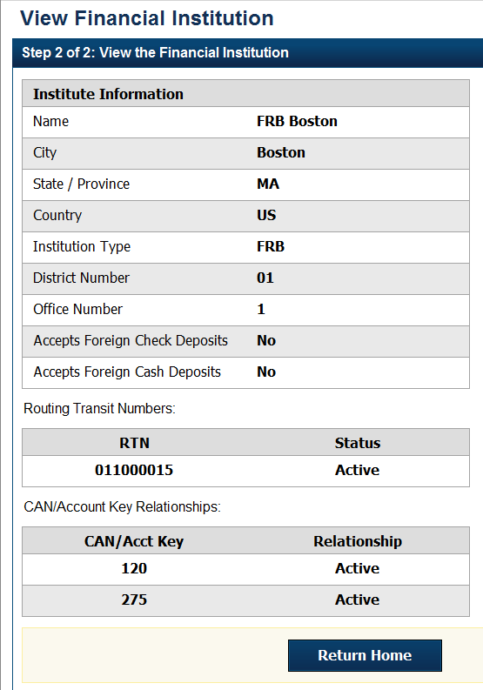

Figure . View Financial Institution Detail

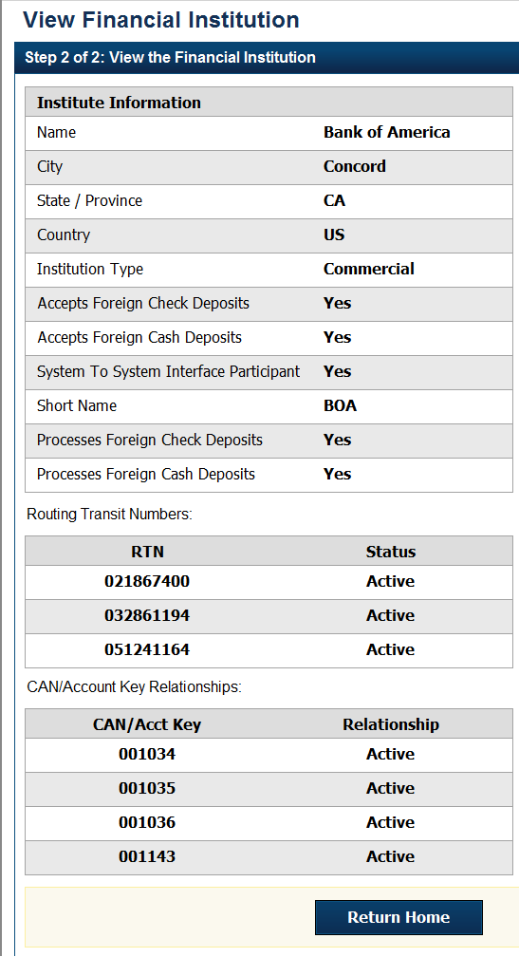

Application Tip



**FI Confirmers,** **Federal Reserve Bank** (**FRB) Confirmers**, **FI Viewers**, and **FRB Viewers** are authorized to view Institution Information, Routing Transit Numbers (RTN) and Status and CAN/Acct Key Relationships.

Additional Button



Click **Return Home** to return to the OTCnet Home Page.

## Summary

In this chapter, you learned how to view a Financial Institution.