

# Chapter 4. Managing Your Agency’s Hierarchy, Accounting Codes and Processing Options

OTCnet Participant User Guide

Table of Contents

Overview, Topics, and Audience 1

Overview 1

Topics 1

Audience 1

Topic 1 The Purpose of the Organizational Hierarchy 3

Topic 2 Creating an Organizational Hierarchy 4

Create an OTC Endpoint 4

Create an OTC Endpoint 5

Topic 3. Managing the Organizational Hierarchy 7

Add a Lower Level to an Existing OTC Endpoint 7

Add a Lower Level to an OTC Endpoint 8

Modify OTC Endpoint Information 10

Modify OTC Endpoint Information 13

Delete or Neutralize an OTC Endpoint 25

Delete or Neutralize an OTC Endpoint 26

View an OTC Endpoint 27

View an OTC Endpoint 28

Search for an OTC Endpoint 30

Search for an OTC Endpoint 31

Topic 4. Managing Accounting Codes 32

Modify Accounting Codes 32

Modify Accounting Codes 33

Import Accounting Codes 35

Import Accounting Codes 36

View Accounting Codes 38

View Accounting Codes 39

Modify Endpoint Mappings 40

Modify Endpoint Mappings 41

Topic 5. Managing Processing Options 44

Modify Processing Options 44

Modify Processing Options 45

View Processing Options 50

View Processing Options 51

Summary 52

List of Figures

Figure 1. Step 2 of 3: Update OTC Endpoint Information 5

Figure 2. Step 2 of 3: Short Name and Description for OTC Endpoint Information 8

Figure 3. Step 2 of 3: Update OTC Endpoint Information - Collapsed 13

Figure 4. Allow OTC Endpoint to create deposits for over-the-counter collections 15

Figure 5. Default Reason Codes 16

Figure 6. Enable Check Capture 19

Figure 7. Enable Card Processing Address, Signature Capture and Return Policy 21

Figure 8. Advanced Administration 23

Figure 9. Special Designation 23

Figure 10. Step 1 of 2: Select the OTC Endpoint(s) 26

Figure 11. View OTC Endpoint 28

Figure 12. Step 2 of 2: View OTC Endpoint 31

Figure 13. Step 2 of 3: Update Accounting Codes 33

Figure 14. Step 3 of 4: Select Accounting Codes 36

Figure 15. View Accounting Codes 39

Figure 16. Step 2 of 4 Continued: Search and Assign Accounting Codes 42

Figure 17. Update Deposit Processing Options with Deposit Preparation expanded 48

Figure 18. View Processing Options 51

Glossary

Click this [link](https://www.fiscal.treasury.gov/otcnet/training/wbt/content/course_OTC/glossary.htm) to access the full OTCnet Glossary.

## Overview, Topics, and Audience

### Overview

Welcome to *Managing Your Agency’s Hierarchy*. In this chapter, you will learn:

* The purpose of organizational hierarchy
* How to add lower level endpoints to the highest level of an organization hierarchy
* How to add additional lower level endpoints/ add financial institution relationship to a hierarchy that was previously defined
* How to make changes to OTC Endpoints
* How to delete or neutralize OTC Endpoints
* How to view OTC Endpoints
* How to modify accounting codes
* How to modify endpoint mappings
* How to modify processing options

### Topics

The topics in this chapter include the following:

1. The Purpose of the Organizational Hierarchy
2. Creating an Organizational Hierarchy
3. Managing the Organizational Hierarchy
4. Managing Accounting Codes
5. Managing Processing Options

### Audience

The intended audience for the *Managing Your Agency’s Hierarchy* *Participant User Guide* varies by system. Note the intended audience, by system, you are capturing or processing on:

Deposit Processing

* Accounting Specialist
* Local Accounting Specialist
* Viewer (View the organization’s hierarchy endpoint only)

Check Capture and Check Processing

* Check Capture Administrator
* Check Capture Supervisor
* Check Capture Lead Operator

Card Processing

* Card Administrator
* Card Operator (View the organization’s hierarchy endpoint only)

## Topic 1 The Purpose of the Organizational Hierarchy

As your Agency’s **Accounting Specialist** (**AS**), **Local Accounting Specialist** (**LAS**), **Check Capture Administrator** (**CCA**), **Check Capture Supervisor (CCS)** and **Card Administrator (CA)** you are responsible for identifying and maintaining the organizational structure for your Agency’s deposits, check capture, and card processing settings. This organizational structure is called a hierarchy.

Creating a hierarchy accomplishes the following:

* Describes the relationships and reporting structures between **OTC Endpoints** (i.e., locations) within your organization that process check transactions, create deposits, submit deposits or that process card transactions, in OTCnet.
* Defines the content of the reports that individuals may run based on their **OTC Endpoints** within the hierarchy.
* Enables staff to process check transactions, create deposits, submit deposits, process card transactions and pull reports on all appropriate **OTC Endpoints** within the organization.

Work with your management to determine your desired hierarchy. Use the OTCnet tools, provided in this document to define your OTCnet hierarchy. The organizational hierarchy you create allows for the following:

* **Deposit Preparers** may create deposits from specific **OTC Endpoints**
* **Check Capture Operators** may scan checks
* **Card Operators** may process payments via credit card, debit card and gift card payments

You are responsible for indicating which hierarchy locations are **OTC Endpoints**, and how deposits at **OTC Endpoints** should be handled. The following describes the label that appears next to the endpoint and the endpoint types, in OTCnet.

* **TGA** – denotes a **Deposit Processing** endpoint
* **CHK** – denotes a **Check Capture** endpoint
* **CDC** – denotes a **Card Processing** endpoint
* **M** – denotes a **Mapped Accounting Code**

## Topic 2 Creating an Organizational Hierarchy

Once your **High-Level Agency Support (HLAS)** has entered your organization into OTCnet, you are responsible for entering your organizational hierarchy. As part of your setup process, the **HLAS** creates the highest level of your hierarchy for you; you add to that hierarchy according to your organization’s needs.

The highest level of your organization cannot be a depositing endpoint. You may create multiple lower levels in your hierarchy, as needed, with multiple **OTC Endpoints** in each level.

You may edit your hierarchy as desired by updating the information for each **OTC Endpoint** you create. You may delete an **OTC Endpoint** from which no deposit, check transaction or card transaction has been made. You may not delete an **OTC Endpoint** once a deposit, check or card transaction has been made from that **OTC Endpoint**.

**OTC Endpoints** may not be deleted after a deposit, check or card transaction has been made because historical information about that deposit or check transaction would also be deleted, creating inaccurate reporting. However, you may neutralize an OTC Endpoint, if deposits or check transactions have been created. Card Processing Endpoints can also be neutralized.

Your organization’s hierarchy is accessible by clicking **Administration** and the **Manage Organization** menu option.

### Create an OTC Endpoint

The **Accounting Specialist**, **Local Accounting Specialist**, **Check Capture Administrator**, **Check Capture Supervisor** and **Card Administrators** can add endpoints.

To add an OTC Endpoint from the highest level of an organizational hierarchy, select your organization’s OTC Endpoint check the **Add lower levels to this OTC Endpoint** checkbox.

Information on **Short Name** and **Description** includes:

* The **Short Name** and **Description** field provide an abbreviation and a full description, respectively, of the **OTC Endpoint** you are adding.
* **Short name(s)** are user-defined text describing an organization. Short names must be unique within an organization hierarchy (e.g. Short name: IRS; Description: Internal Revenue Service).
* Special characters are accepted in **Short Name** and **Description** fields; however, only use standard American Standard Code for Information Interchange (ASCII) characters. The standard ASCII range is 32-126. If non-standard ASCII characters (0-31, 127-255) are entered in the **Short Name** and **Description** fields. Additionally, if non-standard ASCII characters are entered, you cannot manage OTC Endpoints (select endpoints) in OTCnet Online or OTCnet Offline. Instead, an error message appears suggesting you contact Customer Support.

Create an OTC Endpoint

To add an OTC Endpoint from the highest organization hierarchy, complete the following steps:

1. From the **Administration** tab, select **Manage Organization**>**Organization Hierarchy**>**Modify**. The *Step 1 of 3: Select an OTC Endpoint* page appears.
2. Select your OTC Endpoint from the list. The *Step 2 of 3: Update OTC Endpoint Information* page appears. View details for **Add lower levels to this OTC Endpoint checkbox** as shown in Figure 1.
3. Check the **Add lower levels to this OTC Endpoint** checkbox.
4. Enter the lower level OTC Endpoint’s **Short Name(s)** and **Description(s)** and click **Next**.

Application Tip



* In the table that appears, add new **OTC Endpoints** that fall in the level under the current **OTC Endpoint**.
* **Short name(s)** are user-defined text describing an organization. Short names must be unique within an organization hierarchy (e.g., Short name: IRS; Description: Internal Revenue Service).

Figure 1. Step 2 of 3: Update OTC Endpoint Information

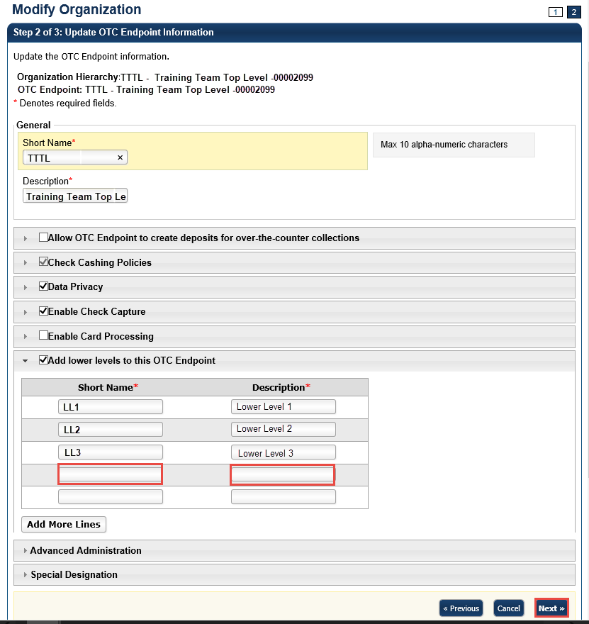

1. In the *Step 3 of 3: Review OTC Endpoint(s)* page, review and verify the OTC Endpoint details and click **Submit**. A *Confirmation* page appears presenting the modified OTC Endpoint (and verifies the added lower level OTC Endpoint).

Additional Buttons



* Click **Add More Lines** to add additional lower levels to this endpoint.
* Click **Cancel** to return to the OTCnet Home Page. No data is saved.
* Click **Previous** to return to the previous page.
* Click **Return Home** to return to the OTCnet Home Page*.*

## Topic 3. Managing the Organizational Hierarchy

Once **Accounting Specialists**, **Local** **Accounting Specialists**, **Check Capture Administrators**, **Check Capture Supervisors** and **Card Administrators** have performed initial setup of your organizational hierarchy, you can add to it and adjust it to suit your needs by performing the following tasks:

* Adding a lower level to existing an OTC Endpoint
* Modifying an OTC Endpoint Information
* Deleting an OTC Endpoint
* Viewing an OTC Endpoint

Before a user is provisioned to a deposit processing OTC Endpoint (**TGA**), ensure the **Allow OTC Endpoint to create deposits for over-the-counter collections** checkbox is checked. Before a user is provisioned to a check capture OTC Endpoint (**CHK**), ensure the **Enable Check Capture** checkbox is checked. Before a user is provisioned to a card processing OTC Endpoint (**CDC**), ensure the **Enable Card Processing** checkbox is checked.

Required fields for **Enable Card Processing** include **Chain Code**, **Division**, **ALC**, **Merchant ID**, **Address**, **Signature Capture** and **Return Policy**.

If the **Allow OTC Endpoint to create deposits for over-the-counter collections** checkbox, the **Enable Check Capture** checkbox and **Enable Card Processing** checkboxes are not checked when modifying OTC Endpoint Information, you cannot provision the user to the appropriate OTCnet Endpoint.

### Add a Lower Level to an Existing OTC Endpoint

**Accounting Specialists**, **Local Accounting Specialists**, **Check Capture Administrators**, **Check Capture Supervisors** and **Card Administrators**,can add as many levels to your Agency hierarchy as needed, each with as many required OTC Endpoints.

To add a lower level to an existing OTC Endpoint, select your OTC Endpoint. Check the **Add lower levels to this OTC Endpoint** checkbox to add lower levels to the existing endpoint. Enter **Short Name** and **Description** fields for all **OTC Endpoints** in the next lower level. Verify the OTC Endpoint details are correct. Click **Submit**. A *Confirmation* page appears presenting the OTC Endpoint that has been modified (added). Verify the OTC Endpoint details are correct.

Add a Lower Level to an OTC Endpoint

To add a lower level to an OTC Endpoint, complete the following steps:

1. From the **Administration** tab, select **Manage Organization**>**Organization Hierarchy**>**Modify**. The *Step 1 of 3: Select an OTC Endpoint* page appears.
2. Select an OTC Endpoint from the list that appears. The *Step 2 of 3: Update OTC Endpoint Information* page appears.
3. Check the **Add lower levels to this OTC Endpoint** checkbox to add lower levels to the existing endpoint as shown in **Error! Reference source not found.**. **Short Name** and **Description** text boxes appear.
4. Enter **Short Name** and **Description** fields for all the **OTC Endpoints** in the next lower level. When you have finished, click **Next**.

Figure 2. Step 2 of 3: Short Name and Description for OTC Endpoint Information

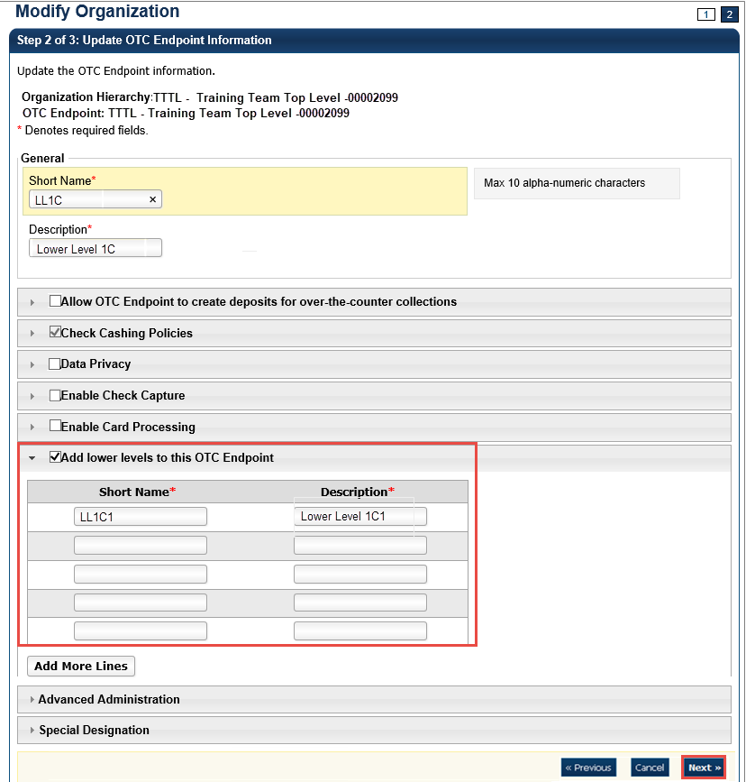

1. Verify the OTC Endpoint details are correct and click **Submit**. A *Confirmation* page appears presenting the modified OTC Endpoint.

Additional Buttons



* Click **Add More Lines** to add additional lower levels to this endpoint.
* Click **Cancel** to return to the OTCnet Home Page. No data is saved.
* Click **Previous** to return to the previous page.
* Click **Return Home** to return to the OTCnet Home Page*.*

### Modify OTC Endpoint Information

**Accounting Specialists**, **Local Accounting Specialists**, **Check Capture Administrators**, **Check Capture Supervisors** and **Card Administrators** are authorized to modify the **Short Name** or **Description** of an existing OTC Endpoint, enable the OTC Endpoint to create deposits (indicated with [**TGA**]), capture checks (indicated with **CHK**), process card transactions (indicated with Card Debit Card or **CDC**), or add a lower level to the OTC Endpoint.

Similarly, any **CDC** endpoint that is also a **TGA** and/or **CHK** endpoint, requires a card processing role with permission to modify an organization (e.g., **Card Administrator**).

To modify endpoint information settings for an OTC Endpoint with **TGA**, **CHK** and **CDC**, the user must have **Accounting Specialist**, **Check Capture Administrator**, **Check Capture Supervisor** and **Card Administrator** privileges.

Additional Information for modifying the OTC Endpoint information includes:

* Special characters are accepted in **Short Name** and **Description** fields; however, only use standard American Standard Code for Information Interchange (ASCII) characters. The standard ASCII range is 32-126. If non-standard ASCII characters (0-31, 127-255) are entered in the **Short Name** and **Description** fields. Additionally, if non-standard ASCII characters are entered, you cannot manage OTC Endpoints (select endpoints) in OTCnet Online or OTCnet Offline. Instead an error message appears asking that Customer Support is contacted.
* The **Agency Assigned Suspensions - Days** allows you to specify the number of calendar days than an individual is unable to cash a check or pay by check and is calculated from the date the system is aware of the return file. The **Agency Assigned Suspensions - Occurrence** allows you to specify the suspension level.
* **Include Represented and Retired Check or Include Retired Check Only** allows you to specify whether the verification record is generated on Represented or Retired items. **Include Retired Check Only** allows you to specify whether the verification record is generated on only Retired items.
* **Include Expired** indicates whether previous suspensions that have since expired are counted when accessing the suspension level to assign when the individual writes a check. **Agency Verification Policies—Delete** allows you to remove the check cashing policy for your OTC Endpoint. Once the check cashing policy is removed for the OTC Endpoint, the higher-level organization’s check cashing policy is automatically assigned to your OTC Endpoint.
* **Data Privacy** defines the extent that users from other locations are able to view verification records from other locations. By default, **Account**, **User Defined Field 1**, **Bank Routing Number**, **Note** and **Mask PII** are checked as **Blocked**. If checkbox is checked, it indicates that the OTC Endpoint information has been defined. For maximum data privacy, all fields would be marked as blocked, except for **Short Name**. However, there may be situations where it is acceptable for outside users to view certain fields of verification records.
* **Enable Card Processing** options are defined as the following:
  + A **Chain Code** is an alphanumeric designator (e.g. 0F123B) assigned by WorldPay to reflect unique channel of card processing. A Chain Code is required for initial setup with lower level endpoints and once the Chain Code is saved, the Chain Code cannot be changed. An agency can have multiple Chain Codes, but no two agencies will have the same Chain Code.
  + A **Division** is a three-digit value assigned at lower level endpoints under the chain code to designate unique lines of accounting. The Division code for all OTC Endpoints is any value from 001 to 999.
  + The **Agency Location Code (ALC)** is required for initial setup and once the ALC is saved it cannot be changed. If an endpoint is adding the card processing functionality to an existing TGA or CHK endpoint, the ALC will already be populated.
  + The **Merchant ID** is a unique alphanumeric designator, received from CAS, and reflects the card processing location. An ALC is associated with multiple merchant IDs; however, each merchant ID must be unique for each lower level endpoint. The Merchant ID field may contain up to 13 characters.

Once the **Chain Code**, **Division**, **ALC**, and **Merchant ID** are saved, they will grey out and cannot be changed. If any of these details need to be changed, a new endpoint must be created, and the information will need to be added again.

* If the **Signature Capture** checkbox is checked, the customer’s signature, the “*I agree to pay the above total amount in accordance with the card issuer’s agreement*” message will appear on your agency’s sales receipts and the “*I agree that I have received a refund for the amount stated above*” message appears on your agency’s refund receipts. By default, the **Signature Capture** checkbox is unchecked.
* A **Return Policy** indicates the agency’s return policy for card transactions, it is stored in the system and generated on receipts as mandated by the Treasury Financial Manual. The default return policy choice is **None**. Selecting a **Return Policy** is optional and does not apply to all endpoints (e.g. where the card user is not purchasing an item, but only paying fee/payment a return policy is not required) appears on receipts.

Return Policy choices include:

* + NO REFUND, ALL SALES FINAL – For any agency that does not accept merchandise in return or exchange and does not issue refunds to cardholders.
  + EXCHANGE ONLY – For any agency that only accepts merchandise in immediate exchange for similar merchandise of a price equal to the amount of the original transaction.
  + IN-STORE CREDIT ONLY – For any agency that accepts merchandise in return and delivers to the cardholder an in-store credit equal to the value of the merchandise returned that may be used only in the agency’s place (s) of business.
  + REFUNDS ONLY AVAILABLE WITHIN 30 DAYS OF SERVICE OR PURCHASE – For any agency that issues refunds to the original credit or debit card within 30 days of purchase or service.
  + Other – The agency is prompted to enter some descriptive text outlining their agency’s return policy.
  + None – Select if a return policy does not apply to an agency.
* Prior to specifying Debit Gateway, confirmation must be received from the OTCnet Deployment Team to set up each applicable OTCnet Endpoint.
  + **No** indicates that Debit Gateway setup is not complete, and the OTC Endpoint is not ready for performing check capturing activities.
  + **Yes** indicates that Debit Gateway setup is complete, and the OTC Endpoint is now ready for performing check capture activities. A notification message appears as a reminder to submit your Agency Site Profile (ASP) for all check capture endpoints. If the ASP is not submitted to the OTCnet Deployment Team, this can prevent transactions from processing. Click OK.
* By default, all agencies will have the **Close Batch** checkbox checked. To close the batch, the user must print the PDF report or export the batch list report.
  + If the **Close Batch** checkbox is unchecked, the user can close the batch without having to print the PDF report or export the batch list report. If the **Close Batch** checkbox is unchecked, the user can close the batch without having to print the PDF report or export the batch list report.
  + By default, all agencies will have the **Approve Batch** checkbox checked. In order to approve the batch, the user must print the PDF report or export the batch list report.
  + If the **Approve Batch** checkbox is unchecked, the user can approve the batch without having to print the PDF report or export the batch list report.
  + If the user is closing or approving multiple batches online and the **Close Batch** or **Approve Batch** checkboxes are checked for any OTCnet endpoint, then the user must print the PDF reports or export the list reports. The batch is not closed or approved until **Confirm** is clicked, which is enabled when the **Print PDF Report** or **Export** is clicked.
  + If the user is closing and/or approving multiple batches online and the **Close Batch** or **Approve Batch** checkboxes are not checked for any OTCnet endpoint, then the user can close and/or approve multiple batches without printing the PDF reports or exporting the list reports. **Confirm** is enabled and the user can click to close and/or approve the multiple batches.
  + If the user is closing and/or approving multiple batches offline, **Confirm** is enabled and the user can close and/or approve multiple batches without needing to print the PDF reports or export the batch list reports. As a best practice, print the PDF reports or export the batch lists prior to closing and/or approving multiple batches.
* If **Special Designation** is selected, a user is able to view which ALCs are CARS Reporters.
  + The CARS Reporter special designation information is read-only and displays for TGA and CHK endpoints. Only an HLAS can specify the **Special Designation** information.
  + **Yes** indicates that the OTC Endpoint is associated with an ALC that has been designated as a CARS Reporter. **No** indicates that the OTC Endpoint is not associated with an ALC that has been designated as a CARS Reporter. If an ALC is identified as a CARS Reporter, entering the Accounting Code information is mandatory. This will apply to all ALC+2 within the hierarchy of the ALC.

Modify OTC Endpoint Information

To modify an OTC Endpoint, complete the following steps:

1. From the **Administration** tab, select **Manage Organizations**>**Organization Hierarchy**>**Modify**. The *Step 1 of 3: Select an OTC Endpoint* page appears.

Application Tip



To modify endpoint information settings for an OTC Endpoint with **TGA**, **CHK** and **CDC**, the user must have **Accounting Specialist**, **Check Capture Administrator** and **Card Administrator** privileges.

1. Select your OTC Endpoint from the list that appears. The *Step 2 of 3: Update OTC Endpoint Information* page appears as shown in **Error! Reference source not found.**.
2. Update the OTC Endpoint Information.

To update the **General** details of an OTC Endpoint, complete the following:

* + Enter the **Short Name** and **Description** for the OTC Endpoint.

Figure 3. Step 2 of 3: Update OTC Endpoint Information - Collapsed

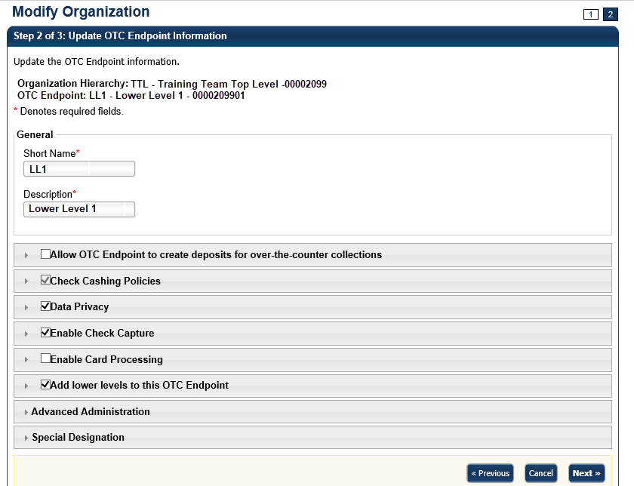

Application Tip



A short name must be entered to identify the OTC Endpoint that is being updated. If an OTC Endpoint exists, the data displayed in the text is available for update.

To allow the OTC Endpoint to create deposits, complete the following:

* + Click the **Allow OTC Endpoint to create deposits for over-the-counter collections** checkbox as shown in **Error! Reference source not found.**.

Application Tip



Before a user is provisioned to a deposit processing OTC Endpoint (**TGA**), ensure the **Allow OTC Endpoint to create deposits for over-the-counter collections** checkbox is checked.

* + Update **Agency Location Code** by completing the following step:
    - Entering the **ALC**
  + Update **Address** by completing the following step:
    - Entering the **address** details
  + Update **Financial Institution Relationship(s)** by completing the following steps:
    - Selecting both the **Financial Institution** and the associated **Routing Transit Number (RTN)**
    - Entering the **Demand Deposit Account (DDA)** and Retype **DDA** and click **Add**.

Application Tip



To delete the Financial Institution relationship, click the **Delete** checkbox(es) under the **Delete** column.

Figure 4. Allow OTC Endpoint to create deposits for over-the-counter collections

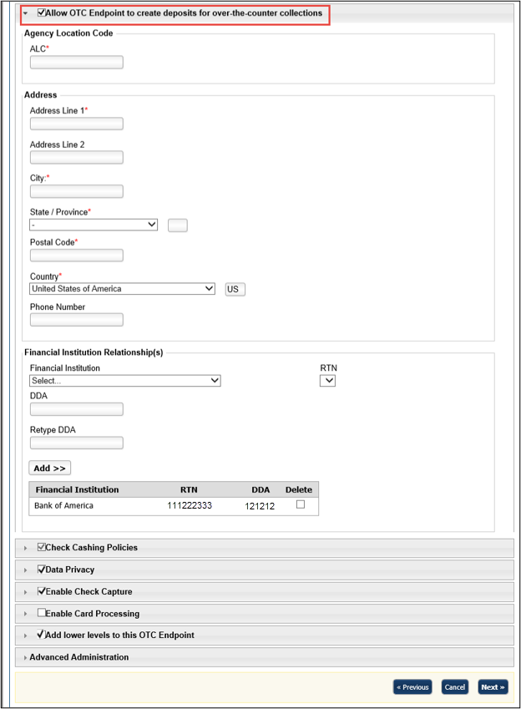

To specify the check cashing policies of the OTC Endpoint, complete the following:

Click the Check Cashing Policies checkbox as shown in

Application Tip



The **Default Reason Codes** allows you to specify the return reason codes relevant to your agency’s program. These codes represent the numeric codes used in the ACH and paper return processing, which specify the reason for the return of the transaction and Check 21 codes.

Figure 5

Application Tip



If checkbox is checked and grayed out, it indicates that this OTC Endpoint is either inheriting the policies from the parent Organization or its own information has already been defined and the user does not have the privilege to make modifications. Only a **CCA** has privileges to modify the check cashing policies.

* + Add **Default Reason Codes** by completing the following steps:
    - Selecting a default reason code and clicking **Add**, optional. Repeat steps as necessary
  + Delete **Assigned Return Reason Code Filters** by completing the following steps:
    - Checking **Delete** box(es) under the **Delete** column, optional

Application Tip



The **Default Reason Codes** allows you to specify the return reason codes relevant to your agency’s program. These codes represent the numeric codes used in the ACH and paper return processing, which specify the reason for the return of the transaction and Check 21 codes.

Figure 5. Default Reason Codes

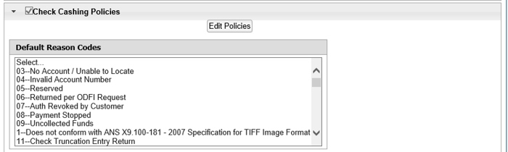

* + Update **Agency Assigned Suspensions** by completing the following steps, *optional*
    - Entering the number of **Days**
    - Entering the **Occurrence** number
    - Selecting **Agency Assigned Suspensions** you want to **Delete** by checking the boxes under the **Delete** column, *if applicable*

Application Tip



* To update the **Agency Assigned Suspensions**, select the **Default Reason Code** it will apply, by clicking in the box provided.
* The **Agency Assigned Suspensions - Days** allows you to specify the number of calendar days than an individual is unable to cash a check or pay by check and is calculated from the date the system is aware of the return file. The **Agency Assigned Suspensions - Occurrence** allows you to specify the suspension level.
  + Update **Agency Verification Policy** by completing the following steps, *optional*
    - Clicking **Include Represented and Retired Check or Include Retired Check Only**
    - Checking **Include Expired**
    - Entering the number of **Expired Days**
    - Checking **Agency Verification Policies**—**Delete**

Application Tip



* **Include Represented and Retired Check** **or** **Include Retired Check   
  Only** allows you to specify whether the verification record is generated   
  on Represented or Retired items. **Include Retired Check Only** allows   
  you to specify whether the verification record is generated on only   
  Retired items.
* **Include Expired** indicates whether previous suspensions that have since expired are counted when accessing the suspension level to assign when the individual writes a check. **Agency Verification Policies—Delete** allows you to remove the check cashing policy for your OTC Endpoint. Once the check cashing policy is removed for the OTC Endpoint, the higher-level organization’s check cashing policy is automatically assigned to your OTC Endpoint.

To specify the data privacy of the OTC Endpoint, complete the following:

* + Click the **Data Privacy** checkbox.
  + Update **Data Privacy**:
    - Select the **Data Privacy – Agency Available Attributes** you want to block or unblock by checking the boxes under the **Blocked** column.

Application Tip



By default, **Account**, **User Defined Field 1**, **Bank Routing Number**, **Note** and **Mask PII** are checked as **Blocked.**

To enable the OTC Endpoint to capture checks, complete the following:

* + Click the **Enable Check Capture** checkbox.
  + Update **Enable Check Capture** by completing the following steps:
  + Enter the **Agency Location Code (ALC+2)**.

Application Tip



* Before a user is provisioned to a check capture OTC Endpoint (CHK), ensure the **Enable Check Capture** checkbox is checked.
* If checkbox is checked, it indicates that the OTC Endpoint information has been defined.
* The ALC+2 is required for initial setup. Once the ALC+2 is entered it cannot be updated.
  + Update **OTC Verification Group** by completing the following steps as shown in Figure 6:
    - Entering the **Short Name** (Starting With) and clicking **Search**
    - Clicking **Yes** or **No** for **Queue Interface**
    - Selecting the **OTC Endpoint** you want to add by checking the box under the **Assign** column and clicking **Add** **Agency Group**

Figure 6. Enable Check Capture

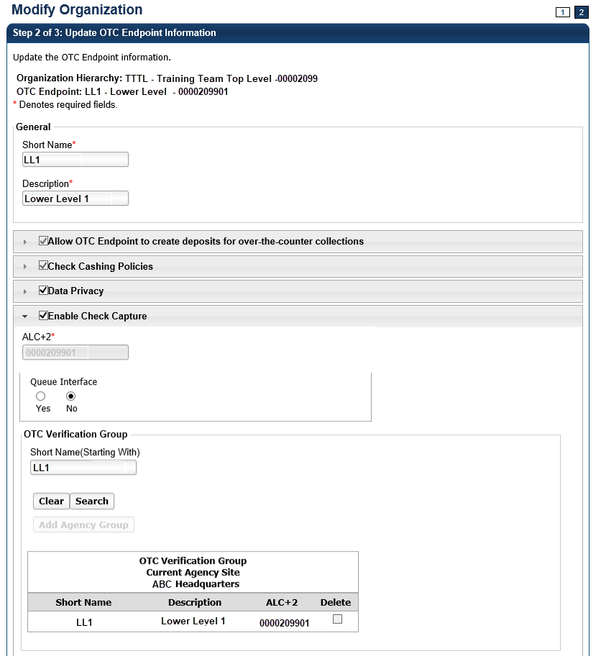

Application Tips



* By default, the OTC Endpoint **Short Name** displays. Add additional OTC Endpoints to the OTC Verification Group by clicking the **Clear** button to clear the **Short Name** and entering a Short Name, clicking **Search** and clicking **Add Agency Group**.
* Designating an **OTC Verification Group** allows for verification data to be shared among non-related OTC Endpoints. For example, **Lower Level 1** and **Lower Level 2** are siblings under the High-level organization, Training Team Top Level. Since there is no parent-child relationship between these two OTC Endpoints, users from one OTC Endpoint are isolated from the other’s Verification data. By adding both unrelated locations to an **OTC Verification Group**, they are able to share information.
* The **Queue Interface** is used by military agencies that utilize the Deployable Disbursing System (DDS) database bridge.
  + - Under **OTC Verification Group, Current Agency Site**,
      * Select the **OTC Endpoint** you want to delete by checking the box under the **Delete** column.

To enable the **OTC Endpoint** to process card payments, complete the following steps:

* + Click the **Enable Card Processing** checkbox

Application Tip



Before a user is provisioned to a card processing OTC Endpoint (**CDC**), ensure the **Enable Card Processing** checkbox is checked.

* + Update **Enable Card Processing** by completing the following steps as show in Figure 7:
  + Entering the **Chain Code**
  + Entering the **Division**
  + Entering the **ALC**
  + Entering the **Merchant ID**
  + Update the **Address** by entering the address details
  + Designate the Signature Capture by completing the following steps:
  + Checking the **Signature Capture** check box, *optional*
  + Select a **Return Policy** by completing the following steps:
  + Clicking the appropriate card transaction policy radio button for your organization, *optional*.

Figure 7. Enable Card Processing Address, Signature Capture and Return Policy

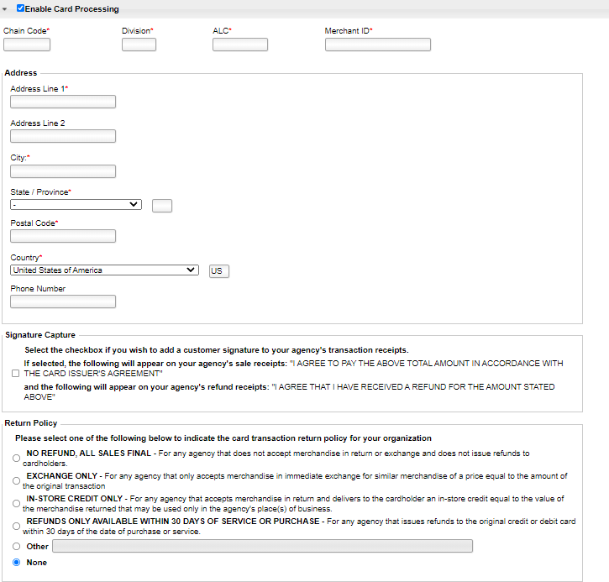

To add lower level endpoints, complete the following:

* Click the **Add lower levels to this OTC Endpoint** checkbox.
* Update **Add lower levels to this OTC Endpoint** by completing the following steps:
* Entering the **Short Name** and **Description**.
* Click **Add More Lines** to add additional lower levels to this OTC Endpoint

Application Tip



A short name must be entered to identify the OTC Endpoint that is being updated. If an OTC Endpoint exists, the data displayed in the text is available for update.

To specify the advanced administration, complete the following:

* Click **Advanced Administration** as shown in
* .
* Specify **Advanced Administration** by completing the following:
* Clicking **Yes** or **No** for **Debit Gateway**

View or specify the **Forms Rendered Solution**

* View the **Report Only Summary Level Data to CIR**
* View the **Summary Level** **Classification**

Application Tip



By default, all forms are set to be rendered and viewed in HTML. Under general circumstances, the ActiveX option does not need to be specified. The **Forms Rendered Solution** is read-only and only an HLAS can specify the option to switch between viewing and accessing forms in HTML or ActiveX.

Application Tips



* The **Report Only Summary Level Data to CIR** Information is read-only and only an HLAS can specify the information.
* A checked box indicates that detailed level data will not be transmitted to Collections Information Repository (CIR) and only summary data is reported to CIR for all the check transactions that are processed under this OTC Endpoint (CHK) or ALC+2. This is mainly for the OTC Endpoints that are used to process tax data. An unchecked box indicates that detailed level data is transmitted to CIR.
* The **Summary Level Classification** is read-only and only a **High-Level Agency Support (HLAS)**, **Check Capture Supervisor**, and **Check Lead Operator** can specify the information.
* A checked box indicates that Check Capture Lead Operators and Check Capture Operators cannot classify individual checks. Instead the classification of the batch will occur after all the checks have been   
  scanned. An unchecked box indicates the Check Capture Operator will have to classify checks at the item level.
* Specify **Batch List Print/Export Required During** options by completing the following:
  + Checking or unchecking the **Close Batch** checkbox
  + Checking or unchecking the **Approve Batch** checkbox
* View or **Specify Agency Comments**

Figure 8. Advanced Administration

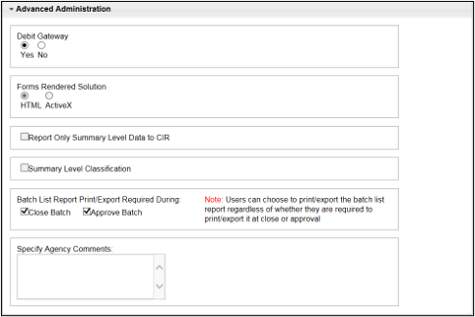

Application Tips



* A Check Capture Lead Operator, Check Capture Supervisor, and HLAS can add, edit, or remove Agency comments **Agency Comments**. A Check Capture Administrator, Check Capture Operator, Agency Manager, and CIRA Viewer can view **Agency Comments**.
* The **Specify Agency Comments** field allows agencies to add, edit, or remove Agency comments which are sent to CIR as part of the check transmission.

To view the special designation, complete the following:

* + Click **Special Designation** as shown in Figure 9

Figure 9. Special Designation

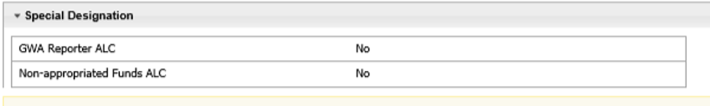

Application Tips



* The CARS Reporter special designation information is read-only   
  and displays for **TGA** and **CHK** endpoints. Only an HLAS can specify the **Special Designation** information.
* **Yes,** indicates that the OTC Endpoint *is* associated with an ALC that has been designated as a CARS Reporter. **No** indicates that the OTC Endpoint *is not* associated with an ALC that has been designated as a CARS Reporter.

1. Click **Next**. The *Step 3 of 3: Review OTC Endpoint* page appears.
2. Verify the information is correct and click **Submit**. Click **Edit**, to modify the information entered and return to Step 4.

Additional Buttons



* Click **Previous** to return to the previous page.
* Click **Cancel** to return to the OTCnet Home Page. No data is saved.
* Click **Return Home** to return to the OTCnet Home Page*.*

### Delete or Neutralize an OTC Endpoint

**Accounting Specialists, Local Accounting Specialists,** **Check Capture Administrators**, **Check Capture Supervisors** and **Card Administrators** are authorized to neutralize an **OTC Endpoint** or delete an **OTC Endpoint.**

Consider the following information on *deleting* an OTC Endpoint:

* You can delete an **OTC Endpoint** if no deposits or check transactions have been made to that endpoint.
* Deleting the **OTC Endpoint** deletes all information associated with the **OTC Endpoint**. This includes deleting deposit information that impacts the reports you run in OTCnet.
* Before deleting an **OTC Endpoint**, All user accounts must be removed from the OTCnet Deposit Processing Endpoint and OTCnet Check Processing Endpoint.

The Agency Form Data must be removed. To remove the Agency Form Data, contact Customer Support at [fiscalservice.otcchannel@citi.com](mailto:fiscalservice.otcchannel@citi.com).

Consider the following information on *neutralizing* an OTC Endpoint:

* You can neutralize an OTC Endpoint when deposits or check transactions are created for an **OTC Endpoint**.
* Once the OTCnet Endpoint is neutralized, however, deposits or check transactions can no longer be created from that OTC Endpoint. The information from previously created deposits or check transactions can be accessed from OTCnet reporting.
* All user accounts must be removed from the OTCnet Deposit Processing Endpoint and OTCnet Check Processing Endpoint.
* The Agency Form Data must be removed. To remove the Agency Form Data, contact Customer Support at fiscalservice.otcchannel@citi.com.

Delete or Neutralize an OTC Endpoint

To delete or neutralize an OTC Endpoint, complete the following steps:

1. From the **Administration** tab, select **Manage Organizations**>**Organization Hierarchy**>**Delete**. The *Step 1 of 2: Select the OTC Endpoint(s)* page appears.
2. Select the OTC Endpoints you would like to **Delete** and click **Next** as shown in Figure 10**.**

Or

Select the OTC Endpoints you would like to Neutralize and click **Next**.

Figure 10. Step 1 of 2: Select the OTC Endpoint(s)

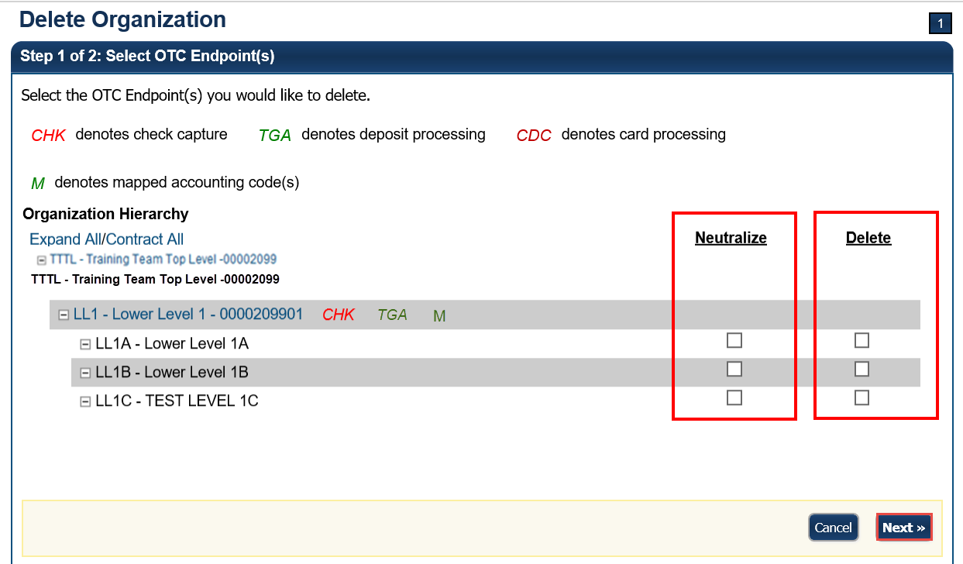

1. The *Step 2 of 2: Review OTC Endpoint(s)* page appears. Verify the correct endpoint is marked for deletion or neutralization and click **Submit**.
2. A *Confirmation* page appears confirming the OTC Endpoint was deleted.

Additional Button



Click **Return Home** to return to the OTCnet Home Page*.*

### View an OTC Endpoint

**Accounting Specialists**, **Local Accounting Specialists**, **Check Capture Administrators**, **Check Capture Supervisors**, **Check Capture Lead Operators**, **Card Administrators** and **Card Operators** are authorized to view an OTC Endpoint.

When the *View OTC Endpoint* page appears, you can verify the following information for the OTC Endpoint:

* **General** information including **Short Name**, **Description**, **ALC** and whether the endpoint is **check capture**, **deposit processing** or **card processing**
* **Address**—including **Address** details
* **Financial Institution Relationships and Active Financial Institution Relationships** including **Financial Institution** and **RTN**
* **Check Cashing Policies** including **Assigned Return Reason Code Filters**
* **Agency Assigned Suspensions** including **Days** and **Occurrence**
* **Agency Verification Policies** including **Include Retired Check Only**, **Include Expired, Expired Days** and **Agency Verification Policies**—**Delete**
* **Data Privacy**—**Agency Available Attributes** including **Attribute Name (Short Name, Account, Mask PII, Bank Routing Number, User Defined Field 1 and Note)** and whether its **Blocked**
* **Check Capture** including the **ALC+2** and **Queue Interface**
* **OTC Verification Current Agency Site Lower Level I** including the **Short Name, Description** and **ALC+2** and whether it should be **Deleted**
* **Card Processing** including the **Chain Code, Division** and **Merchant ID**
* **Lower Levels** includingthe **Short Name** and **Description**
* **Advanced Administration** including **Debit Gateway**, **Forms Rendered Solution**, **Report Only Summary Data to CIR**, **Summary Level Classification**, **Batch List Report Print/Export Required at Close Batch, Batch List Report Print/Export Required at Approve Batch** and **Specify Agency Comments**
* **Special Designation** including **GWA Reporter ALC** and **Non-appropriated Funds ALC**

View an OTC Endpoint

To view an OTC Endpoint, complete the following steps:

1. From the **Administration** tab, select **Manage Organizations**>**Organization Hierarchy**>**View**. The *View Organization* page appears.
2. Select the OTC Endpoint you would like to view. The *View OTC Endpoint* page appears as shown in Figure 11.

Figure 11. View OTC Endpoint

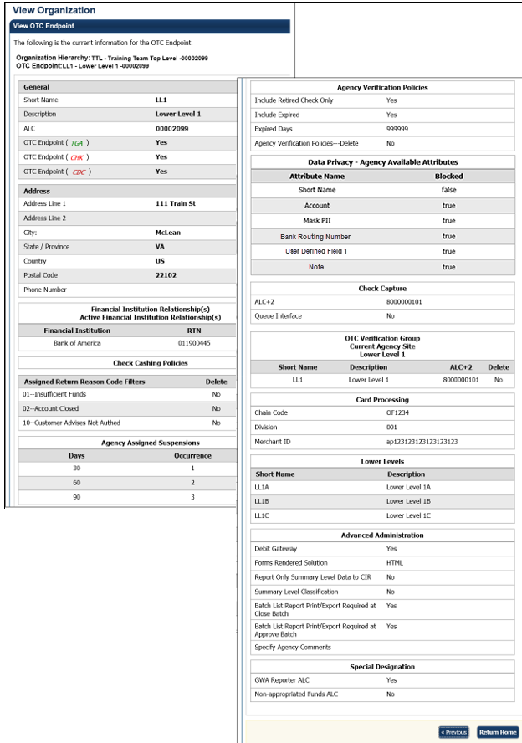

Additional Buttons



* Click **Previous** to return to the previous page.
* Click **Return Home** to return to the OTCnet Home Page*.*

### Search for an OTC Endpoint

**Accounting Specialists**, **Local Accounting Specialists**, **Check Capture Administrators**, Check **Capture Supervisors**, **Check Capture Lead Operators**, **Card Administrators** and **Card Operators** can search an OTC Endpoint.

When the *View OTC Endpoint* page appears, you can verify the following information for the OTC Endpoint:

* **General** information including **Short Name**, **Description**, **ALC** and whether the endpoint is **check capture**, **deposit processing** or **card processing**
* **Address**
* **Financial Institution Relationships and Active Financial Institution Relationships** including **Financial Institution** and **RTN**
* **Check Cashing Policies** including **Assigned Return Reason Code Filters**
* **Agency Assigned Suspensions** including **Days** and **Occurrence**
* **Agency Verification Policies** including **Include Retired Check Only**, **Include Expired, Expired Days** and **Agency Verification Policies**—**Delete**
* **Data Privacy**—**Agency Available Attributes** including **Attribute Name (Short Name, Account, Mask PII, Bank Routing Number, User Defined Field 1 and Note)** and whether its **Blocked**
* **Check Capture** including the **ALC+2** and **Queue Interface**
* **OTC Verification Current Agency Site Lower Level I** including the **Short Name, Description** and **ALC+2** and whether it should be **Deleted**
* **Card Processing** including the **Chain Code, Division** and **Merchant ID**
* **Lower Levels** includingthe **Short Name** and **Description**
* **Advanced Administration** including **Debit Gateway**, **Forms Rendered Solution**, **Report Only Summary Data to CIR**, **Summary Level Classification**, **Batch List Report Print/Export Required at Close Batch, Batch List Report Print/Export Required at Approve Batch** and **Specify Agency Comments**
* **Special Designation** including **GWA Reporter ALC** and **Non-appropriated Funds ALC**

Search for an OTC Endpoint

To search for an OTC Endpoint, complete the following steps:

1. From the **Administration** tab, click **Manage Organizations**>**Organization Hierarchy**>**Search**. The *View Organization* page appears.
2. Select the OTC Endpoint you would like to view. The *View OTC Endpoint* page appears as shown in Figure 12.

Figure 12. Step 2 of 2: View OTC Endpoint



## Topic 4. Managing Accounting Codes

OTCnet provides enhanced check capture and deposit reporting functionalities to support the Central Accounting Reporting System (CARS). The CARS objectives include capturing classification information at the earliest possible time, streamlining central accounting and reporting, eliminating burdensome reconciliation, and providing timely Fund Balance with Treasury (FBWT) information to Agencies.

OTCnet captures classification information for transactions (over-the-counter deposits) processed through the Deposit Reporting function and the Check Capture function to support the CARS requirement that all transactions capture standard classification information.

For OTCnet, standard classification information is accepted in the form of a Treasury Account Symbol (TAS) String or a Classification Key (C-Key), which is an internal Agency Accounting Code that is translated into a valid TAS.

OTCnet sends this C-Key information to CARS through the Collections Information Repository (CIR). CARS then communicates with the Shared Accounting Module (SAM) application to translate the C-Key into a valid TAS/BETC through the Cash Flow and Default Profiles that have been setup in SAM. Initially, classification of check transactions for non-CARS Reporting Agencies is optional.

To learn more about CARS, visit <http://fms.treas.gov/CARS/index.html>.

### Modify Accounting Codes

The **Check Capture Administrator**, **Check Capture Supervisor** and **Accounting Specialist** are authorized to modify an accounting code. They can modify the classification code and description for an accounting code, indicate if it’s a Treasury Account Symbol (TAS) and add and delete accounting codes.

If an **Agency Accounting Code** label is customized, it is displayed as the label above the imported codes, according to the custom label that was defined for the highest-level organization. This applies to OTC Endpoints that use the deposit processing and/or check processing functionalities. The default accounting code label is **Agency Accounting Code**.

Modify Accounting Codes

To modify an existing accounting code, complete the following steps:

1. From the **Administration** tab, select **Manage Organizations**>**Accounting Codes**>**Modify**. The *Step 1 of 3: Select OTC Endpoint* page appears.
2. Select the organization endpoint for the accounting codes you wish to modify. The *Step 2 of 3: Update Accounting Codes* page appears.
3. Under the **New Accounting Codes to be Added** table, enter the accounting code details, and click **Next**.

Application Tip



If an **Agency Accounting Code** label is customized, it is displayed as the label above the imported or modified codes within the Maintain Accounting Codes module, according to the custom label that was defined for the highest-level organization. Within the rest of the application, custom labels apply to deposit processing functionalities, but are not extended to check processing functionalities. The default accounting code label is **Agency Accounting Code**.

Update the details by completing the following:

* Clicking the **TAS** checkbox to indicate that the accounting code is a Treasury Account Symbol (TAS), *if* *applicable*
* Entering details in both the **Agency Accounting Code** and **Description** text boxes as shown in Figure 13
* Checking the **Skip Selected** box to skip saving any of the imported accounting codes

Figure 13. Step 2 of 3: Update Accounting Codes

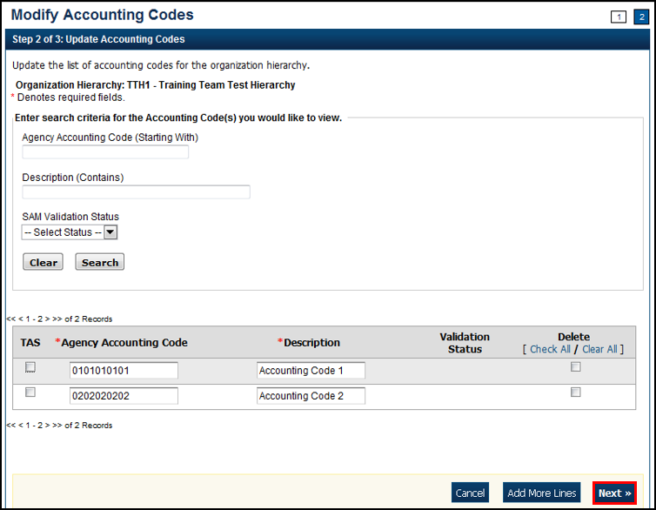

1. The *Step 3 of 3: Review Accounting Codes* page appears. Verify the information is correct and click **Submit**.
2. A *Confirmation* page appears presenting the imported accounting codes. Simultaneously, accounting codes flagged as TAS must be transmitted to the Shared Accounting Module (SAM) to confirm they are valid TAS strings.

Additional Button



Click **Return Home** to return to the OTCnet Home Page*.*

### Import Accounting Codes

The **Check Capture Administrator (CCA)**, **Check Capture Supervisor (CCS)** and **Accounting Specialist (Acc Spec)** are authorized to import accounting codes.

To import an accounting code, the **CCA**, **CCS**, or **Acc Spec** has several options. From the *Import From File* page, they can select the type of accounting code (e.g., CSV File, Fixed File, XML File) they want to import into the system, browse to its location and Import. Next, they can review the accounting codes to be imported into the system and update as needed. Another option is to remove accounting codes before submitting them, by marking them for removal and updating the list of codes.

Details are updated by clicking the **TAS** checkbox to indicate the accounting code is a Treasury Account Symbol (TAS), *if* *applicable*, entering the details in both the **Agency Accounting Code** and **Description** text boxes and/or checking the **Skip Selected** box to skip saving the imported accounting codes.

Once the accounting codes are successfully imported and the *Confirmation* page appears, simultaneously, the accounting codes flagged as TAS must be transmitted to SAM to confirm that they are valid TAS strings.

Import Accounting Codes

To import an accounting code, complete the following steps:

1. From the **Administration** tab, select **Manage Organizations**>**Accounting Codes**>**Import**. The *Step 1 of 4:* *Select OTC Endpoint* page appears.
2. Select the top-level organization endpoint for which you want to import accounting codes. The *Step 2 of 4: Import from File* page appears.
3. Select the type of accounting code to import into the system and browse to its location and click **Import**. The *Step 3 of 4: Select Accounting Codes* page appears.
4. Update the list of accounting codes that are imported into the system and click **Next** as shown in Figure 14.

Figure 14. Step 3 of 4: Select Accounting Codes

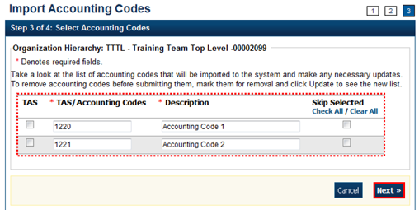

Update the details by completing the following steps:

* + Clicking the **TAS** checkbox to indicate that the accounting code is a Treasury Account Symbol (TAS), *if* *applicable*

Application Tip



Download Treasury Account Symbols (TAS), for import from the Shared Account Module (SAM) site at: <https://www.sam.fms.treas.gov/sampublic/tasbetc.htm>.

* + Entering the details in both the **Agency Accounting Code** and **Description** text boxes
  + Checking the Skip Selected box to skip saving any of the imported accounting codes

1. The *Step 4 of 4: Review* page appears. Verify the information is correct and click **Submit**.
2. A Confirmation page appears showing that the accounting codes have been imported. Simultaneously, accounting codes flagged as TAS will need to be transmitted to the Shared Accounting Module (SAM) to confirm that they are valid TAS strings.

Additional Button



Click **Return Home** to return to the OTCnet Home Page*.*

### View Accounting Codes

The **Accounting Specialist (Acc Spec)**, **Local Accounting Specialist (LAS), Check Capture Administrator (CCA),** and **Check Capture Supervisor (CCS)** are authorized to view the active accounting codes available for the organization hierarchy.

To view an accounting code, the **Acc Spec**, **LAS**, **CCA** or **CCS** selects the highest-level organization endpoint accounting code available to view.

If an Agency Accounting Code label is customized, it is displayed as the label above the imported codes, according to the custom label that was defined for the highest-level organization. This applies to OTC Endpoints that use the deposit processing and/or check processing functionalities. The default accounting code label is **Agency Accounting Code**.

View Accounting Codes

To view an accounting code, complete the following steps:

1. From the **Administration** tab, click **Manage Organizations**>**Accounting Codes**>**View**. The *View Accounting Codes* page appears.
2. Select the highest-level organization endpoint accounting codes available to view. The *View Accounting Codes* page appears as shown in Figure 15.

Figure 15. View Accounting Codes

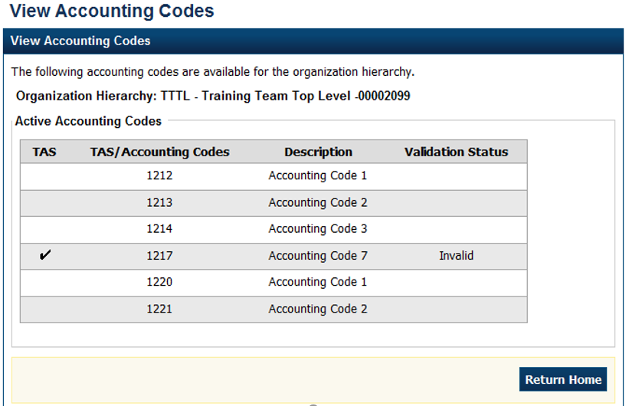

Application Tips



* Only active accounting codes available for deposit processing and check processing (if applicable) appear.
* Under the **Active Accounting Code** table, both **Treasury Account Symbols** (**TAS**) and accounting codes not identified as **TAS** display.
* If an accounting code is a **TAS**, a check mark displays under the **TAS** column and the SAM validation status (**Valid**, **Invalid** or **In Process**) displays under the **Validation Status** column.

Additional Buttons



Click **Return Home** to return to the OTCnet Home Page*.*

### Modify Endpoint Mappings

An endpoint mapping is the assignment of accounting codes to an agency’s OTC Endpoint, to which a deposit amount is allocated.

The accounting codes that display on the page are the codes that:

* Meet your search criteria.
* Are not assigned to your OTC Endpoint.

If you do not enter search criteria, all the accounting codes defined for the highest-level organization appear.

Additional information for modifying Endpoint Mapping includes the following:

* If an Agency has identified accounting codes as a **TAS**, only **TAS** identified as **Valid** by **SAM** will be available for mapping to an OTC Endpoint.
* To remove mappings for an accounting code, check the **Remove** box(es) and click **Update**.
* A mapped accounting code is not eligible for removal if a batch is associated with a transaction within an active batch that is **Open**, **Closed**, or **Approved** or a deposit that is in **Draft** or **Awaiting Approval (AWAP)** status. An error message is displayed to a user if this scenario occurs.

Modify Endpoint Mappings

To map accounting codes to OTC Endpoints, complete the following steps:

1. From the **Administration** tab, select **Manage Organizations**>**Accounting Codes**>**Modify OTC Endpoint Mappings**. The *Step 1 of 4: Select OTC Endpoint* page appears.
2. Select the OTC Endpoint for the accounting code endpoint mapping you would like to assign or remove. *The Step 2 of 4: View Assigned Accounting Codes page* appears.

Application Tip



If an Agency Accounting Code label is customized, it is displayed as the label above the imported or modified codes within the Maintain Accounting Codes module, according to the custom label that was defined for the highest-level organization. Within the rest of the application, custom labels apply to deposit processing functionalities, but are not extended to check processing functionalities. The default accounting code label is **Agency Accounting Code**.

1. Click **Assign Mappings** to assign an accounting code to an OTCnet Endpoint. The *Step 2 of 4 Continued: Search and Assign Accounting Codes* page appears.

or

Click **Remove Mappings** to remove an accounting code from an OTCnet Endpoint. The *Step 3 of 4: Remove Accounting Codes* page appears.

1. Assign or remove an accounting code to or from an OTCnet Endpoint as shown in Figure 16.

To **Assign Mappings** to an OTCnet Endpoint, complete the following:

* Enter the **Accounting Code** **(Starting With)** search criteria, *optional*
* Enter the **Description (Contains)** search criteria, *optional*
* Click **Search**, *optional*
* Check the Assign box(es) for the accounting codes you must assign
* Click **Next** (Proceed to *Step 3 of 4: Assign Accounting Codes*)

Or

To **Remove Mappings** from an OTCnet Endpoint, complete the following:

* Check the **Remove** box(es) for the accounting codes that you must remove
* Click **Next** (Proceed to *Step 4 of 4: Review Accounting Codes from Endpoint*)

Figure 16. Step 2 of 4 Continued: Search and Assign Accounting Codes

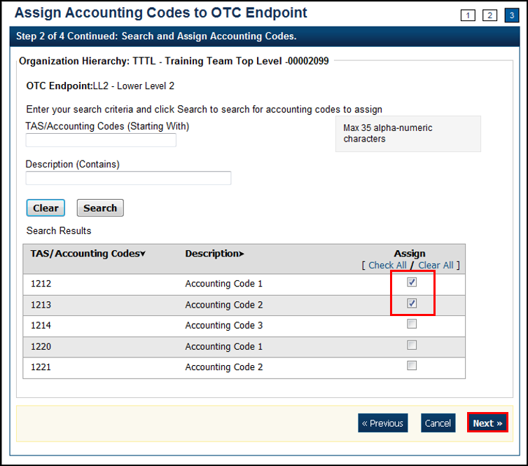

Application Tip



If an Agency has identified accounting codes as a **Treasury Account Symbol** (**TAS**), only TAS identified as **Valid** by **Shared Accounting Module** (**SAM**) is available for mapping to an OTC Endpoint.

1. The *Step 3 of 4: Assign Accounting Codes page appears.* Review and verify the accounting code(s) you would like to assign and click **Next**. (Proceed to *Step 4 of 4: Review Accounting Codes to Endpoint*)

Application Tips



* Check the **Remove** box(es) and click the **Update** button to delete the OTC Endpoint mapping for an accounting code.
* A mapped accounting code is not eligible for removal if a batch is associated with a transaction within an active batch that is **Open**, **Closed**,   
  or **Approved** or a deposit that is in **Draft** or **Awaiting Approval** (**AWAP**) status. An error message is displayed to a user if this scenario occurs.

1. The *Step 4 of 4: Review Accounting Codes to Endpoint* page appears*.* Confirm the information is correct and click **Submit**to assign the accounting code(s) to the OTC Endpoint. OR

The *Step 4 of 4: Review Accounting Codes to Endpoint* page appears*.* Confirm the information is correct and click **Submit**to remove the accounting code(s) to the OTC Endpoint.

1. A *Confirmation* page appears showing that the accounting codes have been assigned to or removed from the OTC Endpoint.

Additional Buttons



* Click Return Home to return to the OTCnet Home Page.
* Click Manage Additional to manage another accounting code.

## Topic 5. Managing Processing Options

As part of managing your organization hierarchy, you need to define your deposit processing options. **Processing options** are parameters for the deposit and adjustments process. You must first define processing options at the highest level of the organization before defining lower level options. For lower-level organizations, if you do not define these options, then the lower-level organizations will take on the options set for the next higher-level organization that does have the options set.

If you do not define processing options, your organization cannot create deposits or classify a batch at the summary level. You can define processing options at any level within your organization. You can also view the processing options by **OTC Endpoint** report to manage processing options in your organization.

As an **Accounting Specialist**, you are authorized to modify the following processing options for your organization’s hierarchy:

* ***Accounting Classifications for Adjustments*, Corrections, and Returned Items**: Identifies the default accounting codes to which you want adjusted amounts credited and debited. This also applies to credit and debit voucher ALC Account Switch Corrections, returned items, and batches classified at the summary level, containing a failed item.
* ***Correspondence***: Provides the financial institution with address information for any correspondence including returned item information
* ***Deposit Preparation***: Sets default settings for deposit preparation to save time for Deposit Preparers
* ***Transaction History***: Sets default settings for historical data about transactions

### Modify Processing Options

The **Accounting Specialist** and **Local Accounting Specialist** are authorized to modify Deposit Processing options. The **Check Capture Supervisor** and **Check Capture Lead Operator** are authorized to modify Check Processing options.

The following items display on the page, Accounting codes:

* Not applied as a debit or credit adjustment to your OTC Endpoint
* That meet your search criteria

If you do not enter search criteria, all accounting codes defined for the highest-level organization appear.

Modify Processing Options

To modify a processing option, complete the following steps:

1. From the **Administration** tab, select **Manage Organizations**>**Processing Options**>**Modify**. The *Step 1 of 3: Select Organization Endpoint*page appears.

Application Tips



* Processing options must first be defined for the highest-level organization before any lower level organization’s processing options are defined.
* If the processing options are not defined for the highest-level organization, all lower level organization links are disabled.

1. Select the OTC Endpoint for which you want to modify a processing option. The *Step 2 of 3: Define Processing Options* page appears.
2. Modify the processing option(s) and click **Next**.

To modify **Accounting Classifications for Adjustments, Corrections, and Returned Items**, complete the following:

Application Tips



* An accounting code is assigned to both a debit adjustment and credit adjustment.
* Accounting classifications for adjustments apply to **Accounting Specialists**, **Check Capture Supervisors** and **Check Capture Lead Operators**. Accounting Classifications for corrections and returned items apply to **Check Capture Supervisors** and **Check Capture Lead Operators**.

Update Default Accounting Codes by completing the following:

* Selecting either **Use parent’s values** or **Use my values**
* Entering the search criteria for the accounting code you would like to view and click **Search** (magnifying glass)

Application Tip



To narrow an accounting code search, enter a partial or full accounting code.

Or

* Clicking **Search** (magnifying glass) to view accounting codes

Application Tip



* All accounting codes that meet your search criteria and are not applied as   
  a debit or credit adjustment, correction or returned item to your OTC Endpoint are displayed on the page. If you do not enter search criteria, all the accounting codes defined for the highest-level organization appear.
* By default, the first ten accounting codes display, first by ascending special character order, by numerical order and finally by ascending alphabetical order by accounting code.
* If organization has more than ten accounting codes, click the pagination menu above the section containing the existing accounting codes to view additional pages of results. The system will only allow a user to view and apply active accounting codes not designated as TAS or those designated as TAS and have been validated by SAM.
* Selecting the accounting code to apply a credit and/or debit type and clicking **Assign to Debit** and/or **Assign to Credit**

Application Tip



* An accounting code is assigned to debit and credit adjustment, correction, and returned item types.
* After an accounting code is assigned to debit or credit adjustment it appears in the Adjustment Type/Default Accounting Code table.
* Selecting **Yes** or **No** to allow changes by an organization lower in hierarchy

Update **Default Accounting Code Usage** by completing the following steps:

* Selecting either **Use parent’s values** or **Use my values**
* Selecting either **Always Use the Default for Deposit Adjustments** or **Default based upon Deposit Subtotals for Deposit Adjustments**
* Selecting **Yes** or **No** to allow changes by an organization lower in hierarchy

To modify **Correspondence**, complete the following steps:

Update **Returned Items** by completing the following steps:

* Selecting **Use parent’s values** or **Use my values**
* Entering the corresponding address information that you would like to be displayed to a financial institution when return item adjustment is created
* Selecting **Yes** or **No** to allow changes by an organization lower in hierarchy

Update **Deposit Adjustment** by completing the following steps:

* Selecting **Use parent’s values** or **Use my values**
* Entering the corresponding address information that you would like to be displayed to a financial institution when a deposit adjustment is created
* Selecting **Yes** or **No** to allow changes by an organization lower in hierarchy

To modify **Deposit Preparation**, complete the following steps:

Update **ITGA Deposit Creation** by:

* Selecting **Use parent’s values** or **Use my values**
* Selecting **Yes** or **No** to allow endpoint to create foreign deposits
* If the endpoint accepts foreign deposits, enter the **Default foreign currency when creating deposits** details
* Selecting **Yes** or **No** to allow changes by an organization lower in hierarchy

Update **Subtotals and Cash Count** by completing the following steps:

* Selecting **Use parent’s values** or **Use my values**
* Selecting **Yes** or **No** for each of the following options
  + - Include Sub-totals for Checks/Money Orders and Cash
    - Include Currency count and sub-totals by denomination
    - Include Coin count and sub-totals by denomination
    - Allow changes by an organization lower in hierarchy

Update **Accounting Code Subtotals** by completing the following steps:

* Selecting **Use parent’s values** or **Use my values**
* Selecting **Yes** or **No** for each of the following options
* Allow negative accounting code subtotals
* Allow changes by an organization lower in hierarchy

Update **Separation of Duties** as shown in **Error! Reference source not found.**Figure 17 and by completing the following steps:

* Selecting **Use parent’s values** or **Use my values**
* Selecting **Yes** or **No** for each of the following options
* Deposits must be prepared and approved by different employees
* Allow changes by an organization lower in hierarchy

Figure 17. Update Deposit Processing Options with Deposit Preparation expanded

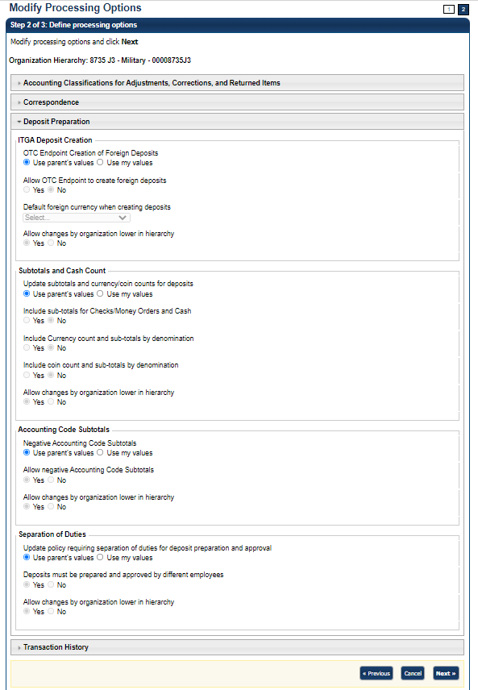

To modify **Transaction History**, complete the following steps:

* Selecting **Use parent’s values** or **Use my values**
* Entering the **Number of days displayed** in the text box, *if applicable*
* Selecting **Yes** or **No** to allow changes by an organization lower in hierarchy

1. The *Step 3 of 3: Review the following processing options* page appears. Verify the information is correct and click **Submit**.
2. A *Confirmation* page appears showing which processing options were applied to the organization.

Additional Buttons



* Click **Cancel** to return to the OTCnet Home Page. No data is saved.
* Click **Edit** to return to the previous page.
* Click **Next** to advance to the next page.
* Click **Previous** to return to the previous page.
* Click **Submit** to complete the process and display the Confirmation page.
* Click **Return Home** to return to the OTCnet Home Page.

### View Processing Options

The **Accounting Specialist** and **Local Accounting Specialist** are authorized to view deposit processing options. The **Check Capture Supervisor** and **Check Capture Lead Operator** are authorized to view check processing options.

When the *View Processing Options* page appears, it presents the custom labels in effect for the organization hierarchy, including the following:

* **Accounting Classifications for Adjustments, Corrections, and Returned Items**
* **Correspondence**
* **Deposit Preparation**
* **Transaction History**

View Processing Options

To view a processing option, complete the following steps:

1. From the **Administration** tab, select **Manage Organizations**>**Processing Options**>**View**. The *Select Organization Endpoint* page appears.
2. Select the highest-level organization or any lower level OTC Endpoint to view the processing options.
3. A *View Processing Options* page appears presenting the custom labels in effect for the organization hierarchy as shown in Figure 18.

Figure 18. View Processing Options

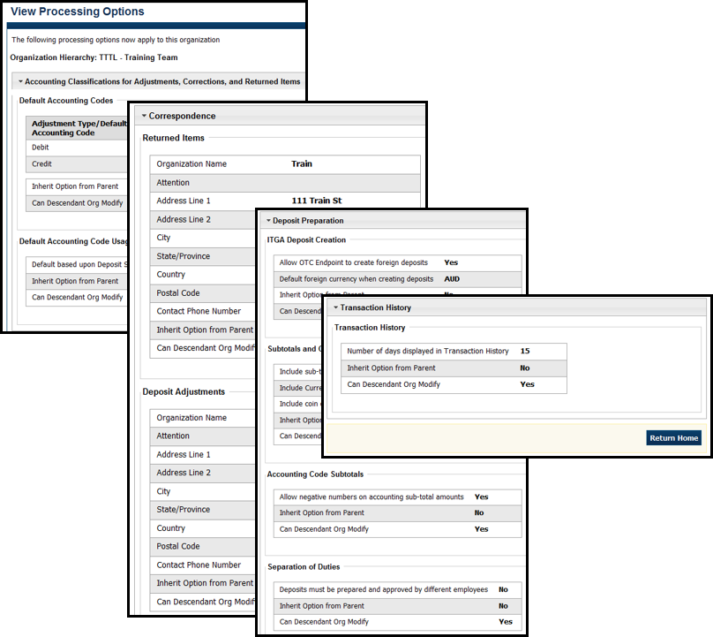

Additional Button



Click **Return Home** to return to the OTCnet Home Page*.*

## Summary

In this chapter, you learned:

* The purpose of organizational hierarchy
* How to add lower level endpoints to the highest level of an organization hierarchy
* How to add additional lower level endpoints/ add financial institution relationship to a hierarchy that was previously defined
* How to make changes to OTC Endpoints
* How to delete OTC Endpoints
* How to view OTC Endpoints
* How to modify accounting codes