

# Chapter 2: Accessing and Navigating OTCnet

OTCnet Participant User Guide

Table of Contents

Overview, Topics, and Audience 1

Overview 1

Topics 1

Audience 1

Topic 1 Starting and Stopping the OTCnet Local Bridge (OLB) Application 2

Start and Stop the OTCnet Local Bridge (OLB) Application 2

Start and Stop the OTCnet Local Bridge (OLB) Application 4

Topic 2 Requesting Access for Yourself in SailPoint IIQ 6

Self-Register/Create an Account in SailPoint IIQ 6

Self-Register/Create an Account in SailPoint IIQ 7

Request Access for Yourself in SailPoint IIQ 8

Request Access for Yourself in SailPoint IIQ 9

Topic 3 Log in to OTCnet Online 12

Log in to OTCnet Online 12

Log in to OTCnet Online 13

Topic 4 Log in to OTCnet Offline 15

Start the OTCnet Offline Server 15

Start the OTCnet Offline Server 16

Log In to OTCnet Offline Application for the First Time 18

Log in to OTCnet Offline Application for the First Time 19

Log in to OTCnet Offline 21

Log in to OTCnet Offline 22

Topic 5 Navigating the OTCnet Online/Offline Home Page 25

OTCnet Online Main Menu 25

OTCnet Online Deposit Processing Tab Functionality 26

OTCnet Online Check Processing Tab Functionality 28

OTCnet Online Card Processing Tab Functionality 29

OTCnet Online Administration Tab Functionality 30

OTCnet Online Reports Tab Functionality 31

OTCnet Offline Check Processing Functionality 32

OTCnet Offline Administration Tab Functionality 33

Summary 34

List of Figures

Figure 1. Stop OTCnet Local Bridge Icon 4

Figure 2. SailPoint IIQ Login Page 7

Figure 3. SailPoint Home Page with Manage My Access Button 9

Figure 4. Add Access Screen 10

Figure 5. Review and Submit Screen 10

Figure 6. OTCnet Log In Screen 13

Figure 7. First Time Log In Screen 14

Figure 8. OTCnet Offline Icon, Production 16

Figure 9. OTCnet Offline Startup 16

Figure 10. OTCnet Offline Application User Login Page 19

Figure 11. Set Permanent Password 20

Figure 12: OTCnet Offline Application User Login Page 22

Figure 13: Prompt for Multi-Factor Authentication Setup 23

Figure 14: Successful Multi-Factor Authentication Setup Message 23

Figure 15: OTCnet Main Menu Page 26

Figure 16. OTCnet Homepage Message Overlay 26

Figure 17. Deposit Processing Tab 27

Figure 18. Check Processing Tab 28

Figure 19. Card Processing Tab 29

Figure 20. Administration Tab 30

Figure 21. Manage Reports 31

Figure 22. OTCnet Offline Check Processing Descriptions 32

Figure 23. OTCnet Offline Administration 33

List of Tables

Table 1. Main Menu Link Descriptions 25

Table 2. Deposit Processing Tab Descriptions 27

Table 3. Check Processing Tab Descriptions 28

Table 4. Card Processing Tab Descriptions 29

Table 5. Administration Tab Descriptions 30

Table 6. Reports Tab Descriptions 31

Table 7. OTCnet Offline Check Processing Descriptions 32

Table 8. OTCnet Offline Administration Descriptions 33

Glossary

Click this [link](https://www.fiscal.treasury.gov/otcnet/training/wbt/content/course_OTC/glossary.htm) to access the full OTCnet Glossary.

## Overview, Topics, and Audience

### Overview

Welcome to *Accessing and Navigating OTCnet*. In this chapter, you will learn how to:

* Start and stop the OTCnet Local Bridge (OLB) application
* Request access for yourself in SailPoint IIQ
* Log in to OTCnet Online/Offline
* Navigate the OTCnet Online/Offline home page

### Topics

The topics in this chapter include the following:

1. Starting and Stopping the OTCnet Local Bridge (OLB) Application
2. Requesting Access for Yourself in SailPoint IIQ
3. Logging in to OTCnet Online
4. Logging in to OTCnet Offline
5. Navigating the OTCnet Online/Offline Home Page

### Audience

The intended audience for the *Accessing and Navigating OTCnet* Participant User Guide includes:

* All OTCnet Users

## Topic 1 Starting and Stopping the OTCnet Local Bridge (OLB) Application

The OTCnet Local Bridge (OLB) application is required for terminal detection and performing check capture, check processing and card processing tasks. If a user logs in to perform one of these operations and the OLB application is not started, the user receives the following message: *Terminal detection failed. Please ensure that the OLB application is running*. The OLB application is also required if you are using the Deployable Disbursing System (DDS) Interface (Department of Defense [DoD] only).

If you are a **Check Capture Administrator**, **Check Capture Supervisor**, **Check Capture Lead Operator**, **Check Capture Operator, Card Operator** or **Card Administrator**, the OLB application must be started on the terminal to perform terminal configuration, check capture, check processing, and card processing tasks.

Before starting the OLB application, ensure the following steps are completed in this order:

1. The **Check Capture Administrator** and **Card Administrator** downloaded the OLB application.
2. The OLB application is installed on the terminal.
3. Each user has created an OLB profile, ensuring that the OLB credential file was not renamed (the file name remained the same as it was generated).
4. Each user has imported his/her OLB credentials to the terminal.

There is no “timeout” with the OLB application (i.e., a suspension or break in OTCnet activity). Therefore, the OLB application stays connected unless one of the following occurs:

* The user logs out of the terminal (Windows session)
* The terminal is restarted or rebooted
* The user stops the OLB application on the terminal

When using Microsoft Edge or Google Chrome:

* Ensure the latest version of the OLB is installed.

### Start and Stop the OTCnet Local Bridge (OLB) Application

All users are authorized to start and stop the OTCnet Local Bridge (OLB) application.

To start the OLB application, either double-click the **Start OTCnet Local Bridge** icon on your terminal desktop or select **Start**>**Programs**>**Start** **OTCnet** **Local** **Bridge**.

If the **Start OTCnet Local Bridge** icon does not reside in either location, contact your **Card Administrator** or **Check Capture Administrator.** They support your completion of the steps required to complete the following:

* Ensure the latest version of the OLB is installed
* Create your OLB profile
* Import your OLB credentials

If the OLB application is started on the terminal, you receive an *OTCnet Local Bridge Application is already running* message.

When the *OTCnet* *Local Bridge Startup* page appears, enter your **OTCnet** **User ID** and **Password** in the appropriate text boxes. (Users will continue to use their User IDs to login to OLB. They will not use their PIV/CAC or ID.me accounts).

Password Criteria includes the following, it must:

* Be at least 12 characters long
* Not have more than two repeating characters
* Not repeat any of your last ten passwords
* Not have been your password during the last ten days
* Not be a word in a language, slang, dialect, or jargon
* Not be related to personal identity, history, environment, or other personal associations

To stop the OLB, double-click the **Stop OTCnet Local Bridge** icon located on the terminal desktop or select **Start**>**Programs**>**Stop OTCnet Local Bridge**.

Start and Stop the OTCnet Local Bridge (OLB) Application

To start the OTCnet Local Bridge (OLB) application, complete the following steps:

1. Double-click the **Start OTCnet Local Bridge** icon located on the terminal desktop.

Or

Select **Start**>**Programs**>**Start** **OTCnet** **Local** **Bridge**

1. The *OTCnet* *Local Bridge Startup* page appears. Enter your **OTCnet** **User ID** and **Password** in the appropriate text boxes.
2. Select **Log In**. A *Login Successful. OTCnet Local Bridge Application Started* message appears.



* Select **Cancel** and the *Are you sure you want to exit* message appears.
* Select **Yes** to cancel the OLB startup.
* Select **No** to return to the OTCnetLocal Bridge Startup page.

1. Select **OK**.

Application Tip



Once you start the OLB application, proceed to log in to OTCnet Online.

1. To stop the OLB application, double-click the **Stop OTCnet Local Bridge** icon located on the terminal desktop as shown in Figure 1.

Figure 1. Stop OTCnet Local Bridge Icon



Or

Select **Start**>**Programs**>**Stop** **OTCnet** **Local** **Bridge**.

1. When the **Stop OTCnet Local Bridge** window and the *Are you sure you want to stop the OTCnet Local Bridge Application?* message appears, select **Yes**.

Application Tips



* If you select **No**, the *Are you sure you want to stop the OTCnet Local Bridge Application?* message closes, and the OLB application remains running.
* Stopping the OLB application ensures the application is completely closed and that your OTCnet session is securely terminated.
* Before uninstalling the OLB application, you must first stop the OLB application. If the OLB application has been started on the terminal, ensure that it is stopped before uninstalling the application.

## Topic 2 Requesting Access for Yourself in SailPoint IIQ

Following the transition to Common Approach to Identity Assurance (CAIA), SailPoint IdentityIQ (IIQ) environment will be used to manage the identities and provisioning of new users.

CAIA is a solution consisting of a common federation platform by which users would be able to register, proof, and authenticate their identity via one or more selected credential service providers to access Fiscal Service programs.

Prospective OTCnet users can create identities through **Personal Identity Verification Cards** (**PIV**) or **Common Access Cards** (**CAC**) or **ID.me**.

As a prospective OTCnet user, you can select your desired role(s) and high-level org(s) based on instructions from your security administrator(s).

### Self-Register/Create an Account in SailPoint IIQ

You can self-register in SailPoint IIQ/create an account using **PIV/CAC** or **ID.me**.

**This functionality is available to all users but is not the preferred method for registering through SailPoint IIQ. The preferred option is for PLSA/LSAs to assist with creating an identity for a user and/or requesting an HLO or role access for them in SailPoint IIQ.**

Follow the on-screen instructions to sign in with an existing account or create an account. If prompted, follow the on-screen instructions to verify your identity. After completing all steps, you should see the SailPoint IIQ home page.

Self-Register/Create an Account in SailPoint IIQ

To self-register in SailPoint IIQ, navigate to the SailPoint IIQ environment at: [*https://iiq.fiscal.treasury.gov/*](https://iiq.fiscal.treasury.gov/) and complete the following steps:

1. Log in using **PIV**/**CAC** or **ID.me** credentials as shown in Figure 2.

Figure 2. SailPoint IIQ Login Page

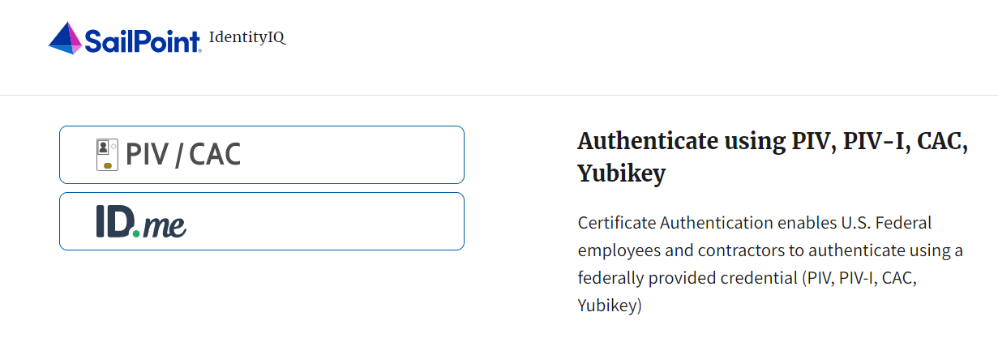

1. Follow the on-screen instructions to sign in with an existing account or create an account.
2. If prompted, follow the on-screen instructions to verify your identity.
3. After completing all steps, you should see the SailPoint IIQ home page.

Application Tip



New OTCnet users including those with **PIV**/**CAC** access can go through SailPoint IIQ to do the self-registration to create an account and request role(s) and high-level org(s) before logging to OTCnet. Once their high-level access is approved in SailPoint IIQ, they can proceed to login to OTCnet.

### Request Access for Yourself in SailPoint IIQ

If you need application entitlement, you can sign into SailPoint IIQ and request the specific access you need (self-request).

To request access for yourself, log into SailPoint IIQ and navigate to **Manage My Access.** Make sure **Add Access** is selected. In the search field, enter part or all of the **HLO**/**role** name you want to request. Select the **HLO**/**role** by clicking the **checkmark** to the left of the **HLO**/**role** name. Then select **Next**. On the **Review and Submit** screen, verify the requested **HLO**/**role(s)** are correct and select the **Submit** button.

A confirmation message will appear. SailPoint IIQ will automatically notify the necessary approvers to review the request. Once approved, your PLSA/LSA can create your identity in OTCnet and assign endpoints and roles for you. You will receive an autogenerated email when your user account is created in OTCnet.

Request Access for Yourself in SailPoint IIQ

To request access for yourself in SailPoint IIQ, complete the following steps:

1. From the **Home** screen of SailPoint, navigate to **Manage My Access** through the **Manage MyAccess** button as shown in Figure 3.

Figure 3. SailPoint Home Page with Manage My Access Button

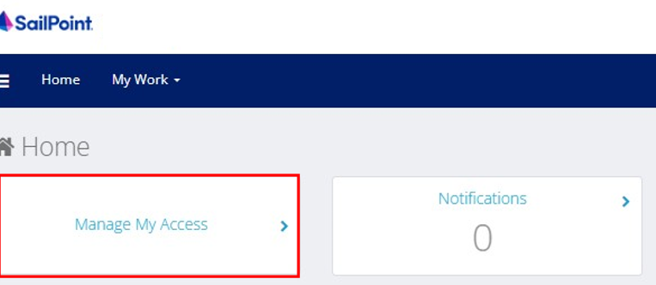

1. On the **Manage My Access** screen, ensure that **Add Access** tab is selected as shown in Figure 4.

Application Tips



Search for the specific **HLO** name (e.g., Alaska USA Federal Credit Union) and user **role** (e.g., Check Capture Operator).If the HLO or user role’s name is not known, type **HLO**/**Role** in the search field.

1. Search for an **HLO**. Select an **HLO** by clicking the **checkmark** to the left of the **HLO’s** name.
2. Continue on the same screen to search for a user role. Select a **role** by clicking the **checkmark** to the left of the **role’s** name. Then select **Next.**

Application Tips



* Multiple **HLOs** and **roles** can be selected.
* All roles selected in SailPoint IIQ will be validated (and edited as needed) in OTCnet by the designated **PLSA**/**LSA**.

Figure 4. Add Access Screen

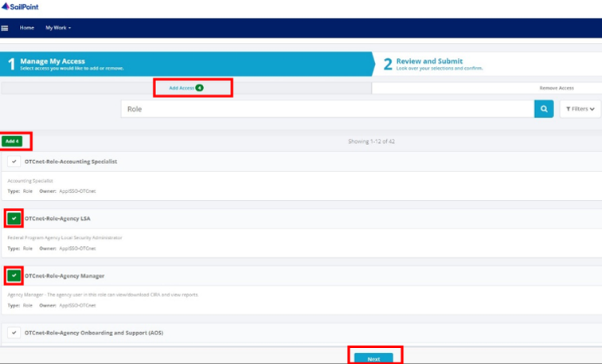

1. On the **Review and Submit** screen, verify the requested **HLOs** and **role(s)** are correct. Select the **voice bubble** to the right of the **HLO** or **role** to add any comments.
2. Select the **Submit** button at the bottom when finished, as shown in Figure 5.

Figure 5. Review and Submit Screen

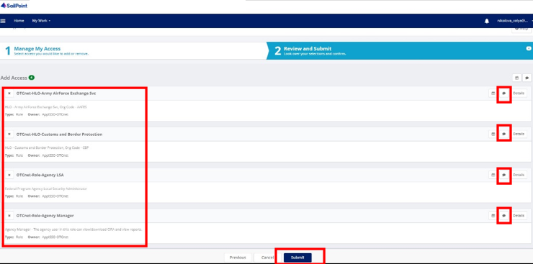

1. A confirmation message will appear. SailPoint IIQ will automatically notify the necessary approvers to review the request. Once approved, your PLSA/LSA can create your identity in OTCnet and assign endpoints and roles for you.

Application Tips



* You will receive an autogenerated email when your user account is created in OTCnet.
* Then you can access the OTCnet application.

## Topic 3 Log in to OTCnet Online

To log in to Fiscal Service Single Sign On (OTCnet Online), from the OTCnet Online login screen, use your **PIV**/**CAC** credentials, if you are a government user or contractor, or **ID.me**, if you are a non-government user.

If you are a non-government user who creates an account through **ID.me,** youwill specify your email address associated with OTCnet. ID.me is a private single sign-on provider that meets the government’s online identity proofing and authentication requirements.

Accounts registered by users for CAIA authentication are not application-specific, the same account credentials can be used on other sites or applications that are linked to CAIA. For example, Social Security Administration, Internal Revenue Service, Department of Veterans Affairs, and other government agencies accept **ID.me** credentials for logging in.

### Log in to OTCnet Online

To log in to OTCnet Online, visit <https://otcnet.for.fiscal.treasury.gov> and log in with the following options: **PIV**/**CAC** or **ID.me.** Select the option that suits you best and follow the on-screen instructions to verify your identity or create an account in SailPoint IIQ.

Once you log in to OTCnet, you will be able to access functionality for one or more of the following:

* Administration
* Deposit Processing and Reporting
* Check Capture
* Check Processing
* Card Processing

The OTCnet Local Bridge (OLB) application is required for performing check processing, check capture, card processing and terminal configuration operations. If you are a **Check Capture Administrator**, **Check Capture Supervisor**, **Check Capture Lead Operator**, **Check Capture Operator, Card Operator** or **Card Administrator**, the **OLB** application must be started on the terminal to perform these operations.

Log in to OTCnet Online

To log in to Fiscal Service Single Sign On (OTCnet Online), complete the following steps:

1. Access [*https://otcnet.for.fiscal.treasury.gov*](https://otcnet.for.fiscal.treasury.gov)*.* A page is presented which displays the following log in options: **PIV/CAC** and **ID.me**, as shown in Figure 6.

Figure 6. OTCnet Log In Screen

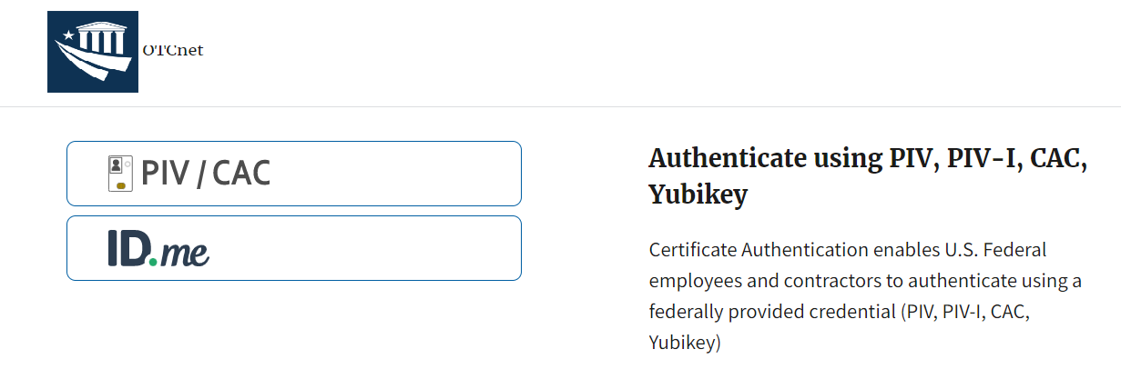

1. Select the option that best represents your status and follow the on-screen instructions to verify your identity or create an account in SailPoint IIQ.

Application Tip

Application Tips



**PIV/CAC (Government Users/Contractors)**

* Select the **PIV**/**CAC** button.
* If prompted, select your certificate, and enter your pin.
* If prompted, follow the on-screen instructions to verify your email address.

The first time a **PIV**/**CAC** certificate is used to authenticate, the email verification process is initiated.

* A web page is displayed prompting you to submit your **email address** that will be associated with your certificate. A **verification code** is sent to the email address specified.
* A web page is displayed to allow you to input the verification code from the email.

Application Tip



**ID.me for Non-Government Users**

* Select the **ID.me** button.
* Follow the on-screen instructions to sign in with an existing account or create an account.
* If prompted, follow the on-screen instructions to verify your identity.
* Use your **work email address** to create initially your **ID.me** identity. It is still recommended to add your personal email to your **ID.me** identity.

1. When you log in to OTCnet Online for first time you may be alerted that you are not permitted to access the application until your agency’s security administrator completes your user provisioning in OTCnet as shown in Figure 7.
2. Once your agency’s security administrator has imported your user identity to OTCnet, and assigned endpoints and roles for you, you will be able to access the application.

Figure 7. First Time Log In Screen

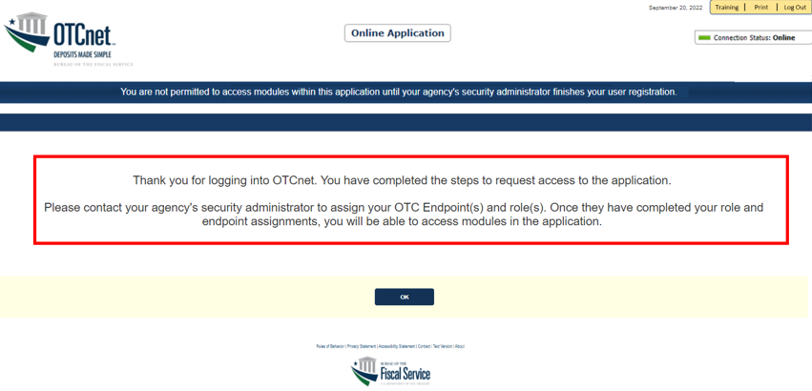

1. To completely log out, close your browser. You will need to reauthenticate next time you login to OTCnet.

Application Tip



As a **Check Capture Administrator**, **Check Capture Supervisor**, **Check Capture Lead Operator**, **Check Capture Operator**, **Card Operator** or **Card Administrator**, when logging in to OTCnet Online and using Microsoft Edge or Google Chrome, the OTCnet splash screen does not appear.

## Topic 4 Log in to OTCnet Offline

To log in to OTCnet Offline, you must have your User ID and temporary password. Your User ID is the same User ID used to log in to OTCnet Online; however, your initial temporary password is different from the password used to access OTCnet Online. To obtain your temporary password, contact your **Check Capture Administrator**. Once you obtain your temporary password, log in to OTCnet Offline.

Keep the following in mind when logging in to OTCnet Offline:

* To log in, double-click the **OTCnet Offline (Production or QA)** icon on your terminal desktop

Or

Click **Start >Programs>OTCnet Offline (Production or QA)>Start OTCnet Offline (Production or QA)**.

* If the OTCnet Offline icon does not reside in either location, contact your **Check Capture Administrator** to configure the terminal. If a terminal has more than one version of the OTCnet Offline application (Production or QA), do not run both at the same time, as running more than one version at a time causes errors.
* As an added layer of security, you must first start and log in to the OTCnet Offline *server* before accessing the OTCnet Offline *application*. To start the Offline server, enter your User ID and Offline password. If this is the first time you are accessing OTCnet Offline, enter your temporary password. Once you have successfully started the Offline server, you are prompted to log in to the OTCnet Offline application.
* If the Offline server is started, log directly in to the OTCnet Offline application. The first time you log in to the OTCnet Offline application you are required to change your password. After your permanent password is set, use your permanent password to startup the Offline server and/or Offline application.
* To stop the OTCnet Offline application, access the **Start** menu and **Programs>Stop OTCnet Offline**. Stopping the OTCnet Offline application ensures the application is completely closed and that your OTCnet session is terminated securely.

### Start the OTCnet Offline Server

As an added layer of security, the **Check Capture Administrator**, **Check Capture Supervisor**, **Check Capture Lead Operator**, and **Check Capture Operator** must first log in to the OTCnet Offline server before accessing the OTCnet Offline application. Identify the Offline Server log in page, it is labeled **OTCnet Offline Server Startup.** The **Retrieve Admin Profile** link *does not* appear on this page.

To start the OTCnet Offline *server,* **OTCnet Offline (Production or QA)** must be started. You’ll import your OTCnet Offline profile and log in to OTCnet Offline.

Start the OTCnet Offline Server

To start the OTCnet Offline *server*, complete the following steps:

1. Double-click the **OTCnet Offline (Production or QA)** icon located on your terminal desktop as shown in Figure 8.

Figure 8. OTCnet Offline Icon, Production

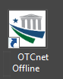

Or

Click **Start**>**Programs**>**OTCnet** **Offline** (**Production or QA)>Start OTCnet Offline (Production or QA)**. The *OTCnet Offline Startup* page appears as shown in **Error! Reference source not found.**.

Application Tips



* If the icon does not reside in either location, contact your **Check Capture Administrator** to configure the offline terminal.
* If a terminal has more than one OTCnet Offline application installed (Production or QA training environment), do not run both at the same time as running more than one offline client at a time causes errors.

1. Enter your **User ID** and **Password** in the appropriate text boxes in the *OTCnet Offline Startup* page as shown in Figure 9. Click **Log In.**

Figure 9. OTCnet Offline Startup

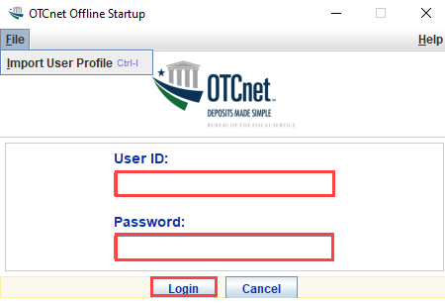

Application Tips



* The *Offline Server Startup* prompt appears as a standalone prompt, outside the browser.
* If you are a **Check Capture Administrator** and this is your first time starting the OTCnet Offline server and logging in to OTCnet, enter the temporary password you created when you created your **Check Capture Administrator** Offline Logon Profile.
* If you are a not a **Check Capture Administrator** and this is your first time starting the OTCnet Offline server and logging in to OTCnet, enter your temporary password.
* After your credentials are successfully authenticated, the *Offline Check Capture* application log in page displays.
* If you have forgotten your Offline password or you are not authorized to start the OTCnet Offline application, contact your **Check Capture Administrator** to reset/create your offline password.

### Log In to OTCnet Offline Application for the First Time

Once you receive your temporary password from your **Check Capture Administrator**, access the OTCnet Offline *application* to create a permanent password. The *application* includes the **Retrieve Admin Profile** link.

To log in to the OTCnet *application* for the first time, you must start the OTCnet Offline *server*, Production or QA and log in from the **Retrieve Admin Profile** page, reset your password and log in to OTCnet Offline.

Log in to OTCnet Offline Application for the First Time

To log in to OTCnet *application* for the first time, complete the following steps:

1. Double-click the **OTCnet Offline (Production or QA)** icon located on your terminal desktop.

Or

Click **Start**>**Programs**>**OTCnet** **Offline** **(Production or QA)**>**Start** **OTCnet** **Offline** **(Production or QA)**. The *Retrieve Admin Profile* page appears as shown in Figure 10.

Figure 10. OTCnet Offline Application User Login Page

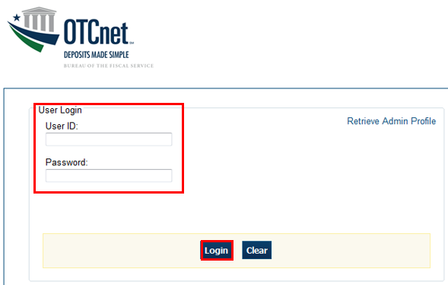

1. Enter your **User** **ID** and *temporary* **Password** in the appropriate text boxes. Click **Log** **In**. The *Set Permanent Password* page appears.

Application Tips



* If the icon does not reside in either location, contact your **Check Capture Administrator** to configure the terminal.
* If a workstation has more than one version of the OTCnet Offline application (Production or QA), do not run both at the same time as running more than one version at a time causes errors.
* If you are a **Check Capture Administrator** and this is your first time logging into OTCnet Offline, or you must download user profiles, click the **Retrieve Admin Profile** *link.*

1. Enter your *temporary* **Password**, **New** **Password**, **Re**-**Enter** **New** **Password** and click **Save** as shown in Figure 11. A Confirmation page appears stating your new password has been set.

Figure 11. Set Permanent Password

Set Permanent Password



Application Tip



After the profile is successfully downloaded and your password was reset, you are prompted to log in to the system with your new password.

1. Click **Return to Login Page** to login to OTCnet Offline.
2. To stop the OTCnet Offline application, click **Start Menu**>**Programs**> **OTCnet Offline (Production or QA)**>**Stop OTCnet Offline (Production or QA).**

Application Tips



* Stopping the OTCnet Offline application ensures the application is completely closed and that your OTCnet session is terminated securely. It is recommended that after stopping OTCnet Offline, you wait at least one to two minutes before restarting.
* If more than one version of the OTCnet Offline application resides on a terminal, stop the correct version of the OTCnet Offline application (Stop OTCnet Offline Production or QA).

### Log in to OTCnet Offline

If you are a **Check Capture Administrator**, **Check Capture Supervisor**, **Check Capture Lead Operator**, or **Check Capture Operator** and you have reset your temporary password, log in to OTCnet Offline.

To log in to OTCnet Offline, you must start OTCnet Offline, Production or QA. Log in to the OTCnet Offline *server.* Select the **Return to Login Page** to return to the Login Page. If you do not immediately access OTCnet Offline after resetting your temporary password, double-click the OTCnet Offline icon or access your **Start Menu** under **Programs**.

Additionally, you will be prompted to set up **multi-factor authentication** if you have not set it up already. Download and install an **authenticator application** on your workstation device and set up two-factor authentication for OTCnet Offline.

The session timeout in the Offline application is 30 minutes which prevents unnecessary timeouts due to inactivity.

Log in to OTCnet Offline

To log in to OTCnet Offline, complete the following steps:

1. Double-click the **OTCnet Offline (Production or QA)** icon located on your terminal desktop.

Or

Click **Start**>**Programs**>**OTCnet** **Offline** **(Production or QA)**>**Start** **OTCnet** **Offline** **(Production or QA)**. The *OTCnet Offline Server Start Up* page appears.

Application Tips



* If the icon does not reside in either location, contact your **Check Capture Administrator** to configure the terminal.
* If a terminal has more than one version of the OTCnet Offline application (Production or QA), do not run both at the same time, as running more than one version at a time causes errors.
* If the Offline server was not previously started, enter your User ID and password to start the Offline server.

1. Enter your **User ID** and **Password** in the appropriate text boxes. Select **Login as shown in** Figure 12**.**

Figure 12: OTCnet Offline Application User Login Page

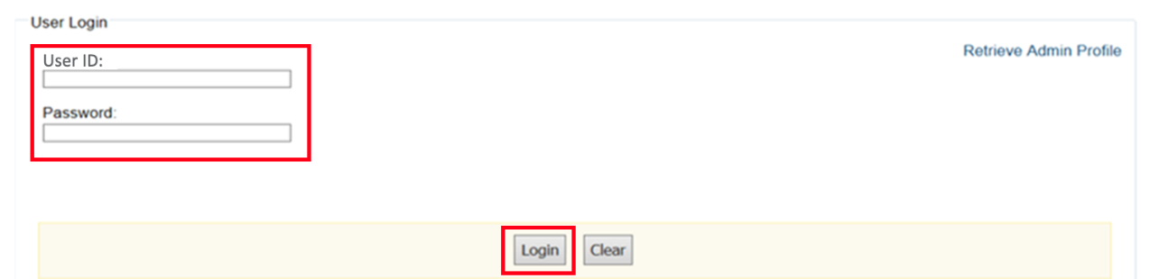

1. The system validates your **User ID** and **offline password** and determines if you have **multi-factor authentication** (**MFA**) set up.
2. If you have already set up **MFA**, you will be prompted to input your one-time code.
3. If you have not set up the **MFA**, the system prompts you to set up **MFA** with your chosen authenticator application by downloading the application on your workstation device.
4. Follow the steps in the authenticator to set up **MFA**. The system displays the **authenticator secret** and instructs you to enter it into your chosen authenticator as shown in Figure 13.
5. Input the **authenticator secret** into your authenticator application and label it as “**OTCnet Offline**.”
6. Enter your **Time-Based One-Time Password (TOTP)** code generated by the authenticator into the textbox and select **OK.**

Figure 13: Prompt for Multi-Factor Authentication Setup

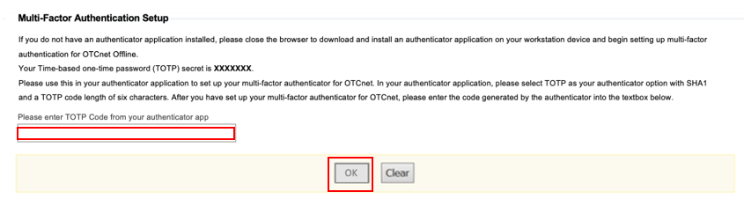

Application Tip



User must ensure they have selected **TOTP** as their authenticator option with **SHA1** and an **OTP code** length of six characters. Not all authenticators will present this option, but if it is an option, these parameters should be selected.

1. If you enter correctly the **TOTP** code, system will display a message that you have successfully set up multi-factor authentication for OTCnet Offline. Select the **OK** button to proceed to the login page as shown in Figure 14. Otherwise, system will prompt you to verify your **MFA** setup and **TOTP** code and try again.

Figure 14: Successful Multi-Factor Authentication Setup Message

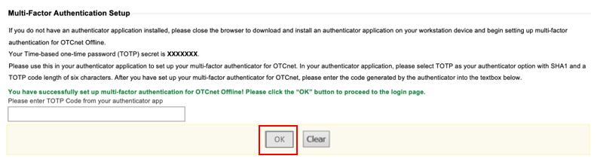

1. The system completes user authentication and displays a message informing you that **MFA** has been successfully set up.
2. Acknowledge the **message**. The system logs you out and displays the *OTCnet Offline* login screen.

Application Tip



* To stop the OTCnet Offline application, click Start>Programs>OTCnet Offline (Production or QA)>Stop OTCnet Offline (Production or QA).
* Stopping the OTCnet Offline application ensures the application is completely closed and that your OTCnet session is terminated securely.
* If more than one version of the OTCnet Offlineapplication resides on a terminal, be sure to stop the correct version of the OTCnet Offline application (Stop OTCnet Offline Production or QA).

## Topic 5 Navigating the OTCnet Online/Offline Home Page

The *OTCnet Online* home page allows **Check Capture Supervisors**, **Check Capture Lead Operators**, **Check Capture Operators** and **Card Operators** to process deposits, capture checks, process checks, process card transactions, view reports, and perform administrative and security functions. Additionally, a user can access information for training, help and to update a user profile. The OTCnet Online home page is accessible for users to either view or perform any of these functionalities.

The *OTCnet Offline* home page allows **Check Capture Supervisors**, **Check Capture Lead Operators** and **Check Capture Operators** to capture checks along with transaction data, perform administrative functions and access help information. The OTCnet Offline home page is accessible by users to either view or perform any of the functionalities mentioned in *OTCnet Online*.

### OTCnet Online Main Menu

To access the OTCnet Main Menu, log in with your **PIV**/**CAC** or **ID.me** credentials with the following url, *https://otcnet.for.fiscal.treasury.gov*. Table 1 provides a list of the Main Menu options available to you. They are accessible on the upper right corner of the OTCnet application.

Table 1. Main Menu Link Descriptions

| **Link** | **Description** |
| --- | --- |
| Home | Allows a user to return to the OTCnet home page. |
| Training | Allows a user to access the Web-Based Training (WBT) and other corresponding training materials. |
| Print | Allows a user to print the page. |
| Help | Allows a user to access help for the page they are on. |
| Log Out | Allows a user to log out of OTCnet. |

The Main Menu is shown in Figure 15: The links are accessible on the upper right side of the OTCnet home page.

Figure 15: OTCnet Main Menu Page

**OTCnet Homepage Message Overlay**

All user roles have access to the OTCnet Homepage Message Overlay, in OTCnet Online (you will not see it in OTCnet Offline). For all Microsoft Edge and Google Chrome users, the message overlay automatically presents when you first log in to OTCnet.

The message overlay is a messaging platform presenting important news and information on the OTCnet system as shown in Figure 16. It is recommended that you read the messages, close the message overlay, and continue viewing the OTCnet homepage.

Figure 16. OTCnet Homepage Message Overlay

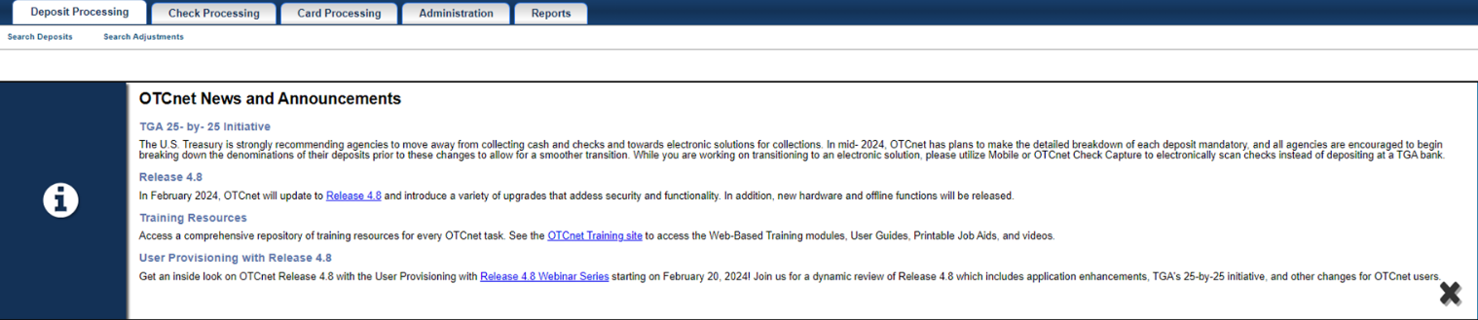

### OTCnet Online Deposit Processing Tab Functionality

To access the OTCnet Deposit Processing functionality, log in with your **PIV**/**CAC** or **ID.me** credentials.

Table 2 provides a list of the Deposit Processing functions that are available to you.

Table 2. Deposit Processing Tab Descriptions

| **Function** | **Description** |
| --- | --- |
| Create Deposit | Allows a user to create deposits for US Currency, Foreign Check Items, and/or Foreign Currency Cash. |
| Search Deposits | Allows a user to search for deposits. |
| Search Adjustments | Allows a user to search for adjustments. |
| Create Returned Item Adjustment | Allows a user to create a returned item adjustment. |

The Deposit Processing tab, as shown in Figure 17, allows you to access Deposit Processing functionality, though depending on your user role, you may not see all functionality.

Figure 17. Deposit Processing Tab

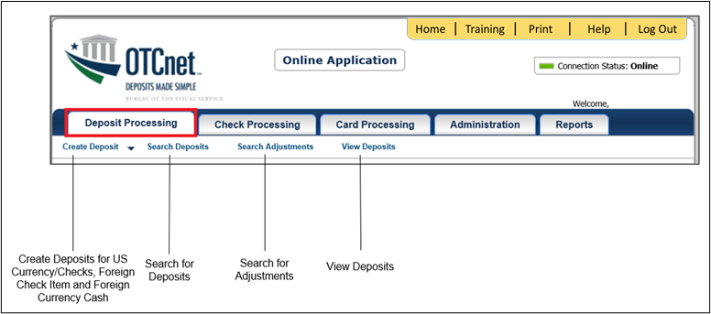

### OTCnet Online Check Processing Tab Functionality

To access the OTCnet Check Processing functionality, log in with your **PIV**/**CAC** or **ID.me** credentials. Table 3 provides a list of the Check Processing functions that are available to you.

Table 3. Check Processing Tab Descriptions

| **Function** | **Description** |
| --- | --- |
| Manage Verification | Allows a user to search and/or create an MVD record. |
| CIRA Query | Allows a user to view and/or modify a CIRA record. |
| Batch Management | Allows a user to search, view, close, approve and submit a batch. A user may edit and void an item within a batch with the proper permission. |
| Check Scan | Allows a user to scan checks. |
| Transmission History | Allows a user to view transmission history for batches that are uploaded from the offline check capture application. |

The Check Processing tab is shown in Figure 18. Depending on your user role, you may not see all functionality shown in the image.

Figure 18. Check Processing Tab

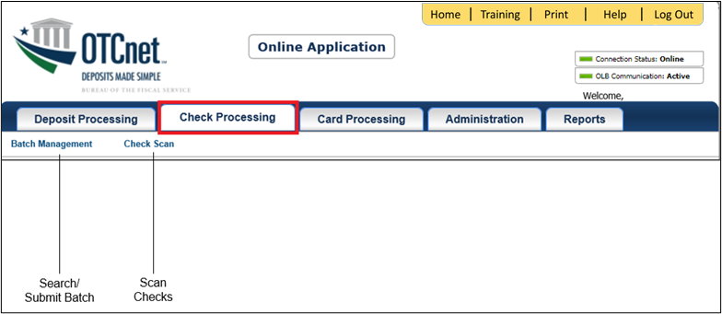

### OTCnet Online Card Processing Tab Functionality

To access the OTCnet card processing functionality, log in with your **PIV**/**CAC** or **ID.me** credentials. Table 4 provides a list of the card processing functions that are available to you.

Table 4. Card Processing Tab Descriptions

| **Function** | **Description** |
| --- | --- |
| Card Transaction Query | Allows a user to query a card transaction. |
| Process Card Payment | Allows a user to process a card payment. |

The Card Processing tab is shown in Figure 19. Depending on your user role, you may not see all functionality shown in the image.

Figure 19. Card Processing Tab

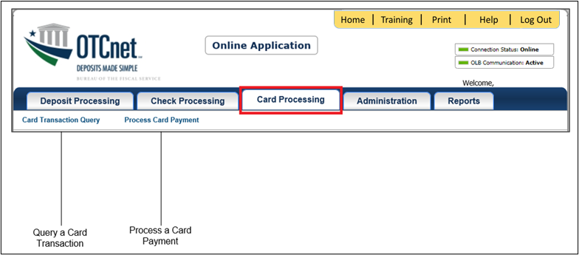

### OTCnet Online Administration Tab Functionality

To access the OTCnet Administration functionality, log in with your **PIV**/**CAC** or **ID.me** credentials. Table 5 provides a list of the Administration functions that are available to you.

Table 5. Administration Tab Descriptions

| **Function** | **Description** |
| --- | --- |
| Manage Organizations | Allows a user to manage Organization Hierarchy, Accounting Codes, Custom Labels, Processing Options, and User Defined Fields. |
| Manage FI | Allows a user to create and/or modify a Financial Institution, transfer FI RTN Numbers, transfer CA$HLINK accounts, and maintain FRB CA$HLINK accounts. |
| Manage Users | Allows a user to manage OTCnet user accounts and profiles. |
| Management | Allows a user to manage OTCnet processes. |
| Manage Check Processing | Allows a user to manage terminal configuration and forms. |
| Manage Card Processing | Allows a user to manage terminal configuration. |
| Manage Centralized Deployment | Allows users access to the following: Release Configuration, Edit Release and Download Release. |
| Audit | Allows a user to review the audit log history. |
| Utilities | Allows a user to review batch utilities, including Batch Recreate and Batch Repair. |

The Administration tab is shown in Figure 20. Depending on your user role, you may not see all functionality shown in the image.

Figure 20. Administration Tab

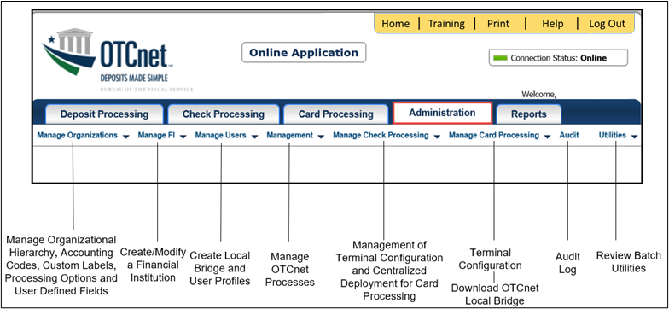

### OTCnet Online Reports Tab Functionality

To access the OTCnet Reports functionality, log in with your **PIV**/**CAC** or **ID.me** credentials. Table 6 provides a list of the Reports functions that are available to you. Depending on your user role, you are only authorized to view and download certain reports.

Table 6. Reports Tab Descriptions

| **Function** | **Description** |
| --- | --- |
| Deposit Processing Reports | Allows a user to view and download Business, Security and Administration reports. |
| Check Processing Reports | Allows a user to access Check Processing reports. |
| Historical Reports | Allows a user to query and download historical reports. |

The Reports tab is shown in Figure 21. Depending on your user role, you may not see all functionality shown in the image.

Figure 21. Manage Reports

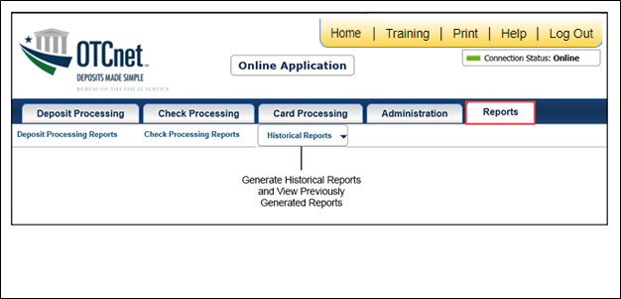

### OTCnet Offline Check Processing Functionality

To access the OTCnet Offline Check Processing functionality, log in with your User ID and password. Table 7Table 8 provides a list of the Check Processing functions available to you.

Table 7. OTCnet Offline Check Processing Descriptions

| **Function** | **Description** |
| --- | --- |
| Manage Verification | Allows a user to select and download OTC Endpoints. |
| Batch Management | Allows a user to search, view, close, approve, upload, and acknowledge a batch. A user may edit and void an item within a batch with the proper permission. |
| Check Scan | Allows a user to scan checks. |

The Check Processing tab is shown in Figure 22. Depending on your user role, you may not see all functionality shown in the image.

Figure 22. OTCnet Offline Check Processing Descriptions

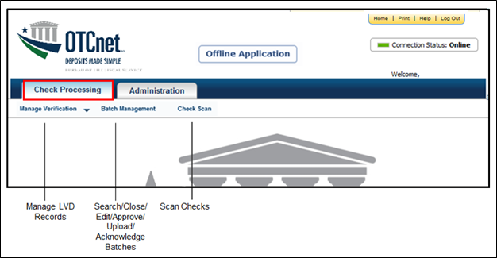

### OTCnet Offline Administration Tab Functionality

To access the OTCnet Offline Administration functionality, log in with your User ID and password. Table 8 provides a list of the Administration functions available to you.

Table 8. OTCnet Offline Administration Descriptions

| **Function** | **Description** |
| --- | --- |
| Manage OTC Endpoints | Allows a user to select and download OTC Endpoints. |
| User Administration | Allows a user to download, update, and manage user profiles. |
| Manage Check Processing | Allows a user to manage terminal configuration and forms. |
| Audit | Allows a user to review the audit log history. |

The Administration tab is shown in Figure 23. Depending on your user role, you may not see all functionality shown in the image.

Figure 23. OTCnet Offline Administration

Offline Application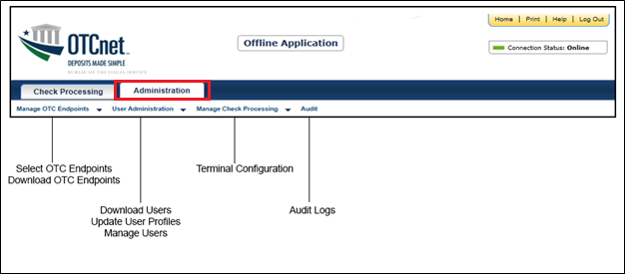

## Summary

In this chapter, you learned how to:

* Start and stop the OTCnet Local Bridge (OLB) application
* Request access for yourself in SailPoint IIQ
* Log in to OTCnet Online
* Log in to OTCnet Offline
* Navigate the OTCnet Online/Offline home page