Chapter 1: Introduction to OTCnet
OTCnet Participant User Guide

Table of Contents
Overview, Topics, and Audience 1
Overview 1
Topics 1
Audience 1
Topic 1. Introduction to OTCnet 2
Overview 2
OTCnet Elements 2
OTCnet Process Flow: Check Capture, Check Processing and Reporting 4
What is ACH? 5
What is Check 21? 5
OTCnet Process Flow: Deposit Reporting 7
OTCnet Process Flow: Card Processing 7
OTCnet Process Flow: Self-Service Kiosk: Check Payment 8
OTCnet Process Flow: Self-Service Kiosk: Deposit Processing 9
OTCnet Process Flow: Self-Service Kiosk: Card Processing 10
OTCnet End Users 11
Topic 2. OTCnet User Roles 13
Agency User Role Combinations 20
Financial Institution (FI) User Role Combinations 22
System Tasks by Agency and Financial Institution (FI) Roles 23
Summary 30

List of Figures
Figure 1. OTCnet Elements 3
Figure 2. Check Capture, Check Processing, and Reporting Process Flow 5
Figure 3. Deposit Processing Workflow 7
Figure 4. Card Processing Workflow 8
Figure 5. Self-Service Kiosk: Check Payment 9
Figure 6. Self-Service Kiosk: Deposit Processing Workflow 10
Figure 7. Self-Service Kiosk: Card Processing Workflow 11

List of Tables
Table 1. FedACH and Check 21 Payment Types 6
Table 2. End User Roles 12
Table 3. OTCnet Agency and FI/FRB User Roles 13
Table 4. Combinable Agency Deposit Processing User Roles 20
Table 5. Combinable Agency Check Capture User Roles 21
Table 6. Combinable Financial Institution User Roles 22
Table 7. Deposit Processing and Reporting Roles 23
Table 8. Check Capture Roles 24
Table 9. Check Processing 26
Table 10. Card Processing 29

Glossary
Click this link to access the full OTCnet Glossary.

Overview, Topics, and Audience

Overview
Welcome to Introduction to OTCnet Overview and OTCnet Course Content. In this chapter, you will learn:
- The introduction to OTCnet
- OTCnet User Roles

Topics
The topics in this chapter include the following:
- OTCnet Elements, Process Flows and End Users
- OTCnet User Roles

Audience
The intended audience for the Introduction to OTCnet includes:
- Administration Users
- Deposit Processing and Reporting Users
- Check Capture, Check Processing and Reporting Users
- Card Processing Users
- Viewers

Topic 1. Introduction to OTCnet

Overview
The Bureau of the Fiscal Service (BFS) Over the Counter Division (OTCD) provides the Over-the-Counter Channel Application (OTCnet) to facilitate the prompt electronic processing, reporting of deposits and transaction activities. OTCnet financial services include retail transactions made at agency offices, face-to-face collection points, and point of sale (POS) locations throughout the US and abroad.
OTCD oversees the systems, networks and program infrastructure which enable world-class OTCnet financial services including the collection of checks, cash, coins and credit, debit, and gift card transactions at agency POS locations around the globe. The OTCD is responsible for implementing a coordinated government-wide strategy for the collection of over-the-counter transaction and deposit activities (cash, card, check, foreign checks/currency, seized currency), and the transition from paper checks to electronic mechanisms.
OTCnet is a secure web-based system that enables federal agencies to integrate check conversion, deposit reporting, and card processing, so that all check, cash, coin, and card deposits to the TGA are handled by one web-based application.
OTCnet offers agencies superior customer service and high-quality e-commerce solutions for collections and reporting needs.
OTCnet Financial Services includes the following:
- Electronic processing of US checks presented for cashing, payment, or deposit
- Processing of US currency, foreign currency cash and foreign check item deposits
- Acceptance of credit, debit, and gift cards (Visa, MasterCard, American Express, Discover)
- Support of the Self-Service Kiosk
- Automation of the collection and settlement process
- Support of online reporting and research capability for reconciliation and inquiries
- Improvements of deposit history record keeping

OTCnet Elements
OTCnet is comprised of five elements:
- *Administration
- Check Capture, Check Processing and Reporting
- Deposit Processing and Reporting
- Card Processing
- Self-Service Kiosk: Web Service
*Administration functions support Check Capture, Check Processing and Reporting, Deposit Processing and Reporting, Card Processing, and Self-Service Kiosk as shown in Figure 1.
Figure 1. OTCnet Elements
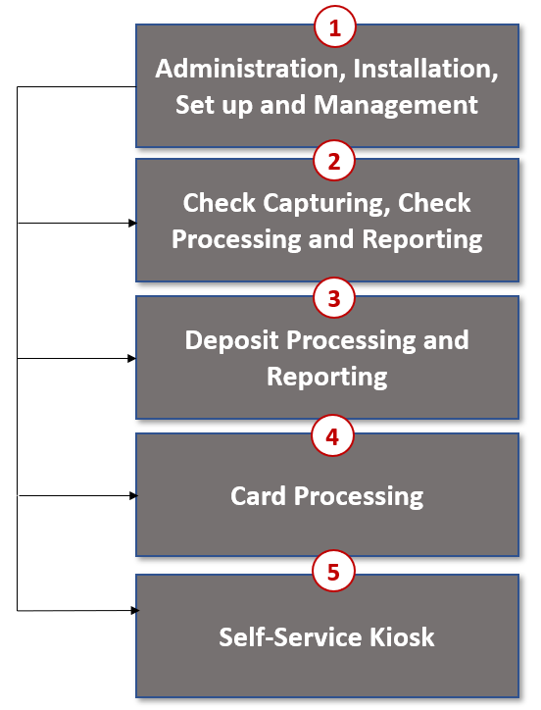
The functions of the five elements are:
- Administration, Installation Set Up and Management: allows for those with administrative permissions to install, setup users, and manage OTCnet
- Check Capturing, Check Processing: converts personal and business checks into electronic fund transfers. Transactions include consumer, consumer accounts receivable, and business transactions
- Deposit Processing: permits federal agencies the ability to create and submit deposits for confirmation. This platform also allows for Financial Institutions (FIs) to confirm those deposits and create adjustments electronically. Deposits are created for US currency, foreign cash, and foreign check items
- Card Processing: allows agencies to provide their customers an option to make payments via credit/debit cards and gift cards
- Self-Service Kiosk: third party vendor standalone kiosk supported by OTCnet

OTCnet Process Flow: Check Capture, Check Processing and Reporting
Check Capture and Check Processing involve converting paper checks received over the counter or through the mail into electronic debits to the check writer’s account. The process is highly automated and greatly improves the collection, reconciliation, research, and reporting processes associated with Federal Agency check collections.
In OTCnet, your Agency scans a check, and the check scanner captures an image of the front and back of each check. In OTCnet Online, the image is available immediately; in OTCnet Offline, the image is stored locally. You can also access Collections Information Repository (CIR) to retrieve deposit information.
The captured image of the check is stored for seven years in OTCnet. You can search the check images as well as the check capture and transaction date throughout the Check Image and Research Archive (CIRA) Query feature within OTCnet.
OTCnet sends summary as well as detailed information to CIR for those agencies that are not processing tax transactions.
CIR sends accounting entries with Treasury Account Symbol/Business Event Type Code (TAS/BETC) or Classification Keys (C-Keys) to Central Accounting Reporting System/ Government Wide Accounting (CARS). CARS invokes Shared Account Module (SAM) to either validate, translate, or default the TAS/BETC based on the accounting information received on the transaction.
OTCnet sends the captured check data to Debit Gateway at the Federal Reserve Bank Cleveland (FRB-C). FRB-C/Debit Gateway sends the data and settles to the appropriate Financial Institutions (FIs) either through FedACH (personal check) or Check 21 (non-personal check) where the check was written. All non-personal items are processed via Check 21.
The FI where the check was written shows the account was debited (Complete Check Capture and Check Processing and Reporting Process flow as shown in Figure 2 ).
If your Agency uses the Master Verification Database (MVD) (which provides downloads of prior negative check information and blocked items) and is working offline, the information is passed to the agency's Local Verification Database (LVD) when each batch is closed. The LVD is then used to determine the check writer's status and implement your Agency's bad check policy, if applicable.
Figure 2. Check Capture, Check Processing, and Reporting Process Flow
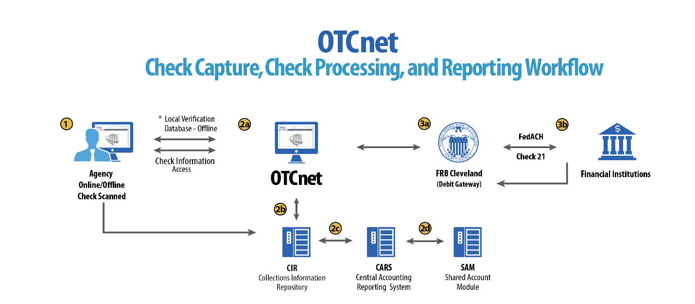

What is ACH?
The ACH Network is a nationwide batch-oriented electronic funds transfer system governed by the NACHA (National Automated Clearing House Association) operating rules which provide for the interbank clearing of electronic payments for participating depository financial institutions. The Federal Reserve and Electronic Payments Network act as ACH Operators, central clearing facilities through which financial institutions transmit or receive ACH entries. ACH payments include:
- Direct Deposit of payroll, Social Security and other government benefits, and tax refunds
- Direct Payment of consumer bills such as mortgages, loans, utility bills and insurance premiums
- Business-to-business payments
- E checks
- E commerce payments
- Federal, state, and local tax payments

What is Check 21?
Check 21, also known as ‘Check Clearing for the 21st Century’ Act, was signed into law on October 28, 2003. Provisions of the law took effect on October 28, 2004. It is important to understand the effects of Check 21 on OTCnet. Check 21 provides the legal framework for the creation of substitute checks, which can be used in place of the original paper document, without an agreement in place with other financial institutions. A substitute check is a paper reproduction of the original check.
To meet legal requirements, a substitute check must:
- Contain an image of the front and back of the original check.
- Bear a legend that states, “This is a legal copy of your check. It can be used the same way you would use the original check.”
- Display a MICR line containing information appearing on the MICR line of the original check.
- Conform in paper stock, dimension, and otherwise, with generally applicable industry standards for substitute checks.
- Be suitable for automated processing in the same manner as the original check.
Overall, this legislation has modernized the nation’s check payments system. Check 21 is designed to foster innovation in the payments system and to enhance its efficiency by reducing some of the legal impediments to check truncation.
ALL payment instruments are eligible for processing under OTCnet, including business checks, money orders, Treasury checks, credit card checks, traveler’s checks, cashier’s checks, official checks, third-party checks, payroll checks and checks drawn on state or local government.
Check 21 requires financial institutions to accept a substitute check from a presenting institute and grant it equivalent status as the original check if the substitute check meets prescribed requirements. It also requires a reconverting bank to meet the warranties and indemnities enacted through the legislation and subsequent regulations. Check 21 requires financial institutions to provide education to individual consumers on substitute checks and consumer re-credit rights.
For more information on Check 21, visit: https://www.frbservices.org/education/products-services-education/check21-act.html
Acceptable forms of FedACH and Check 21 payment types are shown in Table 1.
Table 1. FedACH and Check 21 Payment Types
FedACH | Check 21
- Direct Deposit of payroll, Social Security and other government benefits, and tax refunds  - Direct Payment of consumer bills such  as mortgages, loans, utility bills and insurance premiums  - Business-to-business payments  - E checks  - E commerce payments  - Federal, state, and local tax payments | - Business Checks  - Money Orders  - Treasury Checks  - Credit Card Checks  - Traveler’s Checks  - Cashier’s Checks  - Official Checks  - Third-party Checks  - Payroll Checks  - Checks drawn on state or local government  - Personal Check (No Notice)  - Personal Check (Opt Out)

OTCnet Process Flow: Deposit Reporting
Deposit Processing electronically collects and automates US and Foreign funds which facilitates the classification of Treasury collections daily.
As shown in Figure 3, the Deposit Preparer, or Agency, electronically reports the deposit to Treasury using OTCnet and prints out the OTCnet deposit ticket. The bank deposit ticket, OTCnet deposit ticket, cash, and checks (US and foreign) are taken to your Treasury General Account (TGA) Bank. At the TGA Back, the Deposit Confirmer confirms the deposit, rejects the deposit, or creates an adjustment to the deposit using OTCnet.
OTCnet sends commercial deposit voucher information to CIR. CIR receives commercial deposit information from OTCnet for reconciliation and transmits to Treasury Cash Management System (TCMS) for cash concentration purposes. TCMS receives the commercial deposit data from CIR and initiates the cash concentration activity.
The Deposit Preparer and Deposit Viewer can access OTCnet to view their deposit ticket information, as well as access reports, receive rejections, and view adjustments.
Figure 3. Deposit Processing Workflow
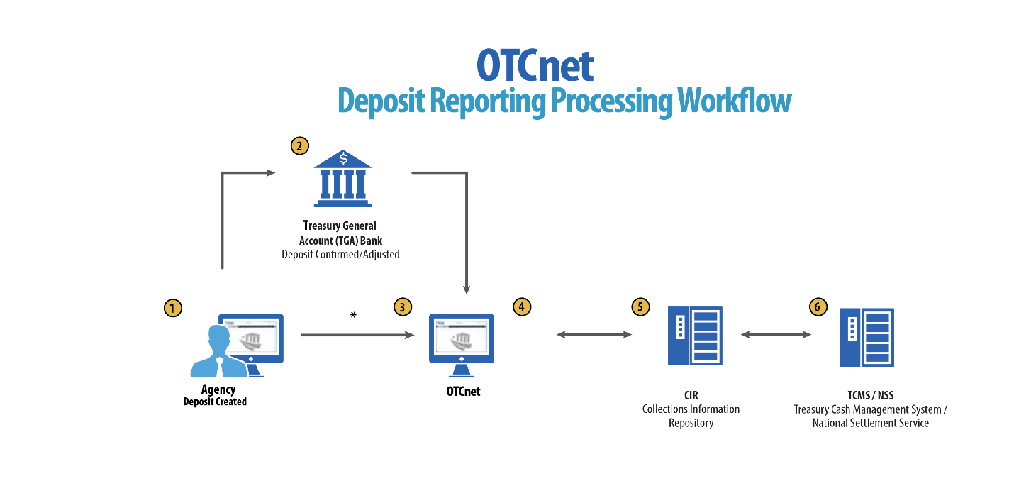

OTCnet Process Flow: Card Processing
Card processing is a web-based functionality that provides agency customers with an option to make payments with a credit, debit, or gift card. Card transactions are sent directly to WorldPay.
As shown in Figure 4, the Agency initiates the Card Processing payment. Currently, OTCnet does not store any card transaction details. The Agency can access Collections Information Repository (CIR) to retrieve deposit and card payment information.
The customer pays with a credit/debit card or gift card at an agency terminal station. The customer authorizes the amount to be charged to their account. The Verifone/OTCnet terminal sends the transaction data to Worldpay for authorization.
Worldpay processes the payment in four steps:
Step 1 - Authorization (Real Time)
Worldpay sends the transaction data to the card issuer through the card networks (e.g., Visa, Discover, Amex and Mastercard). The card issuer determines whether funding is available and returns authorization through the card networks to Worldpay.
Step 2 – Clearing
Funds in the daily transaction batch are cleared from Worldpay to Comerica Bank. The processing cut off for credit card payments is 4:30 AM and 2:00 AM for debit card payments.
Step 3 – Settlement
The card issuer sends the settlement money back to Worldpay via the card networks once the payments have been authorized and cleared. The timing varies by credit/debit network for when the settlement money is sent back to Worldpay.
Step 4 - Deposit Reporting
If the payment is approved, Worldpay sends deposit voucher transaction data to CIR via the Worldpay flat file the following morning between 4:00 AM - 6:00 AM.
CIR sends the voucher information to Treasury Cash Management System (TCMS). TCMS uses National Settlement Service (NSS) to draw funds. NSS transfers funds to the TGA Bank NY/FRB and reconciles them with Worldpay/Comerica Bank.
Figure 4. Card Processing Workflow
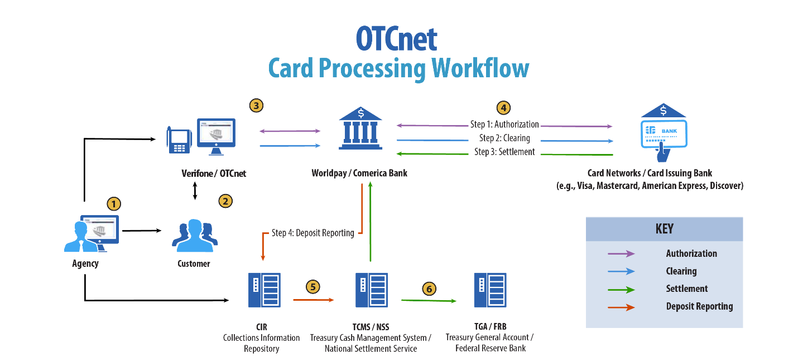

OTCnet Process Flow: Self-Service Kiosk: Check Payment
Self-Service Kiosk: Check Processing is a web-based functionality that provides agency customers with an option to make payments with a check at kiosk. The Kiosk Operator sets up the workstation and Kiosk Tablet daily by logging in to and locking down the Kiosk Tablet.
As shown in Figure 5, the kiosk captures the image of the front and back of each check. Kiosk: Image stored on the kiosk server. The images will be uploaded to the OTCnet server on a scheduled basis. The Agency accesses OTCnet for Check Processing reports. The agency can also access Collections Information Repository (CIR) to retrieve deposit information.
The captured image of the check is stored for seven years in OTCnet. An agency can search for check images as well as the check capture and transaction date throughout the CIRA (Check Image and Research Archive) Query feature within OTCnet. OTCnet sends the captured check data to Debit Gateway at the Federal Reserve Bank Cleveland (FRB-C). FRB-C/Debit Gateway sends the data and settles to the appropriate Financial Institutions (FIs) either through FedACH (personal check) or Check 21 (non-personal check) where the check was written. The FI, where the check was written, shows the account was debited.
OTCnet sends summary as well as detailed information to CIR for those agencies. CIR sends accounting entries with Treasury Account Symbol/Business Event Type Code (TAS/BETC) or Classification Keys (C-Keys) to Central Accounting Reporting System (CARS). CARS invokes Shared Account Module (SAM) to either validate, translate, or default the TAS/BETC based on the accounting information received on the transaction.
Figure 5. Self-Service Kiosk: Check Payment
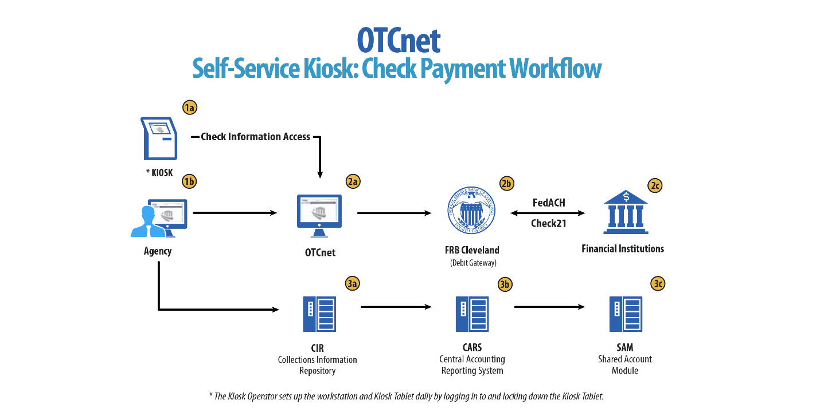

OTCnet Process Flow: Self-Service Kiosk: Deposit Processing
Self-Service Kiosk: Deposit Processing is a web-based functionality that provides agency customers with an option to make US cash payments at a kiosk. The Kiosk Operator sets up the workstation and Kiosk Tablet daily by logging in to and locking down the Kiosk Tablet.
As shown in Figure 6, the customer (kiosk user) makes US cash payments using the kiosk. The kiosk sends the deposit information to OTCnet with draft status. OTCnet creates a deposit voucher for the kiosk’s cash payment transactions with accounting code information. The Agency logs in to OTCnet to classify, approve and submit the voucher to the agency’s FI and can view the Deposit Process report. The cash goes to the bank.
The Agency can also access Collections Information Repository (CIR) to retrieve deposit information. The FI verifies and confirms the deposit in OTCnet. OTCnet sends vouchers information to Collections Information Repository (CIR). CIR sends the voucher information to Treasury Cash Management System (TCMS). TCMS uses National Settlement Service (NSS) to draw funds.
Figure 6. Self-Service Kiosk: Deposit Processing Workflow
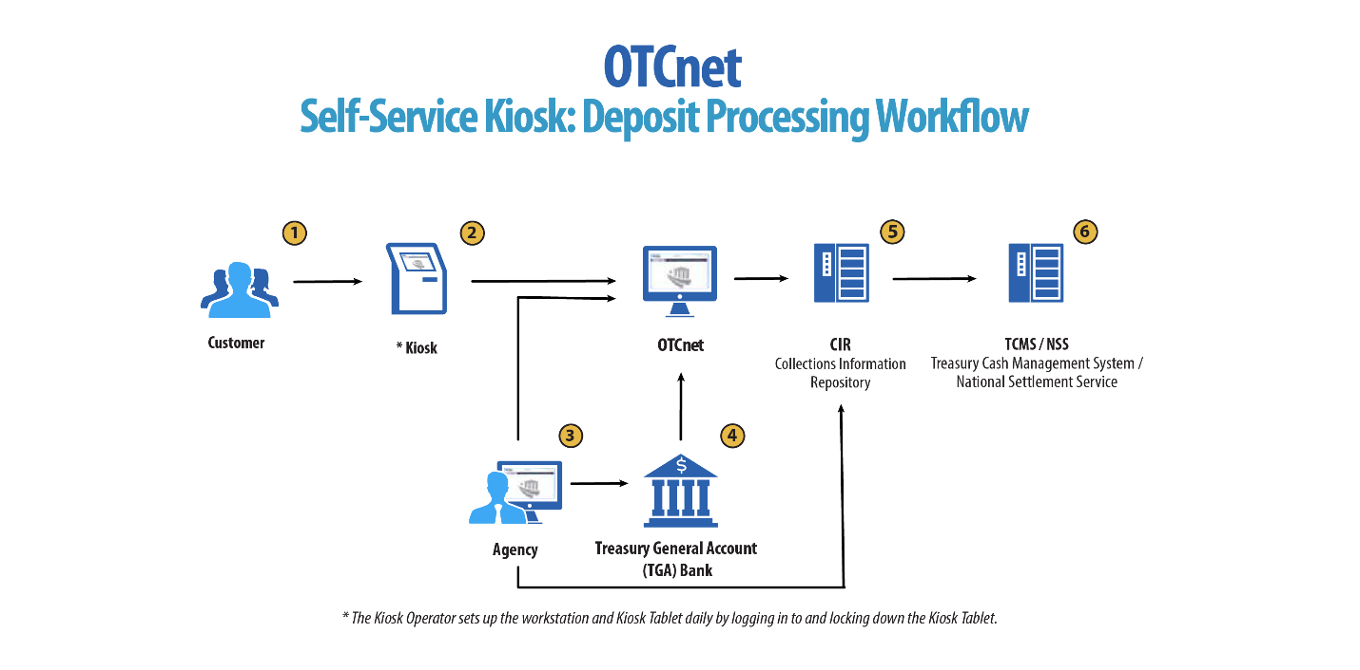

OTCnet Process Flow: Self-Service Kiosk: Card Processing
Self-Service Kiosk: Card Processing is a web-based functionality that provides agency customers with an option to make payments with a credit, debit, or Visa/Mastercard gift card at an agency terminal station. Card transactions are sent directly to WorldPay. The Kiosk Operator sets up the workstation and Kiosk Tablet daily by logging in to and locking down the Kiosk Tablet.
As shown in Figure 7, payments can be made with a credit/debit card or Visa/Mastercard gift card at the kiosk. The customer authorizes the amount to be charged to his/her account. The kiosk sends transaction data to Worldpay for authorization.
Worldpay processes the payment in four steps:
Step 1 - Authorization (Real Time)
Worldpay sends the transaction data over to the card issuer through the card networks (Visa, Discover, Amex and Mastercard). The card issuer determines if funding is available and returns authorization back through the card networks to Worldpay.
Step 2 – Clearing
Funds in the daily transaction batch are cleared from Worldpay to Comerica Bank. Processing cut off for credit card payments is 4:30 AM and 2:00 AM for debit card payments.
Step 3 – Settlement
The card issuer sends the settlement money back to Worldpay via the card networks once the payments have been authorized and cleared. The timing varies by credit/debit network for when the settlement money is sent back to Worldpay.
Step 4 - Deposit Reporting
If the payment is approved, Worldpay sends deposit voucher transaction data to CIR via the Worldpay flat file the following morning between 4:00 AM - 6:00 AM.
CIR sends the voucher information to Treasury Cash Management System (TCMS). TCMS uses National Settlement Service (NSS) to draw funds. The kiosk sends the card transaction data to OTCnet via the card webservice. NSS transfers funds to the TGA Bank NY/FRB and reconciles with Worldpay/Comerica Bank. The Agency accesses OTCnet for Card Processing reporting. The Agency can also access Collections Information Repository (CIR) to retrieve deposit information.
Figure 7. Self-Service Kiosk: Card Processing Workflow
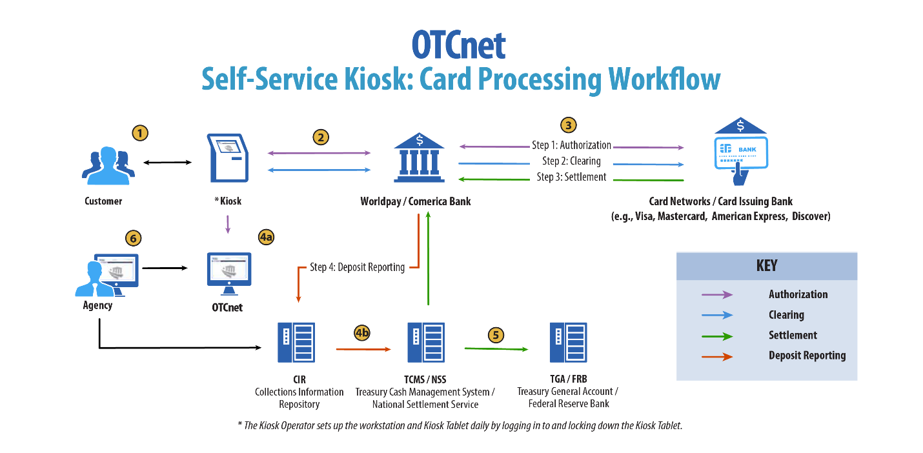

OTCnet End Users
There are four functional areas of the OTCnet application:
- Administration
- Check Capture, Processing and Reporting
- Deposit Processing and Reporting
- Card Processing
The user role you hold is based on the types of tasks you will perform.
- Administration user roles, with varying degrees of permission, and perform administrative duties such as user management and system installation.
- Check Capture/Check Processing and Reporting user roles perform functions to capture checks, process checks, access reports and edit or view the Master Verification Database (MVD).
- Deposit Processing and Reporting user roles create deposits, approve, confirm (reject or adjust), and/or view information as shown in Table 2.
- Card Processing user roles perform functions to process card transactions.
Table 2. End User Roles
Administration | Check Capture/ Check Processing and Reporting | Deposit Processing and Reporting | Card  Processing
Agency  - Check Capture Supervisor  - Check Capture Administrator  - Accounting Specialist/ Local  - Accounting Specialist  - Card Administrator  Financial Institution/ Federal Reserve  - Primary Security Administrator  - Local Security Administrator | Agency  - Check Capture Operator  - Check Capture Lead Operator  - Check Capture Supervisor  - Batch Approver*  - Batch Uploader*  - Master Verification Database (MVD) Editor  - Master Verification Database (MVD) Viewer | Agency  - Deposit Preparer  - Deposit Approver  - Viewer  Financial Institution/ Federal Reserve  - Deposit Confirmer  - Viewer | Agency  - Card Operator
*Batch Approver and Batch Uploader are sub-roles assigned to users with existing roles.

Topic 2. OTCnet User Roles
Individuals are granted user access based on their job roles. Agency and Financial Institution/Federal Reserve Bank (FI/FRB) user roles are listed in Table 3 below with corresponding descriptions of job roles, the user roles that may assign the access, and whether the user can access Check Capture, Deposit Processing, or Card Processing functions.
Table 3. OTCnet Agency and FI/FRB User Roles
User Role | Role  Description | Assignable By | Check Capture | Deposit Processing | Card Processing
Accounting Specialist | The agency user in this role is an expert on the organizational structure, reporting needs and accounting rules for their agency. This role will establish and maintain the organizational foundation, accounting data and accounting relationships at the highest level of the agency in OTCnet. This role can also establish, maintain, and view processing options that one or more lower-level endpoints will use in OTCnet. | Agency PLSA  Agency LSA | BLANK | •
Agency Local Security Administrator (LSA) | The agency user in this role will maintain user access to an organization, including assigning/removing user roles and assigning/removing organization hierarchy access. LSAs can also view security reports. | Agency PLSA | • | •
Agency Primary Local Security Administrator (PLSA) | The agency user in this role has the same capabilities as an LSA with the additional capability of creating and modifying LSAs for their organization. There can only be one PLSA per agency. | OTCnet Customer Support Team | • | •
Agency Manager | The agency user in this role can view and download CIRA CSV reports and ACR Activity reports, run CIRA queries and view other general reports such as the SF215 Deposit Ticket and 5515 Debit Voucher reports. The agency user can view if an endpoint is designated for summary-level classification, and the agency comments associated to an endpoint. | Agency PLSA  Agency LSA | • | BLANK
Batch Approver | The user assigned this role will have the ability to approve a batch either prior to batch upload (from Offline) or when a batch is uploaded/submitted to OTCnet but not yet approved. This permission is granted especially when, in offline mode, a user has configured the terminal to upload a batch upon Batch Close. An example of this permission applies to a Check Capture Operator: though a terminal may be configured to upload upon close, an Operator is able to close a batch but does not inherently have Upload permissions, therefore the user's permissions will override the terminal configuration, and the batch will not be automatically uploaded. Providing this permission along with Batch Uploader allows for the Check Capture Operator to auto-upload the batch upon close. This role should be granted in limited cases at sites where there is a need for the Operator to perform this function without a Supervisor present.  This role only applies to the Offline version of OTCnet. | Agency PLSA  Agency LSA | • | BLANK
Batch Uploader | The user assigned this role will have the ability to upload a batch from Offline OTCnet to the online database; this user has no other permissions, and therefore should typically be granted to a Check Capture Operator and Lead Operator. This permission is granted especially when, in offline mode, a user has configured the terminal to upload a batch upon Batch Close. An example of this permission applies to a Check Capture Operator: though a terminal may be configured to upload upon close, an Operator is able to close a batch but does not inherently have Upload permissions, therefore the user's permissions will override the terminal configuration, and the batch will not be automatically uploaded. Providing this permission along with Batch Approver allows for the Check Capture Operator to auto-upload the batch upon close. This role should be granted in limited cases at sites where there is a need for the Operator to perform this function without a Supervisor present.  This role only applies to the Offline version of OTCnet. | Agency PLSA  Agency LSA | • | BLANK
Card Administrator | The agency user in this role has the capability to manage endpoints for card processing. The user can view and modify terminal configuration. The user can also modify, delete, view, and search organization hierarchy. Lastly, this user has the capability to download releases and read/view audit card modules. | Agency PLSA  Agency LSA |  |  | •
Card Operator | This user views organizational hierarchy and searches within the organization. This user can process credit card payments, query card transactions, and view terminal configuration. Finally, this user can read/view the audit log and has partial access to the user’s own activities. | Agency PLSA  Agency LSA |  |  | •
Check Capture Administrator | The agency user in this role has the capability to define and modify the check capture sites as well as manage accounting codes and modify endpoint mappings. For example, this user can setup the location policy and location group. Additionally, this user can view, modify, and import accounting codes and modify endpoint mappings. This user can also configure the Check Capture functions and perform upgrades of the application as well as has the permission to download user profiles for the site. Furthermore, this user can view checks at the item level or a batch at the summary level classified with multiple accounting codes, view/download CIRA CSV reports and ACR Activity reports, run CIRA queries and view other general reports such as the SF215 Deposit Ticket and 5515 Debit Voucher reports. The agency user can view if an endpoint is designated for summary level classification, and the agency comments associated to an endpoint. This user has the permission to download software or firmware to the terminal using the Download Check Capture application permission. Lastly, this user is authorized to download the OTCnet Local Bridge (OLB) application, install the OLB certificate, install the OLB application, create the OLB profile, and start and stop the OLB application. | Agency PLSA  Agency LSA | • | Check Capture Administrator
Check Capture Administrator | The agency user in this role has the capability to define and modify the check capture sites as well as manage accounting codes and modify endpoint mappings. For example, this user can setup the location policy and location group. Additionally, this user can view, modify, and import accounting codes and modify endpoint mappings. This user can also configure the Check Capture functions and perform upgrades of the application as well as has the permission to download user profiles for the site. Furthermore, this user can view checks at the item level or a batch at the summary level classified with multiple accounting codes, view/download CIRA CSV reports and ACR Activity reports, run CIRA queries and view other general reports such as the SF215 Deposit Ticket and 5515 Debit Voucher reports. The agency user can view if an endpoint is designated for summary level classification, and the agency comments associated to an endpoint. This user has the permission to download software or firmware to the terminal using the Download Check Capture application permission. Lastly, this user is authorized to download the OTCnet Local Bridge (OLB) application, install the OLB certificate, install the OLB application, create the OLB profile, and start and stop the OLB application. | Agency PLSA  Agency LSA | • | BLANK
Check Capture Lead Operator | The agency user in this role will have the ability to scan checks into a batch, view and classify checks at the item level or a batch at the summary level with multiple accounting codes, close a batch, edit a batch, balance check amounts, and enter batch control values during batch closing. This user is authorized to install the OTCnet Local Bridge (OLB) certificate, install the OLB application, create the OLB profile, and start and stop the OLB application. Additionally, this user is authorized to accept checks with poor quality, make MICR line corrections, and accept duplicates. This user is not authorized, however, to use out-of-date LVD. This role can establish, maintain, and view processing options for an endpoint pertaining to summary level classification and agency comments. | Agency PLSA  Agency LSA | • | BLANK
Check Capture Operator | The agency user that has the authorization to in scan checks into a batch, view and classify checks at the item level or a batch at the summary level with multiple accounting codes, close a batch, balance check amounts, and enter batch control values during batch closing. The agency user can also view if an endpoint is designated for summary level classification, and the agency comments associated to an endpoint. This user is authorized to install the OTCnet Local Bridge (OLB) certificate, install the OLB application, create the OLB profile, and start and stop the OLB application. Additionally, the user can enter/apply the Accounting Code at the time of scanning checks is established. However, the user does not have authorization to accept duplicates, make MICR corrections, authorize the use of out-of-date LVD, or accept checks with poor quality. | Agency PLSA  Agency LSA | • | BLANK
Check Capture Supervisor | The agency user in this role is the most powerful user on the Check Capture site. The user can perform almost all the functions in Check Capture including view and classify checks at the item level or a batch at the summary level, accept duplicates, make MICR corrections, authorize the use of out-of-date LVD, accept checks with poor quality, as well as view, modify, and import accounting codes, and modify endpoint mappings. However, this user does not have any permissions associated with scanning checks. To ensure “checks and balances,” scanning checks is reserved for a Check Capture Operator or Lead Operator only. This role can also establish, maintain, and view processing options that one or more lower-level endpoints will use in OTCnet. This user is authorized to install the OTCnet Local Bridge (OLB) certificate, install the OLB application, create the OLB profile, and start and stop the OLB application. | Agency PLSA  Agency LSA | • | BLANK
CIRA Viewer | The agency user in this role can only view organization endpoints and CIRA records. This is the check processing role with the lowest level of access. The agency user can view if an endpoint is designated for summary level classification, and the agency comments associated to an endpoint. | Agency PLSA  Agency LSA | • | BLANK
Deposit Approver | The agency user in this role will approve the deposit report and submit the information to the TGA financial institution. | Agency PLSA  Agency LSA | BLANK | •
Deposit Preparer | The agency user in this role prepares the deposit ticket and supporting information for transmission to the TGA financial institution. | Agency PLSA  Agency LSA | BLANK | •
FPA Viewer | The agency user in this role can only search / view deposit and adjustments and produce reports from it. | Agency PLSA  Agency LSA | BLANK | •
Local Accounting  Specialist | The agency user in this role is an expert on the organizational structure, reporting needs and accounting rules for its depositing and lower-level endpoints. This role will establish, maintain, and view the organizational structure, accounting code mappings to individual endpoints, and the processing options that one or more lower-level endpoints will use in OTCnet. | Agency PLSA  Agency LSA | BLANK | •
MVD Editor | The agency user in this role can create, update, and read verification records. This role can also download CSV formatted reports, view other general reports such as the 215 Deposit Ticket, 5515 Debit Voucher reports and the ACR Activity report. The agency user can view if an endpoint is designated for summary level classification, and the agency comments associated with an endpoint. | Agency PLSA  Agency LSA | • | BLANK
MVD Viewer | The agency user in this role can read CIRA records in addition to read verification records and read block records containing only AB permissions. This role also has the permission to download CSV formatted reports, view other general reports such as the 215 Deposit Ticket, 5515 Debit Voucher reports and the ACR Activity report. The agency user can view if an endpoint is designated for summary level classification, and the agency comments associated to an endpoint. | Agency PLSA  Agency LSA | • | BLANK
View Report | The agency user in this role will have access to agency reports except for the CIRA CSV report. | Agency PLSA  Agency LSA | • | •
Deposit Confirmer | The financial institution user in this role will verify the submitted deposit ticket, reject the deposit ticket if necessary, forward the information to the Treasury, and create adjustments, as necessary. | FI PLSA  FI LSA | BLANK | •
FI Viewer | The financial institution user in this role can only search and view deposits and adjustments, view Financial Institution information and produce reports from it. | FI PLSA  FI LSA | BLANK | •
FI/FRB Local Security Administrator (LSA) | The financial institution/federal reserve bank user in this role will maintain user access to an organization, including assigning/removing user roles and assigning/removing organization hierarchy access. | FI PLSA | BLANK | •
FI/FRB Primary Local Security Administrator (PLSA) | The financial institution/federal reserve bank user in this role has the same capabilities as an LSA, with the additional capability of creating and modifying LSAs for their organization. There can only be one PLSA per financial institution. | OTCnet Customer Support Team | BLANK | •
FI/FRB Confirmer | The FI/FRB user in this role will verify the submitted deposit ticket, reject the deposit ticket if necessary, forward the information to the Treasury, and create adjustments, as necessary. | FI PLSA  FI LSA | BLANK | •
FRB Viewer | The FRB user in this role can only search and view deposits and adjustments, view FRB information and produce reports from it | FI PLSA  FI LSA | BLANK | •

Agency User Role Combinations
As shown in Table 4 and Table 5 Agency Deposit Processing, Check Capture and Card Processing user roles can be combined and assigned to an individual user. “•” indicates that the role in the column heading can be combined with the role to the far left of it.
Table 4. Combinable Agency Deposit Processing, Check Capture and Card Processing User Roles
Agency User Roles | Agency PLSA | Agency LSA | Kiosk Operator | Accounting Specialist | Local Accounting Specialist | Deposit Preparer | Deposit Approver | FPA Viewer
Agency PLSA | BLANK | BLANK |  | BLANK | BLANK | BLANK | BLANK | •
Agency LSA | BLANK | BLANK |  | BLANK | BLANK | BLANK | BLANK | •
Kiosk Operator
Accounting Specialist | BLANK | BLANK |  | BLANK | • | • | • | •
Local Accounting Specialist | BLANK | BLANK |  | • | BLANK | • | • | •
Deposit Preparer | BLANK | BLANK |  | • | • | BLANK | • | •
Deposit Approver | BLANK | BLANK |  | • | • | • | BLANK | •
FPA Viewer | • | • |  | • | • | • | • | •
CIRA Viewer | BLANK | BLANK |  | • | • | • | • | •
View Report | BLANK | BLANK |  | • | • | • | • | •
MVD Editor | BLANK | BLANK |  | • | • | • | • | •
MVD Viewer | • | • |  | • | • | • | • | •
Card Administrator | BLANK | BLANK |  | • | • | • | • | BLANK
Card Operator | BLANK | BLANK | • | • | • | • | • | BLANK
Check Capture Operator | BLANK | BLANK | • | • | • | • | • | •
Check Capture Lead Operator | BLANK | BLANK | • | • | • | • | • | •
Check Capture Administrator | BLANK | • |  | • | • | • | • | •
Check Capture Supervisor | BLANK | BLANK |  | • | • | • | • | •

Table 5. Combinable Agency Check Capture and Card Processing User Roles
Deposit Reporting, Check Capture and Card Processing User Roles | Agency Manager | CIRA Viewer | View Report | MVD Editor | MVD Viewer | Check Capture Operator | Check Capture Lead Operator | Check Capture Admin. | Check Capture Supvr. | Batch Approver | Batch Uploader
Agency PLSA | BLANK | BLANK | BLANK | BLANK | • | BLANK | BLANK | BLANK | BLANK | BLANK | BLANK
Agency LSA | BLANK | BLANK | BLANK | BLANK | • | BLANK | BLANK | • | BLANK | BLANK | BLANK
Accounting Specialist | BLANK | • | • | • | • | • | • | • | • | BLANK | BLANK
Local Accounting Specialist | BLANK | • | • | • | • | • | • | • | • | BLANK | BLANK
Deposit Preparer | BLANK | • | • | • | • | • | • | • | • | BLANK | BLANK
Deposit Approver | BLANK | • | • | • | • | • | • | • | • | BLANK | BLANK
Agency Manager | BLANK | BLANK | BLANK | • | BLANK | BLANK | BLANK | • | • | BLANK | BLANK
CIRA Viewer | BLANK | BLANK | • | • | • | • | • | • | • | BLANK | BLANK
View Report | BLANK | • | BLANK | • | • | • | • | • | • | BLANK | BLANK
MVD Editor | • | • | • | BLANK | • | • | • | • | • | BLANK | BLANK
MVD Viewer |  | • | • | • | BLANK | • | • | • | • | BLANK | BLANK
Card Administrator | blank | blank | blank | blank | blank |  | • | • | • | blank | blank
Card Operator | blank | blank | blank | blank | blank | • | • |  | • | blank | blank
Check Capture Operator | BLANK | • | • | • | • | BLANK | BLANK | BLANK | BLANK | • | •
Check Capture Lead Operator | BLANK | • | • | • | • | BLANK | BLANK | • | • | • | •
Check Capture Administrator | • | • | • | • | • | BLANK | • | BLANK | • | BLANK | BLANK
Check Capture Supervisor | • | • | • | • | • | BLANK | • | • | BLANK | BLANK | BLANK
Batch Approver | BLANK | BLANK | BLANK | BLANK | BLANK | • | • | BLANK | BLANK | BLANK | BLANK
Batch Uploader | BLANK | BLANK | BLANK | BLANK | BLANK | • | • | BLANK | BLANK | BLANK | BLANK

Financial Institution (FI) User Role Combinations
Financial institution user roles that can be combined and assigned to an individual user are shown in Table 6. “•” indicates that the role in the column heading can be combined with the role to the far left of it.
Table 6. Combinable Financial Institution User Roles
Financial Institution (FI)  User Roles | FI PLSA | FI LSA | FI Confirmer | FI Viewer
FI PLSA | BLANK | BLANK | BLANK | •
FI LSA | BLANK | BLANK | BLANK | •
FI Confirmer | BLANK | BLANK | BLANK | •
FI Viewer | • | • | • | BLANK

System Tasks by Agency and Financial Institution (FI) Roles
The two tables below show the system tasks that can be performed by Agency and Financial Institution/Federal Reserve Bank (FI/FRB) user roles as shown in Table 7Error! Not a valid bookmark self-reference. and Table 8. “•” indicates that the user role shown in the column heading can perform the task listed to the far left of it.
Table 7. Deposit Processing and Reporting Roles
Deposit Processing & Reporting Task | Agency PLSA | Agency LSA | Agency Acc Spec | Agency Local Acc Spec | Agency Dep. Prep. | Agency Dep. Appr. | FI/  FRB Viewer | FI/  FRB PLSA | FI/  FRB LSA | FI/  FRB Dep. Confirmer | FI/  FRB Viewer
Add/Update/Delete a User | • | • | BLANK | BLANK | BLANK | BLANK | BLANK | • | • | BLANK | BLANK
Reset Password | • | • | BLANK | BLANK | BLANK | BLANK | BLANK | • | • | BLANK | BLANK
Manage Own Account | • | • | • | • | • | • | • | • | • | • | •
OTCnet Logon and Homepage | • | • | • | • | • | • | • | • | • | • | •
Create/Modify Deposit | BLANK | BLANK | BLANK | BLANK | • | BLANK | BLANK | BLANK | BLANK | BLANK | BLANK
Submit Deposit | BLANK | BLANK | BLANK | BLANK | BLANK | • | BLANK | BLANK | BLANK | BLANK | BLANK
Confirm/Reject Deposit | BLANK | BLANK | BLANK | BLANK | BLANK | BLANK | BLANK | BLANK | BLANK | • | BLANK
View Deposit/Adjustment Detail | BLANK | BLANK | BLANK | BLANK | • | • | • | BLANK | BLANK | • | •
Search Deposit/ Adjustment | BLANK | BLANK | BLANK | BLANK | • | • | • | BLANK | BLANK | • | •
Create Deposit/ Adjustment | BLANK | BLANK | BLANK | BLANK | BLANK | BLANK | BLANK | BLANK | BLANK | • | BLANK
Create Return Item Adjustment | BLANK | BLANK | BLANK | BLANK | BLANK | BLANK | BLANK | BLANK | BLANK | • | BLANK
Modify Organization Hierarchy | BLANK | BLANK | • | • | BLANK | BLANK | BLANK | BLANK | BLANK | BLANK | BLANK
Delete Organization Hierarchy | BLANK | BLANK | • | • | BLANK | BLANK | BLANK | BLANK | BLANK | BLANK | BLANK
View Organization Hierarchy | BLANK | BLANK | • | • | BLANK | BLANK | BLANK | BLANK | BLANK | BLANK | BLANK
Search Organization Hierarchy | BLANK | BLANK | • | • | BLANK | BLANK | BLANK | BLANK | BLANK | BLANK | BLANK
Modify Accounting Codes* | BLANK | BLANK | • | BLANK | BLANK | BLANK | BLANK | BLANK | BLANK | BLANK | BLANK
Import Accounting Codes* | BLANK | BLANK | • | BLANK | BLANK | BLANK | BLANK | BLANK | BLANK | BLANK | BLANK
View Accounting Codes* | BLANK | BLANK | • | • | BLANK | BLANK | BLANK | BLANK | BLANK | BLANK | BLANK
Modify Endpoint Mappings* | BLANK | BLANK | • | • | BLANK | BLANK | BLANK | BLANK | BLANK | BLANK | BLANK
Modify Custom Labels | BLANK | BLANK | • | BLANK | BLANK | BLANK | BLANK | BLANK | BLANK | BLANK | BLANK
View Custom Labels | BLANK | BLANK | • | • | BLANK | BLANK | BLANK | BLANK | BLANK | BLANK | BLANK
Modify Processing Options | BLANK | BLANK | • | • | BLANK | BLANK | BLANK | BLANK | BLANK | BLANK | BLANK
View Processing Options | BLANK | BLANK | • | • | BLANK | BLANK | BLANK | BLANK | BLANK | BLANK | BLANK
Modify User Defined Fields | BLANK | BLANK | • | BLANK | BLANK | BLANK | BLANK | BLANK | BLANK | BLANK | BLANK
View user Defined Fields | BLANK | BLANK | • | • | BLANK | BLANK | BLANK | BLANK | BLANK | BLANK | BLANK
View Financial Institutions | BLANK | BLANK | BLANK | BLANK | BLANK | BLANK | BLANK | BLANK | BLANK | • | •
View Business Reports | BLANK | BLANK | • | • | • | • | • | BLANK | BLANK | • | •
View Security Reports | • | • | BLANK | BLANK | BLANK | BLANK | BLANK | • | • | BLANK | BLANK
View Administrative Reports | BLANK | BLANK | BLANK | BLANK | • | • | • | BLANK | BLANK | • | •
Read/View Audit Log | • | • | BLANK | BLANK | BLANK | BLANK | BLANK | BLANK | BLANK | BLANK | BLANK
View Reporters Flag | BLANK | BLANK | • | • | BLANK | BLANK | BLANK | BLANK | BLANK | BLANK | BLANK
This next table specifies OTCnet Check Capture Roles and corresponding permissions at the Agency level.
Table 8. Check Capture Roles
Check Capture Task | Check Capture Operator | Check Capture Lead Operator | Check Capture  Admin. | Check Capture SupervisorError! Bookmark not defined. | Batch Approver* | Batch Uploader* | Online/Offline
Authorize Duplicates | BLANK | • | BLANK | • | BLANK | BLANK | Online/Offline
Authorize MICR Correction | BLANK | • | BLANK | • | BLANK | BLANK | Online/Offline
Authorize Poor Image Quality | BLANK | • | BLANK | BLANK | BLANK | BLANK | Online/Offline
Balance Check Amounts | BLANK | • | BLANK | • | BLANK | BLANK | Online/Offline
Change Batch Control Values | • | • | BLANK | • | BLANK | BLANK | Online/Offline
Change Batch Status | BLANK | BLANK | BLANK | • | BLANK | BLANK | Online/Offline
Close Batch | • | • | BLANK | • | BLANK | BLANK | Online/Offline
Edit Batch | BLANK | • | BLANK | • | BLANK | BLANK | Online/Offline
Change Mode | • | • | BLANK | BLANK | BLANK | BLANK | Online/Offline
Configure Check Capture System (settings) | BLANK | BLANK | • | • | BLANK | BLANK | Online/Offline
View Check Capture System Configuration | • | • | • | • | BLANK | BLANK | Online/Offline
Configure Batch Manager | • | • | • | • | BLANK | BLANK | Online/Offline
Override Verification | BLANK | BLANK | BLANK | • | BLANK | BLANK | Online/Offline
Process Transactions (Scan Checks) | • | • | BLANK | BLANK | BLANK | BLANK | Online/Offline
Approve/Submit Batch | BLANK | BLANK | BLANK | • | • | BLANK | Online/Offline
View Batch List | • | • | • | • | BLANK | BLANK | Online/Offline
Void Item During Balancing | BLANK | BLANK | BLANK | • | • | BLANK | Online/Offline
Void Transaction | BLANK | BLANK | BLANK | • | • | BLANK | Online/Offline
Check Capture System Maintenance (Upgrade Scanner Firmware) | BLANK | BLANK | • | • | BLANK | BLANK | Online/Offline
Check Capture System Maintenance (Upgrade Application from Online) | BLANK | BLANK | • | • | BLANK | BLANK | Offline
Check Capture System Maintenance (Upgrade Form from Online) | BLANK | BLANK | • | • | BLANK | BLANK | Offline
Upload Batch | BLANK | BLANK | BLANK | • | BLANK | • | Offline
Acknowledge Batch | BLANK | BLANK | BLANK | • | BLANK | • | Offline
Recover from Secondary Storage | BLANK | BLANK | BLANK | • | BLANK | BLANK | Offline
Reset LVD | BLANK | BLANK | • | • | BLANK | BLANK | Offline
Update LVD | BLANK | • | BLANK | • | BLANK | BLANK | Offline
Authorize Old Verification | BLANK | BLANK | BLANK | • | BLANK | BLANK | Offline
Create and Download Local Bridge Credential File | • | • | • | • | BLANK | BLANK | Online
Create and Download Initialization File | BLANK | BLANK | • | BLANK | BLANK | BLANK | Offline
Startup of OTCnet Local Bridge (OLB) Application | • | • | • | •
Startup of OTCnet Offline Application Server | • | • | • | • | • | • | Offline
Upgrade Offline OTCnet Version | • | • | BLANK | • | BLANK | BLANK | Offline
Modify Classify Batch | • | • | BLANK | • | BLANK | BLANK | Online/Offline
View Classify Batch | • | • | • | • | BLANK | BLANK | Online/Offline
Modify Classify Item | • | • | BLANK | • | BLANK | BLANK | Online/Offline
View Classify Item | • | • | • | • | BLANK | BLANK | Online/Offline
Download Check Capture Application | BLANK | BLANK | • | • | BLANK | BLANK | Offline
View Activity Log | • | • | BLANK | BLANK | BLANK | BLANK | Offline
Read/View Audit Check Capture Module (Partial – Access User’s Own Activities Only) | BLANK | BLANK | • | BLANK | BLANK | BLANK | Offline
Manage Users | BLANK | BLANK | • | BLANK | BLANK | BLANK | Offline
Download User Profiles | BLANK | BLANK | • | BLANK | BLANK | BLANK | Offline
Update User Profiles | BLANK | BLANK | • | BLANK | BLANK | BLANK | Offline
Download OTC Endpoints | BLANK | BLANK | • | BLANK | BLANK | BLANK | Offline
Update OTC Endpoints (Offline) | BLANK | BLANK | • | • | BLANK | BLANK | Offline
The OTCnet Agency Check Processing user roles and their associated permissions are shown in Table 9.
Table 9. Check Processing
Check Processing Task | Agency Manager | Check Capture Operator | Check Capture Lead Operator | Check Capture Admin. | Check Capture Supervisor | CIRA Viewer* | View Reports* | MVD Editor | MVD Viewer | Batch Approver*
Manage Own Account | • | • | • | • | • | •• | BLANK | • | • | BLANK
OTCnet Logon and Homepage | • | • | • | • | • | • | BLANK | • | • | BLANK
Modify Organization Hierarchy | BLANK | BLANK | • | • | • | BLANK | BLANK | BLANK | BLANK | BLANK
Delete Organization Hierarchy | BLANK | BLANK | BLANK | • | • | BLANK | BLANK | BLANK | BLANK | BLANK
View organization Hierarchy | • | • | • | • | • | • | BLANK | • | • | BLANK
Search Organization | • | • | • | • | • | • | BLANK | • | • | BLANK
Create/Modify Verification Records | BLANK | BLANK | BLANK | BLANK | BLANK | BLANK | BLANK | • |  | BLANK
View Verification Records | BLANK | BLANK | BLANK | BLANK | BLANK | BLANK | BLANK | • | • | BLANK
Read Block Record Containing Only an ABA | BLANK | BLANK | BLANK | BLANK | BLANK | BLANK | BLANK | • | • | BLANK
Create/Modify Check Capture Site | BLANK | BLANK | BLANK | • | BLANK | BLANK | BLANK | BLANK | BLANK | BLANK
Download Release** | BLANK | BLANK | BLANK | • | BLANK | BLANK | BLANK | BLANK | BLANK | BLANK
View CIRA | • | BLANK | BLANK | BLANK | BLANK | • | • | • | • | BLANK
Read/View Audit Admin (Partial) | BLANK | BLANK | BLANK | • | BLANK | BLANK | BLANK | BLANK | BLANK | BLANK
Read/View Audit Check Capture (All) | BLANK | BLANK | BLANK | • | BLANK | BLANK | BLANK | BLANK | BLANK | BLANK
Read/View Audit Check Capture Module (Partial) | BLANK | BLANK | BLANK | BLANK | • | BLANK | BLANK | BLANK | BLANK | BLANK
Read/View Audit Check Capture Module (Partial – User’s Own Activity) | BLANK | • | • | BLANK | BLANK | BLANK | BLANK | BLANK | BLANK | BLANK
Read/View Audit Check Processing (All) | BLANK | BLANK | BLANK | BLANK | BLANK | BLANK | BLANK | • | BLANK | BLANK
Read CIRA Check Image Report | • | BLANK | BLANK | • | BLANK | BLANK | • | • | • | BLANK
Read CIRA CSV Report | • | BLANK | BLANK | • | BLANK | BLANK | BLANK | • | • | BLANK
Download CIRA CSV Historical Report | • | BLANK | BLANK | • | BLANK | BLANK | • | • | • | BLANK
Read Deposit Ticket Report | • | BLANK | BLANK | • | BLANK | BLANK | • | • | • | BLANK
Read Debit Voucher Report | • | BLANK | BLANK | • | BLANK | BLANK | • | • | • | BLANK
Modify Accounting Codes | BLANK | BLANK | BLANK | • | • | BLANK | BLANK | BLANK | BLANK | BLANK
Import Accounting Codes | BLANK | BLANK | BLANK | • | • | BLANK | BLANK | BLANK | BLANK | BLANK
View Accounting Codes | BLANK | BLANK | BLANK | • | • | BLANK | • | BLANK | BLANK | BLANK
Modify Endpoint Mappings | BLANK | BLANK | BLANK | • | • | BLANK | BLANK | BLANK | BLANK | BLANK
Modify Summary level Classification Flag | BLANK | BLANK | • | BLANK | • | BLANK | BLANK | BLANK | BLANK | BLANK
View Summary Level Classification Flag | • | • | • | • | • | • | BLANK | • | • | BLANK
Edit Agency Comments | BLANK | BLANK | • | BLANK | • | BLANK | BLANK | BLANK | BLANK | BLANK
View Agency Comments | • | • | • | • | • | • | BLANK | • | • | BLANK
Modify Processing Options | BLANK | BLANK | • | BLANK | • | BLANK | BLANK | BLANK | BLANK | BLANK
View Processing Options | BLANK | BLANK | • | BLANK | • | BLANK | BLANK | BLANK | BLANK | BLANK
ACR Activity Report | • | BLANK | BLANK | • | BLANK | BLANK | • | • | • | BLANK
*CIRA Viewer, View Reports, and Batch Approver are sub-roles assigned to users with existing roles.
**Download Release – includes downloading firmware, OTCnet Offline software, the OTCnet Local Bridge (OLB) application, and Security Updates.

Table 10. Card Processing
Card Processing Task | Card  Operator | Card Administrator | Card  Uploader*
Manage Own Account | • | • | BLANK
OTCnet Logon and Homepage | • | • | BLANK
Modify Organization Hierarchy | BLANK | • | BLANK
Delete Organization Hierarchy | BLANK | • | BLANK
View Organization Hierarchy | • | • | BLANK
Search Organization | • | • | BLANK
Process Card Payments | • | BLANK | BLANK
Print Receipts | •
Card Transaction Query | • | BLANK | BLANK
Modify User Defined Fields (UDF) |  | •
View User Defined Fields (UDF) |  | •
Manage Card Process – Modify Terminal Configuration |  | • | BLANK
Manage Card Process – View Terminal Configuration | • | • | BLANK
Download OTCnet Local Bridge | BLANK | • | BLANK
Create OTCnet Local Bridge OLB Credentials | • | •
Import OTCnet Local Bridge OLB Credentials | • | •
Read/View Audit Admin – (Partial) | BLANK | • | BLANK
Read/View Audit Card Module – (All) | BLANK | • | BLANK
Read/View Audit Card Module – (Partial – Access User's Own Activities Only) | • | BLANK | BLANK
Card Web Service | BLANK | BLANK | •
*The Card Uploader is a Self-Service kiosk-server system role that is authorized to transmit card data from an external kiosk system to OTCnet. This role requests acknowledgement of the data transmitted; the system account with this role has no other permissions.

Summary
In this chapter, you learned:
- OTCnet Background and Organization
- OTCnet User Roles

