

# Chapter 10. Setting Up and Configuring Check Capture Offline

Table of Contents

Overview, Topics, and Audience 1

Overview 1

Topics 1

Audience 1

Topic 1 Purpose of Setting Up and Configuring Check Capture Offline 2

Topic 2 Download, Install, and Upgrade OTCnet Offline Check Capture Software 3

Download the OTCnet Offline Check Capture Software 4

Install OTCnet Offline Check Capture Software 6

Install OTCnet Offline Check Capture Software 7

Upgrade OTCnet Offline Check Capture Software 9

Upgrade OTCnet Offline Check Capture Software 10

Topic 3 Manage a Check Capture Administrator Profile 12

Create a Check Capture Administrator Offline Logon Profile 12

Create a Check Capture Administrator Offline Logon Profile 13

Import a Check Capture Administrator Offline Logon Profile 15

Import a Check Capture Administrator Offline Logon Profile 16

Retrieve a Check Capture Administrator Offline Logon Profile 18

Retrieve a Check Capture Administrator Offline Logon Profile 19

Reset a Check Capture Administrator Multi-Factor Authentication Status 22

Reset Your Own Multi-Factor Authentication Status 23

Topic 4 Manage OTC Endpoints 25

Select OTC Endpoints 25

Select OTC Endpoints 26

Download OTC Endpoints 28

Download OTC Endpoints 29

Topic 5 Manage User Profiles 31

Download User Profiles 31

Download User Profiles 32

Topic 6 Manage Offline Users 33

Creating Check Capture Override and Online Authentication Password 33

Create Check Capture Override and Online Authentication Password 34

Activating/Deactivating a User 36

Activate/Deactivate a User 37

Unlocking a User Account 38

Unlocking a User Profile 39

Resetting a User Password and Multi-Factor Authentication (MFA) 41

Resetting a User Password and Multi-Factor Authentication (MFA) 42

Printing a User List 44

Printing a User List 45

Topic 7 Manage a Check Capture Terminal Offline 46

Configure a Check Capture Terminal Offline 46

Configure a Check Capture Terminal Offline 47

View a Check Capture Terminal Offline Configuration 57

View a Check Capture Terminal Offline Configuration 58

Topic 8 Search an Audit Log Offline 59

Search an Audit Log Offline 59

Topic 9 Recover a Batch 63

Recover a Batch 64

Summary 65

List of Figures

Figure 1. Select Application for Download 4

Figure 2. Review Application Download 4

Figure 3. Destination Location Dialog Box 7

Figure 4. Java message 8

Figure 5. Stop OTCnet Offline 10

Figure 6. Destination Location 10

Figure 7. Installation Error 11

Figure 8. Save Credential File 14

Figure 9. OTCnet Offline Startup 16

Figure 10. Select User Profile 17

Figure 11. OTCnet Offline Home Page 19

Figure 12. Retrieve Admin Profile Online Credentials 20

Figure 13: Prompt for Multi-Factor Authentication Setup 23

Figure 14: Successful Multi-Factor Authentication Setup Message 24

Figure 15. Online Password 26

Figure 16. Select OTC Endpoints 27

Figure 17. Download OTC Endpoints Review 29

Figure 18. Step 2 of 3: Select Users 32

Figure 19: Create Check Capture Override and Online Authentication Password 34

Figure 20: Confirmation Page (Check Capture Override/Online Authentication) 35

Figure 21. Step 1 of 2: Select a User (Activate/Deactivate a User) 37

Figure 22. Step 1 of 2: Select a User (Unlock User Account) 39

Figure 23. Step 1 of 2: Select a User (Resetting a User Password and MFA) 42

Figure 24: Step 2 of 2: Review User Profile for Password Reset and MFA 42

Figure 25. Step 1 of 2: Select a User (Print User List) 45

Figure 26. Step 1 of 4: Gathering Terminal Information 47

Figure 27. Step 3 of 4: Update the Configured OTC Endpoints 47

Figure 28. LVD Usage 48

Figure 29: Device Configuration 52

Figure 30. Step 3 of 4: Update the Configured OTC Endpoints 56

Figure 31. View Terminal Configuration Page 58

Figure 32. Audit Log ID 61

Figure 33: Batch Recovery Review 64

List of Tables

Table 1. Offline/Online Functions, Internet Connectivity and User Matrix 2

Table 2: Audit Log User Permissions 59

Table 3. Event Types 60

Glossary

Select this [link](https://www.fiscal.treasury.gov/otcnet/training/wbt/content/course_OTC/glossary.htm) to access the full OTCnet Glossary.

## Overview, Topics, and Audience

### Overview

Welcome to *Setting Up and Configuring Check Capture Offline*. In this chapter, you will learn:

* Purpose of Setting Up and Configuring Check Capture Offline
* Download and Install OTCnet Offline Check Capture Software
* Manage a Check Capture Administrator Profile
* Manage OTC Endpoints
* Manage User Profiles
* Manage Offline Users
* Manage a Check Capture Terminal
* Search an Audit Log
* Recover a Batch

### Topics

This topics in this chapter include following:

1. Purpose of Setting Up and Configuring Check Capture Offline
2. Download and Install OTCnet Offline Check Capture Software
3. Manage a Check Capture Administrator Profile
4. Manage OTC Endpoints
5. Manage User Profiles
6. Manage Offline Users
7. Manage a Check Capture Terminal
8. Search an Audit Log
9. Recover a Batch

### Audience

The intended audience for Setting Up and Configuring Check Capture Offline includes:

* Check Capture Administrator
* Check Capture Supervisor
* Check Capture Lead Operator
* Check Capture Operator

## Topic 1 Purpose of Setting Up and Configuring Check Capture Offline

OTCnet Offline allows an OTC Endpoint to scan checks and close batches without internet connectivity. Online functions (i.e., upload a batch, acknowledge a batch, or manage OTC Endpoints or users) require appropriate permission in addition to internet connectivity. Table 1, the Offline/Online Functions, Internet Connectivity and User Matrix illustrates the functions of each user role and whether they are performed Online or Offline.

Table 1. Offline/Online Functions, Internet Connectivity and User Matrix

| Function | OTCnet Offline | OTCnet Online | Requires Internet Connectivity | User |
| --- | --- | --- | --- | --- |
| Download and Install* OTCnet Offline Check Capture Software |  | 4 | 4 | CCA |
| Create a CCA Offline Logon Profile** |  | 4 | 4 | CCA |
| Retrieve a Check Capture Administrator Profile | 4 |  | 4 | CCA |
| Manage OTC Endpoints | 4 |  | 4 | CCA, CCS, CCLO |
| Manage User Profiles | 4 |  |  | CCA |
| Manage Offline Users | 4 |  |  | CCA |
| Manage a Check Capture Terminal | 4 |  |  | CCA, CCS |
| View an Audit Log | 4 |  |  | CCA, CCS, CCLO |
| Recover a Batch | 4 |  |  | CCS |

CCA = Check Capture Administrator, CCS = Check Capture Supervisor, CCL/O = Check Capture Lead Operator or Check Capture Operator.

* Installation does not require the user to be logged into either OTCnet Online or Offline, and it does not require internet access.

** The OTCnet Offline application must be installed before a CCA Offline logon profile can be created.

## Topic 2 Download, Install, and Upgrade OTCnet Offline Check Capture Software

If you are assigned the role of **CCA**, you are authorized to manually download check capture application firmware. The firmware “release” allows for the initial download or upgrades to the scanner software that enables a scanner to be used on a terminal. The firmware version you install also contains a series of other back-end installation files that must be used on a terminal to enable it to be used for Check Capture in OTCnet.

Prior to each firmware upgrade, the currently installed firmware must be uninstalled first.

Additionally, firmware upgrades are operating system (Windows 10) and scanner (e.g., EC7000i, EC9100i, Panini MyVision, or Panini Vision X) specific.

Downloading and executing the correct firmware upgrades ensures that a terminal and scanner are functioning properly. To determine firmware upgrades by firmware version, scanner, and operating system, refer to the *OTCnet System Requirements and Reference Guide* at: <https://www.fiscal.treasury.gov/files/otcnet/OTCnet-SysReq.pdf>.

If an agency (OTC Endpoint) has multiple terminals and requires more than one firmware install due to varying workstation requirements, download and execute the firmware for each terminal.

For offline users, this topic allows a user to download a “client” version of the OTCnet application to install on their terminals. Once the upgrade is downloaded to the terminal, an authorized user with terminal administrator rights must log in to the terminal and execute the upgrade. If there is more than one terminal per **OTC Endpoint**, the **CCA** must download and execute the firmware (release) for each terminal.

You must download firmware using **Download Release**, selecting **Firmware** and saving the file to your chosen location.

Download the OTCnet Offline Check Capture Software

To download the OTCnet Offline Check Capture Software in OTCnet Online, complete the following steps:

1. From the **Administration** tab, select **Manage Centralized Deployment>Download Release**. The *Download Release* pageappears.
2. From the **Application** drop-down menu, select **OTCnet**.

Application Tips



* By default, the **Application** drop-down menu is set to **Firmware**.
* The OTCnet application is the OTCnet Offline check capture software.
* Before a terminal can scan checks in **OTCnet Offline**, you must download and install *both t*he **Firmware** and **OTCnet** application.
* If you are upgrading OTCnet Offline, and your Agency manages verification records, you do not need to reset and download the Local Verification Database (LVD).

1. Select **Next**. The *Select Application for Download* page appears.
2. Select the **OTCnet** hyperlink to download the software as shown in Figure 1. The *Review Application Download* page appears.

Figure 1. Select Application for Download

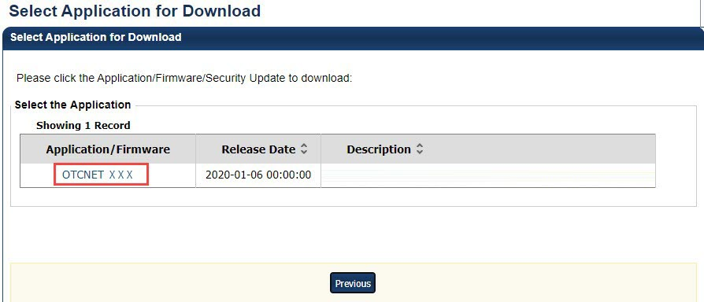

1. Select **Download** as shown in Figure 2. The file downloads to your workstation.

Figure 2. Review Application Download

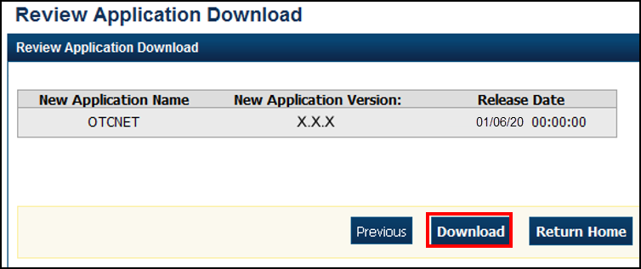

Additional Buttons



* Select **Previous** to return to the previous page.
* Select **Return Home** to the OTCnet Home page.

### Install OTCnet Offline Check Capture Software

After the OTCnet Offline Check Capture Software is downloaded, the next step is to install the software (must be done for each terminal). The Offline software was developed to provide the same functionality offered by OTCnet Online to agencies that cannot rely on a consistent online connection.

To *install* the OTCnet Offline Check Capture software, there must not be a previous version of OTCnet Offline installed on a workstation. You must have Windows Administrator privileges on each workstation. Additionally, more than one version of the OTCnet Offline (Production or QA) application can be installed on a terminal. Each version of the application must be installed separately.

If installing the OTCnet Offline Check Capture Software for the first time (i.e., not upgrading from an older version), you must install the application *before* creating the **Check Capture Administrator (CCA)** Offline logon profile. If you are installing the OTCnet Offline application, you must also install the application *before* creating the CCA Offline logon profile. Next, you must create a CCA Offline logon profile to run the OTCnet application, it can only be created *after* installing the OTCnet Offline application.

To install OTCnet Offline Check Capture Software, you must start the **OTCnet Offline installation** and complete theOTCnet Offline QA-Future Setup program. Choose the **C:\Program Files\OTCnet_qai_future** destination folder to save the file and start the installation. Server Port settings prepopulate and the files install.

**Offline Installer**  
For the Offline Installer, the bundled Java Runtime Environment (JRE) was removed. The Offline installer now verifies whether Java is installed on the workstation, and if the Java version installed is one that OTCnet supports. If Java is not installed on the workstation, Windows Administrator privileges are required to install Java.

For additional information, and to verify that you meet system and configuration requirements, review the system requirements document:  
<https://fiscal.treasury.gov/files/otcnet/otcnet-sys-req.pdf>

Install OTCnet Offline Check Capture Software

To install the OTCnet Offline Check Capture software, complete the following steps:

1. Locate the folder on the workstation where the OTCnet Offline zip file resides, e.g., your Downloads folder. Double select the zip file. Double-click the EXE file. The *Welcome to OTCnet Offline QA Setup program* dialog box appears.

Application Tips



The EXE must be launched and executed by a Windows Administrator.

1. Select **Next**. The *Destination Location* dialog box appears as shown in **Error! Reference source not found.**.

Figure 3. Destination Location Dialog Box

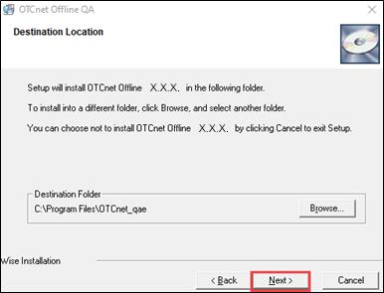

Application Tips



* To install the software to another folder destination, select **Browse** to select a different folder.
* Select **Back** to go back.
* Select **Cancel** to exit the setup.

1. Select **Next**. The *Start Installation* dialog box appears.
2. Select **Next**. The *Server Port Settings* dialog box appears.
3. Select **Next**. The *Installing* dialog box appears. Wait a moment while the files install.

Application Tips



* The Server Port Settings are pre-populated with the default values.
* If your location has specific **Server Port Settings**, enter the **Server Start Port**, **Server Stop Port** **details**, **Server HTTPS Port**, and **Server Monitor Port** details.

1. The message “*OTCnet Offline* X.X.X *has been successfully installed”* appears. Select **Finish**. The OTCnet Offline icon appears on your desktop.

Application Tip



* The Offline Installer verifies that Java is installed on the workstation.
* If Java is not installed, you will receive a “*Java must be installed for the Offline to function. The JAVA_HOME environment variable must also be set pointing to the main Java installation folder*” message as shown in Figure 4. A Windows Administrator must install Java.

Figure 4. Java message

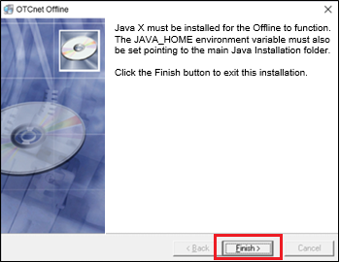

### Upgrade OTCnet Offline Check Capture Software

As new versions of OTCnet Offline Check Capture software become available, your Agency may choose to upgrade its terminals. *Upgrade* refers to installing an updated version of OTCnet Offline on a terminal that has a previous version of OTCnet Offline installed.

Before initiating an OTCnet Offline Application upgrade, consider the following information:

* Before uninstalling the OTCnet Offline Application, you must first stop the OTCnet Offline Application. If the OTCnet Offline Application has been started on the terminal, ensure that it is stopped before uninstalling the application.
* When upgrading to a newer OTCnet Offline version, you must uninstall the previous offline version and perform a new installation.
* When upgrading OTCnet Offline, you must install the application first, *before*creating the **Check Capture Administrator (CCA)** Offline logon profile. You also need to create a CCA Offline logon profile to run the OTCnet Offline application, but it can only be created *after* installing the OTCnet Offline application.
* When upgrading OTCnet Offline, and your Agency manages verification records, you do not need to reset and download the Local Verification Database (LVD) for each terminal.
* More than one OTCnet Offline application environment (Production or QA) can be installed and upgraded on a computer. Each Offline application environment must be upgraded separately.
* You need Windows Administrator privileges for each computer you are upgrading.
* To upgrade the OTCnet Offline Check Capture Software, close any open batches, upload all existing batches and stop the Offline application.
* You must install the files using the **OTCnet Offline.EXE** icon and click through the OTCnet Offline QAi-Future setup to install the software.

Upgrade OTCnet Offline Check Capture Software

To upgrade OTCnet Offline Check Capture software, complete the following steps:

1. Close any open batches and upload all existing batches in **Batch Management**.
2. From the Windows Start Button menu, select **Stop OTCnet Offline** to stop the offline application as shown in Figure 5.

Figure 5. Stop OTCnet Offline

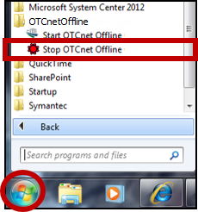

1. After downloading the latest version of OTCnet Offline, locate the folder on the workstation where the OTCnet Offline zip file resides e.g., your Downloads folder. Double click the zip file. Double click the EXE file to start the installation. *Welcome to OTCnet Offline QA Setup program* dialog box appears.
2. Select **Next**. The *Destination Location* dialog box appears as shown in Figure 6.

Figure 6. Destination Location

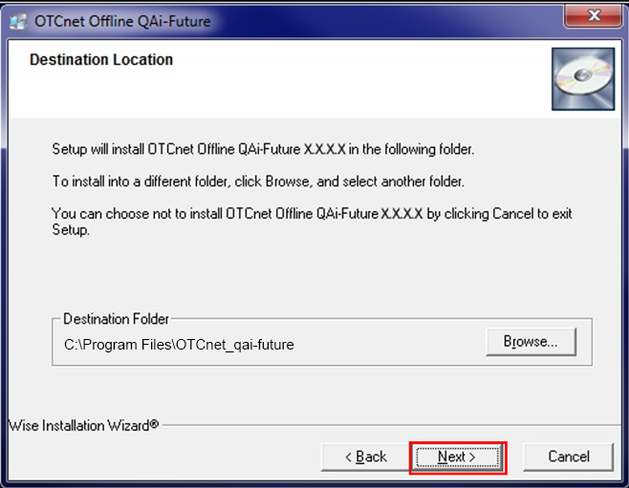

Application Tips



* To install the software to another folder destination, select **Browse** to select a different folder.
* Select **Back** to go back.
* Select **Cancel** to exit the setup.

1. Select **Next**. The *Start Installation* dialog box appears.
2. Select **Next**. The *CCA Offline User Credentials* dialog box appears.
3. Enter your **User ID** and **Offline Password** in the appropriate text boxes and select **Next**. Wait while the files install.

Application Tips



* If an incorrect **User ID** and/or **Offline Password** is entered, an *Installation Error* dialog box message appears stating that the entered username (User ID) and/or password is invalid as shown in Figure 7.
* Select **OK**. The upgrade process is cancelled.
* Run the installer again and enter the correct credentials.

Figure 7. Installation Error

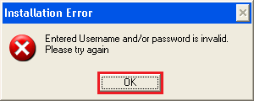

1. After the *OTCnet Offline* *has been successfully installed* message appears, select **Finish**. You have the upgraded version of OTCnet Offline Check Capture Software.

Application Tip



* The Offline Installer verifies that Java is installed on the workstation.
* If Java is not installed, you will receive a “*Java must be installed for the Offline to function. The JAVA_HOME environment variable must also be set pointing to the main Java installation folder*” message. A Windows Administrator must install Java.

## Topic 3 Manage a Check Capture Administrator Profile

### Create a Check Capture Administrator Offline Logon Profile

A **Check Capture Administrator (CCA)** Offline logon profile is required for upgrading the OTCnet Offline application and starting the OTCnet Offline server.

The CCA Offline logon profile is also referred to as the *User profile*.

Before creating a CCA Offline logon profile, for the new OTCnet Offline release, any previous existing installation cannot be upgraded. You must uninstall the older Offline version and install the new version.

To create a Check Capture Administrator Offline Logon Profile, log in to **OTCnet Online** as a **CCA** from each workstation where OTCnet is installed and select **Create Local Bridge and User Profile.** Choose the latest version (recommended) of **Offline** (3.4.0.0 or newer) and enter/confirm your **Local Bridge/Offline Password**.

Password Criteria includes the following, it must:

* Be at least 12 characters long
* Not have more than two repeating characters
* Not repeat any of your last ten passwords
* Not have been your password during the last ten days
* Not be a word in a language, slang, dialect, or jargon
* Not be related to personal identity, history, environment, or other personal associations
* Not be shared or displayed in plain view

The password criteria is displayed on the page when you enter and confirm your **Offline** password.

Save the .ini file. The Offline logon profile credential file is saved in the appropriate folder on the terminal (C:\OTCnetOffline\data\ini*[file name]*.ini).

Create a Check Capture Administrator Offline Logon Profile

To create a **Check Capture Administrator (CCA)** Offline logon profile, complete the following steps:

1. Log into **OTCnet Online** from the workstation in which you will be using the OTCnet Offline application.
2. From the **Administration** tab, select **Manage Users**>**Create Local Bridge and User Profile**. The *Create Local Bridge and User Profile* page appears.
3. Under **Application**, choose your **OTCnet Offline** version.

Application Tip



The first two radio buttons on this page, **Online Local Bridge version XXX or newer** and **Online Local Bridge version XXX or older** are for OTCnet Online users.

1. Enter your **Offline Password** and **Confirm Offline Password**.

Application Tips



* If you forget your Offline password and the OTCnet Offline server is not available, you must log in to OTCnet Online from your OTCnet Offline workstation and create a new CCA Offline logon profile. You must be logged into your OTCnet workstation as a CCA to create your CCA Offline logon profile again.
* If you have an existing CCA account from an older version of OTCnet Offline installed, it is recommended that you set your CCA’s Offline logon profile password to the *same* password used for logging in to the Offline application.

1. Select **Submit**.

Additional Buttons



* Select **Submit**, the system generates the credential file based on the application version selected.
* Select **Clear** to reset the password fields.
* Select **Cancel** to return to the OTCnet Home Page.

1. A *Do you want to open or save* ***[file name].ini****?* dialog box appears. Select the **Save** drop-down arrow and select **Save as**.

Additional Buttons



* Save the *Offline logon profile credential file* with its generated file name, ***do not*** rename the file as the file name must remain the same.
* Store the Offline logon profile credential file in the OTCnet Offline folder on the terminal.
* If the file name is changed, or if the file is saved in the wrong folder location, the OTCnet application will not run.
* Select **Open** and the opens in the Microsoft Notepad application.
* Select **Cancel** and the *Do you want to open or save* dialog box closes, and you remain on the *Create Local Bridge and User Profile* page.

1. The *Save* dialog box appears. To store the Offline logon profile credential file in the Offline folder on the terminal:
   * Select **Local Disk (C:)**
   * Double-click the **OTCnetOffline** folder
   * Double-click the **data f**older
   * Double-click the **ini** folder
2. Select **Save** as shown in Figure 8) and the Offline logon profile credential file is saved in the appropriate folder on the terminal **(C:\OTCnetOffline\data\ini*[file name]*.ini)**.

Figure 8. Save Credential File

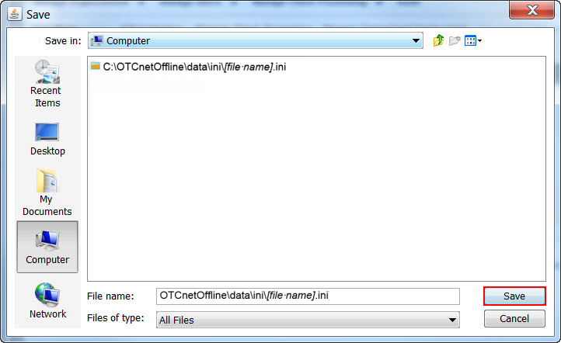

### Import a Check Capture Administrator Offline Logon Profile

After creating your Check Capture Administrator Offline Logon Profile (credential file) in OTCnet Online, import your Offline User Profile in OTCnet Offline. You must import the credential file to start the Offline application.

To import the *Check Capture Administrator Offline Logon Profile*, start **OTCnet Offline** (**Production** or **QA**). Import your user profile and navigate to the location on the workstation where the *Check Capture Administrator Offline Logon Profile* was saved and   
import it.

Import a Check Capture Administrator Offline Logon Profile

To import the Check Capture Administrator Offline Logon Profile, complete the following steps:

1. Double-click the **OTCnet Offline** (**Production** or **QA**)icon located on the workstation desktop.

Or

Select **Start>Programs**>**OTCnet Offline** (**Production** or **QA**). The *OTCnet* *Offline Startup* window appears.

1. Select the **File** menu. Select **Import User Profile** as shown in Figure 9. The *Select User Profile File* dialog box appears.

Figure 9. OTCnet Offline Startup

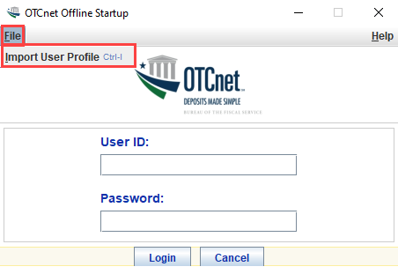

1. Navigate to the location on the workstation where the *Check Capture Administrator Offline Logon Profile* is saved. Select the file and select **Import** as shown in Figure 10. Proceed with starting OTCnet Offline on the workstation.

Figure 10. Select User Profile

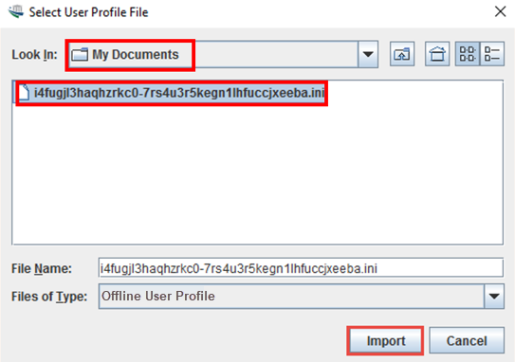

Application Tips



* The default location on the *Select User Profile File* dialog box is the user’s **My Documents** folder.
* Once you have successfully imported the Check Capture Administrator Offline Logon Profile, you receive the *Successfully imported user profile* message.

### Retrieve a Check Capture Administrator Offline Logon Profile

Once the OTCnet Offline Check Capture software is downloaded and installed, the **Check Capture Administrator’s (CCA)** Offline logon profile is created and imported, and the Offline server is started. The next step is to retrieve (download) your Offline logon profile.

Once the Microsoft Edge or Chrome browser opens to the OTCnet Offline logon page, select the **Retrieve Admin Profile** hyperlink. If it is the first time you installed and accessed OTCnet Offline on a workstation, or if you forgot your Offline password and had to create a new CCA Offline logon profile, this step is required.

To download your CCA Offline logon profile, enter your Online User ID and Password, and specify the Proxy settings for the terminal (if required). Once your credentials are confirmed, the system connects with the OTCnet Online server, validates your credentials, and downloads your Administrator Profile locally. You are prompted to enter a new Permanent Password for your offline account. Once completed, you are returned to the login page to re-login to OTCnet Offline.

If you are upgrading an existing OTCnet Offline version to a newer version and you have already created a CCA Offline logon profile, you do not need to retrieve your Administrator Profile. Skip this step and proceed to logging in to the Offline application.

If you forget both your online and offline passwords, contact the Customer Service Team at (866) 945-7920 to reset your online password. Log in to OTCnet Online and re-establish a permanent password. Once your online password is reset, you must create another CCA Offline logon profile in OTCnet Online and access OTCnet Offline (internet connectivity is required) and repeat the steps for retrieving your administrator profile.

Your Offline password does not need to match your online account credentials.

Password Criteria includes the following, it must:

* Be at least 12 characters long
* Not have more than two repeating characters
* Not repeat any of your last ten passwords
* Not have been your password during the last ten days
* Not be a word in a language, slang, dialect, or jargon
* Not be related to personal identity, history, environment, or other personal associations
* Not be shared or displayed in plain view

Retrieve a Check Capture Administrator Offline Logon Profile

To retrieve a Check Capture Administrator Offline logon profile, complete the following steps:

1. Double-click the **OTCnet Offline** **(Production** or **QA)** icon on the workstation desktop.

Or

Select **Start**>**Programs**>**OTCnet Offline** **(Production or QA)**>**Start OTCnet Offline (Production or QA)**. The *OTCnet Offline Server* *Startup* page appears.

Application Tips



* If the OTCnet Offline icon is not located on the workstation desktop or Start Menu, under Programs, download and install the OTCnet Offline Check Capture software.
* If the Offline *server* was previously started, proceed to Step 3.

1. Enter your **User ID** and **Password** in the appropriate text boxes and select **Log In** (if applicable). The *OTCnet Login* page appears.
2. Select the **Retrieve Admin Profile** hyperlink as shown in Figure 11. The *Retrieve Admin Profile* page appears.

Figure 11. OTCnet Offline Home Page

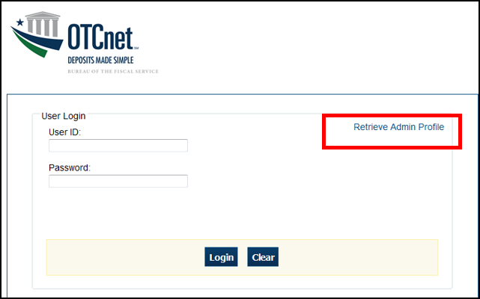

Application Tip



Use the **Retrieve Admin Profile** hyperlink if this is the first time you are installing the OTCnet Offline application on your workstation or if you forgot your Offline password and had to create a new CCA Offline logon profile.

1. Enter your **Online User ID** and **Online Password**.
2. Under Proxy Server Configuration (if applicable)*:*

* Check **Use Firewall Agent** and enter the **Firewall Agent**
* Check **Use Proxy** and enter **Proxy Timeout**, **Proxy Password**, **Proxy Server** and **Proxy Port**

Application Tips



* If **Proxy Server Configuration** settings are entered, they are saved in the system and can later be **viewed** and modified in **Terminal Configuration**.
* If the **Use Firewall Agent** option is enabled, the Firewall Agent is available for configuration and the agent name can be entered.
* If the **Use Proxy** option is enabled, **then Proxy Timeout, Proxy Password, Proxy Server**, and **Proxy Port** are available for configuration.
* The **Proxy Timeout** value is the number of minutes the application waits for a connection to the server before giving up. The maximum allowed timeout is 30 minutes.

1. Select **Retrieve Profile** as shown in Figure 12.

Figure 12. Retrieve Admin Profile Online Credentials

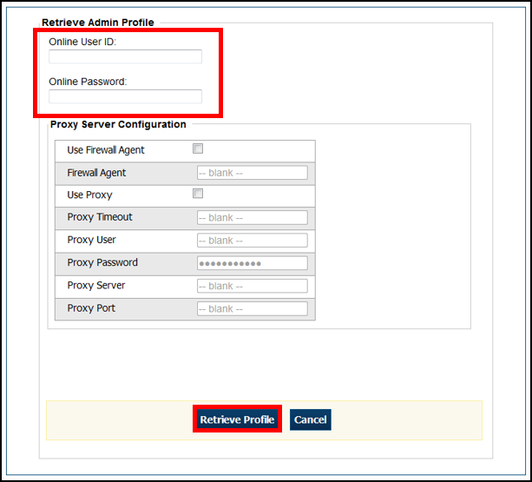

1. Enter your **New Password**, and **Re-Enter New Password**.
2. Select **Save**. A *Confirmation page* appears stating your new password has been set.

Application Tips



* This new password is also the permanent password for your offline logon profile, used for starting up the Offline server and application.
* Once the profile is successfully downloaded and your permanent password is set, you are prompted to log in to the Offline application with your new password.
* If the profile download was unsuccessful, a message appears stating that the profile download was unsuccessful and to contact Customer Service for assistance.

1. Restart your computer to ensure that all OTCnet security features are fully enabled.

### Reset a Check Capture Administrator Multi-Factor Authentication Status

When logging in to OTCnet Offline, you will be prompted to set up **two-factor authentication.** Youwilldownload and install an **authenticator application** on your workstation device and set up two-factor authentication for OTCnet Offline.

As a **Check Capture Administrator**, you can reset your own **multi-factor authentication** (**MFA**) status if you change your **offline password**, need to download your **offline profile** again, or input the **one-time** MFA code 10 times incorrectlyso that you can login to OTCnet offline.

Download your offline profile by selecting **Retrieve Admin Profile**. YourMFAstatus resets and offline prompts you to set up your **MFA** status again.

Reset Your Own Multi-Factor Authentication Status

To reset your own multi-factor authentication status, complete the following steps:

1. On the **Offline Application** login page, select **Retrieve Admin Profile.**
2. The system retrieves your user profile and prompts you to change your offline password.
3. Change your **offline password.**
4. The system updates your offline password and initialization file and saves your profile and login credentials.
5. The system will prompt you to set up **multi-factor authentication** (**MFA**).
6. If you have already set up **MFA**, you will be prompted to input your one-time code.
7. If you have not set up the **MFA**, the system prompts you to set up **MFA** with your chosen authenticator application by downloading the application on your workstation device.
8. Follow the steps in the authenticator to set up **MFA**. The system displays the **authenticator secret** and instructs you to enter it into your chosen authenticator as shown in Figure 13.
9. Input the **authenticator secret** into your authenticator application and label it as “**OTCnet Offline**.”
10. Enter your **Time-Based One-Time Password (TOTP)** code generated by the authenticator into the textbox and select **OK.**

Figure 13: Prompt for Multi-Factor Authentication Setup

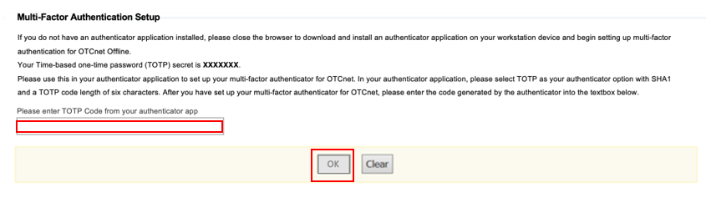

Application Tip



User must ensure they have selected **TOTP** as their authenticator option with **SHA1** and an **OTP code** length of six characters. Not all authenticators will present this option, but if it is an option, these parameters should be selected.

1. If you enter correctly the **TOTP** code, system will display a message that you have successfully set up multi-factor authentication for OTCnet Offline. Select the **OK** button to proceed to the login page as shown in Figure 14. Otherwise, system will prompt you to verify your **MFA** setup and **TOTP** code and try again.

Figure 14: Successful Multi-Factor Authentication Setup Message

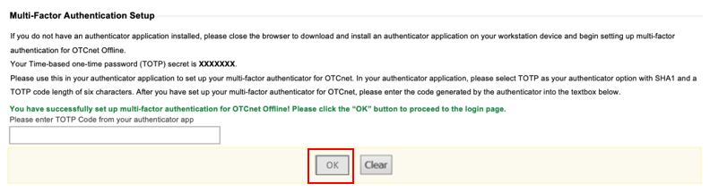

1. The system completes user authentication and displays a message informing you that **MFA** has been successfully set up.
2. Acknowledge the **message**. The system logs you out and displays the *OTCnet Offline* login screen.

## Topic 4 Manage OTC Endpoints

After the **Check Capture Administrator’s (CCA)** profile is downloaded to the terminal, as the **CCA** you are authorized to manage OTC Endpoints. Managing OTC Endpoints allows for the user to select which OTC Endpoint(s) (e.g., **CHK**) and OTC Endpoint information is downloaded to the OTCnet Offline Check Capture application. As a **Check Capture Supervisor (CCS)**, you are authorized to download OTC Endpoints after the **CCA** selects the OTC Endpoint for download.

Before you can manage your OTC Endpoints, you must access the OTCnet Offline application and enter your online User ID and password. Once connectivity is established to the Online server from OTCnet Offline the system retrieves all OTC Endpoints (**CHK**): **Agency Location Code plus 2 (ALC+2)**, Short Name, and Description, that you have access to Online. After the system has successfully retrieved all accessible OTC Endpoints (**CHK**), you are redirected to the OTC Endpoint selection screen.

Once the OTC Endpoints are saved into the local offline database, perform the Download OTC Endpoints function to download the form and form data, DDS flags (Department of Defense [DoD] only), Government-Wide Accounting (GWA) flag, Summary Level Classification flag, accounting code mapping (a link is provided to review the list of accounting codes before downloading), OTC Endpoint updates, and other information necessary for performing check scanning in offline mode. Internet connectivity is required.

Agencies that capture accounting codes have the ability to retrieve and save the accounting codes that have been set up online and mapped to that endpoint. If a **CCA** or **CCS** updates an accounting code online, the Offline application incorporates those adjustments.

### Select OTC Endpoints

The **Select OTC Endpoints** function allows you to select OTC Endpoint(s) to be retrieved from the hierarchy. You must first select the OTC Endpoints you want to retrieve before you can download to the OTCnet Endpoints.

Select OTC Endpoints

To select OTC Endpoints, complete the following steps:

1. From the **Administration** tab, select **Manage OTC Endpoints**>**Select OTC Endpoints**. The *Online User ID and Online Password* dialog appears.
2. Enter your **Online Password** and select **Login** as shown in Figure 15. The *Select* *OTC Endpoint Downloads* dialog box appears.

Figure 15. Online Password

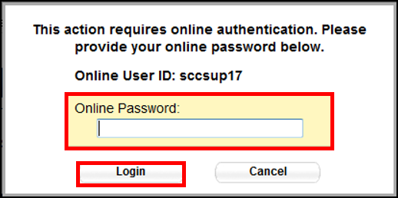

Application Tips



* Enter the password that you use to access OTCnet Online.
* If your OTCnet Online credentials (Log In and Password) are expired or do not exist an error message appears.
* Ensure your OTCnet Offline credentials correspond to an existing OTCnet Online account.

1. Select **Close**. The *Step 1 of 2 Select OTCnet Endpoint(s)* page appears with the *Select OTC Endpoint* message.

Application Tips



* It is recommended that you do not select the **Cancel** button. Instead, wait for the **Close** button to ensure the OTC Endpoints (**CHK**) display on the *Select OTC Endpoints* page.
* When the *Select OTC Endpoints* *Task* dialog boxappears, the system downloads the OTC Endpoint information (**CHK**) (**Short Name**, **Agency Location Code plus 2 [ALC+2]**, and **Description**).

1. Select the OTC Endpoint(s) that you want to download to the OTCnet Offline Check Capture application by checking the check box(es) under the **Select** column as shown in Figure 16.

Figure 16. Select OTC Endpoints

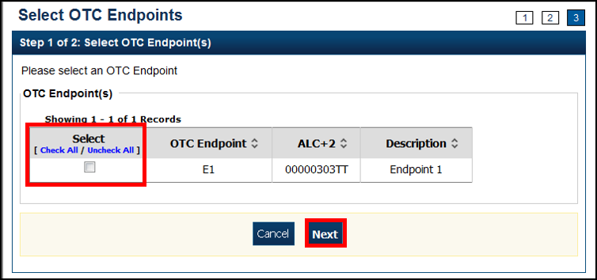

Application Tips



* Only active OTC Endpoints (**CHK**) to which a user has access is listed.
* OTC Endpoints (**TGA**) are not displayed.

1. Select **Next**. The *Step of 2 of 2 Review OTC Endpoint(s)* page appears.
2. Verify the OTC Endpoints to be saved to the database. Select **Submit**.
3. A *Confirmation page* appears presenting the OTC Endpoints that have been successfully saved into the local offline database.

Additional Button



Select **Return Home** to the OTCnet Home Page.

### Download OTC Endpoints

The Download OTC Endpoints function allows you to download OTC Endpoint information, i.e., the form and form data; Deployable Disbursing System (DDS) flag configurations (Department of Defense (DoD) only); GWA Reporter flag configurations; accounting codes that are mapped explicitly to the OTC Endpoints or inherited from a higher-level OTC Endpoint or highest level organization (HLO); and other information necessary to perform check scanning in Offline mode. Only OTC Endpoints that have been retrieved using the Select OTC Endpoints function are available for download using the **Download OTC Endpoints** function.

The **Check Capture Administrator** and **Check Capture Supervisor** are authorized to download OTC endpoints.

Download OTC Endpoints

To download OTC Endpoints, complete the following steps:

1. From the **Administration** tab, select **Manage OTC Endpoints**>**Download OTC Endpoints**. The *Download OTC Endpoint* message appears.
2. Select **Download** as shown in Figure 17. The *OTC Endpoint and Form Update* dialog box appears.

Figure 17. Download OTC Endpoints Review

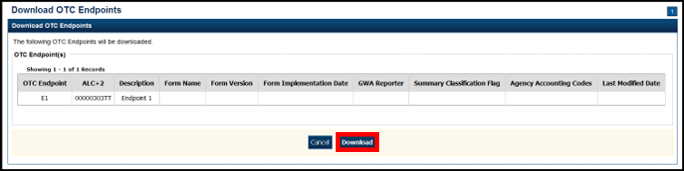

Application Tips



* When the *Task Download OTC Endpoint Started…* message appears, the system downloads the check capture forms and form data, DDS flag configurations, accounting code information, and organization hierarchy details for all OTC Endpoint (**CHK**) for all OTC Endpoints present on the local application.
* To view the accounting codes associated with the OTC Endpoint before downloading the OTC Endpoints, select **View**on the *Download OTC Endpoints* page. After viewing the accounting codes, select **Previous** to return to the *Download OTC Endpoints* page.

1. Select **Close**.

Application Tips



* It is recommended that the **Cancel** button is not selected. Instead, wait for the **Close** button to ensure the OTC Endpoints (**CHK**) and forms are downloaded on the *Download OTC Endpoints* page.
* Only active OTC Endpoints (**CHK**) that a user has access to are listed.
* OTC Endpoints (**TGA**) do not display.
* **CHK** denotes check capture.
* **TGA** denotes deposit processing.
* **CDC** denotes card processing.

1. A *Confirmation* page appears presenting the OTC Endpoints that have been successfully downloaded.

Additional Button



Select **Return** Home to return the OTCnet Home Page.

## Topic 5 Manage User Profiles

If you are assigned the role of **Check Capture Administrator (CCA)**, you are the only authorized user who can download and update user profiles.

Downloading user profiles allows a user to perform the check capture function using OTCnet Offline. The user can only perform this function within the OTC Endpoints that he/she is provisioned to in OTCnet Online. After the user profiles are downloaded to the appropriate OTC Endpoints, temporary passwords are displayed. Communicate the User ID and temporary password details to the appropriate users.

Updating user profiles allows for updating account status, personal information, and provisioning. If a profile is inactive, and it must be used, it must be reactivated in OTCnet Offline. Updating user profiles in OTCnet Offline does not change the user’s profile in OTCnet Online.

### Download User Profiles

To manage user profiles, you must first download your user profile(s) to the OTCnet Offline application. Select the user profile(s) that you want to download to the OTCnet Offline Check Capture application and review the users selected to download.

Download User Profiles

To download user profiles, complete the following steps:

1. From the **Administration** tab, select **User** **Administration**>**Download Users**. The *Step 1 of 3: Select OTCnet Endpoint(s)* page appears.
2. Select the OTC Endpoint(s) where you want to download the user profile(s) to the OTCnet Offline Check Capture application.
3. Select **Next**. The *Download Users* dialog box appears.
4. Select **Close**. The *Step 2 of 3: Select User(s)* page appears.
5. Select the user profile(s) that you want to download to the OTCnet Offline Check Capture application as shown in Figure 18.

Figure 18. Step 2 of 3: Select Users

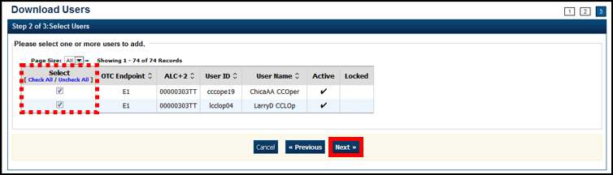

1. Select **Next**. The *Step 3 of 3: Review Users* page appears.
2. Verify the user profiles for the selected OTC Endpoints that should be downloaded to the local offline database. Select **Submit**.
3. A *Confirmation* page appears presenting the user profiles for the OTC Endpoints that have been successfully downloaded to the local offline database, along with the users’ temporary passwords, used to access OTCnet Offline.

Application Tips



* Communicate the User IDs and temporary passwords to the appropriate users.
* The User ID is the same one you use to access OTCnet Online.
* If the **Check Capture Administrator** forgets to record the temporary password, he/she may reset the user profile’s password for another temporary password.

Additional Button



Select **Return Home** to the OTCnet Home Page.

## Topic 6 Manage Offline Users

If you are assigned the role of **Check Capture Administrator (CCA)**, you are the only authorized user in OTCnet Offline that can manage Offline users. Upon downloading the user profiles to a local terminal, the user accounts must be managed locally. Once you download the OTCnet Offline software and configure each terminal, you have the ability to create check capture override and online authentication password, activate/deactivate a user, unlock a user account, reset a user password and multi-factor authentication (MFA), and print the system users list.

Before a user can access OTCnet Offline, the **Primary/Local Security Administrator (P/LSA)** must not only create the OTC Online user identity, but this user identity must also be successfully provisioned and approved, and a password must be provided.

### Creating Check Capture Override and Online Authentication Password

**Check Capture Administrators** can create passwords for online authentication into offline so that they can continue to perform functions in offline.

From the **Administration** tab, select **Manage Users**>**Create Check Capture Override and Online Authentication Password**. Enter and confirm your **password**, then select the **Submit** button. A **Confirmation** page displays stating that you have successfully created your **Check Capture Override and Online Authentication password**. Select **OK** to return to the *OTCnet homepage.*

Create Check Capture Override and Online Authentication Password

To create check capture override and online authentication password, complete the following steps:

1. From the **Administration** tab, select **Manage Users**>**Create Check Capture Override and Online Authentication Password**. The **Create Password** screen displays as shown in Figure 19.
2. Enter and confirm your **password**.

Application Tip



The **Check Capture Administrator** can create a new password that is either the same or different from their old password. The password must satisfy the flowing requirements:

* Must be at least 12 characters long.
* Must not be longer than 64 characters.
* Must not have more than two repeating characters.
* Must not be a word in a language, slang, dialect, or jargon.
* Must not be related to personal identity, history, environment, or other personal associations.
* Must not be shared or displayed in plain view.

1. Select the **Submit** button to process the data.

Figure 19: Create Check Capture Override and Online Authentication Password

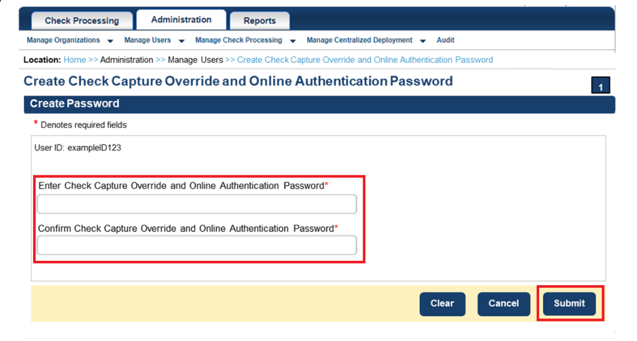

Additional Buttons



If your **password** does not comply with the Fiscal Service password policy requirements, you will get an error message to try again. The password requirements will be displayed on the screen.

1. A **Confirmation** page displays, as show in Figure 20, stating that you have successfully created your **Check Capture Override and Online Authentication** **Password**.
2. Select **OK** to return to the *OTCnet Homepage*.

Figure 20: Confirmation Page (Check Capture Override/Online Authentication)

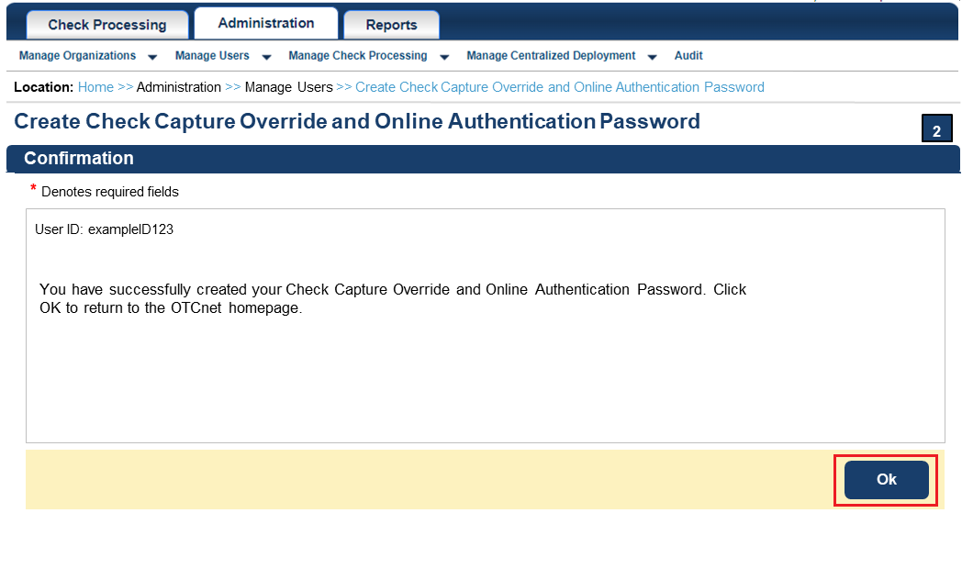

### Activating/Deactivating a User

It is recommended that the user’s account be deactivated if the user is not going to access OTCnet Offline for an extended period (e.g., vacation or leave). Temporarily deactivating a user’s account disables the user’s account, disallowing the capture of checks and/or managing or uploading batches. Activating a user’s account allows the user to capture checks and/or manage or upload batches.

To activate/deactivate a user account, you must select a user and activate or deactivate it.

Activate/Deactivate a User

To activate/deactivate a user, complete the following steps:

1. From the **Administration** tab, select **User Administration**>**Manage Users**. The *Step 1 of 2: Select a User* page appears.
2. Select the **user profile** **radio button** that you want to activate/deactivate.

Application Tip



You can only activate/deactivate one user profile at a time.

1. Select **Activate/Deactivate** as shown in Figure 21.

Figure 21. Step 1 of 2: Select a User (Activate/Deactivate a User)

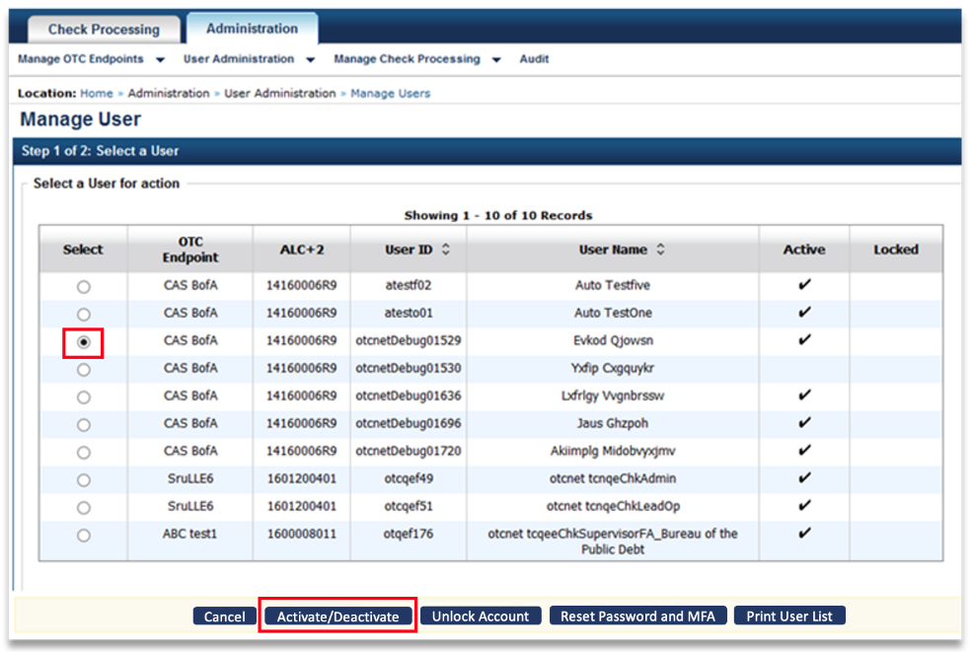

1. The Step 2 of 2: Review User Profile for Activation/Deactivation page appears.
2. Verify the user profile should be activated/deactivated. Select **Submit**. A *Confirmation* page appears presenting the user profile that is activated/deactivated.

Additional Buttons



* Select **Return to View User Profile List** to return to the View User Profile List for that terminal.
* Select **Return Home** to the OTCnet Home Page.

### Unlocking a User Account

Unlocking a user account allows the user to log on to OTCnet Offline using his/her original password. For example, if a user locks his/her account after three failed log on attempts and remembers his/her password, you can unlock the user’s account without resetting the user’s password.

Unlocking a User Profile

To unlock a user profile, complete the following steps:

1. From the **Administration** tab, select **User Administration**>**Manage Users**. The *Step 1 of 2 Select a User* page appears.
2. Select the **user profile radio button** that you want to unlock.
3. Select **Unlock Account** as shown inFigure 22**.**

Figure 22. Step 1 of 2: Select a User (Unlock User Account)

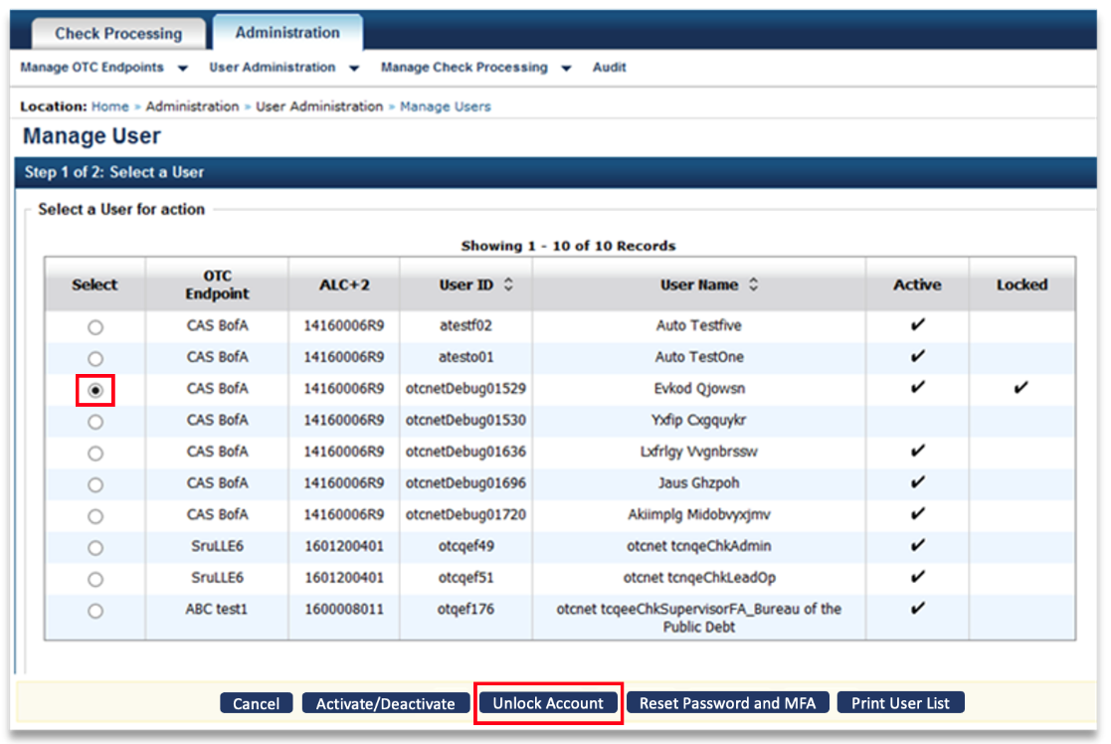

Application Tips



* You can only unlock one user profile at a time.
* Unlocking a user profile allows the user to log in to OTCnet Offline using his/her original password.

1. Verify the specific user profile should be unlocked and select **Submit.**  A Confirmation page appears verifying the user profile is unlocked.

Additional Buttons



* Select **Return to View User Profile List** to return to the View User Profile List for that terminal.
* Select **Return Home** to return to the OTCnet Home Page.

Application Tips



Unlocking a user account also allows the user to reset/change their offline password and **multi-factor authentication** (**MFA**). The application resets their **MFA** status, updates the **offline password** for the user and initialization file, and prompts the user to set up again their **two-factor authentication**. The user then can login to their OTCnet offline account.

### Resetting a User Password and Multi-Factor Authentication (MFA)

Resetting a user’s password allows the user to receive a new temporary password to access OTCnet Offline. For example, if a user locks his/her account after three failed log in attempts and does not remember his/her password, or if a user forgets his/her password, you can reset the user’s password to a temporary password. After the password is reset, communicate the temporary password to the appropriate user.

To reset a user password from Manage Users, select the user profile for the user whose password and reset the password.

If the user enters their **password incorrectly** three times or inputs their **one-time MFA code incorrectly** 10 times, they must contact their administrator to reset their account.

Resetting a User Password and Multi-Factor Authentication (MFA)

To reset a user password, complete the following steps:

1. From the **Administration** tab, select **User Administration**>**Manage Users**. The *Step 1 of 2 Select a User* page appears.
2. Select the **user profile radio button** for the password you want to reset.
3. Select the **Reset Password and MFA** buttonas shown inFigure 23.

Figure 23. Step 1 of 2: Select a User (Resetting a User Password and MFA)

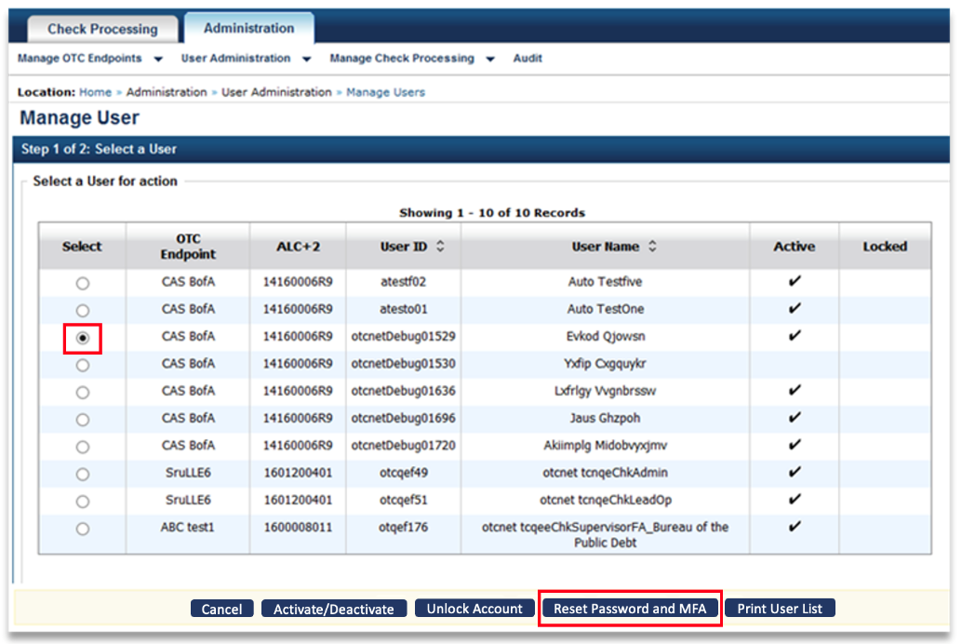

1. *The Step 2 of 2 Review User Profile for Password Reset* *and Multi-Factor Authenticatio*n page appears. Verify the following user’s profile password and MFA should be reset and select **Submit** asshown in Figure 24Figure 23.

Figure 24: Step 2 of 2: Review User Profile for Password Reset and MFA

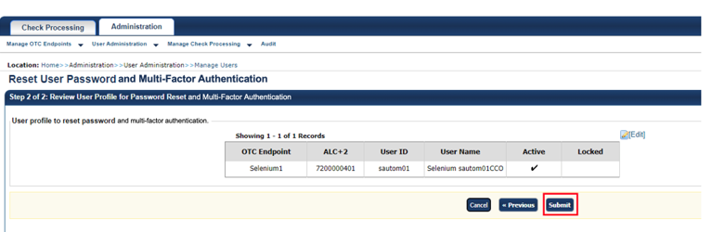

1. The system resets user **MFA** status as part of this step. User will need to set up the **MFA** again upon next login.
2. The system displays the user’s **temporary password** to you, the **Check Capture Administrator,** on the screen.

Application Tips



The user must have already:

* Entered their **password** incorrectly three times
* Input their **one-time code** incorrectly 10 times
* Contacted their administrator to **reset** their status

1. Copy and paste the **temporary password** and provide it to the user whose account has been unlocked.
2. User receives temporary password from you, the **Check Capture Administrator**, and logs into offline using the **temporary password** and **email address**.
3. The system prompts the user to change offline **password**.
4. User changes offline **password**.
5. The system updates the offline **password** for user and initialization file and prompts the user to set up their **MFA** again.

Application Tips



* You can only reset one user password at a time.
* Communicate the User ID and temporary password and provide it to the appropriate user. The User ID is the same as the one used to access OTC Online.

Additional Buttons



* Select **Return to View User Profile List** to return to the View User Profile List for that terminal.
* Select **Return Home** to return to the OTCnet Home Page.

### Printing a User List

When managing user profiles, you can export and print out a detailed user list in the following formats: **Word, Excel** or **PDF**. The User List report provides details, i.e., **OTC Endpoint, Agency Location Code plus 2 (ALC+2), User ID, User Name, Create Date, Last Access Time, Download Time,** and **Role Name**.

Printing a User List

To print a user list, complete the following steps:

1. From the **Administration** tab, select **User Administration**>**Manage Users**. The *Step 1 of 2 Select a User* page appears.
2. Select **Print User List** as shown in Figure 25.

Figure 25. Step 1 of 2: Select a User (Print User List)

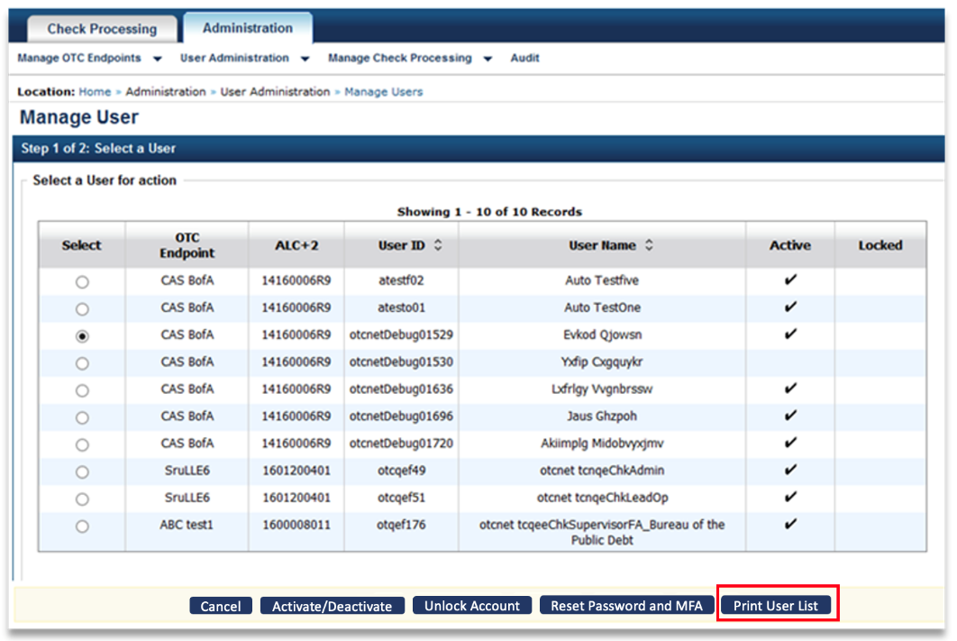

1. The *Print User List* preview page appears. Under **Export as**, you have the following options:
   * Select **PDF, Word** or **Excel**
   * Select **Download**

Or

* + Select **Print PDF Report**

Additional Button



Select **Previous** to return to the View User Profile List for that terminal.

## Topic 7 Manage a Check Capture Terminal Offline

If you are assigned the role of **Check Capture Administrator (CCA)** or **Check Capture Supervisor (CCS)**, you are the only authorized users who can configure the OTCnet Offline check capture settings for your agency’s terminal(s). To meet your location’s check capture needs, each OTCnet terminal must have configuration settings individually applied.

You can add or update the following:

* **System Configuration**: Used to ensure Task Execution on Start Up or Batch Close, LVD usage, and receipt printing.
* **Application Configuration:** Used to define a Terminal ID, processing mode, specify a cashflow method, as well as specify batch control and batch control prompts.
* **Devices Configuration:** Used to specify the scanner type and communication channel and enable franking.
* **Standalone Configuration:** Used to define a secondary storage, specify if supervisor approval is required to upload a batch, specify retention periods for batches and audit logs, as well as specify secure batch transmission details and proxy server configuration details (if applicable).
* **Available OTC Endpoints:** Used to add available OTC Endpoints for check capture.
* **Configured OTC Endpoints:** Used to set a default OTC Endpoint, review already-configured OTC Endpoints or remove unused OTC Endpoints from the terminal.

### Configure a Check Capture Terminal Offline

To configure a check capture terminal offline, you must update the terminal configuration, which consists of the **System Configuration (Task Execution, LVD Usage and Receipt Printing), Application Configuration, Devices Configuration (Scanner Model, USB Port, Serial Port** and **Franking Enabled),** and the **Standalone Configuration (Secondary Storage, Supervisor Approval, Retention Periods, Secure Batch Transmissions and Proxy Server Configuration).**  Once you have configured these settings, you can update the **Configured OTC Endpoints** and/or add the **Available OTC Endpoints** and review the configuration options.

Configure a Check Capture Terminal Offline

To configure a check capture terminal offline, complete the following steps:

1. From the **Administration** tab, select **Manage Check Processing**>**Terminal Configuration** >**Modify**. The *Step 1 of 4: Gathering Terminal Information* page may appear briefly as shown in Figure 26.

Figure 26. Step 1 of 4: Gathering Terminal Information

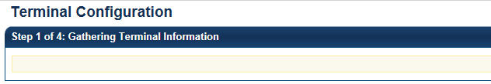

Application Tip



When the *Automated terminal detection in progress* message appears, the system reads the desktop settings and displays the appropriate information on the next page.

1. The *Step 2 of 4: Update the Terminal Configuration* page appears. Enter the system configuration.

Under **System Configuration**:

Set **Task Execution** by completing the following:

* + Checking or unchecking **Start Up** and/or **Close Batch** for the following:
    - Download OTC Endpoint
    - LVD Download
    - Acknowledge Batch
    - Upload Batch

1. Select **Next**. The *Step 3 of 4: Update the Configured OTC Endpoints* page appears as shown in Figure 27.

Figure 27. Step 3 of 4: Update the Configured OTC Endpoints

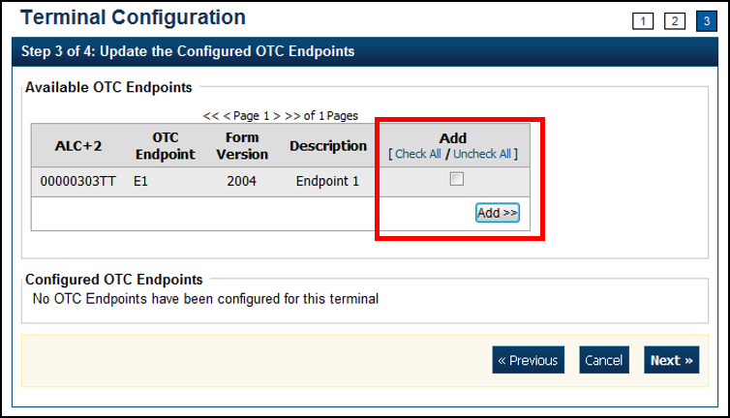

Application Tips



* By default, all tasks execute on **Start Up** and **Close Batch**. Unless you want the tasks to execute on **Start Up** and **Batch Close** every time, customize your options appropriately. If none of the tasks are checked, then none of the tasks are executed.
* **Download OTC Endpoint**: If enabled, the offline application automatically downloads updated forms, organization information, DDS flags, and the endpoint status from the OTCnet Online servers.
* **LVD Download:** If enabled and there is no previous LVD located on the terminal, the full LVD downloads. Subsequent LVD Downloads:
  + Update existing records (if necessary)
  + Download new records
* **Acknowledge Batch:** If enabled, the offline application automatically acknowledges any uploaded batches that have successfully been processed by the OTCnet Online application.
* **Upload Batch:** If enabled, OTCnet Offline automatically uploads any approved batches. If the supervisor approval flag is unchecked in terminal configuration, the Upload Batch task uploads Closed batches. The local activity log also uploads during the Upload Batch task. Additionally, the terminal configuration information uploads for use by Customer Service in Terminal Query.

Set **LVD Usage** as shown in Figure 28 by, *optional*

* Checking or unchecking **Personal Check** and/or **Non Personal** for Customer Present
* Checking or unchecking **Personal Check** and/or **Non Personal** for Customer Not Present
* Entering the number of **days** an **LVD Download override is required after**

Figure 28. LVD Usage

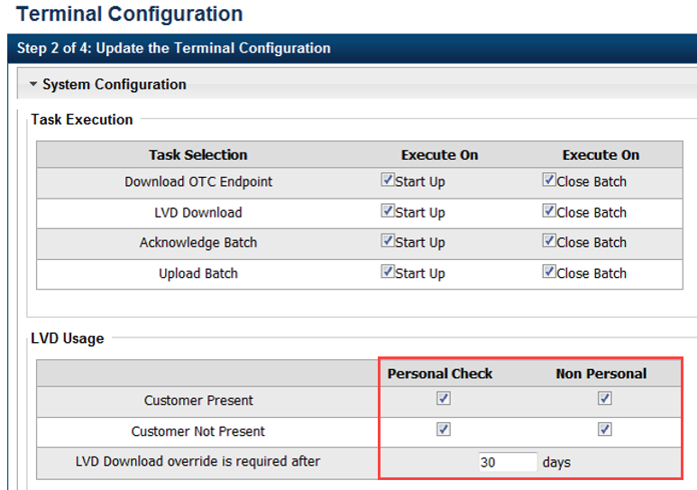

Application Tips



* By default, all four checkboxes (**Personal** and/or **Non Personal** checks and **Customer Present** and/or **Customer Not Present**) for (Local Verification Database) LVD Usage are checked and they are optional. If none of these items are checked, the LVD verification feature is disabled.
* If any of the **LVD Usage** check boxes are checked, the number of days an **LVD Download override is required after** is required. The **LVD Download override is required after** field specifies the number of days that can pass before the LVD is considered stale and requires a **Check Capture Supervisor** to approve scanning checks against the stale LVD; otherwise, the operator is required to download the latest LVD.

Set **Receipt Printing** by, *optional*

* Checking **Person Present**, *optional*
  + Select the **Manual** or **Automatic** radio button
    - Check **with preview**
* Checking **Person Not Present**, *optional*
  + Select the **Manual** or **Automatic** radio button
    - Check **with preview**

Application Tips



* Leaving both the **Person Present** and **Person Not Present** fields unchecked results in the disabling of this option. If receipts are desired, select the appropriate box(es).
* Choosing **Manual** requires that the operator take additional steps to print the receipt.
* Choosing **Automatic** results in a receipt printout each time a transaction has been entered.
* Choosing the **with preview** option allows the operator to see the receipt on the screen prior to the generation of the printout.
* When the **Person Present** and/or **Person Not Present** fields are selected, the default setting is **Manual**.
* When printing receipts, the system prints to the Windows default printer. All receipts print to the Windows default printer.

Under **Application Configuration**, enter the **Terminal ID**, **Processing** option, **Cashflow**, **Batch Control** and **Batch Control Attempts**:

* Enter the **Terminal ID**

Application Tips



* The **Terminal ID** field is available for data entry during initial setup. After the **Terminal ID** is assigned it is protected and cannot be changed.
* The **Host Name** field is automatically generated based on your computer’s registry and cannot be changed.
* Select **Single** or **Batch** for Processing mode

Application Tips



* **Single** processing mode allows the user to scan only one check at a time.
* **Batch** processing mode allows groups of checks to be scanned all at once, prior to the data entry for the items. The **Batch** processing mode is available for EC7000i, EC9100i, and all Panini scanners.
* Select **Settle Best Method** or **Truncate All Items** for Cashflow
  + Check **Back Office Processing Only**

Application Tips



* The **Settle Best Method** is the default selection and when selected exclusively on the configuration screen, all processing methods (**Customer Present**, **Customer Not Present**, and **Back Office**) are allowed for either personal or non-personal items on the Entry Screen.
* The **Back Office** **Processing method** should be used by agencies that receive payments in person and scan the checks at a later time in a controlled, back office environment.
* **Truncate All Items** represents only non-personal items are allowed (for all processing methods) on the Entry Screen.
* Select **Optional** or **Mandatory** for Batch Control

Application Tips



* If the **Batch Control** is set to **Optional**, OTCnet prompts the user to use the batch control and enter the batch control totals.
* If the **Batch Control** is set to **Mandatory**, OTCnet prompts for batch control totals.
* Select **Prompt on Batch Create** and/or **Prompt on Batch Close** for Batch Control Prompts.

Under **Devices Configuration** as shown in Figure 29,

* Select the **Scanner** model, *required*
* Select **USB Port** or **Serial Port**, *required*
  + Select the Serial Port type

Figure 29: Device Configuration

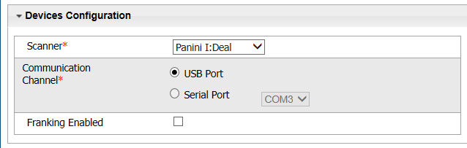

Application Tips



* **USB Port:** EC7000i, EC9100i, Panini MyVision, Panini VisionX, and Panini I: Deal scanners require a USB port communication channel. EC7000i scanners support USB and Serial communication channels.
* **Serial Port and COM dropdown:** The user selects the serial port (i.e., COM port) where they have connected a serial scanner.
* **USB-to-serial adapters:** USB-to-serial adapters are not supported. EC7000i scanners support USB and Serial communication channels.
* A “*No Serial Ports are available for configuration”* message displays if a Serial Port is not available for the terminal. A “*No Serial Ports are available for configuration”* message does not display if the terminal has a COM port enabled or if there a COM port enabled and there is no physical Serial Port.
* Check **Franking Enabled**, *optional*

Application Tip



The **Franking Enabled** option allows the scanner to automatically stamp the front of checks. Franking is available for EC7000i, EC9100i, and Panini I: Deal scanners.

Under **Standalone Configuration**,

* Set **Secondary Storage** by, *required*
  + Specifying the preferred **Secondary Storage** folder location in the **Secondary Storage** location

Application Tips



* As a best practice, it is recommended that you use an external secondary storage folder location, for example a shared or network drive (e.g., E:\OTCnet\SecondaryStorage).
* If you do not specify an external folder location and attempt to use a folder on your local workstation, you receive a warning message.
* You can use Windows Explorer to specify (and enter) the preferred folder location for **Secondary Storage** on the terminal.
* You can either manually enter the preferred folder location or copy the path from the Windows Explorer path field and paste it into the **Secondary Storage** field.
* Set **Supervisor Approval** by, *optional*
  + Checking or unchecking **Supervisor Approval Required for Upload Batch**

Application Tips



* By default, the **Supervisor Approval Required** for **Upload Batch** is unchecked. Checking **Supervisor Approval Required for Upload Batch** indicates that a **Check Capture Supervisor’s (CCS)**, or a check capture user with the **Batch Approver** permission, approval is required to upload a batch to the OTCnet server when there is internet connectivity.
* Additionally, the **Check Capture Supervisor** must
* .+ approve the batch from the terminal where the checks were captured. If unchecked, batches that are Closed but not Approved may be uploaded but must be approved once the batch is available in Online OTCnet.
* Set **Retention Periods** by,
  + Entering the number of **days** for Batch Retention Period
  + Entering the number of **days** for Audit Log Retention Period

Application Tips



* The **Batch Retention Period** refers to the period of time that a batch is available in both primary storage and secondary storage.
* After the **Batch** **Retention Period** passes for a batch, the batch is removed from Primary and Secondary Storage. This only applies to Acknowledged and Deactivated batches. All other batches remain in Primary and Secondary storage indefinitely.
* By default, the **Batch Retention Period** is set to **30** days. By default, the **Audit Log Retention Period** is set to **365** days.

Under **Secure Batch Transmission**,

* Set the **WSDL URL** by,
  + Selecting the **Number of Re-Tries**
  + Entering the **number of milliseconds** for Re-Try Interval

Application Tips



* By default, the **WSDL URL Number of Retries** is set to 3.
* The **Number of Re-Tries** is the number of attempts the OTCnet Offline application makes to connect with the OTCnet Online server.
* The **Re-Try Interval** allows for specifying the number of milliseconds before the OTCnet Offline attempts another connection to the OTCnet Online server (to maximum of 100,000 ms) in order to transmit the batch.

Under **Proxy Server Configuration**, *if applicable*

* Check **Use Firewall Agent**
  + Enter the **Firewall Agent**
* Check **User Proxy**
  + Enter the **Proxy Timeout**
  + Enter the **Proxy User**
  + Enter the **Proxy Password**
  + Enter the **Proxy Server**
  + Enter the **Proxy Port**

Application Tips



* If **Proxy Server Configuration** settings are entered when the **Check Capture Administrator’s** profile was retrieved, then the Proxy Server Configuration settings are saved in the system, are displayed here, and can be modified.
* If the **Use Firewall Agent** option is enabled, then the **Fire Agency** is available for configuration and the agent name can be entered.
* If the **Use Proxy** option is enabled, then **Proxy Timeout**, **Proxy User**, **Proxy Password**, **Proxy Server**, and **Proxy Port** are available for configuration.

1. Add or remove the OTCnet endpoint(s) that performs check scan, designate a default OTC Endpoint. Select **Next**.

Under **Available** **OTC Endpoints**,

* Select the **OTC Endpoint(s)** you want to add by checking the box(es) under the **Add** column, and select **Add** as seen in Figure 30.

Figure 30. Step 3 of 4: Update the Configured OTC Endpoints



Under **Configure OTC Endpoint**,

* Select a **Default OTC Endpoint**, *required.*
* Select the OTC Endpoint(s) you want to **Delete** by checking the box(es) under the **Remove** column, and select **Remove**, *if applicable.*

Application Tips



* The OTC Endpoints are permission based and are only visible to users with the appropriate permissions.
* Selecting a **Default OTC Endpoint** determines which OTC Endpoint to use when performing Scan Checks actions.
* Multiple OTC Endpoints can be selected but only one can be set as a **Default OTC Endpoint**.
* At least one **Default OTC Endpoint** is required per terminal.

1. Select **Next**. The *Step 4 of 4: Review the Terminal Configuration* page appears. Verify the Terminal Configuration is correct and select **Submit**. Select **Edit** to modify the information entered.
2. A *Confirmation* page appears stating that the Terminal Configuration record has been updated.

Additional Button



Select **Return Home** to the OTCnet Home Page.

### View a Check Capture Terminal Offline Configuration

To view a check capture terminal configuration, you can view all aspects of the configuration, including the **Default OTC Endpoint**, **System Configuration**, **Application Configuration, Devices Configuration** and **Standalone Configuration**.

View a Check Capture Terminal Offline Configuration

To view check capture terminal configuration settings, complete the following steps:

1. Select the **Administration** tab and select **Manage Check Processing>Terminal Configuration**>**View**. The *View* page appears as shown in Figure 31.

Figure 31. View Terminal Configuration Page

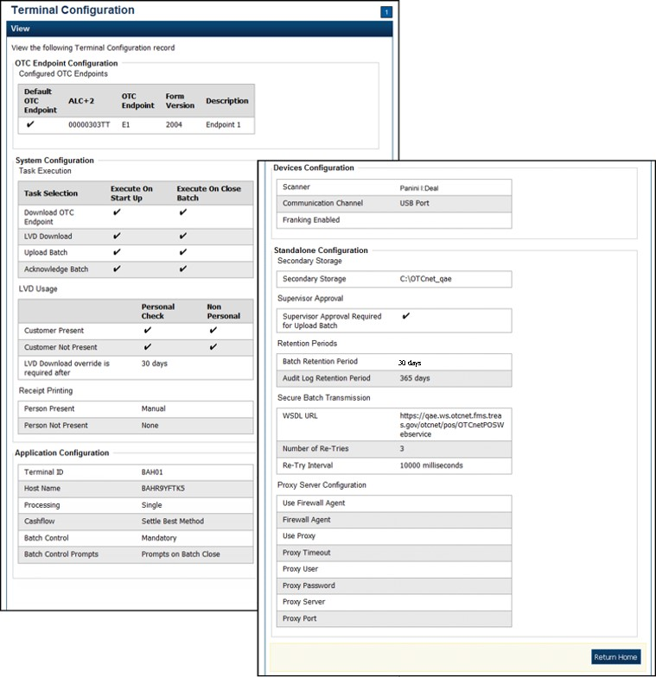

Additional Button



Select **Return Home** to the OTCnet Home Page.

## Topic 8 Search an Audit Log Offline

The audit log records all interactions between the user and OTCnet. It allows users to search and view Audit Log entries for the completed audit trail within OTCnet. The Audit Log is available for download to a *comma separated value* (CSV) report and opens in a spreadsheet program. It’s also available to print in a formatted audit log report.

If the audit log records contain Personally Identifiable Information (PII), the data is masked in the Transaction Description. To view more details about a specific batch, including PII, access **Batch Management**.

Each user role is authorized to view specific audit logs as shown in Table 2.

Table 2: Audit Log User Permissions

| User Role | Audit Log Access |
| --- | --- |
| Check Capture Administrator (CCA) | Partial administration-related activities and all check capture-related activities |
| Check Capture Operator (CCO) | Own check capture-related activities |
| Check Capture Lead Operator (CCLO) | Own check capture-related activities |
| Check Capture Supervisor (CCS) | Partial check capture-related activities pertaining to own actions or actions taken by their CCO or CCLO |
| FS Viewer or Security Viewer | Administration-related, check capture-related, check processing-related, and deposit processing-related activities |
| Card Administrator  (CA) | Partial administration-related activities and all card-related activities |
| Card Operator  (CO) | Partial access to user’s own card-related activities |

### Search an Audit Log Offline

You can search audit logs by module, user, OTC Endpoint, and other search criteria, i.e., **From** and **To** date, **Keyword**, **Category Name**, **Terminal ID**, **Batch ID**, **Event Type** and **Operation Mode**. If you run additional searches, the *Search Results* table repopulates with the results of the new search. Before you can view an audit log, you must access OTCnet Offline and enter your online User ID and offline password.

**Search an Audit Log Offline**

To search an audit log using OTCnet Offline, complete the following steps:

1. From the **Administration** tab, select **Audit**. The *Search Audit Logs* page appears.
2. Enter the search criteria for the activities you would like to view.

Under **Search Criteria**, *optional*

* + - Select a **Module** type, *optional*
    - Enter a **User**
    - Select an **OTC Endpoint**
    - Enter the **From** and **To** date and time ranges, *required*
    - Select a **Keyword**, *required*
    - Select a **Category Name**
    - Enter the **Terminal ID**
    - Enter the **Batch ID**
    - Select an **Event Type**
    - Select an **Operation Mode**

Application Tips



* The **Module** drop-down options vary by user role. **Module** options include **Administration**, **Check Processing**, and **Deposit Processing**.
* If you do not know the full name of the OTC Endpoint, enter a partial name search (as few as one letter) in the **Starts with** text box and select the **Select From List** icon (magnifying glass).
* The **From** and **To** **Created** **On** **Date** must be entered in MM/DD/YYYY format and cannot exceed 30 days.
* The **Keyword** and **Category** **Name** drop-down options vary by user role.
* **Event Types** are categories of events recorded by the audit log as shown in Table 3. Event Types.
* **Operation Mode** option includes **Offline**.

Table 3. Event Types

| Event Type | Description |
| --- | --- |
| All | Includes all event types in the audit log |
| Error | Error entries are created when the system is unable to complete an action. |
| Informational | Information entries are general records of the activity that has happened while using OTCnet. |
| Warning | Warning entries are created to inform the user when events of note have taken place. This includes cancelling an action, deleting information from the system and inactive users. |

1. Select **Search**. The *Search Results* table appears.

Application Tips

s



* If you run a search without specifying any criteria, the search results include all activities in the system that you have access to view. Run additional searches and the *Search Results* table repopulates with the results of the new search.
* Select **Download** to download the search results.
* Select **Print Audit Log Records** to print a formatted audit log record.

1. Select the **Audit Log ID** hyperlink to view additional details for an individual audit log entry. The *View Audit Log Details* page appears.

Application Tip



If the audit log records contain **Personally Identifiable Information (PII)** in the **Transaction Description**, the data is masked. To view more details about a specific batch including PII, access **Batch Management**.

1. Select **Download** to download the search results as shown in Figure 32. Select **Print Audit Log Records** to print a formatted audit log record as shown in Figure 32.

Figure 32. Audit Log ID

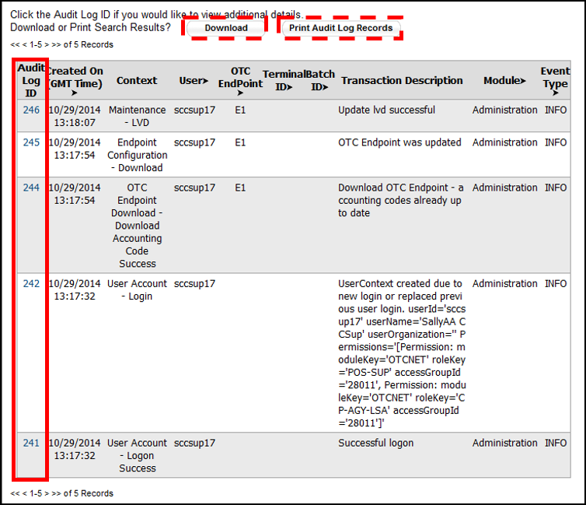

Additional Buttons



* Select **Cancel** to return to the OTCnet Home Page. No data is saved.
* Select **Clear** to clear all data fields and reset to the default selections.
* Select **Previous** to return to the previous page.
* Select **Return Home** to the OTCnet Home Page.

## Topic 9 Recover a Batch

If you are assigned the role of **Check Capture Supervisor (CCS)**, you can recover a batch from a non-functioning terminal and restore items to a backup terminal. Batch Recovery occurs when a check capture terminal unexpectedly fails - any time prior to batches being uploaded Online.

For the Batch Recovery function to work, the following steps must be completed:

* The backup or contingency terminal being used to process batches must be closed and transmitted before using the terminal for batch recovery.
* The primary terminal and the contingency terminal must both have the same storage or a compatible secondary storage.
* You must review the total number of batches that were successfully recovered from secondary storage.
* The full name of the user on the new terminal must match the name of the user that created the batch.
* The Agency Location Code (ALC) and Terminal ID must match the ALC and Terminal ID for the recovered batch.
* The Recover Batch function supports the recovery of batches that contain transactions with associated accounting codes from secondary storage.

Recover a Batch

To recover a batch, complete the following steps:

1. From the **Administration** tab, select **Utilities>Batch Utilities**>**Batch Recovery**. The *Review Recovery* page appears.

Application Tip



The **Recover Batch** function supports the recovery of batches containing transactions with associated accounting codes from secondary storage.

1. Select **Submit** as shown inFigure 33. The *Percentage Complete* dialog box appears.

Figure 33: Batch Recovery Review

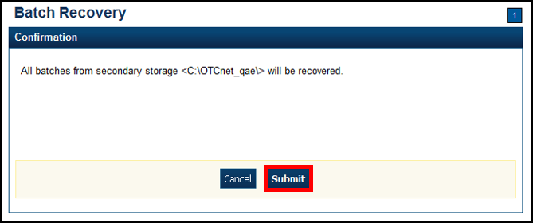

Application Tip



Wait until the display percent completion reaches 100% before selecting **Close**.

Select **Close**. The *Review* page presents the total number of batches that were successfully recovered from the secondary storage.

Additional Buttons



* If the **Cancel** button is selected before the batch recovery is complete, a dialog box appears asking if you want to cancel the batch recovery.
* Select **Yes** to cancel the batch recovery.
* Select **No** to continue recovering the batch.
* Select **Return Home** to return to the OTCnet Home Page.

## Summary

In this chapter, you learned:

* The purpose of Setting Up and Configuring Check Capture Offline
* Downloading and Installing OTCnet Offline Check Capture Software
* Retrieving a Check Capture Administrator Profile
* Managing OTC Endpoints
* Managing User Profiles
* Managing Offline Users
* Managing a Check Capture Terminal Offline
* Searching an Audit Log
* Recovering a Batch