

Agency Viewer
OTCnet Participant User Guide

Table of Contents
Overview, Topics, and Audience 1
Overview 1
Topics 1
Audience 2
Topic 1 Introduction to OTCnet 3
Overview 3
OTCnet Elements 3
OTCnet Process Flow: Deposit Reporting 5
OTCnet End Users 5
Topic 2 Overview of OTCnet Participant User Guide Content 7
Introduction 7
Administration Participant User Guide 7
Deposit Processing and Reporting Participant User Guides 8
Topic 3 Requesting Access for Yourself in SailPoint IIQ 10
Self-Register/Create an Account in SailPoint IIQ 10
Self-Register/Create an Account in SailPoint IIQ 11
Request Access for Yourself in SailPoint IIQ 12
Request Access for Yourself in SailPoint IIQ 13
Topic 4 Log in to OTCnet Online 16
Log in to OTCnet Online 16
Log in to OTCnet Online 17
Topic 5 Navigating the OTCnet Home Page 20
OTCnet Online Main Menu 20
OTCnet Online Deposit Processing Tab Functionality 22
OTCnet Online Check Processing Tab Functionality 22
OTCnet Online Card Processing Tab Functionality 23
OTCnet Online Administration Tab Functionality 25
OTCnet Online Reports Tab Functionality 26
Topic 6 Viewing Deposits 27
View a Deposit 27
View a Deposit 29
Topic 7 Search for a Deposit 31
Search for a Deposit 32
Download Deposit Information 34
Download Deposit Information 35
Topic 8 Searching Adjustments 38
Searching for and Viewing Adjustments 38
Searching for and Viewing Adjustments 39
Downloading Search Results for Adjustments 41
Downloading Search Results for Adjustments 42
Topic 9 Viewing Reports 43
Topic 10 Reports by User Role 44
Topic 11 Types of Reports 47
Business Reports 47
Security Reports 49
Administration Reports 50
Scheduled Reports 50
Topic 12 Viewing Reports 51
Business Reports 51
View Business Reports: Adjustments by OTC Endpoint 53
View Business Reports: Deposits by Accounting Code 55
View Business Reports: Deposits by OTC Endpoint 57
View Business Reports: Deposit History by Status 59
View Business Reports: Non-Reporting OTC Endpoints 61
Administration Reports 63
View Administrative Reports: Vouchers Completed 64
View Administrative Reports: Vouchers in Progress 66
Scheduled Reports 68
View Scheduled Reports: Deposit Historical Report 70
View Scheduled Reports: Adjustment Historical Report 73
Summary 76

List of Figures
Figure 1: OTCnet Elements 4
Figure 2: Deposit Processing Workflow 5
Figure 3. SailPoint IIQ Login Page 11
Figure 4. SailPoint Home Page with Manage My Access Button 13
Figure 5. Add Access Screen 14
Figure 6. Review and Submit Screen 14
Figure 7. OTCnet Log In Screen 17
Figure 8. First Time Log In Screen 18
Figure 9. OTCnet Main Menu Page 20
Figure 10. OTCnet Homepage Message Overlay 21
Figure 11: Treasury OTC Support Contact Form 21
Figure 12. Deposit Processing Tab 22
Figure 13. Check Processing Tab 23
Figure 14. Card Processing Tab 24
Figure 15. Administration Tab 25
Figure 16. Manage Reports 26
Figure 17: View Deposits Page 29
Figure 18: Search Results Table 33
Figure 19: Download Button 35
Figure 20: Download Attributes Selection 36
Figure 21: Additional Search Criteria 39
Figure 22: Download Button 42
Figure 23: Adjustments by OTC Endpoint Parameters Page 53
Figure 24: Deposits by Accounting Code Report Preview Page 55
Figure 25: Deposits by OTC Endpoint Report Preview Page 57
Figure 26: Deposit History by Status Preview Page 59
Figure 27: Non-Reporting OTC Endpoints Preview Page 61
Figure 28: View Voucher Event Log Page 64
Figure 29: Voucher Event Details Report Output 65
Figure 30: In Progress View Voucher Event Log Page 66
Figure 31: In Progress Voucher Event Details Report Output 67
Figure 32: Deposit Historical Report Criteria Page 70
Figure 33: Adjustment Historical Report Criteria Page 73

List of Tables
Table 1: End User Roles 6
Table 2: Administration User Guides 7
Table 3: Deposit Processing User Guides 8
Table 4. Main Menu Link Descriptions 20
Table 5. Deposit Processing Tab Descriptions 22
Table 6. Check Processing Tab Descriptions 23
Table 7. Card Processing Tab Descriptions 23
Table 8. Administration Tab Descriptions 25
Table 9. Reports Tab Descriptions 26
Table 10: Deposit Status 27
Table 11: Search Criteria Fields 31
Table 12: Search Results Deposit Statuses 31
Table 13: Search Criteria Fields 38
Table 14: Types of Reports and Purpose 43
Table 15: Business Reports by Federal Program Agency User Roles 44
Table 16: Business Reports by Financial Institution/Federal Reserve Bank as Financial Institution User Roles 44
Table 17: Security Reports by Federal Program Agency User Roles 45
Table 18: Security Reports by Financial Institution/Federal Reserve Bank as Financial Institution User Roles 45
Table 19: Administration Reports by Federal Program Agency User Roles 45
Table 20: Administration Reports by Financial Institution/Federal Reserve Bank as Financial Institution User Roles 46
Table 21: Scheduled Reports by Federal Program Agency User Roles 46
Table 22: Scheduled Reports by Financial Institution/Federal Reserve Bank as Financial Institution User Roles 46
Table 23: Business Reports by User Role 47
Table 24: Security Reports by Federal Program Agency User Roles 47
Table 25: Security Reports by Financial Institution/Federal Reserve Bank as Financial Institution User Roles 48
Table 26: Administration Reports by Federal Program Agency User Roles 48
Table 27: Business Reports 48
Table 28: Security Reports by User Role 49
Table 29: Administration Reports by Financial Institution/Federal Reserve Bank as Financial Institution User Roles 49
Table 30: Security Reports 49
Table 31: Administration Reports 50
Table 32: Deposit Processing Historical Report 50

Glossary
Select this link to access the full OTCnet Glossary.

Overview, Topics, and Audience

Overview
Welcome to the Agency Viewer Participant User Guide. In this guide, you will learn:
- The introduction to OTCnet
- The overview of the OTCnet Participant User Guide content
- How to request access for yourself in SailPoint IIQ
- How to log in to OTCnet
- How to navigate the OTCnet home page
- The purpose of viewing deposits
- How to view a deposit draft
- How to view a deposit awaiting approval
- How to view a submitted deposit
- How to view a confirmed deposit
- How to view a deposit adjustment
- How to view a rejected deposit details
- How to search for and locate deposits using one or more search criteria
- How to download deposit voucher(s) as an XML or CSV file
- The purpose of searching adjustments
- How to search and locate adjustments using one or more search criteria
- How to download adjustment voucher(s) as an XML or CSV file
- The purpose of viewing reports
- The various types of reports you can access by role
- The types of reports
- The detail each report provides and how to view and download those reports

Topics
- Introduction to OTCnet
- Overview of OTCnet Participant User Guide Content
- Requesting access for yourself in SailPoint IIQ
- Logging in to OTCnet
- Navigating the OTCnet Home Page
- Viewing Deposits
- Searching Deposits
- Searching Adjustments
- Viewing Reports
- Reports by Access Type
- Types of Reports
- Viewing Reports

Audience
The intended audience for the Agency Viewer Participant User Guide includes:
- Agency Viewer

Topic 1 Introduction to OTCnet

Overview
The Bureau of the Fiscal Service (BFS) Over the Counter Division (OTCD) provides the Over-the-Counter Channel Application (OTCnet) to facilitate the prompt electronic processing, reporting of deposits and transaction activities. OTCnet financial services include retail transactions made at agency offices, face-to-face collection points, and point of sale (POS) locations throughout the US and abroad.
OTCD oversees the systems, networks and program infrastructure which enable world-class OTCnet financial services including the collection of checks, cash, coins and credit, debit, and gift card transactions at agency POS locations around the globe. The OTCD is responsible for implementing a coordinated government-wide strategy for the collection of over-the-counter transaction and deposit activities (cash, card, check, foreign checks/currency, seized currency), and the transition from paper checks to electronic mechanisms.
OTCnet is a secure web-based system that enables federal agencies to integrate check conversion, deposit reporting, and card processing, so that all check, cash, coin, and card deposits to the TGA are handled by one web-based application.
OTCnet offers agencies superior customer service and high-quality e-commerce solutions for collections and reporting needs.
OTCnet Financial Services includes the following:
- Electronic processing of US checks presented for cashing, payment, or deposit
- Processing of US currency, foreign currency cash and foreign check item deposits
- Acceptance of credit, debit, and gift cards (Visa, MasterCard, American Express, Discover)
- Support of the Self-Service Kiosk
- Automation of the collection and settlement process
- Support of online reporting and research capability for reconciliation and inquiries
- Improvements of deposit history record keeping

OTCnet Elements
OTCnet is comprised of five elements:
- *Administration
- Check Capture, Check Processing and Reporting
- Deposit Processing and Reporting
- Card Processing
- Self-Service Kiosk: Web Service
*Administration functions support Check Capture, Check Processing and Reporting, Deposit Processing and Reporting, Card Processing, and Self-Service Kiosk as shown in Figure 1.
Figure 1: OTCnet Elements
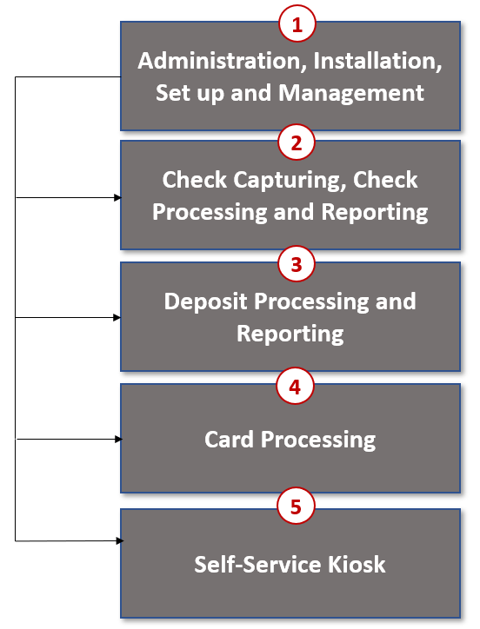
The functions of the five elements are:
- Administration: allows for those with administrative permissions to install, setup users, and manage OTCnet
- Deposit Processing: permits federal agencies the ability to create and submit deposits for confirmation. This platform also allows for Financial Institutions (FIs) to confirm those deposits and create adjustments electronically. Deposits can be created for US currency, foreign cash, and foreign check items
- Check Capturing, Check Processing: converts personal and business checks into electronic fund transfers. Transactions can be consumer, consumer accounts receivable, and business transactions
- Card Processing: allows agencies to provide their customers an option to make their payments via credit/debit cards and gift cards
- Self-Service Kiosk: third party vendor standalone kiosk supported by OTCnet

OTCnet Process Flow: Deposit Reporting
Deposit Processing electronically collects and automates US and Foreign funds which facilitates the classification of Treasury collections daily.
As shown in Figure 2, the Deposit Preparer, or Agency, electronically reports the deposit to Treasury using OTCnet and prints out the OTCnet deposit ticket. The bank deposit ticket, OTCnet deposit ticket, cash, and checks (US and foreign) are taken to your Treasury General Account (TGA) Bank. At the TGA Back, the Deposit Confirmer confirms the deposit, rejects the deposit, or creates an adjustment to the deposit using OTCnet. The Collections Information Repository (CIR) is formerly the Transaction Reporting System (TRS).
OTCnet sends commercial deposit voucher information to CIR. CIR receives commercial deposit information from OTCnet for reconciliation and transmits to Treasury Cash Management System (TCMS) for cash concentration purposes. TCMS receives the commercial deposit data from CIR and initiates the cash concentration activity.
The Deposit Preparer and Deposit Viewer can access OTCnet to view their deposit ticket information, as well as access reports, receive rejections, and view adjustments.
Figure 2: Deposit Processing Workflow
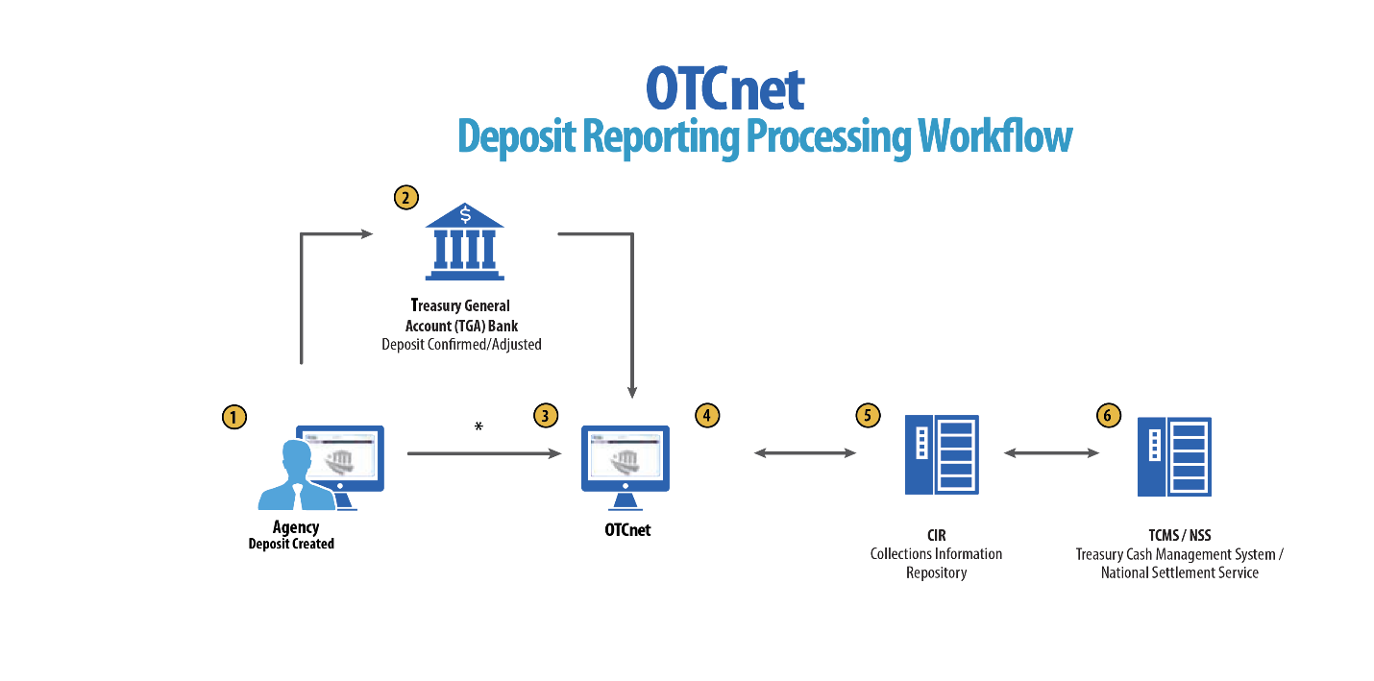

OTCnet End Users
There are four functional areas of the OTCnet application:
- Administration
- Check Capture, Processing and Reporting
- Deposit Processing and Reporting
- Card Processing
The user role you hold is based on the types of tasks you perform.
- Administration user roles, with varying degrees of permission, and perform administrative duties such as user management and system installation.
- Check Capture/Check Processing and Reporting user roles perform functions to capture checks, process checks, access reports and edit or view the Master Verification Database (MVD).
- Deposit Processing and Reporting user roles create deposits, approve, confirm (reject or adjust), and/or view information as shown in Table 1.
- Card Processing user roles perform functions to process card transactions.
Table 1: End User Roles
Administration | Check Capture/ Check Processing and Reporting | Deposit Processing and Reporting | Card  Processing
Agency  - Check Capture Supervisor  - Check Capture Administrator  - Accounting Specialist/ Local  - Accounting Specialist  - Card Administrator  Financial Institution/ Federal Reserve  - Primary Security Administrator  - Local Security Administrator | Agency  - Check Capture Operator  - Check Capture Lead Operator  - Check Capture Supervisor  - Batch Approver*  - Batch Uploader*  - Master Verification Database (MVD) Editor  - Master Verification Database (MVD) Viewer | Agency  - Deposit Preparer  - Deposit Approver  - Viewer  Financial Institution/ Federal Reserve  - Deposit Confirmer  - Viewer | Agency  - Card Operator
*Batch Approver and Batch Uploader are sub-roles assigned to users with existing roles.

Topic 2 Overview of OTCnet Participant User Guide Content

Introduction
These OTCnet Participant User Guides are intended to provide you with the skills you need to use OTCnet, a system by which users can capture and process checks, and/or process deposits. Users with appropriate permissions can install, setup, and manage OTCnet.
The Participant User Guide can be used independent of or in conjunction with the OTCnet Web-based Training (WBT). The Participant User Guides are accessible through the OTCnet web site, OTCnet application help link site or through the User Guides button located within the WBT.
The Participant User Guides offer a series of 32 functionality-related user guides with individual topics for Administration, Deposit Processing, Check Capture and Check Processing and Card Processing. Each OTCnet Participant User Guide topic includes step-by-step instructions with critical images for completing tasks.
Although separated by segment, the User Guides may be printed individually or as one complete manual. You are not required to complete all 32 user guides, though it is highly encouraged that you access the guides pertaining to your user role.
In addition to the above-mentioned guides, this OTCnet Participant User Guide was created to support Agency Viewer specific instruction. Below is an introduction to the related Deposit Processing OTCnet functionality.

Administration Participant User Guide
The Administration Participant User Guide includes ten user guides, including Check Capture, Check Processing, Deposit Processing and Card Processing Administrative functionality. Table 2 describes the related concepts covered in each guide:
Table 2: Administration User Guides
User Guides | Description
- Introduction to OTCnet and Overview of OTCnet Participant User Guide Content | In this user guide, you will learn about the background of OTCnet, the element and process flows that make up OTCnet as well as overview of the Participant User Guides.
- Accessing and Navigating OTCnet | In this user guide, you will learn how to log in, establish security settings and how to use the OTCnet Main Page.
- Managing Users | In this user guide, you will learn how to assist with creating an identity for a user and requesting an HLO and role access for them in SailPoint IIQ and OTCnet.
- Managing Your Agency’s Hierarchy, Accounting Codes, and Processing Options | In this user guide, you will learn how to create a hierarchy, designate an OTC Endpoint, establish a Financial Institution relationship, and designate a check capture location, modify and import accounting codes, modify endpoint mappings, and modify and view processing options.
- Configuring Administration and Card Processing Settings | In this user guide, you will learn how to manage custom labels, manage processing options and create and edit user defined fields.
- Viewing Financial Institutions | In this user guide, you will learn how to view Financial Institution details.
- OLB Setup Guide | In this user guide, you will learn how to download and install the OTCnet Local Bridge (OLB) Application, create the OLB profile and import OLB credentials.
- Configuring Card Terminal Processing Settings | In this user guide, you will learn how to set up or modify card terminal configuration, unregister a card terminal, view card terminal configuration, search an audit log and select a 80mm card receipt printer.
- Configuring Check Processing Settings Online | In this user guide, you will learn how to set up, modify and view a terminal configuration, view an audit log and download firmware.
In addition to the Participant User Guides, the OTCnet Printable Job Aids walks an Administrator through the steps to e.g., set up an organizational hierarchy and Check Capture and Check Processing Administrative settings. These may be used in conjunction with the 10 Administration user guides reviewed above.

Deposit Processing and Reporting Participant User Guides
10 Chapters make up the Deposit Processing and Reporting Participant User Guide. Table 3 describes the related concepts covered in each Chapter:
Table 3: Deposit Processing User Guides
User Guides | Description
- Introduction to OTCnet and Overview of OTCnet Participant User Guide Content | In this user guide, you will learn about the background of OTCnet, the element and process flows that make up OTCnet as well as overview of the Participant User Guides.
- Accessing and Navigating OTCnet | In this user guide, you will learn how to log in, establish security settings and how to use the OTCnet Main Page.
- Creating and Modifying Deposits | In this user guide, you will learn how to create and modify deposits.
- Searching for Deposits | In this user guide, you will learn how to search for and download deposits.
- Approving Deposits or Returning Deposits to Draft | In this user guide, you will learn how to approve deposits or return deposits to draft.
- Confirming, Rejecting or Adjusting Deposits | In this user guide, you will learn how to confirm deposits, adjust deposits, or apply a credit/debit adjustment for US Currency and Foreign Check Items.
- Managing Adjustments | In this user guide, you will learn how to create a returned item adjustment for US Currency and Foreign Check Items.
- Searching Adjustments | In this user guide, you will learn how to search and download adjustments.
- Viewing Reports | In this user guide, you will learn how to view and pull administrative and business reports.
- Viewing Deposits | In this user guide, you will learn how to view deposit drafts, deposits awaiting approval, confirmed deposits, deposit adjustments, rejected deposit details, submitted deposits and how to download vouchers.

Topic 3 Requesting Access for Yourself in SailPoint IIQ
Following the transition to Common Approach to Identity Assurance (CAIA), SailPoint IdentityIQ (IIQ) environment will be used to manage the identities and provisioning of new users.
CAIA is a solution consisting of a common federation platform by which users would be able to register, proof, and authenticate their identity via one or more selected credential service providers to access Fiscal Service programs.
Prospective OTCnet users can create identities through Personal Identity Verification Cards (PIV) or Common Access Cards (CAC), or ID.me.
- Government agency users and contractors with PIV/CAC linked to their OTCnet accounts will have their identities transitioned seamlessly into CAIA.
- Non-government users without PIV/CAC cards will not be able to automatically transition their identities once the move to CAIA has been made. These users will need to use ID.me to create new user identities.
While completing your self-registration in SailPoint IIQ, as a prospective OTCnet user, you can select your desired role(s) and high-level org(s) based on instructions from your security administrator(s).

Self-Register/Create an Account in SailPoint IIQ
You can self-register in SailPoint IIQ/create an account using PIV/CAC or ID.me.
Follow the on-screen instructions to sign in with an existing account or create an account. If prompted, follow the on-screen instructions to verify your identity. After completing all steps, you should see the SailPoint IIQ home page.

Self-Register/Create an Account in SailPoint IIQ
To self-register in SailPoint IIQ, navigate to the SailPoint IIQ environment at: https://iiq.fiscal.treasury.gov/ and complete the following steps:
- Log in using PIV/CAC or ID.me, as shown in Figure 3.
Figure 3. SailPoint IIQ Login Page
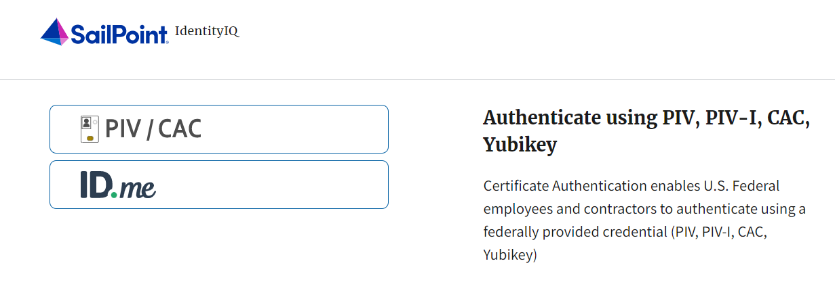
- Follow the on-screen instructions to sign in with an existing account or create an account.
- If prompted, follow the on-screen instructions to verify your identity.
- After completing all steps, you should see the SailPoint IIQ home page.
Application Tip

New OTCnet users including those with PIV/CAC access should go through SailPoint IIQ to do the self-registration to create an account and request role(s) and high-level org(s) before logging to OTCnet. Once their high-level access is approved in SailPoint IIQ, they can proceed to login to OTCnet.

Request Access for Yourself in SailPoint IIQ
If you need application entitlement, sign into SailPoint IIQ and request the specific access you need (self-request). Then the application approvers will receive a notification that there is an access request available to review. Once approved, you will be able to refresh your browser and successfully sign into the OTCnet application.
To request access for yourself, log into SailPoint IIQ and navigate to Manage My Access. Make sure Add Access is selected. In the search field, enter part or all of the HLO/role name you want to request. Select the HLO/role by selecting the checkmark to the left of the HLO/role name. Then select Next. On the Review and Submit screen, verify the requested HLO/role(s) are correct and select the Submit button.
A confirmation message will appear. SailPoint IIQ will automatically notify the necessary approvers to review the request. Once approved, your PLSA/LSA can create your identity in OTCnet and assign endpoints and roles for you. You will receive an autogenerated email when your user account is created in OTCnet.

Request Access for Yourself in SailPoint IIQ
To request access for yourself in SailPoint IIQ, complete the following steps:
- From the Home screen of SailPoint, navigate to Manage My Access through the Manage MyAccess button as shown in Figure 4.
Figure 4. SailPoint Home Page with Manage My Access Button
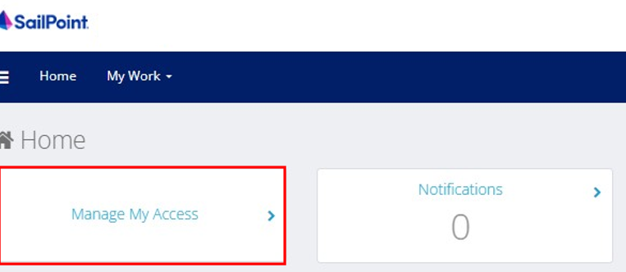
- On the Manage My Access screen, ensure that Add Access tab is selected as shown in Figure 5.
Application Tips

Search for the specific HLO name (e.g., Alaska USA Federal Credit Union) and user role (e.g., Check Capture Operator). If the HLO or user role’s name is not known, type HLO/Role in the search field.

- Search for an HLO. Select an HLO by selecting the checkmark to the left of the HLO’s name.
- Continue on the same screen to search for a user role. Select a role by selecting the checkmark to the left of the role’s name. Then select Next.
Application Tips

- Multiple HLOs and roles can be selected.
- All roles selected in SailPoint IIQ will be validated (and edited as needed) in OTCnet by the designated PLSA/LSA.

Figure 5. Add Access Screen
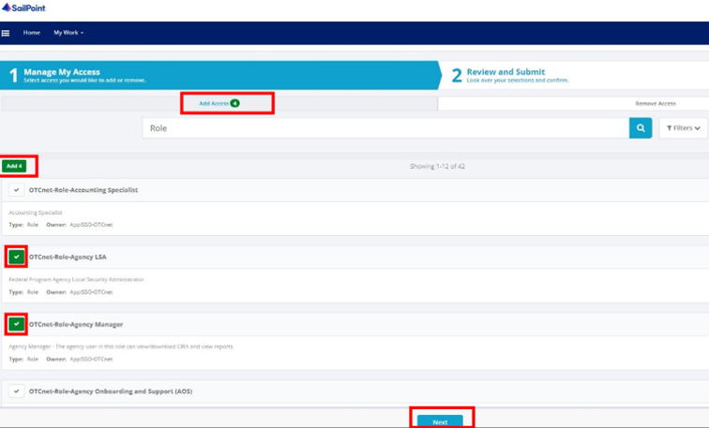
- On the Review and Submit screen, verify the requested HLOs and role(s) are correct. Select the voice bubble to the right of the HLO or role to add any comments.
- Select the Submit button at the bottom when finished, as shown in Figure 6.
Figure 6. Review and Submit Screen
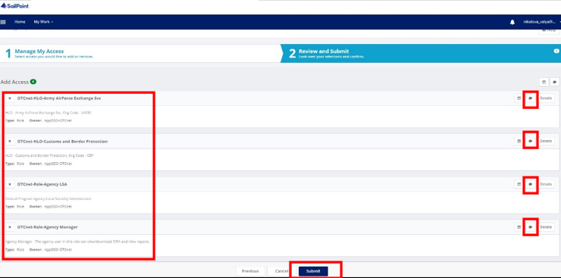
- A confirmation message will appear. SailPoint IIQ will automatically notify the necessary approvers to review the request. Once approved, your PLSA/LSA can create your identity in OTCnet and assign endpoints and roles for you.
Application Tips

- You will receive an autogenerated email when your user account is created in OTCnet.
- Then you can access the OTCnet application.

Topic 4 Log in to OTCnet Online
To log in to Fiscal Service Single Sign On (OTCnet Online), from the OTCnet Online login screen, use your PIV/CAC credentials, if you are a government user or contractor or ID.me, if you are a non-government user.
If you are a government employee or contractor who has a PIV/CAC card, you must link it to your BFS SSO account.
If you are a non-government user who creates an account through ID.me, you will specify your email address. ID.me is a private single sign-on provider that meets the government’s online identity proofing and authentication requirements.
Accounts registered by users for CAIA authentication are not application-specific, the same account credentials can be used on other sites or applications that are linked to CAIA. For example, Social Security Administration, Internal Revenue Service, Department of Veterans Affairs, and other government agencies accept ID.me credentials for logging in.

Log in to OTCnet Online
To log in to OTCnet Online, visit https://otcnet.for.fiscal.treasury.gov and log in with the following options: PIV/CAC or ID.me. Select the option that suits you best and follow the on-screen instructions to verify your identity or create an account in SailPoint IIQ.
Once you log in to OTCnet, you will be able to access functionality for one or more of the following:
- Administration
- Deposit Processing and Reporting
- Check Capture
- Check Processing
- Card Processing
The OTCnet Local Bridge (OLB) application is required for performing check processing, check capture, card processing and terminal configuration operations. If you are a Check Capture Administrator, Check Capture Supervisor, Check Capture Lead Operator, Check Capture Operator, Card Operator or Card Administrator, the OLB application must be started on the terminal to perform these operations.
When a new first-time OTCnet agency end-user has been fully provisioned with roles and endpoints, and also when they log into OTCnet, they will receive an autogenerated email ‘Welcome to OTCnet!’ that includes a list of resources to learn how to use OTCnet as well as important contact information to get acclimated to everything that OTCnet has to offer.

Log in to OTCnet Online
To log in to Fiscal Service Single Sign On (OTCnet Online), complete the following steps:
- Access https://otcnet.for.fiscal.treasury.gov. A page is presented which displays the following log in options: PIV/CAC and ID.me, as shown in Figure 7.
Figure 7. OTCnet Log In Screen
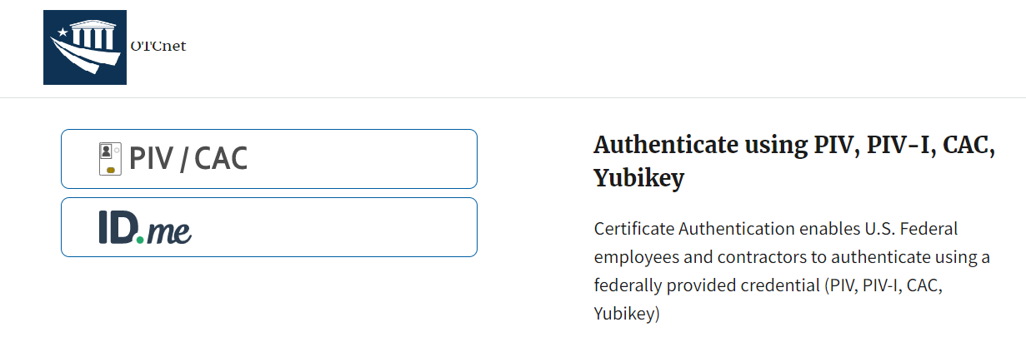
- Select the option that best represents your status and follow the on-screen instructions to verify your identity or create an account in SailPoint IIQ.
Application Tip
Application Tips

PIV/CAC (Government Users/Contractors)
- Select the PIV/CAC button.
- If prompted, select your certificate, and enter your pin.
- If prompted, follow the on-screen instructions to verify your email address
The first time a PIV/CAC certificate is used to authenticate, the email verification process is initiated.
- A web page is displayed prompting you to submit your email address that will be associated with your certificate. A verification code is sent to the email address specified.
- A web page is displayed to allow you to input the verification code from the email.

Application Tip

ID.me for Non-Government Users
- Select the ID.me button.
- Follow the on-screen instructions to sign in with an existing account or create an account.
- If prompted, follow the on-screen instructions to verify your identity.

- When you log in to OTCnet Online for first time you may be alerted that you are not permitted to access the application until your agency’s security administrator completes your user provisioning in OTCnet as shown in Figure 8.
- Once your agency’s security administrator has imported your user identity to OTCnet, and assigned endpoints and roles for you, you will be able to access the application.
Figure 8. First Time Log In Screen
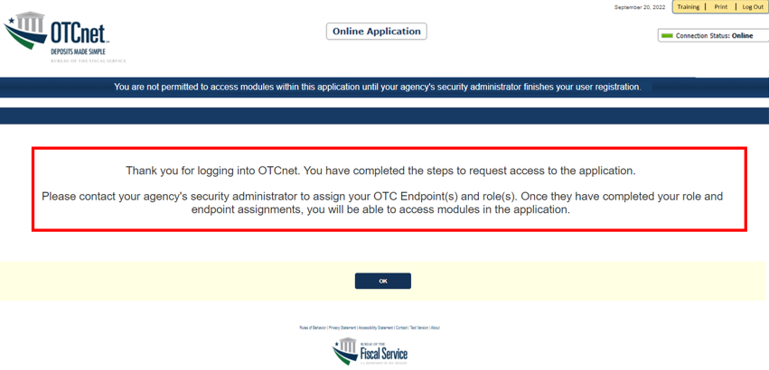
- To completely log out, close your browser. You will need to reauthenticate next time you login to OTCnet.
Application Tips

- Ensure that you login to OTCnet at least once every 120 days (or four months). Your user account will be disabled after 120 consecutive days of inactivity. To restore your account, contact the Customer Support Team to begin the process.

Application Tip

As a Check Capture Administrator, Check Capture Supervisor, Check Capture Lead Operator, Check Capture Operator, Card Operator or Card Administrator, when logging in to OTCnet Online and using Microsoft Edge or Google Chrome, the OTCnet splash screen does not appear.

Topic 5 Navigating the OTCnet Home Page
The OTCnet Online home page allows Check Capture Supervisors, Check Capture Lead Operators, Check Capture Operators and Card Operators to process deposits, capture checks, process checks, process card transactions, view reports, and perform administrative and security functions. Additionally, a user can access information for training, help and to update a user profile. The OTCnet Online home page is accessible for users to either view or perform any of these functionalities.

OTCnet Online Main Menu
To access the OTCnet Main Menu, log in with your PIV/CAC or ID.me credentials with the following url, https://otcnet.for.fiscal.treasury.gov. Table 4 provides a list of the Main Menu options available to you. They are accessible on the upper right corner of the OTCnet application.
Table 4. Main Menu Link Descriptions
Link | Description
Home | Allows a user to return to the OTCnet home page.
Training | Allows a user to access the Web-Based Training (WBT) and other corresponding training materials.
Print | Allows a user to print the page.
Help | Allows a user to access help for the page they are on.
Log Out | Allows a user to log out of OTCnet.

The Main Menu is shown in Figure 9. The links are accessible on the upper right side of the OTCnet home page.
Figure 9. OTCnet Main Menu Page
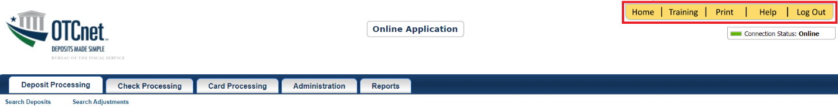

OTCnet Homepage Message Overlay
All user roles have access to the OTCnet Homepage Message Overlay in OTCnet. For all Microsoft Edge and Google Chrome users, the message overlay automatically presents when you first log in to OTCnet.
The message overlay is a messaging platform presenting important news and information on the OTCnet system as shown in Figure 10. It is recommended that you read the messages, close the message overlay, and continue viewing the OTCnet homepage.
Figure 10. OTCnet Homepage Message Overlay
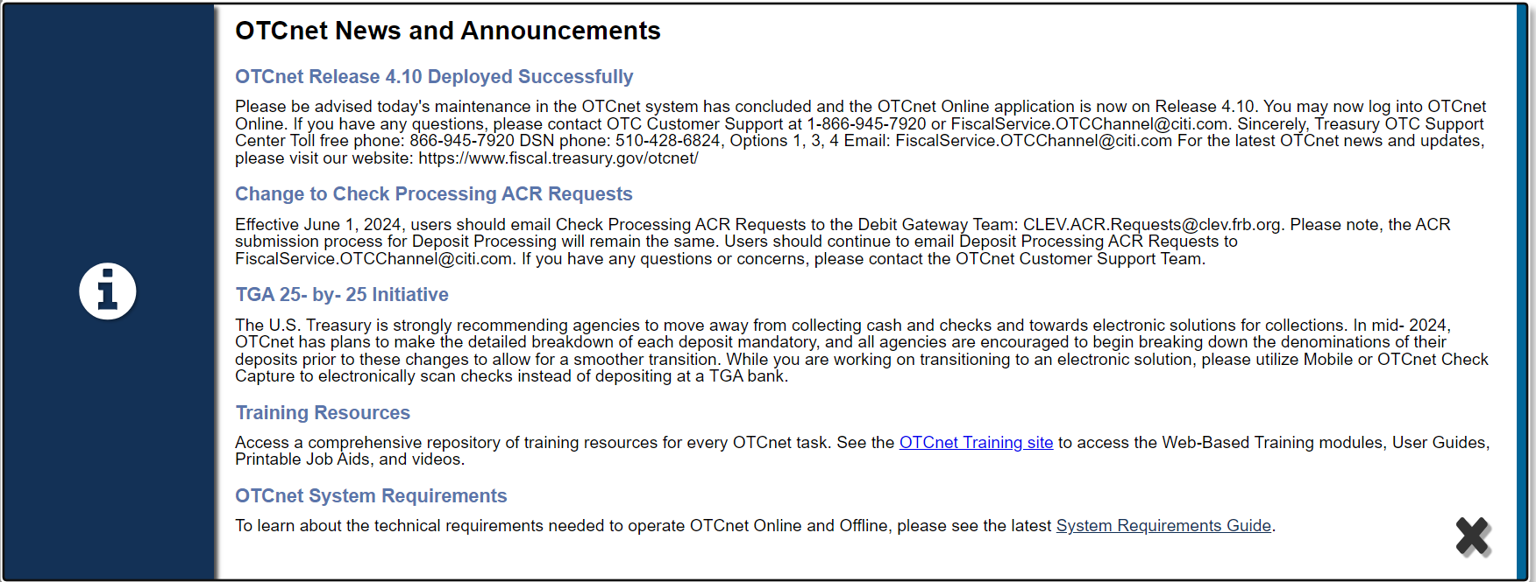

OTCnet Support Contact Overlay
Users can contact the OTCnet Customer Service team by submitting a form through the Customer Support button on the OTCnet homepage. This feature helps to standardize and streamline the inquiries and requests made to Customer Service. Select the Customer Support button on the bottom of the OTCnet homepage. The Treasury OTC Support Contact overlay appears over the homepage as shown in Figure 11.
Figure 11: Treasury OTC Support Contact Form
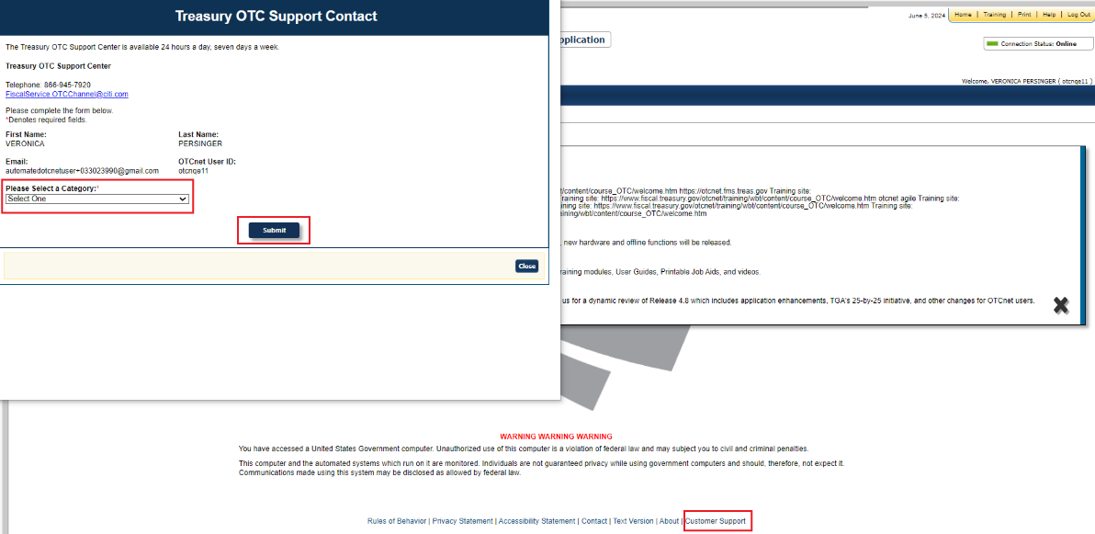

Select the Please Select a Category dropdown. The following options appear:
- Batch Management
- Check Scan
- Deposit Processing
- OTCnet Local Bridge (OLB)
- User Management
- Other

After you make the selections, select the Submit button to submit the request.

OTCnet Online Deposit Processing Tab Functionality
To access the OTCnet Deposit Processing functionality, log in with your PIV/CAC or ID.me credentials. Table 5 provides a list of the Deposit Processing functions that are available to you.
Table 5. Deposit Processing Tab Descriptions
Function | Description
Create Deposit | Allows a user to create deposits for US Currency, Foreign Check Items, and/or Foreign Currency Cash.
Search Deposits | Allows a user to search for deposits.
Search Adjustments | Allows a user to search for adjustments.
Create Returned Item Adjustment | Allows a user to create a returned item adjustment.
The Deposit Processing tab, as shown in Figure 12, allows you to access Deposit Processing functionality, though depending on your user role, you may not see all functionality.
Figure 12. Deposit Processing Tab
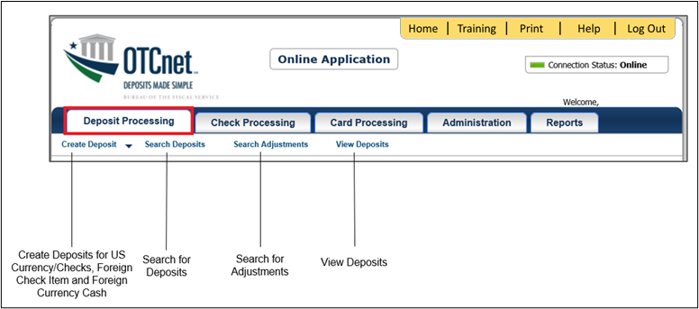

OTCnet Online Check Processing Tab Functionality
To access the OTCnet Check Processing functionality, log in with your PIV/CAC or ID.me credentials. Table 6 provides a list of the Check Processing functions that are available to you.
Table 6. Check Processing Tab Descriptions
Function | Description
Manage Verification | Allows a user to search and/or create an MVD record.
CIRA Query | Allows a user to view and/or modify a CIRA record.
Batch Management | Allows a user to search, view, close, approve and submit a batch. A user may edit and void an item within a batch with the proper permission.
Check Scan | Allows a user to scan checks.
The Check Processing tab is shown in Figure 13. Depending on your user role, you may not see all functionality shown in the image.
Figure 13. Check Processing Tab
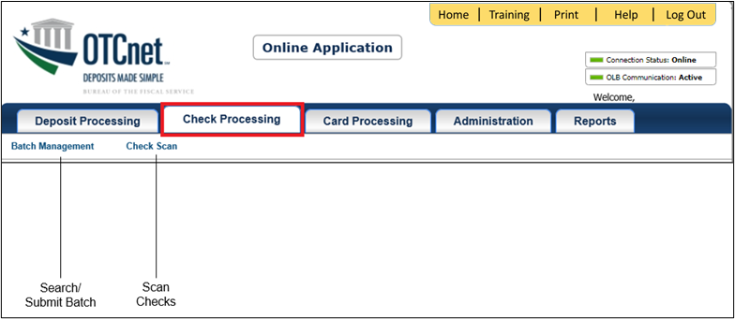

OTCnet Online Card Processing Tab Functionality
To access the OTCnet card processing functionality, log in with your PIV/CAC or ID.me credentials. Table 7 provides a list of the card processing functions that are available to you.
Table 7. Card Processing Tab Descriptions
Function | Description
Card Transaction Query | Allows a user to query a card transaction.
Process Card Payment | Allows a user to process a card payment.
The Card Processing tab is shown in Figure 14. Depending on your user role, you may not see all functionality shown in the image.
Figure 14. Card Processing Tab
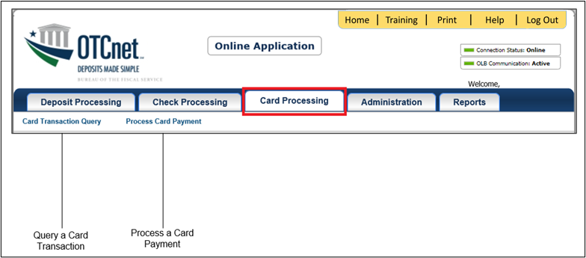

OTCnet Online Administration Tab Functionality
To access the OTCnet Administration functionality, log in with your PIV/CAC or ID.me credentials. Table 8 provides a list of the Administration functions that are available to you.
Table 8. Administration Tab Descriptions
Function | Description
Manage Organizations | Allows a user to manage Organization Hierarchy, Accounting Codes, Custom Labels, Processing Options, and User Defined Fields.
Manage FI | Allows a user to create and/or modify a Financial Institution, transfer FI RTN Numbers, transfer CA$HLINK accounts, and maintain FRB CA$HLINK accounts.
Manage Users | Allows a user to manage OTCnet user accounts and profiles.
Management | Allows a user to manage OTCnet processes.
Manage Check Processing | Allows a user to manage terminal configuration and forms.
Manage Card Processing | Allows a user to manage terminal configuration.
Manage Centralized Deployment | Allows users access to the following: Release Configuration, Edit Release and Download Release.
Audit | Allows a user to review the audit log history.
Utilities | Allows a user to review batch utilities, including Batch Recreate and Batch Repair.
The Administration tab is shown in Figure 15. Depending on your user role, you may not see all functionality shown in the image.
Figure 15. Administration Tab
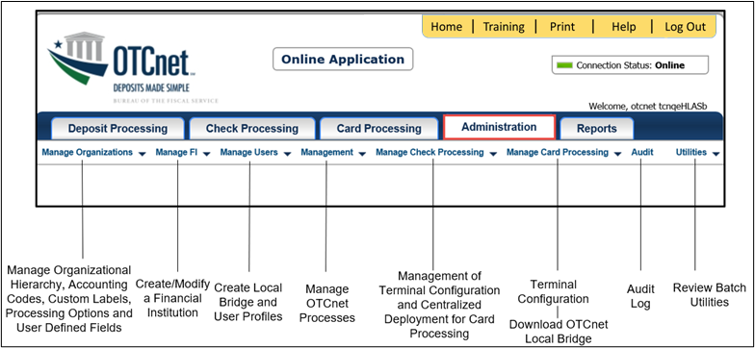

OTCnet Online Reports Tab Functionality
To access the OTCnet Reports functionality, log in with your PIV/CAC or ID.me credentials. Table 9 provides a list of the Reports functions that are available to you. Depending on your user role, you are only authorized to view and download certain reports.
Table 9. Reports Tab Descriptions
Function | Description
Deposit Processing Reports | Allows a user to view and download Business, Security and Administration reports.
Check Processing Reports | Allows a user to access Check Processing reports.
Scheduled Reports | Allows a user to query and download scheduled and historical reports.
The Reports tab is shown in Figure 16. Depending on your user role, you may not see all functionality shown in the image.
Figure 16. Manage Reports
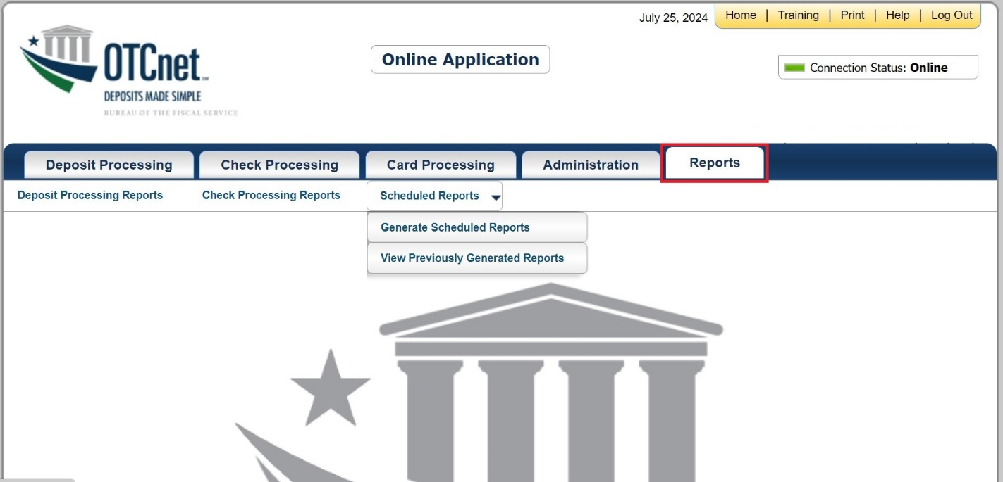

Topic 6 Viewing Deposits
As an Agency Viewer, you are authorized to view deposit vouchers. You may view deposits to locate those in process or see deposit transactions belonging to others in the organization.
You have permission to view only certain deposits. The deposit status types available for viewing are included in Table 10.
Table 10: Deposit Status
Deposit Status | Description
Draft | A deposit that is saved for modification at a later date by a Deposit Preparer
Awaiting Approval | A deposit that is waiting for deposit confirmation by a Deposit Approver
Submitted | A deposit that is submitted and waiting deposit confirmation by a Deposit Confirmer
Confirmed | A deposit that has been reviewed and confirmed by a financial institution (FI) or federal reserve bank (FRB)
Rejected | A deposit that is returned by a Financial Institution or FRB to the Deposit Preparer to create a new deposit

View a Deposit
To view a deposit, select My Deposits in Process, Adjustments in Error, Deposits in Error, or Deposits Within My Organization. Select the voucher number of the deposit you would like to view and change the number of records displayed per page, from the drop-down menu options next to record count.
- My Deposits in Process: Displays deposits that require addition action (e.g. Draft, Awaiting Approval, Submitted, Rejected, and Confirmed) based on user permissions.
If the user only has an FI Viewer or FRB Viewer role and selects this page, it returns no results. If the user is a Deposit Confirmer or FRB Confirmer, the table displays the column indicating the Confirm option to allow for multiple confirmations at the same time. For all other user roles, this column is hidden.
- Adjustments in Error: Displays adjustments that have validation errors awaiting acknowledgement by the financial institution that the error has been resolved.
The Adjustments in Error page displays any CA$HLINK II validation errors that need acknowledgment by the financial institution that the error has been resolved. No results appear if there are not any CA$HLINK II validation errors. To document why the error occurred and how the error was resolved, select the Voucher Number link is selected. This page only returns results for the Deposit Confirmer and FI Viewer roles. Other roles have the ability to select this page from the dropdown but do not see no results. Vouchers displayed in this section are also displayed in the History section of the page with the appropriate deposit status (Confirmed).
- Deposits in Error: Displays deposits that have validation errors awaiting acknowledgement by the financial institution that the error is resolved. With Deposit Confirmer or FI Viewer privileges, the Deposits in Error details appears.
The Deposits in Error page displays any CA$HLINK II validation errors that need acknowledgment by the financial institution that the error has been resolved. No results appear if there are not any CA$HLINK II validation errors. To document why the error occurred and how the error was resolved, select the Voucher Number link is selected. This page only returns results for the Deposit Confirmer and FI Viewer roles. Other roles have the ability to select this page from the dropdown but do not see results. Vouchers displayed in this section are also displayed in the History section of the page with the appropriate deposit status (Confirmed).
- Deposits Within My Organization: Displays a list of deposits that have been entered in the system, based on the agency endpoint or financial institution to which the user has access. With Deposit Confirmer or FI Viewer privileges, the Deposits Within My Organization details appears.
- The Deposits Within My Organization page displays voucher dates in reverse chronological order (including future dated deposits) and the status within (i.e. Draft, Submitted, Rejected, and Confirmed). The number of deposits displayed is based upon the display days processing options defined for the OTC Endpoint that the agency user has permission to view. If the user has permission for more than one OTC Endpoint, the processing option with the greatest number of days is used. If the user is an FI Viewer or an FS Viewer, the number of display days is set at 45.

View a Deposit
To view a deposit, complete the following steps:
- From the Deposit Processing tab, select View Deposits. The View Deposit page appears.
- From the Select Display drop-down menu, select My Deposits in Process, Adjustments in Error, Deposits in Error, or Deposits Within My Organization.
- Select the Voucher Number of the deposit you need to view as shown in Figure 17.
Figure 17: View Deposits Page
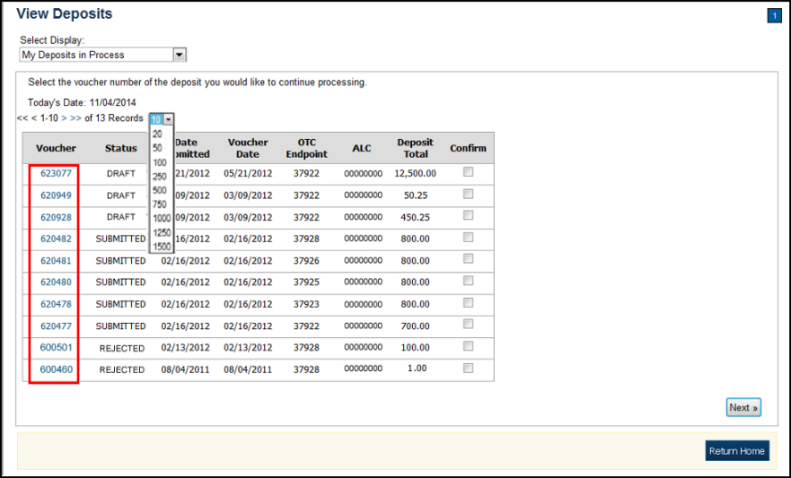
Application Tips

- By default, up to 10 records are displayed per page. To change the number of records displayed per page, select from the drop-down menu options next to the record count.
- When your Financial Institution makes an adjustment to a deposit, it appears in the Adj. column of the Deposit Transactions section of the table.
- To view additional details, select the appropriate Voucher Number.
- The View Confirmed Deposit page appears. Under Adjustment Information, select the Voucher Number to view the deposit adjustment details.


Additional Buttons
- Select Cancel to return to the OTCnet Home Page. No data
is saved.
- Select Confirm to confirm a deposit (Visible if a user has
Deposit Confirmer privileges).
- Select Clear to clear all data fields and reset to the default selections.
- Select Delete to eliminate the deposit. (Visible if a user has Deposit
- Preparer privileges.)
- Select Print Deposit Ticket to print a formatted deposit ticket.
- Select View Voucher Event Log to view the history of the
deposit voucher.
- Select Voucher Event State to view voucher details.
- Select Next to advance to the next page. (Visible only in My Deposits in Process view).
- Select Previous to return to the previous page.
- Select Return Home to return to the OTCnet Home Page.
- Select Reject to reject a deposit (Visible if a user has Deposit Confirmer privileges.)
- Select Adjust to adjust a deposit (Visible if a user has Deposit Confirmer privileges.)
- Select Save as Draft to save the information without submitting the deposit. (Visible if a user has Deposit Preparer privileges.)
- Select Submit to complete the process and display the Confirmation
page. (Visible if a user has Deposit Approver privileges.)
- Select Update CAN/ACCT Key to update the account number assigned to a deposit. (Visible if a user has Deposit Confirmer privileges.)
- Select Add Adjustment to adjust a deposit. (Not visible for Foreign Check Items.)

Topic 7 Search for a Deposit
As an Agency Viewer, you are authorized to search for a deposit voucher and download and save the searched deposit voucher(s) as an XML or CSV file.
To search for a deposit, select the Search Deposits function. The Search Deposits function enables you to search for a deposit voucher using one or more criteria. If you do not specify any criteria, the search results include all deposits in the system that you have access to view. You can run additional searches; the Search Results table that appears is cleared and re-populated with the results of the new search. See Table 11 for search criteria fields.
Table 11: Search Criteria Fields
Search Criteria Groupings | Search Criteria Fields
Search Conditions | - Organization  - OTC Endpoint  - ALC  - Prepared by  - Voucher Number  - Deposit Status  - Agency Block 6  - Deposit Type
Voucher Date | - From and To Date
Deposit Date | - From and To Date
Deposit Total | - From and To Total
Financial Institution Information | - Routing Transit Number  - Demand Deposit Account  - CA$HLINK II Account Number  - FRB Account Key  - FRB Cost Center Work Unit
Under the Search Deposits function, if you run a search without specifying any criteria, the search results include all deposits in the system that you have access to view Table 12.
Table 12: Search Results Deposit Statuses
Draft | A deposit that is saved for modification at a later date by a Deposit Preparer
Awaiting Approval | A deposit that is waiting for deposit confirmation by a Deposit Approver
Submitted | A deposit that is submitted and waiting deposit confirmation by a Deposit Confirmer
Confirmed | A deposit that has been reviewed and confirmed by a Financial Institution or FRB
Rejected | A deposit that is returned by a Financial Institution or FRB to the Deposit Preparer to create a new deposit

Search for a Deposit
To search for a deposit, complete the following steps:
- From the Deposit Processing tab, select Search Deposit. The Search Deposit page appears.
- Enter the search criteria for the deposit you would like to view and select Search. The Search Results table appears.
Under Search Conditions, optional
- Select the Organization
- Select the OTC Endpoint
- Enter the ALC (Agency Location Code)
- Enter Prepared by details
- Enter the Voucher #
- Select the Deposit Status
- Enter Agency Use (Block 6) details
- Select the Deposit Type
- Enter the From and To Voucher Date
- Enter the From and To Deposit Date
- Enter the From and To Deposit Total
Application Tip

Voucher From date must be 5 years or less from the current date. Vouchers more than five years old are viewed from the Scheduled Reports menu.

Under Financial Institution Information, optional
- Enter the RTN (Routing Transit Number)
- Enter the DDA (Demand Deposit Account)
- Enter the CAN (CA$HLINK II Account Number)
- Enter the FRB Account Key (Federal Reserve Bank Account Key)
- Enter the FRB CCWU (Federal Reserve Bank Cost Center Work Unit)
Under User Defined Field Information, if applicable, optional
- Enter the Deposit UDF (User Defined Fields)
- Enter the Accounting Subtotal UDF details
Application Tips

- User Defined Fields (UDFs) only display to users who have access to an organization that has previously defined UDFs.
- UDFs appear at the bottom of the page.
- Up to three UDFs can be displayed for Deposit and two for Accounting Subtotal.

- Select the Voucher Number of the deposit whose details you would like to view as shown in Figure 18.
Figure 18: Search Results Table
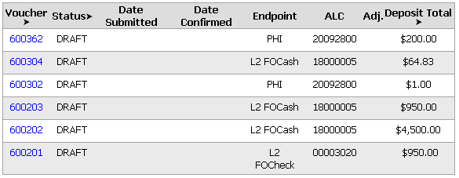
Application Tips

- Deposit totals are not displayed for unconfirmed foreign check items for which Other was selected as the country of deposit during deposit creation.
- Select Download to save the search deposit results as an XML or CSV file.
Additional Buttons
- Select Edit to modify the deposit draft. (Visible if a user has Deposit Preparer privileges.)
- Select Previous to return to the previous page.
- Select Print Deposit Ticket to print a formatted deposit ticket.
- Select Return Home to return to the OTCnet Home Page.
- Select View Voucher Event Log to view the history of the
deposit voucher events.

Download Deposit Information
After searching for your deposit, you can download the retrieved information. To download the results of a deposit, first use the Search Deposits function.
To download search results, enter the optional search criteria for the deposit you would like to view and select Search. Search criteria under Search Conditions, including Voucher, Status, Date Submitted, Date Confirmed, OTC Endpoint, ALC, Adj., and Deposit Total.
Search criteria under Financial Institution Information and enter User Defined Field Information details.
You can also download your results by selecting the XML file or CSV file format. Check the desired attributes that you want to download for Deposit Information, Financial Institution Information, Agency Information, Accounting Subtotals and User Defined Data, and Foreign Deposit Information. Open or save your file.

Download Deposit Information
To download the search results for a deposit, complete the following steps:
- Select Download from the Search Results table. The Download Deposits page appears as shown in Figure 19.
Figure 19: Download Button
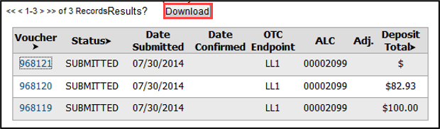
Application Tip

The Search Results table does not display Deposit Total values for unconfirmed Foreign Check Item deposits associated with a Country of Deposit selection of Other.

- Select XML file or CSV file as the file format.
- Check the desired attributes that you want to download for the following:
  - Deposit Information
  - Financial Institution Information
  - Agency Information
  - Accounting Subtotals and User Defined Data
  - Foreign Deposit Information

- Select Submit as shown in Figure 20. The File Download dialog box appears.
Figure 20: Download Attributes Selection
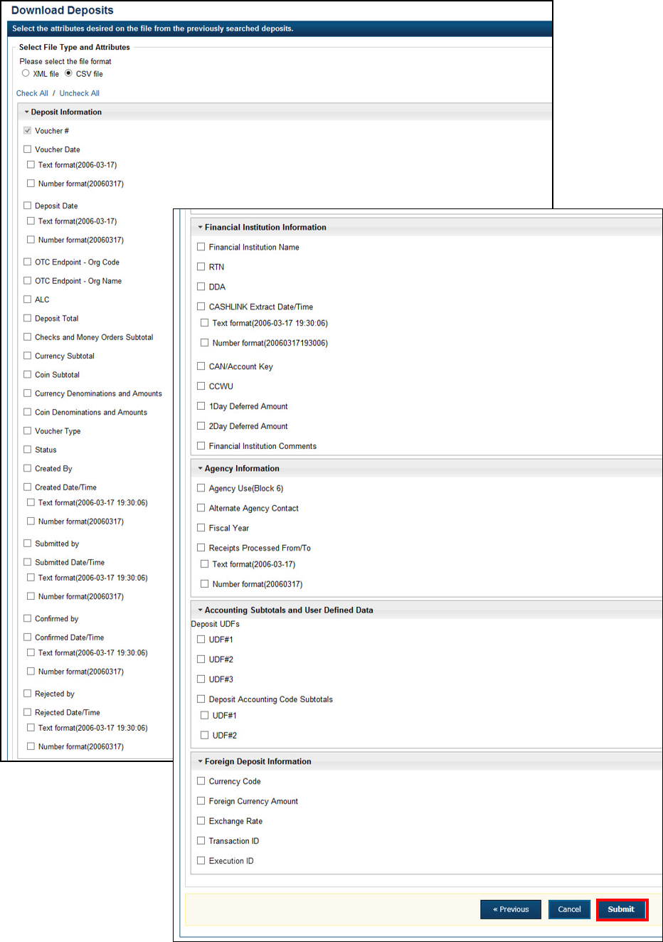

- Select Open or Save.
Application Tips

- Select Open and the content of the file displays.
- Select Save to choose the location where you want to save the file.

Additional Buttons
- Select Cancel to return to the OTCnet Home Page. No data is saved.
- Select Clear to clear all data fields and reset to the default selections.
- Select Download to download the search results.
- Select Previous to return to the previous page.
- Select Print Deposit Ticket to print a formatted deposit ticket.
- Select Search to display the deposits that match the search criteria.
- Select Return Home to return to the OTCnet Home Page.

Topic 8 Searching Adjustments
As an Agency Viewer, you are authorized to search for and view adjustments and download and save the searched adjustment voucher(s) as an XML or CSV file. You may review adjustments to understand why a deposit is adjusted and what corrections were made.
To search for an adjustment to a US Currency or Foreign Check Items deposit, select the Search Adjustments function. The Search Adjustments function enables you to search for a deposit voucher using one or more criteria.
If you do not specify any criteria, the search results include all deposits in the system that you have access to view. If you run additional searches, the Search Results table repopulates with the results of the new search. See Table 13 for search criteria fields.
Table 13: Search Criteria Fields
Search Criteria Groupings | Search Criteria Fields
Search Conditions | - Organization  - OTC Endpoint  - ALC  - Adjustment Category  - Voucher Number  - Adjustment Type  - Prepared By  - Adjustment Reason
Voucher Date | - Date Range
Adjustment Amount | - Total Range
Deposit Date | - Date Range
Original Deposit Date | - Date Range
Financial Institution Information | - Routing Number  - Demand Deposit Account  - CA$HLINK II Account Number  - FRB Account Key  - FRB Cost Center Work Unit

Searching for and Viewing Adjustments
Search Adjustments—you may search adjustments by selecting specific criteria. For this function, if you run a search without specifying any criteria, the search results include all deposits in the system that you have access to view.
To view an adjustment, you can download your search results by selecting the Voucher #, Voucher Date, Date of Deposit, Reason Code, ALC, Adj. (Type), Debit/Credit and Adjustment Amount.

Searching for and Viewing Adjustments
To search for and view an adjustment, complete the following steps:
- Select the Deposit Processing tab, select Search Adjustments. The Search Adjustments page appears.
- Enter the search criteria and select Search.
Under Search Conditions, optional
  - Select an Organization
  - Select an OTC Endpoint
  - Enter an ALC (Agency Location Code)
  - Select an Adjustment Category
  - Enter a Voucher #
  - Select an Adjustment Type
  - Enter the Prepared by name
  - Select an Adjustment Reason
  - Enter the From: and To: Voucher Dates
  - Enter the From: and To: Adjustment Amount
  - Enter the From: and To: Deposit Date
  - Enter the From: and To: Original Deposit Date
Additional search criteria are displayed as shown in Figure 21.
Figure 21: Additional Search Criteria
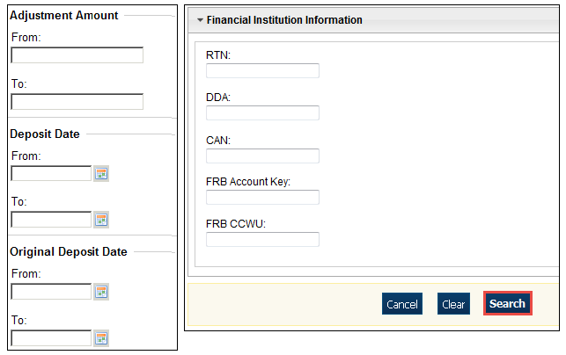

Application Tip

Voucher From date must be five years or less prior to the current date. Vouchers more than five years old can be viewed from the Scheduled Reports menu.

- The Search Results table appears. Select the Voucher Number of the adjustment for the details you need to view.
Application Tip

Values do not display in the Adjustment Amount column for unconfirmed foreign check item deposits that were entered with a Country of Deposit of Other.

Additional Buttons
- Select Download to save the adjustment results as an XML or CSV file.
- Select Previous to return to the previous page.
- Select Return Home to return to the OTCnet Home Page.
- Select View Voucher Event Log to view the history of the deposit voucher.

Downloading Search Results for Adjustments
To download your search results, use the Search Adjustments function. After searching for your adjusted deposit, you can download the information you retrieve.
To download your search results for a deposit, enter the optional search criteria for your adjusted deposit, e.g., Voucher #, Voucher Date, Date of Deposit, Reason Code, ALC, Adj. (Type), Debit/Credit and Adjustment Amount. You can also download the results.
Select either the XML file or CSV file format. Verify the desired attributes you want to download for Adjustment Information, Original Deposit Information, Financial Institution Information and Foreign Return Item Information. Open or save the file.

Downloading Search Results for Adjustments
To download the search results for a deposit, complete the following steps:
- The Search Results table appears, select Download as shown in Figure 22. The Download Deposits page appears.
Figure 22: Download Button
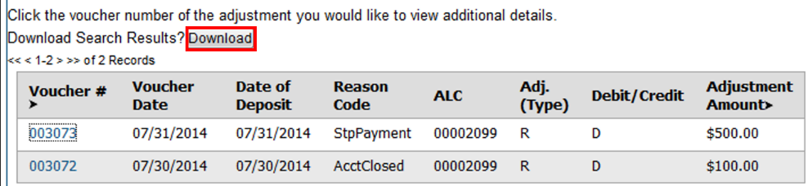

- Select either the XML file or CSV file format.
- Verify your desired attributes for download:
  - Deposit Information
  - Financial Institution Information
  - Agency Information
  - Accounting Subtotals and User Defined Data
  - Foreign Deposit Information
- Select Submit. The File Download dialog box appears.
- Select Open or Save.
Application Tips

- Select Open and the content of the file appears.
- Select Save to choose the location where you will save the file.

Additional Button
Select Cancel to return to the OTCnet Home Page. No data is saved.

Topic 9 Viewing Reports
As a user or viewer with access to the Deposit Processing functionality, you may access one or more of the Business Reports, Security Reports, Administration Reports or Scheduled Reports. You may need to view or download a report for e.g., adjustment activity, user information or voucher status. Each report provides deposit information specific to the select type of data requested. Table 14 describes the purpose of each report type.
Table 14: Types of Reports and Purpose
Report | Purpose of Report
Business | Provides specific reporting detail for deposit and adjustment activity by type, status and processing options for Agencies and Financial Institutions
Security | Provides specific reporting detail for access groups and users for Agencies and Financial Institutions
Administration | Provides specific reporting detail for interface to CIR,* as well as detailed information about completed and in progress vouchers
*The Collections Information Repository (CIR) was formerly referred to as the Transaction Reporting System (TRS).

Topic 10 Reports by User Role
Access to view reports in OTCnet is dependent on your user role. Table 15 presents the OTCnet user roles with access to each OTCnet report. Reports are grouped into the following categories:
- Business Reports
- Security Reports
- Administration Reports
- Scheduled Reports
Table 15: Business Reports by Federal Program Agency User Roles
Business Reports | Deposit Preparer | Deposit Approver | Accounting Specialist | Local Accounting Specialist | FPA Viewer | Agency LSA | Agency PLSA
Adjustment Activity (FI) | blank | blank | blank | blank | blank | blank | blank
Adjustments By OTC Endpoint | • | • | blank | blank | • | blank | blank
Daily Voucher Report | blank | blank | • | • | blank | blank | blank
Deposit Activity (FI) | blank | blank | blank | blank | blank | blank | blank
Deposits By Accounting Code | • | • | blank | blank | • | blank | blank
Deposits By OTC Endpoint | • | • | blank | blank | • | blank | blank
Deposit History By Status (FPA) | • | • | blank | blank | • | blank | blank
Non-Reporting OTC Endpoint | • | • | • | • | • | blank | blank
Processing Options by Agency EP | blank | blank | • | • | blank | blank | blank
Table 16: Business Reports by Financial Institution/Federal Reserve Bank as Financial Institution User Roles
Business Reports | FI  Confirmer | FRB  Confirmer | FI  Viewer | FRB  Viewer | LSA | PLSA
Adjustment Activity (FI) | • | blank | • | blank | blank | blank
Adjustments By OTC Endpoint | blank | blank | blank | blank | blank | blank
Daily Voucher Report | blank | blank | blank | blank | blank | blank
Deposit Activity (FI) | • | blank | • | blank | blank | blank
Deposits By Accounting Code | blank | blank | blank | blank | blank | blank
Deposits By OTC Endpoint | blank | blank | blank | blank | blank | blank
Deposit History By Status (FPA) | blank | blank | blank | blank | blank | blank
Non-Reporting OTC Endpoint | blank | blank | blank | blank | blank | blank
Processing Options by Agency EP | blank | blank | blank | blank | blank | blank

Table 17: Security Reports by Federal Program Agency User Roles
Security Reports | Deposit Preparer | Deposit Approver | Accounting Specialist | Local Accounting Specialist | FPA Viewer | Agency LSA | Agency PLSA
Primary Access Groups without a PLSA | blank | blank | blank | blank | blank | blank | blank
Users by Access Group (FI) | blank | blank | blank | blank | blank | blank | blank
Users by Access Group (FPA) | blank | blank | blank | blank | blank | • | •
Users by Role (FI) | blank | blank | blank | blank | blank | blank | blank
Users by Role (FPA) | blank | blank | blank | blank | blank | • | •
User Information | blank | blank | blank | blank | blank | • | •
Table 18: Security Reports by Financial Institution/Federal Reserve Bank as Financial Institution User Roles
Security Reports | FI  Confirmer | FRB  Confirmer | FI  Viewer | FRB  Viewer | LSA | PLSA
Primary Access Groups without a PLSA | blank | blank | blank | blank | blank | blank
Users by Access Group (FI) | blank | blank | blank | blank | • | •
Users by Access Group (FPA) | blank | blank | blank | blank | blank | blank
Users by Role (FI) | blank | blank | blank | blank | • | •
Users by Role (FPA) | blank | blank | blank | blank | blank | blank
User Information | blank | blank | blank | blank | • | •
Table 19: Administration Reports by Federal Program Agency User Roles
Admin. Reports/ Misc. | Deposit  Preparer | Deposit Approver | Accounting Specialist | Local Accounting Specialist | FPA Viewer | Agency LSA | Agency PLSA
View CIR File Status* | blank | blank | blank | blank | blank | blank | blank
View Vouchers Complete | • | • | blank | blank | • | blank | blank
View Voucher Event Log | • | • | blank | blank | • | blank | blank
View Voucher Event Detail | • | • | blank | blank | • | blank | blank
View Vouchers In Progress | • | • | blank | blank | • | blank | blank
View Voucher Event Log | • | • | blank | blank | • | blank | blank
View Voucher Event Detail | • | • | blank | blank | • | blank | blank
Change Current State | blank | blank | blank | blank | blank | blank | blank
Acknowledge Error Resolution | blank | blank | blank | blank | blank | blank | blank
* The Collections Information Repository (CIR) was formerly referred to as the Transaction Reporting System (TRS).

Table 20: Administration Reports by Financial Institution/Federal Reserve Bank as Financial Institution User Roles
Admin. Reports/ Misc. | FI  Confirmer | FRB  Confirmer | FI  Viewer | FRB  Viewer | LSA | PLSA
View CIR File Status | • | • | • | • | blank
View Vouchers Complete | • | • | • | • | blank
View Voucher Event Log | • | • | • | • | blank
View Voucher Event Detail | • | • | • | • | blank
View Vouchers In Progress | • | • | • | • | blank
View Voucher Event Log | • | • | • | • | blank
View Voucher Event Detail | • | • | • | • | blank
Change Current State | blank | blank | blank | blank | blank
Acknowledge Error Resolution | • | • | blank | blank | blank
Table 21: Scheduled Reports by Federal Program Agency User Roles
Scheduled Reports | Deposit Preparer | Deposit Approver | Accounting Specialist | Local Accounting Specialist | FPA Viewer | Agency LSA | Agency PLSA
Deposit Historical Report | • | • | blank | blank | • | blank | blank
Adjustment Historical Report | • | • | blank | blank | • | blank | blank
Table 22: Scheduled Reports by Financial Institution/Federal Reserve Bank as Financial Institution User Roles
Scheduled Reports | FI Confirmer | FRB Confirmer | FI Viewer | FRB Viewer | LSA | PLSA
Deposit Historical Report | • | • | • | • | blank | blank
Adjustment Historical Report | • | • | • | • | blank | blank

Topic 11 Types of Reports
There are four primary report categories within OTCnet:
- Business Reports
- Security Reports
- Administration Reports
- Scheduled Reports

Business Reports
If you are a Deposit Preparer, Deposit Approver, Accounting Specialist, Local Accounting Specialist, Federal Program Agency (FPA) Viewer, Financial Institution (FI) Confirmer, Federal Reserve Bank (FRB) Confirmer, FI Viewer, or FRB Viewer, you may access to one or more of the reports listed below.
Table 23: Business Reports by User Role
Business Reports | FI  Confirmer | FRB  Confirmer | FI  Viewer | FRB  Viewer | LSA | PLSA
Adjustment Activity (FI) | • | blank | • | blank | blank | blank
Adjustments By OTC Endpoint | blank | blank | blank | blank | blank | blank
Daily Voucher Report | blank | blank | blank | blank | blank | blank
Deposit Activity (FI) | • | blank | • | blank | blank | blank
Deposits By Accounting Code | blank | blank | blank | blank | blank | blank
Deposits By OTC Endpoint | blank | blank | blank | blank | blank | blank
Deposit History By Status (FPA) | blank | blank | blank | blank | blank | blank
Non-Reporting OTC Endpoint | blank | blank | blank | blank | blank | blank
Processing Options by Agency EP | blank | blank | blank | blank | blank | blank
Table 24: Security Reports by Federal Program Agency User Roles
Security Reports | Deposit Preparer | Deposit Approver | Accounting Specialist | Local Accounting Specialist | FPA Viewer | Agency LSA | Agency PLSA
Primary Access Groups without a PLSA | blank | blank | blank | blank | blank | blank | blank
Users by Access Group (FI) | blank | blank | blank | blank | blank | blank | blank
Users by Access Group (FPA) | blank | blank | blank | blank | blank | • | •
Users by Role (FI) | blank | blank | blank | blank | blank | blank | blank
Users by Role (FPA) | blank | blank | blank | blank | blank | • | •
User Information | blank | blank | blank | blank | blank | • | •

Table 25: Security Reports by Financial Institution/Federal Reserve Bank as Financial Institution User Roles
Security Reports | Deposit Preparer | Deposit Approver | Accounting Specialist | Local Accounting Specialist | FPA Viewer | Agency LSA | Agency PLSA
Primary Access Groups without a PLSA | blank | blank | blank | blank | blank | blank | blank
Users by Access Group (FI) |  |  |  |  |  | • | •
Users by Access Group (FPA)
Users by Role (FI) |  |  |  |  |  | • | •
Users by Role (FPA)
User Information |  |  |  |  |  | • | •
Table 26: Administration Reports by Federal Program Agency User Roles
Admin. Reports/ Misc. | Deposit Preparer | Deposit Approver | Accounting Specialist | Local Accounting Specialist | FPA Viewer | Agency LSA | Agency PLSA
View CIR File Status | blank | blank | blank | blank | blank | blank | blank
View Vouchers Complete | • | • | blank | blank | • | blank | blank
View Voucher Event Log | • | • | blank | blank | • | blank | blank
View Voucher Event Detail | • | • | blank | blank | • | blank | blank
View Vouchers In Progress | • | • | blank | blank | • | blank | blank
View Voucher Event Log | • | • | blank | blank | • | blank | blank
View Voucher Event Detail | • | • | blank | blank | • | blank | blank
Change Current State | blank | blank | blank | blank | blank | blank | blank
Acknowledge Error Resolution | blank | blank | blank | blank | blank | blank | blank
Table 27: Business Reports
Business Report | Purpose of Business Report
Adjustment Activity (FI) | Allows you to view adjustments made by your Financial Institution (FI)
Adjustments by OTC Endpoints | Allows you to view adjustments made by your Agency Location Code (ALC)
Daily Voucher Report | Allows you to view the daily voucher extract
Deposit Activity (FI) | Allows you to view deposits submitted to your FI
Deposits by Accounting Code | Allows you to view deposits by accounting code
Deposits by OTC Endpoint | Allows you to view deposits by OTC Endpoint.
Deposit History by Status | Allows you to view deposits by status
Non-Reporting OTC Endpoints | Allows you to view OTC Endpoints that have not reported a deposit.
Processing Options by OTC Endpoints | Allows you to view processing options defined for endpoints within the organization.

Security Reports
If you are an Agency Primary Security Administrator (PLSA), Agency Local Security Administrator (LSA), FI/FRB PLSA or FI/FRB LSA, you may access one or more of the reports listed below.
Table 28: Security Reports by User Role
Admin. Reports/ Misc. | Deposit Preparer | Deposit Approver | Accounting Specialist | Local Accounting Specialist | FPA Viewer | Agency LSA | Agency PLSA
View CIR File Status | blank | blank | blank | blank | blank | blank | blank
View Vouchers Complete | • | • | blank | blank | • | blank | blank
View Voucher Event Log | • | • | blank | blank | • | blank | blank
View Voucher Event Detail | • | • | blank | blank | • | blank | blank
View Vouchers In Progress | • | • | blank | blank | • | blank | blank
View Voucher Event Log | • | • | blank | blank | • | blank | blank
View Voucher Event Detail | • | • | blank | blank | • | blank | blank
Change Current State | blank | blank | blank | blank | blank | blank | blank
Acknowledge Error Resolution | blank | blank | blank | blank | blank | blank | blank
Table 29: Administration Reports by Financial Institution/Federal Reserve Bank as Financial Institution User Roles
Admin. Reports/ Misc. | FI Confirmer | FRB Confirmer | FI  Viewer | FRB  Viewer | LSA | PLSA
View CIR File Status | • | • | • | • | blank | blank
View Vouchers Complete | • | • | • | • | blank | blank
View Voucher Event Log | • | • | • | • | blank | blank
View Voucher Event Detail | • | • | • | • | blank | blank
View Vouchers In Progress | • | • | • | • | blank | blank
View Voucher Event Log | • | • | • | • | blank | blank
View Voucher Event Detail | • | • | • | • | blank | blank
Change Current State | blank | blank | blank | blank | blank | blank
Acknowledge Error Resolution | • | • | blank | blank | blank | blank
To obtain specific details for the reports that each role may view or download, refer to the table above.
Table 30: Security Reports
Security Report | Purpose of Security Report
Users by Access Group (FI) | Allows you to view users by Financial Institution.
Users by Access Group (FPA) | Allows you to view users by OTC Endpoint.
User Information | Allows that you to view a user’s contact information.
Users by Role (FI) | Allows you to view users by role for your Financial Institution.
Users by Role (FPA) | Allows you to view users by role for your OTC Endpoint.

Administration Reports
If you are a Deposit Preparer, Deposit Approver, FPA Viewer, FI Confirmer, FRB Confirmer, FI Viewer, or FRB Viewer, you may access one or more of the reports listed in Table 30.
To obtain specific details for the reports each role may view or download, refer to Table 30.
Table 31: Administration Reports
Administration Report | Purpose of Administration Report
View CIR File Status | The status of CIR files that have been processed by Collections Information Repository (CIR) or are ready for CIR to process.
View Vouchers Completed | Allows you to view the status of deposit and adjustment vouchers that have completed processed through the FI System To System Interface in the past 36 hours.
View Vouchers in Progress | Allows you to view the status of deposit and adjustment vouchers in progress.

Scheduled Reports
Scheduled Reports are asynchronous reports that you can request in advance and review later. They include historical reports older than 18 months for check processing and 5 years for deposit processing.
As a Financial Institution Viewer, you have access to the reports listed in Table 31.
Table 32: Deposit Processing Historical Report
Deposit Processing Historical Report | Purpose of Report
Deposit Historical Report | Allows you to view scheduled deposit transaction data.
Adjustment Scheduled Report | Allows you to view scheduled deposit adjustment and returned item adjustment transaction data.

Topic 12 Viewing Reports

Business Reports
This section provides you with details on how to view and download Business Reports.

Adjustments by OTC Endpoint
To view adjustments by OTC Endpoint, you are presented with the option to include search criteria, i.e., Organization, Adjustment Type, ALC, Adjustment Date (From: and To:), Deposit Date (From: and To:), Adjustment Amount (From: and To:), and Report With Children.
The report presents adjustment activity by OTC Endpoint, including the Financial Institution, Adjust Date, Deposit Date, Voucher Date, Voucher #, Adjustment Amount, and Adjustment Type by credit or debit. It also presents the ALC# You can export the report as a PDF, Excel or Word file, download it or print it.

Deposits by Accounting Code
To view deposits by accounting code, you are presented with the option to include search criteria, i.e., the Organization, ALC, Accounting Code, Voucher Date (From: and To:), Deposit Total (From: and To:), and Report with Children.
The report presents deposits by Accounting Code, including the OTC Endpoint, Voucher #, Deposit Date, and Accounting Code Amount. You can export the report as a PDF, Excel or Word file, download it or print it.

Deposits by OTC Endpoint
To view deposits by OTC Endpoint, you are presented with the option to include search criteria, i.e., Organization, ALC, Voucher Date (From: and To:), Deposit Total (From: and To:) and Report With Children.
The report presents deposits by OTC Endpoint, including the Status Date, Voucher Date, Voucher #, Voucher Type, Deposit Amount, and Status Code (Awaiting Approval [AWAP] or DRAFT). You can export the report as a PDF, Excel or Word file, download it or print it.

Deposit History by Status
To view deposit history by status, you are presented with the option to include search criteria, i.e., Organization, ALC, Status, Status Date (From: and To:), Deposit Total (From: and To:), and Report With Children.
The report presents deposit history by status, including the Voucher Type, Status Date, Voucher Date, Voucher #, and Deposit Amount. It also includes the Status Code: Awaiting Approval and ALC#. You can export the report as a PDF, Excel or Word file, download it or print it.

Non-Reporting OTC Endpoints
To view non-reporting OTC endpoints, you are presented with the option to include search criteria, i.e., the Deposit Date (From: and To:) and Report with Children.
The report presents Non-Reporting OTC Endpoints, including the Date of Creation (Highest Level) and OTC Endpoint (Training Team Top Level and Lower Levels). You can export the report as a PDF, Excel or Word file, download it or print it.

View Business Reports: Adjustments by OTC Endpoint
To view adjustments by OTC Endpoint report, complete the following steps:
- From the Reports tab, select Deposit Processing Reports. The View Reports page appears.
- Under Business Reports, select Adjustments by OTC Endpoint. The Adjustments by OTC Endpoint parameters page appears.
- Enter your search criteria.
  - Select the Organization, required
  - Select the Adjustment Type, required
  - Select the ALC (Agency Location Code)
  - Enter the From: and To: Adjustment Date range
  - Enter the From: and To: Deposit Date range
  - Enter the From: and To: Adjustment Amount range
  - Select Yes or No for Report With Children
Application Tips

- The date range for Adjustment Date and Deposit Date cannot exceed 15 months.
- Select Yes For Report with Children to generate a report that contains data for the selected OTC Endpoint and all lower-level OTC Endpoints.
- Select No For Report with Children to generate a report that contains data only for the selected OTC Endpoint.

- Select an OTC Endpoint to initiate the report. The Adjustments by OTC Endpoint preview appears as shown in Figure 23.
Figure 23: Adjustments by OTC Endpoint Parameters Page
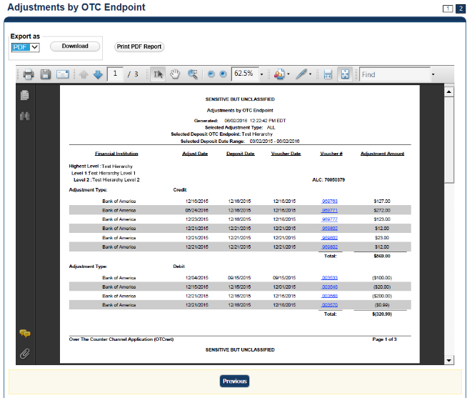
Application Tips

- TGA denotes a deposit processing OTC Endpoint.
- CHK denotes a check capture OTC Endpoint.
- M denotes a mapped accounting code; an open lock denotes access permission; and a closed lock denotes no access permission.
- CDC denotes card processing OTC Endpoint.

- Under Export as, you have the following options:
  - Select PDF, Excel or Word format
  - Select Download
    - Or
  - Select Print PDF Report
Application Tip

All Adjustments associated with Deposits with an original voucher date older than 5 years and Returned Item Adjustments with an adjustment voucher date older than 5 years have been archived to the archive database, according to the Fiscal Service data retention policy. These transactions are viewable through the Scheduled Reports page (Home>Reports>Scheduled Reports).

Additional Button
Select Previous to return to the previous page.

View Business Reports: Deposits by Accounting Code
To view a deposit by accounting code report, complete the following steps:
- From the Reports tab, select Deposit Processing Reports. The View Reports page appears.
- Under Business Reports, select Deposits by Accounting Code. The Deposits by Accounting Code parameters page appears.
- Enter your search criteria.
  - Select the Organization, required
  - Select the ALC (Agency Location Code)
  - Select the Account Code, required
  - Enter the From: and To: Voucher Date range
  - Enter the From: and To: Deposit Total range
  - Select Yes or No for Report With Children
Application Tips

- The date range for Voucher Date cannot exceed 15 months.
- Select Yes for Report With Children to generate a report that contains data for the selected OTC Endpoint as well as all of the lower-level OTC Endpoints.
- Select No for Report With Children to generate a report that contains data only for the selected OTC Endpoint.

- Select an OTC Endpoint to initiate the report. The Deposits by Accounting Code preview page appears as shown in Figure 24.
Figure 24: Deposits by Accounting Code Report Preview Page
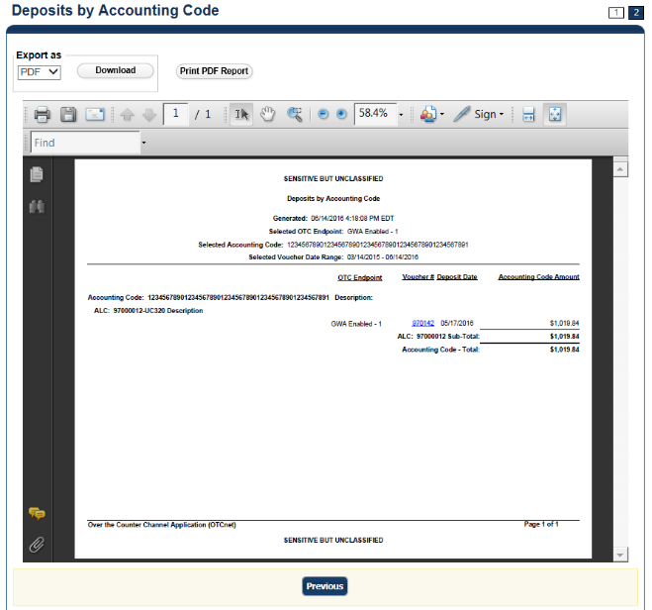
Application Tips

- TGA denotes a deposit processing OTC Endpoint.
- CHK denotes a check capture OTC Endpoint.
- M denotes a mapped accounting code; an open lock denotes access permission; and a closed lock denotes no access permission.
- CDC denotes card processing OTC Endpoint.

- Under Export as, you have the following options:
  - Select PDF, Excel or Word format
  - Select Download
Or
  - Select Print PDF Report
Application Tips

- Deposits with a voucher date older than five years does not display on the report but they may be viewed from the Scheduled Reports page (Home>Reports>Scheduled Reports).
- Unconfirmed Foreign Check items entered with a Country of Deposit value of Other does not display values in the Voucher Amount column.

Additional Button
Select Previous to return to the previous page.

View Business Reports: Deposits by OTC Endpoint
To view a deposit by OTC Endpoint report, complete the following steps:
- From the Reports tab, select Deposit Processing Reports. The View Reports page appears.
- Under Business Reports, select Deposits by OTC Endpoint. The Deposits by OTC Endpoint parameters page appears.
- Enter your search criteria.
  - Select the Organization, required
  - Select the ALC (Agency Location Code)
  - Enter the From: and To: Voucher Date range
  - Enter the From: and To: Deposit Total range
  - Select Yes or No for Report With Children
Application Tips

- The date range for Voucher Date cannot exceed 15 months.
- Select Yes for Report With Children to generate a report that contains data for the selected OTC Endpoint as well as all of the lower-level OTC Endpoints.
- Select No for Report With Children to generate a report that contains data only for the selected OTC Endpoint.

- Select an OTC Endpoint to initiate the report. The Deposits by OTC Endpoint preview page appears as shown in Figure 25.
Figure 25: Deposits by OTC Endpoint Report Preview Page
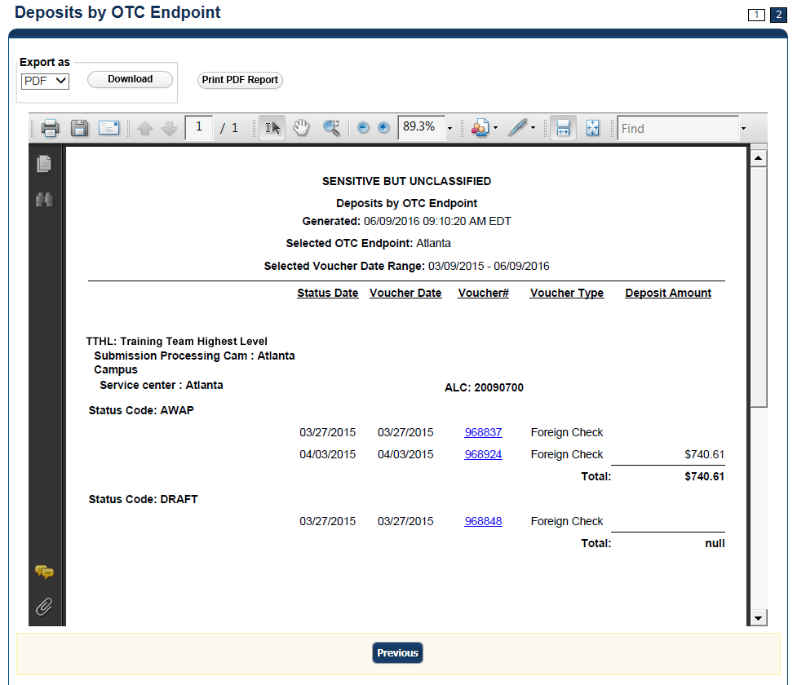
Application Tips

- TGA denotes a deposit processing OTC Endpoint.
- CHK denotes a check capture OTC Endpoint.
- M denotes a mapped accounting code; an open lock denotes access permission; and a closed lock denotes no access permission.
- CDC denotes card processing OTC Endpoint.

- Under Export as, you have the following options:
  - Select PDF, Excel or Word format
  - Select Download
Or
  - Select Print PDF Report
Application Tips

- Deposits with a voucher date older than five years does not display on the report but they may be viewed from the Scheduled Reports page (Home>Reports>Scheduled Reports).
- Unconfirmed Foreign Check items entered with a Country of Deposit value of Other does not display values in the Voucher Amount column.

Additional Button
Select Previous to return to the previous page.

View Business Reports: Deposit History by Status
To view a deposit history by status report, complete the following steps:
- From the Reports tab, select Deposit Processing Reports. The View Reports page appears.
- Under Business Reports, select Deposit History by Status. The Deposit History by Status parameters page appears.
- Enter your search criteria.
  - Select the Organization, required
  - Select the ALC (Agency Location Code)
  - Select the Status, required
  - Enter the From: and To: Status Date range
  - Enter the From: and To: Deposit Total range
  - Select Yes or No for Report With Children
Application Tips

- Select Yes for Report With Children to generate a report that contains data for the selected OTC Endpoint as well as all of the lower-level OTC Endpoints.
- Select No for Report With Children to generate a report that contains data only for the selected OTC Endpoint.

- Select an OTC Endpoint to initiate the report. The Deposit History by Status preview page appears as shown in Figure 26.
Figure 26: Deposit History by Status Preview Page
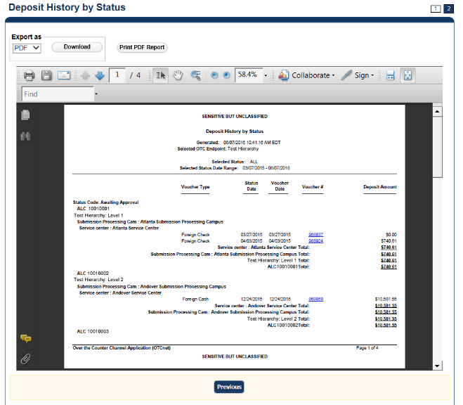
Application Tips

- TGA denotes a deposit processing OTC Endpoint.
- CHK denotes a check capture OTC Endpoint.
- M denotes a mapped accounting code; an open lock denotes access permission; and a closed lock denotes no access permission.
- CDC denotes card processing OTC Endpoint.

- Under Export as, you have the following options:
  - Select PDF, Excel or Word format
  - Select Download
Or
  - Select Print PDF Report
Application Tips

- Deposits with a voucher date older than five years does not display on the report but they may be viewed from the Scheduled Reports page (Home>Reports>Scheduled Reports).
- Unconfirmed Foreign Check items entered with a Country of Deposit value of Other does not display values in the Voucher Amount column.

Additional Button
Select Previous to return to the previous page.

View Business Reports: Non-Reporting OTC Endpoints
To view a non-reporting OTC Endpoint report, complete the following steps:
- From the Reports tab, select Deposit Processing Reports. The View Reports page appears.
- Under Business Reports, select Non-Reporting OTC Endpoints. The Non-Reporting OTC Endpoints parameters page appears.
- Enter your search criteria.
  - Enter the From: and To: Deposit Date range
  - Select Yes or No for Report With Children
Application Tips

- The date range for Deposit Date cannot exceed 15 months.
- Select Yes for Report With Children to generate a report that contains data for the selected OTC Endpoint as well as all of the lower-level OTC Endpoints.
- Select No for Report With Children to generate a report that contains data only for the selected OTC Endpoint.

- Select an OTC Endpoint to initiate the report. The Non-Reporting OTC Endpoints preview page appears as shown in Figure 27.
Figure 27: Non-Reporting OTC Endpoints Preview Page
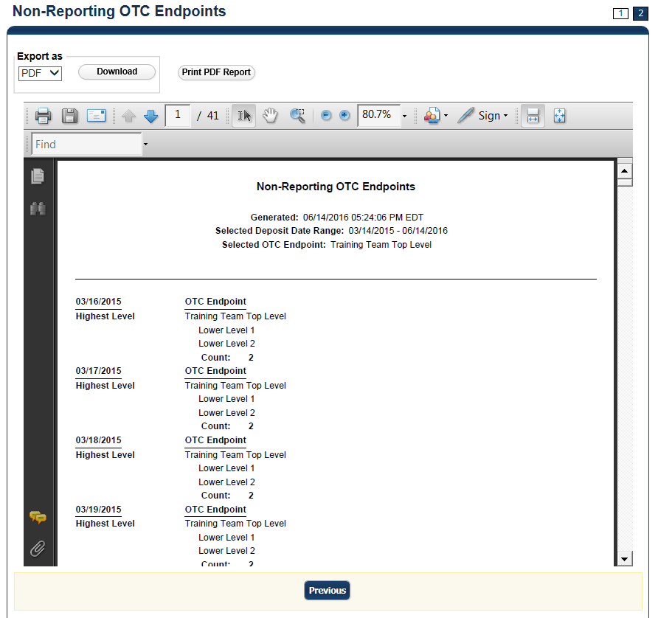
- Under Export as, you have the following options:
  - Select PDF, Excel or Word format
  - Select Download
Or
  - Select Print PDF Report
Application Tips

- TGA denotes a deposit processing OTC Endpoint.
- CHK denotes a check capture OTC Endpoint.
- M denotes a mapped accounting code; an open lock denotes access permission; and a closed lock denotes no access permission.
- CDC denotes card processing OTC Endpoint.

Additional Button
Select Previous to return to the previous page.

Administration Reports
This section provides you with detail on how to view and download Administration Reports.
Administration Reports available for viewing include:

View Vouchers Completed
To view the Vouchers Completed report, you are presented with the option to include search criteria for the following items: Voucher #, Voucher Status, Voucher Type, Financial Institution, Voucher Complete Timestamp, and CL II Trace Number.
The report presents the event log, including Voucher Information, i.e., Voucher #, Voucher Date, Voucher Type, Voucher Status, Voucher Status Timestamp, Deposit Date, CA$HLINK II Trace # and Financial Institution and Voucher Event State, including the date the voucher was created on.
Additionally, the Voucher Event Details report presents the Voucher #, Voucher Date, Voucher Event State, Voucher Event State Timestamp, Voucher Event LoginID, Voucher Type, Voucher Status, Voucher Status Timestamp, Deposit Date, CA$HLINK II Trace #, Financial Institution, and Voucher Event Comments.

View Vouchers in Progress
To view the Vouchers in Progress report, you are presented with the option to include search criteria, i.e., Voucher #, Voucher Status, Voucher Type, and Financial Institution.
The report presents vouchers in progress and includes the Voucher Information: Voucher #, Voucher Date, Voucher Type, Voucher Status, Voucher Status Timestamp, Deposit Date, CA$HLINK II Trace #, and Financial Institution. The Voucher Event Log includes the Voucher Event State and the date the voucher was created on.
Additionally, the Voucher Event Details report presents the Voucher #, Voucher Date, Voucher Event State, Voucher Event State Timestamp, Voucher Event LoginID, Voucher Type, Voucher Status, Voucher Status Timestamp, Deposit Date, CA$HLINK II Trace #, Financial Institution, and Voucher Event Comments.

View Administrative Reports: Vouchers Completed
To view a voucher’s completed report, complete the following steps:
- From the Reports tab, select Deposit Processing Reports. The View Reports page appears.
- Under Administration Reports, select View Vouchers Completed. The View Vouchers Completed page appears.
- Select the Voucher # hyperlink. The Voucher Event Log page appears as shown in
Figure 28.
Figure 28: View Voucher Event Log Page
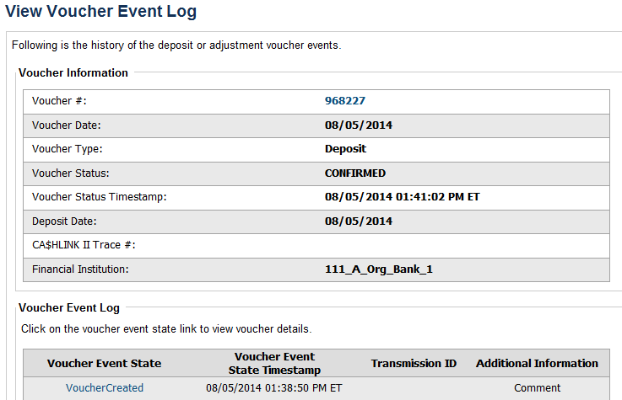
Application Tip

The View Voucher Event shows additional information about the voucher and the history of the voucher events through the FI System to System Interface.

- Select the Voucher # hyperlink to view the details of the deposit or adjustment. The Voucher Details Information page or the View Adjustment Details page appears.
Or

Select a Voucher Event State hyperlink to view the voucher event details. The Voucher Event Details page appears as shown in Figure 29.
Figure 29: Voucher Event Details Report Output
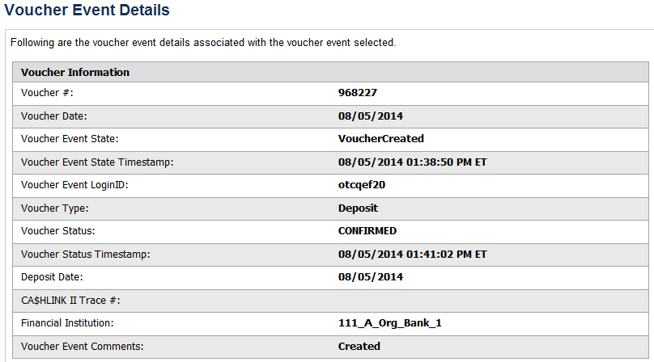
Application Tips

The Voucher Event Details page presents the following:
- Processing errors associated with the voucher event
- Additional information about the voucher and the transmission associated with the voucher events through the FI System To System Interface
- The Collections Information Repository (CIR) interface

Additional Buttons
- Select Cancel to return to the OTCnet Home Page. No data is saved.
- Select Clear to clear all data fields and reset to the default selections.
- Select Previous to return to the previous page.
- Select Refresh to redisplay the page with any additional vouchers that are in-process.
- Select Return Home to return to the previous page.

View Administrative Reports: Vouchers in Progress
To view a voucher in progress report, complete the following steps:
- From the Reports tab, select Deposit Processing Reports. The View Reports page appears.
- Under Administration Reports, select View Vouchers In Progress. The View Vouchers in Progress page appears.
Application Tip

The Vouchers In Progress page only displays non-archived deposits or adjustments with a voucher date that is five years or less from to the current date.

- Select the Voucher # hyperlink to view the Voucher Event Log page and additional voucher information. The View Voucher Event Log page appears as shown in Figure 30.
Figure 30: In Progress View Voucher Event Log Page
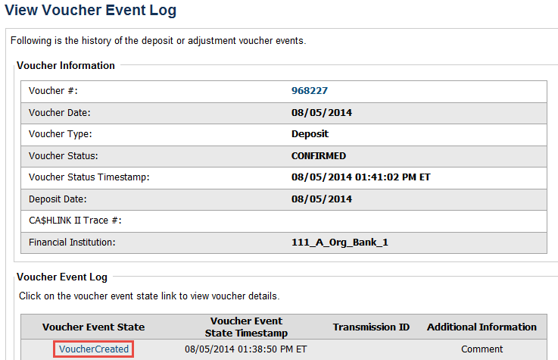
Application Tip

The View Voucher Event presents additional information about the voucher and the history of the voucher events through the FI System To System Interface.

- Select the Voucher # hyperlink to view the details of the deposit or adjustment. The Voucher Details Information page or the View Adjustment Details page appears.
Or
Select a Voucher Event State hyperlink to view the voucher event details. The Voucher Event Details page appears as shown in Figure 31.
Figure 31: In Progress Voucher Event Details Report Output
Application Tip

The Voucher Event Details page presents processing errors associated with the voucher event and additional information about the voucher and the transmission associated with the voucher events through the FI System To System Interface, and the Collections Information Repository (CIR) interface.

Additional Buttons
- Select Cancel to return to the OTCnet Home Page. No data is saved.
- Select Clear to clear all data fields and reset to the default selections.
- Select Previous to return to the previous page.
- Select Refresh to redisplay the page with any additional vouchers that
are in-process.
- Select Return Home to return to the previous page.

Scheduled Reports
This section provides you with detail on how to generate and view previously generated Deposit Processing Scheduled Reports.

Deposit Processing Scheduled Report
Deposit Processing Scheduled reports are used to query and download deposit information with a specified Voucher Date from the archival database. Deposit transactions with a voucher date older than the minimum data retention period, as specified by Fiscal Service, may not be displayed on the report as these transactions are eligible to be deleted. As a result, this deposit information may not be accessible and will be removed from the archival database.
Scheduled reports are generated asynchronously (not occurring at the same time), allowing you to continue to use OTCnet.
Depending on the volume of data requested, it can take between 5 and 20 minutes for the report to generate.
You can search for check records by Organization, OTC Endpoint, Agency Location Code (ALC), Prepared by, Voucher Number, Deposit Status, Agency Use (Block 6), Deposit Type, Voucher Date, Deposit Date, Deposit Total, and Financial Institution Information search criteria.
When the report request is submitted, its status is set to Submitted. After the report is successfully generated, the status is set to Completed and the report is available for download in CSV format.

Deposit Historical Report
To generate a deposit scheduled report, you are presented with the option to include search criteria, i.e., Organization, OTC Endpoint, ALC, Prepared by, Voucher #, Deposit Status, Agency Use (Block 6) details, Deposit Type, Voucher Date (From: and To:), Deposit Date (From: and To:) and Deposit Total (From and To:).
The report presents a scheduled record of deposits and can only be downloaded in CSV format.

Adjustment Historical Report
To generate an adjustment scheduled report, you are presented with the option to include search criteria, i.e., Organization, OTC Endpoint, ALC, Adjustment Category, Voucher #, Adjustment Type, Prepared By, Adjustment Reason, Voucher Date (From: and To:), Adjustment Amount (From and To:), Deposit Date (From: and To:) and Original Deposit Date (From: and To:).
The report presents a scheduled record of adjustments and can only be downloaded in CSV format.
Adjustments associated to deposits with a voucher date older than the minimum data retention period, as specified by Fiscal Service, may not be displayed on the report as these transactions are eligible to be deleted. As a result, this adjusted deposit information may not be accessible and will be removed from the archival database.

Previously Generated Reports
To view previously generated scheduled reports, you are presented with a table of criteria, i.e., Report Type, Submitted Time, Search Criteria Parameters, Status, and Download.
The reports present a scheduled record of deposits or adjustments, the details of which are available above under their respective types. These reports can only be downloaded in CSV format.

View Scheduled Reports: Deposit Historical Report
To generate a Deposit Scheduled Report, complete the following steps:
- From the Reports tab, select Scheduled Reports>Generate Scheduled Reports. The Generate Scheduled Reports page appears.
- Under Deposit Processing Scheduled Reports, select Deposit Historical Report. The Deposit Historical Report page appears as shown in Figure 32.
Figure 32: Deposit Historical Report Criteria Page
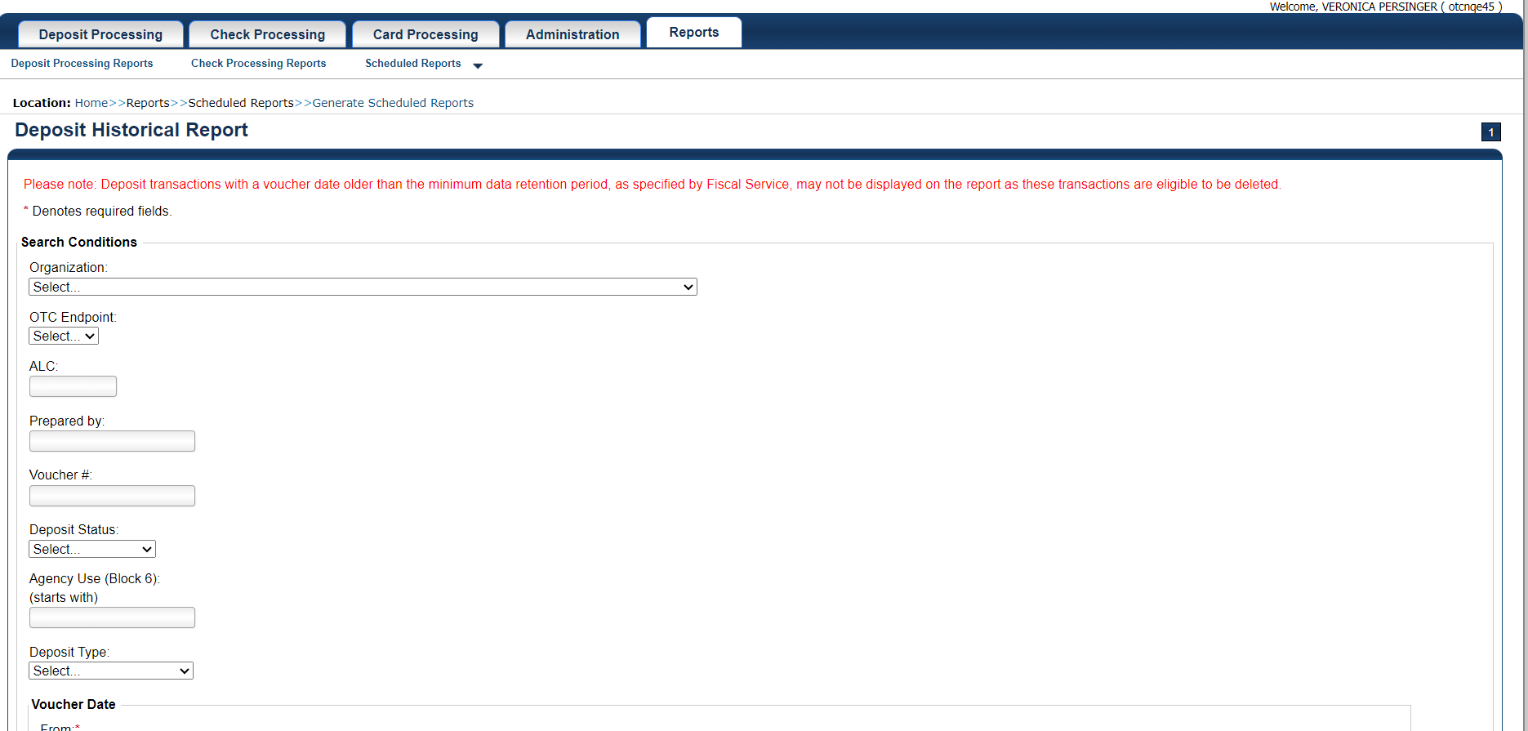
Application Tip

The Deposit Historical Report is generated asynchronously (not occurring at the same time) allowing you to continue using the OTCnet application. The time it takes to generate a report depends on the volume of data queried and therefore varies.

- Enter your search criteria.
Under Search Conditions:
- Select an Organization
- Select an OTC Endpoint
- Enter an ALC
- Enter the Prepared by
- Enter the Voucher #
- Select a Deposit Status
- Enter the Agency Use (Block 6) details
- Select a Deposit Type
- Enter the From and To Voucher Date, required
- Enter the From and To Deposit Date
- Enter the From and To Deposit Total
Application Tips

- The Voucher Date is a required field and the maximum date range for the From and To Voucher Date is one year. The Voucher Date must be entered in MM/DD/YYYY format.
- The From and To Deposit Date must be entered in MM/DD/YYYY format.

Under Financial Institution Information, optional
- Enter the RTN (Routing Transit Number)
- Enter the DDA (Demand Deposit Account)
- Enter the CAN (CA$HLINK II Account Number)
- Enter the FRB Account Key (Federal Reserve Bank Account Key)
- Enter the FRB CCWU (Federal Reserve Bank Cost Center Work Unit)
Application Tips

- The FRB Account Key must be three digits in length. The FRB Account Key field does not display for FI Deposit Confirmers or FI Viewers.
- The FRB CCWU must be four digits in length. If it is less than four digits, enter a zero at the beginning of the CCWU number (e.g. 0123). The FRB Account Key field does not display for FI Deposit Confirmers or FI Viewers.

Under User Defined Field Information, if applicable, optional
- Enter the Deposit UDF (User Defined Field) details
- Enter the Accounting Subtotal UDF details
Application Tip

User Defined Fields (UDFs) only display to users who have access to an organization that has previously defined UDFs. UDFs appear at the bottom of the page. Up to three UDFs can be displayed for Deposit and two for Accounting Subtotal.

- Select Submit Request. A “Your report request has been successfully received” message appears.
Application Tip

Once a request is submitted you cannot submit the same request again for seven days. If a duplicate request is submitted within seven days, the following message displays: “Duplicate Request: You have submitted a report request based on identical report criteria in the last 7 days. Please revise your report criteria or access the previously generated report request.”

Additional Buttons
- Select Cancel to return to the OTCnet Home Page. No data is saved.
- Select Clear to clear all data fields and reset to the default selections.

- Once the request is submitted, navigate to Previously Generated Reports (Reports tab>Scheduled Reports>View Previously Generated Reports) and download the report in CSV format by selecting the CSV icon in the Download column for the report.

View Scheduled Reports: Adjustment Historical Report
To generate an Adjustment Scheduled Report, complete the following steps:
- From the Reports tab, select Scheduled Reports and select Generate Scheduled Reports.
- From the Deposit Processing Historical Reports section of the page, select Adjustment Historical Report. The Adjustment Historical Report page appears as shown in Figure 33.
Figure 33: Adjustment Historical Report Criteria Page
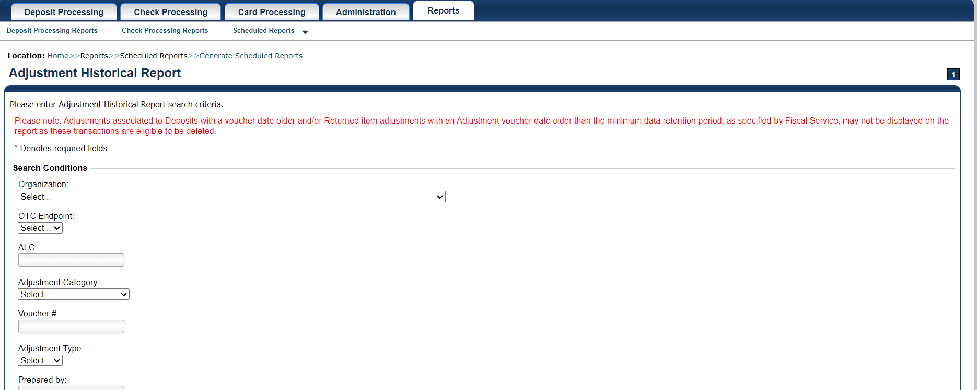
Application Tip

The Adjustment Historical Report is generated asynchronously (not occurring at the same time) allowing you to continue using the OTCnet application. Depending on the volume of data queried it can take between 5 and 20 minutes to generate the report.

- Enter your search criteria.
Under Search Conditions
- Select an Organization
- Select an OTC Endpoint
- Enter an ALC
- Select an Adjustment Category
Application Tips

- Select Deposit Adjustment to include deposit adjustments in the search results. The Deposit Adjustment search can be further limited by the user by selecting either Debit or Credit from the Adjustment Type drop-down list.
- Select Returned Item Adjustment to include only returned item adjustments (US Currency and Foreign Check Item) in the search results. The Returned Item Adjustment search does not have to be further qualified using the Adjustment Type drop-down list since returned item adjustments always have an Adjustment Type of Debit. If the user selects Credit from the Adjustment Type drop-down list after selecting a Returned Item Adjustment, no results appear since Credit returned item adjustments do not exist.
- Select RIA – Foreign Currency to only include returned item adjustments related to Foreign Check Items in the search results.
- Select RIA – US Currency to only include US Currency Returned Item Adjustments in the search results.
- Select no Adjustment Category (e.g., Select...), both deposit and returned item adjustments are included in the search results.
- Select Adjustment Type Debit to include all debit deposit adjustments and returned item adjustments in the search results. Select Credit to include only credit deposit adjustments in the search results.

  - Enter the Voucher #
  - Select an Adjustment Type
  - Enter the Prepared by
  - Select an Adjustment Reason
  - Enter the From and To Voucher Date, required
- Enter the From and To Adjust Amount Date
- Enter the From and To Deposit Date
- Enter the From and To Original Deposit Date
Application Tips

- The Voucher Date is a required field and the maximum date range for the From and To Voucher Date is one year. The Voucher Date must be entered in MM/DD/YYYY format.
- The From and To Deposit Date must be entered in MM/DD/YYYY format.

Under Financial Institution Information, optional
- Enter the RTN (Routing Transit Number)
- Enter the DDA (Demand Deposit Account)
- Enter the CAN (CA$HLINK II Account Number)
- Enter the FRB Account Key (Federal Reserve Bank Account Key)
- Enter the FRB CCWU (Federal Reserve Bank Cost Center Work Unit)
Application Tips

- The FRB Account Key must be three digits in length. The FRB Account Key field does not display for FI Deposit Confirmers or FI Viewers.
- The FRB CCWU must be four digits in length. If it is less than four digits, enter a zero at the beginning of the CCWU number (e.g., 0123). The FRB Account Key field does not display for FI Deposit Confirmers or FI Viewers.

- Select Submit Request. A “Your report request has been successfully received” message appears.
Application Tip

Once a request is submitted you cannot submit the same request again for seven days. If a duplicate request is submitted within seven days, the following message displays: “Duplicate Request: You have submitted a report request based on identical report criteria in the last 7 days. Please revise your report criteria or access the previously generated report request.”

Additional Buttons
- Select Cancel to return to the OTCnet Home Page. No data is saved.
- Select Clear to clear all data fields and reset to the default selections.

- Once the request has been submitted, navigate to Previously Generated Reports (Reports tab>Scheduled Reports>View Previously Generated Reports) and download the report in CSV format by selecting the CSV icon in the Download column for the report.

Summary
In this chapter, you learned:
- The Introduction to OTCnet
- The Overview of OTCnet Participant User Guide Content
- How to request access for yourself in SailPoint IIQ
- How to log on to OTCnet
- How to navigate the OTCnet home page
- The purpose of viewing deposits
- How to view a deposit draft
- How to view a deposit awaiting approval
- How to view a submitted deposit
- How to view a confirmed deposit
- How to view a deposit adjustment
- How to view a rejected deposit details
- How to search for and locate deposits using one or more search criteria
- How to download deposit voucher(s) as an XML or CSV file.
- The purpose of searching adjustments
- How to search and locate adjustments using one or more search criteria
- How to download adjustment voucher(s) as an XML or CSV file
- The purpose of viewing reports
- The various types of reports you can access by role
- The types of reports
- The detail each report provides and how to view and download those reports

