

Chapter 10. Viewing Deposits
OTCnet Participant User Guide

Table of Contents
Overview, Topics, and Audience 1
Overview 1
Topics 1
Audience 1
Topic 1 Viewing Deposits 2
View a Deposit 2
View a Deposit 4
Summary 6

List of Figures
Figure 1. View Deposits Page 4

List of Tables
Table 1. Deposit Status 2

Glossary
Click this link to access the full OTCnet Glossary.

Overview, Topics, and Audience

Overview
Welcome to Viewing Deposits. In this chapter, you will learn:
- The purpose of viewing deposits
- How to view a deposit draft
- How to view a deposit awaiting approval
- How to view a submitted deposit
- How to view a confirmed deposit
- How to view a deposit adjustment
- How to view a rejected deposit detail

Topics
This chapter includes information on viewing deposits.

Audience
The intended audience for the Viewing Deposits Participant User Guide includes:
- Deposit Preparer
- Deposit Approver
- Deposit Confirmer
- Viewer

Topic 1 Viewing Deposits
As a Deposit Preparer, Deposit Approver, Deposit Confirmer, or Viewer, you are authorized to view deposit vouchers. You may view deposits to locate deposits in process or to verify deposit transactions belonging to others in the organization.
Depending on your user role, you may have permission to view only certain deposits. The Deposit Status types are included in Table 1.
Table 1. Deposit Status
Deposit Status | Description
Draft | A deposit that is saved for modification at a later date by a Deposit Preparer
Awaiting Approval | A deposit that is waiting for deposit confirmation by a Deposit Approver
Submitted | A deposit that is submitted and waiting deposit confirmation by a Deposit Confirmer
Confirmed | A deposit that has been reviewed and confirmed by a financial institution (FI) or federal reserve bank (FRB)
Rejected | A deposit that is returned by a Financial Institution or FRB to the Deposit Preparer to create a new deposit

View a Deposit
To view a deposit, select My Deposits in Process, Adjustments in Error, Deposits in Error, or Deposits Within My Organization. Click the voucher number of the deposit you would like to view and change the number of records displayed per page, from the drop-down menu options next to record count.
- My Deposits in Process: Displays deposits that require addition action (e.g. Draft, Awaiting Approval, Submitted, Rejected, and Confirmed) based on user permissions.
If the user only has an FI Viewer or FRB Viewer role and selects this page, it returns no results. If the user is a Deposit Confirmer or FRB Confirmer, the table displays the column indicating the Confirm option to allow for multiple confirmations at the same time. For all other user roles, this column is hidden.
- Adjustments in Error: Displays adjustments that have validation errors awaiting acknowledgement by the financial institution that the error has been resolved.
The Adjustments in Error page displays any CA$HLINK II validation errors that need acknowledgment by the financial institution that the error has been resolved. No results appear if there are not any CA$HLINK II validation errors. To document why the error occurred and how the error was resolved, select the Voucher Number link is selected. This page only returns results for the Deposit Confirmer and FI Viewer roles. Other roles have the ability to select this page from the dropdown but do not see no results. Vouchers displayed in this section are also displayed in the History section of the page with the appropriate deposit status (Confirmed).
- Deposits in Error: Displays deposits that have validation errors awaiting acknowledgement by the financial institution that the error is resolved. With Deposit Confirmer or FI Viewer privileges, the Deposits in Error details appears.
The Deposits in Error page displays any CA$HLINK II validation errors that need acknowledgment by the financial institution that the error has been resolved. No results appear if there are not any CA$HLINK II validation errors. To document why the error occurred and how the error was resolved, select the Voucher Number link is selected. This page only returns results for the Deposit Confirmer and FI Viewer roles. Other roles have the ability to select this page from the dropdown but do not see results. Vouchers displayed in this section are also displayed in the History section of the page with the appropriate deposit status (Confirmed).
- Deposits Within My Organization: Displays a list of deposits that have been entered in the system, based on the agency endpoint or financial institution to which the user has access. With Deposit Confirmer or FI Viewer privileges, the Deposits Within My Organization details appears.
- The Deposits Within My Organization page displays voucher dates in reverse chronological order (including future dated deposits) and the status within (i.e. Draft, Submitted, Rejected, and Confirmed). The number of deposits displayed is based upon the display days processing options defined for the OTC Endpoint that the agency user has permission to view. If the user has permission for more than one OTC Endpoint, the processing option with the greatest number of days is used. If the user is an FI Viewer or an FS Viewer, the number of display days is set at 45.

View a Deposit
To view a deposit, complete the following steps:
- From the Deposit Processing tab, click View Deposits. The View Deposit page appears.
- From the Select Display drop-down menu, select My Deposits in Process, Adjustments in Error, Deposits in Error, or Deposits Within My Organization.
- Click the Voucher Number of the deposit you need to view as shown in Figure 1.
Figure 1. View Deposits Page
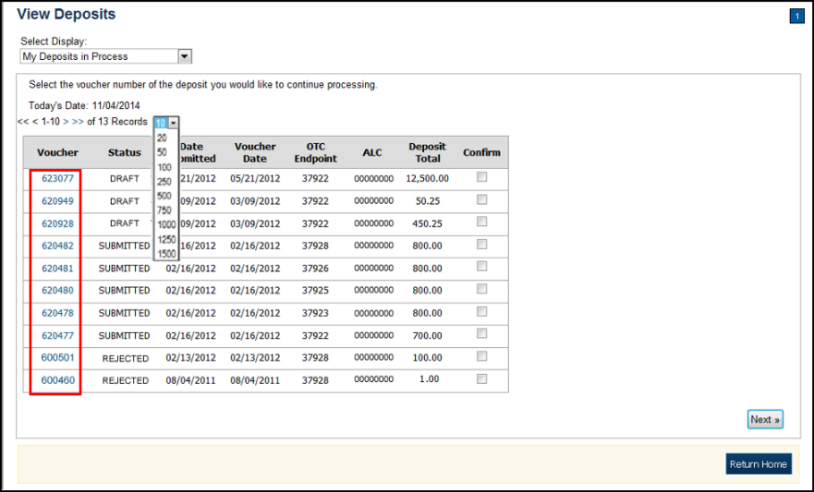
Application Tips

- By default, up to 10 records are displayed per page. To change the number of records displayed per page, select from the drop-down menu options next to the record count.
- When your Financial Institution makes an adjustment to a deposit, it appears in the Adj. column of the Deposit Transactions section of the table.
- To view additional details, click the appropriate Voucher Number.
- The View Confirmed Deposit page appears. Under Adjustment Information, click the Voucher Number to view the deposit adjustment details.


Additional Buttons
- Click Cancel to return to the OTCnet Home Page. No data
is saved.
- Click Confirm to confirm a deposit (Visible if a user has
Deposit Confirmer privileges).
- Click Clear to clear all data fields and reset to the default selections.
- Click Delete to eliminate the deposit. (Visible if a user has Deposit
- Preparer privileges.)
- Click Print Deposit Ticket to print a formatted deposit ticket.
- Click View Voucher Event Log to view the history of the
deposit voucher.
- Click Voucher Event State to view voucher details.
- Click Next to advance to the next page. (Visible only in My Deposits in Process view).
- Click Previous to return to the previous page.
- Click Return Home to return to the OTCnet Home Page.
- Click Reject to reject a deposit (Visible if a user has Deposit Confirmer privileges.)
- Click Adjust to adjust a deposit (Visible if a user has Deposit Confirmer privileges.)
- Click Save as Draft to save the information without submitting the deposit. (Visible if a user has Deposit Preparer privileges.)
- Click Submit to complete the process and display the Confirmation
page. (Visible if a user has Deposit Approver privileges.)
- Click Update CAN/ACCT Key to update the account number assigned to a deposit. (Visible if a user has Deposit Confirmer privileges.)
- Click Add Adjustment to adjust a deposit. (Not visible for Foreign Check Items.)

Summary
In this chapter, you learned:
- The purpose of viewing deposits
- How to view a deposit draft
- How to view a deposit awaiting approval
- How to view a submitted deposit
- How to view a confirmed deposit
- How to view a deposit adjustment
- How to view a rejected deposit detail

