

Chapter 9. Viewing Reports
OTCnet Participant User Guide

Table of Contents
Overview, Topics, and Audience 1
Overview 1
Topics 1
Audience 1
Topic 1 Viewing Reports 2
Topic 2 Reports by User Role 3
Topic 3 Types of Reports 6
Business Reports 6
Security Reports 8
Administration Reports 10
Scheduled Reports 11
Topic 4 Viewing Reports 12
Business Reports 12
Security Reports 33
Administration Reports 44
Scheduled Reports 53
Topic 5 Viewing a Financial Institution 63
View a Financial Institution 63
View a Financial Institution 64
Summary 66

List of Figures
Figure 1: Adjustments Activity (FI) Preview Page 15
Figure 2: Adjustments by OTC Endpoint Parameters Page 17
Figure 3: Daily Voucher Report Page 19
Figure 4: Deposit Activity (FI) Preview Page 21
Figure 5: Deposits by Accounting Code Report Preview Page 23
Figure 6: Deposits by OTC Endpoint Report Preview Page 25
Figure 7: Deposit History by Status Preview Page 27
Figure 8: Non-Reporting OTC Endpoints Preview Page 29
Figure 9: Processing Options by OTC Endpoints Report Output Preview Page 32
Figure 10: Users by Access Group (FI) Report Preview Page 34
Figure 11: Users by Access Group (FPA) Preview Page 36
Figure 12: User Information Preview Page 38
Figure 13: Users by Role (FI) Preview Page 41
Figure 14: Users by Role (FPA) Preview Page 42
Figure 15: View CIR File and Schedule Report 46
Figure 16: Adjustment-Voucher Detail PDF 48
Figure 17: View Voucher Event Log Page 49
Figure 18: Voucher Event Details Report Output 50
Figure 19: In Progress View Voucher Event Log Page 51
Figure 20: In Progress Voucher Event Details Report Output 52
Figure 21: Deposit Historical Report Criteria Page 55
Figure 22: Adjustment Historical Report Criteria Page 58
Figure 23: View Previously Generated Reports 61
Figure 24: View FRB Detail 64
Figure 25: View Financial Institution Detail 64

List of Tables
Table 1: Types of Reports and Purpose 2
Table 2: Business Reports by Federal Program Agency User Roles 3
Table 3: Business Reports by Financial Institution/Federal Reserve Bank as Financial Institution User Roles 3
Table 4: Security Reports by Federal Program Agency User Roles 4
Table 5: Security Reports by Financial Institution/Federal Reserve Bank as Financial Institution User Roles 4
Table 6: Administration Reports by Federal Program Agency User Roles 4
Table 7: Administration Reports by Financial Institution/Federal Reserve Bank as Financial Institution User Roles 5
Table 8: Scheduled Reports by Federal Program Agency User Roles 5
Table 9: Scheduled Reports by Financial Institution/Federal Reserve Bank as Financial Institution User Roles 5
Table 10: Business Reports by User Role 6
Table 11: Security Reports by Federal Program Agency User Roles 6
Table 12: Security Reports by Financial Institution/Federal Reserve Bank as Financial Institution User Roles 7
Table 13: Administration Reports by Federal Program Agency User Roles 7
Table 14: Business Reports 7
Table 15: Security Reports by User Role 8
Table 16: Administration Reports by Financial Institution/Federal Reserve Bank as Financial Institution User Roles 8
Table 17: Security Reports 9
Table 18: Administration Reports 10
Table 19: Deposit Processing Historical Report 11

Glossary
Select this link to access the full OTCnet Glossary.

Overview, Topics, and Audience

Overview
Welcome to Viewing Reports. In this chapter, you will learn:
- The purpose of viewing reports
- The various types of reports you can access by role
- The types of Business, Security, Administration and Scheduled reports
- The detail each report provides and how to view and download the reports

Topics
This chapter is organized by the following topics:
- Viewing Reports
- Reports by User Role
- Types of Reports
- Viewing Reports
- Viewing a Financial Institution

Audience
The intended audience for the Viewing Reports Participant User Guide includes:
- All Deposit Processing Users (viewing various reports depends on your level of access)

Topic 1 Viewing Reports
As a user or viewer with access to the Deposit Processing functionality, you may access one or more of the Business Reports, Security Reports, Administration Reports or Scheduled Reports. You may need to view or download a report for e.g., adjustment activity, user information or voucher status. Each report provides deposit information specific to the select type of data requested. Table 1 below describes the purpose of each report type.
Table 1: Types of Reports and Purpose
Report | Purpose of Report
Business | Provides specific reporting detail for deposit and adjustment activity by type, status and processing options for Agencies and Financial Institutions
Security | Provides specific reporting detail for access groups and users for Agencies and Financial Institutions
Administration | Provides specific reporting detail for interface to CIR,* as well as detailed information about completed and in progress vouchers
*The Collections Information Repository (CIR) was formerly referred to as the Transaction Reporting System (TRS).

Topic 2 Reports by User Role
Access to view reports in OTCnet is dependent of your user role. Table 2 presents the OTCnet user roles with access to each OTCnet report. Reports are grouped into the following categories:
- Business Reports
- Security Reports
- Administration Reports
- Scheduled Reports
Table 2: Business Reports by Federal Program Agency User Roles
Business Reports | Deposit Preparer | Deposit Approver | Accounting Specialist | Local Accounting Specialist | FPA Viewer | Agency LSA | Agency PLSA
Adjustment Activity (FI) | blank | blank | blank | blank | blank | blank | blank
Adjustments By OTC Endpoint | • | • | blank | blank | • | blank | blank
Daily Voucher Report | blank | blank | • | • | blank | blank | blank
Deposit Activity (FI) | blank | blank | blank | blank | blank | blank | blank
Deposits By Accounting Code | • | • | blank | blank | • | blank | blank
Deposits By OTC Endpoint | • | • | blank | blank | • | blank | blank
Deposit History By Status (FPA) | • | • | blank | blank | • | blank | blank
Non-Reporting OTC Endpoint | • | • | • | • | • | blank | blank
Processing Options by Agency EP | blank | blank | • | • | blank | blank | blank
Table 3: Business Reports by Financial Institution/Federal Reserve Bank as Financial Institution User Roles
Business Reports | FI  Confirmer | FRB  Confirmer | FI  Viewer | FRB  Viewer | LSA | PLSA
Adjustment Activity (FI) | • | blank | • | blank | blank | blank
Adjustments By OTC Endpoint | blank | blank | blank | blank | blank | blank
Daily Voucher Report | blank | blank | blank | blank | blank | blank
Deposit Activity (FI) | • | blank | • | blank | blank | blank
Deposits By Accounting Code | blank | blank | blank | blank | blank | blank
Deposits By OTC Endpoint | blank | blank | blank | blank | blank | blank
Deposit History By Status (FPA) | blank | blank | blank | blank | blank | blank
Non-Reporting OTC Endpoint | blank | blank | blank | blank | blank | blank
Processing Options by Agency EP | blank | blank | blank | blank | blank | blank

Table 4: Security Reports by Federal Program Agency User Roles
Security Reports | Deposit Preparer | Deposit Approver | Accounting Specialist | Local Accounting Specialist | FPA Viewer | Agency LSA | Agency PLSA
Primary Access Groups without a PLSA | blank | blank | blank | blank | blank | blank | blank
Users by Access Group (FI) | blank | blank | blank | blank | blank | blank | blank
Users by Access Group (FPA) | blank | blank | blank | blank | blank | • | •
Users by Role (FI) | blank | blank | blank | blank | blank | blank | blank
Users by Role (FPA) | blank | blank | blank | blank | blank | • | •
User Information | blank | blank | blank | blank | blank | • | •
Table 5: Security Reports by Financial Institution/Federal Reserve Bank as Financial Institution User Roles
Security Reports | FI  Confirmer | FRB  Confirmer | FI  Viewer | FRB  Viewer | LSA | PLSA
Primary Access Groups without a PLSA | blank | blank | blank | blank | blank | blank
Users by Access Group (FI) | blank | blank | blank | blank | • | •
Users by Access Group (FPA) | blank | blank | blank | blank | blank | blank
Users by Role (FI) | blank | blank | blank | blank | • | •
Users by Role (FPA) | blank | blank | blank | blank | blank | blank
User Information | blank | blank | blank | blank | • | •
Table 6: Administration Reports by Federal Program Agency User Roles
Admin. Reports/ Misc. | Deposit  Preparer | Deposit Approver | Accounting Specialist | Local Accounting Specialist | FPA Viewer | Agency LSA | Agency PLSA
View CIR File Status* | blank | blank | blank | blank | blank | blank | blank
View Vouchers Complete | • | • | blank | blank | • | blank | blank
View Voucher Event Log | • | • | blank | blank | • | blank | blank
View Voucher Event Detail | • | • | blank | blank | • | blank | blank
View Vouchers In Progress | • | • | blank | blank | • | blank | blank
View Voucher Event Log | • | • | blank | blank | • | blank | blank
View Voucher Event Detail | • | • | blank | blank | • | blank | blank
Change Current State | blank | blank | blank | blank | blank | blank | blank
Acknowledge Error Resolution | blank | blank | blank | blank | blank | blank | blank
* The Collections Information Repository (CIR) was formerly referred to as the Transaction Reporting System (TRS).

Table 7: Administration Reports by Financial Institution/Federal Reserve Bank as Financial Institution User Roles
Admin. Reports/ Misc. | FI  Confirmer | FRB  Confirmer | FI  Viewer | FRB  Viewer | LSA | PLSA
View CIR File Status | • | • | • | • | blank
View Vouchers Complete | • | • | • | • | blank
View Voucher Event Log | • | • | • | • | blank
View Voucher Event Detail | • | • | • | • | blank
View Vouchers In Progress | • | • | • | • | blank
View Voucher Event Log | • | • | • | • | blank
View Voucher Event Detail | • | • | • | • | blank
Change Current State | blank | blank | blank | blank | blank
Acknowledge Error Resolution | • | • | blank | blank | blank
Table 8: Scheduled Reports by Federal Program Agency User Roles
Scheduled Reports | Deposit Preparer | Deposit Approver | Accounting Specialist | Local Accounting Specialist | FPA Viewer | Agency LSA | Agency PLSA
Deposit Historical Report | • | • | blank | blank | • | blank | blank
Adjustment Historical Report | • | • | blank | blank | • | blank | blank
Table 9: Scheduled Reports by Financial Institution/Federal Reserve Bank as Financial Institution User Roles
Scheduled Reports | FI Confirmer | FRB Confirmer | FI Viewer | FRB Viewer | LSA | PLSA
Deposit Historical Report | • | • | • | • | blank | blank
Adjustment Historical Report | • | • | • | • | blank | blank

Topic 3 Types of Reports
There are four primary report categories within OTCnet:
- Business Reports
- Security Reports
- Administration Reports
- Scheduled Reports

Business Reports
If you are a Deposit Preparer, Deposit Approver, Accounting Specialist, Local Accounting Specialist, Federal Program Agency (FPA) Viewer, Financial Institution (FI) Confirmer, Federal Reserve Bank (FRB) Confirmer, FI Viewer, or FRB Viewer, you may access to one or more of the reports listed below.
Table 10: Business Reports by User Role
Business Reports | FI  Confirmer | FRB  Confirmer | FI  Viewer | FRB  Viewer | LSA | PLSA
Adjustment Activity (FI) | • | blank | • | blank | blank | blank
Adjustments By OTC Endpoint | blank | blank | blank | blank | blank | blank
Daily Voucher Report | blank | blank | blank | blank | blank | blank
Deposit Activity (FI) | • | blank | • | blank | blank | blank
Deposits By Accounting Code | blank | blank | blank | blank | blank | blank
Deposits By OTC Endpoint | blank | blank | blank | blank | blank | blank
Deposit History By Status (FPA) | blank | blank | blank | blank | blank | blank
Non-Reporting OTC Endpoint | blank | blank | blank | blank | blank | blank
Processing Options by Agency EP | blank | blank | blank | blank | blank | blank
Table 11: Security Reports by Federal Program Agency User Roles
Security Reports | Deposit Preparer | Deposit Approver | Accounting Specialist | Local Accounting Specialist | FPA Viewer | Agency LSA | Agency PLSA
Primary Access Groups without a PLSA | blank | blank | blank | blank | blank | blank | blank
Users by Access Group (FI) | blank | blank | blank | blank | blank | blank | blank
Users by Access Group (FPA) | blank | blank | blank | blank | blank | • | •
Users by Role (FI) | blank | blank | blank | blank | blank | blank | blank
Users by Role (FPA) | blank | blank | blank | blank | blank | • | •
User Information | blank | blank | blank | blank | blank | • | •

Table 12: Security Reports by Financial Institution/Federal Reserve Bank as Financial Institution User Roles
Security Reports | Deposit Preparer | Deposit Approver | Accounting Specialist | Local Accounting Specialist | FPA Viewer | Agency LSA | Agency PLSA
Primary Access Groups without a PLSA | blank | blank | blank | blank | blank | blank | blank
Users by Access Group (FI) |  |  |  |  |  | • | •
Users by Access Group (FPA)
Users by Role (FI) |  |  |  |  |  | • | •
Users by Role (FPA)
User Information |  |  |  |  |  | • | •
Table 13: Administration Reports by Federal Program Agency User Roles
Admin. Reports/ Misc. | Deposit Preparer | Deposit Approver | Accounting Specialist | Local Accounting Specialist | FPA Viewer | Agency LSA | Agency PLSA
View CIR File Status | blank | blank | blank | blank | blank | blank | blank
View Vouchers Complete | • | • | blank | blank | • | blank | blank
View Voucher Event Log | • | • | blank | blank | • | blank | blank
View Voucher Event Detail | • | • | blank | blank | • | blank | blank
View Vouchers In Progress | • | • | blank | blank | • | blank | blank
View Voucher Event Log | • | • | blank | blank | • | blank | blank
View Voucher Event Detail | • | • | blank | blank | • | blank | blank
Change Current State | blank | blank | blank | blank | blank | blank | blank
Acknowledge Error Resolution | blank | blank | blank | blank | blank | blank | blank
Table 14: Business Reports
Business Report | Purpose of Business Report
Adjustment Activity (FI) | Allows you to view adjustments made by your Financial Institution (FI)
Adjustments by OTC Endpoints | Allows you to view adjustments made by your Agency Location Code (ALC)
Daily Voucher Report | Allows you to view the daily voucher extract
Deposit Activity (FI) | Allows you to view deposits submitted to your FI
Deposits by Accounting Code | Allows you to view deposits by accounting code
Deposits by OTC Endpoint | Allows you to view deposits by OTC Endpoint.
Deposit History by Status | Allows you to view deposits by status
Non-Reporting OTC Endpoints | Allows you to view OTC Endpoints that have not reported a deposit.
Processing Options by OTC Endpoints | Allows you to view processing options defined for endpoints within the organization.

Security Reports
If you are an Agency Primary Security Administrator (PLSA), Agency Local Security Administrator (LSA), FI/FRB PLSA or FI/FRB LSA, you may access one or more of the reports listed below.
Table 15: Security Reports by User Role
Admin. Reports/ Misc. | Deposit Preparer | Deposit Approver | Accounting Specialist | Local Accounting Specialist | FPA Viewer | Agency LSA | Agency PLSA
View CIR File Status | blank | blank | blank | blank | blank | blank | blank
View Vouchers Complete | • | • | blank | blank | • | blank | blank
View Voucher Event Log | • | • | blank | blank | • | blank | blank
View Voucher Event Detail | • | • | blank | blank | • | blank | blank
View Vouchers In Progress | • | • | blank | blank | • | blank | blank
View Voucher Event Log | • | • | blank | blank | • | blank | blank
View Voucher Event Detail | • | • | blank | blank | • | blank | blank
Change Current State | blank | blank | blank | blank | blank | blank | blank
Acknowledge Error Resolution | blank | blank | blank | blank | blank | blank | blank
Table 16: Administration Reports by Financial Institution/Federal Reserve Bank as Financial Institution User Roles
Admin. Reports/ Misc. | FI Confirmer | FRB Confirmer | FI  Viewer | FRB  Viewer | LSA | PLSA
View CIR File Status | • | • | • | • | blank | blank
View Vouchers Complete | • | • | • | • | blank | blank
View Voucher Event Log | • | • | • | • | blank | blank
View Voucher Event Detail | • | • | • | • | blank | blank
View Vouchers In Progress | • | • | • | • | blank | blank
View Voucher Event Log | • | • | • | • | blank | blank
View Voucher Event Detail | • | • | • | • | blank | blank
Change Current State | blank | blank | blank | blank | blank | blank
Acknowledge Error Resolution | • | • | blank | blank | blank | blank
To obtain specific details for the reports that each role may view or download, refer to the table above.

Table 17: Security Reports
Security Report | Purpose of Security Report
Users by Access Group (FI) | Allows you to view users by Financial Institution.
Users by Access Group (FPA) | Allows you to view users by OTC Endpoint.
User Information | Allows that you to view a user’s contact information.
Users by Role (FI) | Allows you to view users by role for your Financial Institution.
Users by Role (FPA) | Allows you to view users by role for your OTC Endpoint.

Administration Reports
If you are a Deposit Preparer, Deposit Approver, FPA Viewer, FI Confirmer, FRB Confirmer, FI Viewer, or FRB Viewer, you may access one or more of the reports listed in Table 18: Administration Reports.
To obtain specific details for the reports each role may view or download, refer to Table 18.
Table 18: Administration Reports
Administration Report | Purpose of Administration Report
View CIR File Status | The status of CIR files that have been processed by Collections Information Repository (CIR) or are ready for CIR to process.
View Vouchers Completed | Allows you to view the status of deposit and adjustment vouchers that have completed processed through the FI System To System Interface in the past 36 hours.
View Vouchers in Progress | Allows you to view the status of deposit and adjustment vouchers in progress.

Scheduled Reports
As a Financial Institution Viewer, you have access to the reports listed in Table 14.
Table 19: Deposit Processing Historical Report
Deposit Processing Historical Report | Purpose of Report
Deposit Historical Report | Allows you to view scheduled deposit transaction data.
Adjustment Historical Report | Allows you to view scheduled deposit adjustment and returned item adjustment transaction data.

Topic 4 Viewing Reports

Business Reports
This section provides you with details on how to view and download Business Reports.

Adjustment Activity (FI)
To view adjustments by financial institution activity, you are presented with the option to include search criteria, i.e., Adjustment Type, Adjustment Reason, Voucher Date (From: and To:), Original Date of Deposit (From: and To:), Agency Location Code (ALC), Routing Transit Number (RTN), Demand Deposit Account (DDA), Adjustment Amount, Deposit Date, CA$HLINK II Account Number (CAN), CASHLINK II Trace# and Report With Children.
The report presents adjustment activity by Financial Institution, including the Voucher #, Adjustment Type, Voucher Date, ALC, Deposit Date, Create Date, CAN, CL II Trace #, Original Deposit # and Voucher Amount. You can export the report as a PDF, Excel or Word file, download it or print it.

Adjustments by OTC Endpoint
To view adjustments by OTC Endpoint, you are presented with the option to include search criteria, i.e., Organization, Adjustment Type, ALC, Adjustment Date (From: and To:), Deposit Date (From: and To:), Adjustment Amount (From: and To:), and Report With Children.
The report presents adjustment activity by OTC Endpoint, including the Financial Institution, Adjust Date, Deposit Date, Voucher Date, Voucher #, Adjustment Amount, and Adjustment Type by credit or debit. It also presents the ALC# You can export the report as a PDF, Excel or Word file, download it or print it.

Daily Voucher Report
To view a daily voucher report, you are presented with the option to include search criteria, e.g., the OTC Endpoint, Date Type (Confirmed by Financial Institution or Date of Deposit and a date range). The report presents a list of all vouchers on the selected date and can only be downloaded as a .txt file.

Deposit Activity (FI)
To view deposit activity for a financial institution, you are presented with the option to include search criteria, i.e., the Status, Voucher Type, Status Date (From: and To:), Voucher Date (From: and To:), ALC, RTN, DDA, Deposit Total (From: and To:), Deposit Date (From: and To:), CAN, CA$HLINK II Trace #, and Report with Children.
The report presents deposit activity by Financial Institution, including the Status, Voucher Type, Voucher #, Voucher Date, ALC, Deposit Date, Status Date, CAN, CL II Trace #, and Voucher Amount. You can export the report as a PDF, Excel or Word file, download it or print it.

Deposits by Accounting Code
To view deposits by accounting code, you are presented with the option to include search criteria, i.e., the Organization, ALC, Accounting Code, Voucher Date (From: and To:), Deposit Total (From: and To:), and Report with Children.
The report presents deposits by Accounting Code, including the OTC Endpoint, Voucher #, Deposit Date, and Accounting Code Amount. You can export the report as a PDF, Excel or Word file, download it or print it.

Deposits by OTC Endpoint
To view deposits by OTC Endpoint, you are presented with the option to include search criteria, i.e., Organization, ALC, Voucher Date (From: and To:), Deposit Total (From: and To:) and Report With Children.
The report presents deposits by OTC Endpoint, including the Status Date, Voucher Date, Voucher #, Voucher Type, Deposit Amount, and Status Code (Awaiting Approval [AWAP] or DRAFT). You can export the report as a PDF, Excel or Word file, download it or print it.

Deposit History by Status
To view deposit history by status, you are presented with the option to include search criteria, i.e., Organization, ALC, Status, Status Date (From: and To:), Deposit Total (From: and To:), and Report With Children.
The report presents deposit history by status, including the Voucher Type, Status Date, Voucher Date, Voucher #, and Deposit Amount. It also includes the Status Code: Awaiting Approval and ALC#. You can export the report as a PDF, Excel or Word file, download it or print it.

Non-Reporting OTC Endpoints
To view non-reporting OTC endpoints, you are presented with the option to include search criteria, i.e., the Deposit Date (From: and To:) and Report with Children.
The report presents Non-Reporting OTC Endpoints, including the Date of Creation (Highest Level) and OTC Endpoint (Training Team Top Level and Lower Levels). You can export the report as a PDF, Excel or Word file, download it or print it.

Processing Options by OTC Endpoints
To view processing options by OTC endpoints, you are presented with the option to include search criteria, i.e., the Processing Option and Report With Children.
The report presents Processing Options, including the Accounting Code Classification for Adjustments, Inherit from Parent, DR Account Code, TAS, CR Account Code, TAS, and Descendants can Modify. You can export the report as a PDF, Excel or Word file, download it or print it.

View Business Reports: Adjustment Activity (FI)
To view the adjustment activity (FI) report, complete the following steps:
- From the Reports tab, select Deposit Processing Reports. The View Reports page appears.
- Under Business Reports, select Adjustment Activity (FI). The Adjustment Activity (FI) parameters page appears.
- Enter your search criteria.
  - Select the Adjustment Type, required
  - Select the Adjustment Reason
  - Enter the From: and To: Voucher Date range
  - Enter the From: and To: Original Date of Deposit range
  - Enter the ALC (Agency Location Code)
  - Enter the RTN (Routing Transit Number)
  - Enter the DDA (Demand Deposit Account)
  - Enter the From: and To: Adjustment Amount range
  - Enter the From: and To: Deposit Date range
  - Enter the CAN (CA$HLINK II Account Number)
  - Enter the CA$HLINK II Trace #
Application Tip

- The date range for Voucher Date, Original Date of Deposit, and Deposit Date cannot exceed 15 months.

  - Select Yes or No for Report With Children.
Application Tips

- Select Yes to generate a report that contains data for the selected OTC Endpoint and the lower-level OTC Endpoints.
- Select No to generate a report that contains data only for the selected OTC Endpoint.

- Select an OTC Endpoint to initiate the report. The Adjustment Activity (FI) preview page appears as shown in Figure 1.
Figure 1: Adjustments Activity (FI) Preview Page
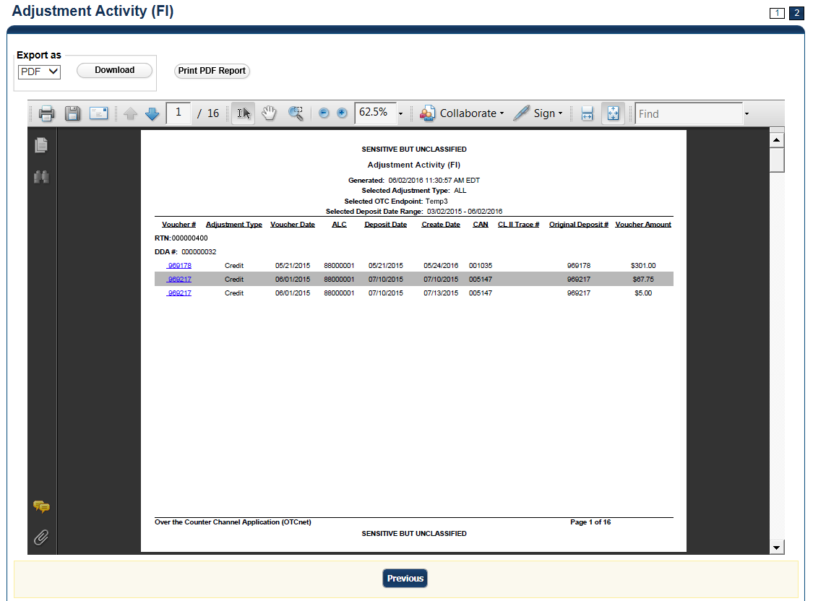
Application Tips

- TGA denotes a deposit processing OTC Endpoint.
- CHK denotes a check capture OTC Endpoint.
- M denotes a mapped accounting code; an open lock denotes access permission; and a closed lock denotes no access permission.
- CDC denotes card processing OTC Endpoint.

- Under Export as, you have the following options:
  - Select PDF, Excel or Word format
  - Select Download
Or
  - Select Print PDF Report
Application Tip

All Adjustments associated with Deposits with an original voucher date older than 5 years and Returned Item Adjustments with an adjustment voucher date older than 5 years are archived to the archive database, according to the Fiscal Service data retention policy. These transactions are viewable through the Scheduled Reports page (Home>Reports>Scheduled Reports).


Additional Button
Select Previous to return to the previous page.

View Business Reports: Adjustments by OTC Endpoint
To view adjustments by OTC Endpoint report, complete the following steps:
- From the Reports tab, select Deposit Processing Reports. The View Reports page appears.
- Under Business Reports, select Adjustments by OTC Endpoint. The Adjustments by OTC Endpoint parameters page appears.
- Enter your search criteria.
  - Select the Organization, required
  - Select the Adjustment Type, required
  - Select the ALC (Agency Location Code)
  - Enter the From: and To: Adjustment Date range
  - Enter the From: and To: Deposit Date range
  - Enter the From: and To: Adjustment Amount range
  - Select Yes or No for Report With Children
Application Tips

- The date range for Adjustment Date and Deposit Date cannot exceed 15 months.
- Select Yes For Report with Children to generate a report that contains data for the selected OTC Endpoint and all lower-level OTC Endpoints.
- Select No For Report with Children to generate a report that contains data only for the selected OTC Endpoint.

- Select an OTC Endpoint to initiate the report. The Adjustments by OTC Endpoint preview appears as shown in Figure 23.
Figure 2: Adjustments by OTC Endpoint Parameters Page
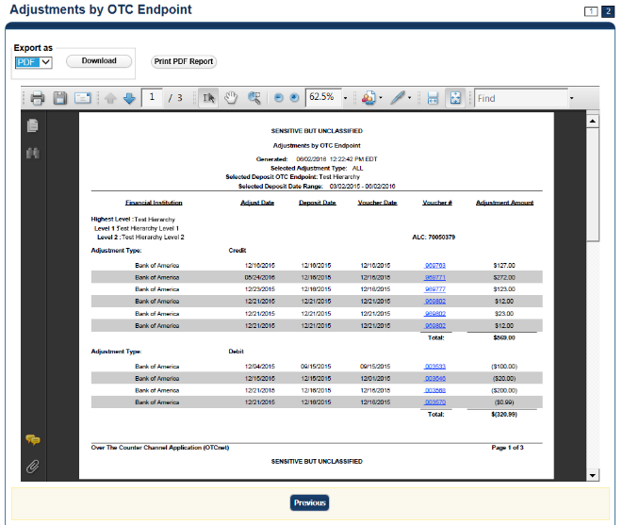
Application Tips

- TGA denotes a deposit processing OTC Endpoint.
- CHK denotes a check capture OTC Endpoint.
- M denotes a mapped accounting code; an open lock denotes access permission; and a closed lock denotes no access permission.
- CDC denotes card processing OTC Endpoint.

- Under Export as, you have the following options:
  - Select PDF, Excel or Word format
  - Select Download
    - Or
  - Select Print PDF Report
Application Tip

All Adjustments associated with Deposits with an original voucher date older than 5 years and Returned Item Adjustments with an adjustment voucher date older than 5 years have been archived to the archive database, according to the Fiscal Service data retention policy. These transactions are viewable through the Scheduled Reports page (Home>Reports>Scheduled Reports).

Additional Button
Select Previous to return to the previous page.

View Business Reports: Daily Voucher Report
To view a daily voucher report, complete the following steps:
- From the Reports tab, select Deposit Processing Reports. The View Reports page appears.
- Under Business Reports, select Daily Voucher Report. The Daily Voucher Report page appears as shown in Figure 2.
Figure 3: Daily Voucher Report Page
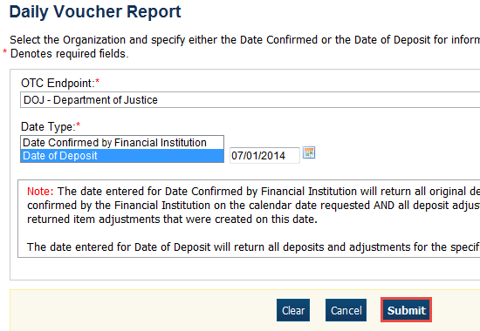
- Enter your search criteria.
  - Select the OTC Endpoint, required
  - Select the Date Confirmed by Financial Institution or Date of Deposit, required
  - Enter the date range for the date the deposit was confirmed by FI or Date of Deposit
- Select Submit. The File Download dialog box appears.
- Select Open, Save, or Cancel.
Additional Buttons
- Select Open—the content of the file displays.
- Select Save—choose the location where you want to save the file.
- Select Cancel—the content does not display.

View Business Reports: Deposit Activity (FI)
To view a deposit activity (FI) report, complete the following steps:
- From the Reports tab, select Deposit Processing Reports. The View Reports page appears.
- Under Business Reports, select Deposit Activity (FI). The Deposit Activity (FI) parameters page appears.
- Enter your search criteria.
  - Select the Status, required
  - Select the Voucher Type
  - Enter the From: and To: Status Date range
  - Enter the From: and To: Voucher Date range
  - Enter the ALC (Agency Location Code)
  - Enter the RTN (Routing Transit Number)
  - Enter the DDA (Demand Deposit Account)
  - Enter the From: and To: Deposit Total range
  - Enter the From: and To: Deposit Date range
  - Enter the CAN (CA$HLINK II Account Number)
  - Enter the CA$HLINK II Trace #
  - Select Yes or No for Report With Children
Application Tips

- Select Yes for Report With Children to generate a report that contains data for the selected OTC Endpoint and all lower-level OTC Endpoints.
- Select No for Report With Children to generate a report that contains data only for the selected OTC Endpoint.

- Select an OTC Endpoint to initiate the report. The Deposit Activity (FI) preview page appears as shown in Figure 3.
Figure 4: Deposit Activity (FI) Preview Page
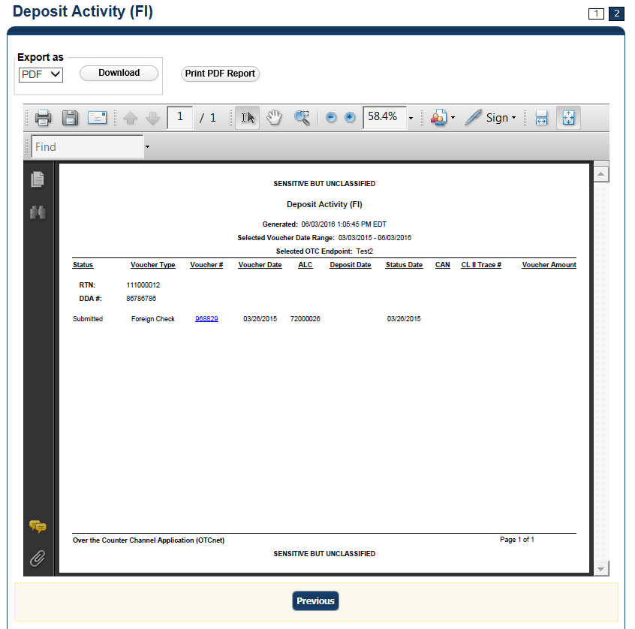
Application Tip

TGA denotes an OTC Endpoint; an open lock denotes access permission; and a closed lock denotes no access permission.

- Under Export as, you have the following options:
  - Select PDF, Excel or Word format
  - Select Download
  - Or
  - Select Print PDF Report
Application Tips

- Deposits with a voucher date older than five years does not display on the report but they may be viewed from the Scheduled Reports page (Home>Reports>Scheduled Reports).
- Unconfirmed Foreign Check items entered with a Country of Deposit value of Other does not display values in the Voucher Amount column.

Additional Button
Select Previous to return to the previous page.

View Business Reports: Deposits by Accounting Code
To view a deposit by accounting code report, complete the following steps:
- From the Reports tab, select Deposit Processing Reports. The View Reports page appears.
- Under Business Reports, select Deposits by Accounting Code. The Deposits by Accounting Code parameters page appears.
- Enter your search criteria.
  - Select the Organization, required
  - Select the ALC (Agency Location Code)
  - Select the Account Code, required
  - Enter the From: and To: Voucher Date range
  - Enter the From: and To: Deposit Total range
  - Select Yes or No for Report With Children
Application Tips

- The date range for Voucher Date cannot exceed 15 months.
- Select Yes for Report With Children to generate a report that contains data for the selected OTC Endpoint as well as all of the lower-level OTC Endpoints.
- Select No for Report With Children to generate a report that contains data only for the selected OTC Endpoint.

- Select an OTC Endpoint to initiate the report. The Deposits by Accounting Code preview page appears as shown in Figure 5.
Figure 5: Deposits by Accounting Code Report Preview Page
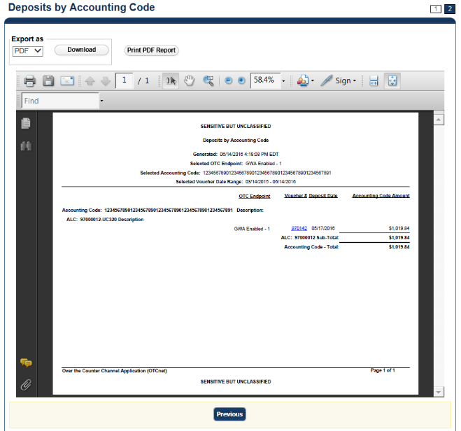

Application Tips

- TGA denotes a deposit processing OTC Endpoint.
- CHK denotes a check capture OTC Endpoint.
- M denotes a mapped accounting code; an open lock denotes access permission; and a closed lock denotes no access permission.
- CDC denotes card processing OTC Endpoint.

- Under Export as, you have the following options:
  - Select PDF, Excel or Word format
  - Select Download
Or
  - Select Print PDF Report
Application Tips

- Deposits with a voucher date older than five years does not display on the report but they may be viewed from the Scheduled Reports page (Home>Reports>Scheduled Reports).
- Unconfirmed Foreign Check items entered with a Country of Deposit value of Other does not display values in the Voucher Amount column.

Additional Button
Select Previous to return to the previous page.

View Business Reports: Deposits by OTC Endpoint
To view a deposit by OTC Endpoint report, complete the following steps:
- From the Reports tab, select Deposit Processing Reports. The View Reports page appears.
- Under Business Reports, select Deposits by OTC Endpoint. The Deposits by OTC Endpoint parameters page appears.
- Enter your search criteria.
  - Select the Organization, required
  - Select the ALC (Agency Location Code)
  - Enter the From: and To: Voucher Date range
  - Enter the From: and To: Deposit Total range
  - Select Yes or No for Report With Children
Application Tips

- The date range for Voucher Date cannot exceed 15 months.
- Select Yes for Report With Children to generate a report that contains data for the selected OTC Endpoint as well as all of the lower-level OTC Endpoints.
- Select No for Report With Children to generate a report that contains data only for the selected OTC Endpoint.

- Select an OTC Endpoint to initiate the report. The Deposits by OTC Endpoint preview page appears as shown in Figure 6.
Figure 6: Deposits by OTC Endpoint Report Preview Page
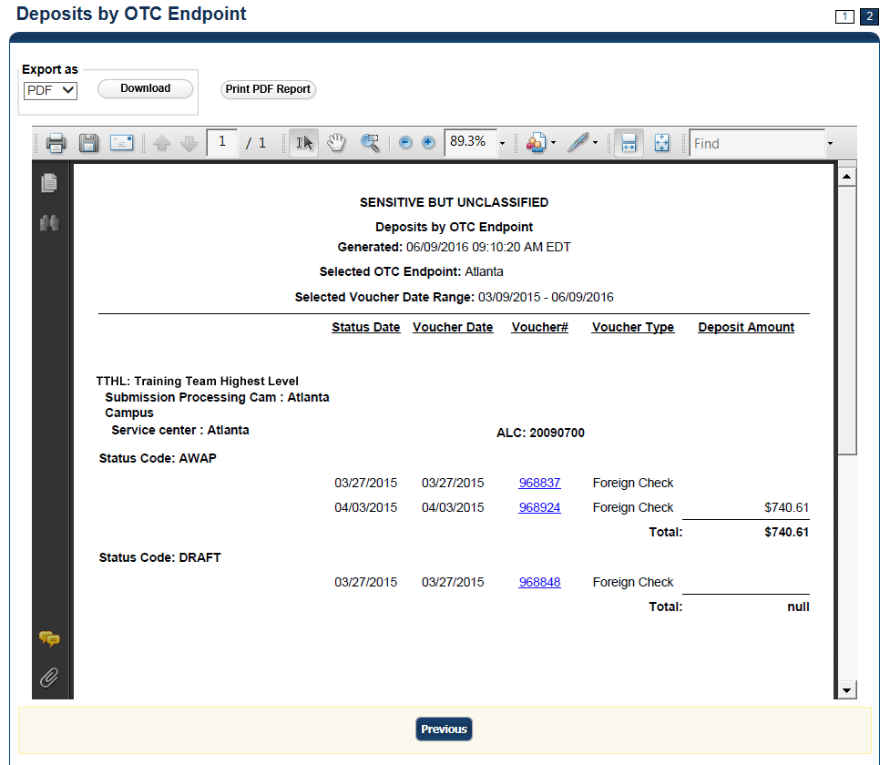
Application Tips

- TGA denotes a deposit processing OTC Endpoint.
- CHK denotes a check capture OTC Endpoint.
- M denotes a mapped accounting code; an open lock denotes access permission; and a closed lock denotes no access permission.
- CDC denotes card processing OTC Endpoint.

- Under Export as, you have the following options:
  - Select PDF, Excel or Word format
  - Select Download
Or
  - Select Print PDF Report
Application Tips

- Deposits with a voucher date older than five years does not display on the report but they may be viewed from the Scheduled Reports page (Home>Reports>Scheduled Reports).
- Unconfirmed Foreign Check items entered with a Country of Deposit value of Other does not display values in the Voucher Amount column.

Additional Button
Select Previous to return to the previous page.

View Business Reports: Deposit History by Status
To view a deposit history by status report, complete the following steps:
- From the Reports tab, select Deposit Processing Reports. The View Reports page appears.
- Under Business Reports, select Deposit History by Status. The Deposit History by Status parameters page appears.
- Enter your search criteria.
  - Select the Organization, required
  - Select the ALC (Agency Location Code)
  - Select the Status, required
  - Enter the From: and To: Status Date range
  - Enter the From: and To: Deposit Total range
  - Select Yes or No for Report With Children
Application Tips

- Select Yes for Report With Children to generate a report that contains data for the selected OTC Endpoint as well as all of the lower-level OTC Endpoints.
- Select No for Report With Children to generate a report that contains data only for the selected OTC Endpoint.

- Select an OTC Endpoint to initiate the report. The Deposit History by Status preview page appears as shown in Figure 7.
Figure 7: Deposit History by Status Preview Page
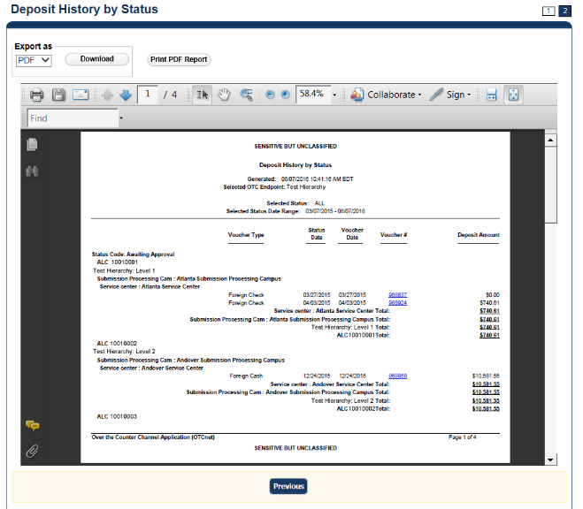
Application Tips

- TGA denotes a deposit processing OTC Endpoint.
- CHK denotes a check capture OTC Endpoint.
- M denotes a mapped accounting code; an open lock denotes access permission; and a closed lock denotes no access permission.
- CDC denotes card processing OTC Endpoint.

- Under Export as, you have the following options:
  - Select PDF, Excel, or Word format
  - Select Download
Or
  - Select Print PDF Report
Application Tips

- Deposits with a voucher date older than five years does not display on the report but they may be viewed from the Scheduled Reports page (Home>Reports>Scheduled Reports).
- Unconfirmed Foreign Check items entered with a Country of Deposit value of Other does not display values in the Voucher Amount column.

Additional Button
Select Previous to return to the previous page.

View Business Reports: Non-Reporting OTC Endpoints
To view a non-reporting OTC Endpoint report, complete the following steps:
- From the Reports tab, select Deposit Processing Reports. The View Reports page appears.
- Under Business Reports, select Non-Reporting OTC Endpoints. The Non-Reporting OTC Endpoints parameters page appears.
- Enter your search criteria.
  - Enter the From: and To: Deposit Date range
  - Select Yes or No for Report With Children
Application Tips

- The date range for Deposit Date cannot exceed 15 months.
- Select Yes for Report With Children to generate a report that contains data for the selected OTC Endpoint as well as all of the lower-level OTC Endpoints.
- Select No for Report With Children to generate a report that contains data only for the selected OTC Endpoint.

- Select an OTC Endpoint to initiate the report. The Non-Reporting OTC Endpoints preview page appears as shown in Figure 8.
Figure 8: Non-Reporting OTC Endpoints Preview Page
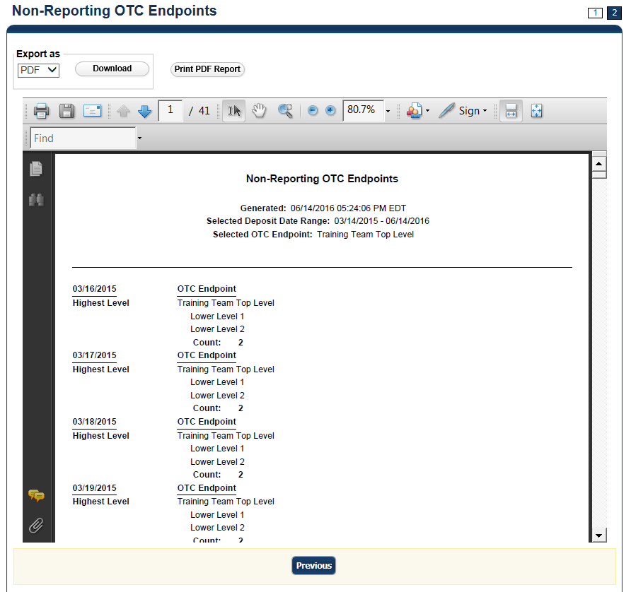
- Under Export as, you have the following options:
  - Select PDF, Excel or Word format
  - Select Download
Or
  - Select Print PDF Report
Application Tips

- TGA denotes a deposit processing OTC Endpoint.
- CHK denotes a check capture OTC Endpoint.
- M denotes a mapped accounting code; an open lock denotes access permission; and a closed lock denotes no access permission.
- CDC denotes card processing OTC Endpoint.

Additional Button
Select Previous to return to the previous page.

View Business Reports: Processing Options by OTC Endpoints
To view processing options by OTC Endpoints report, complete the following steps:
- From the Reports tab, select Deposit Processing Reports. The View Reports page appears.
- Under Business Reports, select Processing Options by OTC Endpoints. The Processing Options by OTC Endpoint parameters page appears.
- Enter you search criteria.
  - Enter the Processing Option, required
  - Select Yes or No for Report With Children
Application Tips

- For Report With Children, select Yes to generate a report that contains data for the selected OTC Endpoint as well as all of the lower-level OTC Endpoints.
- For Report With Children, select No to generate a report that contains data only for the selected OTC Endpoint.
- TGA denotes a deposit processing OTC Endpoint.
- CHK denotes a check capture OTC Endpoint.
- M denotes a mapped accounting code; an open lock denotes access permission; and a closed lock denotes no access permission.
- CDC denotes card processing OTC Endpoint.

- Select an OTC Endpoint to initiate the report. The Processing Options by OTC Endpoints preview page appears as shown in Figure 9.
Figure 9: Processing Options by OTC Endpoints Report Output Preview Page
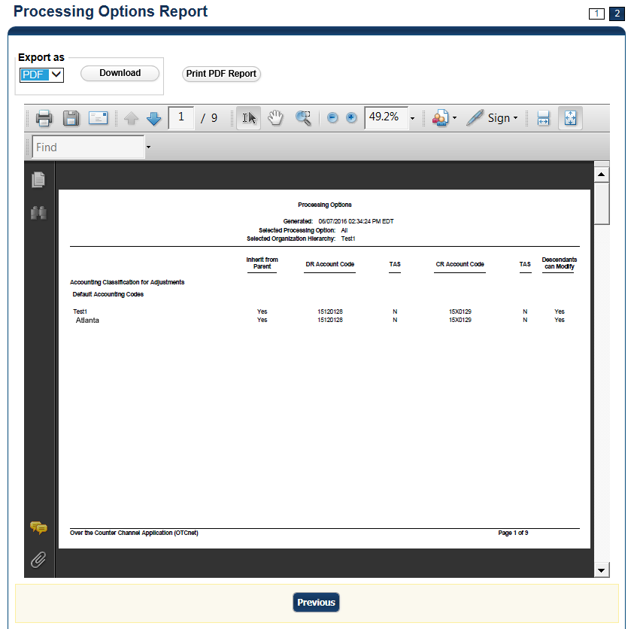
Application Tips

- TGA denotes a deposit processing OTC Endpoint.
- CHK denotes a check capture OTC Endpoint.
- M denotes a mapped accounting code; an open lock denotes access permission; and a closed lock denotes no access permission.
- CDC denotes card processing OTC Endpoint.

- Under Export as, you have the following options:
  - Select PDF, Excel or Word format
  - Select Download
Or
  - Select Print PDF Report
Additional Button
Select Previous to return to the previous page.

Security Reports
This section provides you with detail on how to view and download Security Reports.
There are six Security Reports available for viewing. This does not include the Primary Access Groups without a PLSA. This report is viewable to a FS Security user only. Security reports available for viewing include:

Users by Access Group (FI)
To view users by access group (FI), you are presented with the option to include search criteria for Report With Children for your selected Financial Institutions.
The report presents Users by Financial Institution Access Groups, including the OTCnet Role, OTCnet Status, User Name, User ID, and Email Address. You can export the report as a PDF, Excel or Word file, download it or print it.

Users by Access Group (FPA)
To view users by access group (FPA), you are presented with the option to include search criteria for Report With Children.
The report presents Users by Federal Program Agency Access, including the OTCnet Role, OTCnet Status, User Name, User ID, and Email Address. You can export the report as a PDF, Excel or Word file, download it or print it.

User Information
To view user information, you are presented with the option to include search criteria i.e., User ID, Email Address, First Name, and Last Name.
The report presents user information, including the User ID, User Name, User Phone Number, Email, OTCnet Status, OTCnet Role, Access Group, Assigned Organizations, Employer, Employer Address, and Admin ID. You can export the report as a PDF, Excel or Word file, download it or print it.

Users by Role (FI)
To view users by role (FI), you are presented with the option to include search criteria, i.e., Role and Report With Children.
The report presents Users by Financial Institution, including the OTCnet Status, User Name, User ID, Email, Phone Number, and OTCnet Access Granted. You can export the report as a PDF, Excel or Word file, download it or print it.

Users by Role (FPA)
To view users by role (FPA), you are presented with the option to include search criteria, e.g., Role and Report With Children.
The report presents Users by Federal Program Agency Access, including the OTCnet Status, User Name, User ID, Email address, Phone Number, and OTCnet Access Granted. You can export the report as a PDF, Excel or Word file, download it or print it.

View Security Reports: Users by Access Group (FI)
To view users by access group (FI) report, complete the following steps:
- From the Reports tab, select Deposit Processing Reports. The View Reports page appears.
- Under Security Reports, select Users by Access Group (FI). The Users by Access Group (FI) parameters page appears. Enter your search criteria.
  - Select Yes or No for Report With Children
Application Tips

- Select Yes to generate a report that contains data for the selected FIs and all lower level FIs.
- Select No to generate a report that contains data only for the selected FI.

- Select a Financial Institution to initiate the report. The Users by Access Group (FI) preview page appears in a new window as shown in Figure 10.
Figure 10: Users by Access Group (FI) Report Preview Page
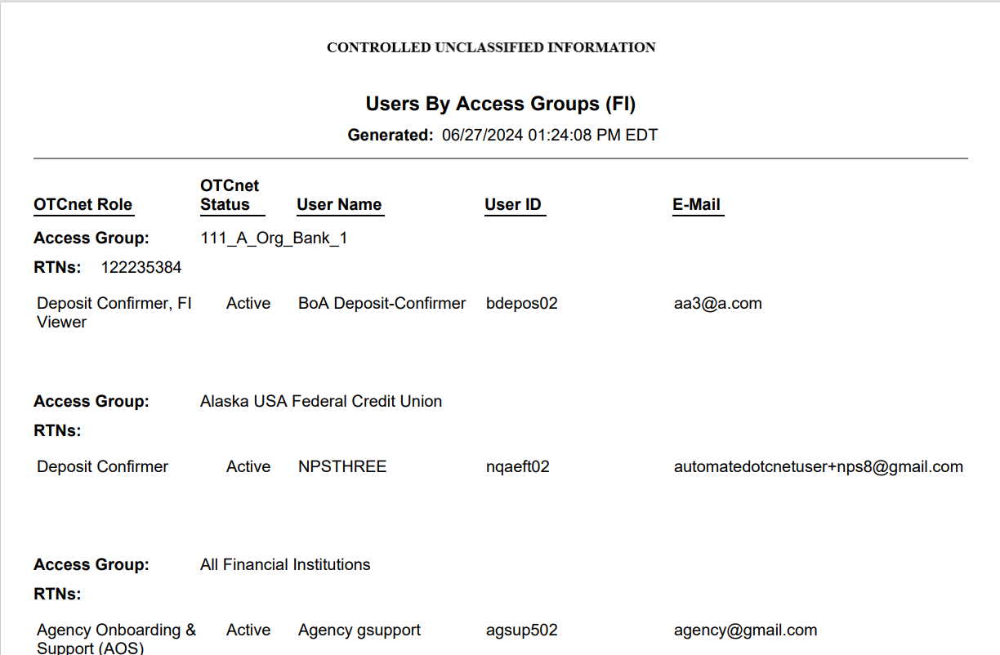

Application Tips

- For new users who have not logged into OTCnet yet, both the User Name and User ID values will be empty in the database and displayed as blank values on the preview page.
- TGA denotes a deposit processing OTC Endpoint.
- CHK denotes a check capture OTC Endpoint.
- M denotes a mapped accounting code; an open lock denotes access permission; and a closed lock denotes no access permission.
- CDC denotes card processing OTC Endpoint.

- Under Export as, you have the following options:
  - Select PDF, Excel or Word format
  - Select Download
Or
  - Select Print PDF Report
Additional Button
Select Previous to return to the previous page.

View Security Reports: Users by Access Group (FPA)
To view the Users by Access Group (FPA) report, complete the following steps:
- From the Reports tab, select Deposit Processing Reports. The View Reports page appears.
- Under Security Reports, select Users by Access Group (FPA). The Users by Access Group (FPA) parameters page appears. Enter your search criteria.
  - Select Yes or No for Report With Children
Application Tips

- Select Yes to generate a report that contains data for the selected OTC Endpoint as well as all of the lower-level Endpoints.
- Select No to generate a report that contains data only for the selected OTC Endpoint.

- Select an OTC Endpoint to initiate the report. The Users by Access Group (FPA) preview page appears in a new window as shown in Figure 11.
Under Export as, you have the following options:
  - Select PDF, Excel or Word format
  - Select Download
Or
  - Select Print PDF Report
Figure 11: Users by Access Group (FPA) Preview Page
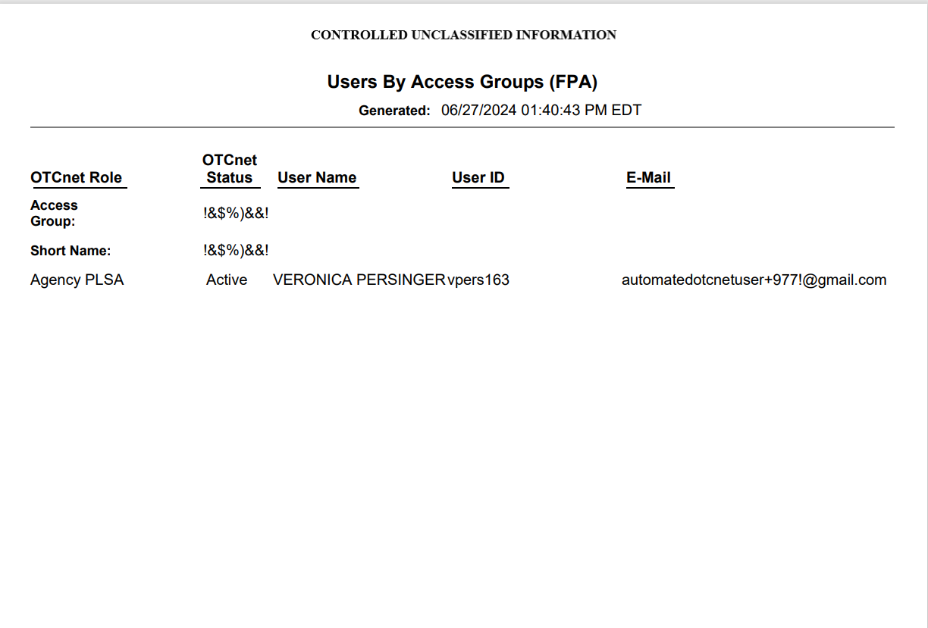
Application Tips

- For new users who have not logged into OTCnet yet, both the User Name and User ID values will be empty in the database and displayed as blank values on the preview page.
- If your agency has over 50 endpoints and/or over 100 users, you must drill down to a lower level within your agency to run the report. Running the report at a lower level prevents the report from overloading. Overloading results in a report with no
- data output.
- TGA denotes a deposit processing OTC Endpoint.
- CHK denotes a check capture OTC Endpoint.
- M denotes a mapped accounting code; an open lock denotes access permission; and a closed lock denotes no access permission.
- CDC denotes card processing OTC Endpoint.

Additional Button
Select Previous to return to the previous page.

View Security Reports: User Information
To view a user information report, complete the following steps:
- From the Reports tab, select Deposit Processing Reports. The View Reports page appears.
- Under Security Reports, select User Information. The User Information parameters page appears.
- Enter the User ID or E-mail Address of the user you must view.
Or
Enter both the First Name and Last Name of the user.
- Select Submit to initiate the report. The User Information preview page appears as shown in Figure 12.
- Under Export as, you have the following options:
  - Select PDF, Excel or Word format
  - Select Download
Or
  - Select Print PDF Report
Figure 12: User Information Preview Page
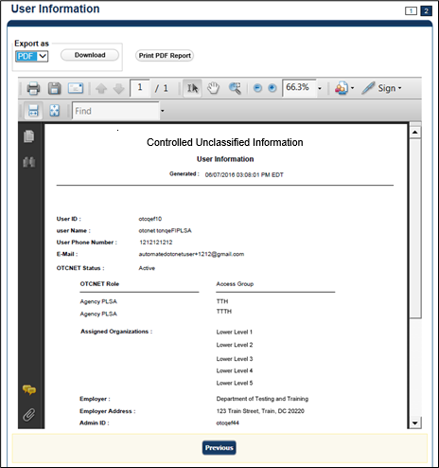
Application Tip

For new users who have not logged into OTCnet yet, the User Name, User ID, and Phone Number values will be empty in the database and displayed as blank values on the preview page.

View Security Reports: Users by Role (FI)
To view users by role (FI) report, complete the following steps:
- From the Reports tab, select Deposit Processing Reports. The View Reports page appears.
- Under Security Reports, select User by Role (FI). The Users by Role (FI) parameters page appears.
Enter your search criteria.
  - Select a user Role.
  - Select Yes or No for Report With Children.
Application Tips

- For Report with Children, select Yes to generate a report that contains data for the selected FIs and all lower level FIs.
- For Report with Children, select No to generate a report that contains data only for the selected FI.
- TGA denotes a deposit processing OTC Endpoint.
- CHK denotes a check capture OTC Endpoint.
- M denotes a mapped accounting code; an open lock denotes access permission; and a closed lock denotes no access permission.
- CDC denotes card processing OTC Endpoint.

- Select a Financial Institution to initiate the report. The Users by Role (FI) preview page appears as shown in Figure 13.
- Under Export as, you have the following options:
  - Select PDF, Excel or Word format
  - Select Download
Or
  - Select Print PDF Report

Figure 13: Users by Role (FI) Preview Page
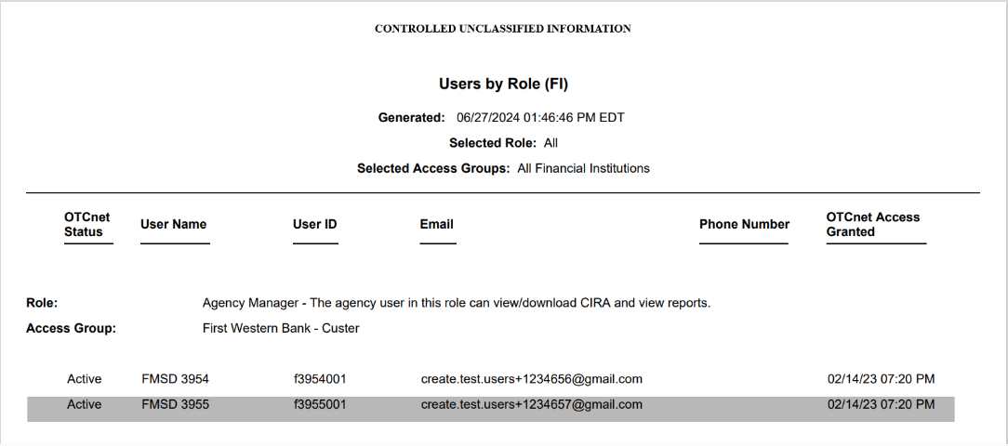
Application Tip

For new users who have not logged into OTCnet yet, both the User Name and User ID values will be empty in the database and displayed as blank values on the preview page.

Additional Button
Select Previous to return to the previous page.

View Security Reports: Users by Role (FPA)
To view users by role (FPA) report, complete the following steps:
- From the Reports tab, select Deposit Processing Reports. The View Reports page appears.
- Under Security Reports, select User by Role (FPA). The Users by Role (FPA) parameters page appears.
Enter your search criteria.
  - Select a user Role.
  - Select Yes or No for Report With Children
Application Tips

- Select Yes to generate a report that contains data for the selected OTC Endpoint as well as all of the lower level OTC Endpoints.
- Select No to generate a report that contains data only for the selected OTC Endpoint.

- Select an OTC Endpoint to initiate the report. The report Users by Role (FPA) preview page appears as shown in Figure 14.
- Under Export as, you have the following options:
  - Select PDF, Excel or Word format
  - Select Download
Or
  - Select Print PDF Report
Figure 14: Users by Role (FPA) Preview Page
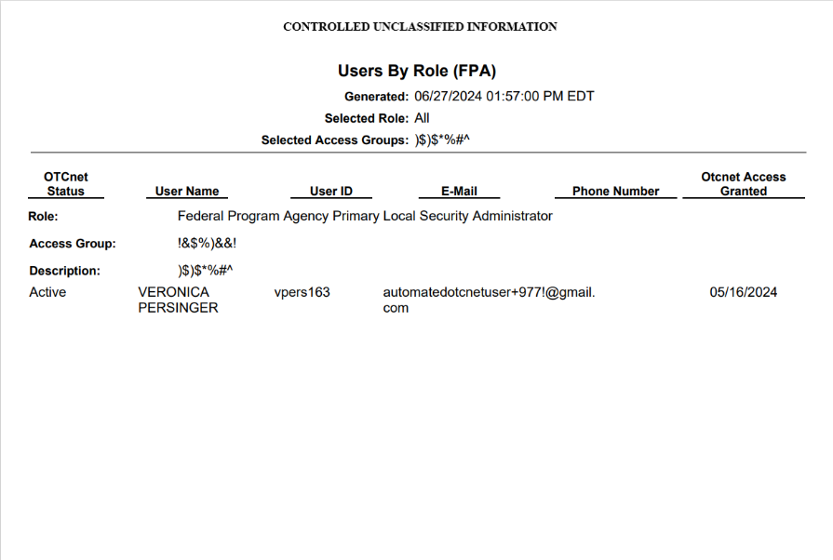
Application Tips

- For new users who have not logged into OTCnet yet, both the User Name and User ID values will be empty in the database and displayed as blank values on the preview page.
- If your agency has over 50 endpoints and/or over 100 users, you must drill down to a lower level within your agency to run the report. Running the report at a lower level prevents the report from overloading. Overloading results in a report with no data output.

Application Tips

- TGA denotes a deposit processing OTC Endpoint.
- CHK denotes a check capture OTC Endpoint.
- M denotes a mapped accounting code; an open lock denotes access permission; and a closed lock denotes no access permission.
CDC denotes card processing OTC Endpoint.

Additional Button
Select Previous to return to the previous page.

Administration Reports
This section provides you with detail on how to view and download Administration Reports.
Administration Reports available for viewing include:

View CIR File Status
To view the CIR file status report, you are presented with the following options: Transmission(s) Not Processed and All Transmission(s). Both options include Transmission ID, Status, Create Timestamp, Transmit Timestamp, Acknowledge Timestamp, CA$HLINK Type and CA$HLINK Acknowledge Timestamp.
The report presents CIR File Status for FI, including Status, Voucher Type, Voucher #, Voucher Date, Agency Location Code (ALC), Deposit Date, Status Date, CA$HLINK II Account Number (CAN), TCMS Trace #, Voucher Amount, Bank, Routing Transit Number (RTN), and Demand Deposit Account (DDA) #. You can export the report as a PDF, Excel or Word file and download or print it.
Additionally, the report presents Deposit or Adjustment Voucher details in PDF form, including the Voucher #, Adjustment Type, Voucher Date, ALC, Deposit Date, CAN, Voucher Amount, Original Deposit Date, Original Deposit Number, Organization Name, OTC Endpoint Short Name, OTC Endpoint Description, Financial Institution, RTN, DDA, Creation Date, Creation User, CLII Extract Date, CLII Sent Date, Acknowledgement by CLII Date, CL II Trace #, and Voucher Status History.

View Vouchers Completed
To view the Vouchers Completed report, you are presented with the option to include search criteria for the following items: Voucher #, Voucher Status, Voucher Type, Financial Institution, Voucher Complete Timestamp, and CL II Trace Number.
The report presents the event log, including Voucher Information, i.e., Voucher #, Voucher Date, Voucher Type, Voucher Status, Voucher Status Timestamp, Deposit Date, CA$HLINK II Trace # and Financial Institution and Voucher Event State, including the date the voucher was created on.
Additionally, the Voucher Event Details report presents the Voucher #, Voucher Date, Voucher Event State, Voucher Event State Timestamp, Voucher Event LoginID, Voucher Type, Voucher Status, Voucher Status Timestamp, Deposit Date, CA$HLINK II Trace #, Financial Institution, and Voucher Event Comments.

View Vouchers in Progress
To view the Vouchers in Progress report, you are presented with the option to include search criteria, i.e., Voucher #, Voucher Status, Voucher Type, and Financial Institution.
The report presents vouchers in progress and includes the Voucher Information: Voucher #, Voucher Date, Voucher Type, Voucher Status, Voucher Status Timestamp, Deposit Date, CA$HLINK II Trace #, and Financial Institution. The Voucher Event Log includes the Voucher Event State and the date the voucher was created on.

Additionally, the Voucher Event Details report presents the Voucher #, Voucher Date, Voucher Event State, Voucher Event State Timestamp, Voucher Event LoginID, Voucher Type, Voucher Status, Voucher Status Timestamp, Deposit Date, CA$HLINK II Trace #, Financial Institution, and Voucher Event Comments.

View Administration Reports: CIR File Status
To view a CIR file status report, complete the following steps:
- From the Reports tab, select Deposit Processing Reports. The View Reports page appears.
- Under Administration Reports, select View CIR File Status. The View CIR File Status page appears.
Application Tip

The Collections Information Repository (CIR) was formerly referred to as Transaction Reporting System (TRS).

- Select a date (From and To) using the date filter to filter CIR file status reports by date. (From/To dates cannot be in the future or older than 18 months.)
- Select the Submit button under the date filter to retrieve the results.
- Select the Schedule button under Schedule Reports as shown in Figure 15 to schedule an asynchronous report.
- The system displays a message to inform the user that their request has been submitted.
Figure 15: View CIR File and Schedule Report
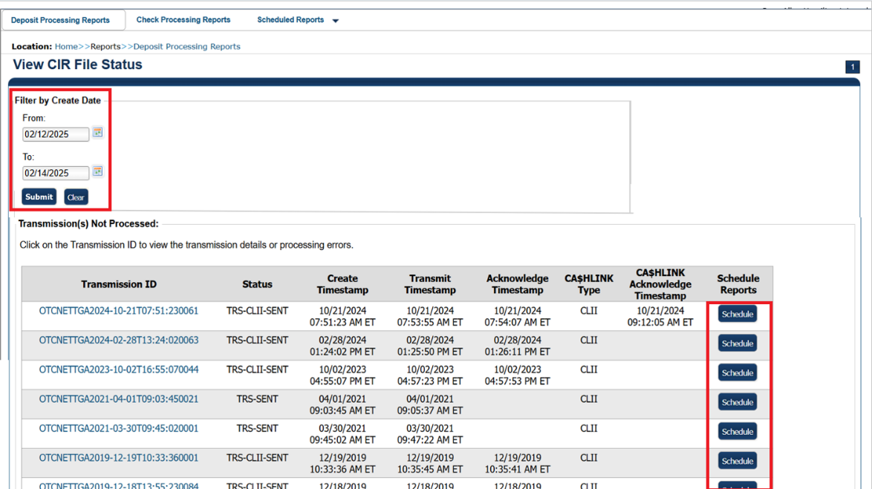

- To view the report and its sub-reports on the screen, under the Transmission(s) Not Processed section, select a Transmission ID of the CIR transmission details you must view.
Or
Under the All Transmission(s) section, select a Transmission ID of the CIR transmission details or processing errors you must view.
Application Tips

- If a Transmission ID with FRB CL CA$HLINK Type is selected, the CIR Transmission Status (FRB) report appears in a new window.
- If a Transmission ID with CLII CA$HLINK Type is selected, the CIR Transmission Status (FI) report appears in a new window.
- There are two sections on the View CIR File Transmission Status page. The Transmission(s) Not Processed section displays report files that have not been successfully processed by CIR.
- The All Transmission(s) section displays all deposit report files regardless of transmission status or success.

- The View CIR Transmission Status preview page appears.
Under Export as, you have the following options:
  - Select PDF, Excel or Word format
  - Select Download
Or
  - Print PDF Report
- For further debit or adjustment voucher details, select the Voucher # hyperlink. The Deposit or Adjustment Voucher Detail report appears.
- Select Open, Save or Cancel.
- The DepositVoucherDetail_XXX.pdf or AdjustmentVoucherDetail_ XXXX.pdf report appears as shown in Figure 16.
Figure 16: Adjustment-Voucher Detail PDF
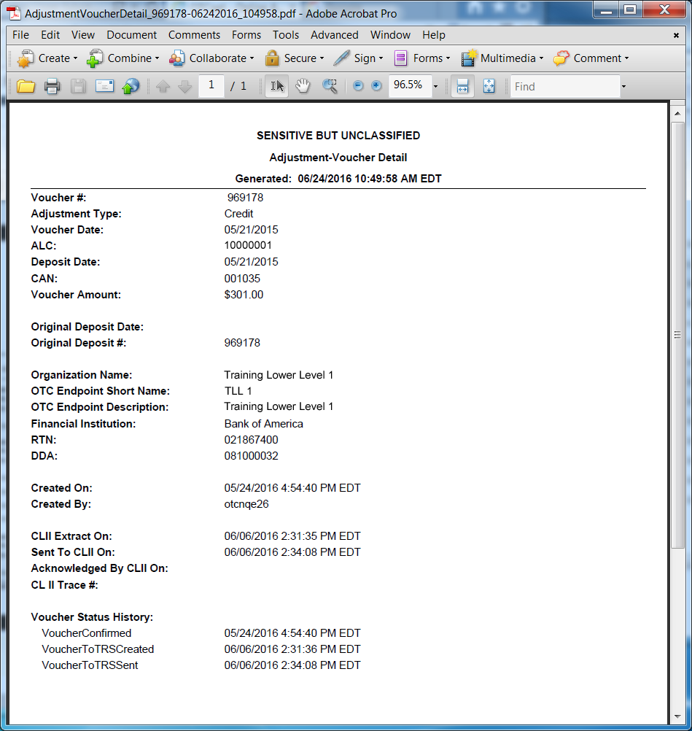
Additional Buttons
- Select Open the PDF is displayed.
- Select Save choose the location where to save the file.
- Select Cancel to return to the View CIR File Status preview page.
- Select Previous to return to the previous page.

View Administration Reports: Vouchers Completed
To view a voucher’s completed report, complete the following steps:
- From the Reports tab, select Deposit Processing Reports. The View Reports page appears.
- Under Administration Reports, select View Vouchers Completed. The View Vouchers Completed page appears.
- Select the Voucher # hyperlink. The Voucher Event Log page appears as shown in Figure 17.
Figure 17: View Voucher Event Log Page
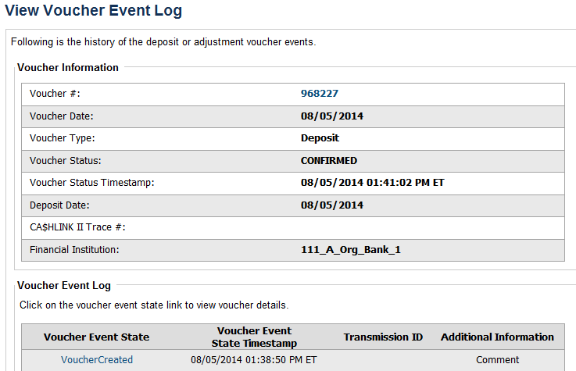
Application Tip

The View Voucher Event shows additional information about the voucher and the history of the voucher events through the FI System to System Interface.

- Select the Voucher # hyperlink to view the details of the deposit or adjustment. The Voucher Details Information page or the View Adjustment Details page appears.
Or
Select a Voucher Event State hyperlink to view the voucher event details. The Voucher Event Details page appears as shown in Figure 18.

Figure 18: Voucher Event Details Report Output
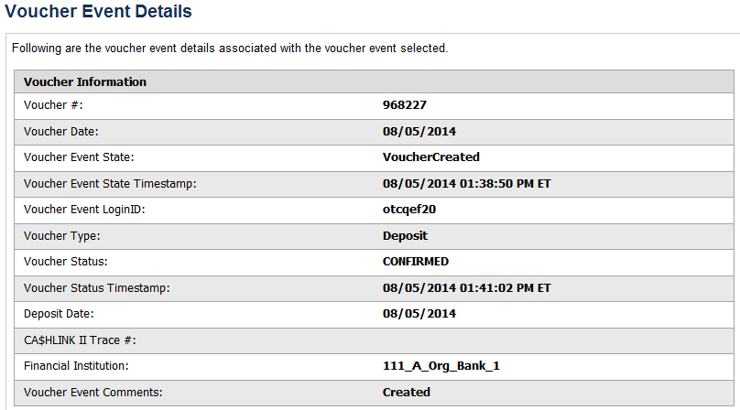
Application Tips

The Voucher Event Details page presents the following:
- Processing errors associated with the voucher event
- Additional information about the voucher and the transmission associated with the voucher events through the FI System To System Interface
- The Collections Information Repository (CIR) interface

Additional Buttons
- Select Cancel to return to the OTCnet Home Page. No data is saved.
- Select Clear to clear all data fields and reset to the default selections.
- Select Previous to return to the previous page.
- Select Refresh to redisplay the page with any additional vouchers that are in-process.
- Select Return Home to return to the previous page.

View Administration Reports: Vouchers in Progress
To view a voucher in progress report, complete the following steps:
- From the Reports tab, select Deposit Processing Reports. The View Reports page appears.
- Under Administration Reports, select View Vouchers In Progress. The View Vouchers in Progress page appears.
Application Tip

The Vouchers In Progress page only displays non-archived deposits or adjustments with a voucher date that is five years or less from to the current date.

- Select the Voucher # hyperlink to view the Voucher Event Log page and additional voucher information. The View Voucher Event Log page appears as shown in Figure 19.
Figure 19: In Progress View Voucher Event Log Page
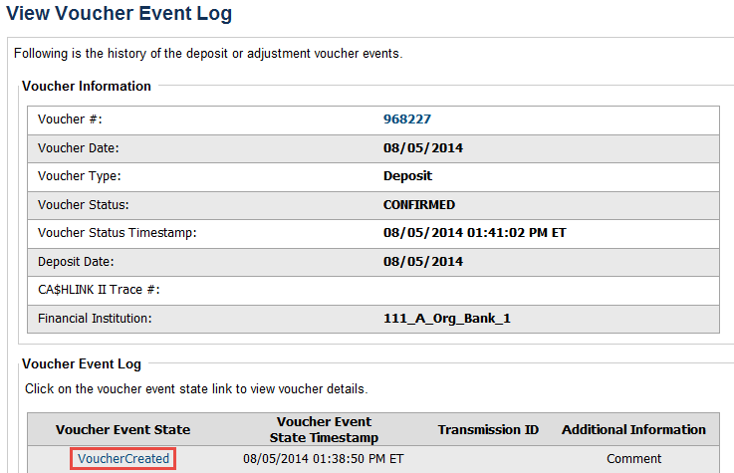
Application Tip

The View Voucher Event presents additional information about the voucher and the history of the voucher events through the FI System To System Interface.

- Select the Voucher # hyperlink to view the details of the deposit or adjustment. The Voucher Details Information page or the View Adjustment Details page appears.
Or
Select a Voucher Event State hyperlink to view the voucher event details. The Voucher Event Details page appears as shown in Figure 20.
Figure 20: In Progress Voucher Event Details Report Output
Application Tip

The Voucher Event Details page presents processing errors associated with the voucher event and additional information about the voucher and the transmission associated with the voucher events through the FI System To System Interface, and the Collections Information Repository (CIR) interface.

Additional Buttons
- Select Cancel to return to the OTCnet Home Page. No data is saved.
- Select Clear to clear all data fields and reset to the default selections.
- Select Previous to return to the previous page.
- Select Refresh to redisplay the page with any additional vouchers that
are in-process.
- Select Return Home to return to the previous page.

Scheduled Reports
Scheduled Reports are asynchronous reports that you can request in advance and review later. They include historical reports older than 18 months for check processing and 5 years for deposit processing.
This section provides you with detail on how to generate and view previously generated Check Processing and Deposit Processing Historical Reports.

Deposit Processing Historical Reports
Deposit Processing Historical Reports are used to query and download deposit information with a specified Voucher Date from the archival database. Deposit transactions with a voucher date older than the minimum data retention period, as specified by Fiscal Service, may not be displayed on the report as these transactions are eligible to be deleted. As a result, this deposit information may not be accessible and will be removed from the archival database.
Scheduled reports are generated asynchronously (not occurring at the same time), allowing you to continue to use OTCnet.
Depending on the volume of data requested, it can take between 5 and 20 minutes for the report to generate.
If you are assigned the role of Deposit Preparer, Deposit Approver, FI Confirmer, FRB Confirmer, FRB Viewer, or FI Viewer, you are authorized to query and download Deposit Processing Scheduled reports.
You can search for check records by Organization, OTC Endpoint, Agency Location Code (ALC), Prepared by, Voucher Number, Deposit Status, Agency Use (Block 6), Deposit Type, Voucher Date, Deposit Date, Deposit Total, and Financial Institution Information search criteria.
When the report request is submitted, its status is set to Submitted. After the report is successfully generated, the status is set to Completed and the report is available for download in CSV format.
Scheduled reports available for viewing include:

Deposit Historical Report
To generate a Deposit Historical Report, you are presented with the option to include search criteria, i.e., Organization, OTC Endpoint, ALC, Prepared by, Voucher #, Deposit Status, Agency Use (Block 6) details, Deposit Type, Voucher Date (From: and To:), Deposit Date (From: and To:) and Deposit Total (From and To:).
The report presents a scheduled record of deposits and can only be downloaded in CSV format.

Adjustment Historical Report
To generate an Adjustment Historical Report, you are presented with the option to include search criteria, i.e., Organization, OTC Endpoint, ALC, Adjustment Category, Voucher #, Adjustment Type, Prepared By, Adjustment Reason, Voucher Date (From: and To:), Adjustment Amount (From and To:), Deposit Date (From: and To:) and Original Deposit Date (From: and To:).
The report presents a scheduled record of adjustments and can only be downloaded in CSV format.
Adjustments associated to deposits with a voucher date older than the minimum data retention period, as specified by Fiscal Service, may not be displayed on the report as these transactions are eligible to be deleted. As a result, this adjusted deposit information may not be accessible and will be removed from the archival database.

View Previously Generated Reports
To view Previously Generated Reports, you are presented with a table of criteria, i.e., Report Type, Submitted Time, Search Criteria Parameters, Status, and Download.
The reports present a scheduled record of deposits or adjustments, the details of which are available above under their respective types. These reports can only be downloaded in CSV format.

Deposit Historical Report
To generate a Deposit Historical Report, complete the following steps:
- From the Reports tab, select Scheduled Reports>Generate Scheduled Reports.
- Under Deposit Processing Historical Reports, select Deposit Historical Report. The Deposit Historical Report page appears as shown in Figure 21.
Figure 21: Deposit Historical Report Criteria Page
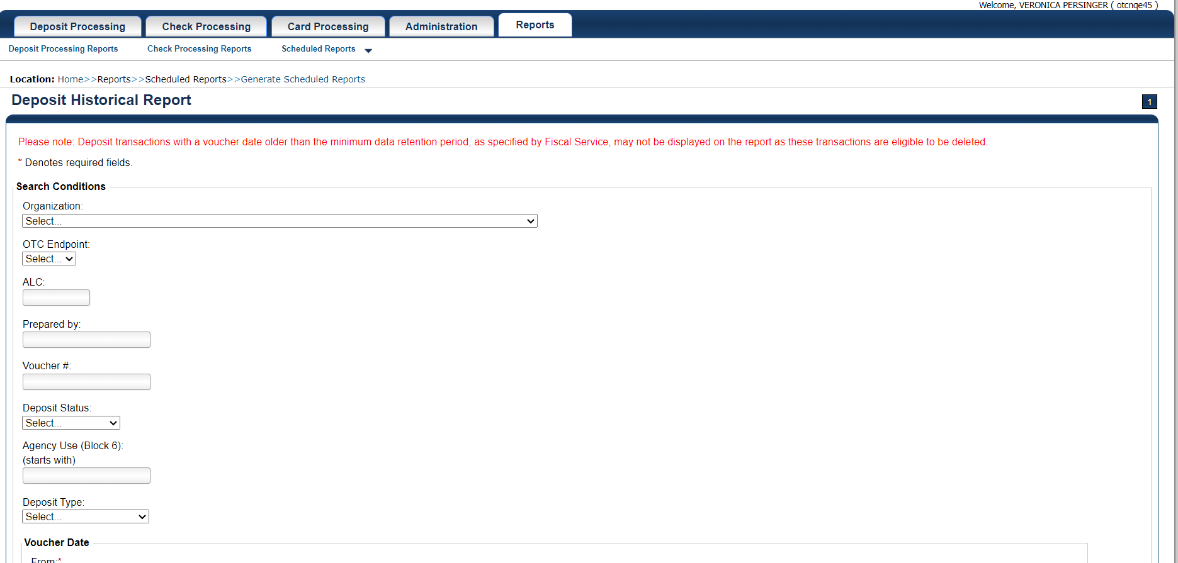
Application Tip

The Deposit Historical Report is generated asynchronously (not occurring at the same time) allowing you to continue using the OTCnet application. The time it takes to generate a report depends on the volume of data queried and therefore varies.

- Enter your search criteria.
Under Search Conditions:
- Select an Organization
- Select an OTC Endpoint
- Enter an ALC
- Enter the Prepared by
- Enter the Voucher #
- Select a Deposit Status
- Enter the Agency Use (Block 6) details
- Select a Deposit Type
- Enter the From and To Voucher Date, required
- Enter the From and To Deposit Date
- Enter the From and To Deposit Total
Application Tips

- The Voucher Date is a required field and the maximum date range for the From and To Voucher Date is one year. The Voucher Date must be entered in MM/DD/YYYY format.
- The From and To Deposit Date must be entered in MM/DD/YYYY format.

Under Financial Institution Information, optional
- Enter the RTN (Routing Transit Number)
- Enter the DDA (Demand Deposit Account)
- Enter the CAN (CA$HLINK II Account Number)
- Enter the FRB Account Key (Federal Reserve Bank Account Key)
- Enter the FRB CCWU (Federal Reserve Bank Cost Center Work Unit)
Application Tips

- The FRB Account Key must be three digits in length. The FRB Account Key field does not display for FI Deposit Confirmers or FI Viewers.
- The FRB CCWU must be four digits in length. If it is less than four digits, enter a zero at the beginning of the CCWU number (e.g., 0123). The FRB Account Key field does not display for FI Deposit Confirmers or FI Viewers.

Under User Defined Field Information, if applicable, optional
- Enter the Deposit UDF (User Defined Field) details
- Enter the Accounting Subtotal UDF details
Application Tip

User Defined Fields (UDFs) only display to users who have access to an organization that has previously defined UDFs. UDFs appear at the bottom of the page. Up to three UDFs can be displayed for Deposit and two for Accounting Subtotal.

- Select Submit Request. A “Your report request has been successfully received” message appears.
Application Tip

Once a request is submitted you cannot submit the same request again for seven days. If a duplicate request is submitted within seven days the following message displays: “Duplicate Request: You have submitted a report request based on identical report criteria in the last 7 days. Please revise your report criteria or access the previously generated report request.”

Additional Buttons
- Select Cancel to return to the OTCnet Home Page. No data is saved.
- Select Clear to clear all data fields and reset to the default selections.

- Once the request is submitted, navigate to Previously Generated Reports (Reports tab>Scheduled Reports>View Previously Generated Reports) and download the report in CSV format by selecting the CSV icon in the Download column for the report.

Adjustment Historical Report
To generate an Adjustment Historical Report, complete the following steps:
- From the Reports tab, select Scheduled Reports and select Generate Scheduled Reports.
- From the Deposit Processing Historical Reports section of the page, select Adjustment Historical Report. The Adjustment Historical Report page appears as shown in Figure 22.
Figure 22: Adjustment Historical Report Criteria Page
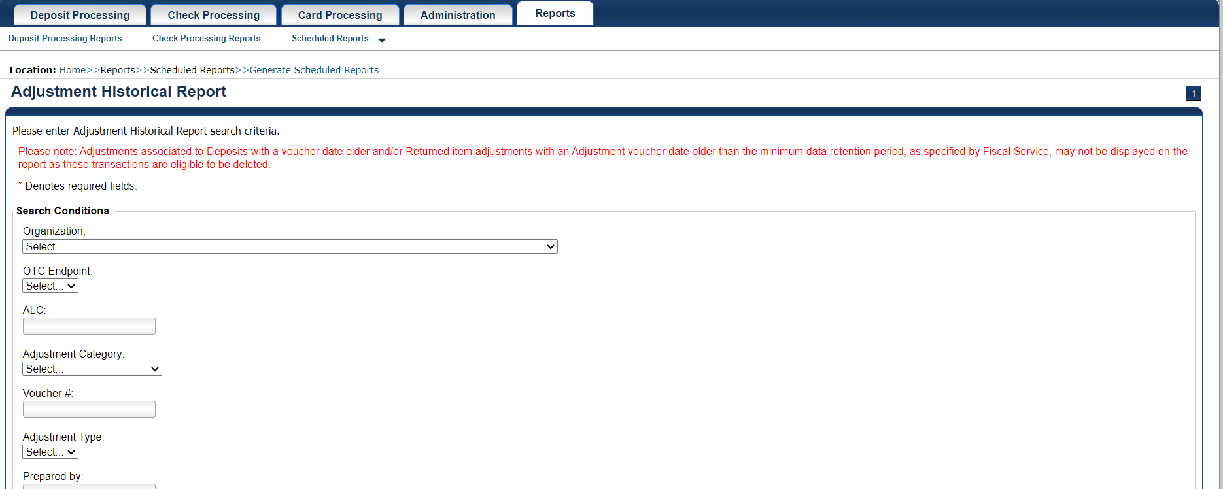
Application Tip

The Adjustment Historical Report is generated asynchronously (not occurring at the same time) allowing you to continue using the OTCnet application. Depending on the volume of data queried it can take between 5 and 20 minutes to generate the report.

- Enter your search criteria.
Under Search Conditions
- Select an Organization
- Select an OTC Endpoint
- Enter an ALC
- Select an Adjustment Category
Application Tips

- Select Deposit Adjustment to include deposit adjustments in the search results. The Deposit Adjustment search can be further limited by the user by selecting either Debit or Credit from the Adjustment Type drop-down list.
- Select Returned Item Adjustment to include only returned item adjustments (US Currency and Foreign Check Item) in the search results. The Returned Item Adjustment search does not have to be further qualified using the Adjustment Type drop-down list since returned item adjustments always have an Adjustment Type of Debit. If the user selects Credit from the Adjustment Type drop-down list after selecting a Returned Item Adjustment, no results appear since Credit returned item adjustments do not exist.
- Select RIA – Foreign Currency to only include returned item adjustments related to Foreign Check Items in the search results.
- Select RIA – US Currency to only include US Currency Returned Item Adjustments in the search results.
- Select no Adjustment Category (e.g., Select...), both deposit and returned item adjustments are included in the search results.
- Select Adjustment Type Debit to include all debit deposit adjustments and returned item adjustments in the search results. Select Credit to include only credit deposit adjustments in the search results.

  - Enter the Voucher #
  - Select an Adjustment Type
  - Enter the Prepared by
  - Select an Adjustment Reason
  - Enter the From and To Voucher Date, required
- Enter the From and To Adjust Amount Date
- Enter the From and To Deposit Date
- Enter the From and To Original Deposit Date
Application Tips

- The Voucher Date is a required field and the maximum date range for the From and To Voucher Date is one year. The Voucher Date must be entered in MM/DD/YYYY format.
- The From and To Deposit Date must be entered in MM/DD/YYYY format.

Under Financial Institution Information, optional
- Enter the RTN (Routing Transit Number)
- Enter the DDA (Demand Deposit Account)
- Enter the CAN (CA$HLINK II Account Number)
- Enter the FRB Account Key (Federal Reserve Bank Account Key)
- Enter the FRB CCWU (Federal Reserve Bank Cost Center Work Unit)
Application Tips

- The FRB Account Key must be three digits in length. The FRB Account Key field does not display for FI Deposit Confirmers or FI Viewers.
- The FRB CCWU must be four digits in length. If it is less than four digits, enter a zero at the beginning of the CCWU number (e.g. 0123). The FRB Account Key field does not display for FI Deposit Confirmers or FI Viewers.

- Select Submit Request. A “Your report request has been successfully received” message appears.
Application Tip

Once a request is submitted you cannot submit the same request again for seven days. If a duplicate request is submitted within seven days the following message displays: “Duplicate Request: You have submitted a report request based on identical report criteria in the last 7 days. Please revise your report criteria or access the previously generated report request.”

Additional Buttons
- Select Cancel to return to the OTCnet Home Page. No data is saved.
- Select Clear to clear all data fields and reset to the default selections.

- Once the request has been submitted, navigate to Previously Generated Reports (Reports tab>Scheduled Reports>View Previously Generated Reports) and download the report in CSV format by selecting the CSV icon in the Download column for the report.

View Previously Generated Reports
To view Previously Generated Reports, complete the following steps:
- From the Reports tab, select Scheduled Reports and then select View Previously Generated Reports.
Application Tips

- When a report request is submitted and the Historical database is unavailable, an informational message appears stating, “Historical database is currently unavailable. All reports in Submitted status are processed when the Historical database is available.” Report requests that are in Submitted status remain in Submitted status until the database is available and the report is generated. After the report is generated, a Completed status is displayed.
- When a report request is submitted and the report could not generate, its status is Error. Resubmit your report request to ensure your report is generated. If a report displays an Error status, the request can be resubmitted at any time without receiving a duplicate request message.
- Report requests are user specific and are not viewable by other users.

- The View Previously Generated Reports page appears as shown in Figure 23.The page lists reports that were requested within the last 7 days.
- Select the CSV icon in the Download column to view your desired report. The report opens as a csv file.
Figure 23: View Previously Generated Reports
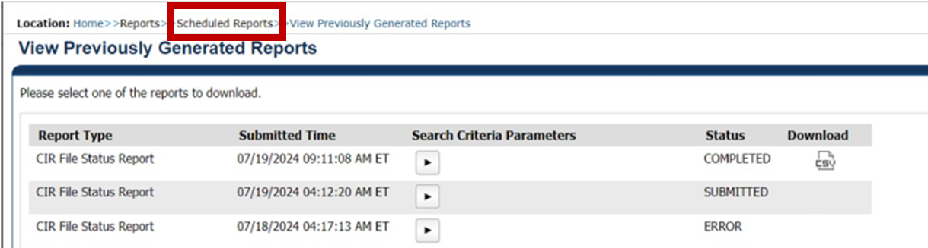
Application Tips

- After the CSV file is downloaded, open it using Excel or Notepad.
- Duplicate report requests based on identical report parameters cannot be made within seven days, however, after 7 days a duplicate report request can be submitted.

- The File Download dialog box appears. Select Open, Save, or Cancel.
Additional Buttons
- Select Open and the content of the file displays.
- Select Save to and choose the location where you want to save the file.
- Select Cancel and the dialog box closes. No data is saved.

Topic 5 Viewing a Financial Institution
As a FRB Viewer, you can locate and view the Financial Institution details that you have access to. You can only view a Financial Institution that has an Active status.
Viewing a Financial Institution (FI) allows you to see related details such as: Institution Information, Routing Transit Numbers (RTN) and Status and CA$HLINK II Account Number (CAN)/Acct Key Relationships.

View a Financial Institution
When viewing a financial institution (FI), you are presented with a table containing FI details, i.e., Name, City, State/Province, Country, Institution Type, Accepts Foreign Check Deposits, Accepts Foreign Cash Deposits, System to System Interface Participant, Short Name, Processes Foreign Check Deposits, Processes Foreign Cash Deposits, and Routing Transit Numbers.

View a Financial Institution
To view a Financial Institution, complete the following steps:
- From the Administration tab, select Manage FI>Financial Institution>View. The View the Financial Institution pages appear as shown in Figure 24 and Figure 25 below.
Figure 24: View FRB Detail
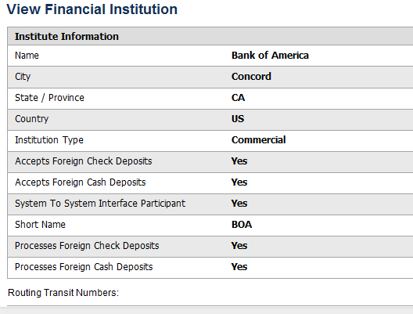
Figure 25: View Financial Institution Detail
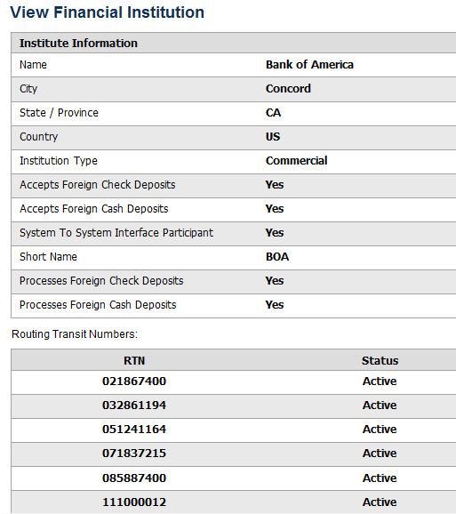
Application Tips

- Only Active Financial Institutions display for the selection.
- FI Confirmers, FRB Confirmers, FI Viewers, and FRB Viewers are authorized to view Institution Information, Routing Transit Numbers (RTN) and Status, and CA$HLINK II Account Number (CAN)/Acct Key Relationships.

Additional Button
Select Return Home to return to the OTCnet Home Page.

Summary
In this chapter, you learned:
- The purpose of viewing reports
- The types of reports you can access by role
- The types of business, security, administration, and scheduled reports
- How to view, generate, and download reports

