

Chapter 8. Searching Adjustments
OTCnet Participant User Guide

Table of Contents
Overview, Topics, and Audience 1
Overview 1
Topics 1
Audience 1
Topic 1 Purpose of Searching Adjustments 2
Topic 2 Searching Adjustments Using Select Criteria 3
Search and View an Adjustment 3
Search and View an Adjustment 4
Topic 3 Downloading Adjustments 6
Download Search Results for a Deposit 6
Download Search Results for a Deposit 7
Summary 8

List of Figures
Figure 1. Additional Search Criteria 4
Figure 2. Download Button 7

List of Tables
Table 1. Search Criteria Fields 2

Glossary
Select this link to access the full OTCnet Glossary.

Overview, Topics, and Audience

Overview
Welcome to Searching Adjustments. In this chapter, you will learn:
- The purpose of searching adjustments
- How to search and locate adjustments using one or more search criteria
- How to download adjustment voucher(s) as an XML or CSV file

Topics
This chapter is organized by the following topics:
- Purpose of Searching Adjustments
- Searching Adjustments Using Select Criteria
- Downloading Adjustments

Audience
The intended audience for the Searching Adjustments Participant User Guide includes:
- Deposit Preparer
- Deposit Approver
- Deposit Confirmer
- Viewer

Topic 1 Purpose of Searching Adjustments
As a Deposit Preparer, Deposit Approver, Deposit Preparer/Approver, Deposit Confirmer, or Viewer, you are authorized to search for and view adjustments and download and save the searched adjustment voucher(s) as an XML or CSV file. You may review adjustments to understand why a deposit is adjusted and the corrections that were made.
To search for an adjustment to a US Currency or Foreign Check Items deposit, select the Search Adjustments function. The Search Adjustments function enables you to search for a deposit voucher using one or more criteria.
If you do not specify any criteria, the search results include all deposits in the system that you have access to view. If you run additional searches, the Search Results table repopulates with the results of the new search. See Table 1 for search criteria fields.
Table 1. Search Criteria Fields
Search Criteria Groupings | Search Criteria Fields
Search Conditions | - Organization  - OTC Endpoint  - ALC  - Adjustment Category  - Voucher Number  - Adjustment Type  - Prepared By  - Adjustment Reason
Voucher Date | - Date Range
Adjustment Amount | - Total Range
Deposit Date | - Date Range
Original Deposit Date | - Date Range
Financial Institution Information | - Routing Number  - Demand Deposit Account  - CA$HLINK II Account Number  - FRB Account Key  - FRB Cost Center Work Unit

Topic 2 Searching Adjustments Using Select Criteria
Search Adjustments—for this function, if you run a search without specifying any criteria, the search results include all deposits in the system that you have access to view.

Search and View an Adjustment
To search adjustments using select criteria, you will enter your specific search criteria under Search Conditions, e.g., select an Organization or an Endpoint, etc. and select the Voucher Number for the adjustment that you need to view.

Search and View an Adjustment
To search for and view an adjustment, complete the following steps:
- Select Deposit Processing, select Search Adjustments. The Search Adjustments page appears.
- Enter the search criteria and select Search.
Under Search Conditions, optional
  - Select an Organization
  - Select an OTC Endpoint
  - Enter an ALC (Agency Location Code)
  - Select an Adjustment Category
  - Enter a Voucher #
  - Select an Adjustment Type
  - Enter the Prepared by name
  - Select an Adjustment Reason
  - Enter the From: and To: Voucher Dates
  - Enter the From: and To: Adjustment Amount
  - Enter the From: and To: Deposit Date
  - Enter the From: and To: Original Deposit Date
Additional search criteria is displayed as shown in Figure 1.
Figure 1. Additional Search Criteria
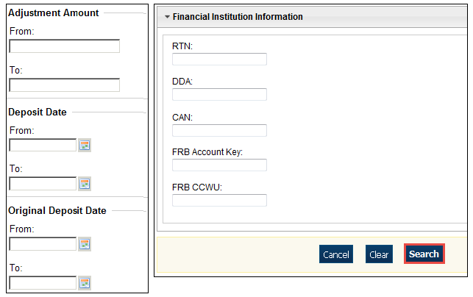

Application Tip

Voucher From date must be five years or less prior to the current date. Vouchers more than five years old can be viewed from the Scheduled Reports menu.

- The Search Results table appears. Select the Voucher Number of the adjustment for the details you need to view.
Application Tip

Values do not display in the Adjustment Amount column for unconfirmed foreign check item deposits that were entered with a Country of Deposit of Other.

Application Tip

Select Download to save the adjustment results as an XML or CSV file.


Additional Buttons
- Select Previous to return to the previous page.
- Select Return Home to return to the OTCnet Home Page.
- Select View Voucher Event Log to view the history of the deposit voucher.

Topic 3 Downloading Adjustments
To download your search results, first use the Search Adjustments function. After searching for your adjusted deposit, you can download the information you retrieve.

Download Search Results for a Deposit
To download your search results for a deposit, enter the search criteria for your adjusted deposit, enter the optional search criteria for the adjusted deposit you need to view and search for it. Download your results, select your file format e.g., XML file or CSV file. Verify the attributes that you want to download and submit. Open the file or save it.

Download Search Results for a Deposit
To download the search results of a deposit, complete the following steps:
- The Search Results table appears, select Download as shown in Figure 2. The Download Deposits page appears.
Figure 2. Download Button
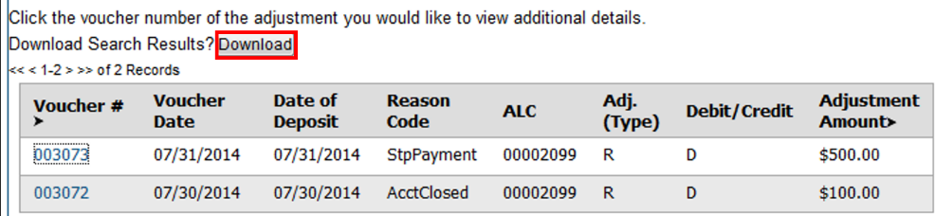
- Select either the XML file or CSV file format.
- Check the desired attributes that you need to download for:
  - Deposit Information
  - Financial Institution Information
  - Agency Information
  - Accounting Subtotals and User Defined Data
  - Foreign Deposit Information
- Select Submit. The File Download dialog box appears.
- Select Open or Save.
Application Tips

- Select Open and the content of the file appears.
- Select Save to choose the location where you will save the file.

Additional Button
Select Cancel to return to the OTCnet Home Page. No data is saved.

Summary
In this chapter you learned:
- The purpose of searching adjustments
- How to search for and locate adjustments using one or more search criteria
- How to download adjustment voucher(s) as an XML or CSV file

