

Chapter 7. Managing Adjustments
OTCnet Participant User Guide

Table of Contents
Overview, Topics, and Audience 1
Overview 1
Topics 1
Audience 1
Topic 1 Reasons for Creating a Returned Item Adjustment 2
Create a Returned Item Adjustment for US Currency 3
Create a Returned Item Adjustment for Foreign Check Item 5
Summary 7

List of Figures
Figure 1. Define Returned Item Adjustment 4
Figure 2. Step 1 of 2: Define Returned Item Adjustment Information 7

Glossary
Select this link to access the full OTCnet Glossary.

Overview, Topics, and Audience

Overview
Welcome to Creating Adjustments. In this chapter, you will learn:
- The reasons for creating a returned item adjustment
- How to create a returned item adjustment for US Currency and Foreign Check Items

Topics
This chapter is organized by the following topics:
- Reasons for Creating a Returned Item Adjustment

Audience
The intended audience for the Creating Adjustments Participant User Guide includes:
- Deposit Confirmer

Topic 1 Reasons for Creating a Returned Item Adjustment
As a Deposit Confirmer, you are authorized to create a returned item adjustment for US Currency Check Items and Foreign Check Items.
If an item is received that must be returned to the agency, a return item adjustment must be created. Only deposits with a Submitted status can be returned. Examples of reasons for adjustments include:
- Checks returned for insufficient funds
- Closed account
- Stop payment
- Uncollected funds

Create a Returned Item Adjustment for US Currency
To create a returned item adjustment for US Currency, complete the following steps:
- From the Deposit Processing tab, select Create Returned Item Adjustment>US Currency. The Step 1 of 2: Define Returned Item Adjustment Information page appears as shown in Figure 1.
Figure 1. Define Returned Item Adjustment
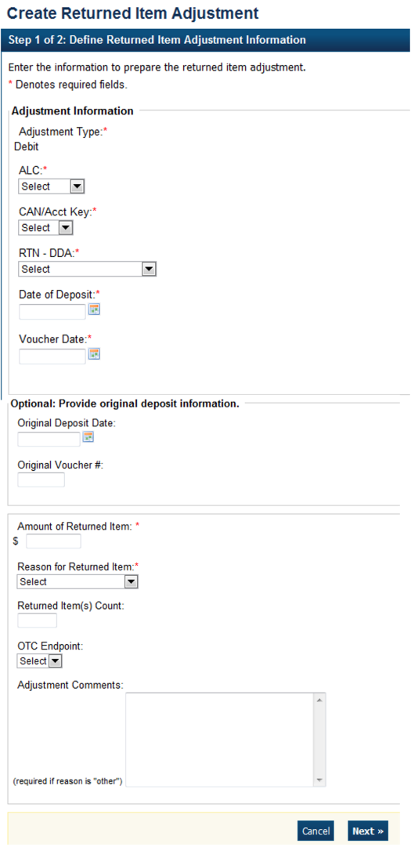
- Enter the information to prepare the returned item adjustment.
Under Adjustment Information, complete the following:
  - Select the ALC (Agency Location Code)
  - Select the CAN/Acct Key (CA$HLINK II Account Number/Account Key)
  - Select the RTN – DDA (Route Transit Number – Demand Deposit Account)
  - Enter the Date of Deposit (for the adjustment)
  - Enter the Voucher Date (for the adjustment)
  - Enter the Amount of Returned Item
  - Select a Reason for Returned Item
  - Enter the Returned Item(s) Count
  - Select an OTC Endpoint
  - Enter Adjustment Comments
Application Tips

- It is recommended to include the original deposit information so that the adjustment can be easily linked to the original deposit for reporting purposes.
- Users can find the original deposit information when they search for a deposit.
- On the search deposit page, users can search for any confirmed deposits and view the original deposit information.
- Users should have key data (e.g., original date of deposit, original voucher number, ALC, OTCnet endpoint) available before populating the fields to avoid any errors.

Application Tips

- The CCWU is for FRB deposits only.
- Adjustment Comments are required if the reason for the returned item is Other.

Under Optional: Provide original deposit information, optional
  - Select the Original Deposit Date
  - Enter the Original Voucher #
- After entering the information, select Next. The Step 2 of 2: Review Item Adjustment appears.
- Verify the information is correct and select Submit. Select Edit to make changes to the information entered.
- A Confirmation page appears stating that the returned item adjustment was created.

Additional Buttons
- Select Cancel to return to the OTCnet Home Page. No data is saved.
- Select Previous to return to the previous page.
- Select Return Home to return to the OTCnet Home Page.

Create a Returned Item Adjustment for Foreign Check Item
To create a returned item adjustment for Foreign Check Items, complete the following steps:
- From the Deposit Processing tab, select Create Returned Item Adjustment>Foreign Check Item. The Step 1 of 2: Define Returned Item Adjustment Information page appears as shown in Figure 2 below.
Figure 2. Step 1 of 2: Define Returned Item Adjustment Information
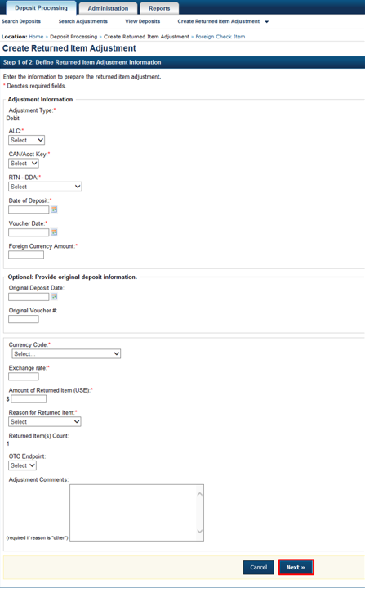
- Enter the information to prepare the returned item adjustment.
  - Select the ALC (Agency Location Code), CAN/Acct Key (CA$HLINK II Account Number/Account Key) and RTN-DDA (Routing Transit Number- Demand Deposit Account) from their drop-down lists
  - Enter the Date of Deposit and Voucher Date (for the adjustment), and Foreign Currency Amount
  - Select the Original Deposit Date and enter the Original Voucher #, optional
  - Select the Country of Deposit
If the name of the country is not listed, select Other. The Currency Code and Exchange Rate will automatically populate based on the Country of Deposit selection
  - Enter the Amount of Returned Item (USE)
  - Select a Reason for Returned Item and OTC Endpoint
  - Enter Adjustment Comments, required if the reason for the returned item is “other”
Application Tips

- It is recommended to include the original deposit information so that the adjustment can be easily linked to the original deposit for reporting purposes.
- Users can find the original deposit information when they search for a deposit.
- On the search deposit page, users can search for any confirmed deposits and view the original deposit information.
- Users should have key data (e.g., original date of deposit, original voucher number, ALC, OTCnet endpoint) available before populating the fields to avoid any errors.

- After entering the information, select Next. The Step 2 of 2: Review Item Adjustment page appears.
- Verify the information is correct and select Submit. Select Edit to make changes to the information entered.
- A Confirmation page appears stating that the returned item adjustment was created.
Additional Buttons
- Select Cancel to return to the OTCnet Home Page. No data is saved.
- Select Previous to return to the previous page.
- Select Return Home to return to the OTCnet Home Page.

Summary
In this chapter, you learned:
- The reasons for creating a returned item adjustment
- How to create a returned item adjustment for US Currency and Foreign Check Items

