

Chapter 5. Approving Deposits or Returning Deposits to Draft
OTCnet Participant User Guide

Table of Contents
Overview, Topics, and Audience 1
Overview 1
Topics 1
Audience 1
Topic 1 Purpose of Approving Deposits or Returning a Deposit to Draft 2
Topic 2 Approving Deposits 3
Topic 3 Returning Deposits to Draft 4
Approve or Return a Deposit to Draft 5
Summary 9

List of Figures
Figure 1: Approving Deposits or Returning a Deposit to Draft 2
Figure 2. Return Deposit to Draft Status 6
Figure 3. Submit Deposit 7

Glossary
Click this link to access the full OTCnet Glossary.

Overview, Topics, and Audience

Overview
Welcome to Approving Deposits or Returning Deposits to Draft. In this chapter, you will learn:
- The purpose of approving a deposit or returning a deposit to draft
- How to approve deposits
- How to return a deposit to draft

Topics
This chapter is organized by the following topics:
- Purpose of Approving Deposits or Returning a Deposit to Draft
- Approving Deposits
- Returning Deposits to Draft

Audience
The intended audience for the Approving Deposits or Returning Deposits to Draft Participant User Guide includes:
- Deposit Approver
- Deposit Preparer and Deposit Approver

Topic 1 Purpose of Approving Deposits or Returning a Deposit to Draft
An organization may find it necessary to enforce a separation of duties, where a designated user is responsible for approving deposits that were already prepared. When a deposit is approved, it is sent to your Financial Institution for confirmation. You cannot modify a deposit after it is approved (submitted) and awaiting confirmation from your Financial Institution.
You may be assigned the Deposit Approver role, or both the Deposit Preparer and Deposit Approver roles. As a Deposit Approver, you are authorized to approve (submit) or return a deposit to draft status. Only deposits that are saved with an Awaiting Approval (AWAP) status can be approved (submitted) or returned to draft status.
When a deposit is returned to Draft status, a Deposit Preparer modifies and resubmits the deposit. The deposit is returned to Draft status if information is found to be inaccurate (e.g., incorrect currency denominations, incorrect total deposit, etc.) See Figure 1 for the process flow when approving deposits or returning a deposit to draft status.
Figure 1: Approving Deposits or Returning a Deposit to Draft
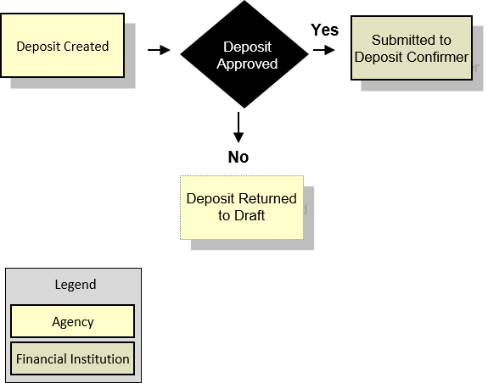

Topic 2 Approving Deposits
As a Deposit Preparer and Deposit Approver without an enforced separation of duties, you have the ability to approve (submit) a deposit.
As a Deposit Preparer and Deposit Approver with an enforced separation of duties, you have the ability to approve (submit) a deposit if the deposit was created by another user.
To approve (submit) a deposit, the deposit must be saved with AWAP status. To locate deposits with AWAP status, use the View Deposits function. After locating the deposit, you can approve (submit) the deposit for confirmation by your financial Institution.
To approve a deposit, either search your deposits or view deposits. Select your deposits in process and your voucher number. The other items displayed are Status, Date Submitted, Voucher Date, OTC Endpoint, ALC and Deposit Total. Review your details and submit them to process the deposit awaiting approval.

Topic 3 Returning Deposits to Draft
As a Deposit Preparer and Deposit Approver without an enforced separation of duties, you have the ability to return a deposit to Draft status.
As a Deposit Preparer and Deposit Approver with an enforced separation of duties, you have the ability to return a deposit to Draft status, if another user created the deposit. Return a deposit to Draft status when inaccuracies appear on the deposit ticket.
As a Deposit Preparer, you can modify and resubmit deposits returned to Draft status. To return a deposit to draft, the deposit must first have AWAP status. To locate deposits with AWAP status, use the View Deposits function. After you locate the deposit, return it to Draft status.
To return a deposit to draft, click either View Deposits or Search Deposits to locate deposits. Select My Deposits in Process. Select your Voucher Number. Review the deposit details, e.g., Voucher Type, Voucher #, Voucher Date, Fiscal Year, OTC Endpoint, ALC, Status, Submitted Time/Date, Submitted By, Checks & Money Order Subtotal, Currency Subtotal, Deposit Total, Currency Denominations, Financial Institution Information, Agency Information and Subtotals by Accounting Code. Review the details and return to draft.

Approve or Return a Deposit to Draft
To approve a deposit or return a deposit to draft, complete the following steps:
- From the Deposit Processing tab, click View Deposits. The View Deposits page appears.
Application Tip

To locate deposits, you can also select Search Deposits.

- From the Select Display drop-down menu, select My Deposits in Process.
- Click the Voucher Number for the deposit details you want to process.
Application Tips

- There are two sections on the View Deposits page. The My Deposits in Process section displays your current deposits.
- The Deposit Transactions section displays your deposit history.
- Depending on your user role, the page displays deposits on the My Deposits in Process page.
- For the Viewer only role, the My Deposits in Process does not appear.

- Review the details and click Return to Draft, as shown in Figure 2 or Submit as shown in Figure 3 to process the deposit awaiting approval. The Confirmation page appears, confirming the deposit was submitted to your Financial Institution.
Figure 2. Return Deposit to Draft Status
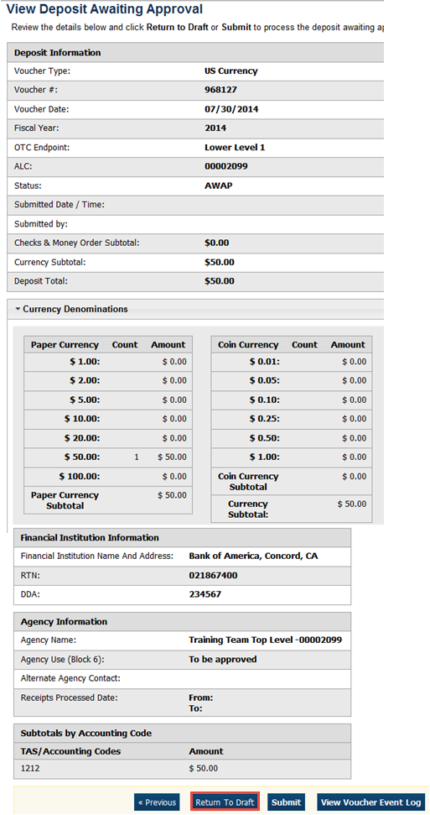
Figure 3. Submit Deposit
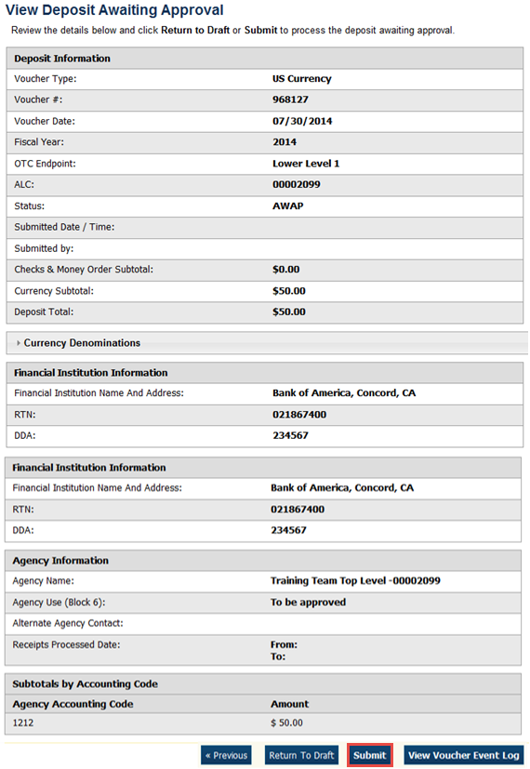
Application Tips

- Click Return to Draft—the deposit voucher returns to Draft status. A Deposit Preparer can modify the deposit.
- Click Submit. The deposit is submitted to your Financial Institution and the OTCnet Deposit Ticket displays, followed by the Print dialog box—it prompts you to print your deposit ticket.
- Ensure the deposit ticket is printed and included with the items sent to the bank for deposit.
- You cannot modify a deposit after it is submitted. Only a Deposit Confirmer from a Financial Institution can modify deposits by creating adjustments.


Additional Buttons
- Click Adjust to adjust a deposit.
- Click Cancel to return to the OTCnet Home Page. No data is saved.
- Click Confirm to confirm a deposit.
- Click Next to advance to the next page.
- Click Print Deposit Ticket to print a formatted deposit ticket.
- Click Previous to return to the previous page.
- Click Return Home to return to the OTCnet Home Page.
- Click Reject to reject a deposit (visible if a user has Deposit Confirmer privileges) .
- Click View Voucher Event Log to view the history of the deposit voucher.

Summary
In this chapter, you learned:
- The purpose of approving a deposit or returning a deposit to draft
- How to approve deposits
- How to return a deposit to draft

