

Chapter 4: Searching for Deposits
OTCnet Participant User Guide

Table of Contents
Overview, Topics, and Audience 1
Overview 1
Topics 1
Audience 1
Topic 1 Searching for Deposits 2
Search for a Deposit 3
Topic 2 Downloading Deposit Information 5
Download Search Results for a Deposit 6
Summary 9

List of Figures
Figure 1. Search Results Table 4
Figure 2. Download Button 6
Figure 3. Download Attributes Selection 7

List of Tables
Table 1. Search Criteria Fields 2
Table 2. Search Results Deposit Statuses 2

Glossary
Select this link to access the full OTCnet Glossary.

Overview, Topics, and Audience

Overview
In this chapter, you will learn:
- How to search for and locate deposits using one or more search criteria
- How to download deposit voucher(s) as an
- XML or CSV file

Topics
This chapter is organized by the following topics:
- Searching for Deposits
- Downloading Deposit Information

Audience
The intended audience for Search for Deposits Participant User Guide includes:
- Deposit Preparer
- Deposit Approver
- Deposit Confirmer
- Viewer

Topic 1 Searching for Deposits
As a Deposit Preparer, Deposit Approver, Deposit Preparer and Approver, Deposit Confirmer, or Viewer, you are authorized to search for a deposit voucher and download and save the searched deposit voucher(s) as an XML or CSV file.
To search for a deposit, select the Search Deposits function. The Search Deposits function enables you to search for a deposit voucher using one or more criteria. If you do not specify any criteria, the search results will include all deposits in the system that you have access to view. You can run additional searches; the Search Results table that appears is cleared and re-populated with the results of the new search. See Table 1 for search criteria fields.
Table 1. Search Criteria Fields
Search Criteria Groupings | Search Criteria Fields
Search Conditions | - Organization  - OTC Endpoint  - ALC  - Prepared by  - Voucher Number  - Deposit Status  - Agency Block 6  - Deposit Type
Voucher Date | - From and To Date
Deposit Date | - From and To Date
Deposit Total | - From and To Total
Financial Institution Information | - Routing Transit Number  - Demand Deposit Account  - CA$HLINK II Account Number  - FRB Account Key  - FRB Cost Center Work Unit
Under the Search Deposits function, if you run a search without specifying any criteria, the search results include all deposits in the system that you have access to view (see Table 2).
Table 2. Search Results Deposit Statuses
Draft | A deposit that is saved for modification at a later date by a Deposit Preparer
Awaiting Approval | A deposit that is waiting for deposit confirmation by a Deposit Approver
Submitted | A deposit that is submitted and waiting deposit confirmation by a Deposit Confirmer
Confirmed | A deposit that has been reviewed and confirmed by a Financial Institution or FRB
Rejected | A deposit that is returned by a Financial Institution or FRB to the Deposit Preparer to create a new deposit

Search for a Deposit
To search for a deposit, complete the following steps:
- From the Deposit Processing tab, select Search Deposit. The Search Deposit page appears.
- Enter the search criteria for the deposit you would like to view and select Search. The Search Results table appears.
Under Search Conditions, optional
- Select the Organization
- Select the OTC Endpoint
- Enter the ALC (Agency Location Code)
- Enter Prepared by details
- Enter the Voucher #
- Select the Deposit Status
- Enter Agency Use (Block 6) details
- Select the Deposit Type
- Enter the From and To Voucher Date
- Enter the From and To Deposit Date
- Enter the From and To Deposit Total
Application Tip

Voucher From date must be five years or less from the current date. Vouchers more than five years old are viewed from the Scheduled Reports menu.

Under Financial Institution Information, optional
- Enter the RTN (Routing Transit Number)
- Enter the DDA (Demand Deposit Account)
- Enter the CAN (CA$HLINK II Account Number)
- Enter the FRB Account Key (Federal Reserve Bank Account Key)
- Enter the FRB CCWU (Federal Reserve Bank Cost Center Work Unit)

Under User Defined Field Information, if applicable, optional
- Enter the Deposit UDF (User Defined Fields)
- Enter the Accounting Subtotal UDF details

Application Tips

- User Defined Fields (UDFs) only display to users who have access to an organization that has previously defined UDFs.
- UDFs appear at the bottom of the page.
- Up to three UDFs can be displayed for Deposit and two for Accounting Subtotal.

- Select the Voucher Number of the deposit whose details you would like to view as shown in Figure 1.
Figure 1. Search Results Table
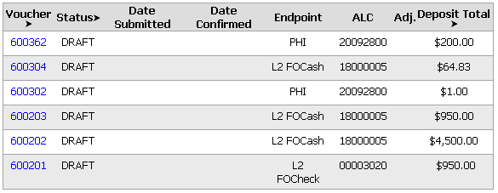
Application Tips

- Deposit totals are not displayed for unconfirmed foreign check items for which Other was selected as the country of deposit during deposit creation.
- Select Download to save the search deposit results as an XML or CSV file.

Additional Buttons
- Select Edit to modify the deposit draft. (Visible if a user has Deposit Preparer privileges.)
- Select Previous to return to the previous page.
- Select Print Deposit Ticket to print a formatted deposit ticket.
- Select Return Home to return to the OTCnet Home Page.
- Select View Voucher Event Log to view the history of the
deposit voucher events.

Topic 2 Downloading Deposit Information
After searching for your deposit, you can download the retrieved information. To download the results of a deposit, first use the Search Deposits function.
To download search results, enter the optional search criteria for the deposit you would like to view and select Search. Search criteria under Search Conditions, including Voucher, Status, Date Submitted, Date Confirmed, OTC Endpoint, ALC, Adj., and Deposit Total.
Search criteria under Financial Institution Information and enter User Defined Field Information details.
You can also download your results by selecting the XML file or CSV file format. Check the desired attributes that you want to download for Deposit Information, Financial Institution Information, Agency Information, Accounting Subtotals and User Defined Data, and Foreign Deposit Information. Open or save your file.

Download Search Results for a Deposit
To download the search results for a deposit, complete the following steps:
- Select Download from the Search Results table. The Download Deposits page appears as shown in Figure 2.
Figure 2. Download Button
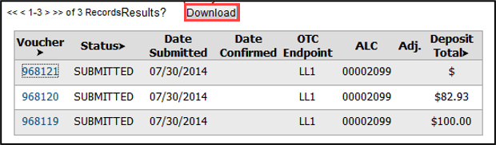
Application Tip

The Search Results table does not display Deposit Total values for unconfirmed Foreign Check Item deposits associated with a Country of Deposit selection of Other.

- Select XML file or CSV file as the file format.
- Check the desired attributes that you want to download for the following:
  - Deposit Information
  - Financial Institution Information
  - Agency Information
  - Accounting Subtotals and User Defined Data
  - Foreign Deposit Information
- Select Submit as shown in Figure 3. The File Download dialog box appears.
Figure 3. Download Attributes Selection
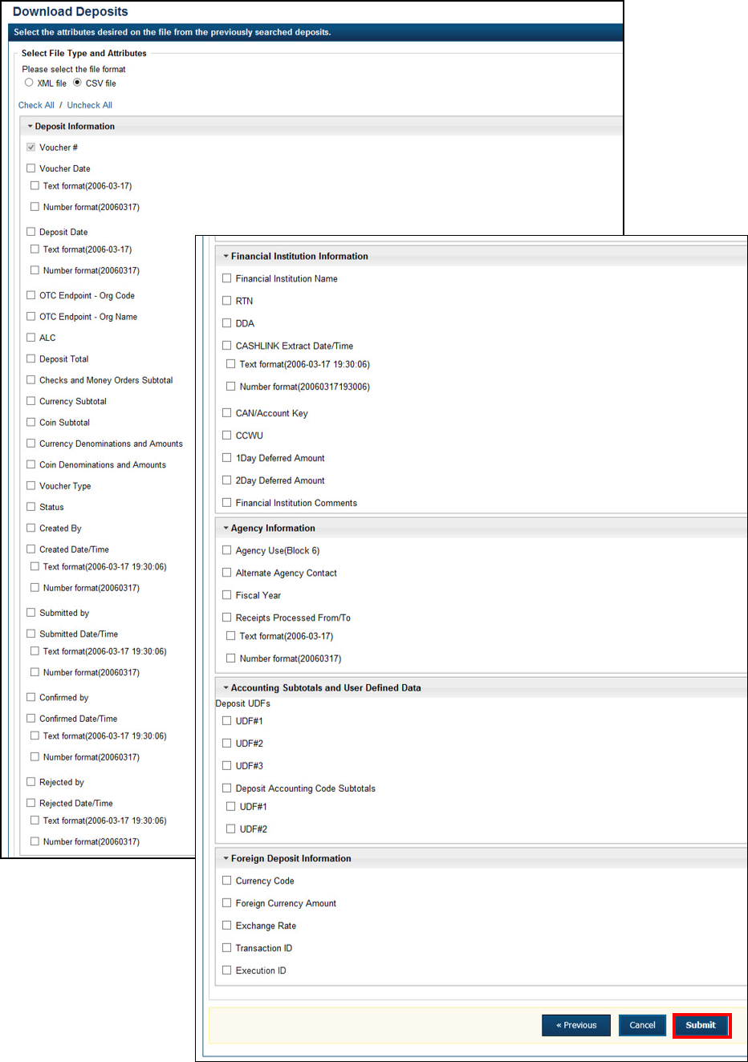

- Select Open or Save.
Application Tips

- Select Open and the content of the file displays.
- Select Save to choose the location where you want to save the file.

Additional Buttons
- Select Cancel to return to the OTCnet Home Page. No data is saved.
- Select Clear to clear all data fields and reset to the default selections.
- Select Download to download the search results.
- Select Previous to return to the previous page.
- Select Print Deposit Ticket to print a formatted deposit ticket.
- Select Search to display the deposits that match the search criteria.
- Select Return Home to return to the OTCnet Home Page.

Summary
In this chapter, you learned:
- How to search for and locate deposits using one or more search criteria
- How to download deposit voucher(s) as an XML or CSV file.

