

Chapter 5. Managing Verification Records
OTCnet Participant User Guide

Table of Contents
Overview, Topics, and Audience 1
Overview 1
Topics 1
Audience 1
Topic 1 Purpose of Managing Verification Records (MVD/LVD) 2
Topic 2 Create an MVD Record 6
Create an MVD Record 7
Topic 3 Search an MVD Record 9
Search an MVD Record 10
Topic 4 Edit an MVD Record 12
Edit an MVD Record 13
Summary 15

List of Figures
Figure 1: MVD Lifecycle 3
Figure 2: LVD Lifecycle 4
Figure 3: Define the MVD Record 7
Figure 4: Search MVD Records 10
Figure 5. Edit Verification Record 13

List of Tables
Table 1: MVD/LVD Record Trade Status 2
Table 2: Special Character Handling 5
Table 3: Search Results 9

Glossary
Select this link to access the full OTCnet Glossary.

Overview, Topics, and Audience

Overview
Welcome to Managing Verification Records (MVD/LVD). In this chapter, you will learn:
- The purpose of managing verification records
- How to create a Master Verification Database (MVD) record
- How to search for a MVD record
- How to edit a MVD record

Topics
The topics in this chapter include the following:
- Purpose of Managing Verification Records, Master Verification Database (MVD and Local Verification Database (LVD)
- Create an MVD Record
- Search for an MVD Record
- Edit an MVD Record

Audience
The intended audience for the Managing Verification Records Participant User Guide includes:
- MVD Editor
- MVD Viewer
- Check Capture Administrator (CCA)
- Check Capture Supervisor (CCS)

Topic 1 Purpose of Managing Verification Records (MVD/LVD)
The Master Verification Database (MVD) aids the agency in determining the history of a particular check writer. The verification database is an optional Online database that maintains the agency hierarchy check cashing policy, dishonored check information, and manually entered blocked items—based on agency policy.
The MVD provides the OTCnet application information to ensure a presented check is acceptable. The MVD is a negative Online database, specific to an agency that contains return information on:
- Checks and accounts that have failed to clear in a previous OTCnet transaction attempt
- Blocked accounts/routing numbers or individuals that have been identified where future transactions are not desired
The Local Verification Database (LVD) is a verification database that resides locally on each terminal. The information in the LVD prevents checks from being cashed on accounts, or other agency-specified criteria, that are in violation of agency policy. Verification information is available for download.
Verification records are derived from returns of previously processed payments originated through the OTCnet application and manually entered records (i.e., a blocked, suspended, or denied record). The bad check information is accumulated in the MVD as agencies start to process checks through Check Capture.
If an item is identified as a red flag item, you have the ability to set an MVD/LVD Record Trade Status as seen in Table 1.
Table 1: MVD/LVD Record Trade Status
Suspend | Indicates that an individual’s record is set to a predetermined suspension period. During this time, the OTCnet system prevents an individual from cashing a check through OTCnet. The individual’s database record has a Trade Status of Suspend and the expiration date is set until a specific date
Denied | Indicates that an individual’s record is set to a permanent deny date of 9/09/2099. The OTCnet system permanently denies this person from cashing a check through OTCnet
Blocked | Indicates a manual entry by authorized person into the MVD rather than the result of a failed transaction. If desired, authorized users can edit the transaction record to a clear status
As an MVD Editor, you can create, search, and edit MVD records. As an MVD Viewer, you can search and view MVD records only.

How Does the MVD Work?
Verification records are derived from returns of previous processed payments originated through OTCnet and manually-entered records (i.e., a blocked, suspended, or denied record). Blocked, suspended, or denied data is entered manually by an authorized person from an agency location, region, or even the Treasury OTC Support Center.
By default, an OTC Endpoint receives all blocked, suspended, and denied records created at the location; all blocked, suspended, and denied records of the OTC Endpoint’s subordinate sites; all blocked records created at all Parent Level OTC Endpoints; and any blocked, suspended, or denied records from any OTC Endpoint and their subordinates in the requesting organization’s OTC Verification Group. An OTC Verification Group typically includes OTC Endpoints from the hierarchy of respective OTC Endpoint’s agency. See Figure 1 for the MVD lifecycle.
Figure 1: MVD Lifecycle
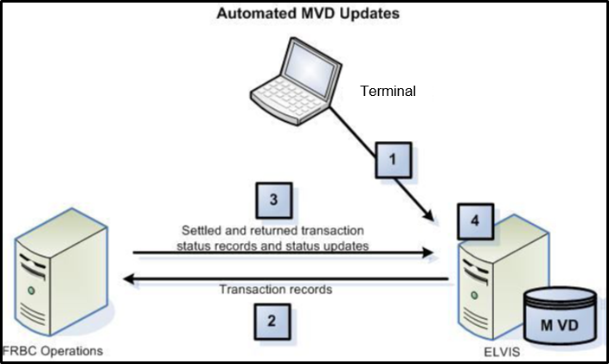
The MVD Lifecycle includes the following steps:
- Check transactions are processed in OTCnet.
- Check transaction data is sent from OTCnet to the Treasury/Bureau of the Fiscal Service (BFS).
- The negative returns on check transactions are sent from the Treasury/BFS operations to the MVD.
- The verification record is completed with information from the original payment transaction.
How does the LVD Work?
Blocked, suspended, or denied data is entered manually, online, by an authorized person from a site, a region, an agency, or even the Treasury OTC Support Center. By default, a location receives all blocked, suspended and denied records created at the location; all blocked, suspended, and denied records of the location’s subordinate sites; all blocked records created at all direct ancestors above the location; and any blocked, suspended, or denied records from any location and their subordinates in the requesting location’s location group.
Figure 2: LVD Lifecycle
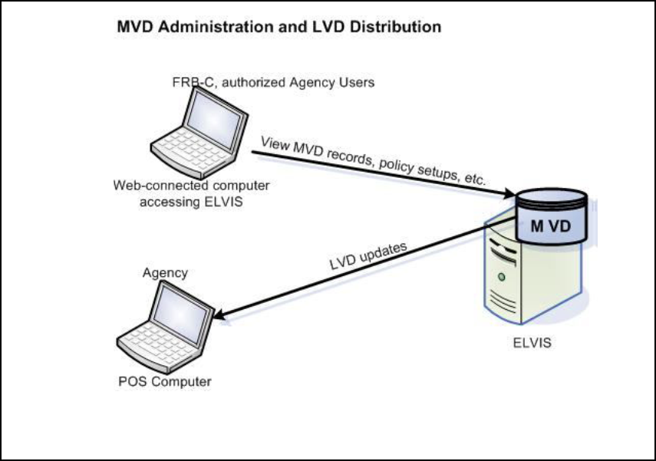
OTC Verification Group Management
An OTC Verification Group represents a listing of any OTC Endpoints outside the requesting OTC Endpoint’s hierarchy that share records. The MVD restricts the display of data based on the OTC Endpoint of the user. A user only sees records which are associated with OTC Endpoints at or below the user’s OTC Endpoint in the hierarchy, or at OTC Endpoints specified in the OTC Verification Group. Depending on the type of data being requested, different rules will apply.
What is Included in an OTC Endpoint’s Policy?
An OTC Endpoint’s policy helps automate an agency’s check cashing/collection policy. The OTC Endpoint policy is based upon the agency's overall program or policy to ensure a consistent application of agency-wide check verification, including returned reason codes, suspension periods, and the inclusion of expired items. As part of the agency’s participation in the OTCnet program, the agency provides the Treasury OTC Support Center, via the Agency Site Profile (ASP), their check collection policy regarding:
- Number of returns permissible by the agency
- Length of time for each suspension period
Generate Verification records based on:
- The inclusion of Represented and Retired checks
- The inclusion of Retired checks only
- The number and timing of representments
An agency chooses when MVD records are created, either:
- With any return item
Or
- When items are retired to the agency
The final piece of information required in an OTC Endpoint policy is which other OTC Endpoints are included in the OTC Verification Group. The OTC Verification Group typically includes OTC Endpoints from the hierarchy of the respective higher level organization.
The OTC Endpoint policy is established during the set-up of an OTC Endpoint in the MVD system. Treasury OTC Support Center administers the setup of all endpoints based on the agency’s and the OTC Endpoint’s ASP. Treasury OTC Support Center administers all edits or modifications to an OTC Endpoint, including the OTC Endpoint’s policy.
Special Character Handling (when creating, searching or editing an MVD record)
Table 2: Special Character Handling
Special Characters | Handling
‘ _ - @ # | Valid if surrounded by alpha characters.  Exception: The hyphen (dash) is only permitted for the fields associated with the MICR, Raw MICR, account number, routing number, and check number. The hyphen shall be permitted in the Batch ID field if surrounded by alphanumeric characters. The hyphen and/or underscore special characters shall be permitted in the I R N field in the Verification Query. The hyphen shall be permitted in the first configurable field of verification and CIRA records. Two consecutive hyphens are not allowed.
| $ | Valid if surrounded by alpha or numeric characters.
. / : _ | Allowed wherever a URL must be entered. The forward slash is also permitted for use in a date entry field. The period is also permitted for use in free text fields if the period is preceded by an alpha or numeric character. The amount field only accepts numeric characters and one period.
All Other Special Characters | If a character was not specifically mentioned, it is not permitted at all. Passwords are exempt from these special character handling rules.

Topic 2 Create an MVD Record
Agencies can add suspended, denied, or blocked records. This function is used to add manual records beyond the records automatically created from returned transactions (e.g., your agency may be aware of individuals for whom you do not want to accept checks).
An agency has the option of adding a manual suspend record to prevent that check writer from cashing a check, from the current day through a defined suspend until date. Agencies also have the option of adding a manually denied or blocked record, which denies the check writer from cashing a check indefinitely.
Once these records are added, transactions that match the information on the manual records display a pop-up message to the operator, advising them of the suspend/blocked/denied record.
Manually-added records are not handled the same as dynamically calculated records. The manual records are not used for calculations of the number of offenses against the check writer, nor do they count as another offense against the agency’s policy.
If an item is identified as a red flag item, you have the ability to set an MVD Record’s Trade Status. The Trade Status types include:
- Suspend: Indicates that an individual’s record is set to a predetermined suspension period. During this time, the OTCnet system prevents an individual from cashing a check through OTCnet. The individual’s database record has a Trade Status of Suspend and the expiration date is set until a specific date.
- Denied: Indicates that an individual’s record is set to a permanent deny date of 9/09/2099. The OTCnet system permanently denies this person from cashing a check through OTCnet.
- Blocked: Indicates a manual entry by authorized persons into the MVD rather than the result of a failed transaction. If desired, an authorized user can edit the transactional record to a clear status.

Create an MVD Record
To create an Master Verification Database (MVD) Record, complete the following steps:
- From the Check Processing tab, select Manage Verification>Create MVD Record. The Step 1 of 2: Define the MVD Record page appears as shown in Figure 3.
Figure 3: Define the MVD Record
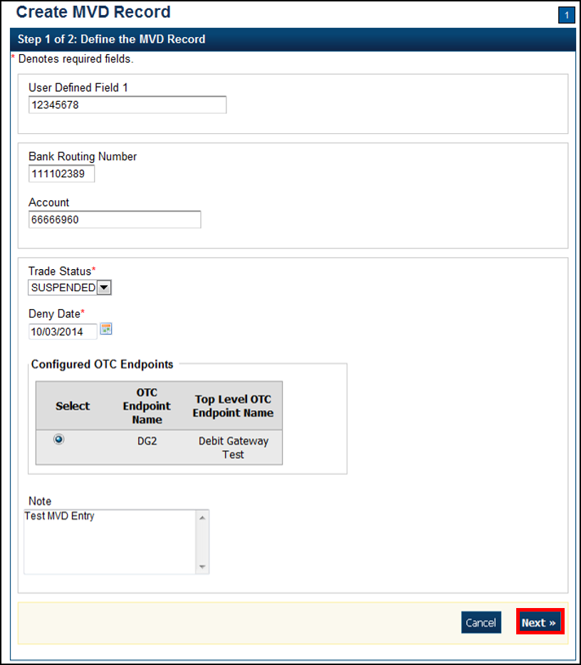
- Enter the MVD details and select Next.
  - Enter the User Defined Field details
  - Select the Search Type
  - Enter the Bank Routing Number, required
  - Enter the Account number
  - Select the Trade Status, required
  - Enter the Deny Date, required
  - Select the OTC Endpoint, required
  - Enter comments in the Note
Application Tips

- A trade status of Blocked or Denied automatically defaults to the Deny Date of 9/09/2099 and the date cannot be modified.
- The Deny Date indicates the date when the suspension period ends. The Deny Date must be greater than or equal to today's date.

- The Step 2 of 2: Create MVD Record page appears. Verify the information is correct and select Submit. Select Edit to modify the information entered.
- A Confirmation page appears stating that the MVD Record has been created.

Additional Buttons
- Select Cancel to return to the OTCnet Home Page. No data is saved.
- Select Clear to clear all data fields and reset to the default selections.
- Select Previous to return to the previous page.
- Select Return Home to the OTCnet Home Page.

Topic 3 Search an MVD Record
As an MVD Editor or MVD Viewer, you are authorized to search for MVD records. The MVD supports the agency by determining the history of a particular check writer. The verification database is an optional online database that maintains the agency hierarchy check cashing policy, dishonored check information, and manually entered blocked items based on an agency’s policy.
Since the MVD can potentially contain thousands of records, the ability to clearly define your search results provides better system results. Search for data by OTC Endpoint, Individual Reference Number (IRN), and other search criteria. If you run a search without specifying any criteria other than OTC Endpoint, the search results include all records in the system that you have access to view. To limit a search, enter the search criteria as shown in Table 3.
Table 3: Search Results
OTC Endpoint
Individual Reference Number (IRN)
User Defined Field
Search Type
Bank Routing Number
Account Number
Trade Status (Blocked, Denied, Suspended, Cleared, D-Suspended)
From and To MVD Date

Search an MVD Record
To search an Master Verification Database (MVD) Record, complete the following steps:
- From the Check Processing tab, select Manage Verification>Search MVD Record. The Step 1 of 4: Search MVD Record page appears as shown in Figure 4.
Figure 4: Search MVD Records
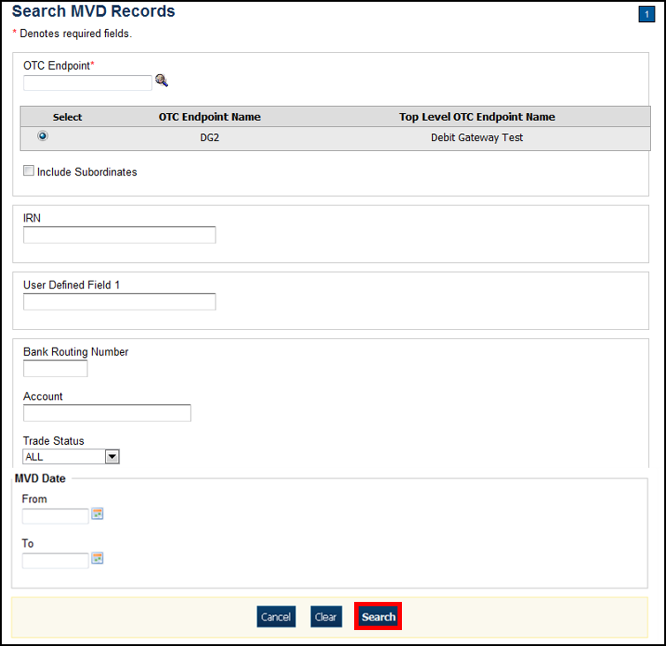
- Enter the MVD search criteria and select Search.
- Enter the OTC Endpoint, required
- Check Include Subordinates
- Enter the IRN (Individual Record Number)
- Enter the User Defined Field information
- Select the Search Type
- Enter the Bank Routing Number
- Enter the individual’s Account number
- Select the Trade Status
- Enter the From and To MVD Date
Application Tip

The From and To MVD Date is the date that the returned record was created in the MVD.

- Select Search to initiate the search. The records appear in a table.
- Select the IRN link of the check details you would like to view. The Step 2 of 4: Review the MVD Record page appears.
- Review the verification record details. Select Edit to modify the MVD record.
Additional Buttons
- Select Cancel to return to the OTCnet Home Page. No data is saved.
- Select CIRA Detail to display CIRA details (Visible only if is a CIRA record exists.)
- Select Edit to update the MVD record.
- Select Previous to return to the previous page.
- Select Return Home to the OTCnet Home Page.

Topic 4 Edit an MVD Record
As an MVD Editor, you can edit MVD records. Before editing an MVD record, you must first search for the record. Once the record is located, you can edit or update the following for a verification record:
- Trade Status (Cleared, Suspended, Denied, Blocked)
- Deny Date
- Return Reason Code
- Note (reason for suspending, denying, or blocking)
You are also authorized to clear a record’s Trade Status. A Clear Trade Status indicates that prior restrictions on the individual check payments are removed.

Edit an MVD Record
To edit an Master Verification Database (MVD) record, complete the following steps:
- From the Check Processing tab, select Manage Verification>Search MVD Record. The Step 1 of 4: Search MVD Record page appears.
- Enter the MVD search criteria and select Search.
- Enter the OTC Endpoint, required
- Check Include Subordinates, optional
- Enter the IRN (Individual Record Number)
- Enter the User Defined Field, optional
- Select the Search Type, optional
- Enter the Bank Routing Number, optional
- Enter the individual’s Account number, optional
- Select the Trade Status, optional
- Enter the From and To MVD Date, optional
Application Tip

The From and To MVD Date is the date that the returned record was created in the MVD.

- Select Search to initiate the search. The records appear in a table.
- Select the IRN hyperlink for the check whose details you would like to view. The Step 2 of 4: Review the MVD Record page appears.
- Select Edit to edit the MVD record. The Step 3 of 4: Edit the MVD Record page appears as shown in Figure 5. Edit the appropriate details.
Figure 5. Edit Verification Record
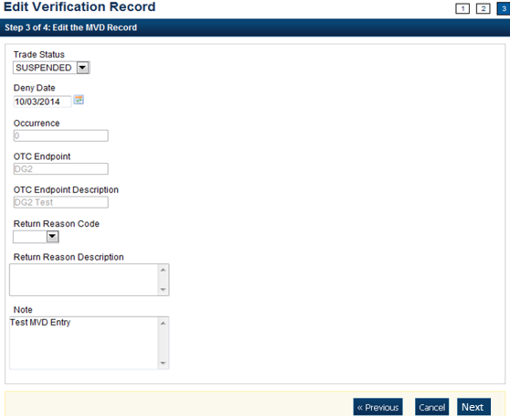

- Select Next.
- Select the Trade Status
Application Tip

A Cleared Trade Status removes the Deny Date from the verification record and accepts the record into the system.

- Enter the Deny Date
Application Tips

- The Deny Date indicates the date when the suspension period ends.
- The Deny Date must be greater or equal to today's date and is mandatory for a Suspend Trade Status.
- The Deny Date for a Denied and Blocked trade status defaults to 9/09/2099.

- Select a Return Reason Code
Application Tip

The Return Reason Description is not editable and appears after a Return Reason Code is selected.

- Enter a Note referencing the reason for suspending, denying, or blocking the record.
- The Step 4 of 4: Review the edited MVD Record. Verify the verification record information is correct and select Submit. Select Edit to modify the information entered.
- A Confirmation page appears stating that the MVD record has been updated.
Additional Buttons
- Select Cancel to return to the OTCnet Home Page. No data is saved.
- Select CIRA Detail to display CIRA details. (Visible only if is a CIRA record exists.)
- Select Edit to update the MVD record.
- Select Previous to return to the previous page.
- Select Return Home to the OTCnet Home Page.

Summary
In this chapter, you learned:
- The purpose of managing verification records (MVD/LVD) records
- How to create an MVD record
- How to search for an MVD record
- How to edit an MVD record

