

Chapter 6. Viewing Financial Institutions
OTCnet Participant User Guide

Table of Contents
Overview, Topics, and Audience 1
Overview 1
Topics 1
Audience 1
Topic 1 Viewing a Financial Institution 2
View a Financial Institution 3
Summary 5

List of Figures
Figure 1. View FRB Detail 3
Figure 2. View Financial Institution Detail 4

Glossary
Click this link to access the full OTCnet Glossary.

Overview, Topics, and Audience

Overview
Welcome to Viewing Financial Institutions. In this chapter, you will learn:
- How to view a financial instruction

Topics
The topic in this chapter is: Viewing Financial Institutions.

Audience
The intended audience for the Viewing Financial Institutions Participant User Guide includes:
- Financial Institution (FI) Confirmer
- Federal Reserve Bank (FRB) Confirmer
- FI Viewer
- FRB Viewer

Topic 1 Viewing a Financial Institution
Financial Institution (FI) Confirmers, Federal Reserve Bank (FRB) Confirmers, FI Viewers and FRB Viewers are authorized to locate and view financial institution details. You can only view a financial institution with an Active status.
Viewing a financial institution allows you to see related details, including the following:
- Institute Information
- Routing Transit Numbers (RTN) and Status
- CA$HLINK II Account Number (CAN)/Account Key Relationships

View a Financial Institution
To view a Financial Institution (FI), complete the following steps:
- From Administration, select Manage FI>Financial Institution>View.
- The View the Financial Institution page appears. View details for financial institutions as shown in Figure 1 and Figure 2.
Figure 1. View FRB Detail
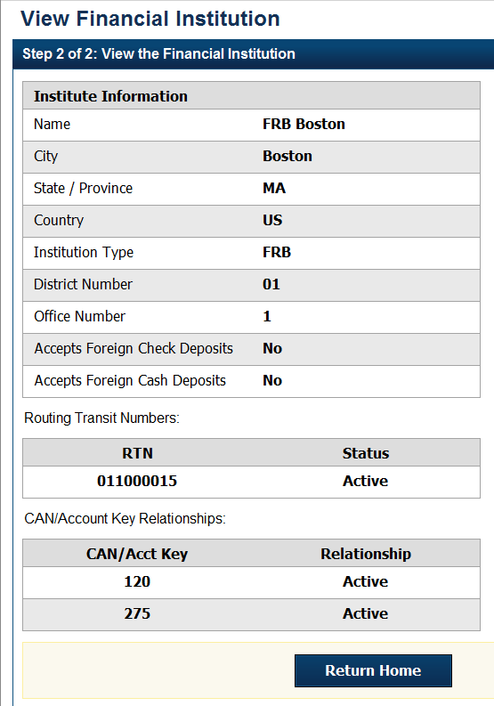
Figure 2. View Financial Institution Detail
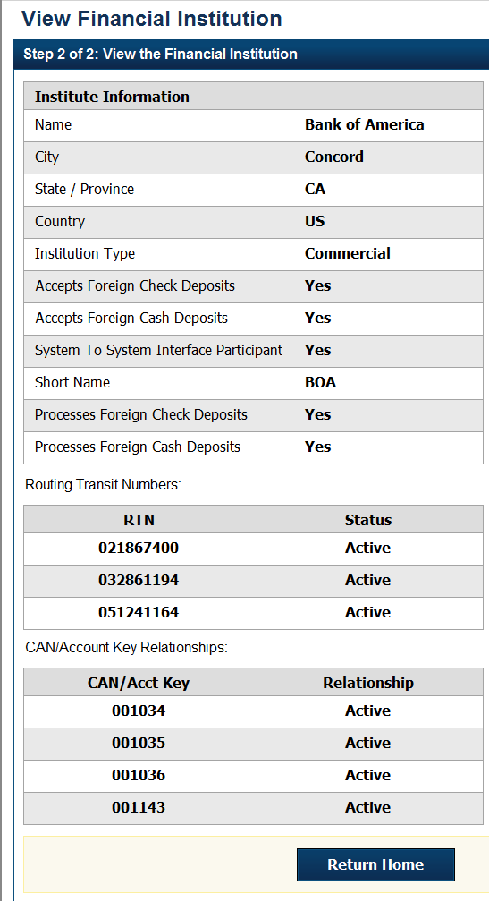
Application Tip

FI Confirmers, Federal Reserve Bank (FRB) Confirmers, FI Viewers, and FRB Viewers are authorized to view Institution Information, Routing Transit Numbers (RTN) and Status and CAN/Acct Key Relationships.


Additional Button
Click Return Home to return to the OTCnet Home Page.

Summary
In this chapter, you learned how to view a financial institution.

