

Chapter 2: Accessing and Navigating OTCnet
OTCnet Participant User Guide

Table of Contents
Overview, Topics, and Audience 1
Overview 1
Topics 1
Audience 1
Topic 1 Starting and Stopping the OTCnet Local Bridge (OLB) Application 2
Start and Stop the OTCnet Local Bridge (OLB) Application 2
Start and Stop the OTCnet Local Bridge (OLB) Application 4
Topic 2 Requesting Access for Yourself in SailPoint IIQ 6
Self-Register/Create an Account in SailPoint IIQ 6
Self-Register/Create an Account in SailPoint IIQ 7
Request Access for Yourself in SailPoint IIQ 8
Request Access for Yourself in SailPoint IIQ 9
Topic 3 Logging in to OTCnet Online 12
Log in to OTCnet Online 12
Log in to OTCnet Online 13
Topic 4 Navigating the OTCnet Online Home Page 15
OTCnet Online Main Menu 15
OTCnet Online Deposit Processing Tab Functionality 17
OTCnet Online Check Processing Tab Functionality 18
OTCnet Online Card Processing Tab Functionality 18
OTCnet Online Administration Tab Functionality 19
OTCnet Online Reports Tab Functionality 21
Summary 22

List of Figures
Figure 1. Stop OTCnet Local Bridge Icon 4
Figure 2. SailPoint IIQ Login Page 7
Figure 3. SailPoint Home Page with Manage My Access Button 9
Figure 4. Add Access Screen 10
Figure 5. Review and Submit Screen 10
Figure 6. OTCnet Login Screen 13
Figure 7. First Time Log In Screen 14
Figure 8: OTCnet Main Menu Page 15
Figure 9. OTCnet Homepage Message Overlay 16
Figure 10: Treasury OTC Support Contact Form 16
Figure 11. Deposit Processing Tab 17
Figure 12. Check Processing Tab 18
Figure 13. Card Processing Tab 19
Figure 14. Administration Tab 20
Figure 15. Manage Reports 21

List of Tables
Table 1. Main Menu Link Descriptions 15
Table 2. Deposit Processing Tab Descriptions 17
Table 3. Check Processing Tab Descriptions 18
Table 4. Card Processing Tab Descriptions 18
Table 5. Administration Tab Descriptions 19
Table 6. Reports Tab Descriptions 21

Glossary
Select this link to access the full OTCnet Glossary.

Overview, Topics, and Audience

Overview
Welcome to Accessing and Navigating OTCnet. In this chapter, you will learn how to:
- Start and stop the OTCnet Local Bridge (OLB) application
- Request access for yourself in SailPoint IIQ
- Log in to OTCnet Online
- Navigate the OTCnet Online home page

Topics
The topics in this chapter include the following:
- Starting and Stopping the OTCnet Local Bridge (OLB) Application
- Requesting Access for Yourself in SailPoint IIQ
- Logging in to OTCnet Online
- Navigating the OTCnet Online Home Page

Audience
The intended audience for the Accessing and Navigating OTCnet Participant User Guide includes:
- All OTCnet users

Topic 1 Starting and Stopping the OTCnet Local Bridge (OLB) Application
The OTCnet Local Bridge (OLB) application is required for terminal detection and performing check capture, check processing and card processing tasks. If a user logs in to perform one of these operations and the OLB application is not started, the user receives the following message: Terminal detection failed. Please ensure that the OLB application is running. The OLB application is also required if you are using the Deployable Disbursing System (DDS) interface (Department of Defense [DoD] only).
If you are a Check Capture Administrator, Check Capture Supervisor, Check Capture Lead Operator, Check Capture Operator, Card Operator or Card Administrator, the OLB application must be started on the terminal to perform terminal configuration, check capture, check processing, and card processing tasks.
Before starting the OLB application, ensure the following steps are completed in this order:
- The Check Capture Administrator and Card Administrator downloaded the OLB application.
- The OLB application is installed on the terminal.
- Each user has created an OLB profile, ensuring that the OLB credential file was not renamed (the file name remained the same as it was generated).
- Each user has imported his/her OLB credentials to the terminal.
There is no “timeout” with the OLB application (i.e., a suspension or break in OTCnet activity). Therefore, the OLB application stays connected unless one of the following occurs:
- The user logs out of the terminal (Windows session).
- The terminal is restarted or rebooted.
- The user stops the OLB application on the terminal.
When using Microsoft Edge or Google Chrome:
- Ensure the latest version of the OLB is installed.

Start and Stop the OTCnet Local Bridge (OLB) Application
All users are authorized to start and stop the OTCnet Local Bridge (OLB) application.
To start the OLB application, either double-click the Start OTCnet Local Bridge icon on your terminal desktop or select Start>Programs>Start OTCnet Local Bridge.
If the Start OTCnet Local Bridge icon does not reside in either location, contact your Card Administrator or Check Capture Administrator. They will support your completion of the following steps:
- Ensure the latest version of the OLB is installed.
- Create your OLB profile.
- Import your OLB credentials.
If the OLB application is started on the terminal, you will receive an OTCnet Local Bridge Application is already running message.
When the OTCnet Local Bridge Startup page appears, enter your OTCnet User ID and Password in the appropriate text boxes. (Users will continue to use their User IDs to log in to OLB. They will not use their PIV/CAC or ID.me accounts).
Password Criteria includes the following. Your password must meet the following criteria:
- Be at least 12 characters long
- Not have more than two repeating characters
- Not repeat any of your last ten passwords
- Not have been your password during the last ten days
- Not be a word in a language, slang, dialect, or jargon
- Not be related to personal identity, history, environment, or other personal associations
To stop the OLB, double-click the Stop OTCnet Local Bridge icon located on the terminal desktop or select Start>Programs>Stop OTCnet Local Bridge.

Start and Stop the OTCnet Local Bridge (OLB) Application
To start the OTCnet Local Bridge (OLB) application, complete the following steps:
- Double-click the Start OTCnet Local Bridge icon located on the terminal desktop.
Or
Select Start>Programs>Start OTCnet Local Bridge
- The OTCnet Local Bridge Startup page appears. Enter your OTCnet User ID and Password in the appropriate text boxes.
- Select Log In. A Login Successful. OTCnet Local Bridge Application Started message appears.

- Select Cancel and the Are you sure you want to exit message appears.
- Select Yes to cancel the OLB startup.
- Select No to return to the OTCnet Local Bridge Startup page.

- Select OK.
Application Tip

Once you start the OLB application, proceed to log in to OTCnet Online.

- To stop the OLB application, double-click the Stop OTCnet Local Bridge icon located on the terminal desktop as shown in Figure 1.
Figure 1. Stop OTCnet Local Bridge Icon

Or
Select Start>Programs>Stop OTCnet Local Bridge.
- When the Stop OTCnet Local Bridge window and the Are you sure you want to stop the OTCnet Local Bridge Application? message appears, select Yes.
Application Tips

- If you select No, the Are you sure you want to stop the OTCnet Local Bridge Application? message closes, and the OLB application remains running.
- Stopping the OLB application ensures the application is completely closed and that your OTCnet session is securely terminated.
- Before uninstalling the OLB application, you must first stop the OLB application. If the OLB application has been started on the terminal, ensure that it is stopped before uninstalling the application.

Topic 2 Requesting Access for Yourself in SailPoint IIQ
Following the transition to Common Approach to Identity Assurance (CAIA), the SailPoint IdentityIQ (IIQ) environment will be used to manage the identities and provisioning of new users.
CAIA is a solution consisting of a common federation platform by which users seeking access to Fiscal Service programs will be able to register, proof, and authenticate their identity via one or more selected credential service providers.
Prospective OTCnet users can create identities through Personal Identity Verification Cards (PIV), Common Access Cards (CAC), or ID.me.
As a prospective OTCnet user, you can select your desired role(s) and high-level organization(s) based on instructions from your security administrator(s).

Self-Register/Create an Account in SailPoint IIQ
You can self-register in SailPoint IIQ and create an account using PIV/CAC or ID.me.
This functionality is available to all users but is not the preferred method for registering through SailPoint IIQ. The preferred option is for Primary Local Security Administrators or Local Security Administrators (PLSAs/LSAs) to assist with creating an identity for a user and/or requesting an HLO or role access for them in SailPoint IIQ.
Follow the on-screen instructions to sign in with an existing account or create an account. If prompted, follow the on-screen instructions to verify your identity. After completing all steps, you should see the SailPoint IIQ home page.

Self-Register/Create an Account in SailPoint IIQ
To self-register in SailPoint IIQ, navigate to the SailPoint IIQ environment at: https://iiq.fiscal.treasury.gov/ and complete the following steps:
- Log in using PIV/CAC or ID.me credentials as shown in Figure 2.
Figure 2. SailPoint IIQ Login Page
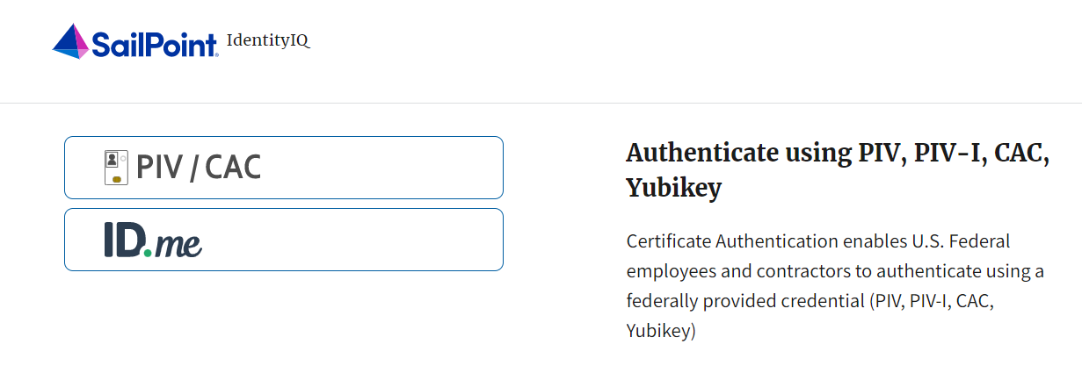
- Follow the on-screen instructions to sign in with an existing account or create an account.
- If prompted, follow the on-screen instructions to verify your identity.
- After completing all steps, you should see the SailPoint IIQ home page.
Application Tip

New OTCnet users including those with PIV/CAC access can go through SailPoint IIQ to do the self-registration to create an account and request role(s) and high-level organization(s) before logging in to OTCnet. Once their high-level access is approved in SailPoint IIQ, they can proceed to log in to OTCnet.

Request Access for Yourself in SailPoint IIQ
If you need application entitlement, you can sign in to SailPoint IIQ and request the specific access you need (self-request).
To request access for yourself, log in to SailPoint IIQ and navigate to Manage My Access. Make sure Add Access is selected. In the search field, enter part or all of the HLO/role name you want to request. Select the HLO/role by selecting the checkmark to the left of the HLO/role name. Then select Next. On the Review and Submit screen, verify the requested HLO/role(s) are correct and select the Submit button.
A confirmation message will appear. SailPoint IIQ will automatically notify the necessary approvers to review the request. Once approved, your PLSA/LSA can create your identity in OTCnet and assign endpoints and roles for you. You will receive an autogenerated email when your user account is created in OTCnet.

Request Access for Yourself in SailPoint IIQ
To request access for yourself in SailPoint IIQ, complete the following steps:
- From the Home screen of SailPoint, navigate to Manage My Access through the Manage MyAccess button as shown in Figure 3.
Figure 3. SailPoint Home Page with Manage My Access Button
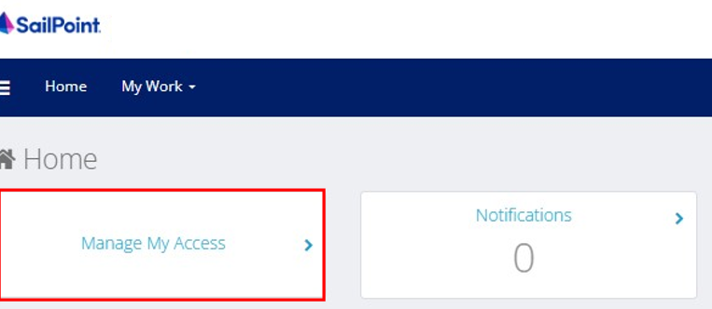
- On the Manage My Access screen, ensure that the Add Access tab is selected as shown in Figure 4.
Application Tips

Search for the specific HLO name (e.g., Alaska USA Federal Credit Union) and user role (e.g., Check Capture Operator). If the HLO or user role’s name is not known, type HLO/Role in the search field.

- Search for an HLO. Select an HLO by selecting the checkmark to the left of the HLO’s name.
- Continue on the same screen to search for a user role. Select a role by selecting the checkmark to the left of the role’s name. Then select Next.
Application Tips

- Multiple HLOs and roles can be selected.
- All roles selected in SailPoint IIQ will be validated (and edited as needed) in OTCnet by the designated PLSA/LSA.

Figure 4. Add Access Screen
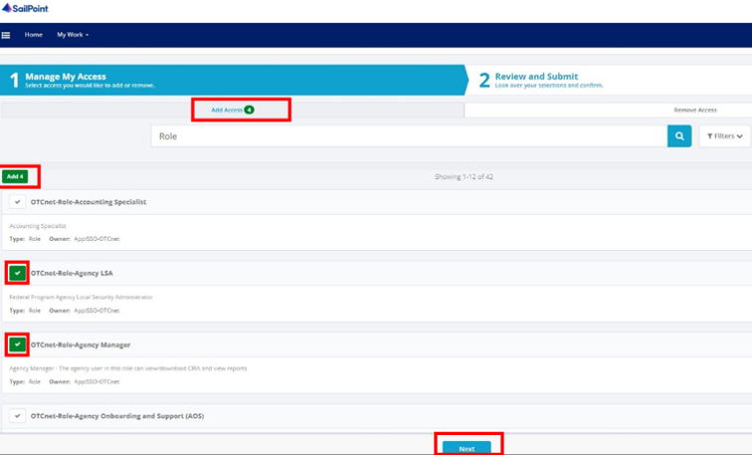
- On the Review and Submit screen, verify the requested HLOs and role(s) are correct. Select the voice bubble to the right of the HLO or role to add any comments.
- Select the Submit button at the bottom of the screen when finished, as shown in Figure 5.
Figure 5. Review and Submit Screen
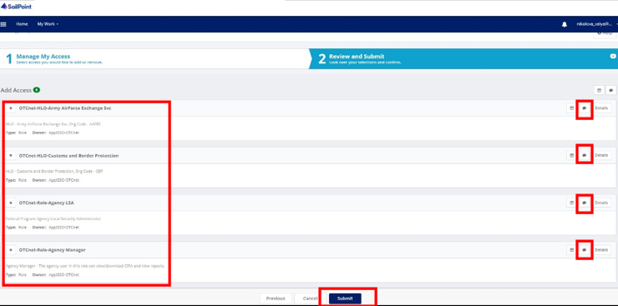
- A confirmation message will appear. SailPoint IIQ will automatically notify the necessary approvers to review the request. Once approved, your PLSA/LSA can create your identity in OTCnet and assign endpoints and roles for you.
Application Tips

- You will receive an autogenerated email when your user account is created in OTCnet.
- Then you can access the OTCnet application.

Topic 3 Logging in to OTCnet Online
To log in to Fiscal Service Single Sign On (OTCnet Online) from the OTCnet Online login screen, use your PIV/CAC credentials if you are a government user or contractor, or ID.me if you are a non-government user.
If you are a non-government user who creates an account through ID.me, you will specify your email address associated with OTCnet. ID.me is a private single sign-on provider that meets the government’s online identity proofing and authentication requirements.
Accounts registered by users for CAIA authentication are not application-specific, the same account credentials can be used on other sites or applications that are linked to CAIA. For example, Social Security Administration, Internal Revenue Service, Department of Veterans Affairs, and other government agencies accept ID.me credentials for logging in.

Log in to OTCnet Online
To log in to OTCnet Online, visit https://otcnet.for.fiscal.treasury.gov and log in with the following options: PIV/CAC or ID.me. Select the option that suits you best and follow the on-screen instructions to verify your identity or create an account in SailPoint IIQ.
Once you log in to OTCnet, you will be able to access functionality for one or more of the following:
- Administration
- Deposit Processing and Reporting
- Check Capture
- Check Processing
- Card Processing
The OTCnet Local Bridge (OLB) application is required for performing check processing, check capture, card processing and terminal configuration operations. If you are a Check Capture Administrator, Check Capture Supervisor, Check Capture Lead Operator, Check Capture Operator, Card Operator or Card Administrator, the OLB application must be started on the terminal to perform these operations.
Once a new, first-time OTCnet agency end-user has been fully provisioned with roles and endpoints, the first time they log in to OTCnet, they will receive an autogenerated email ‘Welcome to OTCnet!’ that includes a list of resources to learn how to use OTCnet as well as important contact information to get acclimated to everything that OTCnet has to offer.

Log in to OTCnet Online
To log in to Fiscal Service Single Sign-On (OTCnet Online), complete the following steps:
- Access https://otcnet.for.fiscal.treasury.gov. A page is presented which displays the following login options: PIV/CAC and ID.me, as shown in Figure 6.
Figure 6. OTCnet Login Screen
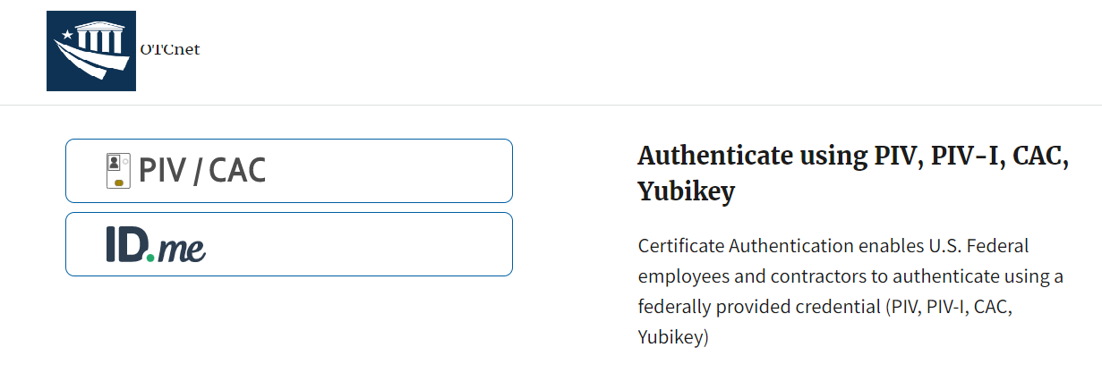
- Select the option that best represents your status and follow the on-screen instructions.
Application Tips
Application Tips

PIV/CAC (Government Users/Contractors)
- Select the PIV/CAC button.
- If prompted, select your certificate and enter your PIN. If prompted, follow the on-screen instructions to verify your email address.
The first time a PIV/CAC certificate is used to authenticate, the email verification process is initiated.
- A web page is displayed prompting you to submit the email address that will be associated with your certificate. A verification code is sent to the email address specified.
- A web page is displayed to allow you to input the verification code from the email.
ID.me for Non-Government Users
- Select the ID.me button.
- Follow the on-screen instructions to sign in with an existing account or create an account. If prompted, follow the on-screen instructions to verify your identity.
- Use your work email address to create initially your ID.me identity. It is still recommended to add your personal email to your ID.me identity.

- When you log in to OTCnet Online for first time you may be alerted that you are not permitted to access the application until your agency’s security administrator completes your user provisioning in OTCnet, as shown in Figure 7.
- Once your agency’s security administrator has imported your user identity to OTCnet and assigned endpoints and roles for you, you will be able to access the application.
Figure 7. First Time Log In Screen
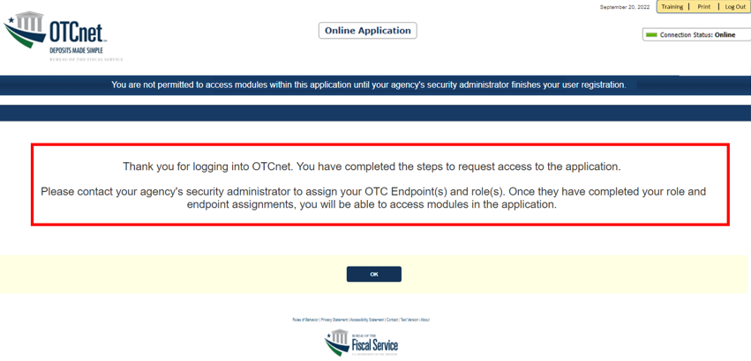
- To completely log out, close your browser. You will need to reauthenticate the next time you log in to OTCnet.
Application Tip

Ensure that you log in to OTCnet at least once every 120 days (or four months). Your user account will be disabled after 120 consecutive days of inactivity. To restore your account, contact the Customer Support Team to begin the process.

Application Tip

If you are a Check Capture Administrator, Check Capture Supervisor, Check Capture Lead Operator, Check Capture Operator, Card Operator or Card Administrator, and use Microsoft Edge or Google Chrome when logging in to OTCnet Online, you will not see the OTCnet splash screen. Instead, the system automatically displays the OTCnet Homepage Message Overlay.

Topic 4 Navigating the OTCnet Online Home Page
The OTCnet Online home page allows Check Capture Supervisors, Check Capture Lead Operators, Check Capture Operators and Card Operators to process deposits, capture checks, process checks, process card transactions, view reports, and perform administrative and security functions. Additionally, a user can access information for training, help and to update a user profile. The OTCnet Online home page is accessible for users to either view or perform any of these functionalities.

OTCnet Online Main Menu
To access the OTCnet Main Menu, log in with your PIV/CAC or ID.me credentials at the following URL: https://otcnet.for.fiscal.treasury.gov. Table 1 provides a list of the Main Menu options available to you. They are accessible on the upper right corner of the OTCnet application.
Table 1. Main Menu Link Descriptions
Link | Description
Home | Allows a user to return to the OTCnet home page.
Training | Allows a user to access Web-Based Training (WBT) and other corresponding training materials.
Print | Allows a user to print the page.
Help | Allows a user to access help for the page they are on.
Log Out | Allows a user to log out of OTCnet.

The Main Menu is shown in Figure 8. The links are accessible on the upper right side of the OTCnet home page.
Figure 8: OTCnet Main Menu Page
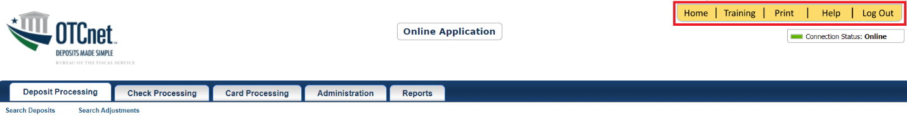

OTCnet Homepage Message Overlay
All user roles have access to the OTCnet Homepage Message Overlay in OTCnet Online. For all Microsoft Edge and Google Chrome users, the message overlay automatically presents when you first log in to OTCnet.
The message overlay is a messaging platform presenting important news and information on the OTCnet system as shown in Figure 9. It is recommended that you read the messages, close the message overlay, and continue viewing the OTCnet homepage.
Figure 9. OTCnet Homepage Message Overlay
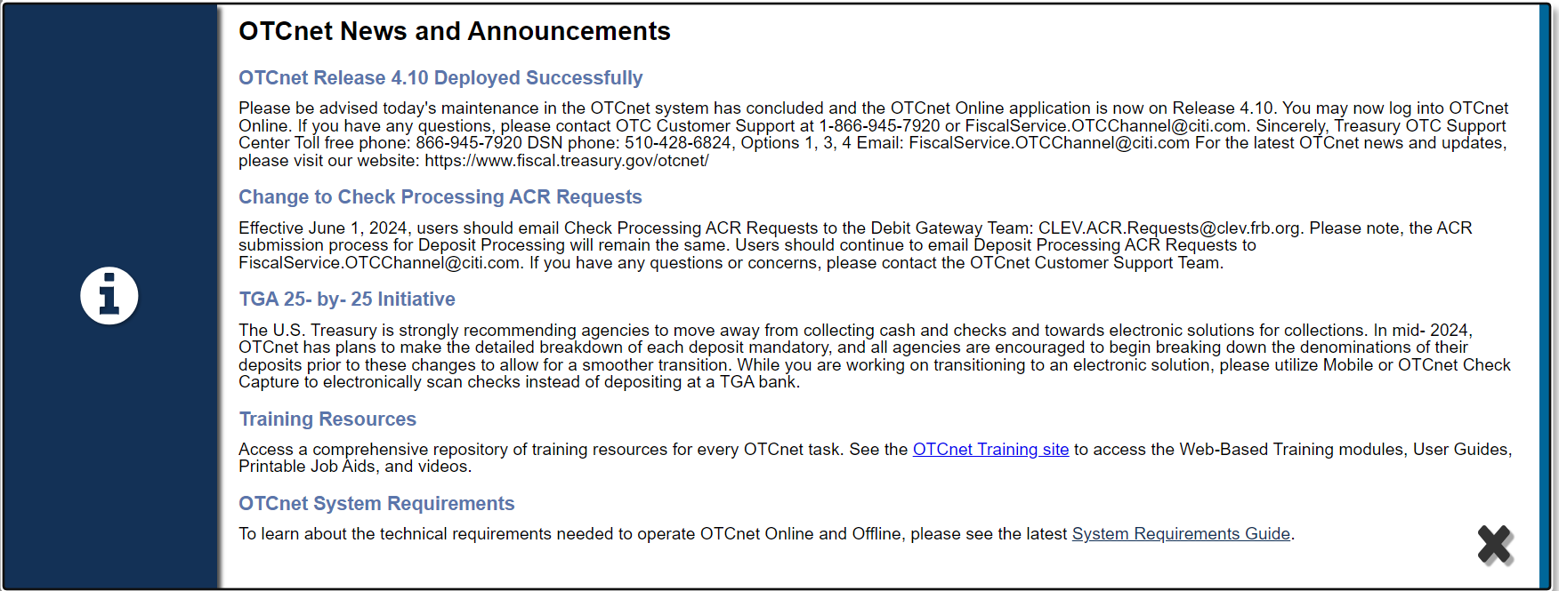

OTCnet Support Contact Overlay
Users can contact the OTCnet Customer Service team by submitting a form through the Customer Support button on the OTCnet homepage. This feature helps to standardize and streamline the inquiries and requests made to Customer Service. Select the Customer Support button on the bottom of the OTCnet homepage. The Treasury OTC Support Contact overlay appears over the homepage as shown in Figure 10.
Figure 10: Treasury OTC Support Contact Form
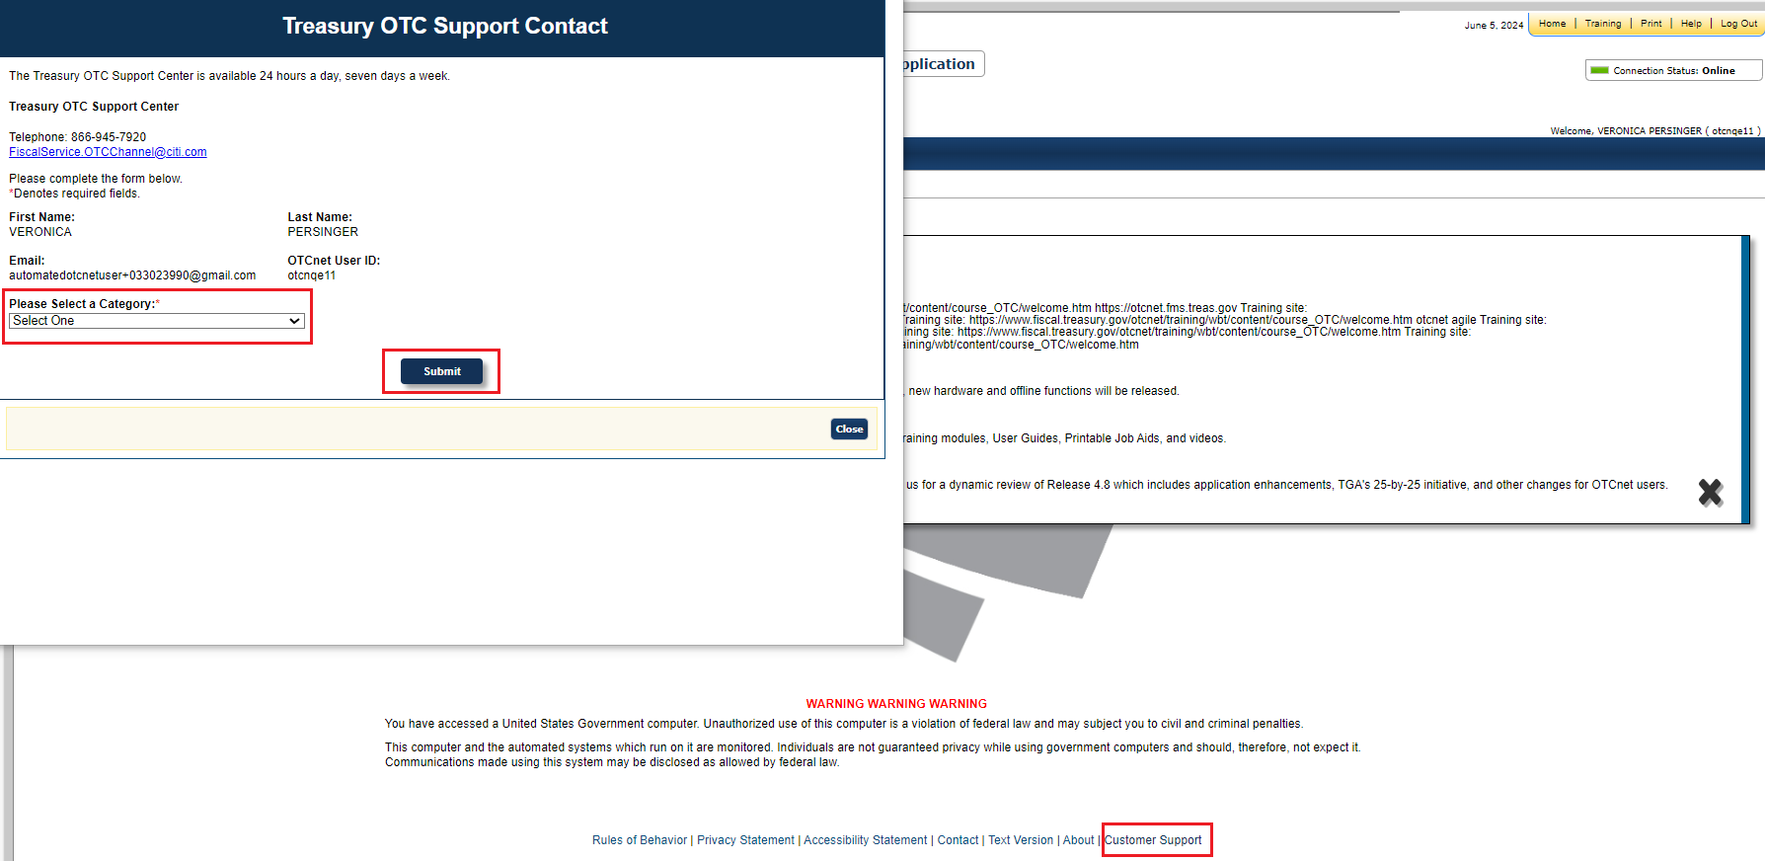
Select the Please Select a Category dropdown. The following options appear:
- Batch Management
- Check Scan
- Deposit Processing
- OTCnet Local Bridge (OLB)
- User Management
- Other
After you make the selections, select the Submit button to submit the request.

OTCnet Online Deposit Processing Tab Functionality
To access the OTCnet Deposit Processing functionality, log in with your PIV/CAC or ID.me credentials. Table 2 provides a list of the Deposit Processing functions that are available to you.
Table 2. Deposit Processing Tab Descriptions
Function | Description
Create Deposit | Allows a user to create deposits for US Currency, Foreign Check Items, and/or Foreign Currency Cash.
Search Deposits | Allows a user to search for deposits.
Search Adjustments | Allows a user to search for adjustments.
Create Returned Item Adjustment | Allows a user to create a returned item adjustment.
The Deposit Processing tab, as shown in Figure 11, allows you to access Deposit Processing functionality, although depending on your user role, you may not see all functionality.
Figure 11. Deposit Processing Tab
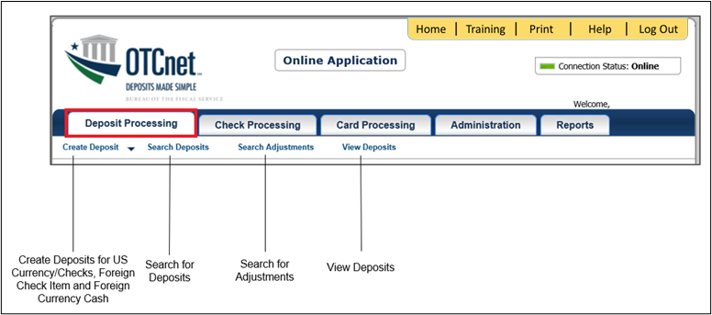

OTCnet Online Check Processing Tab Functionality
To access the OTCnet Check Processing functionality, log in with your PIV/CAC or ID.me credentials. Table 3 provides a list of the Check Processing functions that are available to you.
Table 3. Check Processing Tab Descriptions
Function | Description
Manage Verification | Allows a user to search and/or create an MVD record.
CIRA Query | Allows a user to view and/or modify a CIRA record.
Batch Management | Allows a user to search, view, close, approve and submit a batch. A user may edit and void an item within a batch with the proper permission.
Check Scan | Allows a user to scan checks.
The Check Processing tab is shown in Figure 12. Depending on your user role, you may not see all functionality shown in the image.
Figure 12. Check Processing Tab
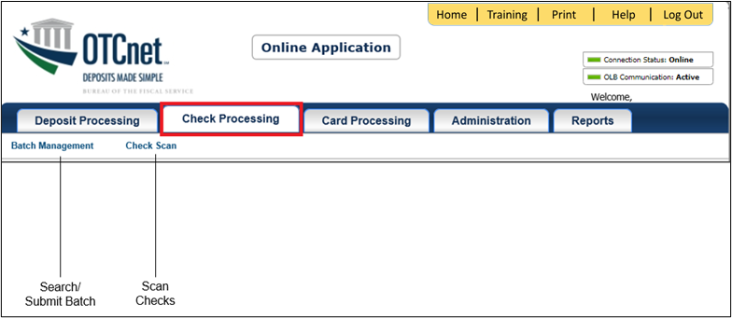

OTCnet Online Card Processing Tab Functionality
To access the OTCnet card processing functionality, log in with your PIV/CAC or ID.me credentials. Table 4 provides a list of the card processing functions that are available to you.
Table 4. Card Processing Tab Descriptions
Function | Description
Card Transaction Query | Allows a user to query a card transaction.
Process Card Payment | Allows a user to process a card payment.
The Card Processing tab is shown in Figure 13. Depending on your user role, you may not see all functionality shown in the image.
Figure 13. Card Processing Tab
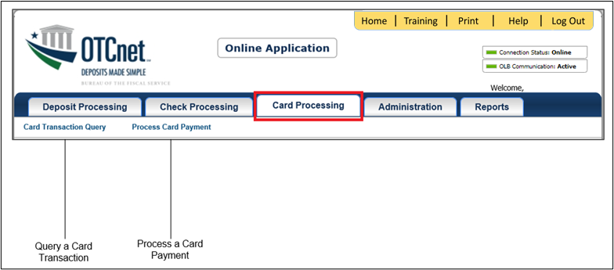

OTCnet Online Administration Tab Functionality
To access the OTCnet Administration functionality, log in with your PIV/CAC or ID.me credentials. Table 5 provides a list of the Administration functions that are available to you.
Table 5. Administration Tab Descriptions
Function | Description
Manage Organizations | Allows a user to manage Organization Hierarchy, Accounting Codes, Custom Labels, Processing Options, and User Defined Fields.
Manage FI | Allows a user to create and/or modify a Financial Institution, transfer FI RTN Numbers, transfer CA$HLINK accounts, and maintain FRB CA$HLINK accounts.
Manage Users | Allows a user to manage OTCnet user accounts and profiles.
Management | Allows a user to manage OTCnet processes.
Manage Check Processing | Allows a user to manage terminal configuration and forms.
Manage Card Processing | Allows a user to manage terminal configuration.
Manage Centralized Deployment | Allows users access to the following: Release Configuration, Edit Release and Download Release.
Audit | Allows a user to review the audit log history.
Utilities | Allows a user to review batch utilities, including Batch Recreate and Batch Repair.
The Administration tab is shown in Figure 14. Depending on your user role, you may not see all functionality shown in the image.
Figure 14. Administration Tab
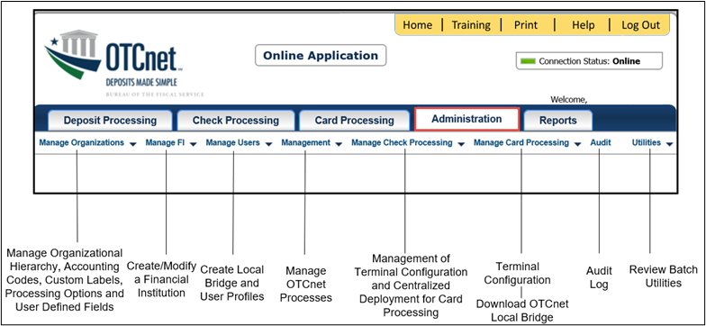

OTCnet Online Reports Tab Functionality
To access the OTCnet Reports functionality, log in with your PIV/CAC or ID.me credentials. Table 6 provides a list of the Reports functions that are available to you. Depending on your user role, you are only authorized to view and download certain reports.
Table 6. Reports Tab Descriptions
Function | Description
Deposit Processing Reports | Allows a user to view and download Business, Security and Administration reports.
Check Processing Reports | Allows a user to access Check Processing reports.
Scheduled Reports | Allows a user to query and download scheduled reports.
The Reports tab is shown in Figure 15. Depending on your user role, you may not see all functionality shown in the image.
Figure 15. Manage Reports
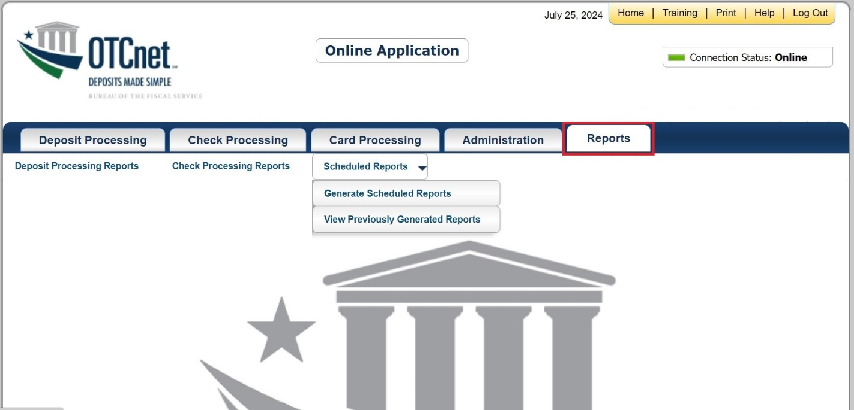

Summary
In this chapter, you learned how to:
- Start and stop the OTCnet Local Bridge (OLB) application
- Request access for yourself in SailPoint IIQ
- Log in to OTCnet Online
- Navigate the OTCnet Online home page

