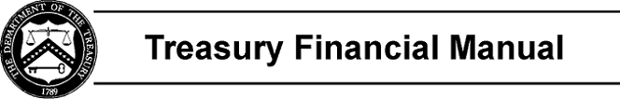

Part 1, Section VII: GTAS Validations and Edits

One of the goals the Bureau of the Fiscal Service (Fiscal Service) has envisioned for GTAS is to improve the consistency in agency trial balance reporting. This will be accomplished through validations and edits.

The validations ensure that the attributes reported in agencies’ GTAS trial balance submissions are valid for the USSGL account. The validations encompass both USSGL level attributes per the USSGL Attribute Table and Treasury Account Symbol (TAS) level attributes found in the Super Master Account (SMAF).
Simple validations are those involving one attribute while special validations involve more than one attribute. All validations are fatal.

The edits compare the agency trial balances with USSGL rules and with data from authoritative sources such as the Central Accounting Reporting System (CARS), Fiscal Service and the Federal Financing Bank. The edits may be either fatal or proposed. Fiscal Service will use the proposed edits only for analytical purposes. Fiscal Service disclaims any role or responsibility with the agency auditor relationship concerning the GTAS fatal and proposed analytical edits.

The following are the validation and edit reports included in this section:

Section VII | Page Number
GTAS Validation Summary Report (VSR) | VII VSR - 1
GTAS Validation Detail Report (VDR) | VII VDR - 1
GTAS Edits Summary Report (ESR) | VII ESR - 1
GTAS Edits Detail Report (EDR) | VII EDR - 1
GTAS Closing Edits Report (CER) | VII CER - 1

Page 1 of 1

