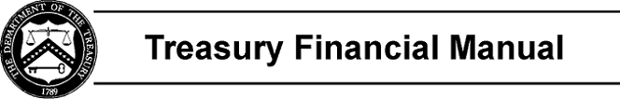

Part 2, Section II: Accounts and Definitions

The account descriptions provide basic information about each USSGL account, including:

Account Title Account Number
Normal Balance of the Account (Debit or Credit) Account Definition

Page 1 of 1

