**Proposed Budgetary Accounts and Transactions (To be Voted on at February 2025 IRC Meeting)**

**FY 25 Modifications**

**Account Title:** Reinstated Undelivered Orders - Obligations, Unpaid

**Account Number:** 480110

**Normal Balance:** Credit

**Definition:** This account is used to reinstate the amount of goods and/or services ordered, which have not been actually or constructively received and for which amounts have not been prepaid or advanced. This USSGL account is only appliable to budget object class 41 for grants and compact agreements.

**Account Title:** Reinstated Delivered Orders - Obligations, Unpaid

**Account Number:** 490110

**Normal Balance:** Credit

**Definition:** This account is used to reinstate the amount accrued or due ~~for: (1) services performed by employees, contractors, vendors, carriers, grantees, lessors, and other government funds; (2) goods and tangible property received; and (3) programs for which no current service performance is required such as annuities, insurance claims, benefit payments, loans, etc~~. This USSGL account is only applicable to budget object class 41 for grants and compact agreements.

**Proposed Accounts and Transactions Effective FY 26**

**Account Title**: Reinstated Undelivered Orders - Obligations, Prepaid/Advanced

**Account Number**: 480210

**Normal Balance**: Credit

**Definition**: This account is used to reinstate the amount of goods and/or services ordered, which have not been actually or constructively received but have been prepaid or advanced.  This USSGL account is only appliable to budget object class 41 for grants and compact agreements.

**Justification:**  This account will provide a mechanism for agencies to record a reinstated undelivered order that has been prepaid or advanced.

**Account Title**: Downward Adjustments of Prior-Year Paid Delivered Orders - Obligations, Non-cash Refunds

**Account Number**: 497210

**Normal Balance**: Debit

**Definition**: This account is used to record the amount of non-cash refunds during the fiscal year resulting from downward adjustments to USSGL account 490200, "Delivered Orders - Obligations, Paid," with a budget object class 41 that were originally recorded in a prior fiscal year.

**Justification:**  This account will provide a mechanism for agencies to record a downward adjustment to a prior-year delivered order with a non-cash refund.

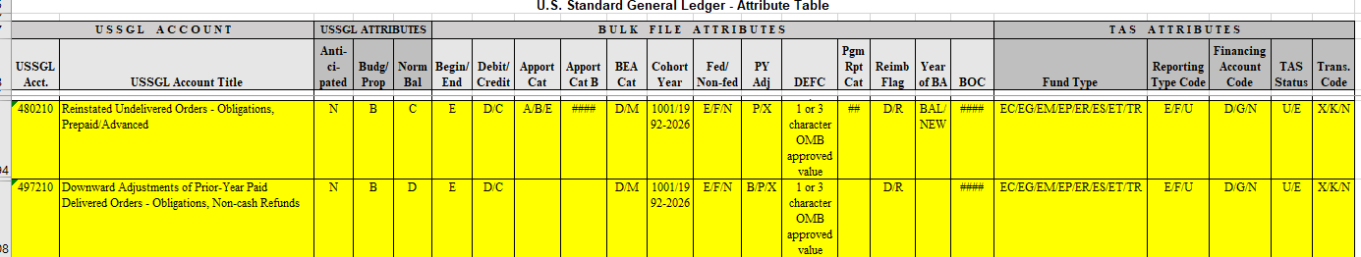

|  |  |  |  |  |  |  |  |  |  |
| --- | --- | --- | --- | --- | --- | --- | --- | --- | --- |
| **USSGL**  **Account** | **Balance**  **Sheet** | **Net**  **Cost** | **Net**  **Position** | **Custodial**  **Activity** | **Reclassified**  **Net Cost** | **Reclassified**  **Net**  **Position** | **SF133** | **Schedule P** | **SBR** |
| **480210**  **(FY 26)** | N/A | N/A | N/A | N/A | N/A | N/A | 1048, 4030,  4033, 4120,  4123 | 1048, 4030,  4033, 4052,  4120, 4123, 4142 | 1071 |
| **497210**  **(FY 26)** | N/A | N/A | N/A | N/A | N/A | N/A | 1020, 1033,  1084, 1089, 4030, 4033, 4053, 4054, 4120, 4123, 4143, 4144 | 1020, 1033, 4030, 4033, 4052, 4053, 4120, 4123, 4142, 4143 | 1071 |

**FY 26 Transaction Additions:**

**D115** To record the reinstatement of a prior-year prepaid or advanced order where an adjustment to the order requires a downward adjustment of a prior-year paid obligation with a non-cash refund.

**Comment:** If funded by direct appropriations also post reversal of B234.

**Budgetary Entry**

Debit 497210 Downward Adjustments of Prior-Year Paid Delivered Orders – Obligations, Non-cash Refunds

Credit 480210 Reinstated Undelivered Orders - Obligations, Prepaid/Advanced

**Proprietary Entry**

None

**F337** To record the closing of reinstated undelivered orders - obligations, prepaid/advanced to undelivered orders - obligations, unpaid.

**Budgetary Entry**

Debit 480210 Reinstated Undelivered Orders - Obligations, Unpaid

Credit 480200 Undelivered Orders - Obligations, Prepaid/Advanced

**Proprietary Entry**

None

**USSGL account 497210 is being added as a credit to closing TC F302.**