Per OMB Circular No. A-11:
1035 Unobligated balance precluded from obligation (limitation on obligations) (-)
In cases where the total budgetary resources are precluded from obligation in a fiscal year by a provision of law (such as a limitation on obligations), unobligated balance of mandatory appropriation or contract authority is also precluded in special and non-revolving trust funds.

Current USSGL account:
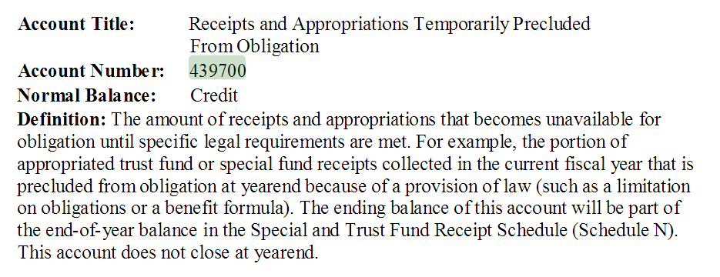

Proposed USSGL Account:
Account Title: Unobligated Balances of Receipts and Appropriations Temporarily Precluded From Obligation
Account Number: 439701
Normal Balance: Credit
Definition: Based on situations where total budgetary resources are precluded from obligation in a fiscal year by a provision of law (such as a limitation on obligations), the amount of unobligated balances of receipts and appropriations that becomes unavailable for obligation until specific legal requirements are met is also precluded in special and non-revolving trust funds.
Justification: To support OMB Circular No. A-11.

TC:
NEW A124 To record unobligated balances of appropriations derived from special or trust fund receipts as temporarily precluded from obligation. For this situation, the appropriation was available for obligation in the previous fiscal year but is not part of an obligation limitation in the subsequent fiscal year.
Comment: The balance in USSGL account 439701 should be reflected as part of the end-of year balance on Schedule N: Special and Trust Fund Receipts Schedule of the Budget of the United States Government. Trust and special funds whose authority is limited to the current year obligations will record this transaction at yearend as a preclosing adjusting entry.

Budgetary Entry
Debit 445000 Unapportioned Authority
Debit 462000 Unobligated Funds Exempt From Apportionment
Credit 439701 Unobligated Balances of Receipts and Appropriations Temporarily
Precluded From Obligation

Attribute Table:
No. | USSGL Account Title | Anticipated | Budg/Prop | Norm Bal | Begin/End | Debit/Credit | Auth Type Code | Apport Cat | Apport Cat B
439701 | Unobligated Balances of Receipts and Appropriations Temporarily Precluded From Obligation | N | B | C | E | D/C

No. | Avail Time | BEA Cat | Borrow Source | Budgetary Impact  Indicator | Cohort Yr | Cust/ Noncust | Exch/ Nonexch | Fed/ NonFed | Trading Ptnr | Trading Ptnr Main | PY Adj | Program Indicator
439701 |  |  |  |  |  |  |  |  |  |  | X

No. | Year of BA | Reduction Type | Fund Type | Reporting Type Code | Financing Account  Code | TAS Status | Trans. Code
439701 |  |  | ES/ET | U | N | U | N

