USSGL 169000 Other Investments

Section I & II – Chart of Accounts & Definitions

Account Title: Other Non-Federal Investments
Account Number: 169000
Normal Balance: Debit
Definition: This account is used to record the value of other non-federal investments owned by a federal entity. This account does not close at year-end.

Section IV – Attribute Table

Section V – Balance Sheet & Schedule P

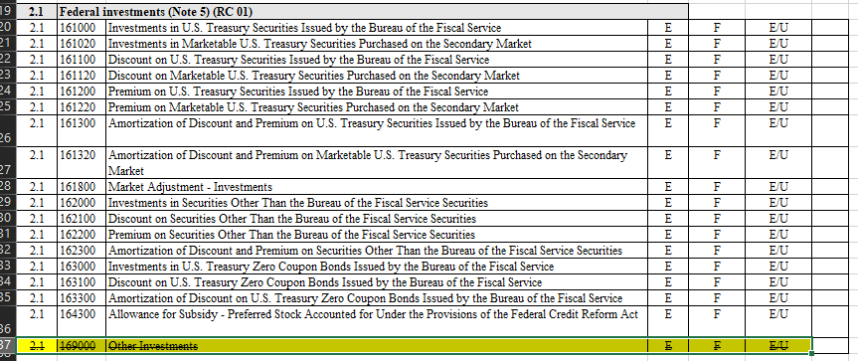

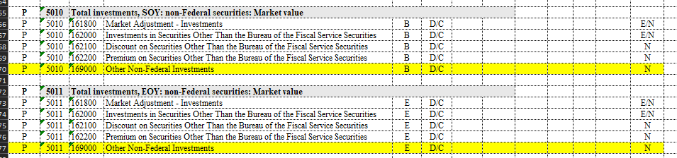

Section VII – GTAS Edits & Validations

- Further analysis is being conducted on whether 169000 can be added to a current edit or if a new edit is necessary to facilitate proper tracking of this USSGL usage compared to balances in Central Accounting Reporting System (CARS).

Timeline

- Should we implement this in Fiscal Year 2024?
- Or wait and make all changes effective for period 01 of FY 2025?

