Proposed FY 2020 Changes to Loan Guarantee Liability Transaction Codes (TCs):

1) Proposed TC Modification to Record Loan Guarantee Fees Earned, But Not Yet Collected:

C428 To record loans, interest, and fees receivable from non-Federal sources for defaulted guaranteed loans and loan guarantee activity. Do not consider as a budgetary resource until collected.

Comment: Applicable to activity for guaranteed loans.

Budgetary Entry
None

Proprietary Entry
Debit 131000 Accounts Receivable
Debit 134100 Interest Receivable – Loans
Debit 135000 Loans Receivable
Credit 139900 Allowance for Subsidy
Credit 218000 Loan Guarantee Liability

Justification: The addition of USSGL 131000 Accounts Receivable allows agencies to record loan guarantee fee earned, but not yet collected, to a receivable account and the offsetting Loan Guarantee Liability account. Once cash is ultimately collected, agencies should record TC A140 and C109.

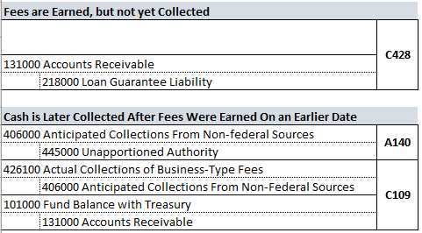

2) Proposed New TC Addition to Record Loan Guarantee Claims Incurred, But Not Yet Disbursed:

B417 To record in a loan guarantee financing account an accrued expense to a third party, in which no asset is received. This transaction includes payments of incurred default claims, interest supplements, and other loan guarantee financing claims.

Comment: Only post this transaction for claims within a loan guarantee financing account that are incurred, but not yet disbursed. At the time of disbursement to a third-party, post USSGL TC-B110.

Reference: USSGL implementation guidance; Credit Reform Case Studies

Budgetary Entry
Debit 461000 Allotments - Realized Resources
Credit 490100 Delivered Orders - Obligations, Unpaid

Proprietary Entry
218000 Loan Guarantee Liability
211000 Accounts Payable
Justification: The addition of TC B417 allows agencies to record loan guarantee claims incurred, but not yet disbursed, directly to the Loan Guarantee Liability account. Once cash is ultimately disbursed, agencies should record TC B110.

