Current Account Tittle: Receipts Unavailable for Obligation Upon Collection
Proposed Account Title: Receipts Unavailable for Obligation Upon Collection - Current-Year Authority
Account Number: 439400
Normal Balance: Credit
Definition: The amount of receipts that, immediately upon collection, is not available for obligation. These receipts, or a portion thereof, may be available for investment before becoming available for obligation. For example, the authorizing legislation may specify a portion of the receipts is available for obligation, while the entire amount of the receipts is available for investment. This account does not close at yearend.
Justification: To separate Current – Year activity from Prior-Year activity.

Proposed Account Title: Receipts Unavailable for Obligation Upon Collection - Prior-Year Balances
Proposed Account Number: 439401
Normal Balance: Credit
Proposed Definition: The unobligated balance of the amount of receipts that, immediately upon collection, is not available for obligation. These receipts, or a portion thereof, may be available for investment before becoming available for obligation. For example, the authorizing legislation may specify a portion of the receipts is available for obligation, while the entire amount of the receipts is available for investment. This account does not close at yearend. This balance is the result of recoveries of prior year obligations and/or unobligated balance transfers in.
Justification: To separate Current – Year activity from Prior-Year activity.

USSGL account 439401 only crosswalks to SF 133/Schedule P line 1020, 1035 (Unobligated balance precluded from obligation (limitation on obligations) (-)) and closes to USSGL account 493400

___________________________________________________________________________
Current Account Title: Receipts and Appropriations Temporarily Precluded From Obligation
Proposed Account Title: Appropriations, Borrowing Authority and Contract Authority Temporarily Precluded From Obligation - Current-Year Balances
Account Number: 439700
Normal Balance: Credit
Definition: The amount of receipts and appropriations (derived from special and trust non-revolving fund receipts), borrowing authority and contract authority that becomes unavailable for obligation until specific legal requirements are met. For example, the portion of appropriated trust fund or special fund receipts collected in the current fiscal year that is precluded from obligation at yearend because of a provision of law (such as a limitation on obligations or a benefit formula). For situations involving borrowing authority and contract authority, the use of this USSGL account is restricted. The ending balance of this account will be part of the end-of-year balance in the Special and Trust Fund Receipt Schedule (Schedule N). This account does not close at yearend. Justification: To separate Current – Year activity from Prior-Year activity.

Current Account Title: Unobligated Balances of Receipts and Appropriations Temporarily Precluded From Obligation
Proposed Account Title: Unobligated Balances of Receipts and Appropriations Temporarily Precluded From Obligation - Prior-Year Balances
Account Number: 439701
Normal Balance: Credit
Proposed Definition Based on situations where total budgetary resources are precluded from obligation in a fiscal year by a provision of law (such as a limitation on obligations), the amount of unobligated balances of appropriations (derived from special and trust non-revolving fund receipts) that becomes unavailable for obligation until specific legal requirements are met is also precluded in special and non-revolving trust funds. This balance is the result of recoveries of prior year obligations and/or unobligated balance transfers in. Justification: To separate Current – Year activity from Prior-Year activity.

___________________________________________________________________________

Current Account Title: Offsetting Collections Temporarily Precluded From Obligation
Proposed Account Title: Offsetting Collections Temporarily Precluded From Obligation - Current-Year Balances
Account Number: 439800
Normal Balance: Credit
Definition: The amount of offsetting collections that becomes unavailable for obligation until specific legal requirements are met. This account does not close at yearend.
Justification: To separate Current – Year activity from Prior-Year activity.

Proposed Account Title: Offsetting Collections Temporarily Precluded From Obligation - Prior-Year Balances
Proposed Account Number: 439801
Proposed Normal Balance: Credit
Proposed Definition: The unobligated balance of the amount of offsetting collections that becomes unavailable for obligation until specific legal requirements are met. This account does not close at yearend. The balance is the result of recoveries of prior year obligations and/or unobligated balance transfers in.
Justification: To separate Current – Year activity from Prior-Year activity.

USSGL account 439801 only crosswalks to SF 133/Schedule P line 1020, 1035 (Unobligated balance precluded from obligation (limitation on obligations) (-)), 1035, 1080, 5091, 5092, 5094, and 5095, and closes to USSGL account 439800

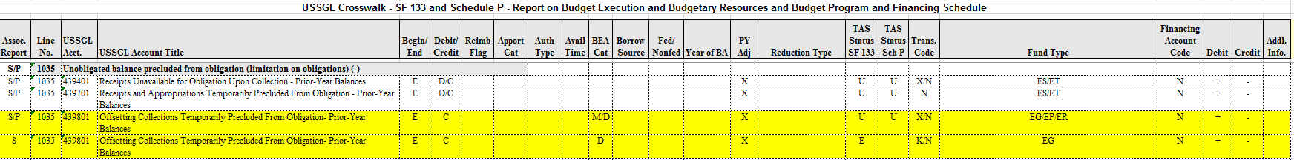

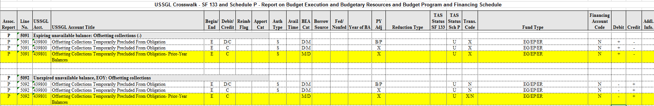

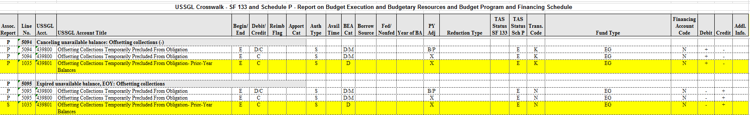
There is a copy paste issue above; the last line should be P, 5094 and 5095.
_________________________________________________________________________

Current Account Title: Repayment of Repayable Advances
Proposed Account Title: Repayment of Repayable Advances - Current-Year Authority
Account Number: 415900
Normal Balance: Credit
Definition: Amounts actually transferred by nonexpenditure transfer during the fiscal year to Advances to the Unemployment Trust Fund and Other Funds for repayment of repayable advances. This transaction is accomplished via a Nonexpenditure Transfer. This USSGL account is to be used by only the Department of Labor and Department of Health and Human Services. Use only with Office of Management and Budget approval.
Justification: To separate Current – Year activity from Prior-Year activity.

NOTE: Please remove Apportionment_Category attribute domain value E for 415900 on lines 1236 and 1422. I don’t know why it is included.

___________________________________________________________________________

Proposed Account Title: Repayment of Repayable Advances - Prior-Year Balances
Proposed Account Number: 415901
Proposed Normal Balance: Credit
Proposed Definition: Amounts actually transferred by nonexpenditure transfer during the fiscal year to Advances to the Unemployment Trust Fund and Other Funds for repayment of repayable advances of prior year balances. This transaction is accomplished via a Nonexpenditure Transfer. This USSGL account is to be used by only the Department of Labor and Department of Health and Human Services. Use only with Office of Management and Budget approval. The balance is the result of recoveries of prior year obligations.
Justification: To separate Current – Year activity from Prior-Year activity.

USSGL account 415901 only crosswalks to SF 133/Schedule P line 1020, 1023, 1080, 5091, 5092, 5094, and 5095. It also closes to USSGL account 420100.

Attribute Table:

No. | USSGL Account Title | Anticipated | Budg/Prop | Norm Bal | Begin/End | Debit/Credit | Auth Type Code | Apport Cat | Apport Cat B
415901 | Repayment of Repayable Advances - Prior-Year Balances | N | B | C | E | D/C | B/P
439401 | Receipts Unavailable for Obligation Upon Collection - Prior-Year Balances | N | B | C | E | D/C
439801 | Offsetting Collections Temporarily Precluded From Obligation - Prior-Year Balances | N | B | C | E | D/C

Avail Time | BEA Cat | Borrow Source | Budgetary Impact  Indicator | Cohort Yr | Cust/ Noncust | Exch/ Nonexch | Fed/ NonFed | Trading Ptnr | Trading Ptnr Main | PY Adj | Program Indicator
 |  |  |  |  |  |  |  |  |  | B/P/X
 | D/M |  |  |  |  |  |  |  |  | B/P/X
 | D/M |  |  |  |  |  |  |  |  | B/P/X

USSGL account 439701 should not have been on the Attribute Table on the original handout.

Program Rpt Cat | Reimb Flag | Year of BA | Reduction Type | Fund Type | Reporting Type Code | Financing Account  Code | TAS Status | Trans. Code
 |  |  |  | ET | E | N | U | N
 |  |  |  | ES/ET | E/F/U | N | U | N
 |  |  |  | EG/EP/ER | E/F/U | N | U/E | X/K/N

