General Fund of the U.S. Government (General Fund)
Loan Business Event Type Code (BETC) GTAS Edits 125-132
*Converting to fatal for the November FY2025 GTAS reporting
18 federal entities report activity subject to GTAS Edits 125-132

FY2022 Q4 – 21% Pass rate
255 instances a TAS failed an edit
69 instances a TAS passed an edit
84 different TAS that failed an edit
1 agency with 100% compliance

FY2023 Q3 – 48% Pass rate
164 instances a TAS failed an edit
151 instances a TAS passed an edit
54 different TAS that failed an edit
7 agencies with 100% compliance

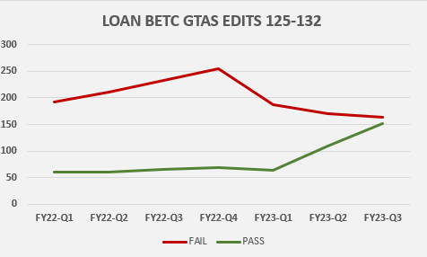

For any questions regarding the use of loan BETCs and the associated GTAS edits, email the General Fund mailbox at generalfund@fiscal.treasury.gov.

