**Proposed New Accounts and Transactions for Year-End Accruals Scenario**

**Effective FY 25**

**Account Title**: Accrued Liabilities

**Account Number**: 299300

**Normal Balance**: Credit

**Definition**: This account will be used to record accrued liabilities where there is not an underlying legally binding obligation that would require a budgetary entry. Or this account can be used in a situation where a proprietary accrual entry is deemed necessary, but the goods or services have not been received. This account does not close at year-end.

**Justification:**  This account will provide a mechanism for agencies to accrue liabilities where there is not an underlying legally binding obligation that would require a budgetary entry, or situations where a proprietary accrual entry is deemed necessary, but goods or services have not been received.

**Account Title**: Accrued Expenses

**Account Number**: 679300

**Normal Balance**: Debit

**Definition**: This account will be used to record expenses for accruals where there is not an underlying legally binding obligation that would require a budgetary entry. Or this account can be used in a situation where a proprietary accrual entry is deemed necessary, but the goods or services have not been received. Although the normal balance for this account is debit, it is acceptable for this account to have a credit balance.

**Justification:** This USSGL account will provide a mechanism for agencies to record accruals for expenses where there is not an underlying legally binding obligation that would require a budgetary entry, or situations where a proprietary accrual entry is deemed necessary, but goods or services have not been received.

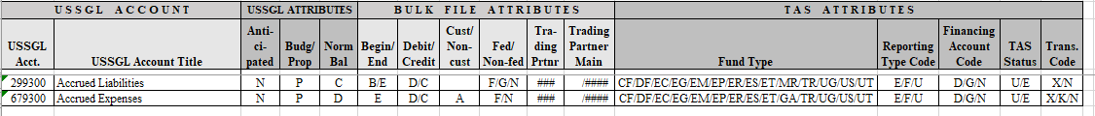

|  |  |  |  |  |  |  |  |  |  |  |
| --- | --- | --- | --- | --- | --- | --- | --- | --- | --- | --- |
| **USSGL**  **Account** | **Balance**  **Sheet** | **Net**  **Cost** | **Net**  **Position** | **Custodial**  **Activity** | **Reclassified**  **Net Cost** | **Reclassified**  **Net**  **Position** | **SF133** | **Schedule P** | **SBR** | **Reciprocal Category** |
| **299300**  **(FY 25)** | 25.6 & 37 | N/A | N/A | N/A | N/A | N/A | N/A | N/A | N/A | 22 |
| **679300 (FY 25)** | 42.1 & 42.2 | 1 | N/A | N/A | 2 & 7.3 | N/A | N/A | N/A | N/A | 24 |

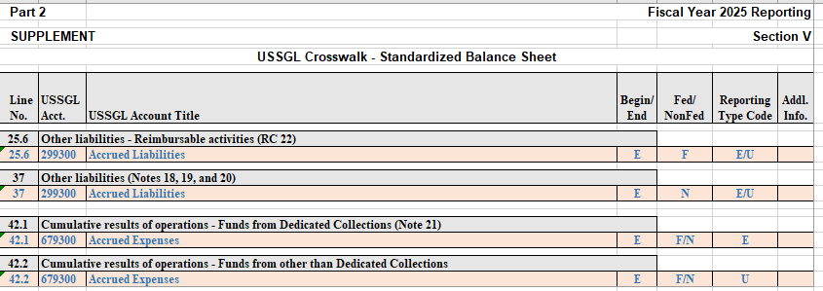

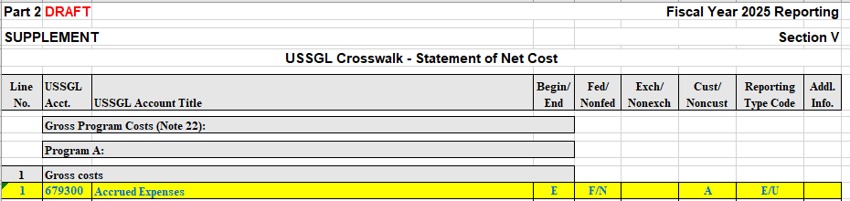

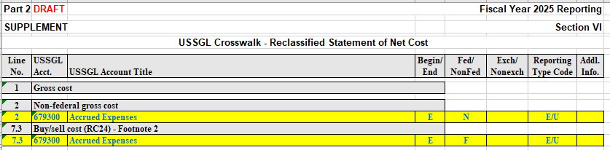

**FY 25 Transactions Additions:**

**B413** To record accrued liabilities and expenses where there is not an underlying legally binding obligation that would require a budgetary entry, or this transaction can be used in a situation where a proprietary accrual entry is deemed necessary, but the goods or services have not been received.

**Comment:** If funded by a direct appropriation, also post USSGL TC-B134.

**Budgetary Entry**

None

**Proprietary Entry**

Debit 679300 Accrued Expenses

Credit 299300 Accrued Liabilities

**B414** To record accrued liabilities and expenses that have been advanced or prepaid, where there is not an underlying legally binding obligation that would require a budgetary entry, or this transaction can be used in a situation where a proprietary accrual entry is deemed necessary, but the goods or services have not been received.

**Comment:** If funded by a direct appropriation, also post USSGL TC-B234.

**Budgetary Entry**

None

**Proprietary Entry**

Debit 679300 Accrued Expenses

Credit 141000 Advances and Prepayments

**FY 25 Transaction Revisions:**

**B134** To record appropriations accrued this fiscal year.

**Comment:** This transaction does not stand alone. Only record this transaction in Treasury Appropriation Fund Symbols (TAFS) that receive amounts appropriated from the General Fund of the U.S. Government via Treasury Appropriation Warrant, or that receive allocation transfers from general fund appropriated TAFS. USSGL transactions that reference this transaction: A492, B402, B406, B412, **B413,** B416, B418, B428, B430, B436, B438, B452, D106, D107, D109, D134, D626, E102, E104, E106, E108, E109, E204, and E412. USSGL transactions that reference a reversal for this transaction: B450, D102, D110, D618, F128, and F148.

**Reference:** USSGL implementation guidance; Appropriations Used

**Budgetary Entry**

None

**Proprietary Entry**

Debit 310700 Unexpended Appropriations - Used - Accrued

Credit 570000 Expended Appropriations - Used - Accrued

**B234** To record the disbursement of appropriations accrued this fiscal year that were not previously accrued.

**Comment:** This transaction does not stand alone. Only record this transaction in Treasury Appropriation Fund Symbols (TAFS) that receive amounts appropriated from the General Fund of the U.S. Government via Treasury Appropriation Warrant, or that receive allocation transfers from general fund-appropriated TAFS in which the use was not previously accrued. If the use of the appropriation was previously accrued, see TC B235. USSGL transactions that reference this transaction: A146, A514, B102, B105, B106, B107, B108, B109, B122, B130, B202, **B414**, B604, C408, and D126. USSGL transactions that reference a reversal for this transaction: C132, C134, C136, C137, C138, C139, and D108.

**Reference:** USSGL implementation guidance; Appropriations Used

**Budgetary Entry**

None

**Proprietary Entry**

Debit 310710 Unexpended Appropriations - Used - Disbursed

Credit 570010 Expended Appropriations - Disbursed

**F336** To record the closing of revenue, expense, and other financing source accounts to cumulative results of operations.

**Budgetary Entry**

None

**Proprietary Entry**

**Debit 679300 Accrued Expenses**

**Credit 679300 Accrued Expense**