**USSGL 169000 Other Investments**

**Section I & II – Chart of Accounts & Definitions**

**Account Title**: Other Non-Federal Investments

**Account Number**: 169000

**Normal Balance**: Debit

**Definition**: This account is used to record the value of other non-federal investments owned by a federal entity. This account does not close at year-end.

**Justification**: There are existing USSGL’s that capture federal investment activity. To be properly reported on Schedule P Memo lines, it is necessary that this account only capture Non-Federal investment activity. There are no current Treasury Account Fund Symbols (TAFS) using this USSGL to report federal investments.

**Section IV – Attribute Table**



**Section V – Balance Sheet & Schedule P**

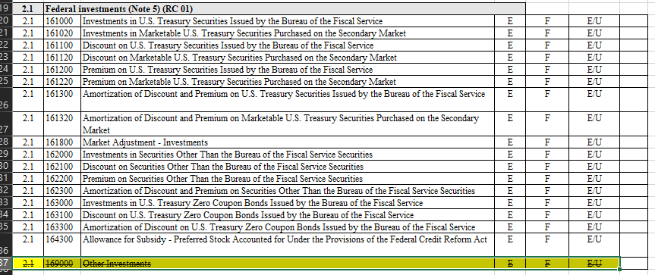

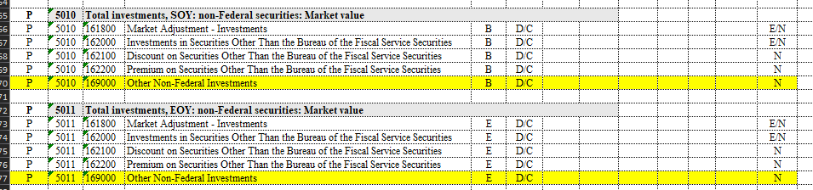

**Section VII – GTAS Edits & Validations**

* New Edit 811 – This edit is for testing purposes only. Fiscal Service and OMB are researching potential changes to Edit 11 and will be using this edit to evaluate the impact of those changes. This edit will remain Proposed Analytical while in use and will be deleted when the analysis is complete.
  + Left side – USSGL’s 161800, 162000, 162100, 162200, and 169000.
  + Right side – Business Line CGHNONFEDSEC (Change in Non-Federal Securities).
* Validation 133 – Restrictions on USSGL Account Permutation Related to Non-Federal Investments.
  + To allow for Financing account values of “D” and “G” (Direct and Guaranteed)
  + Exceptions to TAFS
    - 020X4447
    - 060X8118
    - 086X4587

**TFM 2-4700 Reciprocal Category (Appendix 3) Impact**

* This USSGL will be removed from RC 01 which compares Federal Investments to ensure they match Bureau of Fiscal Service, Federal Financing Bank, or Federal Entity with Authority to Issue Securities

**Effective Date**

* Fiscal Year 2025