Appropriations Provided by a Continuing Resolution

Effective Fiscal Year 2019

GENERAL LEDGER AND ADVISORY BRANCH
BUREAU OF FISCAL SERVICE
U.S. DEPARTMENT OF THE TREASURY

Version  Number | Date | Description of Change | Effective USSGL TFM
1.0 | 04/18 | Original
Continuing resolutions (CRs) are joint resolutions (passed by the House and the Senate and signed by the President) that provide continuing appropriations for a fiscal year. Continuing resolutions are enacted when Congress has not yet passed one or more appropriations bills for a fiscal year or when the President has vetoed congressionally passed appropriations bills. Lacking appropriations, most programs can not incur new obligations.

- Continuing Resolutions usually do not appropriate specific sums of money. Instead the CRs provide “formulas” for calculating the amounts available for continuing programs at minimal levels. Continuing resolutions provide funds for projects and activities. In most cases, the term “programs and projects” refers to appropriation accounts, but not always.

After a CR is enacted into law, the Office of Management and Budget will issue a bulletin to automatically apportion amounts made available by the CR. The amount available during the period covered by the CR will be further defined in the bulletin based on the law.

Generally, warrants are not issued under a CR in anticipation that the appropriation act will be passed. However, Fiscal Service may issue a warrant under the following instances:

- The CR covers specific mandatory federal payments or
- On a case by case basis after the second quarter of the fiscal year; and/or
- The CR covers the entire year.

Although a warrant may not be issued, agencies’ Fund Balance With Treasury (FBWT) should be recorded under a CR. The CR entitles agencies to FBWT. SFFAS No. 7, Accounting for Revenue and Other Financing Sources and Concepts for Reconciling Budgetary and Financial Accounting, paragraph 71 states that appropriations should be recognized in capital as “unexpended appropriations” (and among assets as “funds with Treasury”) when made available for apportionment, even if a Treasury Warrant has not yet been received, or the amount has not been fully apportioned.

Furthermore, until Fiscal Service processes a warrant, agencies’ FBWT will not be posted to its Central Accounting System. The balance in this account will not match CARS. However, agencies will post its normal receipt and disbursement activity using USSGL Account 1010, which should match the balance in CARS.

This scenario illustrates accounting transactions and reporting requirements agencies should use to record FBWT while under a CR.

Proposed USSGL Account Illustrated
Current USSGL accounts:
Account Title: Other Liabilities Without Related Budgetary Obligations
Account Number: 299000
Normal Balance: Credit
Definition: Other liabilities not otherwise classified, for which there is not a related budgetary obligation. The account may be used while awaiting a warrant to be issued for a reduction (i.e., rescission, across-the-board reduction, and sequestration) by the U. S. Department of the Treasury's Bureau of the Fiscal Service. The warrant must be issued by yearend. This account does not close at yearend.
Detailed information related to sequestration will be presented in a new scenario to be developed at a future date.
Justification: To separate warrant activity.

Proposed USSGL Account:

Account Title: Other Liabilities – Reductions
Account Number: 299100
Normal Balance: Credit
Definition: Other liabilities of reductions where there is not a related budgetary obligation. Use while awaiting a warrant to be issued for a reduction (i.e., rescission, across-the-board reduction, and sequestration). The warrant must be issued by yearend. This account does not close at yearend.
Justification: To separate warrant activity.

This scenario presents the first and second quarters of a fiscal year. During the first quarter, the agency is notified that its appropriations bill has not been signed and the agency is under a continuing resolution. In quarter two, the agency’s appropriation bill has been signed. Three separate situations are presented in quarter two, which are as follows:

Situation 1: General Fund Expenditure TAFS receives exact amount in the appropriation.
Situation 2: Special Fund Expenditure TAFS receives exact amount in the appropriation. (Will be presented at a future IRC Meeting)

The following quarterly statements are presented: SF 133, Report on Budget Execution and Budgetary Resources, Consolidated Balance Sheet, Consolidated Statement of Net Cost and Consolidated Statement of Changes in Net Position. The statements are based on fiscal year 2018 crosswalks.

After careful review of the CR, in conjunction with the agency budget office and in compliance with OMB’s automatic apportionment bulletin, it was determined that the annualized level of the appropriation provided under the continuing resolution is $100,000. Since the seasonal obligations for this account are normally higher than the pro rata share and the CR covers the first 21 days of the fiscal year, the amount available for obligation under the CR is $4,783.

QTR 1 Situation 1

1A & B. To record an agencies’ Fund Balance With Treasury under a continuing resolution as determined by OMB’s automatic apportionment bulletin. The apportionment bulletin contained a 1% permanent reduction of unexpended appropriations. No warrants processed.
1A To record the Fund Balance With Treasury under a continuing resolution.
QTR 1 | FPA (F 1XX) |  | The General Fund (G 099)
 | Debit | Credit | Debit | Credit | TC
Budgetary Entry  411900 Other Appropriations Realized  445000 Unapportioned Authority  Proprietary Entry  109000 G 099 Fund Balance With Treasury While Awaiting a Warrant  310100 G 099 Unexpended Appropriations – Appropriations Received  320100 F 1XX Appropriations – Warrants Issued  209010 F 1XX Liability for Fund Balance While Awaiting a Warrant | 100,000  4,783 | 100,000  4,783 | 4,783 | 4,783 | A196  A197  HXX

1B To record the 1% permanent reduction of unexpended appropriations (SW BETC).
QTR 1 | FPA (F 1XX) |  | The General Fund (G 099)
 | Debit | Credit | Debit | Credit | TC
Budgetary Entry  445000 Unapportioned Authority  439200 Permanent Reduction – New Budget Authority  Proprietary Entry  310600 G099 Unexpended Appropriations – Adjustments  299100 G099 Liability for Surplus Warrant to the General Fund of the U.S. Government  199000 F1XX Other Assets  320600 F1XX Appropriations Outstanding - Adjustments | 1,000  1,000 | 1,000  1,000 | 1,000 | 1,000 | A132  HXX
1C. To record authority temporarily unavailable pursuant to public law.
QTR 1 | FPA (F 1XX) |  | The General Fund (G 099)
 | Debit | Credit | Debit | Credit | TC
Budgetary Entry  445000 Unapportioned Authority  439500 Authority Unavailable Pursuant to Public Law  Proprietary Entry  None | 94,217 | 94,217 | N/A | N/A | A128

1D. To record budgetary authority automatically apportioned by OMB and available for allotment.
QTR 1 | FPA (F 1XX) |  | The General Fund (G 099)
 | Debit | Credit | Debit | Credit | TC
Budgetary Entry  445000 Unapportioned Authority  451000 Apportionments  Proprietary Entry  None | 4,783 | 4,783 | N/A | N/A | A116

*Transactions 1A, 1B, 1C and 1D should occur simultaneously.

- To record allotment of authority.
QTR 1 | FPA (F 1XX) |  | The General Fund (G 099)
 | Debit | Credit | Debit | Credit | TC
Budgetary Entry  451000 Apportionments  461000 Allotments – Realized Resources  Proprietary Entry  None | 4,783 | 4,783 | N/A | N/A | A120

- Purchase request for $5,000, was approved. (Commitment)
QTR 1 | FPA (F 1XX) |  | The General Fund (G 099)
 | Debit | Credit | Debit | Credit | TC
Budgetary Entry  461000 Allotments – Realized Resources  470000 Commitments  Proprietary Entry  None | 4,000 | 4,000 | N/A | N/A | B202

- To record current-year undelivered orders without an advance.
QTR 1 | FPA (F 1XX) |  | The General Fund (G 099)
 | Debit | Credit | Debit | Credit | TC
Budgetary Entry  470000 Commitments  480100 Undelivered Orders Obligations – Unpaid  Proprietary Entry  None | 4,000 | 4,000 | N/A | N/A | B204

- To record the delivery of goods and accrue a liability.
QTR 1 | FPA (F 1XX) |  | The General Fund (G 099)
 | Debit | Credit | Debit | Credit | TC
Budgetary Entry  480100 Undelivered Orders Obligations – Unpaid  490100 Delivered Orders – Obligations, Unpaid  Proprietary Entry  610000 N Operating Expenses  211000 N Accounts Payable  310700 G099 Unexpended Appropriations Used  570000 G099 Expended Appropriations  570005 F1XX Appropriations Expended  320700 F1XX Appropriations Outstanding - Used | 4,000  4,000  4,000 | 4,000  4,000  4,000 | 4,000 | 4,000 | B302  B134  HXX

- 6. Payment schedule certified and confirmed.
QTR 1 | FPA (F 1XX) |  | The General Fund (G 099)
 | Debit | Credit | Debit | Credit | TC
Budgetary Entry  490100 Delivered Orders – Obligations – Unpaid  490200 Delivered Orders- Obligations, Paid  Proprietary Entry  211000 N Accounts Payable  101000 G099 Fund Balance with Treasury  201000 F1XX Liability for Fund Balance With Treasury  198000 F020 Asset for Agency’s Custodial and Non-entity Liabilities | 4,000  4,000 | 4,000  4,000 | 4,000 | 4,000 | B110  HXX

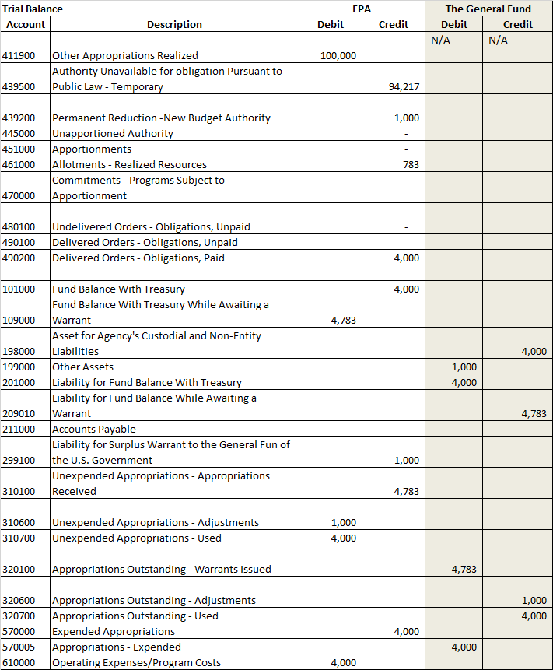
Note, no statements are illustrated in this scenario for period 03.

Appropriations Provided by a Continuing Resolution

Quarter 2
Situation 1

Agency Receives Exact Amount in Appropriations Act Passed by Congress

QTR 2 Situation 1

The CR, passed in Quarter 1 has expired and the agency has received notification that the CR has been extended for an additional 30 days. The amount available for obligation under the extension is $5,783. The annualized level of the appropriation provided under the CR is unchanged.

To record additional Fund Balance With Treasury under a continuing resolution and record authority previously temporarily unavailable as available.
QTR 2 | FPA (F 1XX) |  | The General Fund (G 099)
 | Debit | Credit | Debit | Credit | TC
Budgetary Entry  439500 Authority Unavailable Pursuant to Public  445000 Unapportioned Authority  Proprietary Entry  109000 G099 Fund Balance With Treasury While  Awaiting a Warrant  310100 G099 Unexpended Appropriations – Appropriations Received  320100 F1XX Appropriations – Warrants Issued  209010 F1XX Liability for Fund Balance  While Awaiting a Warrant | 4,783  4,783 | 4,783  4,783 | 4,783 | 4,783 | A128R  HXX

- To record budgetary authority apportioned by OMB and available for allotment.
QTR 2 | FPA (F 1XX) |  | The General Fund (G 099)
 | Debit | Credit | Debit | Credit | TC
Budgetary Entry  445000 Unapportioned Authority  451000 Apportionments  Proprietary Entry  None | 4,783 | 4,783 | N/A | N/A | A116
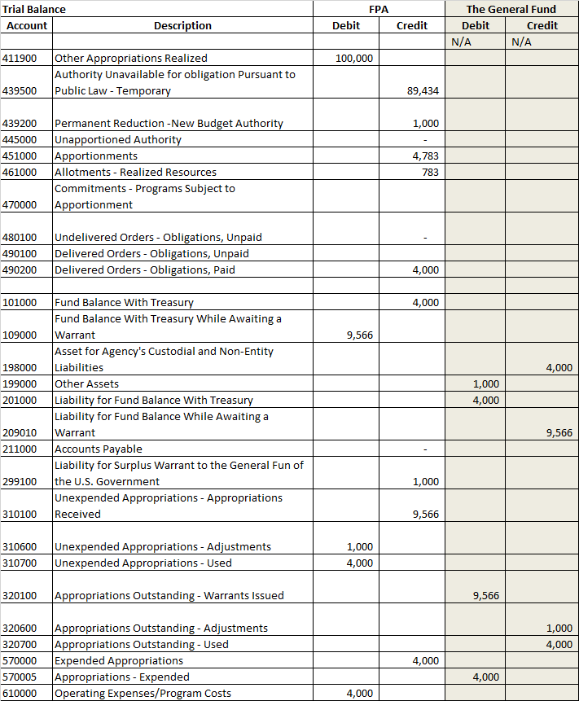
Note, no statements are illustrated in this scenario for period 04.
QTR 2 Period 05 (Situation 1)
Congress enacted the appropriation bill for $100,000 and a 1% reduction.

1. To record receipt of authority (warrant Not received) and record authority previously temporarily unavailable as available.
QTR 2 (Situation 1) | FPA (F 1XX) |  | The General Fund (G 099)
 | Debit | Credit | Debit | Credit | TC
Budgetary Entry  439500 Authority Unavailable Pursuant to Public  445000 Unapportioned Authority  Proprietary Entry  None | 89,434 | 89,434 |  |  | A128R

- To record budgetary authority apportioned by OMB and available for allotment.
QTR 2 (Situation1) | FPA (F 1XX) |  | The General Fund (G 099)
 | Debit | Credit | Debit | Credit | TC
Budgetary Entry  445000 Unapportioned Authority  451000 Apportionments  Proprietary Entry  None | 89,434 | 89,434 | N/A | N/A | A116

- To record allotment of authority.
QTR 2 (Situation1) | FPA (F 1XX) |  | The General Fund (G 099)
 | Debit | Credit | Debit | Credit | TC
Budgetary Entry  451000 Apportionments  461000 Allotments – Realized Resources  Proprietary Entry  None | 94,217 | 94,217 | N/A | N/A | A120

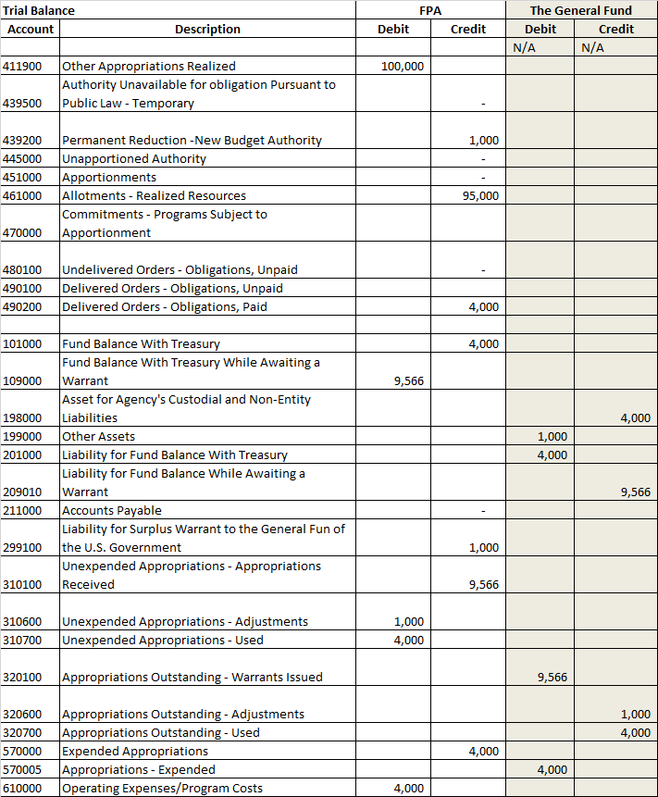
Note, no statements are illustrated in this scenario for period 05.

QTR 2 Period 06 (Situation 1)

To record receipt of the appropriation warrant
QTR 2 (Situation 1) | FPA (F 1XX) |  | The General Fund (G 099)
 | Debit | Credit | Debit | Credit | TC
Budgetary Entry  None  Proprietary Entry  101000 G099 Fund Balance With Treasury  109000 G099 Fund Balance With Treasury  While Awaiting a Warrant  310100 G099 Unexpended Appropriations –  Appropriations Received  320100 F1XX Appropriations – Warrants Issued 201000 F020 Liability for Fund Balance With Treasury  209010 F1XX Liability for Fund Balance While  Awaiting a Warrant  320100 F1XX Appropriations – Warrants Issued | 100,000 | 9,566  90,434 | 100,000  9,566 | 100,000  9,566 | A128R  New??

To record receipt of surplus warrant.
QTR 2 (Situation 1) | FPA (F 1XX) |  | The General Fund (G 099)
 | Debit | Credit | Debit | Credit | TC
Budgetary Entry  None  Proprietary Entry  299100 G 099 Liability for Surplus Warrant to the General Fund of the U.S. Government  101000 G099 Fund Balance With Treasury  201000 F1XX Liability for Fund Balance With Treasury  320600 F1XX  320600 F1XX Appropriations Outstanding - Adjustments  199000 F1XX Other Assets | 1,000 | 1,000 | 1,000  1,000 | 1,000  1,000 | A134R  New??

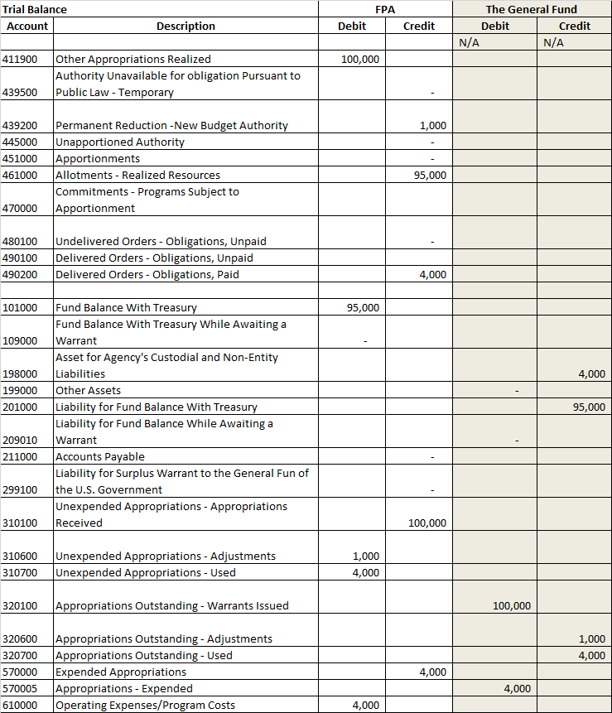
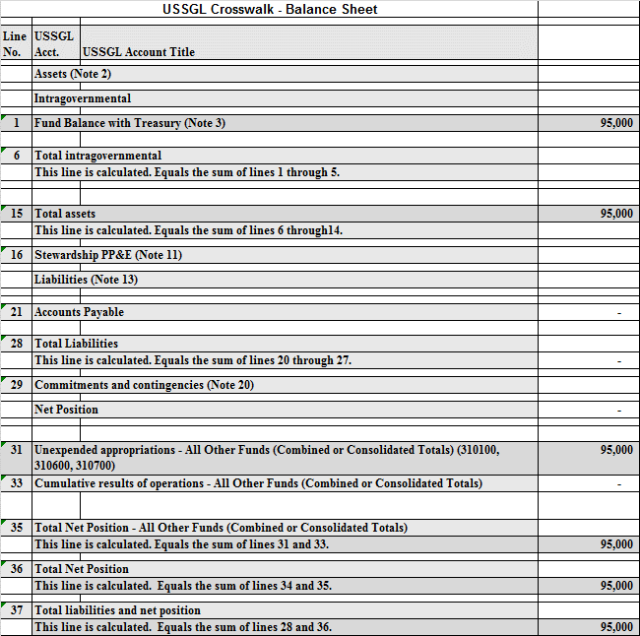
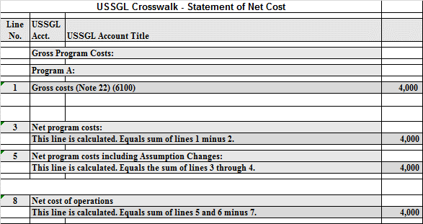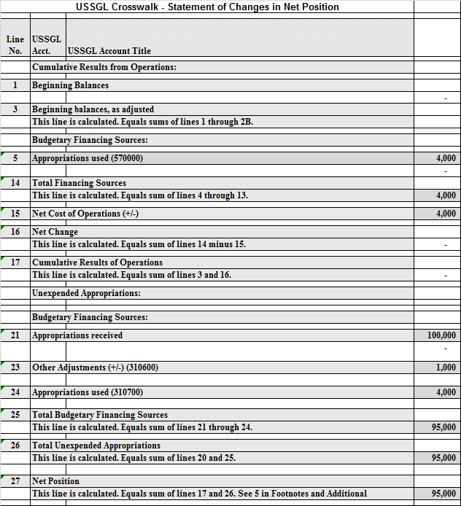

STATEMENT OF BUDGETARY RESOURCES
Line No. | Budgetary resources:
1290 | Appropriations (discretionary and mandatory) (411900, 439200) | 99,000
1910 | Total budgetary resources (calc.) | 99,000
 | Status of budgetary resources:
2190 | New obligations and upward adjustments (total) (Note 31) (490200E) | 4,000
2204 | Apportioned, unexpired account (461000) | 95,000
2490 | Unobligated balance, end of year (total) | 99,000
2500 | Total budgetary resources (calc.) | 99,000
 | Change in obligated balance:
 | Unpaid obligations:
3012 | New obligations and upward adjustments (490200E) | 4,000
3020 | Outlays (gross) (-) (490200E) | (4,000)
 | Memorandum (non-add) entries
3100 | Obligated balance, start of year (+ or -) (calc.) | -
3200 | Obligated balance, end of year (+ or -) (calc.) | -
 | Budget authority and outlays, net:
4175 | Budget authority, gross (discretionary and mandatory) (calc.) | 99,000
4180 | Budget authority, net (total) (discretionary and mandatory) (calc.) | 99,000
4185 | Outlays, gross (discretionary and mandatory) (490200E) | 4,000
4190 | Outlays, net (total) (discretionary and mandatory) (calc.) | 4,000

SF 133 AND SCHEDULE P: REPORT ON BUDGET EXECUTION AND BUDGETARY RESOURCES AND BUDGET PROGRAM AND FINANCING SCHEDULE
Line No. | BUDGETARY RESOURCES | SF 133 | Schedule P
0900 | Total new obligations, unexpired accounts (490200E) | - | 4,000
 | Budget authority:
 | Appropriations:
 | Discretionary:
1100 | Appropriation (411900E) | 99,000 | 99,000
1160 | Appropriation, discretionary (total) | 99,000 | 99,000
 | STATUS OF BUDGETARY RESOURCES
 | New obligations and upward adjustments:
 | Direct:
2001 | Category B (by project) (490200E) | 4,000 | 4,000
2004 | Direct obligations (total) (calc.) | 4,000 | 4,000
2190 | New obligations and upward adjustments (total) | 4,000 | 4,000
 | Unobligated balance:
 | Apportioned, unexpired accounts:
2201 | Available in current period (461000) | 95,000
2412 | Unexpired unobligated balance: end of year (calc) | 95,000
2490 | Unobligated balance, end of year (total) (calc.) | 95,000 | -
 | Memorandum (non-add) entries:
2501 | Subject to apportionment – excluding anticipated amounts (490200E) | 99,000 | -
 | CHANGE IN OBLIGATED BALANCE
 | Unpaid obligations:
3010 | New obligations, unexpired accounts (490200E) | 4,000 | 4,000
3020 | Outlays (gross) (-) (490200E) | (4,000) | (4,000)
 | BUDGET AUTHORITY AND OUTLAYS, NET
 | Discretionary:
 | Gross budget authority and outlays:
4000 | Budget authority, gross (calc.) | 99,000 | 99,000
4010 | Outlays from new discretionary authority (490200E) | 4,000 | 4,000
4020 | Outlays, gross (total) (calc.) | 4,000 | 4,000
4070 | Budget authority, net (discretionary) (calc.) | 4,000 | 4,000
4080 | Outlays, net (discretionary) (calc.) | 99,000 | 99,000
4180 | Budget authority, net (total) | 99,000 | 99,000
4190 | Outlays, net (total) | 99,000 | 99,000

USSGL Crosswalk - Reclassified Balance Sheet
Line No. |  | USSGL Acct. |  | USSGL Account Title |  | FPA |  |  | The General Fund
1 |  | Assets
3 |  | Federal
3.1 |  | Fund balance with Treasury (RC 40)/1 (101000) |  |  |  | 95,000 |  |  | -
3.12 |  | Asset for agency's custodial and non-entity liabilities (RC 46)/1 |  |  |  | - |  |  | (4,000)
3.14 |  | Total federal assets
 |  | This line is calculated. Equals sum of lines 3.1 through 3.13. |  |  |  | 95,000 |  |  | (4,000)
4 |  | Total assets
 |  | This line is calculated. Equals sum of lines 2.9 and 3.14. |  |  |  | 95,000 |  |  | (4,000)
5 |  | Liabilities:
6 |  | Non-federal
7.12 |  | Liability for fund balance with Treasury (RC 40)/1 |  |  |  | - |  |  | 95,000
7.14 |  | Total federal liabilities
 |  | This line is calculated. Equals sum of lines 7.1 through 7.13. |  |  |  |  |  |  | 95,000
8 |  | Total liabilities
 |  | This line is calculated. Equals sum of lines 6.10 and 7.14. |  |  |  |  |  |  | 95,000
9 |  | Net position:
9.2 |  | Net Position - funds other than those from dedicated collections |  |  |  | 95,000 |  |  | (99,000)
10 |  | Total net position
 |  | This line is calculated. Equals sum of lines 9.1 and 9.2. |  |  |  | 95,000 |  |  | (99,000)
11 |  | Total liabilities and net position
 |  | This line is calculated. Equals sum of lines 8 and 10. |  |  |  | 95,000 |  |  | (4,000)
USSGL Crosswalk - Reclassified Statement of Net Cost
Line No. | USSGL Acct. |  | USSGL Account Title |  |  |  |  | FPA |  | The General Fund
1 | Gross cost
2 | Non-federal gross cost (610000) |  |  |  |  |  |  | 4,000 |  | 0
6 | Total non-federal gross cost
 | This line is the sum of lines 2 through 5. |  |  |  |  |  |  | 4,000 |  | 0
9 | Department total gross cost
15 | Net cost of operations
 | This line is the result of subtracting line 14 from line 9. |  |  |  |  |  |  | 4,000 |  | 0

USSGL Crosswalk - Reclassified Statement Of Operations and Changes in Net Position
Line No. | USSGL Acct. | USSGL Account Title | FPA | The General Fund
7 | Budgetary financing sources:
7.1 | Appropriations received as adjusted (rescissions and other adjustments) (RC 41) - Footnote 1 (310100, 310600) |  | 99,000
7.2 | Appropriations used (RC 39) (310700) |  | (4,000)
7.3 | Appropriations expended (RC 38) / 1 (570000) |  | 4,000
7.15 | Warrants issued (RC 41) (320100, 320600) |  |  | (99,000)
7.16 | Appropriations outstanding - used (RC 39) (320700) |  |  | 4,000
7.17 | General Fund of the U.S. Government financed appropriations - expended (RC 38) / 1 (570005) |  |  | (4,000)
7.20 | Total budgetary financing sources
 | This line is calculated. Equals sum of lines 7.1 through 7.19. |  | 99,000 | (99,000)
9 | Net cost of operations (+/-) |  | (4,000) | -
10 | Net position, end of period
 | This line is calculated. Equals sum of lines 4, 5.9, 6.5, 7.20, 8.11, and 9. |  | 95,000 | (99,000)

Appropriations Provided by a Continuing Resolution

Situation 2

1A & B. To record an agencies’ Fund Balance With Treasury under a continuing resolution as determined by OMB’s automatic apportionment bulletin. The apportionment bulletin contained a 1% permanent reduction of unexpended appropriations. No warrants processed.
1A To record the Fund Balance With Treasury under a continuing resolution.
QTR 1 | FPA (F 1XX) |  | FPA Receipt Account
 | Debit | Credit | Debit | Credit | TC
Budgetary Entry  411300 Appropriated Receipts Derived from Unavailable Trust or Special Fund Receipts  445000 Unapportioned Authority  Proprietary Entry  109000 G 099 Fund Balance With Treasury While Awaiting a Warrant  574000 F1XX Appropriated Dedicated Collections Transferred In  574500 F1XX Appropriated Dedicated Collections Transferred Out  299000 F1XX Other Liabilities without related Budgetary Obligation (I see folks hitting 1090 in GTAS) | 100,000  4,783 | 100,000  4,783 | 4,783 | 4,783 | A196  A197  New

1B To record the 1% permanent reduction of unexpended appropriations (SW BETC).
QTR 1 | FPA (F 1XX) |  | FPA Receipt Account
 | Debit | Credit | Debit | Credit | TC
Budgetary Entry  445000 Unapportioned Authority  438700 Temp. Reduction of Appropriation form Unavailable Receipts, PY Balances  Proprietary Entry  574500 F1XX Appropriated Dedicated Collections Transferred Out  299100 1XXOther Liabilities – Reductions  57400 F1XX Appropriated Dedicated Collections Transferred In  ??????? | 1,000  1,000 | 1,000  1,000 | 1,000 | 1,000 | A132  HXX
1C. To record authority temporarily unavailable pursuant to public law.
QTR 1 | FPA (F 1XX) |  | FPA Receipt Account
 | Debit | Credit | Debit | Credit | TC
Budgetary Entry  445000 Unapportioned Authority  439500 Authority Unavailable Pursuant to Public Law  Proprietary Entry  None | 93,217 | 93,217 | N/A | N/A | A128

1D. To record budgetary authority automatically apportioned by OMB and available for allotment.
QTR 1 | FPA (F 1XX) |  | FPA Receipt Account)
 | Debit | Credit | Debit | Credit | TC
Budgetary Entry  445000 Unapportioned Authority  451000 Apportionments  Proprietary Entry  None | 4,783 | 4,783 | N/A | N/A | A116

Transaction 1A-1D need to be discussed prior to completion of the second half of this scenario.
*Transactions 1A, 1B, 1C and 1D should occur simultaneously.

See chapter 8 of the Government Accountability Office’s Appropriation Law. Usually, CRs last no longer than the first quarter of the fiscal year.
OMB Circular No. A-11 (2017), Section 123.1 - 123.5
Treasury Financial Manual, Part 2, Chapter 2000, Section 2030.2
Refer to OMB’s automatic apportionment bulletin to determine the amount available for obligation under a continuing resolution.
Account 1090, Fund Balance With Treasury under a Continuing Resolution, must be zero at year-end.
Account 1090, Fund Balance With Treasury under a Continuing Resolution, must be zero at year-end.
Note: As previously stated, CRs usually do not last longer than the first quarter

